Managing the design and construction process

Produced for Deborah Hughes

Produced by Deri Jones

Index

Introduction pg. 3

Findings pg. 3-7

Findings pg. 7-9

Conclusion pg. 9

References pg. 9

Bibliography pg. 10

Appendices pg. 11-14

- Introduction

In this assignment I will be looking at the offices building. I will firstly be looking at the different types of primary structures, foundations and structural elements that could be used. From this research I will be making my own conclusion on what materials I think will be suitable for the design of the building. I will then be annotating the different elevations of the building showing the different elements including all the primary structural elements. In the second part of the assignment I will be looking at the system of enclosure and why I have decided to use that product over the other methods. In part B I will then be looking at annotating and showing where the system of enclosure is on the drawing.

- Findings
Foundations
The first foundation that I will be looking at is the raft foundation. The job of a raft foundation is to “spread the load of the structure over the entire load of the building” (chudley,2020). As the load is spread instead of all the weight in one area it is used where the area might have softer soil. This is to minimize the risk of subsidence. The raft foundation is commonly used for the smaller and lightly loaded building. The raft foundation uses steel reinforcement throughout the span of the concrete. This is to reduce the risk of cracking.
Next is the strip foundation. This is the more commonly used foundation in construction. The strip foundation is used in “low rise domestic buildings and is formed from a mass concrete strip” (chudley,2020). The strip foundation can be used in “dwellings up to three stories’ high” (chudley,2020). The strip foundation uses tensile stress on the concrete strip underground through the masonry walls. If the foundation depth is not correctly measured out or reinforced correctly then the tensile pressure that is transferred can crack the foundation at the sides at the bottom.
The pad foundation uses beams to transfer the loads over the traditional masonry structure. The pad foundation is used for a light load. To use a pad foundation the soil underneath must be of good quality. The foundation relays on the other pads on the foundation to spread the load equally. The pad foundation uses supporting beams on top to evenly distribute the load.
The pile foundation is used where the soil is soft. By using the pile foundation, it penetrates through the existing ground until it gets to the harder soil below ground. This means that there will be less waste than digging and the structure will be strong. The pile foundation drills into the existing ground with a large drilling excavator. The hole is then filled with concrete and steel reinforcement. There will be many piles to a building and then they are all tied in at ground level. The pile foundation can withstand a lot of downward pressure. This means that it is suitable for the heavy building.
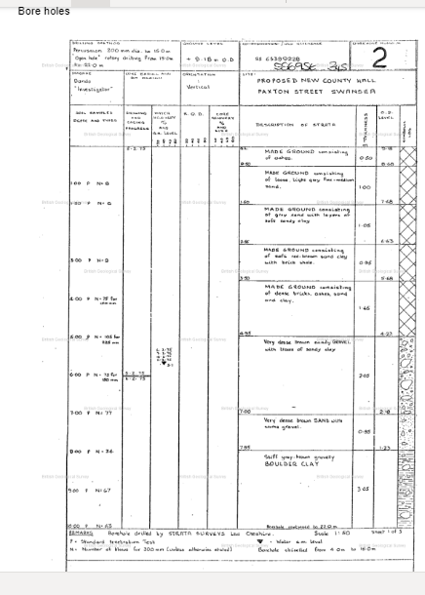
Taken from assignment brief, UWTSD 2022.

Looking from the bore hole results I can see that the ground does not become dense until around 8m down. Using the information that I have gathered and looking at the drawing supplies for the planned layout I think that using the pile foundation would be more than adequate for this building. It has good strength from the columns for underground and would be adequate for the load of the building on top.

External structure of the building

By using the information from the drawing below I can see that the building has long spans over openings. I can also see that the building has columns going through the structure to spread the load. Using this information, I have chosen to look at two of the following options for the primary structure. The two I have chosen are steel and concrete.
For the first floor a type of concrete method would be to use a pre-cast concrete beam floor. This is made off site and then a crane is to lift into position when they arrive on site. They sit on the internal structure of the cavity wall and are held down with mortar and steel reinforced bolts. They are a “pre-cast unit produced widths of 600mm-1200mm” (chudley,2020, pg292). A big advantage to using the concrete flooring is that its fire properties are very good. A disadvantage to the concrete structure is that it is not easily adapted. With the concrete flooring the masonry structure must be used with it. With the building being a block of offices, it needs to be efficient to change if needed to suit clients needs.
The second material I have chosen out of the two to use is the steel. Steel has many benefits the main being the ease of adaption to internal walls as they are not load bearing. Steel can “withstand a considerable amount of external pressure” (NWL,2020). This means that is also has good flexible property if constructed in a windy area. “They are so versatile that they can be easily assembled, disassembled and replaced” (NWL,2020). This mean that the after life of the structure can also be recycled and used on another project unlike the masonry structure. The steel must be used to a minimum “s275 steel to BS EN 1993” (NHBC,2020).
In conclusion from the two that I have chosen the steel would be the best option to use for the structure. The main benefit is that it can span over large areas. Another main advantage is the ease of adaption as it is an office building. Steel has a lot of flex if the building was in a high wind area like the Swansea dockland for example. This will greatly reduce the risk of cracking as it absorbs the movement.
Roof
Looking at the drawing that has been provided the roof is a flat structure and must be sustainable. Looking at the photo it looks like the roof has some sort of vegetation on top of it. The main roof types that I am going to look at is the metal, rubber and corrugated roofing. I have chosen these as they are sustainable and efficient roof types that vegetation would be able to grow on. Being a green roof, it lowers the energy costs as it acts as an insulation barrier on the external. This will lower the energy costs needed.
Firstly, is the metal roofing. “Being extremely durable and offering a lifespan of 50 years, metal roofs are less likely to need replacement for a lifetime” (reliable,2018). This is a major advantage as it means the vegetation will be able to grow on the roof without much maintenance as it is a metal roof it also is able to reflect the suns light off the roof. This is an advantage as it keeps the building cooler in the summer. The corrugated roof I am going to add into the metal roofs as the one I have chosen is constructed out of metal. The main advantage to the corrugated roof is the cost and maintenance. It has the same properties as the metal roof and is easy repaired. One of the disadvantages in using the metal in the green roof would be the rust element. As the roof will need a lot of water and will hold in a lot then it needs to be suffient enough not to rust or corrode.

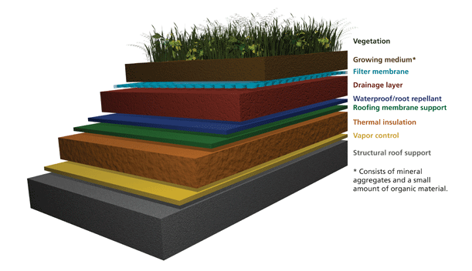
(Image taken from NPS gov, 2022.)
Looking at the image it is apparent that the rubber roof is used under the soil. This is used as it cannot be penetrated easily and is able to hold the moisture in the soil easily without effect. Rubber if installed can last up to 50 years. As is it an eco-roof not just a rubber roof its life expectancy is only 25 years, half that of a 50 year rubber roof. The roof uses a ply base under the membrane. The rubber is not just an ordinary rubber it is a reinforced bitumen membrane. This is to make sure that when it is constructed the chance of penetrating the structure is reduced. The roof structure is layered with hot tar to seal the joints and complete the water tight seal. This can also be used in areas where it may not grow vegetation as it visually has a nice clean finish to the roof.
Under the “BS EN 1992-1-4:2005 Eurocode 1” (NBS,2022). It provides the legal outline to the wind load that is required to be calculated when designing and constructing a building. The British standard code covers buildings up to 200m in height and a span with no greater than 200m. As there are large areas that are lifted away on the roof structure this BS code will need to be considered as it will have a lot of wind load.
Conclusion
Out of the materials that I have discussed I have chosen the best methods / materials to use for the project. For the foundation I have chosen to do the pile foundation due to its ability strength and due to the ground conditions from the bore hole results. For the externals and internal structure, I have chosen to use the steel framed structure due to the tensile and flexible strengths. Finally, for the roof I have chosen to use the bitumen eco-roof due to its sustainability properties and its durability when growing the vegetation illustrated.

Part B – please see appendences
In the second part of the assignment I have shown where the structural walls are on the plans given. I have then given details where the structural beams would run throughout the building.

- Findings
In the next part of the assignment I will be looking at appropriate methods for the enclosed structure of the building. Using the information, I have gathered in task A my methods will be suited to my choices in part 1. From my information gathered above the external structure must be able to work with walls within the steel framed structure.
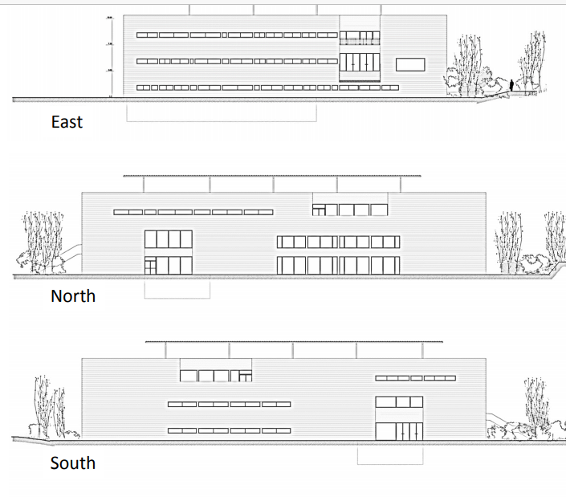
Taken from assignment brief, UWTSD 2022.

Using the information provided on the drawing the closure must be efficient and intelligent to suit the needs of the internal use of the building being an office. The methods I have chosen to look at are cladding and render surface.
Due to the Grenfell disaster in June 2014 the fire safety regs on the cladding must be adequate. The timber framed cladding must be adequate to “BS EN 942” (NHBC,2022). It must also be naturally durable and pressure treated for longevity.
Timber has many main advantages to be used as a cladding. There are also many different types of methods including ship lap and match boarding. Both of these methods provide excellent water proofing and are relatively easy to install. There are many other types of cladding as well as brick slips. This uses a foam board that Is mounted to a timber board. The brick slips then get stuck onto the board using a cement type adhesive. This gives the aesthetic look of the building as if it was a traditional brick face. The brick slips protrude off the structure around 15mm to give the effect of the brick. Finally, is the support system. This is a “profiled galvanized or stainless-steel mesh” (chucley,2020, pg368). This method will give the external look of the building to be metal. This has great properties as it reflects the suns light. This will lower the energy costs needed in the summer.
The next method that I am going to look at is the rendered finish. This is the process of “plastering of external walls with a cement based mortar” (chudley, 2020, pg262). The render technique uses external masonry structure with a wire mesh. This is then plastered over with a cement. The external render must be of good quality following the BS EN 13914-1 standard. One of the benefits of render is that it can come in different texture types. Render also supply’s a good waterproofing to the masonry structure. If the render option was chosen then the external walls between the steel structure would have to be masonry. A rendered masonry structure usually has a life span of between 20-50 years. This is depending on where the building is located and the weather that is in the surrounding area. For example, if this was in the Swansea docklands then the life span of the render would be much lower than if it was in a hotter area. All render must be applicable to the British standard “suitable to the exposure at the site BS 5262: 1991, Figure 2 and BS 8104” (building,2003).
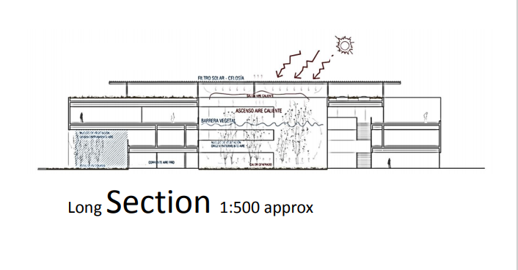
Taken from assignment brief, UWTSD 2022.

Looking at the section drawing supplied I can see a lot of plant and vegetation growing on the building. Using the cladding covered with ivy has many benefits. This includes “increased wind and rain protection, extra thermal insulation and sound insulation, and better air quality” (ecology,2017). This reduces the energy costs that are required to run the building. This is making the building more efficient and cost effective. With the plant added onto the building it also needs added supports to ensure that the building can withstand the added weight.
Using the information from my findings I think that the cladding would be the most sufficient enclosure for the building. I have chosen this option due to the added weight and the life span of the external structure. As the building would also need extra reinforcement this can be added into the cladding and supported into the steels.
Part B – please see appendences
Illustrating the elements of enclosure, I have shown where the cladding is. I have identified the cladding detail in purple. For the cladding wrap around I have made my decision in part A of the question.

- Conclusion
In this assessment I have given my opinion on what materials and methods of construction are best suited to construct the given building. I have covered the foundations, primary structure, roofs. In part 2 of my findings I have then covered the enclosure of the building and the best method for construction.

- References

Pad foundations, author Neenu SK, Date 2020, url: Design Principles, Types and Selection - The Constructor
Steel construction, author NWL, date June 2020, url: Steel Structure Construction (northern-weldarc.com)
Roofs, author proceedinnovative, date 27th 2018, url: Eco-Friendly Roofing Materials to Consider | Reliable Roofing (reliable-roofing.com)
Eco roofs, author 28th October 2018, url: The Eco Roof and Wall Company
Wind load regulation, last updated 2022, URL: BS EN 1991-1-4:2005 Eurocode 1: Actions on structures. General actions - Wind actions (incorporating corrigenda July 2009 and January 2010), British Standards Institution - Publication Index | NBS (thenbs.com)
Cladding NHBC, last updated 2022, URL :6.1.16 Cladding - NHBC Standards 2022 NHBC Standards 2022 (nhbc-standards.co.uk)
Wood cladding article, Wood Protection Association, Publication date: 5 July 2017 url: WPA_Information_Sheet-Timber_Cladding (buildresources.co.uk)
Render life span, written 11 July 2003,author peter Mayer, url: Lifetime costs: renders | Features | Building
Cladding, written 12 July 2017, author ecology centre, URL: Wall cladding with plants - Thermal Insulation - Ecology Centre
Images, Date 2022, author UWTSD, Taken from assignment brief.

- Bibliography

Roy C, Roger G, Karl K, ‘Chudley and greeno’s ‘, twelth edition, raft foundations, pg.220-221
Roy C, Roger G, Karl K, ‘Chudley and greeno’s ‘, twelth edition, strip foundation, pg.213-219.
Roy C, Roger G, Karl K, ‘Chudley and greeno’s ‘, twelth edition, pre-cast concrete floor, pg.292.
Steve wood, ‘NHBC standards, 1st January 2020, steelwork, pg.1-2, chapter 6.5
Roy C, Roger G, Karl K, ‘Chudley and greeno’s ‘, twelth edition, render finishes, pg.262.

- Appendices
Question 1-part B illustrating the structural elements on the structure.
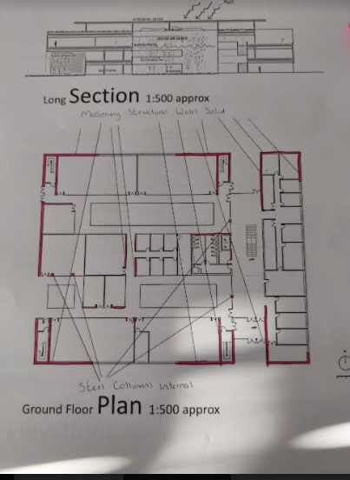
Produced by Deri Jones, 07/03/2022

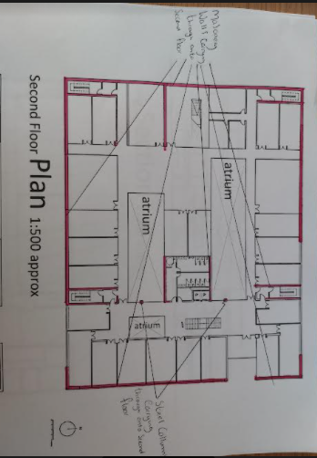
Produced by Deri Jones, 07/03/2022
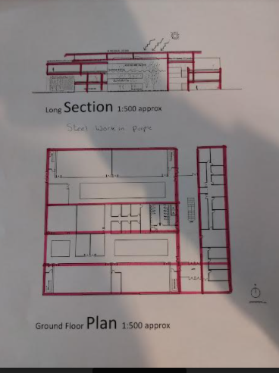
Produced by Deri Jones, 07/03/2022

The structural beams are highlighted in purple.

Question 2 part B
Below I have highlighted the purple enclosure for the cladding wrap around on the building.


