Name: Daniel Rhys Newman
Student Number: 1702330
Module Title: Programming 2
Module Code: ACCA4006
Module Lecturer: Mike Dacey
Assignment Title: Programming 2 Assignment
Date: 20th March 2018

Table of Contents

Section A:
Question 1: page(s) 3

Section B:
Testing: page(s) 3-8

Section C:
Exercise 1 write-up: page(s) 8-9
Exercise 3 write-up: page(s) 9-12

Appendix:
Appendix content: page(s) 13-20

Section 1:

One main technique of problem solving is to divide the problem into multiple steps. Easiest steps first, progressing harder and harder. The reason programmers would do this is to make their harder problems easier. When presented with a difficult problem, it can be tempting to become overwhelmed and to try to tackle the most difficult problem first. The most suitable method however, is to work out the easiest problems first, this is starting from the easiest problems, declaring variables, printing wins, losses etc. then the harder issues become easier to solve because the fundamental elements of that program are already in place, also segmenting the problem into smaller parts means that the programmer and plan the entirety of the program before doing it, which is a good common practise all programmers should be aware of. As a result of having a structured approach to any given problem, the programmer’s program becomes easier to write as it becomes a step by step guide on how to solve the problem.

Section 2: Testing

#01 | Quit Feature “YES”
Description |  | A test to see if typing “YES” works in the quit feature as intended. Testing to see if program does quit, if “YES” works and if any crashes occur
 |  | Test Steps :
1 | Open Program
2 | Select Quit and type “YES”
3 | See what happens

Response |  | The program is supposed to display “quitting” and then quit
Status |  |  | Date |  |  | Description
Fail |  |  | 23/03/18 10:49 |  |  | The program displays “Quitting” but does not end.
Pass |  |  | 23/03/18 11:06 |  |  | Quitting works with response “YES”. Turns out it quits after displaying “Quitting” and awaits any input from the user before it quits.

#02 | Inputting invalid values to Quit
Description |  | Quit only accepts “YES” as a valid result. What happens when someone enters an invalid option
 |  | Test Steps :
1 | When prompted to quit don’t reply “YES”
2 | Try different values like “Yes” and “No” and “1”
3 | See what happens.

Response |  | If an invalid response is entered, it is expected that the program would continue as if the answer was no. However there is a chance it could crash instead.
Status |  |  | Date |  |  | Description
Pass |  |  | 23/03/18 11:15 |  |  | Entering “Yes” resulted in the program continuing as if the answer was no, this was expected.
Pass |  |  | 23/03/18 11:17 |  |  | Entering “No” resulted in the program continuing as if the answer was no, this was expected.
Pass |  |  | 23/03/18 11:19 |  |  | Entering “1” resulted in the program continuing as if the answer was no, this was expected.

#03 | Making “Yes”, “y”, “Y”, “1”, “yes” and “yes” valid answers.
Description |  | Testing the Quit function to make more valid options other than just “YES”.
 |  | Test Steps :
1 | Change the code to include more options.
2 | Test each option to see if they work.
3 | Record Results

Response |  | It is expected that “Yes”, “y”, “Y”, “1” and “yes” will quit the program.
Status |  |  | Date |  |  | Description
Pass |  |  | 23/03/18 11:31 |  |  | After testing “Yes”, it has been confirmed that the program will quit.
Pass |  |  | 23/03/18 11:33 |  |  | After testing “y”, it has been confirmed that the program will quit.
Pass |  |  | 23/03/18 11:35 |  |  | After testing “Y”, it has been confirmed that the program will quit.
Pass |  |  | 23/03/18 11:36 |  |  | After testing “1”, it has been confirmed that the program will quit.
Pass |  |  | 23/03/18 11:37 |  |  | After testing “yes”, it has been confirmed that the program will quit.

#04 | Inputting symbols instead of numbers/letters for Quit
Description |  | “%”, “&” and “£” will be entered to test if these do anything differently to a number or letter.
 |  | Test Steps :
1 | Enter symbols
2 | Record results

Response |  | Expected to result in program accepting answer as a no and continuing.
Status |  |  | Date |  |  | Description
Pass |  |  | 23/03/18 11:57 |  |  | “%” passed through with no issue and was accepted as a negative response to the question.
Pass |  |  | 23/03/18 11:58 |  |  | “&” passed through with no issue and was accepted as a negative response to the question.
Pass |  |  | 23/03/18 11:59 |  |  | “£” passed through with no issue and was accepted as a negative response to the question.

#05 | Inputting letters instead of numbers into option
Description |  | Entering letters to test if the program would crash, or display an incorrect error message.
 |  | Test Steps :
1 | Enter “three” instead of “3” for option
2 | Record results

Response |  | It is expected to display an error message.
Status |  |  | Date |  |  | Description
Pass |  |  | 23/03/18 12:14 |  |  | “Unknown Option Entered” error message appeared.

#06 | Entering text into “adding numbers” section (option 1)
Description |  | When prompted to add numbers, numbers and letters will be entered.
 |  | Test Steps :
1 | Select option 1
2 | Enter numbers and letters
3 | Record results

Response |  | I expect that it will display an error message that would forbid letters being entered to a field that should carry a number.
Status |  |  | Date |  |  | Description
Fail |  |  | 23/03/18 |  |  | After entering 5 numbers, some being a collection of words and some being numbers. Result was displayed as 949378932 which should not have happened.

#07 | Testing New code for entering a letter into a question 1
Description |  | Entering letters into option 1 previously resulted in unusually high or low numbers.
 |  | Test Steps :
1 | Change code to be suitable
2 | Testing values such as “a”, “One” and “Daniel”
3 | Record results.

Response |  | It is expected to show an error message saying that there’s been an invalid input.
Status |  |  | Date |  |  | Description
Pass |  |  | 23/03/18 13:20 |  |  | “a” was entered into the question and resulted in error message “You have not entered a valid number, please go again”.
Pass |  |  | 23/03/18 13:22 |  |  | “One” was entered into the question and resulted in error message “You have not entered a valid number, please go again”.
Pass |  |  | 23/03/18 13:22 |  |  | “Daniel” was entered into the question and resulted in error message “You have not entered a valid number, please go again”.

#08 | Testing invalid numbers for Option 1
Description |  | Due to the change in validation for question 1 there are now some extra pieces of validation in the question.  Shouldn’t be able to enter numbers below 0 or above 999,999.
 |  | Test Steps :
1 | Testing numbers 50 and record results
2 | Testing numbers -5 and record results
3 | Testing numbers 1,000,000 and record results

Response |  | Step One should pass without error. Steps 2 and 3 should show an invalid numbers error.
Status |  |  | Date |  |  | Description
Pass |  |  | 23/03/18 13:32 |  |  | 50 passes through validation just fine.
Pass |  |  | 23/03/18 13:33 |  |  | “-5” was entered into the question and resulted in error message “You have not entered a valid number, please go again”.
Pass |  |  | 23/03/18 13:34 |  |  | “1000000” was entered into the question and resulted in error message “You have not entered a valid number, please go again”.

#09 | Testing Adding numbers display
Description |  | Testing the display which covers the total number
 |  | Test Steps :
1 | Input different numbers “1”, “10”, “100”
2 | Look at display
3 | Record results of each input

Response |  | It was initially expected to wrap around the number
Status |  |  | Date |  |  | Description
Pass |  |  | 23/03/18 18:48 |  |  | “1” passed with the display looking pleasant around it.
Fail |  |  | 23/03/18 18:49 |  |  | “10” went into the display knocking a hash out of place. This will need to be corrected.
Fail |  |  | 23/03/18 18:50 |  |  | “100” went into the display knocking two hashes out of place. This will need to be corrected.

#10 | Testing New Code For Display
Description |  | Will test the numbers “10”, “100”, “1000” and “10000”
 |  | Test Steps :
1 | Input numbers 10. 100, 1000 and 10000
2 | Look at display
3 | Record results.

Response |  | After altering the programs code the display should take into account the length of the total result. The display should be fine until it reaches 10000000000. With the validation on the maximum input value however it is difficult to reach this value.
Status |  |  | Date |  |  | Description
Pass |  |  | 23/03/18 18:55 |  |  | “10” passed through, with display nicely wrapped around it.
Pass |  |  | 23/03/18 18:55 |  |  | “100” passed through, with display nicely wrapped around it.
Pass |  |  | 23/03/18 18:56 |  |  | “1000” passed through, with display nicely wrapped around it.
Pass |  |  | 23/03/18 18:56 |  |  | “10000” passed through, with display nicely wrapped around it.

Section 3:

Exercise 1 asks for a guessing game in which player 1 enters a number and player 2 is meant to guess the number and attempt to get it right within 3 guesses. Additionally the program is meant to give hints to how close the user is to Player 1’s number.
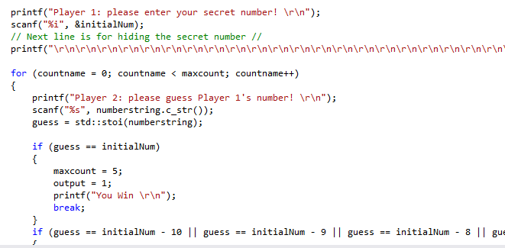
The program asks for player 1’s number and then hides it from view. The player 2 is asked for their guess and depending on where the guess is in correlation to Player 1’s number then it’ll display a relevant hint.
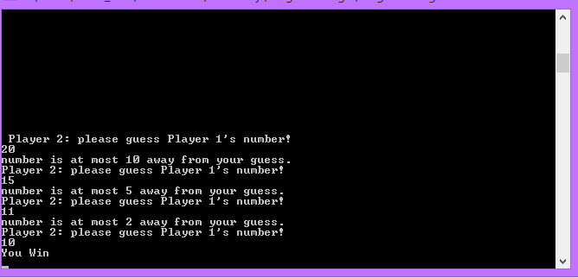
(Player 1’s number in the screenshot above is 10.)

identifying problems. Easiest to hardest.
1. printing "you won"/"you lose".
2. printing hints.
3. inputting a number and reading it.
4. checking inputted number and comparing it to hidden number.
5. checking paramiters for hints.
6. making a loop to repeat guesses.
7. validation for number, no numbers over 20 and no number less than -20

Exercise 3 asks for a game of Connect4 to be created. It’s meant to operate exactly like a digital version of connect4. Player 1 would start to place counters into the playing field and player 2 would follow on, the first player to have 4 adjacent counters (horizontally, vertically or diagonally) wins.

First it was essential to make a list of problems easiest to hardest to solve.
1. Declare variables
2. Printing “you win”/”you lose”
3. Displaying the game board
4. Allow user input using scanf for counter placement
5. Create array for each column containing the spaces for Connect4
6. When counter is placed. Work out which space in the array is available (from bottom to top)
7. Make a counting loop for each column checking each possible criteria for connect4. (Only working when it’s a player 1 or player 2 counter and not blank) (To be done with a loop, there are a total of 4,531,985,219,092 combinations and so this would not be good to do without a loop)

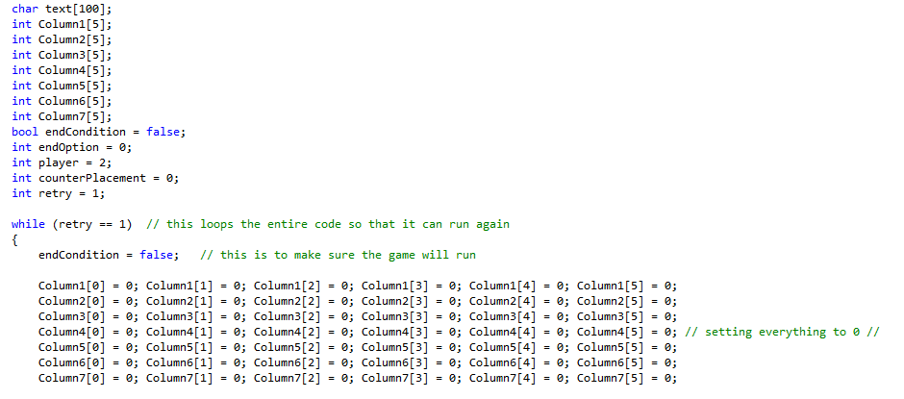
Firstly the arrays were declared, as well as the conditions for the game to end, the option the user picks and the player number (used as counters and player). Secondly set the values for every tile of the board to 0 which will represent a tile that contains no counter.
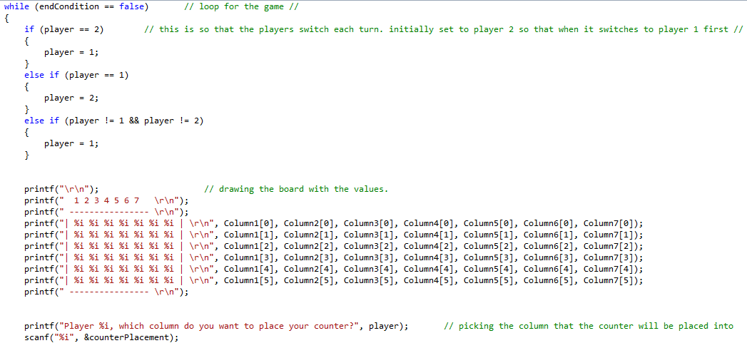
Player is initially set to player 2, this is because the beginning of the loop swaps the player around and so this way it’ll set to 1 at the beginning of the Connect4 game. Next the board is drawn out setting values to 0 first as a blank board.

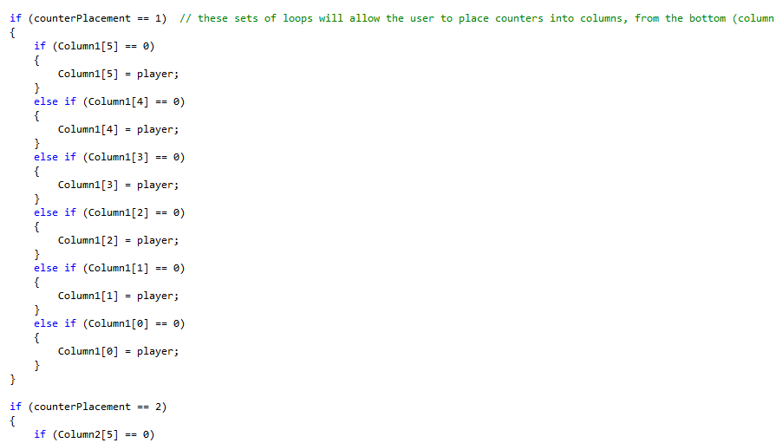

The next few lines are dedicated to putting the counter into the board. It tests the bottom part of the column and if nothing is in it, then it would enter that slot if not it will check the one higher up and so on. Below is an example of what it would look like if a pair of players filled up the third column.
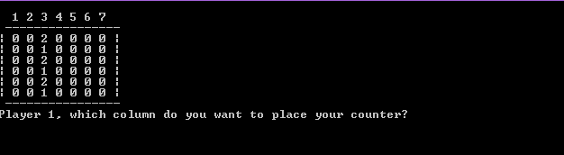
The “1”s represent player 1’s counters, and the “2”s represent player 2’s counters.

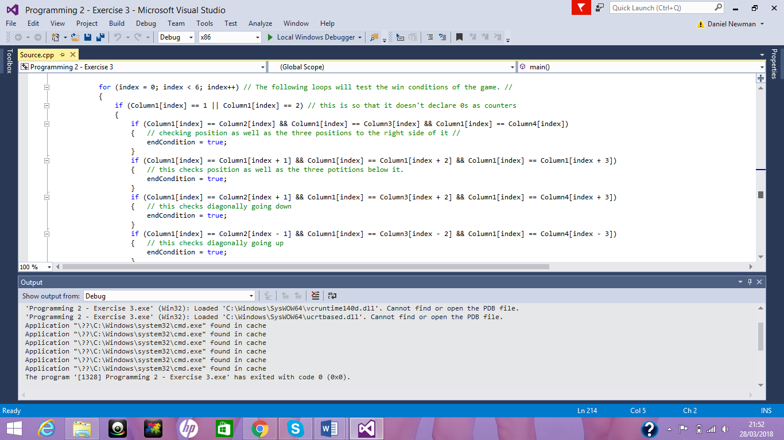

The next group of loops tests every column’s possible Connect4 conditions. As a result of putting these in loops it was only required to do a few tests instead of testing it for every possible outcome.

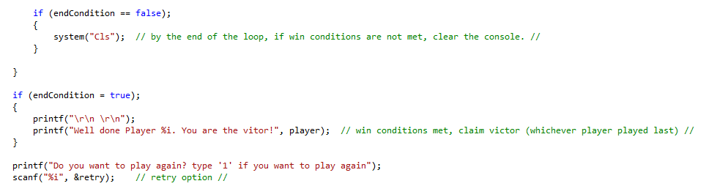

Finally the system clears to reset its display with the newest values. Then if the conditions for a player winning has been met then whichever player made the last move will win as well as a message saying which player won. And finally a retry button to reset the game and play again.

Appendix:

Section B – Testing:

Source:
#define _CRT_SECURE_NO_WARNINGS
#pragma warning(disable:4996)

#include "stdafx.h"
#include <string>

#include "Console.h"
#include "Application.h"

using namespace std;

int main(int args, char* argv[])
{
Console* console = new Console();
Application* application = new Application(console);
bool quit = false;

console->PrintLine("*****************************************************************************");
console->PrintLine("* This application is designed to allow you to select the number of numbers *");
console->PrintLine("* you wish to enter, and sum the numbers that you provide. *");
console->PrintLine("*****************************************************************************");

while (quit == false)
{
application->DisplayMenu();
application->ChooseOption();
quit = application->ProcessOption();
}

console->Pause();

delete application;
delete console;

return 0;
}

Application.h:
#pragma once
#include "Console.h"

class Application
{
// Attributes
private:
Console* _console;
int _chosenOption;
int _numNumbersReqd;

// Constructors
public:
Application(Console* console);

// Properties
// NONE

// Methods
public:
void DisplayMenu();
void ChooseOption();
bool ProcessOption();
private:
int ReadNumber(string prompt);
int GetTotal();
void DisplayResult(int result);
bool IsQuitting();
};

Application.cpp:
#include "stdafx.h"
#include "Application.h"

Application::Application(Console * console)
{
_console = console;
_chosenOption = 0;
_numNumbersReqd = 5;
}

void Application::DisplayMenu()
{
_console->PrintLine("Select an option");
_console->PrintLine("1. Add numbers");
_console->PrintLine("2. Change amount of numbers to be entered");
_console->PrintLine("3. Quit");
}

void Application::ChooseOption()
{
_chosenOption = ReadNumber("Please choose an option:");
}

int Application::ReadNumber(string prompt)
{
_console->Print(prompt);
return _console->ReadInteger();
}

bool Application::ProcessOption()
{
bool quit = false;

switch (_chosenOption)
{
case 1:
int total;
total = GetTotal();
DisplayResult(total);
break;
case 2:
_numNumbersReqd = ReadNumber("Please enter the number of numbers to be entered:");
break;
case 3:
quit = IsQuitting();
break;
default:
_console->PrintLine("Unknown option value entered");
break;
}

return quit;
}

int Application::GetTotal()
{
int temp;
int total = 0;
int index;

for (index = 0; index < _numNumbersReqd; index++)
{
temp = ReadNumber("Please Enter Number: ");

if (temp > 999999)
{
printf("You have not entered a valid number. please go again.\r\n");
index = index - 1;
}
else if (temp < 0)
{
printf("You have not entered a valid number. please go again.\r\n");
index = index - 1;
}
else
{
total = total + temp;
}
}

return total;
}

void Application::DisplayResult(int result)
{
if (result >= 0 && result <= 9)
{
_console->PrintLine("###############################################################################");
_console->PrintLine("###############################################################################");
_console->PrintLine("################## " + to_string(result) + " ##################");
_console->PrintLine("###############################################################################");
_console->PrintLine("###############################################################################");
}
else if (result >= 10 && result <= 99)
{
_console->PrintLine("###############################################################################");
_console->PrintLine("###############################################################################");
_console->PrintLine("################## " + to_string(result) + " ##################");
_console->PrintLine("###############################################################################");
_console->PrintLine("###############################################################################");
}
else if (result >= 100 && result <= 999)
{
_console->PrintLine("###############################################################################");
_console->PrintLine("###############################################################################");
_console->PrintLine("################## " + to_string(result) + " ##################");
_console->PrintLine("###############################################################################");
_console->PrintLine("###############################################################################");
}
else if (result >= 1000 && result <= 9999)
{
_console->PrintLine("###############################################################################");
_console->PrintLine("###############################################################################");
_console->PrintLine("################## " + to_string(result) + " ##################");
_console->PrintLine("###############################################################################");
_console->PrintLine("###############################################################################");
}
else if (result >= 10000 && result <= 99999)
{
_console->PrintLine("###############################################################################");
_console->PrintLine("###############################################################################");
_console->PrintLine("################## " + to_string(result) + " ##################");
_console->PrintLine("###############################################################################");
_console->PrintLine("###############################################################################");
}
else if (result >= 100000 && result <= 999999)
{
_console->PrintLine("###############################################################################");
_console->PrintLine("###############################################################################");
_console->PrintLine("################## " + to_string(result) + " ##################");
_console->PrintLine("###############################################################################");
_console->PrintLine("###############################################################################");
}
else if (result >= 1000000 && result <= 9999999)
{
_console->PrintLine("###############################################################################");
_console->PrintLine("###############################################################################");
_console->PrintLine("################## " + to_string(result) + " ##################");
_console->PrintLine("###############################################################################");
_console->PrintLine("###############################################################################");
}
else if (result >= 10000000 && result <= 99999999)
{
_console->PrintLine("###############################################################################");
_console->PrintLine("###############################################################################");
_console->PrintLine("################## " + to_string(result) + " ##################");
_console->PrintLine("###############################################################################");
_console->PrintLine("###############################################################################");
}
else if (result >= 100000000 && result <= 999999999)
{
_console->PrintLine("###############################################################################");
_console->PrintLine("###############################################################################");
_console->PrintLine("################## " + to_string(result) + " ##################");
_console->PrintLine("###############################################################################");
_console->PrintLine("###############################################################################");
}
else if (result >= 1000000000 && result <= 9999999999)
{
_console->PrintLine("###############################################################################");
_console->PrintLine("###############################################################################");
_console->PrintLine("################## " + to_string(result) + " ##################");
_console->PrintLine("###############################################################################");
_console->PrintLine("###############################################################################");
}
else if (result >= 10000000000 && result <= 99999999999)
{
_console->PrintLine("###############################################################################");
_console->PrintLine("###############################################################################");
_console->PrintLine("################## " + to_string(result) + " ##################");
_console->PrintLine("###############################################################################");
_console->PrintLine("###############################################################################");
}
}

bool Application::IsQuitting()
{
string response;
bool quit = false;

_console->Print("Do you really wish to quit?");

response = _console->ReadString();

if (response == "YES")
{
_console->PrintLine("Quitting");
quit = true;
}
if (response == "yes")
{
_console->PrintLine("Quitting");
quit = true;
}
if (response == "Yes")
{
_console->PrintLine("Quitting");
quit = true;
}
if (response == "Y")
{
_console->PrintLine("Quitting");
quit = true;
}
if (response == "y")
{
_console->PrintLine("Quitting");
quit = true;
}
if (response == "1")
{
_console->PrintLine("Quitting");
quit = true;
}

return quit;
}

Console.h:
#pragma once
#pragma warning(disable:4996)
#include <conio.h>
#include <string>

using namespace std;

class Console
{
// Attributes
// NONE

// Constructors
// NONE

// Properties
// NONE

// Methods
public:
string ReadString();
int ReadInteger();
double ReadDouble();
void Print(string text);
void PrintLine(string line);
void Pause(void);

private:
void ClearInputBuffer();
};

Console.cpp:
#include "stdafx.h"
#include "Console.h"

string Console::ReadString()
{
char text[100];

scanf("%99[^\n]s", text);
ClearInputBuffer();

return (string)text;
}

int Console::ReadInteger()
{
int number;

scanf("%i", &number);
ClearInputBuffer();

return number;
}

double Console::ReadDouble()
{
double number;

scanf("%lf", &number);
ClearInputBuffer();

return number;
}

void Console::ClearInputBuffer()
{
char ch;
while ((ch = getchar()) != '\n' && ch != EOF);
}

void Console::Print(string text)
{
printf("%s", text.c_str());
}

void Console::PrintLine(string line)
{
Print(line + "\r\n");
}

void Console::Pause(void)
{
while (1) { if (_kbhit()) break; } // Pause
_getch();
}

Section C – Implimentation

Exercise One:
#define _CRT_SECURE_NO_WARNINGS
#include <string>
#include <stdio.h>
using namespace std;

// Beginning of Functions //

// End of Functions //

int main()
{
char text[100];
// Exercise 1 //

/*
identifying problems. Easiest to hardest.
1. printing "you won"/"you lose".
2. printing hints.
3. inputting a number and reading it.
4. checking inputted number and comparing it to hidden number.
5. checking paramiters for hints.
6. making a loop to repeat guesses.
7. validation for number, no numbers over 20 and no number less than -20
*/

int initialNum;
int guess;
int output;
int maxcount = 5;
int countname;
string numberstring;
/*
output guide:
1 win
2 within 10
3 within 5
4 within 2
5 loss
*/

printf("Player 1: please enter your secret number! \r\n");
scanf("%i", &initialNum);
// Next line is for hiding the secret number //
printf("\r\n\r\n\r\n\r\n\r\n\r\n\r\n\r\n\r\n\r\n\r\n\r\n\r\n\r\n\r\n\r\n\r\n\r\n\r\n\r\n\r\n\r\n\r\n\r\n\r\n\r\n\r\n\r\n\r\n\r\n\r\n\r\n\r\n\r\n\r\n\r\n\r\n\r\n\r\n\r\n\r\n\r\n\r\n\r\n\r\n\r\n\r\n\r\n ");

for (countname = 0; countname < maxcount; countname++)
{
printf("Player 2: please guess Player 1's number! \r\n");
scanf("%s", numberstring.c_str());
guess = std::stoi(numberstring);

if (guess == initialNum)
{
maxcount = 5;
output = 1;
printf("You Win \r\n");
break;
}
if (guess == initialNum - 10 || guess == initialNum - 9 || guess == initialNum - 8 || guess == initialNum - 7 || guess == initialNum - 6 || guess == initialNum + 6 || guess == initialNum + 7 || guess == initialNum + 8 || guess == initialNum + 9 || guess == initialNum + 10)
{
output = 2;
}
if (guess == initialNum - 5 || guess == initialNum - 4 || guess == initialNum - 3 || guess == initialNum - 2 || guess == initialNum - 1 || guess == initialNum + 1 || guess == initialNum + 2 || guess == initialNum + 3 || guess == initialNum + 4 || guess == initialNum + 5)
{
output = 3;
}
if (guess == initialNum - 2 || guess == initialNum - 1 || guess == initialNum + 1 || guess == initialNum + 2)
{
output = 4;
}

if (output == 2)
{
printf("number is at most 10 away from your guess. \r\n");
output = 0;
}
if (output == 3)
{
printf("number is at most 5 away from your guess.\r\n");
output = 0;
}
if (output == 4)
{
printf("number is at most 2 away from your guess.\r\n");
output = 0;
}
}

if (output != 1)
{
output = 5;
}

if (output == 5)
{
printf("You Lose \r\n");
}

return 0;
}

Exercise Three:
#define _CRT_SECURE_NO_WARNINGS
#include <stdio.h>
#include <string>
using namespace std;

// beginning of functions //

// end of functions //

int main()
{
char text[100];
int Column1[5];
int Column2[5];
int Column3[5];
int Column4[5];
int Column5[5];
int Column6[5];
int Column7[5];
bool endCondition = false;
int endOption = 0;
int player = 2;
int counterPlacement = 0;
int retry = 1;

while (retry == 1) // this loops the entire code so that it can run again
{
endCondition = false; // this is to make sure the game will run

Column1[0] = 0; Column1[1] = 0; Column1[2] = 0; Column1[3] = 0; Column1[4] = 0; Column1[5] = 0;
Column2[0] = 0; Column2[1] = 0; Column2[2] = 0; Column2[3] = 0; Column2[4] = 0; Column2[5] = 0;
Column3[0] = 0; Column3[1] = 0; Column3[2] = 0; Column3[3] = 0; Column3[4] = 0; Column3[5] = 0;
Column4[0] = 0; Column4[1] = 0; Column4[2] = 0; Column4[3] = 0; Column4[4] = 0; Column4[5] = 0; // setting everything to 0 //
Column5[0] = 0; Column5[1] = 0; Column5[2] = 0; Column5[3] = 0; Column5[4] = 0; Column5[5] = 0;
Column6[0] = 0; Column6[1] = 0; Column6[2] = 0; Column6[3] = 0; Column6[4] = 0; Column6[5] = 0;
Column7[0] = 0; Column7[1] = 0; Column7[2] = 0; Column7[3] = 0; Column7[4] = 0; Column7[5] = 0;

while (endCondition == false) // loop for the game //
{
if (player == 2) // this is so that the players switch each turn. initially set to player 2 so that when it switches to player 1 first //
{
player = 1;
}
else if (player == 1)
{
player = 2;
}
else if (player != 1 && player != 2)
{
player = 1;
}

printf("\r\n"); // drawing the board with the values.
printf(" 1 2 3 4 5 6 7 \r\n");
printf(" ---------------- \r\n");
printf("| %i %i %i %i %i %i %i | \r\n", Column1[0], Column2[0], Column3[0], Column4[0], Column5[0], Column6[0], Column7[0]);
printf("| %i %i %i %i %i %i %i | \r\n", Column1[1], Column2[1], Column3[1], Column4[1], Column5[1], Column6[1], Column7[1]);
printf("| %i %i %i %i %i %i %i | \r\n", Column1[2], Column2[2], Column3[2], Column4[2], Column5[2], Column6[2], Column7[2]);
printf("| %i %i %i %i %i %i %i | \r\n", Column1[3], Column2[3], Column3[3], Column4[3], Column5[3], Column6[3], Column7[3]);
printf("| %i %i %i %i %i %i %i | \r\n", Column1[4], Column2[4], Column3[4], Column4[4], Column5[4], Column6[4], Column7[4]);
printf("| %i %i %i %i %i %i %i | \r\n", Column1[5], Column2[5], Column3[5], Column4[5], Column5[5], Column6[5], Column7[5]);
printf(" ---------------- \r\n");

printf("Player %i, which column do you want to place your counter?", player); // picking the column that the counter will be placed into
scanf("%i", &counterPlacement);

if (counterPlacement == 1) // these sets of loops will allow the user to place counters into columns, from the bottom (column[5]) and if it already has a counter then it'll go to the most high up position
{
if (Column1[5] == 0)
{
Column1[5] = player;
}
else if (Column1[4] == 0)
{
Column1[4] = player;
}
else if (Column1[3] == 0)
{
Column1[3] = player;
}
else if (Column1[2] == 0)
{
Column1[2] = player;
}
else if (Column1[1] == 0)
{
Column1[1] = player;
}
else if (Column1[0] == 0)
{
Column1[0] = player;
}
}

if (counterPlacement == 2)
{
if (Column2[5] == 0)
{
Column2[5] = player;
}
else if (Column2[4] == 0)
{
Column2[4] = player;
}
else if (Column2[3] == 0)
{
Column2[3] = player;
}
else if (Column2[2] == 0)
{
Column2[2] = player;
}
else if (Column2[1] == 0)
{
Column2[1] = player;
}
else if (Column2[0] == 0)
{
Column2[0] = player;
}
}

if (counterPlacement == 3)
{
if (Column3[5] == 0)
{
Column3[5] = player;
}
else if (Column3[4] == 0)
{
Column3[4] = player;
}
else if (Column3[3] == 0)
{
Column3[3] = player;
}
else if (Column3[2] == 0)
{
Column3[2] = player;
}
else if (Column3[1] == 0)
{
Column3[1] = player;
}
else if (Column3[0] == 0)
{
Column3[0] = player;
}
}

if (counterPlacement == 4)
{
if (Column4[5] == 0)
{
Column4[5] = player;
}
else if (Column4[4] == 0)
{
Column4[4] = player;
}
else if (Column4[3] == 0)
{
Column4[3] = player;
}
else if (Column4[2] == 0)
{
Column4[2] = player;
}
else if (Column4[1] == 0)
{
Column4[1] = player;
}
else if (Column4[0] == 0)
{
Column4[0] = player;
}
}

if (counterPlacement == 5)
{
if (Column5[5] == 0)
{
Column5[5] = player;
}
else if (Column5[4] == 0)
{
Column5[4] = player;
}
else if (Column5[3] == 0)
{
Column5[3] = player;
}
else if (Column5[2] == 0)
{
Column5[2] = player;
}
else if (Column5[1] == 0)
{
Column5[1] = player;
}
else if (Column5[0] == 0)
{
Column5[0] = player;
}
}

if (counterPlacement == 6)
{
if (Column6[5] == 0)
{
Column6[5] = player;
}
else if (Column6[4] == 0)
{
Column6[4] = player;
}
else if (Column6[3] == 0)
{
Column6[3] = player;
}
else if (Column6[2] == 0)
{
Column6[2] = player;
}
else if (Column6[1] == 0)
{
Column6[1] = player;
}
else if (Column6[0] == 0)
{
Column6[0] = player;
}
}

if (counterPlacement == 7)
{
if (Column7[5] == 0)
{
Column7[5] = player;
}
else if (Column7[4] == 0)
{
Column7[4] = player;
}
else if (Column7[3] == 0)
{
Column7[3] = player;
}
else if (Column7[2] == 0)
{
Column7[2] = player;
}
else if (Column7[1] == 0)
{
Column7[1] = player;
}
else if (Column7[0] == 0)
{
Column7[0] = player;
}
}

int index; // this will refer to the array position

for (index = 0; index < 6; index++) // The following loops will test the win conditions of the game. //
{
if (Column1[index] == 1 || Column1[index] == 2) // this is so that it doesn't declare 0s as counters
{
if (Column1[index] == Column2[index] && Column1[index] == Column3[index] && Column1[index] == Column4[index])
{ // checking position as well as the three positions to the right side of it //
endCondition = true;
}
if (Column1[index] == Column1[index + 1] && Column1[index] == Column1[index + 2] && Column1[index] == Column1[index + 3])
{ // this checks position as well as the three potitions below it.
endCondition = true;
}
if (Column1[index] == Column2[index + 1] && Column1[index] == Column3[index + 2] && Column1[index] == Column4[index + 3])
{ // this checks diagonally going down
endCondition = true;
}
if (Column1[index] == Column2[index - 1] && Column1[index] == Column3[index - 2] && Column1[index] == Column4[index - 3])
{ // this checks diagonally going up
endCondition = true;
}
}

}

for (index = 0; index < 6; index++)
{
if (Column2[index] == 1 || Column2[index] == 2)
{
if (Column2[index] == Column3[index] && Column2[index] == Column4[index] && Column2[index] == Column5[index])
{
endCondition = true;
}
if (Column2[index] == Column2[index + 1] && Column2[index] == Column2[index + 2] && Column2[index] == Column2[index + 3])
{
endCondition = true;
}
if (Column2[index] == Column3[index + 1] && Column2[index] == Column4[index + 2] && Column2[index] == Column5[index + 3])
{
endCondition = true;
}
if (Column2[index] == Column3[index - 1] && Column2[index] == Column4[index - 2] && Column2[index] == Column5[index - 3])
{
endCondition = true;
}
}
}

for (index = 0; index < 6; index++)
{
if (Column3[index] == 1 || Column3[index] == 2)
{
if (Column3[index] == Column4[index] && Column3[index] == Column5[index] && Column3[index] == Column6[index])
{
endCondition = true;
}
if (Column3[index] == Column3[index + 1] && Column3[index] == Column3[index + 2] && Column3[index] == Column3[index + 3])
{
endCondition = true;
}
if (Column3[index] == Column4[index + 1] && Column3[index] == Column5[index + 2] && Column3[index] == Column6[index + 3])
{
endCondition = true;
}
if (Column3[index] == Column4[index - 1] && Column3[index] == Column5[index - 2] && Column3[index] == Column6[index - 3])
{
endCondition = true;
}
}
}

for (index = 0; index < 6; index++)
{
if (Column4[index] == 1 || Column4[index] == 2)
{
if (Column4[index] == Column5[index] && Column4[index] == Column6[index] && Column4[index] == Column7[index])
{
endCondition = true;
}
if (Column4[index] == Column4[index + 1] && Column4[index] == Column4[index + 2] && Column4[index] == Column4[index + 3])
{
endCondition = true;
}
if (Column4[index] == Column5[index + 1] && Column4[index] == Column6[index + 2] && Column4[index] == Column7[index + 3])
{
endCondition = true;
}
if (Column4[index] == Column5[index - 1] && Column4[index] == Column6[index - 2] && Column4[index] == Column7[index - 3])
{
endCondition = true;
}
}
}

for (index = 0; index < 6; index++)
{
if (Column5[index] == 1 || Column5[index] == 2)
{
if (Column5[index] == Column5[index + 1] && Column5[index] == Column5[index + 2] && Column5[index] == Column5[index + 3])
{ // Once I reached this stage, it was no longer possible that it could go three spaces further right and so it was only necassary to test the three below
endCondition = true;
}
}
}

for (index = 0; index < 6; index++)
{
if (Column6[index] == 1 || Column6[index] == 2)
{
if (Column6[index] == Column6[index + 1] && Column6[index] == Column6[index + 2] && Column6[index] == Column6[index + 3])
{
endCondition = true;
}
}
}

for (index = 0; index < 6; index++)
{
if (Column7[index] == 1 || Column7[index] == 2)
{
if (Column7[index] == Column7[index + 1] && Column7[index] == Column7[index + 2] && Column7[index] == Column7[index + 3])
{
endCondition = true;
}
}
}

if (endCondition == false);
{
system("Cls"); // by the end of the loop, if win conditions are not met, clear the console. //
}

}

if (endCondition = true);
{
printf("\r\n \r\n");
printf("Well done Player %i. You are the vitor!", player); // win conditions met, claim victor (whichever player played last) //
}

printf("Do you want to play again? type '1' if you want to play again");
scanf("%i", &retry); // retry option //

}

return 0;
}

