HILTON HOTEL

MODULE NAME: FINANCIAL MANAGEMENT FOR THE HOTEL INDUSTRY
MODULE NUMBER: BMIH5007, BMIH5002
LECTURER: DALE CLARKE

STUDENT NAME: MIHAELA ADRIANA CRISTIAN
STUDNT ID NUMBER: 2017346

Ration Analysis

Executive Summary
In this report, we will conduct a horizontal analysis of Hilton Holdings Inc., an American hospitality multinational company that manages and franchises a broad portfolio of hotels and resorts for the years 2019 and 2020.
Horizontal Analysis is used to review the financial statement of a company over multiple periods of time. Using critical analysis, we can see the trends and the growth pattern of the company which in turn helps in pretending the future of the company.
After this analysis, we will briefly show how these trends and growth patterns can help the company in its financial decisions in the upcoming years.
TABLE OF CONTENTS
INTRODUCTION
HORIZONTAL RATIO
LIMITATIONS OF RATIO ANALYSIS
LIMITATIONS OF RATIO ANALYSIS
CONCLUSION

INTRODUCTION
Hilton Holdings Inc. is an American hospitality multinational company that manages and franchises a broad portfolio of hotels and resorts. This report will consist of a horizontal analysis of the company for the years 2019 and 2020, which will help us understand the trends and the growth patterns of the company.
“Horizontal analysis can refer either to an analysis comparing a specific financial statement with prior or future time periods or to a cross-sectional analysis of one company with another. An examination of horizontal common-size balance sheets reveals the structural changes that have happened in a company. Past patterns are certainly no guarantee of future performance, especially when the economic or competitive environment shifts. When the macroeconomic and competitive situations are reasonably stable, and the analyst is assessing a stable or mature firm, an assessment of prior trends is more informative. Even in less stable environments, though, the historical analysis may be used to generate predictions. Understanding previous patterns might help you determine if they are likely to continue or change direction in the future. One indicator of success is when a company's growth outpaces that of the general market.” (Alexander,2022)
“In financial statement analysis, horizontal analysis is used to evaluate historical data over many accounting periods, such as ratios or line items. Horizontal analysis can utilise either absolute or percentage comparisons, with the numbers in each following period given as a percentage of the amount in the baseline year, with the baseline amount specified as 100%. The base-year analysis is another name for this. Investors and analysts may use horizontal analysis to evaluate what has been driving a company's financial performance over time and identify trends and growth patterns. Analysts can use this form of analysis to evaluate relative changes in distinct line items over time and forecast them into the future. The income statement, the balance sheet, and the cash flow statement are all examined.” (Tuovila,2021)

Horizontal Analysis
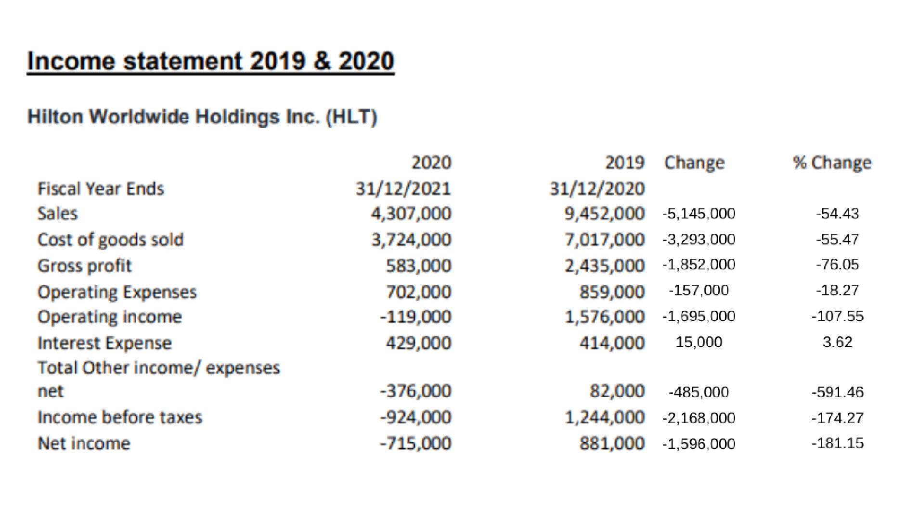
Above is the horizontal analysis of the income statement of Hilton Worldwide Holdings Inc. and the first thing we notice is that the change is negative throughout the income statement. This means that the business is not working well and that is the reason profit has declined by 181%, on the other hand, the expenses have been also reduced to a great amount and the sale declined too. This means the volume of business done was very low, this could be due to the hit of the pandemic and its effect on the hospitality industry which can be clearly shown in the above analysis.
Only the interest Expense was increased but that too from a very marginal percentage of only 3%. We can clearly see a negative trend in sales, profit and at larger the whole income statement.
“If you examine the revenue totals for 2019 and 2020 on a comparative income statement, you can determine if they climbed, declined, or remained reasonably flat. Whether at all feasible, including 2018 in the mix to determine if there was a pattern or if it was simply a fluke. You can simply analyse your progress and position in comparison to your competition by analysing past financial data. To maintain the highest level of accuracy, make sure that all financial statements are produced in accordance with Generally Accepted Accounting Principles (GAAP). Because of the consistency requirement, you must employ the same accounting procedures and principles year after year. Because of the comparability requirement, your assertions and documentation must be comparable.” (Keith,2020)
“Time series analysis is focused on trends and changes in numbers over time. Horizontal analysis can help you to identify growth patterns, cycle times, etc. To compare these factors between different companies. For example, let's look at some of the income statement items for Apple and Google It's hard to tell which is growing faster based on the numbers alone. We need to do some calculations in order to figure out what to do. We can analyse the company's income statement by looking at how its various line items have changed over the past year. By using horizontal analysis, we can see that Google's revenue, gross profit, and EBITDA grew faster than Apple's in every year, except for 2015. We can even go a step further by calculating the compound annual growth rate of each line item from 2012 to 2016 (you can use the function in Excel: =rate (nper, pmt, pv, fv)) - this tells us the company's annual growth rate average growth rate.” (Jhon,2017)
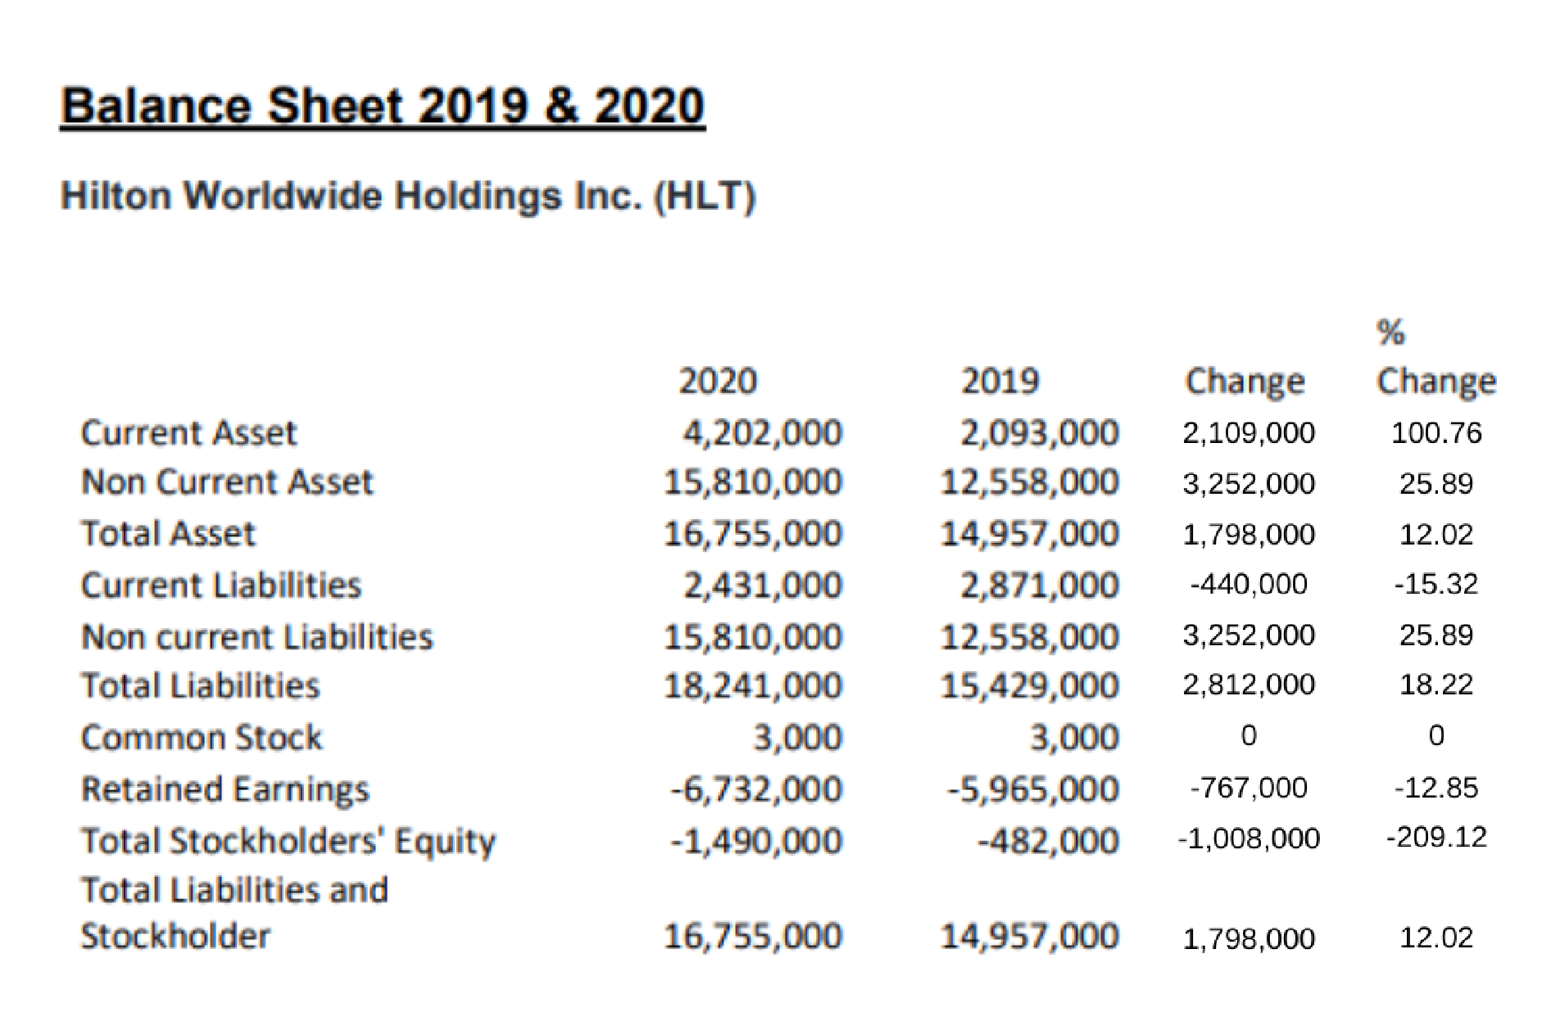
Above we can see the horizontal analysis of the balance sheet of Hilton Worldwide Holding Inc. We notice a 100% increase in current assets which shows that the company's liquidity has increased which an increase in non-current assets we can also say that the company was successful in buying major assets like new property and hotels but the total liability increased is an effect to an increase in assets as they must be taken on a loan from the bank and finally we can see a huge reduction in the shareholder's equity which lead to a decline in the retained earning of the company. A decline in shareholder equity means the share is sold more by the shareholders as they see the company is bearing a loss.
“A base year is selected as a starting point. Either the data from other years is expressed as a percentage of the base year or an absolute comparison is performed. Base year analysis is a technique used to compare data from different years. This method of analysis allows the user of financial statements to easily identify patterns and trends over the years. An absolute comparison compares the amount of the same line of the item in the other accounting periods. Then analyse any changes in a percentage comparison, the increase or decrease in amounts is expressed as a percentage of the amount in the base year. For example, if the base year's cash amount is $100, a 10% increase would make the current accounting period's amount $110, while a 10% decrease would be $90 Different ratios, such as earnings per share (EPS) or current ratio, are compared for different accounts.” (Tamplin,2021).
“If we take a look at the historical financial statements of a company for the years 1 and 2, we can see how many different items have changed over that period of time. We can use this trend to project the costs for future years. One can use year-on-year or quarter-on-quarter growth rates from past financial data to calculate the rate of change for all items on the income statement or balance sheet. After this point, one can make assumptions about future growth rates. For example, in the income statement, we can, based on historical data and trends, make assumptions about sales growth and then forecast the sales growth rates through the forecast periods. Given below is an example of a comparative income statement. year 1 – Barcelona, year 2, and year 3) We used the formulas to calculate the absolute change (in US$) and percentage change (%) of all line items in the income statement between the base year and the third year. The sum of the absolute value of the difference between the two columns is equal to the absolute value of the difference between the two rows.” (Victoria,2018)

Importance of Ratio Analysis for Making Decisions
It is very important for a company to perform ratio analysis and then make their decision as they will then be able to make more efficient decisions. Ration analysis helps the company knows their strengths and weaknesses and hence they can predict the future in a way which helps them to take decisions accordingly. “Financial ratio analysis is a way to show the fiscal health and performance of an organisation to various stakeholders. This is done by analysing the financial statements of a company. This system was originally created in banks in the US in the 19th century to measure the repayment capacity of organizations. The concept of financial ratios was later applied to business decision-making, specifically in terms of measuring a company's financial health. Later, as corporate organizations began to emerge, the importance of ratio analysis was realized even more. With the advent of new technology and science after World War II, new ratios were added to financial analysis. The 1960s saw continued additions and improvements to existing analysis methods, which continued into the 1990s. Over the years, researchers have found that financial ratios can be very useful in investigating various aspects of business-like profitability, solvency and efficiency. It provides trends within organisations by analysing financial statements over a large number of years. This can help you understand the direction of growth for an organization and identify any trends that may affect performance. This type of trend analysis is not possible with single fiscal year data Ratio analysis is a valuable tool for benchmarking one's performance against industry competitors, identifying gaps, and assessing competitive advantages, strengths, weaknesses, opportunities and threats. This information can be used by decision-makers to improve the organisation's position in the industry.” (Kota,2020)
“Accounting is a process that helps decision-makers understand economic information. Accounting is the process of identifying, measuring, and communicating economic information so that informed judgments and decisions can be made. A statement shows a company's financial position at a specific point in time. The balance sheet shows a company's assets and liabilities at a specific point in time.
The Income Statement shows how profitable or successful a business is, while the Balance Sheet shows how solvent or financially sound it is. Decisions are based on information. Bittel et al. found that a person's age is a significant predictor of their likelihood of developing Alzheimer's disease. (1984: 340) Note: “Managers want information because
They need to make decisions The proper use of information is an important part of making good decisions. One effective way of providing information needed for decision-making is ratio analysis. There are many different business decisions that must be made, and no one decision can be the right answer for all businesses.” (Harsha,2017)

LIMITATIONS OF RATIO ANALYSIS
Ratio analysis has some limitations to it even though it helps the company predict the future it is not at all certain and sometimes it could prove wrong for the company, the trends shown by the ratios can perform otherwise in the case of uncertainty. In
Hotel Management fluctuation is essential in analysing information and one should always keep this fluctuation in mind while critically analysing the information to get the best results.
“Ratio analysis is a commonly used tool to look at a company's performance. The company uses its rankings to see where it stands in relation to its competitors. Find out where the area needs improvement, and also where it is doing well. Similarly, investors use ratio analysis to make informed choices before investing in a company. Since financial records are often collected over an extended period of time, it makes sense to take into account the limitations of using ratios. The historical rates at which assets were purchased are reflected in the balance sheets. These rates may not have the same value as they did in the past due to inflation. Inventory value and depreciation value may be different now than at the time of recording.” (Collins,1994)

Conclusion
In the year 2020, we saw that Hilton Worldwide Holding had a major loss in terms of the business as a whole the main reason behind it could be the pandemic which affected the hotel industry adversely and lead to a huge decrease in sales. On the other hand, the company was successful in buying a new property and other non-current assets against a long-term loan as we saw an increase in per cent of both of them.

REFERENCES:
Alexander, D., Britton, A. and Jorissen, A. (2007). International financial reporting and analysis. 5th ed. London: Thomson Learning.
Ciarian Walsh (1996). Key management ratios: how to analyse, compare and control the figures that drive company value. London: Pitman.
Curwin, J. and Slater, R. (2007). Quantitative methods for business decisions. London: Thomson.
Fitzgerald, R. and Netlibrary, I. (2002). Business finance for managers: an essential guide to planning, control & decision making. London: Kogan Page.
Keršulienė, V., Zavadskas, E.K. and Turskis, Z. (2010). SELECTION OF RATIONAL DISPUTE RESOLUTION METHOD BY APPLYING NEW STEP‐WISE WEIGHT ASSESSMENT RATIO ANALYSIS (SWARA). Journal of Business Economics and Management, 11(2), pp.243–258. doi:10.3846/jbem.2010.12.
Lee, C.-F. (2015). Handbook of financial econometrics and statistics. New York: Springer.
Mizen, R. (2009). Some limitations of analysis. Journal of Analytical Psychology, 54(4), pp.461–473. doi:10.1111/j.1468-5922.2009. 01797.x.
Murphy, K. (2021). Horizontal Analysis of Balance Sheets and Financial Statements. [online] PLANERGY Software. Available at: https://planergy.com/blog/horizontal-analysis-balance-sheet/[Accessed 22 May 2022].
Pioneer, T. (2020). English News Paper | Breaking News | Latest Today News in English | News Headlines India. [online] The Pioneer. Available at: https://www.dailypioneer.com/2020/columnists/a-vital-analytical-tool-for-busines
[Accessed 29 May 2022].
Pizzey, A. (1985). Accounting and finance: a firm foundation. English Language Book Society.
Ramuni, L. (2021). Coronavirus and its impact on UK hospitality - Office for National Statistics. [online] ons. Available at: https://www.ons.gov.uk/businessindustryandtrade/business/activitysizeandlocation/articles/coronavirusanditsimpactonukhospitality/january2020tojune2021 [Accessed 27 May 2022].
Reuters.com. (2022). TESCO PLC QUOTE. [online] Available at: http://www.reuters.com/finance/stocks/overview?symbol=TSCO.L [Accessed 27 May 2022].
Situm, M. (2014). Inability of Gearing-Ratio as Predictor for Early Warning Systems. Business Systems Research Journal, [online] 5(2), pp.23–45. doi:10.2478/bsrj-2014-0008.
Szramiak, J. (2017). 2 ways to analyze an income statement. [online] Business Insider. Available at: https://www.businessinsider.com/horizontal-and-vertical-analysis-of-income-statements-2017-3?IR=T [Accessed 27 May 2022].
True, T. (2021). Horizontal Analysis of Financial Statements | Definition and Examples. [online] Finance Strategists. Available at: https://learn.financestrategists.com/explanation/financial-statements/horizonta [Accessed 24 May 2022].
Tuovila, A. (2021). Horizontal Analysis. [online] Investopedia. Available at: https://www.investopedia.com/terms/h/horizontalanalysis.asp#:~:text [Accessed 28 May 2022].

