Picture References


Rogers, T. (2017). 'These five ways to build confidence will get the best out of your students'. Available: https://www.tes.com/news/these-five-ways-build-confidence-will-get-best-out-your-students. Last accessed 12th Dec 2019.
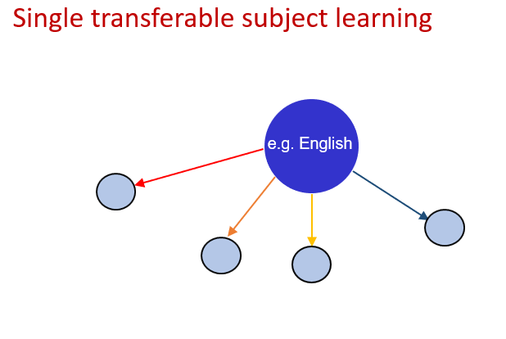after (Barnes, 2015)
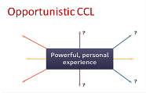
Barnes. J. (2019). Across the Curriculum. Available: https://osiriseducational.co.uk/staffroom/article/across-the-curriculum/. Last accessed 7th Dec 2019.

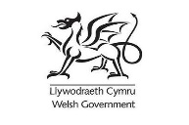
NPTCVS. (2018). Welsh Gov Logo. Available: https://www.nptcvs.wales/autism-awareness-event-24th-april-2018/welsh-gov-logo/. Last accessed 7th Dec 2019.

Welsh Government. (2019). Draft Curriculum for Wales 2022. Available: https://hwb.gov.wales/draft-curriculum-for-wales-2022. Last accessed 7th Dec 2019
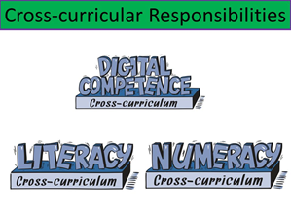
Foster, B. (2016). 4 Schools Conference - Thursday 4th February. Available: https://slideplayer.com/slide/10791875/. Last accessed 7th Dec 2019.
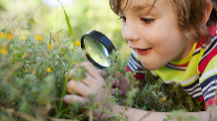
Evans, S. (2019). Outdoor learning ideas for primary. Available: https://www.tes.com/teaching-resources/blog/outdoor-learning-ideas-primary. Last accessed 7th Dec 2019.

References

Ashley, J. (2010). Promoting a creative curriculum and achieving high standards. Available: https://dera.ioe.ac.uk/2078/1/download%3Fid%3D76802%26filename%3Dpromoting-a-creative-curriculum-summary-report.pdf. Last accessed 19th Dec 2019.
Barnes, J., (2012). An introduction to cross-curricular learning. The primary curriculum: A creative approach, pp.235-254
Barnes, J., (2015). Cross-curricular learning 3-14. Sage.
Davies, C., Bebb, L., Davies, G. and Richards, S., (2012). Creativity on Fire in Ynystawe. In The Leonardo Effect: Motivating Children To Achieve Through Interdisciplinary Learning (pp. 113-121). Routledge.
Devine, D., David, M.E. and Menter, I., (2010). Children, their world, their education: final report and recommendations of the Cambridge Primary Review. British Journal of Sociology of Education, 31(6), pp.813-826.
Donaldson, G. (2015). Successful Futures: Independent Review of Curriculum and Assessment Arrangements in Wales. Available at: https://www.nasuwt.org.uk/uploads/assets/uploaded/ad5b4d73-76eb-462a-8ba00412eb6e572a.pdf Last accessed 6th Dec.2019.
Estyn. (2014). A report on Ynystawe Primary School . Available: https://www.estyn.gov.wales/sites/www.estyn.gov.wales/files/documents/Inspection%20report%20Ynystawe%20Primary%20School%202014%20%28English%20only%29_0.pdf. Last accessed 19th Dec 2019.
Estyn. (2017). Active and experiential learning Effective foundation phase practice in delivering literacy and numeracy in Year 1 and Year 2 . Available: https://primarysite-prod-sorted.s3.amazonaws.com/ynystawe-primary-school/UploadedDocument/401d8807db804a9ea18ab5bb29be61da/estyn-active-and-experiential-learning.pdf. Last accessed 19th Dec 2019.
Kuo, M., Barnes, M. and Jordan, C., (2019). Do experiences with nature promote learning? Converging evidence of a cause-and-effect relationship. Frontiers in psychology, 10, p.305.
McGregor, D., (2007). Developing thinking; developing learning. McGraw-Hill Education (UK).
Plowden, B., (1967). The Plowden Report: Children and their primary schools. A Report of the Central Advisory Council for Education (England).
Sugrue, C., (2010). Plowden: Progressive Education—A 4-Decade Odyssey?. Curriculum Inquiry, 40(1), pp.105-124.
Tickell, C. (2011). The Early Years: Foundations for life, health and learning: an independent report on the early years foundation stage to Her Majesty's government.. Available: http://outdoormatters.co.uk/wp-content/uploads/2011/04/The-Early-Years-Foundations-for-life-health-and-learning.pdf. Last accessed 19th Dec 2019.
Wells, N. M., Myers, B. M., Todd, L. E., Barale, K., Gaolach, B., Ferenz, G., et al. (2015). The effects of school gardens on children’s science knowledge: a randomized controlled trial of low-income elementary schools. Int. J. Sci. Educ. 37, 2858–2878. doi: 10.1080/09500693.2015.1112048
Welsh Government. (2013). National Literacy and Numeracy Framework. Available: https://hwb.gov.wales/storage/64812b0e-3d20-4d10-94e8-68221e47a38d/to-support-schools-in-introducing-the-national-literacy-and-numeracy-framework.pdf. Last accessed 19th Dec 2019.
Welsh Government. (2018). Digital Competence Framework guidance. Available: https://hwb.gov.wales/storage/337437b8-cfe3-4305-ae32-f47ad82f3e76/digital-competence-framework-guidance-2018.pdf. Last accessed 19th Dec 2019.
Welsh Government., (2019). A guide to Curriculum for Wales 2022. Available: https://hwb.gov.wales/draft-curriculum-for-wales-2022/a-guide-to-curriculum-for-wales-2022. Last accessed 24th Nov 2019.

