

LOCATION: BIRMINGHAM
LEVEL 4 | LEFEL 4
EXAMINATION PERIOD | CYFNOD ARHOLIADAU
SEPTEMBER 2021 | mEDI 2021

MODULE CODE: ACCA4017
SOFTWARE DEVELOPMENT
TIME: 2 HOURS
ANSWER ALL Question/s in PArt one
answer aNY TWO questions IN PART TWO

Equipment or materials required – Computers with Python installed or Google Colab

Student name: Aleksandar Kushlev
Student ID: 2028393

PART ONE: ANSWER ALL QUESTIONS

1. a) What variable type would Python infer for the following values:

1.32 float

124 integer

Hello string

-34.62 float

[-562] list

[1 mark each - 5 marks total]

1. b) Spot the errors in the following program to calculate the area of a circle and write the error-free program in the empty box.

Program with errors | Error-free program
print("Enter the radius)  radus = input()  area = 3.14*radius*radius  PRINT(" The area of the circle is : " area) | print(“Enter the radius”)  radius = int(input())  area = 3.14*radius*radius  print(“ The area of the circle is : “, area)

[1 mark each mistake identified - 5 marks total]

1. c) How many iterations do the following loops have?

- for i in range(50):
print(i) ……50……

- for i in range(1,10,2):
print(i)
……5……

[2 marks each - 4 marks total]

1.d) What is the value of the integer variable total after the following code is executed?

total=0
for x in range(10):
total=total+x
if(x == 5):
total=0

…if the code remains as it is in the part x= =5, then it will produce invalid syntax. If the syntax is changed to x==5 then it will produce value 30……
[4 marks total]

1.e) Given the following program:

Temp = [23,24,25,29,40,56]

i) Write the code you would use to print the value stored in the third element of the array on the screen

Temp = [23,24,25,29,40,56]
print(Temp[2])

ii) Write the code you would use to sum up the first and last elements of the array

Temp = [23,24,25,29,40,56]
Temp_sum = Temp[0] + Temp[-1]

[1 mark each - 2 marks total]

[20 marks total for Question 1]

Part TWO (Answer any two questions)

1. Calculating the volume of a hemisphere

The volume of a hemisphere (half-sphere) is calculated using the formula:
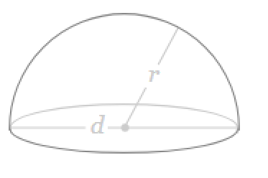

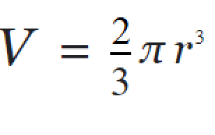

Task:
Write a program to calculate the volume using the above formula.
Allow the user to enter the measurement for r. You may set π as 3.142

#prompting the user to input a value for the radius
print(“Enter the radius”)
radius = float(input())

#setting a variable equal to pi = 3.142
pi_value = 3.142

#setting a variable equal to radius on power 3 and rounded to 2nd decimal place
radius_exp = round(pow(radius, 3), 2)

#calculating the volume of the hemisphere as a rounded (to first decimal place) product of 2, pi value, and the rounded radius on power 3, and the product divided by 3
vol_hemisphere = round(((2*pi_value*radius_exp)/3), 1)

#Printing the volume of the hemisphere
print(“The volume of the hemisphere is:\n”,vol_hemisphere)

[20 marks total]

2. Using List

Task:
Define a list called height and enter the following values:

height= [122,145,163,122,121,141,170,180].

Use the list functions available to do the following:
- Display the created list.
- Append 190 to the list.
- Display total number of elements in the list.
- Sort the list in ascending order and display the modified list.
- Display the list in reverse order.

#1. Display the created list
print(height)

#2.Append 190 to the list
Height.append(190)

#3. Display total number of elements
height_length = len(height)
print(height_length)

#4 sort the list in ascending order and display the modified list
height=sorted(height)
print(height)

#5 display the list in reverse order
height.reverse()
print(height)

[4 marks each - 20 marks total]

3. Using Turtle

Using Python with Turtle, draw the following shapes:
- A triangle with black background



from turtle import *
import turtle
turt = turtle.Turtle()
turt.forward(80)
turt.left(100)
turt.forward(80)
turt.left(100)
turt.forward(80)
turt.set_facecolor(‘xkcd: black’)
[5 marks total]

- An octagon with yellow background and sides in alternative colours (red and black)

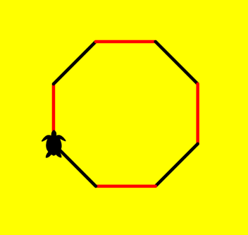

[15 marks total]

[20 marks total for Question 3]

Diwedd/End

