Syed Kazmi
1913454
BMHP5014
CREATIVITY AND VALUE CREATIONS
DR AZORA HURD
TASK 1 AND 2

Task 1 - Create a mind map that demonstrates how the ideas and concepts covered in Unit One of the module are interconnected and how they contributed to the development of your project idea.

Task 2 - Using a medium of your choice, create a summary that outlines how you came up with your idea and how it adds value, based on the concepts introduced You should use a medium appropriate to your subject discipline, this can be a written document, a blog, or a visualisation.

Task 1- Mind map

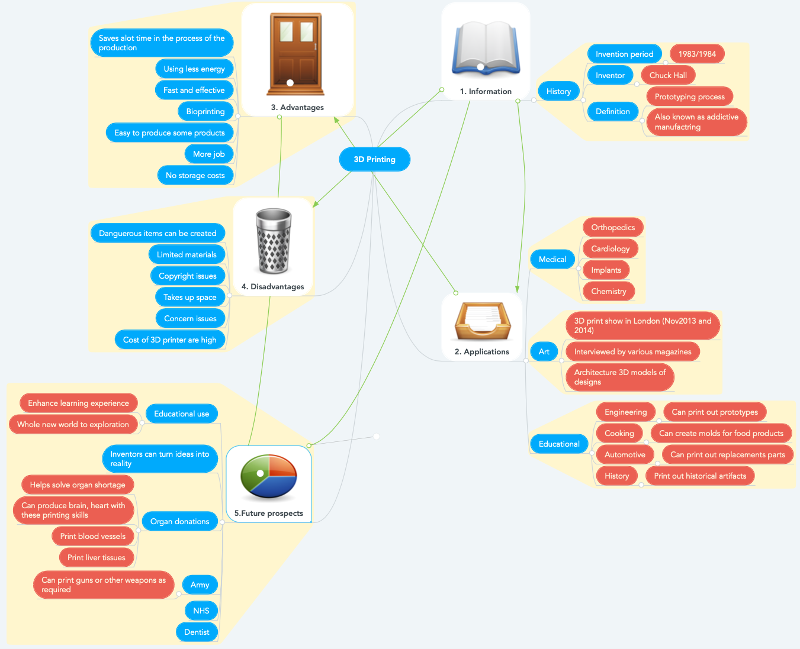

https://www.mindmeister.com/452290055/3d-printing

This mind map was created on the above link. I created an account and created this mind map by using what the above weblink offers. My mind map shows how 3D printing has progressed over the years and what it can achieve in the near future. The mind map has been split into five sections which are numbered, number 1 is giving information that gives a brief insight to who has invented it? when was it invented?

Number 2 is providing a brief insight of which applications can benefit from 3D printing and who already is. In this section we will look into three different applications in particular from 100s of others are medical, art, educational.

Number 3 will be looking at the advantages of 3D printing and how it can be effective in different scenarios, one of the advantages can be that it can easily produce certain products. Now have a think what products can easily be made? There are various items that can be made in emergencies or non-emergencies.

Number 4 is showing what disadvantages can come with 3D printing. A famous actor Kabir Bedi quoted ‘everything has its advantages and disadvantages`. The disadvantage that has been mentioned in the mind map above are issues that relate to cost issues and other issues such as dangerous items can be made. (Kabir Bedi Quote, 2017)

Number 5 will be looking at the future of 3D printing. This section of the mind map will show an insight on what applications 3D printing can be affective for the present and future. This idea of 3D printing can be useful in various different sectors such as the army they can use it to create gear or weapons, the health sector can use it to create bones, liver tissues, vessels and much more.

Task 2 - Blog
 3D Printing is over 30 years old it has actually been around since the 1980s but has not had the popularity since it has been around, but it has exploded in the last couple of years and is getting popular day by day around the world. One day in future, there will be a bioprinting facility in every hospital. We will indeed print out spare parts for bodies. It’s a big challenge, but that’s what makes it fun. And it will have a huge impact on people’s lives, that’s what makes it worthwhile.

3D PRINTING
!!!CHANGI N G THE WORLD!!!
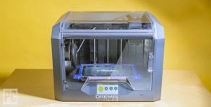

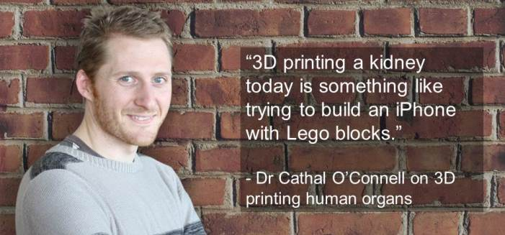
Since its innovation more than 30 years back, 3D printing technology has advanced at a quick speed, with critical effect in both the mechanical and business world. Stereolithography, particular laser sintering, and combined statement displaying were among the main generally effective strategies for 3D printing, at first utilized for mechanical prototyping. 3D printing technology was before long produced for use in a variety of fields, for enormous opportunity engineering, designing of exceptionally complex parts, and in any event, for individual use. In healthcare specifically, 3D printing encourages more patient-explicit intercessions, including careful arranging and embed plan. Also, 3D bioprinting technology assumes an indispensable part in the progression of tissue designing and biomedical exploration. As 3D printing keeps on getting more modern, it is probably going to impact healthcare later on. It isn’t hard to see 3D printing technology is propelling quick and is headed to make it into every household. The Netherlands is as of now dealing with the main 3D printed house and organisations in the united states recently showcased the first ever 3D printed food things like ravioli and chocolate and they also printed a 3D battery. Speed of manufacturing an item will increase intensely. Items will be made from scratch in matter of hours this will shorten the period of time consumed. Costs have been less expensive in some major countries around the world. Thjkjl jhjh jhjh jhe one for you I have not just all

Key Facts  6 different ways 3D printing will change the world  1. Production will take a turn with 3D printing.  2. The clinical world will be flipped around  3. 3D printing will start an innovative renaissance  4. 3D printing could help tackle the housing crisis  5. New sorts of wrongdoing will arise  6. 3D printing could save the climate
  Hull legitimately anticipated that it would require at least 25 years for his innovation to make it into individuals' homes, however since 1984 3D printing has passed gigantic achievements. Below are some accomplishments listed
  - 1999 – A 3D synthetic scaffold is implanted in a human patient.
  - 2002 – A 3D kidney is engineered that can filter blood and produce diluted urine
  - 2008 – The first prosthetic leg is 3D printed and implanted.
  - 2011 – The first 3D printed robotic aircraft is manufactured
  - 2012 – A 3D prosthetic lower jaw is printed and implanted into an 83-year-old woman suffering from chronic bone infection.
  - 2012-2021- 3D printing is been used across the world and is getting popular.
References –

A-Z Quotes. 2017. Kabir Bedi Quote. [online] Available at: <https://www.azquotes.com/quote/1555072> [Accessed 9 February 2021].

Mindmeister.com. 2021. Mind Map Free - Free Mind Mapping Software | MindMeister. [online] Available at: <https://www.mindmeister.com/1767441698?e=turtle#> [Accessed 9 February 2021].
Lipson, H. and Kurman, M., 2013. Fabricated. Indianapolis, Ind.: John Wiley and Sons.

Hoffman, T., 2021. The Best 3D Printers for 2021. [online] PCMag UK. Available at: <https://uk.pcmag.com/3d-printers/36506/the-best-3d-printers> [Accessed 17 February 2021].

Su, A. and Al'Aref, S., 2015. History of 3D Printing. [online] Semanticscholar.org. Available at: <https://www.semanticscholar.org/paper/History-of-3D-Printing-Su-Al%27Aref/0f4605260d0b15f6e43db791b45ecd7932c040cc> [Accessed 19 February 2021].

Blogs.lawrence.edu. 2018. History of 3D Printing | Makerspace. [online] Available at: <https://blogs.lawrence.edu/makerspace/history/> [Accessed 19 February 2021].

Electromaterials.edu.au. 2021. ARC Centre of Excellence for Electromaterial Science | Can you 3D-print organs?. [online] Available at: <https://electromaterials.edu.au/2015/03/23/can-you-3d-print-organs/> [Accessed 19 February 2021].

Cadcrowd.com. 2021. 6 Ways 3D Printing will Change the World | Cad Crowd. [online] Available at: <https://www.cadcrowd.com/blog/6-ways-3d-printing-will-change-the-world/> [Accessed 19 February 2021].

