Commentary of The St John Altarpiece

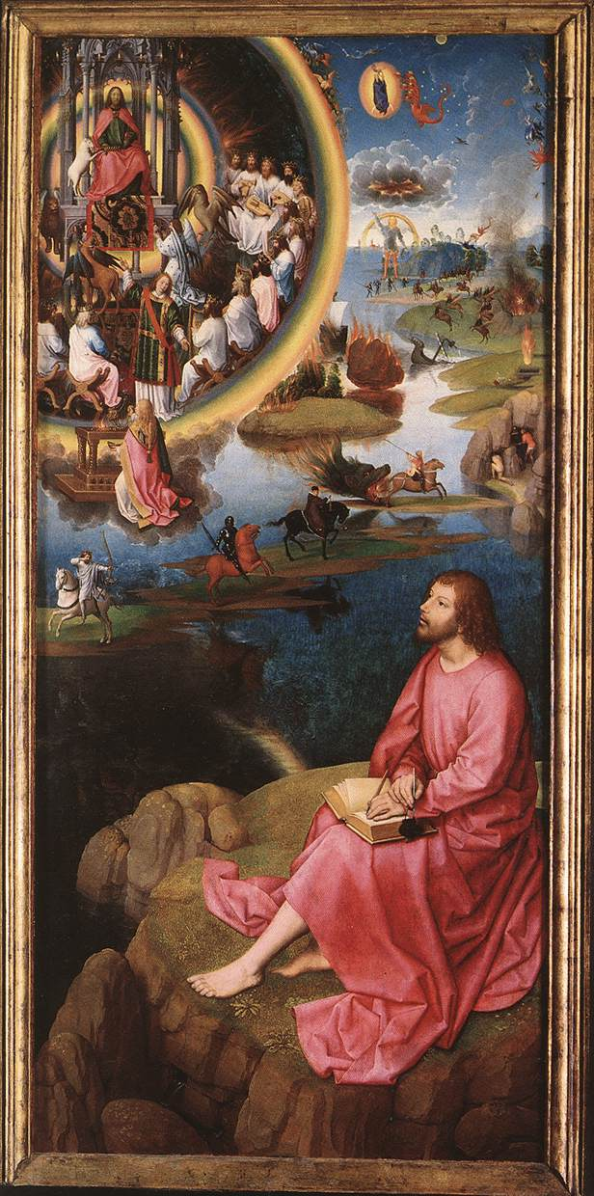

The image that is shown above makes up a part of what is the St John Altarpiece. This work of art was created by the artist Hans Memling in 1479. It is not known exactly who commissioned this piece of work, but it is likely to have been somebody linked to the St John’s Hospital (as that is where it was installed). The image above is from the right panel of the altarpiece, and it depicts John the Evangelist and his vision of the Apocalypse. This image is inspired from its original biblical source in the Book of Revelation.
The image shows John the Evangelist sitting upon the Greek island of Pentos. It is there that John supposedly had his visions of the Apocalypse, and recorded them. Above John, some of the events from chapters four to twelve in the Book of Revelation are depicted. In her thesis called The Art of Revelation in the Apocalypse Panel of Hans Memling's Altarpiece of St John the Baptist and St John the Evangelist, Kalan Greenwood mentions why Memling might have chosen to start on chapter four. Greenwood mentions that it was in chapter four that ‘St John is transported to the state of being “in the spirit”.’ Greenwood also mentions that in the image, John has already recorded part of his visions in the book in his hands, so it is possible that the events of the first three chapters had already occurred.
The top left corner of the image depicts the events in chapter four. God is shown sitting upon a throne and surrounded by men sitting around him. In the Book of Revelation it states that God was surrounded by twenty four wise men upon thrones. It also mentions that there were four beasts in front of the throne. The image shows the four beasts that were mentioned, it pictures them exactly how they were described in the text. Memling used a rainbow to outline this area of the image, and the text does also make mention of a rainbow. The events of chapter four are shown in great detail in this little corner of the image. The only part that is not shown is the twenty four wise men falling down before the throne.
The fifth chapter of the Book of Revelation largely concern the lamb of God. This lamb had seven horns and seven eyes. It is clear that Memling did not see the events in this chapter as being as important as chapter four, as barely any of the events make it into the image. The lamb mentioned in the text is scene next to the throne, but there is no other part of chapter five shown.
The sixth chapter gives a description of the four horsemen of the Apocalypse. The four horsemen are shown in the very centre of the image. This part of the image is extremely accurate, exactly showing the horsemen as they are described in the Book of Revelation. The text describes the horses as white, red, black and pale. The image perfectly shows this and even accurately depicts the weapons they were carrying. Chapter six also describes how ‘the stars of heaven fell upon the earth’. This event is depicted in the image with the stones falling from the sky and causing destruction. It also mentions how men tried to hide from the destruction ‘in the dens and in the rocks of the mountains.’ This is shown in the middle right of the image.
The seventh chapter does not appear to have any of its events shown in the image. Much of the events of this chapter involve the sealing of the tribes of the children of Israel.
The eighth chapter begins with the seven angels and seven trumpets that are depicted emerging out of the rainbow in the top middle of the image. It also gives mention to an angel who stands upon an altar and throws fire upon the earth. There is a figure below the image of God and the wise men who is kneeling before an altar. While this figure is not throwing fire, it is likely that this is the person mentioned in the text. The rest of this chapter involve the destruction that unfolds as each of the angles sounds its trumpet. These events are accurately depicted in the image.
The ninth chapter talks of star falling from heaven and opening up a dark pit in the earth. The image very accurately shows this event. Depicting the pit and the flames and smoke that came out of it. The image also shows the locust that the text mentions came out of the pit.
Chapter ten mentions a mighty angle that came down from heaven. It was ‘clothed with a cloud: and a rainbow was upon its head, and his face was as it were the sun, and his feet as pillars of fire.’ The image shows this angel in the top right, and even accurately shows the angel with one foot in the water and another upon the land.
Much of chapter eleven deals with events that are more insubstantial and not something that could be easily depicted within an image. It is likely for that reason that chapter eleven does not seem to be depicted in this image.
Chapter twelve talks of a woman that was clothed In the sun being in the sky. How she is holding a male child and is attacked by a dragon. This dragon is meant to be the devil and is cast from the earth after a battle with Michael and his angels. These events are depicted in the very top right of the image with a great deal of accuracy.
It is clear that Memling was very picky in which events he depicted in this piece of art. Memling decided to choose the events that he deemed to be the most important from the Book of Revelation. However, he was still able to accurately depict a great deal of the events within just the one image. He depicted the various scenes in a way that flowed very well, and would have been very easily understood by anybody that knew the story of the Apocalypse.

Bibliography
- Greenwood, Kalan, "The Art Of Revelation In The Apocalypse Panel Of Hans Memling's Altarpiece Of St John The Baptist And St John The Evangelist, Sint-Janshospitaal (Memlingmuseum), Bruges" (unpublished Masters, University of Victoria, 2000).
- The Holy Bible, New Revised Standard Version: Containing the Old and New Testaments (Cambridge: Cambridge University Press, 1963).

Kalan Greenwood, "The Art Of Revelation In The Apocalypse Panel Of Hans Memling's Altarpiece Of St John The Baptist And St John The Evangelist, Sint-Janshospitaal (Memlingmuseum), Bruges" (unpublished Masters, University of Victoria, 2000).
Kalan Greenwood, "The Art Of Revelation In The Apocalypse Panel Of Hans Memling's Altarpiece Of St John The Baptist And St John The Evangelist, Sint-Janshospitaal (Memlingmuseum), Bruges" (unpublished Masters, University of Victoria, 2000).
Revelation 4-6.
Revelation 6-7.
Revelation 6-7.
Revelation 9-11.

