STRATEGIC MANAGEMENT LCMB7003 VELICHKA TODOROVA PROKLINOVA 2010826 TUTOR GLADIUS KULOTHUNGAN

Table of Contents
Introduction 2
Industry Overview 2
Characteristics of the industry 2
Key Success Factors for Netflix 4
Value & Mission 4
Organisational culture 4
Market penetration strategy 4
Technological capabilities 5
Organisational design and structure 5
Internal Analysis of Netflix 6
Porter Value Chain Analysis 6
Resources and capabilities of Netflix 11
External Analysis of Netflix 14
Porter’s five forces analysis 14
PESTEL Analysis of Netflix 15
SWOT Analysis and Confrontational matrix 17
Conclusion 18
Recommendations 19
References 22

Netflix goes to Bollywood

Introduction
Netflix is the American OTT services company which provides subscription based streaming service globally. The offerings by the firm includes, movies, TV shows, documentaries web series etc. It is also a production company and creates in-house over-the top content. The company was founded in the year 1997 by Reed Hastings & March Randolph & has its headquarters in California, USA (Netflix Annual Report, 2019). By January 2021, Netflix had around 203.7 million subscribers which includes around 73 million subscribers in United States (Solsman, 2021). The report discusses external and internal factors like culture, capabilities, competencies etc. which impacts the business. It also discusses & suggests strategies that can be incorporated by Netflix inorder to align its capabilities with the market opportunities & threats. The report elaborates on the business level plans and strategies adopted by Netflix & how its startegic management help the firm achieve competitive advantage. In the end, the report will provide necessary recommendations and suggestions for Netflix to continue building their capabilities & expand their territorial presence.

Industry Overview

Characteristics of the industry
The on-demand media and entertainment industry has achieved high market growth and acceptance, particularly driven by the factors like, rising internet penetration, and frequent usage of mobile devices. The global Video-on-Demand market size was $38.9 billion in 2019 (Markets & Markets, 2020). It is expected to increase a cumulative-average rate of 17.5% from 2019 to 2024, to reach $87.1 billion in size. Social trend of watching videos on-the-go, convenience of accessing videos anywhere, high-speed connectivity, and availability of affordable mobile data plans, are some of the factors which will boost the growth in the sector (Markets & Markets, 2020).
Among the geographical markets, the existing demand for Video-on-Demand services is highest in the North American regions. Asia-Pacific remains the second highest market, followed by Europe, South America, and the Middle East. The figure below illustrates the same:
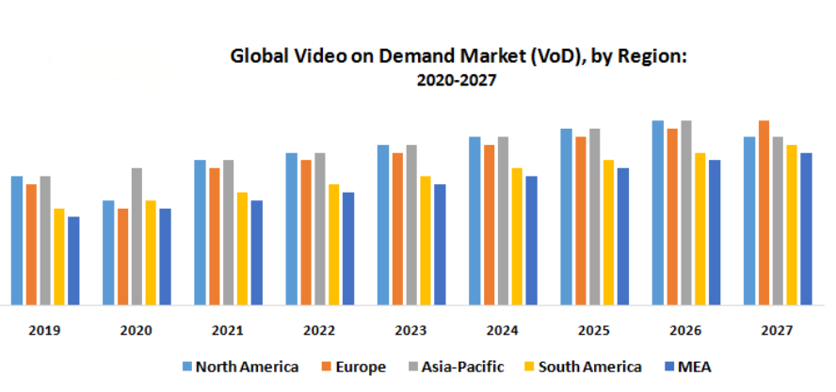
Figure: Global variation of Video-on-demand market (MMR, 2020)
As seen in the figure, all the regions are expected to register a high growth, with cumulative growth expected to be 17.5% average (Markets & Markets, 2020). By 2027, Europe is expected to be the leading market, followed by the North American and Asia-pacific markets.
Some of the key characteristics which determine the success in this industry include:
- Offering exclusive content: Uniqueness of the content plays an important role in determining the customer base. If the content is unique and exclusive, users tend to pay for the subscription-based streaming. New & unique content provided by players allow them to strengthen their customer base (MMR, 2020).
- Reaching a global market: International services is one of the most important KPI’s in media and entertainment sector. Players like Netflix, Amazon, Disney, etc. have adopted the strategy of providing regional as well as international content to its subscribers, thus, ensuring expansion of customer base & improving their footprint. (MMR, 2020).
- Leveraging digitalisation: With the increasing penetration of internet services & its large-scale adoption, media and entertainment industry is no longer bound to television. The content of streaming services is tailored to be experienced over mobiles, various operating systems, androids, tablets, cell phones, iOS etc. This improves the reach of the service and contributes to the market expansion (MMR, 2020).

Key Success Factors for Netflix
Netflix expanded across 130 countries within a 7-year period, crossing 200 million subscribers at the end of 2020 (Solsman, 2021). Some of the key factors which have contributed to the success of Netflix include:

Value & Mission
The mission of Netflix has been “to entertain the world”. The mission of the company is in alignment to its nature of providing on-demand movie streaming services (Netflix Annual Report, 2019). The vision of the company is “to continue being one of the best global entertainment distribution providers”. The vision statement stresses on the fact that the company desires to set quality standards in the OTT content services.

Organisational culture
Netflix encourages its employee to engage in independent decision making. It provides platforms to its employees to voice out their opinions and encourages bottom up movement of ideas and suggestions, thus ensuring an open culture for innovation. Employees are advised to develop their own approaches to handle day to day job challenges (Netflix Annual Report, 2019). The Five core values of Netflix encourage ‘freedom and responsibility’ where employees can take independent decisions. Managers are encouraged to promote transparency between the team members. They are required to be extraordinarily candid, and avoid sticking to rules always. The culture is such that the company encourages managers to openly discuss failure, write about their failed initiatives through short memos, and describe their learnings and experiences in these brief notes (Netflix Annual Report, 2019)

Market penetration strategy
Market Penetration, as a strategy has strongly enabled Netflix. This business strategy is the exhaustive growth approach which is implemented by Netflix to improve its adoption in its current markets. Subscription-based model is one of the main drivers of this business strategy as the Unique Selling Point (USP) of this strategy is unlimited access to company’s content library with no hefty late fees (Alvarez, 2018). To on-board new users, one-month free trials subscription has been a hugely popular strategy for the company. This strategy has done wonders for the company, as there is a 93% conversion rate from free trials subscriptions to paid versions (Venkataraman, 2016).

Technological capabilities
Technology and innovation have been one of the core competencies of Netflix over the years. Technological capabilities have enabled Netflix to sustain as well as add new user base. With more than 200 million subscribers & the catalogues of 6000 entries, the platform of Netflix needs to be robust in nature (Menon, 2020). In order to provide a hassle-free experience to its subscribers, Netflix engineers ensure the platform is usable even with smallest of internet bandwidth. This is possible with the help of artificial intelligence (Alvarez, 2018). The platform also uses HDR programming to provide experience of deeper blacks and richer colour to the content to look appealing.

Organisational design and structure
The organisational design and structure at Netflix have also been a key success factor for Netflix. Netflix follows a Unitary organisational structure (U-Form). In this type of organisational structure, direct executive control lies in the hands of the CEO along with having control of providing direction of different functional levels (Netflix Annual Report, 2019). Though, the organisational structure is comparatively flat since all primary business heads fall directly under the CEO. This type of structure has the following core characteristics:
- Geographical division for managing different regions
- Functional division for handling operations
- Different type of product managed centrally.
The below picture highlights Netflix structure:
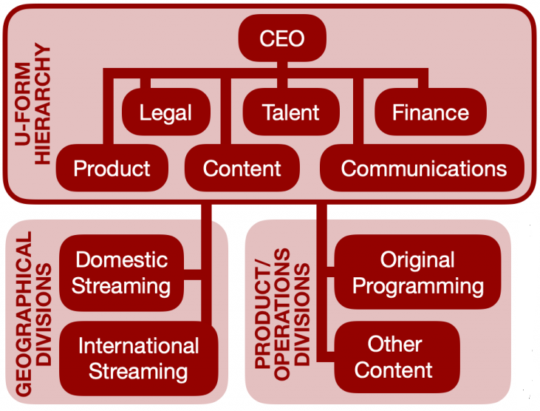
Figure: Netflix Organisational structure (Anderson, 2019)
As highlighted from the above figure, CEO directly controls the functional divisions stating there is a definite level of centralisation in the organisation. The geographical divisions including international and domestic streaming is looked upon by corporate centre. Similarly, the product/operations division is also managed centrally, that incorporates content and original programming. An environment of cooperation and open communication is promoted through the flat structure of the organisation (Taylor, 2016). Strategic direction to the international streaming operations is given by top executives within the corporate headquarters. They also make sure that there is a smooth functioning in the product operations as well. This kind of organisation structure helps top managers to deliver a ground-level customisation of the content, which is derived on the preferences and liking of the regional subscriber base.
Integration strategies and diversification are additional factors promoting Netflix growth strategy. The company has lately formed and is developing up its customer products division to build merchandisable books, games, products, etc. associated to its key characters, brands and original content (Spangler, 2020). The aim is to generate extra revenue from the Intellectual property and promote title awareness. The latest changes in the organisational structure adds to this diversification. For example, as part of Netflix current strategy for market of consumer product, the company lately appointed a new chief of consumer products, Josh Simon, hired as Vice President for consumer products for Netflix, was earlier associated with Nike as the global strategy head. Simon responsibility would be to identify new and improved methods to penetrate Netflix consumer products through different business lines and will coordinate with the content teams for audience and brands strategy (Spangler, 2020).

Internal Analysis of Netflix

Porter Value Chain Analysis
Porter’s value chain analysis can help analyse the collections of activities and processes which are involved to deliver value for the end customers. It comprises of primary and support activities. The figure below denotes the same:
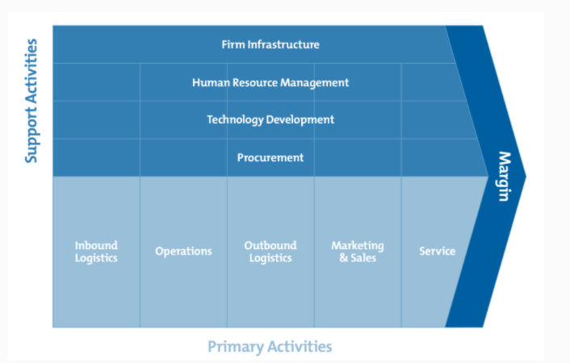
Figure: Porter’s value chain analysis
Primary activities for Netflix are those which are directly involved in creation, sales, maintenance or its services. The primary activities for Netflix are:
Inbound logistics
For Netflix, inbound logistics are essentially the processes utilised to bring in more content, receive and store them (Clegg, et al., 2016). Netflix has a streamlined process for onboarding new content produced by the various production companies and media houses. The content is onboarded based on a wide range of genres, such as, drama and comedy for adult audience, animations for kids and family, war dramas, sitcoms, science fantasy, anthology, or dark comedy, etc. the objective is to have relevant content for each demography or age group (Sadq, 2015). Likewise, a dedicated team of specialists conduct extensive audit of the available content to ensure their relevance to the target customer base of Netflix (Netflix Annual Report, 2019).
Operations
Operations are in the form of the transformational activities performed internally before the final output is delivered to the end customers (DeWit, 2017). Netflix operations include areas like, product management, legal management, financial management, and communications management. Product management is about content planning and execution in the specific market in which the show is to be streamed. Legal management is to ensure that any compliance or audit requirements are adhered to, or any form of legal violations are avoided. Financial management is about planning and budgeting, cash and credit management, to ensure profitability within a market (Netflix Annual Report, 2019). Netflix’s policy of hiring and retaining highly skilled workforce ensures that best performing resources are available to handle the operations. Use of effective team engagement and accountability building measures help to detect and rectify errors.
Outbound logistics
Outbound logistics for Netflix are essentially the activities conducted to store and distribute the content to end users (Clegg, et al., 2016). Netflix makes use of an extensive range of global servers to bring about a smooth experience. Video streaming for a typical user is made from the nearest possible server, with the shortest route, to ensure higher quality streaming. Faster streaming with higher bit rates ensures that blurring and pixilation are minimised, such that the user can easily access the huge base of constantly-refreshed content (Netflix Annual Report, 2019).
Marketing and sales
Marketing and sales are essentially the means to attract and acquire more customers. The objective of the marketing and sales function within Netflix is to boost the regional penetration, add more subscriber base, and help increase market share amongst other digital providers. The digital marketing team makes use of advanced analytics to closely study the consumer watching behaviour (Menon, 2020). The marketing team segments the users based on the streaming behaviour and nature of shows watched. This segmentation is utilised to offer personalized product recommendations based on user preferences. The marketing and sales function also closely work to study the competitive offerings. For instance, Netflix significantly reduced its monthly plans in India, from $7 to $2.8, based on $2 low-cost monthly plans launched by Apple and Spotify (Singh, 2019).
Services
These are the activities which are performed after the end product has been delivered (DeWit, 2017). The customer support at Netflix helps fulfil the services arm. Customer support is available in the form of dedicated web pages available to raise queries or concerns. The social media platform, Twitter, is also extensively utilised by Netflix to engage with customers, receive feedback or respond to queries. The figure below illustrates Netflix usage of Twitter:

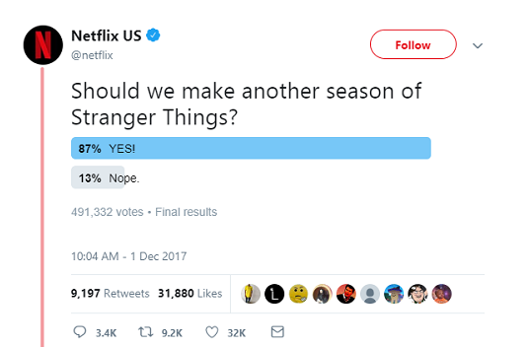
Figure: Netflix engaging with users through social media (Menon, 2020)
Support activities are those which enable these primary activities. The support activities for Netflix are:
Firm infrastructure
Infrastructure refers to the systems and processes which support the daily operations of Netflix. These are in the form of legal, accounting, administrative, general management, and other infrastructure areas. The centralised management at Netflix ensures that the regional capabilities also reflect the corporate culture and innovation of the firm. Individual regional offices like, India, Australia, UK, or Germany have a country head or regional director to oversee the infrastructural set-up in the respective regions (Netflix Annual Report, 2019).
Human resource management
This refers to the strategy of the firm to hire, recruit, train, motivate, reward or manage employees. Netflix is known to offer employee-friendly policies, promoting greater work-life balance. For example: Netflix has a Standard paid-time-off policy wherein employees can avail 10 vacation days and 10 holidays. Other employee friendly practices include, mobile phone discounts, free gym memberships, 12 month’s maternity leave for female employees, etc. (McCord, 2014). Suitable programs are launched to promote a friendly workplace, such as Employee Assistance Program to support the mental and physical health through counselling and guidance. The hiring strategy is based on an extensive screening process gauging a wide range of technical and behavioural parameters (McCord, 2014). Netflix is known to keep only highly effective people. The hiring decision is made 50% on cultural skills and 50% on hard skills. Netflix believes that keeping mediocre people demotivates the others, and hence the focus is to hire, develop, and retain highly talented employees.

Technology development
For Netflix, the technological development plays a crucial role in supporting the business. Managing and processing information, protecting the company’s knowledge base, having the right cloud infrastructure to support its content, etc. are the means to support the business (Netflix Annual Report, 2019). Technology-led digital innovation is the key to the success of the business. Hence, Netflix is seen to continuously invest towards higher research & development. The table below describes the annual outlay or budget towards research and development over the years:
Year | Annual investment into Research & Development
2017 | $0.95 billion
2018 | $1.22 billion
2019 | $1.54 billion
2020 | $1.83 billion
Table: R&D investment by Netflix (macrotrends.net, 2020)
As seen, the annual investment into R&D increased from $0.95 billion to $1.22 billion in 2018, indicating a 28% increase. Likewise, there was a rise of 26.4% in 2019 to reach $1.54 billion in R&D investment. Likewise, a 18.4% increase led to $1.83 billion R&D investment in 2020 (macrotrends.net, 2020).
Procurement
Procurement as a function helps Netflix procure or source the right inputs to conduct its functions. This involves finding and negotiating best prices from vendors. For Netflix, procurement is about obtaining the best possible content from product houses or media firms. It is also about procuring the requirement equipment for its physical facilities located across respective regions. The objective of procurement management for Netflix is to optimise supply chain, keep costs low, minimise risk, and optimise the total cost of ownership (Netflix Annual Report, 2019).

Resources and capabilities of Netflix
The Resource-based view can help capture the various capabilities or resources of the firm (Clegg, et al., 2016). VRIO Analysis can help to determine the various strategic resources or capabilities and their respective contribution towards competitive advantage for Netflix. The table below describes the VRIO analysis for the firm:
Competency or Resource | Valuable | Rare? | Hard to imitate? | Firm organised for it? | Result
Subscription-based model | YES | NO | NO | YES | Temporary Competitive advantage
Unique content | YES | YES | YES | YES | Long-term competitive advantage
High customer engagement | YES | NO | NO | YES | Temporary Competitive Advantage
Talented pool of staff | YES | YES | YES | YES | Long-term competitive advantage
Strong financial position | YES | YES | YES | YES | Long-term competitive advantage
Partnership-based growth | YES | YES | YES | YES | Long-term competitive advantage

Table: VRIO Analysis for Netflix
As seen in the table, Firstly, one of the most important core competencies of Netflix is its subscription based model. It allows the company to reach out to large audience by ensuring low cost, and hassle-free subscriptions (O'Neill, 2015). Unlike TV providers, subscription-based model does not create any lock-in for the end customers. They make it easy for customers to enrol into short-term or monthly plans and cancel their subscription at any stage, without any cancellation charges. The success rate of such subscription has been quite high for Netflix. Only 2% of Netflix subscribers cancelled their membership in July 2020, as compared to 7% for HBO Now, and 5% for Hulu and Disney+ (Sull & Turconi, 2021). Although the subscription-based model gives an advantage, yet, it is not rare or difficult to imitate, and hence offers a temporary competitive advantage to the firm.
Secondly, another core competency is the unique content it provides comprising of web-series, award winning movie shows, documentaries and regional content which attracts people from all age groups (Sull & Turconi, 2021). The capability to create and host unique content can allow long-term competitive advantage to Netflix as the company is well-organised around it. Moreover, it is difficult for other players to imitate. In terms of vertical integration standpoint, the company has started to invest more on owning its supply chain. In year 2018, Netflix spent approximate $15 billion on original content while in year 2019, the company spent around $17.3 billion (Netflix Annual Report, 2019). The company is expected to outlay approximate $26 billion from year 2020 onwards for original content. This shows its growing emphasis to own the content by itself. Owning the content gives more control on content quality and its type. It also provides better profit margins as well. Few of the most Original popular series have been such as Bloodline, Luke Cage, the House of Cards, Fuller House, Grace and Frankie, Daredevil etc. Investing into own and unique content can offer a long-term competitive advantage to the firm (Netflix Annual Report, 2019).
Next, high customer engagement and digital marketing strategy of Netflix allows for a competitive advantage. It ensures that Netflix taps into the rising trend of social media usage. Twitter as a platform enables Netflix to track user behaviour, gather preferences, conduct surveys, respond to queries etc. (Menon, 2020). Netflix has higher focus on building a greater customer experience, and low focus on advertising (Sull & Turconi, 2021). This enables higher customer relationship management. However, it is not rare or difficult to imitate such as digital engagement, and hence it provides a temporary competitive advantage.
Next, the pool of talented human resources comprising of data scientists, marketing managers, qualified engineers, creative marketing heads, data security experts, business strategists, brand managers etc. allow for an advantage (Kain, 2019). Talented and committed human resources are rare and difficult to imitate, and can hence offer a long-term competitive advantage to Netflix. Next, the strong financial position of Netflix allows it to have an advantage over smaller or emerging players. The financial growth of Netflix is quite high with a high year-on-year growth. In the year 2019, the total revenue of the company was reported to be $20.15 billion with the operating margin being 13% (Netflix Annual Report, 2019). This is a huge growth in revenue as compared to the corresponding value of $15.8 billion and 10% margin in 2018 (Netflix Annual Report, 2019). The operating margin of the company has grown 2.6 times in a period of 5 years with total revenue growth being 197%. The company has grown by more than 200% in the last 5 years of its operation. The figure below illustrates the growing revenue, operating income, and the operating margin of Netflix from 2015 to 2020.
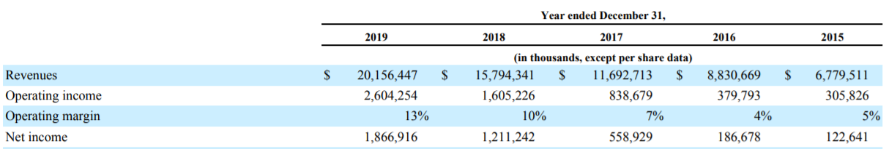
Table: Revenue growth and margins for Netflix (Netflix Annual Report, 2019)
High financial strength is rare and difficult to imitate. Netflix is also well-organised around it, as it allows the firm to enter new ventures, take more risks, diversify into new markets, and continuously invest into research and development. This gives a long-term competitive advantage to Netflix.
Lastly, the strategy of Netflix to build more technology and business partnerships is also rare and difficult to imitate. The company is also well-organised to utilise this towards long-term competitive advantage. The company has hugely benefited from its external association business strategy (Netflix Annual Report, 2019). It is associated with internet service and telecommunications companies such as AT&T, the Verizon, Comcast etc. which makes sures that the users of Netflix have the best online viewing experience (Alvarez, 2018). Amazon Web Services is one of the crucial associates of Netflix as Amazon cloud servers host and support the entire content of the company. Along with this, to increase its content base, Netflix also works closely with content providers and production companies. The company also builds strong relationships with television networks and distribution studios etc. from across the globe based on the geography or the market.

External Analysis of Netflix

Porter’s five forces analysis
Porter’s five forces analysis of the entertainment and media industry can help understand the environment of Netflix.
Bargaining power of Buyers - HIGH
The bargaining power of buyers is high due to the presence of numerous service providers like Amazon, Hot star, Disney+ etc. available in the market. Buyers have a low switching cost, mostly in the form of a minimal subscription fees (Mandal, et al., 2017). Taking one of the emerging markets of Netflix -India. It is seen that the number of players in the Indian SVOD market increased from 9 in 2012 to 32 in 2018 giving buyers more options and powers to choose their subscription. As of January 2020, a single subscription would cost $8.99 for Amazon Prime, $12.99 for Netflix, $5.99 for Hulu and $6.99 for Disney+ a month (Markets & Markets, 2020). Netflix had to roll out its cheapest mobile only monthly subscription plan at just $2.85 targeting Indian users to increase its subscription base.
Bargaining power of Suppliers - HIGH
Similarly, the content creators or suppliers are the production houses or companies producing entertainment and media content. They are limited in number and hence get attractive offers from various digital platforms. Therefore, suppliers of this sector have high bargaining power. In 2018, Netflix had to reduce its profit margins to maintain contracts with its suppliers to expand customer base. In 2018, Netflix original content was 37% of Netflix shows (Brennan, 2018). This indicates that in the current times much of the content on Netflix is from other suppliers, thus giving them an upper hand in price negotiation.
Threat of new entrants -LOW to MODERATE
Since major players HBO, Apple, Brit box, Disney, Amazon are already having their streaming services, the threat of new entrant is low to moderate as any new player would require substantial infrastructural resources and financial capital to set up. Brands like Disney, Amazon, or Netflix have a high brand recall and industry recognition, which is tough for smaller or new players to replicate (Markets & Markets, 2020). Likewise, these major players have significant marketing budgets for mass media advertisements across television, newspapers, magazines, etc. These players can achieve higher reach and user acceptance through offers like, free trials, or discounted subscriptions. It would take high financial resources to obtain this level of customer reach.
Threat of substitute products - HIGH
Substitute products in this sector are essentially the alternative modes of entertainment which can consume the buyer time and money. Threats of substitute products such as social media, movie theatre, television, music, game is medium to high. YouTube makes up for a large portion of total video content viewing as 12% of all time devoted viewing video is on YouTube (Markets & Markets, 2020). Netflix also faces threats from substitute services who are providing comparable products via rental DVD’s option. Netflix has to continuously update its content library by increasing more of movies, TV shows to avoid losing its users to other forms of entertainment. Company spent record $13 billion in 2018 and $15 billion in 2018 on scripting original content which was higher than any other streaming provider, and most traditional major media companies (Netflix Annual Report, 2019).
Competitive Rivalry -HIGH
Competitive rivalry in media and entertainment sector is especially high, with most key players entering or launching their streaming platforms such as Disney+, Apple, Amazon, Hulu, HBO etc. (Kain, 2019). There is always a price war between different providers to get more subscription base. While Netflix has around 200 million subscribers, Amazon prime has already reached 150 million subscribers and is rapidly expanding into new markets. Disney plus has reached 100 million subscribers within just 2 years of operation (Alexander, 2021).

PESTEL Analysis of Netflix
PESTEL Analysis of Netflix can help understand the role of the various driving factors in the external environment:
Political factors
The subscription user base of Netflix is impacted due to political factors of any region since any political restriction would impact its expansion. Since Netflix uses many advanced technologies, thus it is subject to scrutiny by national IT policies, just like other tech companies. Depending upon the regulation level in each region market, Netflix has to customize its services to fit the requirements for that region (Netflix Annual Report, 2019). Also, there is a content restriction based on the geography, due to Chinese regulations Netflix still does not operate in China. One more political factor which widely affects Netflix margins is taxation, which varies across different nations.

Economic factors
Netflix has its operations in more than 130 countries, and hence local revenues get impacted by exchange rate fluctuations. Weak currencies impact the bottom line of Netflix. As a company investing towards content ($ 17 billion in 2019) and technological innovations ($1.5 billion in 2019), any negative impact on a region’s economy will hit Netflix profit margins (Netflix Annual Report, 2019). Besides, costs may also rise due to increase in workforce, increase in general and administrative costs, etc. leading to overall increase in expenditure for Netflix.
Social factors
Netflix provides services to audience globally, thus, it becomes important for the company to consider the differing preferences and tastes of people from different cultures and societies. Netflix is targeting millennials since they are highly tech savvy and watch most of the entertainment content online (Markets & Markets, 2020). The domestic content management team work to tailor or customise the products to accommodate the taste and choices of modern generation. Content is also tailored to include several languages and genres. Netflix also works closely with communities, and is known for providing scholarships to students and charities to support financially challenged students.
Technological factors
Technological innovation is the main source of Netflix’s competitive advantage. Company invested $1.5 billion on technological innovation in 2109 to offer its subscribers best-in-class viewing experience. Netflix has developed a wide set of technologies for its business operations like distribution across different devices, video-compression algorithms, auto resume and skipping trailers (Sadq, 2015). Technological factors such as usage of mobile devices and internet penetration has boosted Netflix market expansion. This has been one of the prime reason for its increasing popularity over last few years.
Environmental factors
As Netflix is an organisation who completely operates online, thus, companies do not have a heavy and direct environmental effect. Though, company’s dependency on the environment for raw material is quite low but still Netflix uses electricity heavily for its online operations. Netflix in year 2019 used approximate 94,000 megawatt hours of direct energy. So, to minimize this, the company is utilising wind energy to compensate its energy usage for cloud storage. This is a new initiative by Netflix to decrease its carbon footprint.
Legal
In today’s times, legal compliance has become extremely important for the technology firms as noncompliance can lead in heavy fines and can cause serious damage to the company’s reputation. For Netflix, protection of user data and user privacy are few of the key concerns. Legal regulations on copyrights, privacy, etc. are crucial towards helping the company achieve maximum from its investments. Netflix also need to check of video piracy, streaming on multiple devices since consumers are sharing credentials to decrease their bills.

SWOT Analysis and Confrontational matrix
The current core competencies of the company can be used to benefit from the opportunities which exist within the company’s external market. It can also be used to neutralize the threats which exist in company’s business. The below table highlights the TOWS matrix, indicating the strategies that can be implemented:
TOWS Analysis | Strengths (S)  - Huge content base  - Subscription Model  - Robust financial position | Weaknesses (W)  - High payment cost of for others’ content  - Expenses on Technology development
Opportunities (O)  - Increasing mobile devices and internet penetration  - Streaming via video game consoles | SO Strategies  Concentrate on market penetration and global expansion | WO Strategies  Use economies of scale to bring better ROI (Return on investment)
Threats (T)  - Threat of big competitors such as Apple, Amazon, Hulu, Disney, AT&T etc. with comparable streaming platforms  - Threat from alternate media and TV, entertainment and Social media. | ST Strategies  Roll out promotions such as free subscriptions for limited time period, or free trials etc. to encourage more subscriptions | WT strategies  Create more inclusive content covering all age groups, genres, and interests to promote habit

Table: TOWS Matrix for Netflix
As highlighted in above table, the SO (Strength-Opportunity) strategies illustrate that Netflix should aim towards achieving higher penetration level within current markets and also should concentrate on global expansion at the same time. There is expected rise in the on-the-go and on-demand entertainment services since there is a steep rise in usage of mobile devices and internet usage (Fiegerman, 2017). Video games consoles would also support in boosting the demand. In addition, strong financial backing and low-cost subscription model should be leveraged to boost further expansion to new geographies. Although, company should leverage economies of scale to lower the technology development cost and high payment costs. This is associated as part of WO (Weakness-Opportunity) strategy which Netflix should pursue.
Thereafter, Netflix should also focus on to lower the competition threat which is rapidly increasing form big competitive online streaming platforms. The ST (Strength-Threat) strategy suggests that company should increase marketing promotions and budgets which can include free subscription for limited time or free trials etc. With wide range of content and low subscription cost, it is possible to help viewers build the habit of watching on-demand video streaming when compared to TV shows (Feinberg & Johnson, 2017).
In the WT (Weakness-Threat) strategy, Netflix should invest in different content or genres, which would attract a wider audience base. It could cover from action, drama, horror, kid shows, science fiction etc. They should also try to tap the local market of that geography by adding more of regional language content and shows as it can boost their expansion. This would also help disseminate the risks or cost of high-cost content, by obtaining a mix of low and high-cost content and making sure highest viewership and Return on Investment (ROI) is achieved.

Conclusion
Overall, analysis of strategic management starts with an efficient assessment of the external market drivers, dynamics, threats, and opportunities. It also incorporates an internal evaluation to determine the main resources and capabilities which an organisation has. The best kind of strategies can be created by having an essential match between the expected opportunities and the capabilities. With respect to Netflix, changing social inclinations and rise in number of internet users present the opportunity for the company whereas increasing competition and substitute products pose a threat to the firm. For strategy building, it is necessary for Netflix to leverage its key strengths of low-cost subscription platform for effective expansion and market penetration. Netflix strategies for external associations, vertical integration, content investments, global outreach etc. are already helping the company achieve its business objectives and obtain higher return on its global investments. It is proposed that the company should continue investing in original content for increased profit margins. The company should also consider launching efficient customer retention and loyalty strategies for long-term user engagement. For effective personalisation and customisation, it is suggested that team flexibility and collaboration is encouraged. In order to cover for the increasing cost platform, company should consider additional revenue streams as online marketing. In totality, the below recommendations could assist Netflix achieve its business and strategic objectives of continued expansion and larger market share of the video-on-demand market.

Recommendations
The analysis helps highlight that Netflix must prepare itself to develop extensive strategic capabilities to neutralize the future threats and leverage the expected opportunities in the future. The below figure highlights the main recommendations

Figure: Recommendations for Netflix for future strategic capability
Netflix needs to keep on investing in good and powerful content both at regional and international level to make sure that its attracts new customers and adds up its subscriber base. In case of original content, company need not pay the huge licensing fees to the production houses. They also enable higher control and also improve the profit margin for Netflix. Thus, it is recommended for Netflix that it should keep on investing on building and creating original content.
In addition, Netflix needs to build more brand loyalty. With big players and cut-throat competition in the industry, the ‘content’ advantage alone might not be sufficient to get competitive advantage. In the long run, engaging and efficient content will support to bring in the required competitive uniformity. Although by efficient usage of marketing communications channels, it can help in long-term consumer retention or true brand loyalty. Also, making sure that subscribers receive good quality experience will also help in achieving this (Brennan, 2018). The company should use marketing budgets to encourage subscription renewal, reward loyal users, provide discounts on family or group subscription renewals etc.
Thirdly, it is recommended that company should make sure that the organisational practices, culture, and processes encourage collaboration and cooperation. Netflix hires several talented personnel across different departments such as designing, production, programming, content creation and platform support (Sadq, 2015). Inter-department cooperation must be encouraged to bring in more flexibility. For example, designers must work diligently with production teams and content specialists for respective geographies or local regions.
Lastly, it is highly recommended that Netflix should consider adding new and additional revenue streams. As of now, Netflix is an Ad-free online streaming platform. Though, as per the analysis by Nomura Instinet, it suggested that if Netflix converts its platform into an ad-supported platform, it could generate $1.3 billion annual revenue in USA alone (Schomer, 2019). The international revenues could likely be projected to several billions. This strategy could help Netflix improve its profit margins and boost revenue growth. This specially would help the company in the scenario when the subscription base starts stagnating. The additional revenue would support Netflix to compensate the high cost of the technology development and the talented staff which as of now represent a major component of its costing structure.
[Word count 5808]

References
Alexander, J., 2021. Disney Plus surpasses 100 million subscribers. [Online]
Available at: https://www.theverge.com/2021/3/9/22320332/disney-plus-100-million-subscribers-marvel-star-wars-wandavision
[Accessed April 2021].
Alvarez, E., 2018. Netflix’s real advantage is that it’s a tech company first. [Online]
Available at: https://www.engadget.com/2018-03-10-netflix-streaming-tech-hollywood.html
[Accessed 20 April 2021].
Anderson, D., 2019. Netflix Inc.’s Organizational Structure & Its Strategic Implications. [Online]
Available at: https://www.rancord.org/netflix-organizational-structure-design-organizational-chart-characteristics
[Accessed 21 April 2021].
Brennan, L., 2018. How Netflix Expanded to 190 Countries in 7 Years. [Online]
Available at: https://hbr.org/2018/10/how-netflix-expanded-to-190-countries-in-7-years
[Accessed 02 May 2021].
Clegg, S., Schweitzer, J., Whittle, A. & Pitelis, C., 2016. Strategy: Theory and Practice. 2nd ed. London: Sage Publications.
DeWit, 2017. Strategy synthesis: for leaders. Andover: Cengage Learning .
Feinberg, Y. & Johnson, C., 2017. Faculty & Research › Case Studies › The Competitive Advantage of Netflix. [Online]
Available at: https://www.gsb.stanford.edu/faculty-research/case-studies/competitive-advantage-netflix
[Accessed 25 April 2021].
Fiegerman, S., 2017. How Netflix beat its rivals and survived the 2000s. [Online]
Available at: https://money.cnn.com/2018/07/24/technology/netflix-2000s/index.html
[Accessed 22 April 2021].
Kain, E., 2019. Here’s Everything Coming To Netflix —And Everything Leaving. [Online]
Available at: https://www.forbes.com/sites/erikkain/2020/05/01/heres-everything-new-and-everything-leaving-netflix-in-may-2020/#614e45e24292
[Accessed 22 April 2020].
macrotrends.net, 2020. Research and Development Expenses 2006-2020 | NFLX. [Online]
Available at: https://www.macrotrends.net/stocks/charts/NFLX/netflix/research-development-expenses
[Accessed 19 April 2021].
Mandal, G., Diroma, F. & Jain, R., 2017. Netflix: An In-Depth Study of their Proactive & Adaptive Strategies to Drive Growth and Deal with Issues of Net-Neutrality & Digital Equity. IRA International Journal of Management & Social Sciences, 8(2), pp. 152-161.
Markets & Markets, 2020. Video on Demand (VoD) Market by Solution (Pay TV, OTT Services, and IPTV), Monetization Model (Subscription-based, and Advertising-based), Industry Vertical (Media, Entertainment, and Gaming and Education), and Region. [Online]
Available at: https://www.marketsandmarkets.com/Market-Reports/audio-video-on-demand-avod-market-1046.html?gclid=Cj0KCQjwmcWDBhCOARIsALgJ2Qc67JTN_iLtnVNZoZZNBuMItK-ecr_m_gXgr5r3hehy51vdrYXN4igaAm6TEALw_wcB
[Accessed 29 April 2021].
McCord, P., 2014. How Netflix Reinvented HR. [Online]
Available at: https://hbr.org/2014/01/how-netflix-reinvented-hr
[Accessed 25 April 2021].
Menon, N., 2020. Why Netflix Is Winning At Digital Marketing. [Online]
Available at: https://medium.com/swlh/why-netflix-is-winning-at-digital-marketing-c31b056c58aa
[Accessed 18 April 2021].
MMR, 2020. Global Video on Demand Market (VoD) : Industry Analysis and Forecast (2019-2027) – by Solution, Delivery Technologies, Application, Vertical and Region.. [Online]
Available at: https://www.maximizemarketresearch.com/market-report/global-video-on-demand-market/29785/
[Accessed 10 April 2021].
Netflix Annual Report, 2019. Netflix Annual Report. [Online]
Available at: https://s22.q4cdn.com/959853165/files/doc_financials/2019/ar/2019-10-K.pdf
[Accessed 29 April 2020].
O'Neill, M., 2015. How Netflix Bankrupted And Destroyed Blockbuster. [Online]
Available at: https://www.businessinsider.com/how-netflix-bankrupted-and-destroyed-blockbuster-infographic-2011-3?IR=T
[Accessed 30 April 2021].
Sadq, Z., 2015. Analysising Netflix‟s Strategy. International Journal of Science and Research, 4(3), pp. 2271-2275.
Schomer, A., 2019. Here's what a Netflix with ads could look like. [Online]
Available at: https://www.businessinsider.com/netflix-could-diversify-business-with-advertisements-2019-7?IR=T
[Accessed 30 April 2021].
Singh, M., 2019. What lower Netflix pricing tells us about competing in India. [Online]
Available at: https://techcrunch.com/2019/07/24/what-lower-netflix-pricing-tells-us-about-competing-in-india/
[Accessed 10 April 2021].
Solsman, J., 2021. Netflix subscriber growth soars past 200 million members. [Online]
Available at: https://www.cnet.com/news/netflix-fourth-quarter-subscribers-soar-past-200-million-members-stock/
[Accessed 19 April 2021].
Spangler, T., 2020. Netflix Hires Nike Exec Josh Simon as VP of Consumer Products. [Online]
Available at: https://finance.yahoo.com/news/netflix-hires-nike-exec-josh-225020687.html
[Accessed 19 April 2021].
Sull, D. & Turconi, S., 2021. Netflix Goes to Bollywood. [Online]
Available at: https://mitsloan.mit.edu/sites/default/files/2021-03/Netflix%20Goes%20to%20Bollywood.IC__1.pdf
[Accessed 28 April 2021].
Taasi, P., 2020. Netflix Just Put A Ton Of Its Shows And Movies On YouTube For Free. [Online]
Available at: https://www.forbes.com/sites/paultassi/2020/04/18/netflix-just-put-a-ton-of-its-shows-and-movie-on-youtube-for-free/#3b3f280737c1
[Accessed 02 May 2020].
Taylor, B., 2016. To See the Future of Competition, Look at Netflix. [Online]
Available at: https://hbr.org/2018/07/to-see-the-future-of-competition-look-at-netflix
[Accessed 29 April 2021].
Venkataraman, V., 2016. Netflix: A Case of Transformation for the Digital Future. [Online]
Available at: https://medium.com/@nvenkatraman/netflix-a-case-of-transformation-for-the-digital-future-4ef612c8d8b
[Accessed 17 April 2021].

