
problem solving and decision making
Student name: Aurelia Denicu (2026240), Module code: BMSW 4004, Module name: Problem Solving and Decision Making, Lecturer: Jonathan Wyatt.


Table of Contents
1.Introduction 2
2. Nature and impact of work-related stress problem on employees and their organisation. 3
3.Cause-and-effect analysis of Work-related stress problem faced by UK employees. 4
4. PESTLE analysis of the macro-environmental factors contributing to the problem 5
5.SWOT analysis 6
6.GRID analysis for decision making 7
7.PMI tool in decision making 9
8.Soultion and action plan for work related stress in UK’s health sector 10
8.1Action plan to monitor and evaluate work related stress problems 11
9.Conclusion 14
10.Reference list 16

1.Introduction
Nature and impact of the problem on employees and their organisation, cause-and-effect analysis of the complex problem, a PESTLE analysis of the macro-environmental factors contributing to the problem and alternative solutions to work related stress are the subjects that will be presented in this report.
A Fishbone diagram and SWOT analysis presenting the factors contributing to work related stress and tools used in decision making will also be included.
Using GRID and PMI analysis for decision making, and implementing the decisions that were made, but having an action plan to monitor and evaluate the problem are also subjects that will be included and explained in this report.

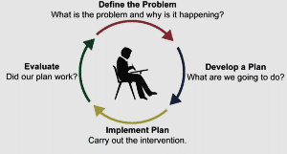

2. Nature and impact of work-related stress problem on employees and their organisation.
Problem-solving process evolves from beginner to expert, in a specific work sector by having a specific plan or schema ,that will help with the existing or future difficulties faced by the organisation.

A situation that is making us doubtful and uncertain is referred to as a problem.
Problems that occur daily at the workplace, from small and insignificant, moderate to major, can affect the productivity of the organisation, employee’s wellbeing, and customer service as well.
Recognising the problem is the first stage in problem-solving process.
Monitoring performance, listening, and observing subordinates’ behaviour, establishing the cause of the problem are processes that can determine the problem.
Gathering information is the first step of problem-solving initial analysis.
Importance of identifying the size of the problem: problems can be deceptive and so to make an effective decision scope and impact also need to be taken in consideration.
How far does the problem reach? is defining the scope.
How are they affected? is the impact of the problem.
After identifying the problem, the scope and impact of it, the fourth step is what to do next.
Sometimes deciding not to do anything regarding that problem can be better than acting.
Monitoring and contain the problem, also finding a solution are steps needed to be followed when facing a problem.
Using tools such as Fishbone diagram, PESTEL and SWOT analysis to identify the factors leading to work-related stress, are essential keys to make effective decisions in workplace environment.

3.Cause-and-effect analysis of Work-related stress problem faced by UK employees.
Working under a lot of pressure, financial stress, over worked employees, shortage of staff, unexpected costumers, high demanding costumers, lack of resources are a few of the factors that related to work stress.
Depression, anxiety, chest pain are health problems that employees face because of work related stress, but also the productivity of the organisation will be affected. GP’s and hospitals in UK faced an increased number of patients during Covid19 pandemic, which lead to an increasing work-related stress problem.
According to Benstead (2020):” A recent survey by our friends at Perkbox revealed that, out of all British adults in employment, 75% commonly experience work-related stress. “
Workplace politics, people, financial stress, equipment are factors presented in the fishbone diagram, that lead to work related stress problem faced by employees. Facing a deadly virus, fear of unknown and pour management made a lot of employees to quit their jobs, which lead to overworked and shortage of staff.
Employees with different background, different qualifications, different dialect, and culture create a good workforce but also can lead to cultural and communication barriers, bullying, cliques, making other colleagues feel left out and discrimination.
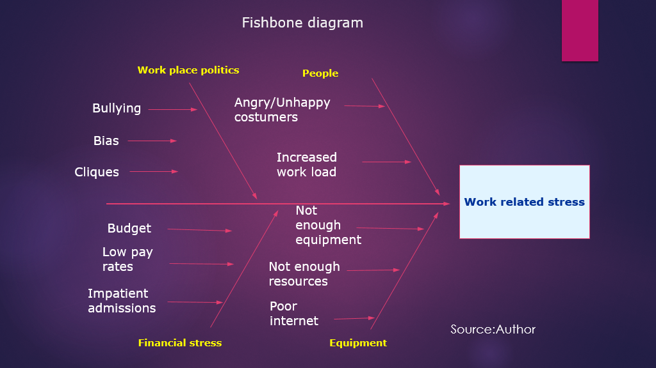

4. PESTLE analysis of the macro-environmental factors contributing to the problem
PESTLE analysis, a tool used by organisations or businesses owners to help identify the external factors that can affect them.
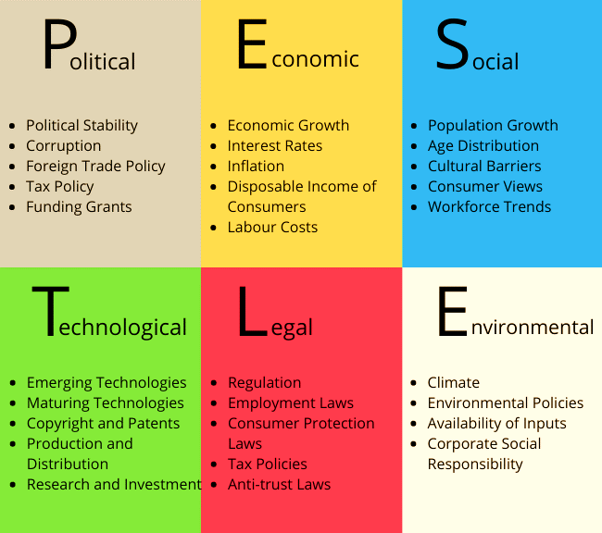
Every letter from PESTLE analysis stands for external factors that can affect the business or organisation.
After a PESTLE analysis on UK healthcare sector, the following external factors were found:
Political: Shortage of staff due to refuse of Covid19 vaccine, quality of products affected by Brexit, Corruption.
Economic: More money spent on hygiene products due to Covid19, unemployment rate increased due to the pandemic, lack of resources.
Social: Having multicultural staff and patients but not being able to fulfil their needs, cultural barriers, overworked employees, staff members quitting their jobs out of fear for the deadly virus, increasing number of patients.
Technological: Online training, poor internet, training for illiterate staff to be competent.
Environmental: climate, changing plastic cups to paper ones, using environmentally friendly detergents and cleaning products.
Legal: Protection of personal data for both staff members and patients referred to the health and safety policy.
Identifying the external factors that can affect the business and the future challenges and being able to be ahead from the competition by acting before difficulties arrive, is what PESTLE analysis is used for.

5.SWOT analysis
To define the level of competition a business is situated on and how to make plans using certain strategies, SWOT analysis must be used. Creating connections between positive and negative sides of a situation is what defines SWOT analysis.
S (Strengths), W(Weakness), O(Opportunities), T(Threats) is about finding and analysing the internal and external factors that can affect a person, place, or organisation.
A tool that identifies both internal and external factors that can affect an organisation or business, but also what that work excels at and what needs to be upgraded, is what SWOT analysis is about.
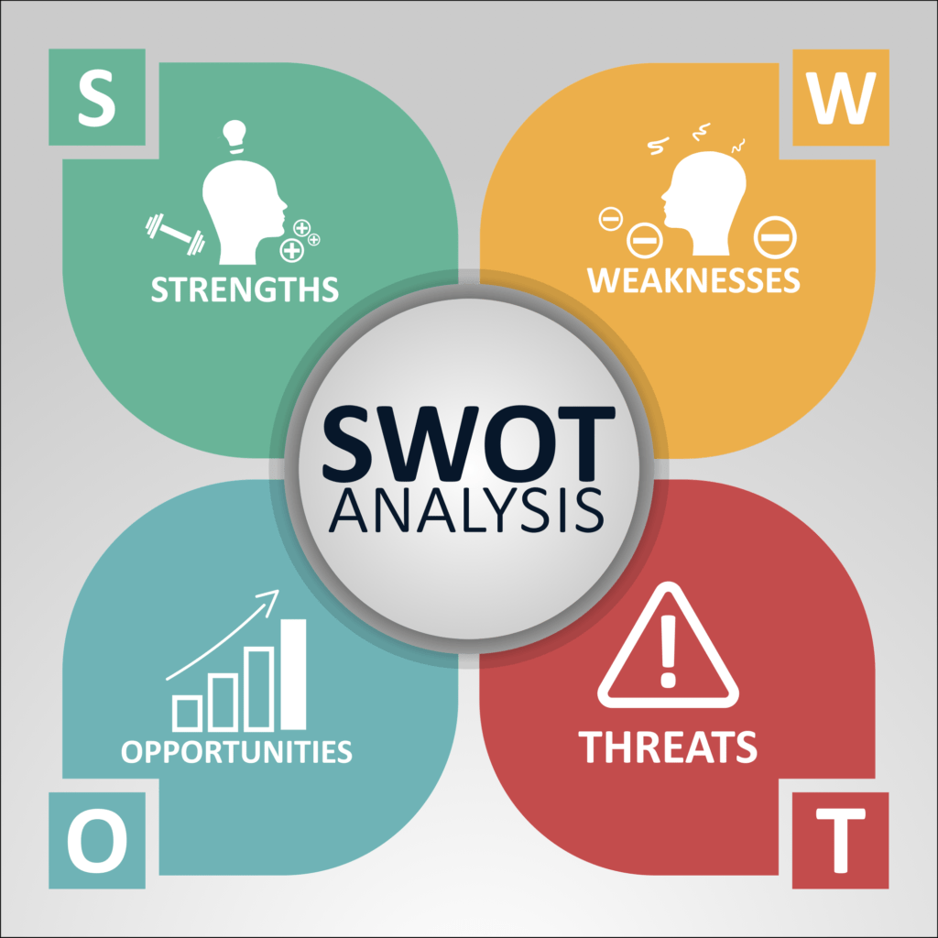
Internal factors: Strengths (Positive factors) and Weakness (Negative factors).
External factors: Opportunities (Positive factors) and Threats (Negative factors).
A limitation of using the analysis mentioned above is that SWOT is used only for identifying the problems, without solving them.
Solutions must be found by the person facing the problem.

6.GRID analysis for decision making
When facing a vast number of possibilities, that include problems that need to be sorted, GRID analysis is the right tool to be used.
Writing on a piece of paper the options that need to be considerate before making a decision and rate them from 0 to 5, where 0 is the less important and 5 is the most important, is what defines GRID analysis.
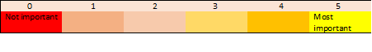
Scoring the factors from 0 to 3 is important, where 0 is less important and 3 is the most important is the next step to be followed in decision making. Multiplying the scores by 3, is the final step, where the highest score wins. The final score is what will be taken in consideration when making a decision.

7.PMI tool in decision making
PMI tool is referring to the positive, negative, and interesting points that need to be talking in consideration before deciding.
The decision needs to be made according to the highest number of points, either positive or negative.
P – positive points
M – minus/negative points
I – interesting points
Writing down the good points, the bad points and the interesting ones, before making a decision is what defines this tool.
Applying PMI tool on Work related stress in UK’s Health sector, the following positive, negative, and interesting points were found:
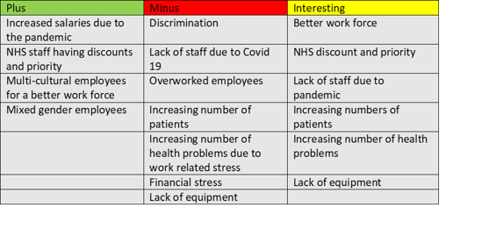
As shown in the picture above, more negative points were identified, so to make a decision, solutions to the presented problems must be found, and an action plan to make sure the chosen solutions are the correct ones and will be improving or solving the existing problems.

8.Soultion and action plan for work related stress in UK’s health sector
PESTLE, GRID, Fishbone diagram, PMI and Swot analysis were the tools used to find the following problems related to work related stress:
- Overworked staff,
- Lack of resources,
- Unhappy costumers,
- Increased number of patients,
- Discrimination,
- Low payment.

From the problems presented above, the author of this report considered that two are more important. Overworked staff and unhappy customers are two major problems that lead to work related stress.
Overworking can lead to major health problems such as strokes, heart problems, depression, anxiety, drinking problems, impaired memory, and exhaustion.
Unhappy costumers have both positive and negatives impact on employees and business. Costumer reviews can help employers lead the business better, because the costumers leave most of the time honest reviews that expose the problems that the business is facing.
Bad reviews are bad for organisations because is creating a bad name for business.

Solutions followed by and action plan were found by the author of the report and will presented.
In the author of this report opinion, solutions for overworked staff are the following:
- Applying the employees reword system- reword hard working employees, that can work efficient in stressful situations, that have good feedback from customers and bring new ideas of how to improve thing to provide good workforce.
- Creating a pleasant work environment, where employee’s needs, and culture are respected- praying arias, serving food made according to employees’ religion or background.
- Providing relaxing arias where employees can spend time during their breaks.
- Hiring more staff that can provide flexible working hours and shift covering.
Solutions for unhappy customers according to the author of this report are the following:
- Checking the customers’ reviews- to find out what are their complains and provide solutions for it.
- Make waiting rooms comfortable –getting comfortable chairs, having ac system or heathers in perfect working order, having tv on all the time to keep the customers entertained while waiting.
- Having playing arias for children in the waiting room, to keep them entertained.
- Vending machines in waiting rooms -for customers to have refreshments and food while waiting.

8.1Action plan to monitor and evaluate work related stress problems



Planning your day-to-day activities is what defines an action plan.
Without having an action plan, everything at work or daily basis activities will be a chaos.
Employees will not be able to have a routine, managers will not know how to act and what is needed to be improved or if the solutions that were found are effective.
To help work related stress problems such as overworked staff and unhappy costumers, the following action plan was conceived:
- Providing training for staff members for three months, two times a week for 2 hours at the workplace between 8am to 10am Mondays and Wednesdays.
- Providing online training for employees that are not able to attend the workplace, for three months, two times a week from 6pm to 8pm on Tuesdays and Fridays.
- The training will be compulsory for all the staff members.
- Surveys will be created to find out customers’ opinion regarding the service they are getting.
- Reflection on the surveys will be necessary, to check for improvements if needed.
- Monitoring via recorded phone calls.
- Implementing and apply the reward program for the employees to make them more determined and to increase productivity.
- Once a month, a two-hour meeting every Thursday at 9am, with the employees will be made, to make sure they understood the training and to help them with any problems they are facing.

- Creating relaxing arias for employees, where they can spend time during breaks.
- Organising parties for season holidays to get to know the employees better and create a bond with them and between themselves as well.
- Making a friendly work environment where both employees and customers can feel safe and relaxed.
- Providing supervised playing arias where customers can leave their children while are getting treated.
- After the three months of training are done, giving deadlines to see how the employees respond under stress, will be a first step in realising if the training had made any improvements or not.
- Proving more training if needed.
- Checking if the customer’s rate has increased and the customers service has improved.
- Always have an alternative plan if the initial one is not working or making sure to have alternative improvements to the initial plan.
Training employees can help improve the workforce and the productivity of the business of organisation.
Customer service is a direct line between employees and customers because happy employees result happy customers.

9.Conclusion


In conclusion identifying the problem is the first step in making an effective decision making.
Tools such as PESTLE, GRID, PMI, and Fishbone diagram must be used to identify the factors that can affect an organisation, business, place, or person, and the positive and negative points, to help finding the correct decisions.
Finding the internal and external factors that can affect the organisation, business or person is what define these tools.
Also providing a list of factors both positive and negative will make the decision much easier and will ease the process of overthinking.
After using these tools, the next step is finding solutions to the problems that were found and implement them.
Next step after find and implementing the solution is to have an action plan that will help monitor and evaluate the solutions.
Having an alternative action plan or improvement to the initial plan is a must when running a business.

10.Reference list
- Benstead, S.(2020) Workplace stress in the UK: 7 statistics that will blow your mind.[website].Available at: Workplace stress in the UK: 7 statistics that will blow your mind (breathehr.com) (Accessed : 07.12.2021).
- Bright Hub PM(2011) Decision Tree vs. Grid Analysis: Comparison of Techniques [website].Available at: Decision Tree vs. Grid Analysis: Comparison of Techniques - BrightHub Project Management (brighthubpm.com) (Accessed: 07.12.2021).
- Davis, B. (2021) What is the scope of a research problem? [website]. Available at : https://www.mvorganizing.org/what-is-the-scope-of-a-research-problem-3/ (Accessed :06.12.2021).
- Indeed Editorial Team(2021) The Importance of Training Employees: 11 Benefits [website].Available at: The Importance of Training Employees: 11 Benefits | Indeed.com (Accessed: 07.06.2021).
- Jessee(2021) How To Do A SWOT Analysis In Healthcare[website].Available at: How To Do A SWOT Analysis In Healthcare - ClearPoint Strategy (Accessed :07.12.2021).
- Marino,J.L.,Jr. (2017) The Nature and Impact of Task Definition: Information Problem Categorization During Task Definition Within the Information ProblemSolving Process ,Washington: university of Washington .
- Meier,J.D.(2009) How To Use the PMI Technique to Think Better [website].Available at: How To Use the PMI Technique to Think Better (sourcesofinsight.com) (Accessed: 07.12.2021).
- NHS Improvement(2011) An Overview of Action Planning [website].Available at: Microsoft Word - An Overview of Action Planning.doc (england.nhs.uk) (Accessed :07.12.2021).
- Reding ,M. (2021)What is a PESTLE analysis? [website]. Available at : What is a PESTLE analysis? | How To Do, How To Apply, Who Created It? (cpdonline.co.uk) (Accessed :06.12.2021).
- Seel ,N.M. (2012) Problems: Definition, Types, and Evidence. (eds) Encyclopedia of the Sciences of Learning. Springer, Boston,p 115 .Available at : https://link.springer.com/referenceworkentry/10.1007%2F978-1-4419-1428-6_914
- Virtual Library(2021) ​PMI - Plus, Minus, Interesting [website].Available at : https://www.virtuallibrary.info/pmi-plus-minus-interesting-strategy.html (Accessed : 07.12,2021).
- Leo,H.(2021) Why Overworking Is Bad for Workplace Health and Safety?[website].Available at: Why Overworking Is Bad for Workplace Health and Safety? (uniquenewsonline.com) (Accessed :10.12.2021).
- Boeckelman,C.(2016) Why Unhappy Customers Are a Valuable Resource [website].Available at: Why Unhappy Customers Are a Valuable Resource - GetFeedback (Accessed: 12.12.2021).

