

University of wales trinity saint David
School of engineering
Assignment Title: project planning
Student name: Yahye Hussein
Student number: 1703137
Course: BEng motorcycle engineering
Module name: Management, Innovation and Sustainability
Module code: M5X01176

Contents
i
Abstract ii
List all team member’s roles and responsibilities iii
A list of overall group tasks and associated timings v
A detailed list of your task vii
Identify significant milestones for the whole project ix
Identify two areas of concern within your section of the project x
Generate an overall summary Gantt chart for the whole project and generate a second xi
more detailed plan for the section of the project that you are responsible for xi
Bibliography xiv

Abstract

The topic of the project is chassis design and redevelopment. We are re-design a Ducati 999s frame and learning about different topics that we each find interesting individually. The aim is to improve motorcycle handling and to understand what is the right amount of flex and stiffness. My interest is how I can manipulate different material to get me the results I am after and how can I dynamically improve the motorcycle. I will measure success by seeing what improvement we have made and how it compares to the original.
objectives
- Designing a carbon fibre reinforced aluminium frame
- Comparing different material
- Measuring frame flex
- When prototype is built compare it to the originals and see how much of an improvement we have made.

List all team member’s roles and responsibilities

My role with the group is materials application because I have found an interest in composite materials to be specific I have found an interest in carbon fibre reinforced aluminium because even though carbon fibre on its own has benefits like high tensile strength and is very rigid but the issue is when the frame needs to flex in the corner and when it hits any rough surfaces like an uneven track. Carbon fibre has a low bending strength, so that would translate to the rider as being stiff. when it does bend it bends very little or it catastrophically fails but if we use a carbon fibre reinforced aluminium the bending strength will increase and the bike will be stiff in some areas but flex in other areas.
My responsibility for this project is to validate the material and to create the motorcycle frame in the ideal material for this to be possible I have to validate that the material will work and for me to do this I have measure stress, strain shear stress and shear strain. I will do this by experimenting on a small size of materials like carbon fibre, aluminium, steel, carbon fibre reinforced plastic, carbon fibre reinforced aluminium. When I have completed the experiments, I will recreate the same experiments in solid works using finite element analysis to validate my solid works. Then I will be looking at recreating the whole frame in carbon fibre reinforced aluminium but first I will need to create a forces diagram so I can work out the correct ratio of carbon fibre and aluminium, and what areas need to have high stiffness and when areas need to flex more then I can work out what strength and strain I will be aiming for when deciding how much materials to use.
 | role | responsibilities
Connor William | Investigating frame flex and dong FEA on 999s | Modelling and completing finite element analysis on 999s frame and investing static and intrastate frame flex.
Wesley Patrick | Investigating delta box flex and comparing it to 999s | 3d scanning delta box frame and comparing to 999s frame.

The Belbin self-precipitation inventory was design create self-awareness of roles that you most succeed in and what roles you least succeed in so it can improve the productivity in a team. even though Belbin mentions 9 different team role it also mentions that the team can have two or three team members, so this means that we will have to adapt to different roles we most feel comfortable in and as the project progress. The group decided that it would be beneficial that we all take part in the Belbin self-precipitation inventory and that we all individually asses what team role member each individual best occupies. (BELBIN Associates., 2019)

 | IMPLEMENTER | COORDINATOR | SHAPER | PLANT | RESOURCE  INVESTIGATOR | MONITOR  EVALUATOR | TEAM  WORKER | COMPLETE  FINISHER
Score | 5 | 7 | 13 | 6 | 4 | 10 | 12 | 10

I scored the highest in shaper meaning that is role I would be most effective in. A shaper provides the drive for the team to ensure that the team keeps on task and schedule and does not lose focus or momentum. Although the Belbin self-precipitation is quite useful it should be taken with a pinch of salt because there are other factors that may hold a team member back, so I will take these results as a start point to start looking at my potential. One factor that was important when choose a project was picking a topic that I had real interest in and I found that chassis design and materials was something that I found interesting.
The lowest part of the Belbin test that I was found least effective in was resource investigator. A resource investigator is a person who is has an inquisitive nature and brings I ideas back to the group. His information is useful for me to when I am assessing my behaviour, in my opinion I believe that because I have chosen a topic of the project that I am interested in and it will help me focus, so I will be more eager to bring ideas to my section and the group as I have already done so for example I decided that we should make the frame from carbon fibre.

A list of overall group tasks and associated timings

Group task | Description | Timings
Initial planning | At the start of the project we started to decide what are goals where and how to achieve that. | Start:21/10/2019  Finish:04/11/2019
Management report | We were given an assignment in our management class that would help us plan for the project | Start:24/10/2019  Finish: 25/11/2019
Theoretical testing | we researched the stress and strain to calculate the young’s modulus of steel and aluminium. We did the bending test on cad. | Start:04/11/2019  Finish:11/11/2019
Practical sample testing | We did the bending test and worked out stress and strain and solved for young’s modulus | Start: 04/11/2019  Finish:18/11/2019
viva | Viva is when we first have to present what we have done so far and we have to present it. | Start: 01/01/2020  Finish:01/03/2020
Results breakdown | We share what we have done so far and what results we have gained. | Start: 24/02/2020  Finish: 02/03/2020
Final report | We finally have to submit our final project and show what we have done and achieved. | Start:02/03/2020  Finish: 23/03/2020

The above table describes the group task that we all have to participate in and how long each task will take. The group task we have are all related to planning, agreeing on the specification so our project is coherent, and present the project. The first task was the initial planning when we I identifying a critical path to take and where decided to that each member should take a path where they are interested in so they can achieve good job satisfaction, so each member feels like they belong to the group and therefore feel motivated and their performance is increased so the feel reward when a task is completed.
The management report is this assignment and it is a planning assignment that shows teaches real life engineering practices. From this report we learned how to plan an assignment the same way it would be done in real life, so we do our best to take in every possible factor like cost, timings and team roles.
The theoretical testing was done because we decided in the initial planning what frame we wanted to do the project on and the material of frame was steel. we wanted to see if the solid works models would be accurate so we did a theoretical test in cad and recorded the results and then we did the next task which is practical same testing. which was to do the same bending test in real life and the results gained was similar to the cad models and excel calculations.
Then in this team we have a viva where we all have to do a joint presentation where we show what we have achieved so far where intend to go from here. The first viva is a 15-minute presentation and 10 minutes of questions.
The next group task is result breakdown where we share our results amongst each and explain what we have done to each other we link each other’s sections and we start to put it all together and hopefully we show that we have achieved our ultimate goal. Then we have the final report where we will be presenting our final report to be assessed.

A detailed list of your task
tasks | description | timings | costs
Material research | Material research is me learning about composite material and how it can work in my application | Finish:18/11/2019 | 0
  Start:15/10/2019
Material validation | Material validation is proving that it can work fundamentally and from a motorcycle dynamic prospective. | Finish:29/11/2019 | Prepreg carbon (300mm)-2m roll  £23.50
  Start:18/11/2019
Frame prototype research | Frame prototype research is finding the best way of constructing the frame. |  | 0
  Start:01/01/2020
  Finsh:31/01/2020
Frame prototype building and testing | Frame prototype building is when I will be constructing the frame. | Finsh:02/03/2020 | Aluminium: £1.50-£2.50 per kilo  Prepreg carbon (300mm)-2m roll  £23.50
  Start:01/02/2020

The material research is a fundamental aspect of this project because it will allow me to learn and gain knowledge of composite materials and what benefits would we gain from a motorcycle dynamics perceptive for example we would want it to be stiff near the headstock because the headstock vital part of the steering if we had loads of flex in that area it would effect the steering in a negative way but we would want to make the frame to deflect laterally because when the bike is mid corner the forks are acting side to side not up and down so when going over rough surfaces you need the frame to deflect (Vittore_Cossalter, 2006). So, this mean that different levels of carbon and aluminium are required at different part of the frame. The material validation is when we are testing carbon and aluminium and steel because we are steel is the original material of the original frame so I will try to figure out the young’s modulus of the frame and then the individual carbon and aluminium and then try and create a solid work test piece of the carbon fibre reinforced aluminium and test on solid works and then test it in real life and compare the results, then that would complete my validation.
Frame prototype research is research how to construct the frame using the tools available to us we are fortunate to have most of the tools like autoclave in the university but the issue comes when bonding the carbon fibre and aluminium because it need to be heated in a Lindenberg furnace to 850 degrees (Hasan AliAlhashmy, 2014) and the problem is that the university furnace does not reach those temperatures. I will have to go to an outside source for use to a furnace which reaches those temperatures or find another method that does not require those levels of heat. When I have found a method that can work using the tools available to me I will be on my next task which is frame prototype building, that will include the construction of the frame and testing which will include the use of strain gauges to use if I have achieved my goal of flex in the right areas and stiff in the other areas like the head stock.

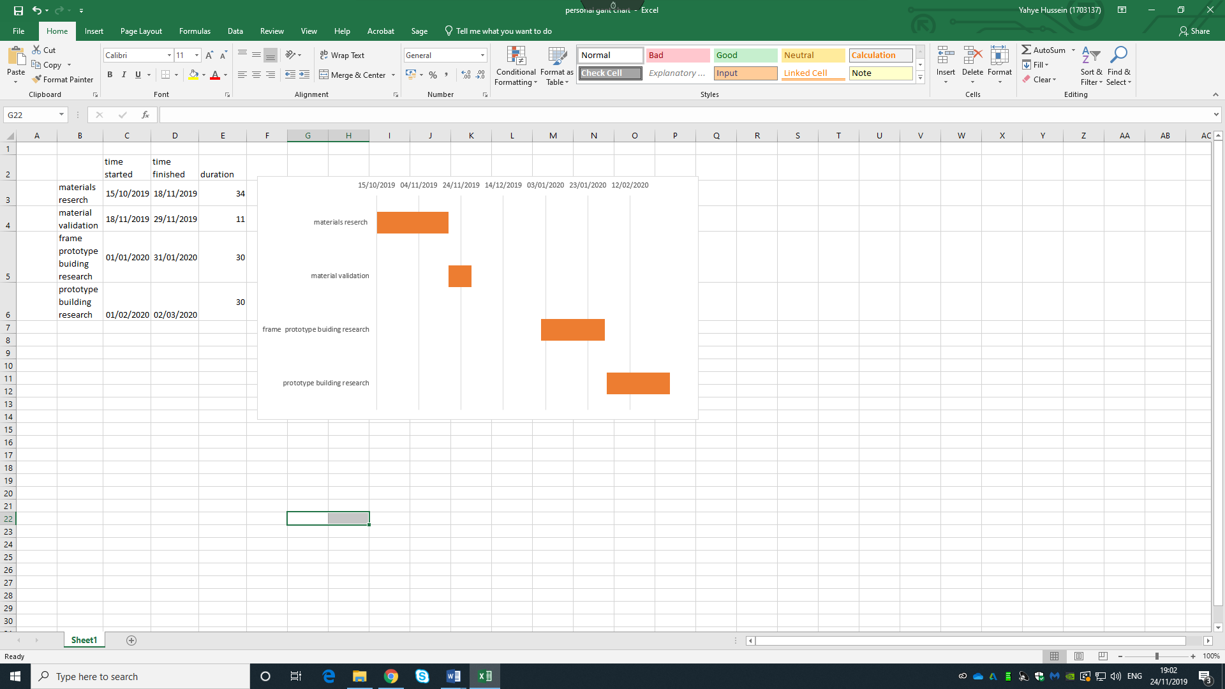

Identify significant milestones for the whole project

During this project theirs has been numerous millstones, one was when I knew that I wanted to a carbon fibre reinforced aluminium but I had no Idea where to start from because this is a learning progress the we had a meeting with Owen William and he gave me suggestions like I should start on validation first and that gave me a point where to start from and it became clear where to go from. I learned validation is important because it can show you what you are doing is even beneficial. For my task it shows me that how much the material bend and deform and what material is more of in different areas for example carbon fibre does not flex very well meaning it is very stiff and rigid so more carbon is better near the headstock than aluminium is which deflects more. Another milestone will be completing the first viva and receiving feedback because we can see if we are headed in the right direction or not.
One gate way was when I made the carbon fibre test piece to do material validation because it gave me a different insight that I could not have got from a book or a article and it was an important part that I needed for the validation it meant I could finally start the experiment because I have waiting for the autoclave to be available.one gateway will be when I have completed the validation and I have received the solid work model on the 999s and the finite element analysis tells us where there is the most forces and I can start to decide how much material we will need in what areas and I can do an effective costing of the whole project.

Identify two areas of concern within your section of the project

One area of concern is if I can gain access to a furnace which can reach the temperature that I require to manufacture the composite. I have found out that the university furnace deo sot reaches the temperature that I need to bond the aluminium and carbon fibre. Even though this is a concern I believe that I can find an alternate route of manufacturing or alternate method. For example in my reach I have found that in construction carbon fibre reinforced aluminium is used in construction and there various ways of manufacturing the one which I found most interesting was using a carbon fibre tube and inserting a aluminium tube within the carbon fibre tube and using a high strength bonding glue to bond the two material but I would need to do further stress test to see if it is suitable the stress and strain of a motorcycle. This method holds the benefit of being simple to manufacture and would require a lot less energy to manufacture. It would be cheaper as well it build.
Another area of concern is that the fact is that it would be extremely challenging to construct a carbon fibre reinforced aluminium frame in university. Because it requires a lot of energy and time, form what I have seen in past projects it took one to construct a fully carbon fibre swing arm. So, to mitigate the risk I would first look at design a small section of the frame and seeing if that work and then using solid work to prove that the concept is valid and then when proven I would later be looking at constructing the whole frame. When I have completed the frame, I would make it into a running bike and gain feedback from the rider because I have spoken to the owner and he is willing to test the frame on his bike using my chassis.

Generate an overall summary Gantt chart for the whole project and generate a second

more detailed plan for the section of the project that you are responsible for
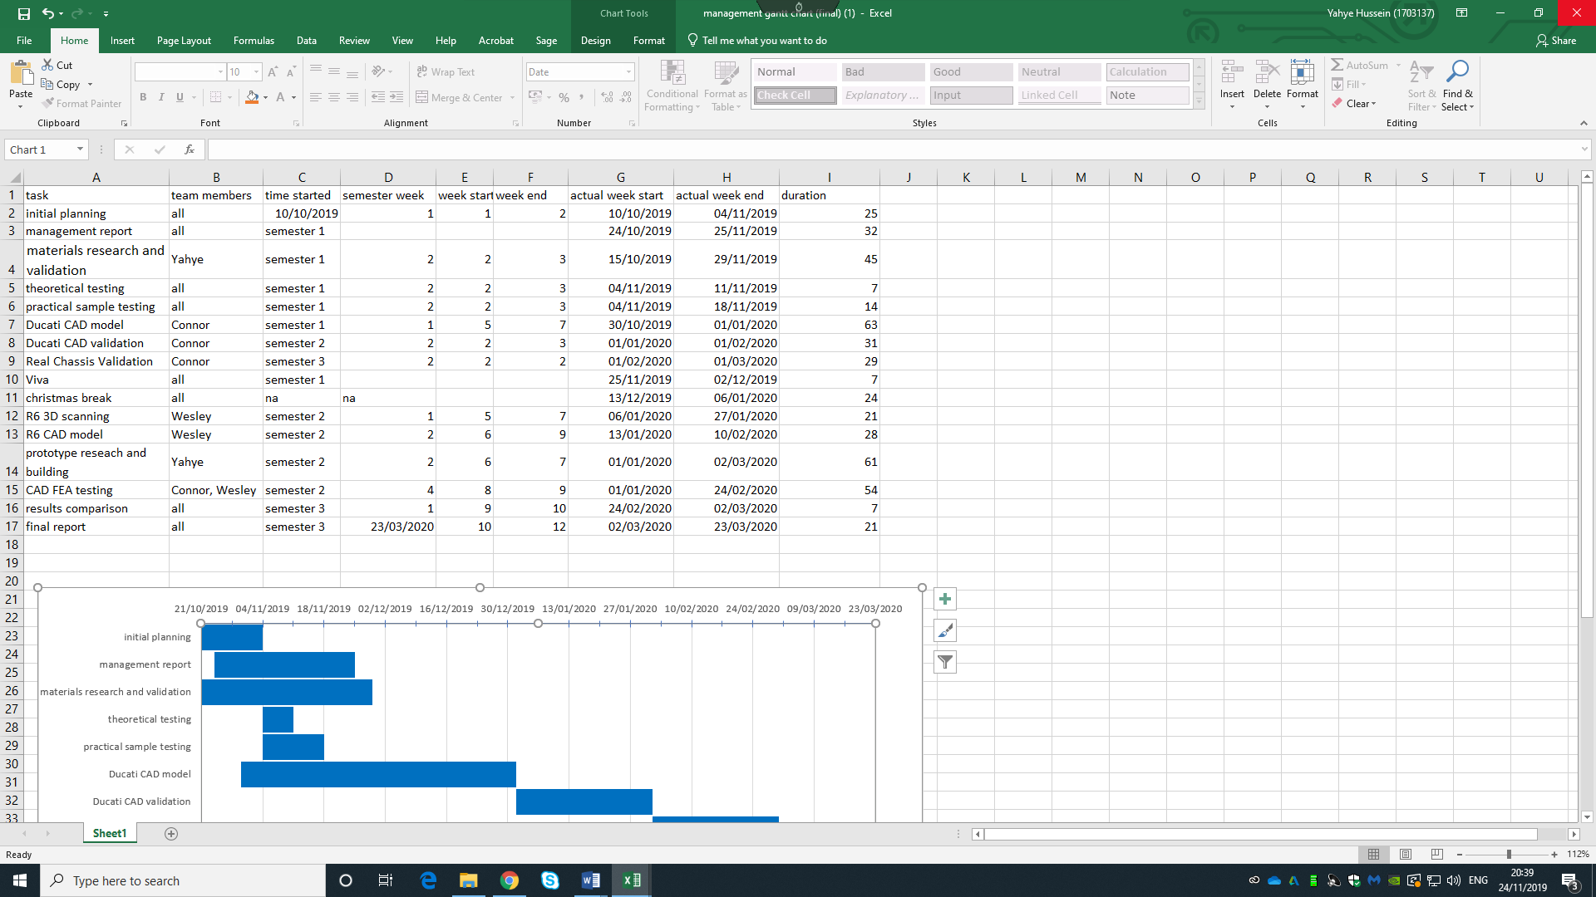

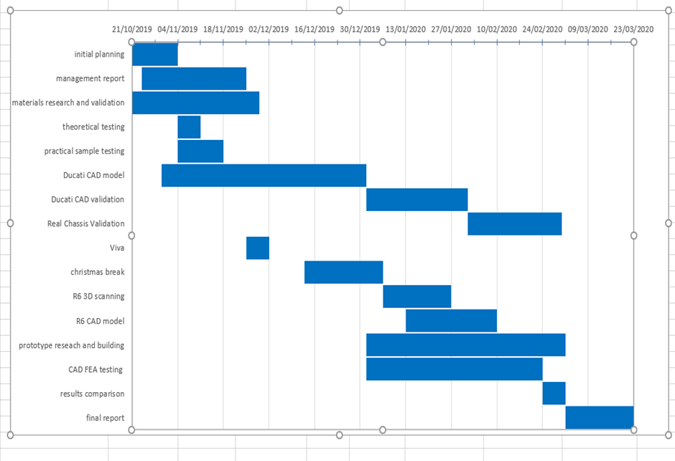

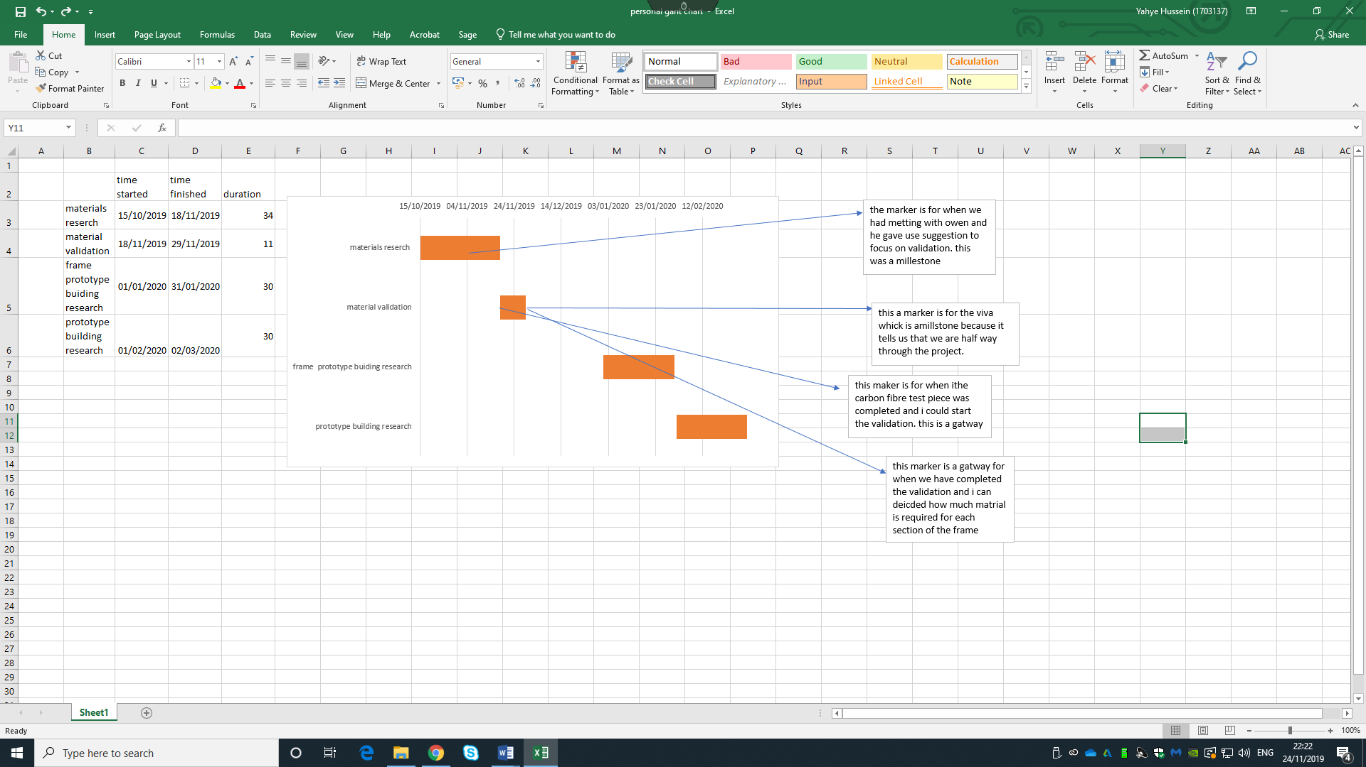

Bibliography
BELBIN Associates., 2019. The Nine Belbin Team Roles. [Online]
Available at: https://www.belbin.com/about/belbin-team-roles/
Hasan AliAlhashmy, M. N., 2014. Laminate squeeze casting of carbon fiber reinforced aluminum matrix composites.
Vittore_Cossalter, 2006. Motorcycle_Dynamics. second ed. s.l.:s.n.

