DS 1 Template

My Screenshots/Photos
- Please add 4–6 screenshots or photos of your digital life.
- You can use your phone or laptop.
- For each screenshot, write one or two sentences explaining what it shows.

Screenshot/Photo 1
[Ins 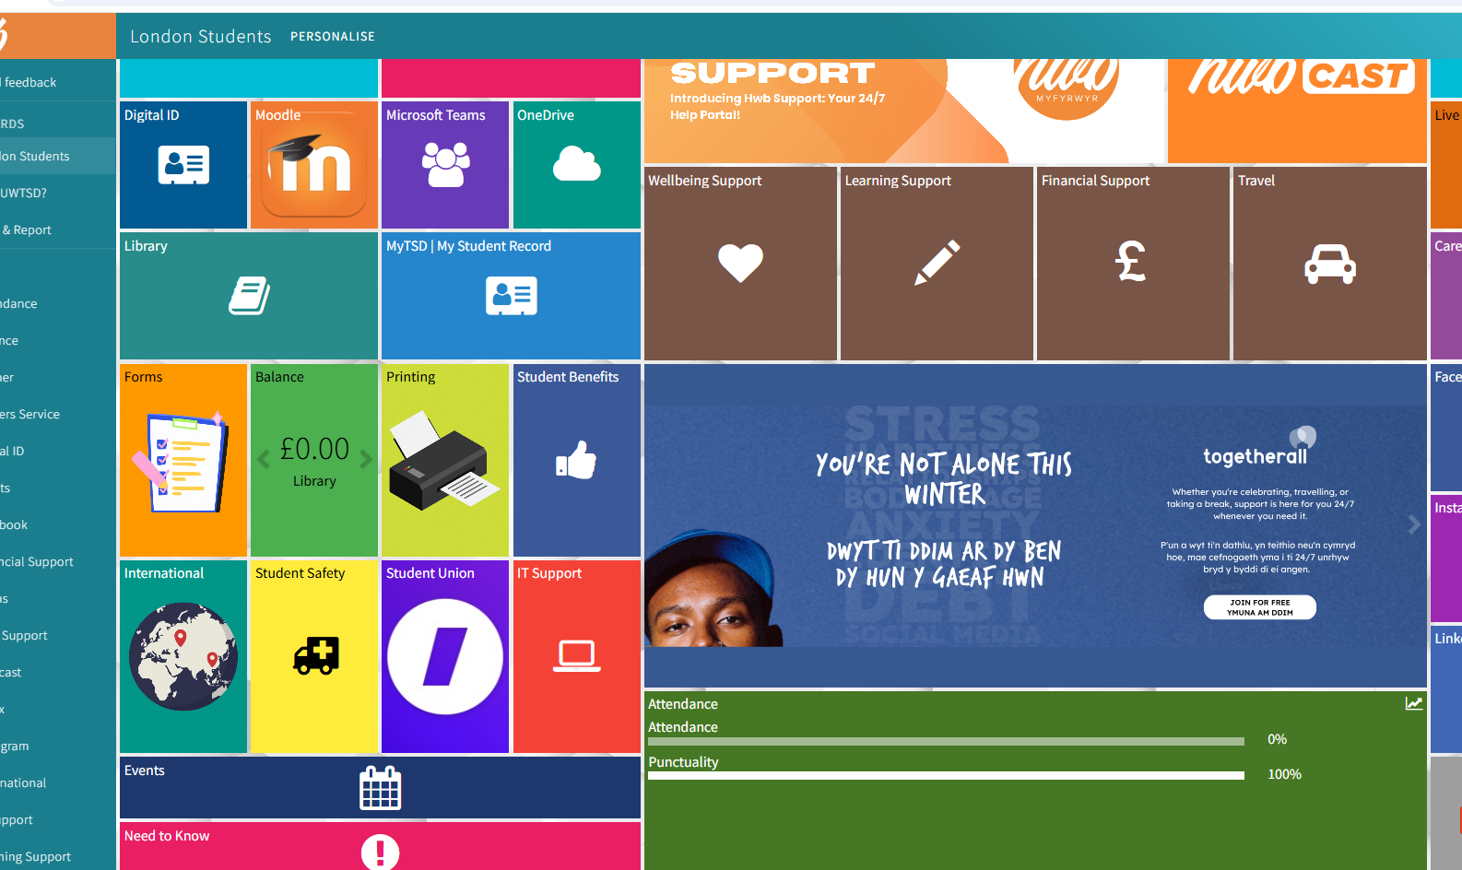

I use Moodle for university and for learn

Screenshot/Photo 2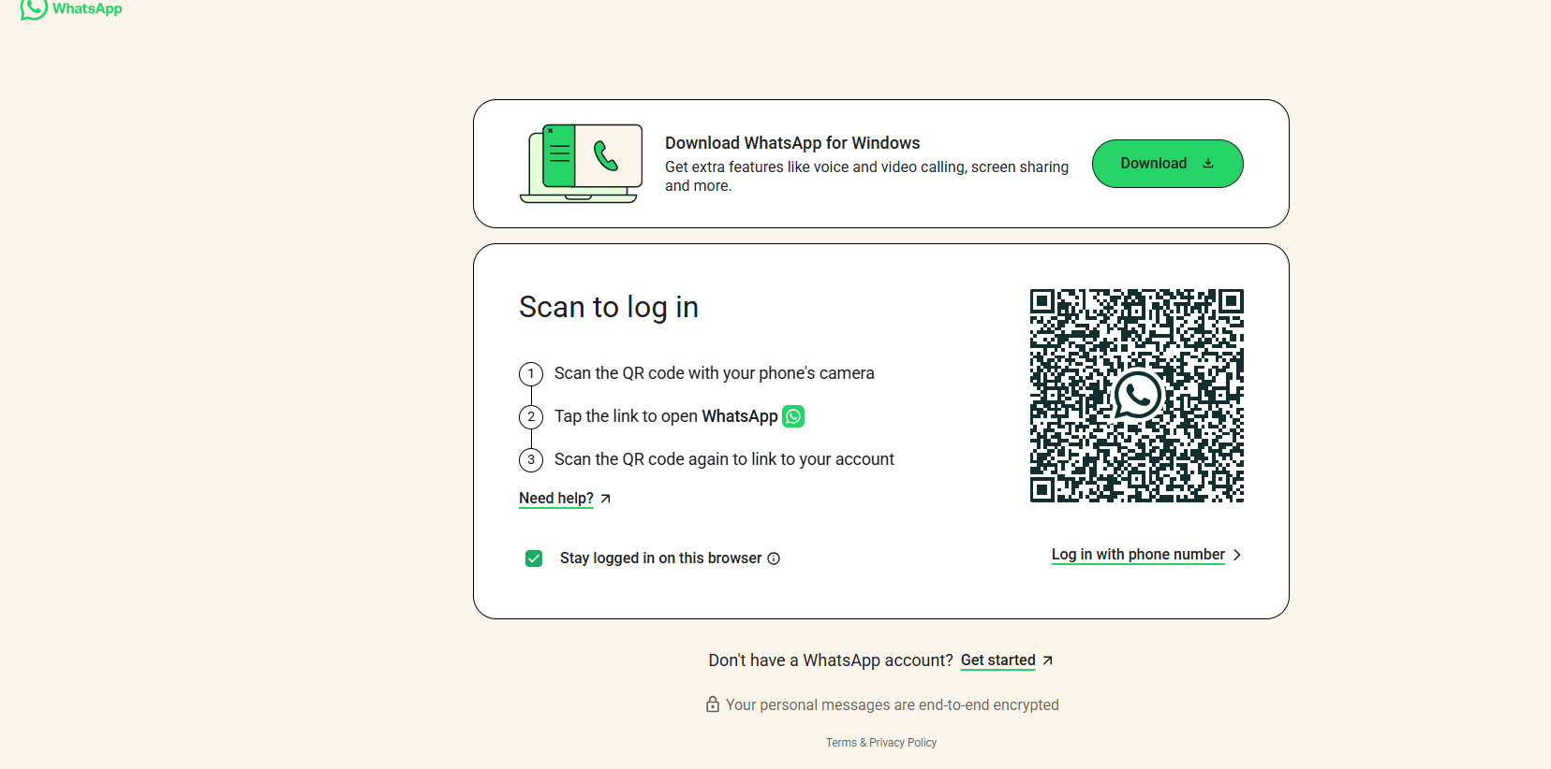
I use whatsup to communicate international

[Write what this shows of your digital

Screenshot/Photo 3
[Insert Photo/Screenshot below]
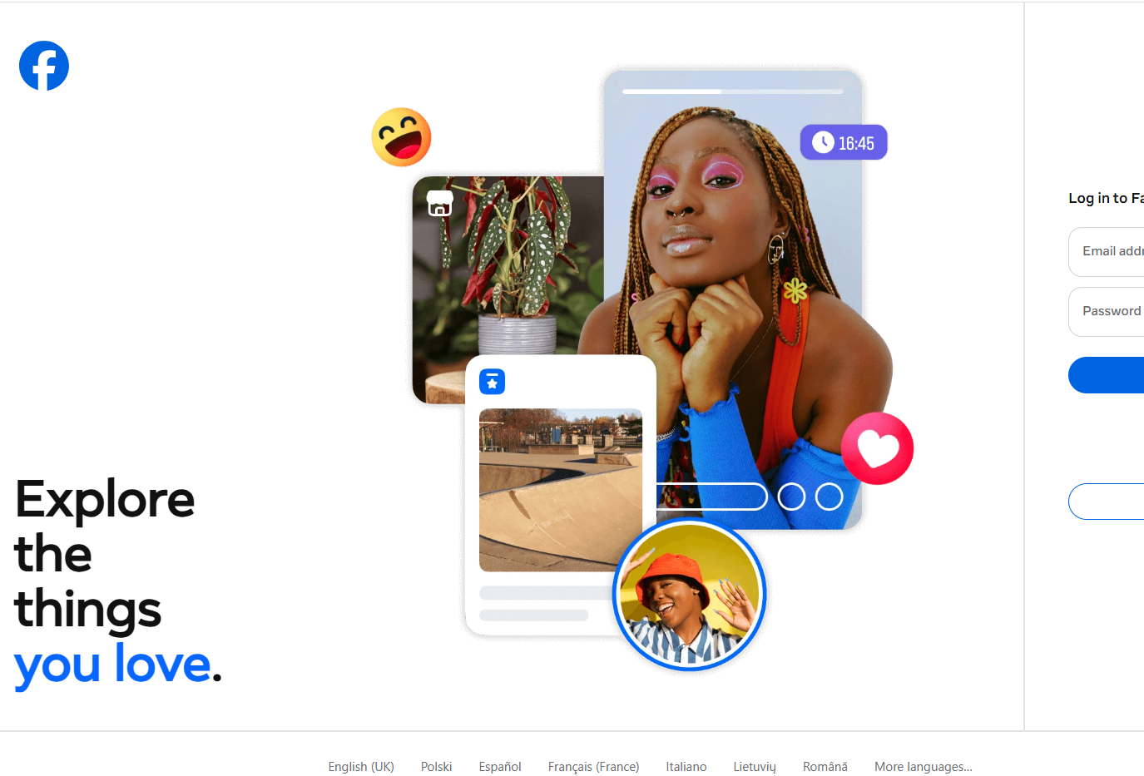
I use Facebook to communicate white other people and to socialize

Screenshot/Photo 4
[Insert Photo/Screenshot below]
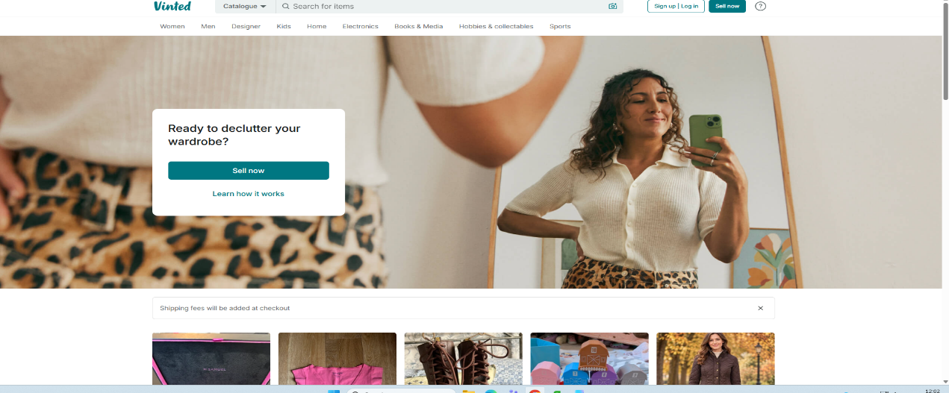

I use vinted to sell and buy old shoes clothes and many other thing

Screenshot/Photo 5
[Insert Photo/Screenshot below] 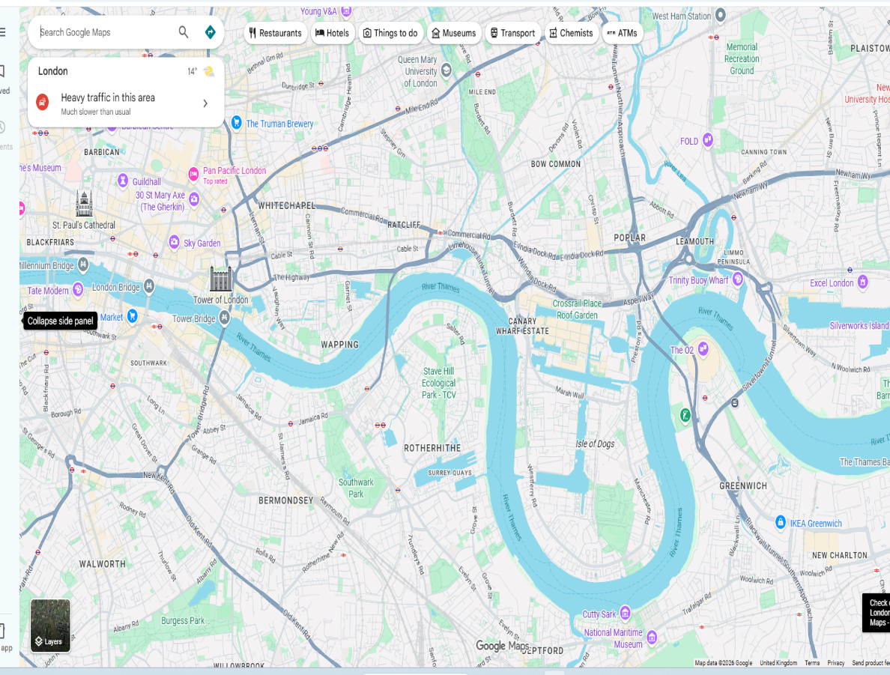
I use google maps to get indicate so i won’t get lost and knowing new places

I use Gmail for my email

Screenshot/Photo 6
[Insert Photo/Screenshot below]
[Write what this shows of your digital life]

My Short Reflection
- Write 5–8 simple sentences about your digital life.
- You can use the sentence starters below if helpful.
I use digital tools to do my day to day tasks
I would further like to improve my digital skills
I like to come university and learn digital tools
I hope this module will help me to further learn the knowledge
I feel confident to get use to the various tools that I learn in the class.

Sentence starters
- I use digital tools to …
- I feel confident when I …
- I want to improve …
- I often use these tools: …
- I sometimes feel nervous about …
- I hope this module will help me …
- Digital skills are important for me because …
You can write more if you want.

Submission Checklist
Before you submit, please check:
​​​ ☒ I added 4–6 screenshots
☒ I wrote short sentences for each screenshot
☒ I wrote my short reflection
☒ My work is my own
☒ My file opens correctly
​​☒ My file opens correctly

