

Image [4]

Assignment 1
Name: Zaeem
Student No.: 1902036
Course: Applied Computing (Web Development)
Module: Databases and Application Development
Date: 12/01/2021

Table Of Contents
Content Page Number
Introduction 3
ERD Diagram 4
Database 6
Tables 8
Records 13
Performance Turing (Indexes) 18
Transactions 22
Conclusion 30
References 31

Introduction
The Smile Factory is a local dental and orthodontic surgery which is private. In total, there will four dentists, six dental nurses and six dental hygienists within the surgery. Also, in total, there will be six appointments as four surgeries will run in the morning from 8.30am to 11:30am and two surgeries will run in the afternoon from 2pm to 5pm. These surgeries will run from Monday to Friday and emergency surgeries on Saturday morning. Patients will have appointments which is given by the reception staff as they are scheduled in 15 minutes slots but depending on the specific treatment, patients may have multiple slots. Patients will have different classes as some patients will be classed as Private and some patients will be classed as NHS if they under 18 years old. If the patient is classed as Private, they will have to pay for the specific treatment. The surgery would now like their appointment system to be computerise.
To do this, a database will need to be created on a specific program called Microsoft SQL Server Management Studio. Microsoft SQL Server Management Studio will be a specialised development platform which allows SQL Server database engines to be configured, managed and administered by users. [1] The language that will be used to create the queries will be called SQL.

Image [5]
ERD Diagram
Before the database can be created on SQL Server Management, an ERD diagram will be need to be created to show the design and how the database will look like in its final production.
The ERD Diagram will be created on Microsoft Visio.


Image [6]

Below will be a image of the ERD Diagram. To view the ERD Diagram in-depth, please view “My ERD Diagram.vsdx” file.

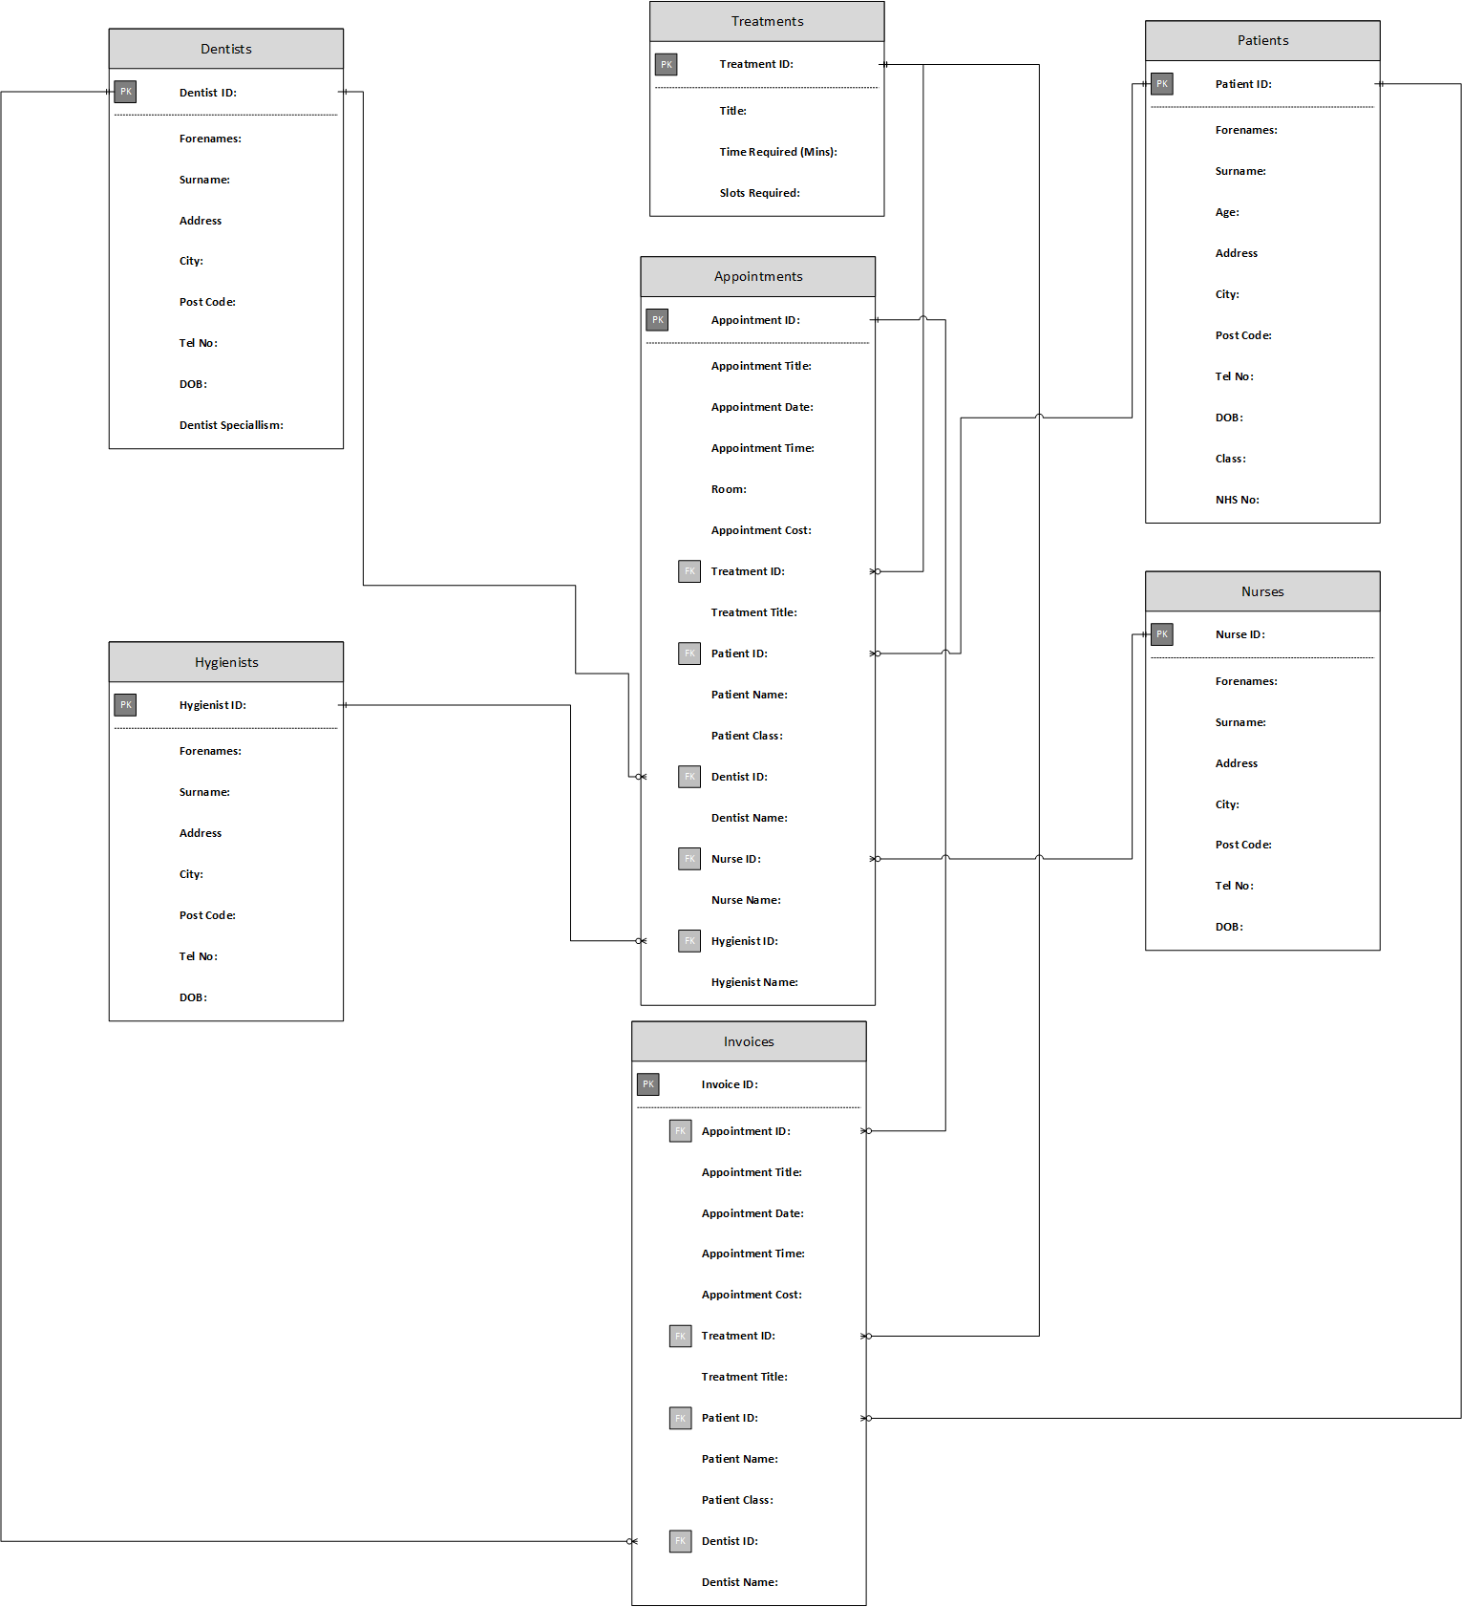

Database
Once the ERD Diagram is successfully created, database can be created next in SQL Server Management.
The first step will be to connect to the server in SQL Server Management.
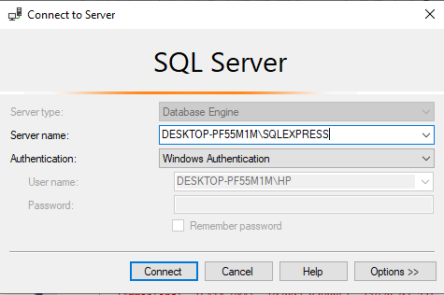

The second step is to create new query.
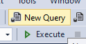

The third step is to input the specific SQL code in the query.

/* Creates the Database */
CREATE DATABASE The_Smile_Factory
GO

The fourth step is to the execute the SQL code in the query.
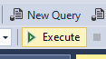

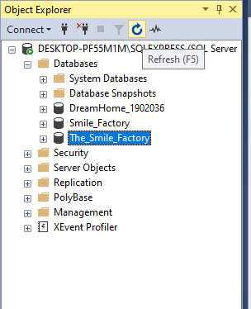
The final step is to refresh the Object Explorer and check if the database has been created.

With these steps mentioned above, the database has been successfully created.

Tables
Once the database is successfully created, the tables can be created next in SQL Server Management.
There will be a total of 8 tables created in the database and they are called:
- Patients Table
- Dentists Table
- Nurses Table
- Hygienists Table
- Treatments Table
- Appointments Table
- Invoices Table
- Bank Details Table
Also, the tables involved in the database are designed towards 3NF.
The first step will be to input the specific SQL code in the database query to connect to the database in SQL Server Management.

/* Connects to the Database*/
USE The_Smile_Factory
GO

The second step will be to input the specific SQL code in the database query to create the tables within the database in SQL Server Management.
/* Creates the Patients Table */
CREATE TABLE Patients(
Patient_ID varchar(5) NOT NULL CHECK(Patient_ID LIKE 'ID[0-9][0-9][0-9]')
PRIMARY KEY,
Forenames varchar(30) NOT NULL,
Surname varchar(30) NOT NULL,
Age int NOT NULL CHECK (Age BETWEEN 0 AND 999),
Address_ varchar(30) NOT NULL,
City varchar(20) NOT NULL,
Post_Code varchar(8) NOT NULL CHECK (LEN(Post_Code) > 6),
Tel_No varChar(12) NOT NULL CHECK(Tel_No LIKE '[0-9][0-9][0-9][0-9][0-9] [0-9][0-9][0-9][0-9][0-9][0-9]'),
DOB date NOT NULL,
Class varchar(30) NOT NULL,
NHS_No varchar(30) NOT NULL,
);

GO

/* Creates the Dentists Table */
CREATE TABLE Dentists(
Dentist_ID varchar(6) NOT NULL CHECK(Dentist_ID LIKE 'DEN[0-9][0-9][0-9]')
PRIMARY KEY,
Forenames varchar(30) NOT NULL,
Surname varchar(30) NOT NULL,
Address_ varchar(30) NOT NULL,
City varchar(20) NOT NULL,
Post_Code varchar(8) NOT NULL CHECK (LEN(Post_Code) > 6),
Tel_No varChar(12) NOT NULL CHECK(Tel_No LIKE '[0-9][0-9][0-9][0-9][0-9] [0-9][0-9][0-9][0-9][0-9][0-9]'),
DOB date NOT NULL,
Dentist_Speciallism varchar(30) NOT NULL,
);

GO

/* Creates the Nurses Table */
CREATE TABLE Nurses(
Nurse_ID varchar(6) NOT NULL CHECK(Nurse_ID LIKE 'NUR[0-9][0-9][0-9]')
PRIMARY KEY,
Forenames varchar(30) NOT NULL,
Surname varchar(30) NOT NULL,
Address_ varchar(30) NOT NULL,
City varchar(20) NOT NULL,
Post_Code varchar(8) NOT NULL CHECK (LEN(Post_Code) > 6),
Tel_No varChar(12) NOT NULL CHECK(Tel_No LIKE '[0-9][0-9][0-9][0-9][0-9] [0-9][0-9][0-9][0-9][0-9][0-9]'),
DOB date NOT NULL,
);
GO
To view the SQL code to create tables in-depth, please view “Smile Factory File 1.sql” file.
The third step is to the execute the SQL code in the query.

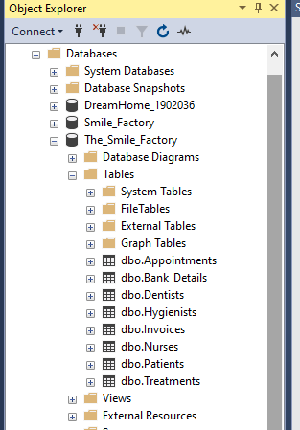
The final step is to refresh the Object Explorer and check if the tables has been created.

With these steps mentioned above, the tables have been successfully created within the database.
Also, every table will include a column that will check constraint. A check constraint will be SQL function that is used to validate data to show if the inputted data is correct or incorrect.
The columns that contain a check constraint in the database will be:
- Patient ID in Patients Table
- Age in Patients Table
- Post Code in Patients Table
- Tel No in Patients Table

- Dentist ID in Dentists Table
- Post Code in Dentists Table
- Tel No in Dentists Table

- Nurse ID in Nurses Table
- Post Code in Nurses Table
- Tel No in Nurses Table

- Hygienist ID in Hygienists Table
- Post Code in Hygienists Table
- Tel No in Hygienists Table

- Treatment ID in Treatments Table

- Appointment ID in Appointments Table
- Treatment ID in Appointments Table
- Patient ID in Appointments Table
- Dentist ID in Appointments Table
- Nurse ID in Appointments Table
- Hygienist ID in Appointments Table

- Invoice ID in Invoices Table
- Appointment ID in Invoices Table
- Treatment ID in Invoices Table
- Patient ID in Invoices Table
- Dentist ID in Invoices Table

- User ID in Bank Details Table
- Patient ID in Bank Details Table
- Appointment ID in Bank Details Table
- Card No in Bank Details Table
- CVS No in Bank Details Table
Even more, when inputting the specific SQL code into the query and executing it, it will also create Primary Keys and Foreign Keys for the tables.
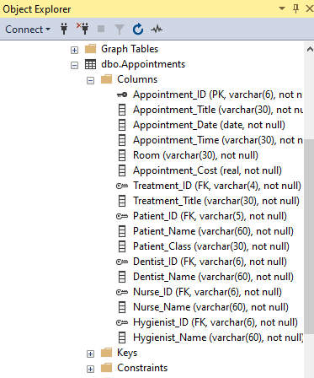

Records
Once the tables are successfully created, the records can be created next in SQL Server Management.
The first step is to create new query.

The second step will be to input the specific SQL code in the query to connect to the database in SQL Server Management.

/* Connects to the Database*/
USE The_Smile_Factory
GO
The third step will be to input the specific SQL code in the query to create the records within the database in SQL Server Management.

/* Insert Data INTO Patients Table */
INSERT INTO Patients (Patient_ID, Forenames, Surname, Age, Address_, City, Post_Code, Tel_No, DOB, Class, NHS_No) VALUES ('ID001', 'Zaeem', 'Gul', '20', '1 New Road', 'Swansea', 'SA4 3AB', '07772 558660', '2000-09-26', 'Private', 'PRIV01')

INSERT INTO Patients (Patient_ID, Forenames, Surname, Age, Address_, City, Post_Code, Tel_No, DOB, Class, NHS_No) VALUES ('ID002', 'Corey', 'Wheeler', '21', '70 Boat Lane', 'Carmarthen', 'SA14 1LE', '07013 396835', '1999-03-07', 'Private', 'PRIV02')

GO

/* Insert Data INTO Dentists Table */
INSERT INTO Dentists (Dentist_ID, Forenames, Surname, Address_, City, Post_Code, Tel_No, DOB, Dentist_Speciallism) VALUES ('DEN001', 'Leah', 'Burrows', '56 West Lane', 'Swansea', 'SA2 5BC', '07858 469561', '1983-05-02', 'Endodontist')

INSERT INTO Dentists (Dentist_ID, Forenames, Surname, Address_, City, Post_Code, Tel_No, DOB, Dentist_Speciallism) VALUES ('DEN002', 'Sophia', 'Gordon', '7 Newton Road', 'Mumbles', 'SA3 6PW', '07080 032656', '1996-09-08', 'Orthodontist')
GO

To view the SQL code to create records in-depth, please view “Smile Factory File 2.sql” file.

The fourth step is to the execute the SQL code in the query.

The final step is to refresh the Object Explorer, type the specific SQL code and check if the records has been created.

USE The_Smile_Factory

SELECT * FROM [Insert Table Name]
GO
For Example,

USE The_Smile_Factory

SELECT * FROM Patients
GO

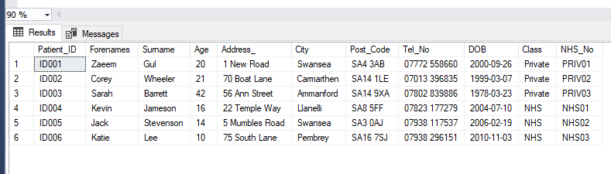

With these steps mentioned above, the records have been successfully created within the database.
Also, the data that was used to help create the records was a website called https://www.fakenamegenerator.com/ and another website called https://credit-card-generator.datagemba.com/. These websites will generate random, fake data ready to be used.
As there some check constraints in the tables within the database, below will be an image to show how the check constraints can be tested using the specific SQL code.

Wrong Code:

/* Insert Data INTO Patients Table */
INSERT INTO Patients (Patient_ID, Forenames, Surname, Age, Address_, City, Post_Code, Tel_No, DOB, Class, NHS_No) VALUES ('ID0000000000000001', 'Zaeem', 'Gul', '20000000000', '1 New Road', 'Swansea', 'SA44444445 3ABBBBBBBBA', '044 017772 558660', '2000-09-26', 'Private', 'PRIV01')

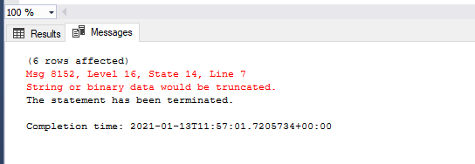
Result:

Correct Code:

/* Insert Data INTO Patients Table */
INSERT INTO Patients (Patient_ID, Forenames, Surname, Age, Address_, City, Post_Code, Tel_No, DOB, Class, NHS_No) VALUES ('ID001', 'Zaeem', 'Gul', '20', '1 New Road', 'Swansea', 'SA4 3AB', '07772 558660', '2000-09-26', 'Private', 'PRIV01')

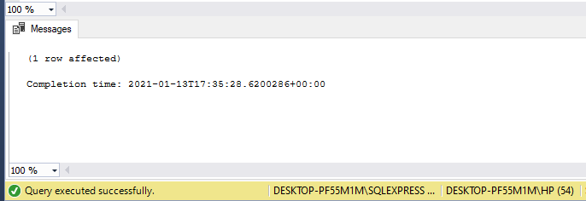
Result:

This shows how the check constraints will operate within the database and how it can prevent records being created if incorrect data has been inputted.

Performance Turing (Indexes)
Once the records are successfully created, the indexes can be created next in SQL Server Management.
Indexes enable data collection queries to speed up and will be a key element of SQL Server's high performance. [2]
Secondary Indexes are functions that are used in SQL Server Management as they operate as advanced filtering. These functions are used when the user is looking for a specific data or column in the table without looking throughout the whole table.
When a table is created in SQL Server Management, the database will automatically create a clustered index to every single Primary Key within the database.
The data pages are manually sorted by clustered indexes using a column or columns that is piece of the clustered table. It is possible to construct a clustered index in one or more columns, and the user can only have one clustered index per table. [2]
The columns that can contain an index in the database would be:
- City in Patients Table
- Class in Patients Table
- Age in Patients Table (Unique Index)
- Dentist Speciallism in Dentists Table
- Appointment Date in Appointments Table
- Appointment Time in Appointments Table
These specific columns are chosen to become indexes because it can be easier for users to look for specific data quickly. For example, if the reception staff want to look for patients that are NHS first then Private after, they can use an index function for this solution to look for the data in an organised design.
Another example will be if the reception staff want to view all the appointments dates or times from ascending to descending order, they can use an index function for this solution to look for the data in an organised design. This index is very important because it can help out staff when booking more appointments for new patients.

The first step is to create new query.

The second step will be to input the specific SQL code in the query to connect to the database in SQL Server Management.

/* Connects to the Database*/
USE The_Smile_Factory
GO

The third step will be to input the specific SQL code in the query to create the indexes within the database in SQL Server Management.

/* Creates an Index on the Patients Table and on the City Column */
CREATE INDEX idx1_patients_city
ON Patients(City);

GO
Or
To create a Unique index
/* Creates an Unique Index on the Patients Table and on the Age Column */
CREATE UNIQUE INDEX idx3_patients_age
ON Patients(Age DESC);

GO

To view the SQL code to create indexes in-depth, please view “Smile Factory File 1.sql” file.

The fourth step is to the execute the SQL code in the query.

The final step is to refresh the Object Explorer and check if the indexes has been created.
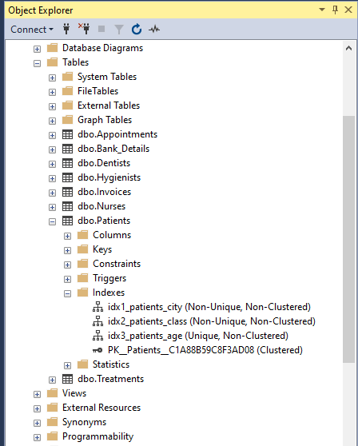

The indexes listed above were added to the database as they will improve the performance of data queries included in the database.
With these steps mentioned above, the indexes have been successfully created within the database.

Transactions
Once the records and indexes are successfully created, the transactions can be created next in SQL Server Management.
Transactions are functions that are used in SQL Server Management as they operate insert a record or update a table within the database. The key feature within the transactions feature would be a rollback function as this will validate the inputted data to process if its correct or incorrect. If the inputted data is correct, it would update the database with a new or a modified record. If the inputted is incorrect, it will revert back to the original data and it would not update the database with a new or a modified record. This will prevent the database from being damaged or broken.
This can be done by hand, including a user query of a UPDATE statement in SQL Server Management Studio or a program that INSERTS data in a database. [3]

The first step is to create new query.

The second step will be to input the specific SQL code in the query to connect to the database in SQL Server Management.

/* Connects to the Database*/
USE The_Smile_Factory
GO

The third step will be to input the specific SQL code in the query to create the transactions within the database in SQL Server Management.

/* Create Transactions to Insert Records on the Dentists Table */
BEGIN TRANSACTION AddNewDentist
BEGIN TRY

/* Add New Dentist 1 */
INSERT INTO Dentists (Dentist_ID, Forenames, Surname, Address_, City, Post_Code, Tel_No, DOB, Dentist_Speciallism) VALUES ('DEN004', 'George', 'Jarvis', '27 Gate Road', 'Swansea', 'SA3 7OP', '07031 736293', '1981-03-09', 'Prosthodontist')

COMMIT TRANSACTION;
END TRY
BEGIN CATCH
-- A Error Has Occurred, Rollback To Old Data
ROLLBACK TRANSACTION;
PRINT ('A Error Has Occurred, Rollback To Old Data');
THROW --Throw the error which has triggered, This will stop the transaction command and will not add new record to the specific table
END CATCH;

To view the SQL code to create transactions in-depth, please view “Smile Factory File 2.sql” file.

(This SQL code would not work because there is already a Dentist ID = DEN004 created before so it would rollback to the original data and would not add the new record.)

The fourth step is to the execute the SQL code in the query.

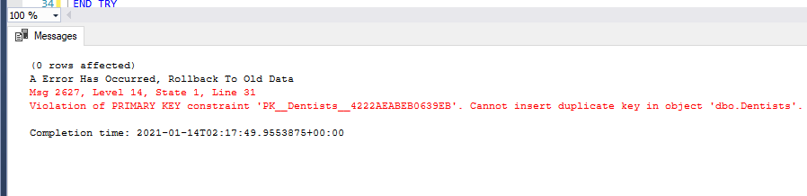
Result:

Correct Code:

/* Create Transactions to Insert Records on the Dentists Table - Correct Code */
BEGIN TRANSACTION AddNewDentist
BEGIN TRY

/* Add New Dentist 1 */
INSERT INTO Dentists (Dentist_ID, Forenames, Surname, Address_, City, Post_Code, Tel_No, DOB, Dentist_Speciallism) VALUES ('DEN005', 'George', 'Jarvis', '27 Gate Road', 'Swansea', 'SA3 7OP', '07031 736293', '1981-03-09', 'Prosthodontist')

COMMIT TRANSACTION;
END TRY
BEGIN CATCH
-- A Error Has Occurred, Rollback To Old Data
ROLLBACK TRANSACTION;
PRINT ('A Error Has Occurred, Rollback To Old Data');
THROW --Throw the error which has triggered, This will stop the transaction command and will not add new record to the specific table
END CATCH;

The final step is to refresh the Object Explorer, type the specific SQL code and check if the records has been created.

USE The_Smile_Factory

SELECT * FROM [Insert Table Name]
GO
For Example,

USE The_Smile_Factory

SELECT * FROM Dentists
GO

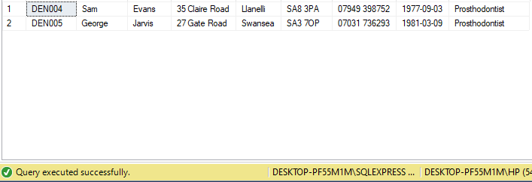

Another Example of creating a transaction.
The first step will be to input the specific SQL code in the query to create the transaction within the database in SQL Server Management.

/* Create Transactions to Insert Records on the Bank_Details Table */
BEGIN TRANSACTION AddNewBank_Detail

/* Add New Bank_Detail 1 */
INSERT INTO Bank_Details (User_ID_, Patient_ID, Patient_Name, Appointment_ID, Appointment_Title, Appointment_Date, Appointment_Time, Card_Holder, Card_No, CVS_No, Appointment_Cost, Payment_Date, Payment_Time) VALUES ('USER001', 'ID001', 'Zaeem Gul', 'APP001', 'Filling - Zaeem Gul', '2020-01-11', '9:00AM', 'MR ZAEEM GUL', '4721 4872 1602 4140', '855', '£20.00', '2020-01-11', '10:15AM')

COMMIT TRANSACTION AddNewBank_Detail

To view the SQL code to create transactions in-depth, please view “Smile Factory File 2.sql” file.

The next step is to the execute the SQL code in the query.

The final step is to refresh the Object Explorer, type the specific SQL code and check if the records has been created.

USE The_Smile_Factory

SELECT * FROM [Insert Table Name]
GO
For Example,

USE The_Smile_Factory

SELECT * FROM Bank_Details
GO

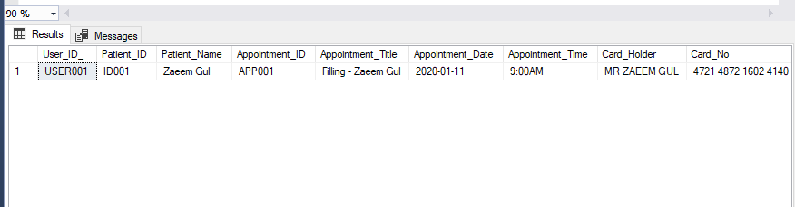

This transaction has been created without using the rollback function.

Below will be a transaction that will update the bank details for the patient after they have paid for their appointment.
The first step will be to input the specific SQL code in the query to create the transaction within the database in SQL Server Management.

/* Create Transactions to Check or Update Records on the Bank_Details Table */
DECLARE @CardDetailsCorrect AS BIT

-- Update Bank Detail 1
BEGIN TRANSACTION Bank_Detail_No_1
UPDATE Bank_Details
SET Card_No = '0000 0000 0000 0000'
WHERE User_ID_ = 'USER001'
SET @CardDetailsCorrect = 'false'
-- Equivalent to:- If Bank Card Correct (logic) is true --
IF @CardDetailsCorrect = 'true'
COMMIT TRANSACTION Bank_Detail_No_1
ELSE
ROLLBACK TRANSACTION Bank_Detail_No_1

The next step is to the execute the SQL code in the query.

The final step is to refresh the Object Explorer, type the specific SQL code and check if the records has been created.

USE The_Smile_Factory

SELECT * FROM [Insert Table Name]
GO
For Example,

USE The_Smile_Factory

SELECT * FROM Bank_Details
GO
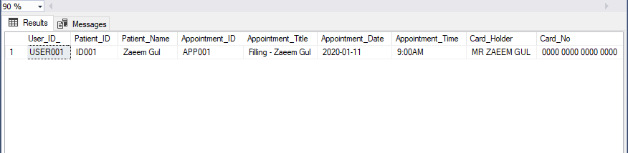

This specific transaction has showed that the patient card number will be updated back to 0000 0000 0000 0000 instead of storing the existing card number within the database. This can prevent hackers going in the database and stealing the patient card details.

With these steps mentioned above, the transactions have been successfully created within the database.
Conclusion
Overall, this assignment has showed how to create a basic database with advanced features such as indexes and transactions using the language called SQL and the program called Microsoft SQL Server Management Studio. The database will allow staff users to add new tables and records or update the tables and records by using INSERT or UPDATE commands. This has also showed that the ability to create multiple SQL features has been gained which has improved skills of creativity and adaptability towards a website development environment. The most important element of this assignment would be understanding how to design a database, how to create a database and how to use a database.

References

References

[1] | E. Erkec, "Overview of Microsoft SQL Server Management Studio (SSMS)," 27 January 2020. [Online]. Available: https://www.sqlshack.com/overview-of-microsoft-sql-server-management-studio-ssms/. [Accessed 12 January 2021].
[2] | J. Viswanathan, "Creating Indexes with SQL Server Management Studio," 20 August 2018. [Online]. Available: https://www.mssqltips.com/sqlservertip/5573/creating-indexes-with-sql-server-management-studio/. [Accessed 1 January 2021].
[3] | B. Upton, "What is a transaction?," 25 March 2014. [Online]. Available: https://www.mssqltips.com/sqlservertutorial/3304/what-is-a-transaction/. [Accessed 18 January 2021].
[4] | M. Raza, "DBMS: An Intro to Database Management Systems," 29 August 2018. [Online]. Available: https://www.bmc.com/blogs/dbms-database-management-systems/. [Accessed 12 January 2021].
[5] | R. Patil, "SQL Server Management Studio," 20 April 2020. [Online]. Available: https://medium.com/@rohitpatil97/sql-server-management-studio-5b3633e0a9c3. [Accessed 12 January 2021].
[6] | VADIM.MIKHAILENKO, "How to Draw Basic Diagram in Microsoft Visio," 17 June 2015. [Online]. Available: https://www.howtoanalyzedata.net/tutorial-how-to-build-basic-diagram-in-microsoft-visio-2013/. [Accessed 12 January 2021].

