University Of Wales Trinity Saint David

BA Business and Management

Module Name: LCBB4005 The global business environment
Title: Environmental analysis of an industry

Lecturer: Dr. Nadeem Mirza
Student name: Cerasela Stoica
Student Id: 2125057

Submission date: 11/05/2022

Table of Contents
Introduction 2
Critical Analysis of the Impact of Covid-19 Pandemic on Automobile Industry 2
Consideration of Megatrends 5
Development of Success and Survival Factors for Automobile Industry 7
Conclusion 8
List of References 10

Introduction
Over the last couple of years, the Covid-19 pandemic has brought in a significant swift as well as stark influence on the globally integrated automobile industry. As opined by Vitale (2020), indications include a strategic disruption in exportation of Chinese parts, interruptions in large-scale manufacturing all over Europe and the shutting down of assembly plants in US. This has in turn posed extreme pressure on automobile industry, which is already trying to cope up with downshift in worldwide demand and prospectively led to upsurge in merger and acquisition activity. In this report, the potential long-term influence scenarios on automobile companies have been critically analysed. Extending further, the upcoming megatrends in the concerned industry have been identified and thoroughly reviewed. In addition, practical next steps to be taken up by companies for preserving business continuity through development of strategic survival and success factors has been portrayed for the overall automobile industry.

Critical Analysis of the Impact of Covid-19 Pandemic on Automobile Industry
Considering the scenario in US, closure of assembly plans are accumulatively contributing to intensification of pressure on incessantly distressed global supply base in which automobile brands are pushed to high risk of being defaulted on covenants so which potentially requiring banks to actively step in. Exogenous shock of Covid-19 pandemic has pointedly exacerbated already existing downshift in international demand which already or in near future would most appreciably led to upsurge in merger and acquisition activities as opportunities for sector consolidation arise for private equity players. As discussed by Kim (2020), automobile industry has been hit hard by the adversaries of Covid-19 pandemic as the new car sales, which was expected to decline by around 80%. Meanwhile, stock values for online car sales services, that include Copart, Carvana and CarMax, have significantly escalated, where shareholder value for Carvana has almost doubled since date of the WHO announcement of Covid-19 pandemic.
These are extremely challenging times for automobile industry, which is one of the most authoritative drivers of global economy with employments for numerous people across the world. According to Ha and Woo (2022), with huge number of other industries, like logistics and steel that are dependent on automotive industry, the go-slow in vehicle sales because of Covid-19 has created a ripple effect. Even after reopening of businesses, social distancing has sustained; hence, automakers need to adapt with innovative ways of working. Although, as discussed by Moosavi and Hosseini (2021), automobile industry witnessed tremendous resilience from economic depths experienced in 2020 and rebounded to deliver year-on-year growth in new auto sales across US, China and Europe. Nevertheless, as argued by Collie et al. (2020), in spite of such encouraging report, numerous risks endure and sales forecasted in US and Europe will not rebound to pre-Covid-19 pandemic era until 2023 at earliest.
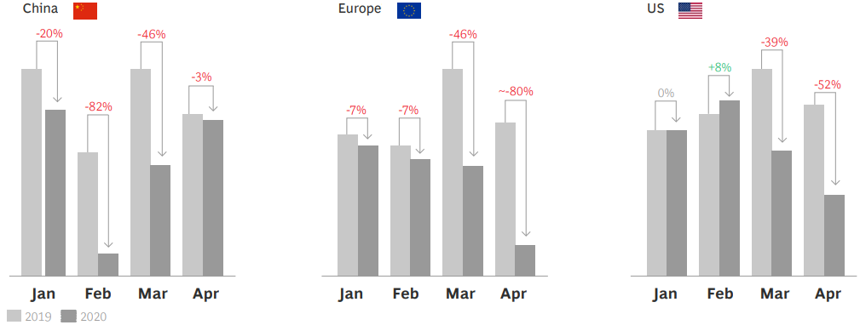
Figure 1: Vehicle Sales’ Recovery
(Source: Collie et al., 2020)
In the automobile industry, Foreign Direct Investment (FDI) has amplified in developed economies like EU and US for strategic purposes for overcoming trade regulations as well as trade pressures, to lessen disagreements among countries and to maintain the local market. However, as per Ha and Woo (2022), because of adversarial impact of Covid-19 pandemic, the emphasis of supply chain management (SCM) in car manufacturing brands is ostensibly shifting from effectiveness to gain resilience. The economic forecasting seemed to deteriorate all over the world for 2020 yet remained stable in 2021.
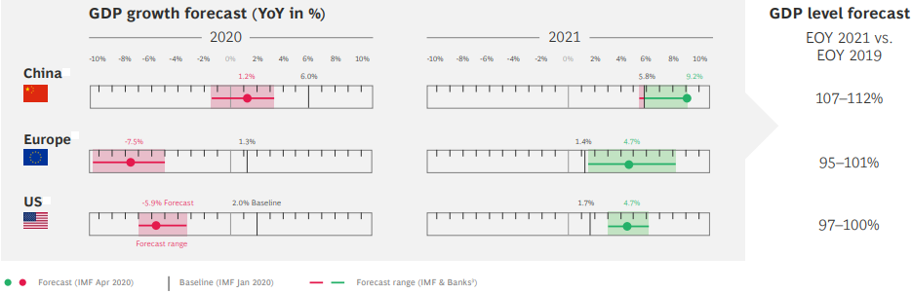
Figure 2: Economic Recovery Level
(Source: Collie et al., 2020)
Absence of low-cost component in the auto manufacturing workstations stopped production line which eventually outcome in profit loss as well as customer dissatisfaction (Chirra and Kumar, 2018). Automobile exportation of China plunged to record financial low of 80% because of decreased market demand (Segal and Gerstel, 2020). Disruption in automobile part exports of China outcome in large-scale vehicle production disruption all over Europe and assembly plant closure in US. Covid-19 mainly affected auto industry as hotel business, transportation and tourism came to stoppage due to lockdown (Raj and Kumar, 2021). People started avoiding unnecessary travel to crowded places for staying safe. With the rising Covid-19 cases and an upsurge in quarantine measures, overall demand has declined across North America and Europe. Sales in Western Europe dropped by around 15% in 2020, whereas sales in USA declined by approximately 15% and in China sales wilted by more than 10% (accenture.com, 2020). Evidently, lockdown progressively affected lifestyle of people and forced to adopt simplest standard of living.
Auto shows has been such a platform for effective launching of new automobile vehicles, debate and even proposal of innovative technologies in order to create and attract interest of automobile lovers. Due to adverse effects of Covid-19 pandemic, numerous auto shows were cancelled or postponed for indefinite time because of which launching of latest automobiles has been suspended and hence resulted in further delay of expected investments (oica.net, 2022). Motor shows that are hosted in New York, Detroit, Geneva, Paris and other places have been annulled, Bangkok International Auto Show (2020) rescheduled to be held later on (Levin, 2020), Brussels Motor Show that was about to be held in 2021 has been Postponed to 2022.
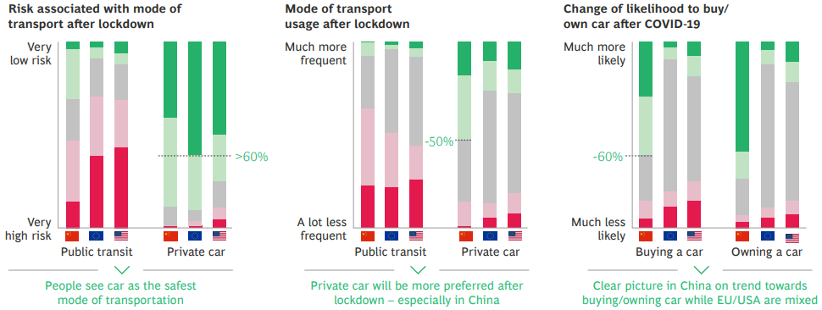
Figure 3: Future Economic Return in UK, US and China
(Source: Collie et al., 2020)
While talking about long-term impact on automobile companies a persistent truncation of customer demand as nations engaged in working through various lockdown restrictions significantly sparked global recession (Rahman, 2021). Covid-19 pandemic has caused in extensive loss of purchasers’ confidence that conspicuously affected profitability and revenue generation of automakers. Strategic choices of exiting from unprofitable international marketplaces as well as vehicle segments might be fast-tracked for considerably lowering output, as production capacity is consolidated or rationalised (Hojdik, 2021). Suppliers confronted with liquidity problems might succumb to rapid deterioration of market conditions, which in turn could cause extensive disruption as well as potentially catastrophic consequences in entire global auto manufacturing ecosystem. According to Tardivo, Zanuy and Martín (2021), automakers can be driven to diversify their capital investment for shoring up continuous production operations, starving R&D financing for taking initiatives in advanced technology and other flexible projects. A substantial amount of restructuring might be likely in auto retailing sector for the reason that dealers are unable of quickly pivoting dynamisms in demand conditions.

Development of Success and Survival Factors for Automobile Industry
The practical next steps in automobile industry must be focused on sustainability and eco-friendliness. Following Covid-19 pandemic era, the automakers must go for collaboration of operations whereby identify, accelerate and prioritise cost effective measures. Essentially the working capital must be optimised, and strategic measures must be identified for delivering tangible and rapid cash flow benefits. As opined by Vitale (2020), forecasting assumptions must essentially be revised and downside scenarios must be given priority based on present level of market uncertainty. In addition, in the post-Covid-19 pandemic era automakers must identify potential sources of collateral for securing accessibility to excess borrowing solutions based on which active scenario planning must be suggested for which liquidity will no longer be an issue for the suppliers in automobile industry. The automakers must be extensively focused on care as well as safety of employees for which a potential recovery would be necessary for engaging workforce.
The automakers must drive focus on designing enhancements wherein technical upgrades would impart an important role to increase automobile sales. In the post-Covid-19 pandemic era, for coping up with the economic downturn that sincerely affected purchasing intention of customers, affordability must essentially be prioritised in regard to costing involved for purchasing, maintenance and running vehicles. The essential factors that can undoubtedly ensure survival of automakers by providing potential breakthrough are cost competitiveness, product aesthetics, light weighting and safety (Gajendragadkar, 2020). To thrive successfully, automakers ensure safety features for pedestrians as well as passengers at a much more competitive price point.
In the post-Covid-19 pandemic period, for deliverance of product agility as well as excellence, automobile companies must be staying much attentive towards Quality Management System (QMS) and Application Lifecycle Management (ALM) (Banjanin, 2019). Strategic incorporation of engineering tools and capabilities are proven to drive best product development outcomes. Could technology should be prioritised for reducing barriers in between QMS and ALM solutions and hence provide benefits in multiple dimensions which includes agility, flexibility and affordability.

Consideration of Megatrends
Digitalisation and connectivity are prominently redefining the strategies by which automakers are moulding in the new age. With the increasing prioritisation of Internet-of-Things, the auto industry is progressively becoming more complicated and stressing on development of symbiotic relationships. In precise, post-Covid-19 pandemic era characterised auto industry with digitalisation, connectivity and dynamic customer demands which is an outcome of social changes and urbanisation (Wibbing, 2018). On regards to sustainability, transition to electric motors is gaining prominence.
Digitalization– Network of Connected Vehicles: Just as automobile industry changed entire world during pre-Covid-19 pandemic era, digitalization is further transforming all features of customers’ lives. With the advent of Covid-19 pandemic era by 2020, over half of all public would prefer living on digitally connected in addition to the reality that almost 20 billion devices would become connected. As described by Dolgui and Ivanov (2022), strategic integration of 5G in digital supply chain networks and operations management would bring in significant impact on complexity of systems and would empower mobile phone providers and retailers to become a significant portion of the automobile ecosystem. However, this would foster flexibility real-time visibility and end-to-end connectivity via internet-of-everything.
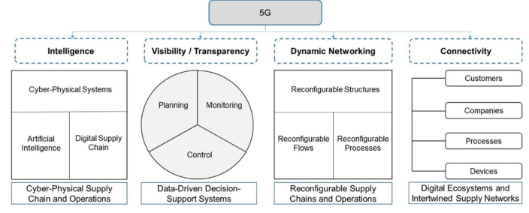
Figure 4: Competences of Digital Supply Chain and Smart Operations Using 5G
(Source: Sjoberg, 2020)
Connectivity– Completely Autonomous Driving as the Developmental Goal: Autonomous driving as well as artificial intelligence are considered as two indispensable facets of present megatrend connectivity. A major developmental goal seems to be fully autonomous driving, which necessitates innovative technologies such as machine learning of being introduced into the automobile industry. MIQ performance dashboard is the performance management solution, which enables global connectivity in business units to provide one view for RDCs, warehouses and plants from anywhere. The increasing usage of actuators and sensors provides, on the one, additional functionality as well as hand comfort for car purchasers (Sjoberg, 2020). All of such features should be addressed and anticipated during development starting from rudimentary interoperability up to functional security in networked systems in vehicles as well as interactive systems (Desai, 2020).
Urbanization– Emergence of Megacities: More number of people prefers to live in cities rather than in rural areas worldwide. This is actually bringing in a significant effect on the automobile companies business models for tomorrow. Numerous European cities are engaged in working on mobility concepts deprived of vehicles. Such innovative trend will necessarily be reinforced with the sharing of economy as well as mobility-on-demand resolutions (Pal et al., 2021). According to Canton et al. (2021), due to Covid-19 crisis, the digital transition could have secondary negative effects for instance production growth is negatively affected by minimised agglomeration effects because of de-urbanisation and teleworking. Hence, the automobile industry should be discovering innovative services as well as business models for revenue generation, which would also be desired in cities of future that in turn would be supplementing all existing vehicle ownership models.
Social Dynamics- Smartphone Generation: Strategic modifications in value systems are prominently making significant effect on business models of automakers for near future. As described by Wibbing (2018), for the smartphone generation, vehicles are no longer considered as a status symbol in the society for which people are negligibly interested in the way they reach their destination. This is no more essential for essentially owning a vehicle intending to be mobile. The megatrend during the post-Covid-19 pandemic phase, regarding to employment, the market is such that automation technology, potential de-urbanisation and teleworking has skewed labour markets to high-wage and high-skilled employment.
Sustainability– Acceleration in Technological Changes: Combustion engines are significantly losing societal acceptance specifically for the reason of particulate emissions (Xiarewana and Civelek, 2020). In present time, automobiles are progressively being prioritised as the foundation of global warming. As per Kirschner and Lanzendorf (2020), discussions of driving sanctions in German city centres have significantly accelerated such developments. The automotive industry is experiencing a paradigm change as it makes the transition to electric motors. These require completely different vehicle architectures and charging infrastructures. In this regards for bringing in changes in global value chain, incentives for reinforcing EU crucial manufacturing segments for sustainability and resilience has been ensured besides boosting circular economy and lean manufacturing for green economy. Simultaneously, a significant organizational change is occurring in order to guarantee the competencies, processes and methods for future development.
Platforms– Disruption in Markets and Business Models: Digitalization has been significantly driving change in automakers’ business models in terms of platform based and multi-faceted business models, which are evidently increasing (Butt, 2021). These are focused on extensive collection as well as exchange of information from which automakers can offer personalized as well as customer-oriented services.

Conclusion
While drawing the inferences, this is worth mentioning that automobile industry is the leading shareholder in national economy. From the aforementioned discussions, this has been revealed that following Covid-19 pandemic situation automakers are really facing a hard time to bounce back. However, for overcoming such critical situation, automakers must take effective initiative for increasing car sales by reducing prices or providing extra feature offerings. This might upsurge sales and make brand survive successfully ever after.

List of References
accenture.com, 2020. [online] Accenture.com. Available at: <https://www.accenture.com/_acnmedia/PDF-121/Accenture-Covid-19-Impact-Automotive-Industry.pdf> [Accessed 11 May 2022].
Banjanin, G. (2019). Methodological Framework of Improving the Governance of Project Portfolios by Agile and Lean Methods (Doctoral dissertation, University of Zagreb. Faculty of Organization and Informatics).
Butt, A.S. (2021). Strategies to mitigate the impact of COVID-19 on supply chain disruptions: a multiple case analysis of buyers and distributors. The international journal of logistics management.
Canton, E., Colasanti, F., Durán, J., Garrone, M., Hobza, A., Simons, W. and Vandeplas, A. (2021). [online] Ec.europa.eu. Available at: <https://ec.europa.eu/info/system/files/economy-finance/eb069_en.pdf> [Accessed 11 May 2022].
Chirra, S. and Kumar, D. (2018). Evaluation of supply chain flexibility in automobile industry with fuzzy DEMATEL approach. Global Journal of Flexible Systems Management, 19(4), pp.305-319.
Collie, B., Wachtmeister, A., Waas, A., Kirn, R., Krebs, K. and Quresh, H. (2020). COVID-19’s Impact on the Automotive Industry. [online] BCG Global. Available at: <https://www.bcg.com/publications/2020/covid-automotive-industry-forecasting-scenarios> [Accessed 19 March 2022].
Desai, N. (2020). Impact of COVID-19 on New Vehicle Technology Uptake. Urban Transportation and how its Future will be affected by COVID-19, p.45.
Dolgui, A. and Ivanov, D. (2022). 5G in digital supply chain and operations management: fostering flexibility, end-to-end connectivity, and real-time visibility through internet-of-everything. International Journal of Production Research, 60(2), pp.442-451.
Gajendragadkar, P. (2020). Growth of the Key Factors in the Indian Automotive industry : Light-weighting, Cost Competitiveness, Safety and Aesthetics. [online] Linkedin.com. Available at: <https://www.linkedin.com/pulse/growth-key-factors-indian-automotive-industry-cost-gajendragadkar> [Accessed 19 March 2022].
Ha, Y.K. and Woo, S.H. (2022). Transportation Infrastructure or Economic Power? Development of the Automobile Industry in the United States. Sustainability, 14(3), p.1649.
Hojdik, V. (2021). Current challenges of globalization in the automotive industry in European countries. In SHS Web of Conferences (Vol. 92). EDP Sciences.
Kim, R.Y. (2020). The impact of COVID-19 on consumers: Preparing for digital sales. IEEE Engineering Management Review, 48(3), pp.212-218.
Kirschner, F. and Lanzendorf, M. (2020). Parking management for promoting sustainable transport in urban neighbourhoods. A review of existing policies and challenges from a German perspective. Transport Reviews, 40(1), pp.54-75.
Levin, T. (2020). Bangkok is hosting the first major auto show since the COVID-19 pandemic began, and it may offer a glimpse into the future of large events. [online] Business Insider. Available at: <https://www.businessinsider.in/thelife/news/bangkok-is-hosting-the-first-major-auto-show-since-the-covid-19-pandemic-began-and-it-may-offer-a-glimpse-into-the-future-of-large-events/slidelist/77008586.cms> [Accessed 19 March 2022].
Moosavi, J. and Hosseini, S. (2021). Simulation-based assessment of supply chain resilience with consideration of recovery strategies in the COVID-19 pandemic context. Computers & Industrial Engineering, 160, p.107593.
oica.net, 2022. Calendar of Auto Shows | www.oica.net. [online] Oica.net. Available at: <https://www.oica.net/category/calendar/> [Accessed 19 March 2022].
Pal, S., Dey, B., Chattopadhyay, B., Samanta, S., Roy, D.S., Roy, T.D. and Chakraborty, S. (2021), February. Recent Developments and Future Scopes of Electrical Vehicles in Power Market on Covid-19 Pandemic situation. In Journal of Physics: Conference Series (Vol. 1797, No. 1, p. 012058). IOP Publishing.
Rahman, A. (2021). IMPACT OF COVID-19 ON WORKING CAPITAL MANAGEMENT IN SELECTED FOUR-WHEELER AUTOMOBILE COMPANIES IN INDIA.
Raj, K.K. and Kumar, K.N. (2021). Impact of Covid-19 Pandemic in the Automobile Industry: A Case Study.
Segal, S. and Gerstel, D. (2020). The global economic impacts of COVID-19.
Sjoberg, K. (2020). Automotive Industry Faces Challenges [Connected and Autonomous Vehicles]. IEEE Vehicular Technology Magazine, 15(3), pp.109-112.
Tardivo, A., Carrillo Zanuy, A. and Sánchez Martín, C. (2021). COVID-19 impact on transport: A paper from the railways’ systems research perspective. Transportation Research Record, 2675(5), pp.367-378.
Vitale, J. (2020). Understanding COVID-19’s impact on the automotive sector | Deloitte Global. [online] Deloitte. Available at: <https://www2.deloitte.com/global/en/pages/about-deloitte/articles/covid-19/understanding-covid-19-s-impact-on-the-automotive-sector.html> [Accessed 19 March 2022].
Wibbing, P. (2018). Current Megatrends in the Automotive Industry. [online] Linkedin.com. Available at: <https://www.linkedin.com/pulse/current-megatrends-automotive-industry-philipp-wibbing> [Accessed 19 March 2022].
Xiarewana, B. and Civelek, M.E. (2020). Effects of covid-19 on China and the world economy: Birth pains of the post-digital ecosystem. Journal of International Trade, Logistics and Law, 6(1), pp.147-157.

