DS 1 Assessment My Digital Life

Md Mukammel Hoque

My Screenshots/Photos

Screenshot/Photo 1
UWTSD HUB App
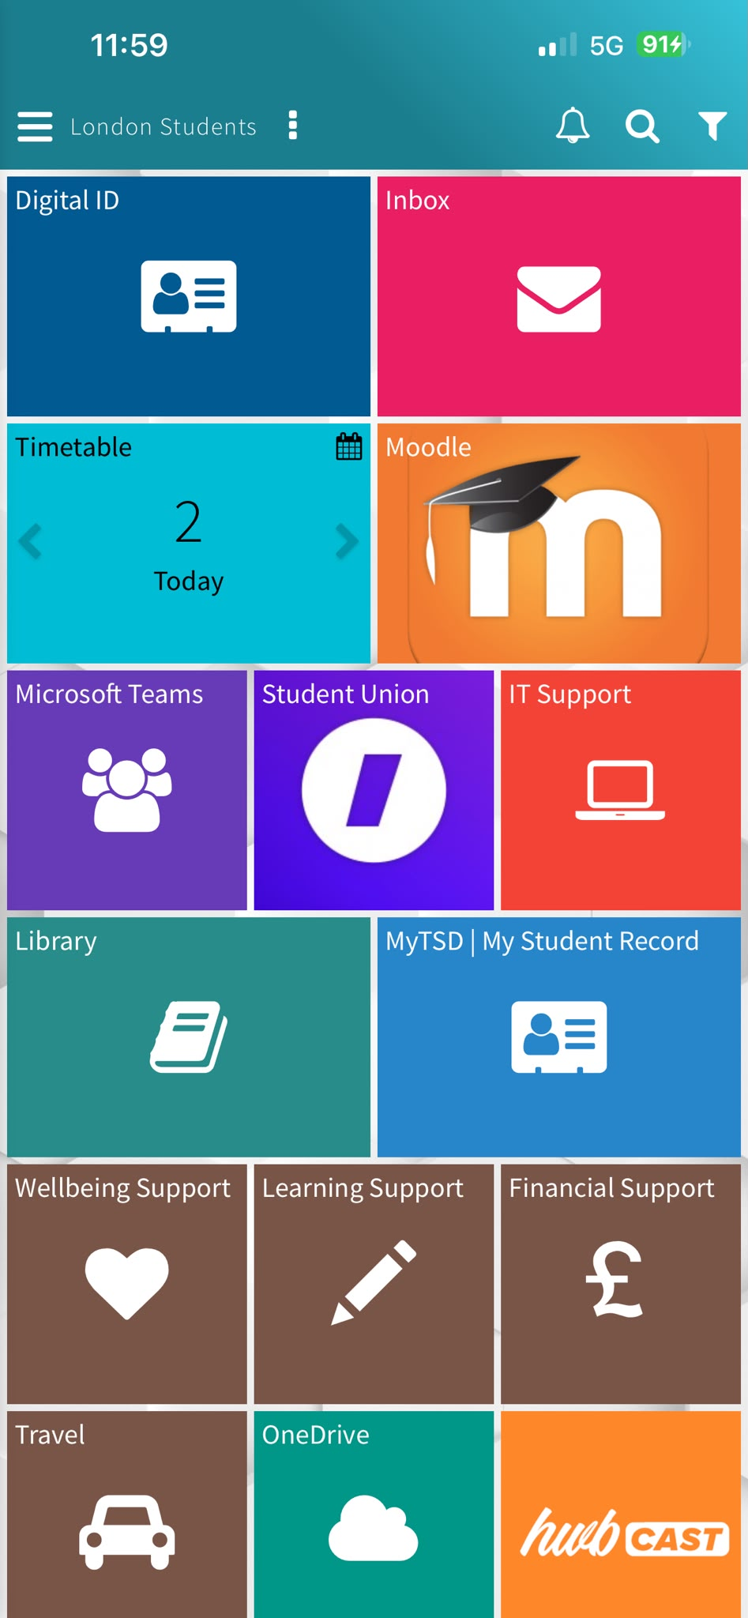
I use the London Students (UWTSD HUB) app for my studies. I use Moodle to read class materials, check assignments and submit my homework. I also use the timetable to see my classes. In this app I need to improve my skills in using library to find better resources.

Screenshot/Photo 2
WhatsApp
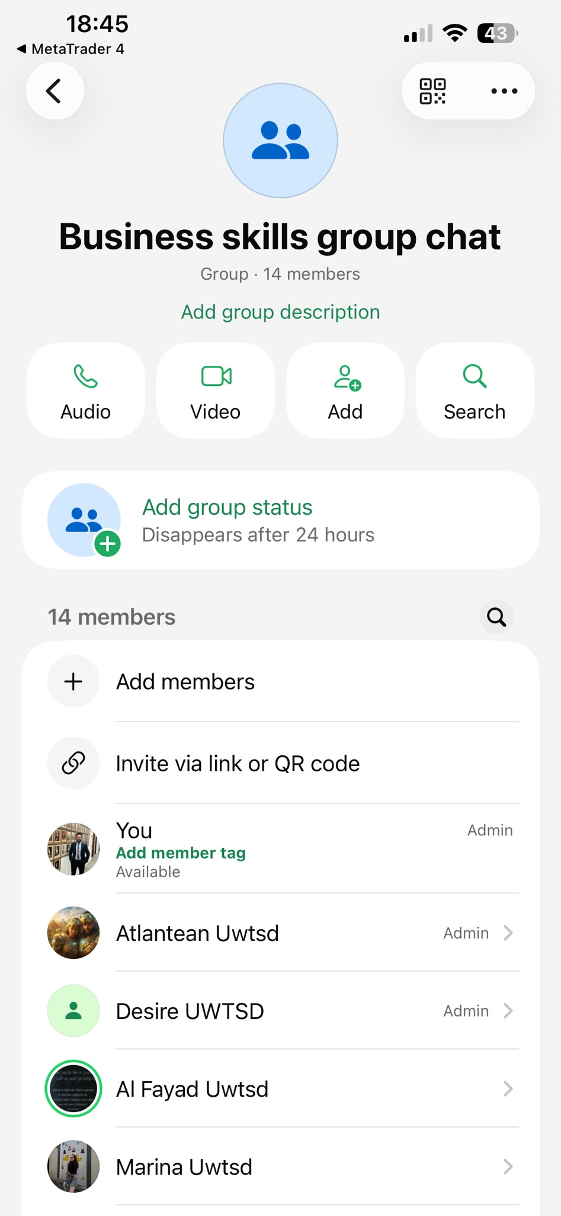
This is our WhatsApp group chat. We created it this week to stay connected and help each other with our studies. I also use WhatsApp to keep in touch with my friends and family. It’s a good digital platform to make call, chat, share photo and videos.

Screenshot/Photo 3
YouTube
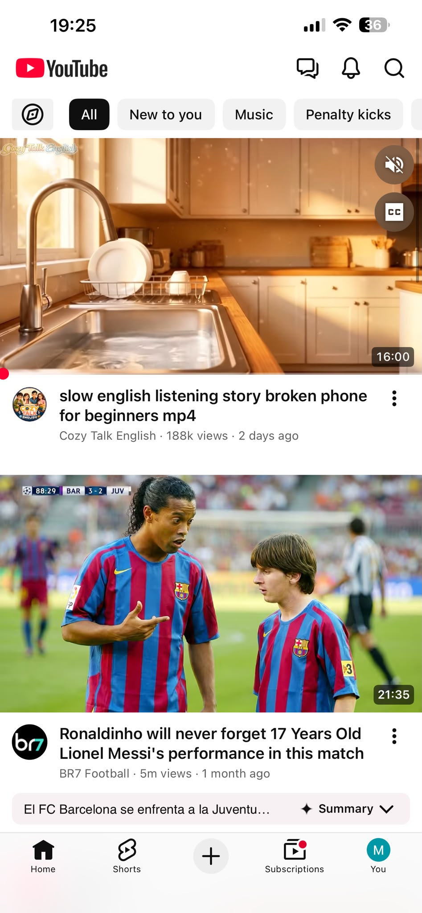
YouTube is the most popular video sharing platform where we can watch and share videos. I use it to watch movie, educational videos, football highlights and music. I also use it to learn new things.

Screenshot/Photo 4
Email
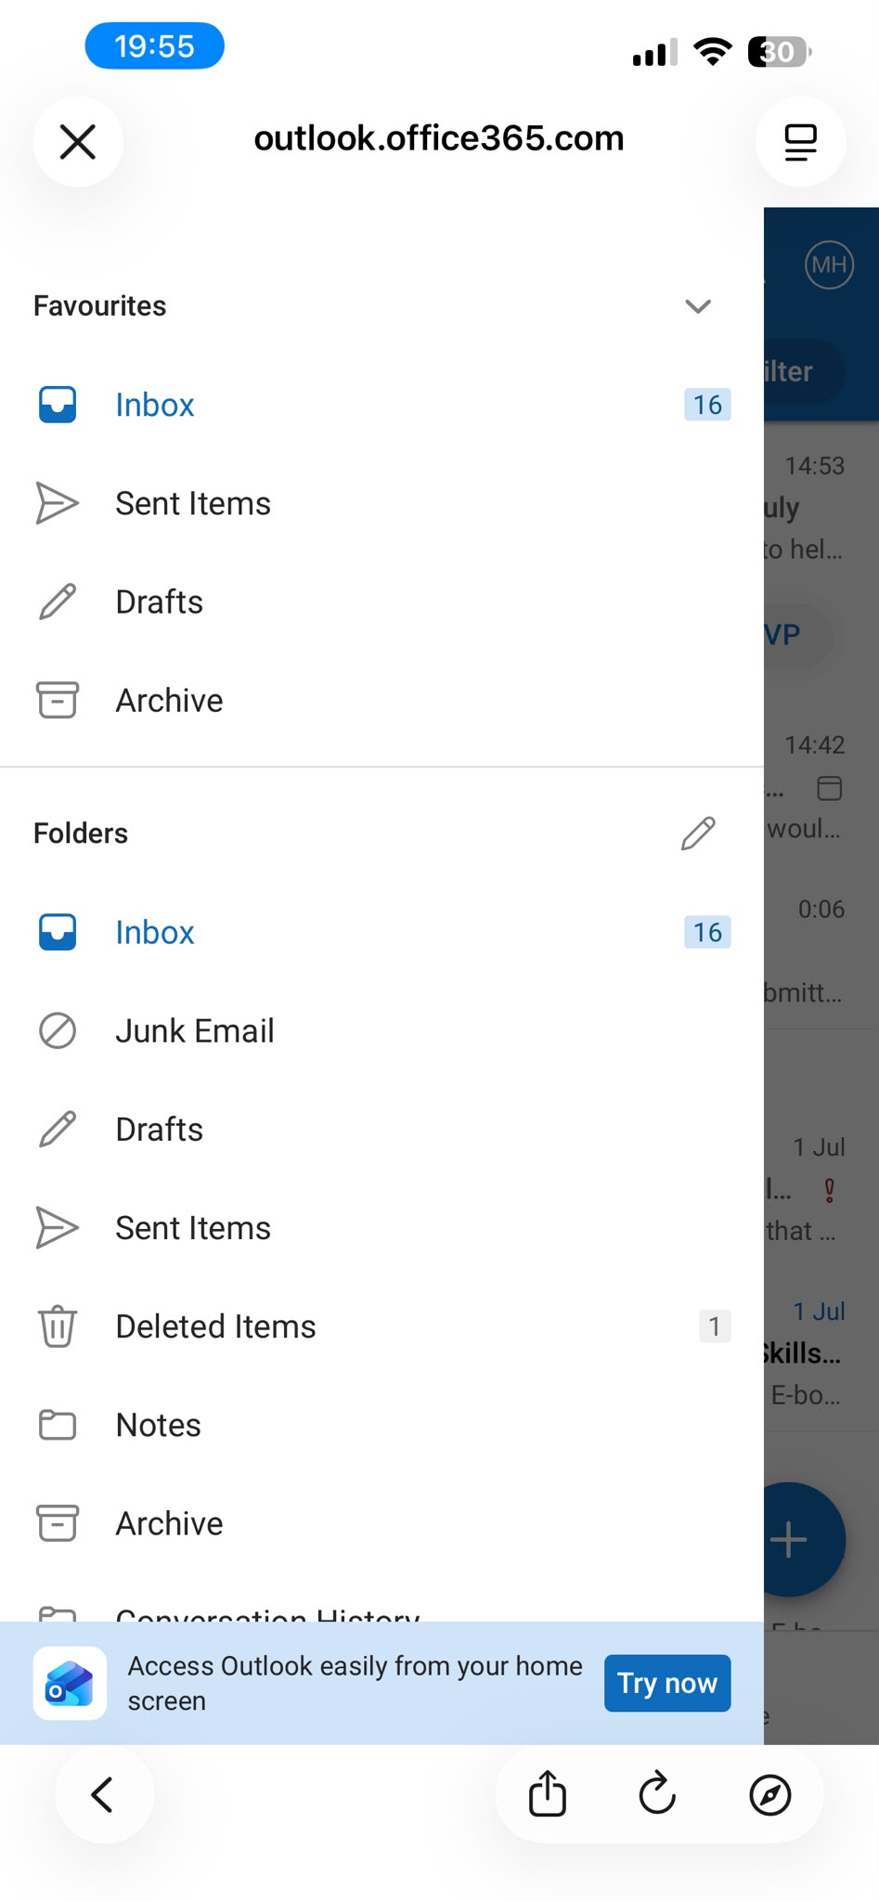
I use email every day for my work and university. I check my inbox regularly to see if my lecturer has shared any study material, updates or any message from the university. I use it to read and send emails. I’m confident using email to send messages and attachment.

Screenshot/Photo 5
Ride sharing app UBER
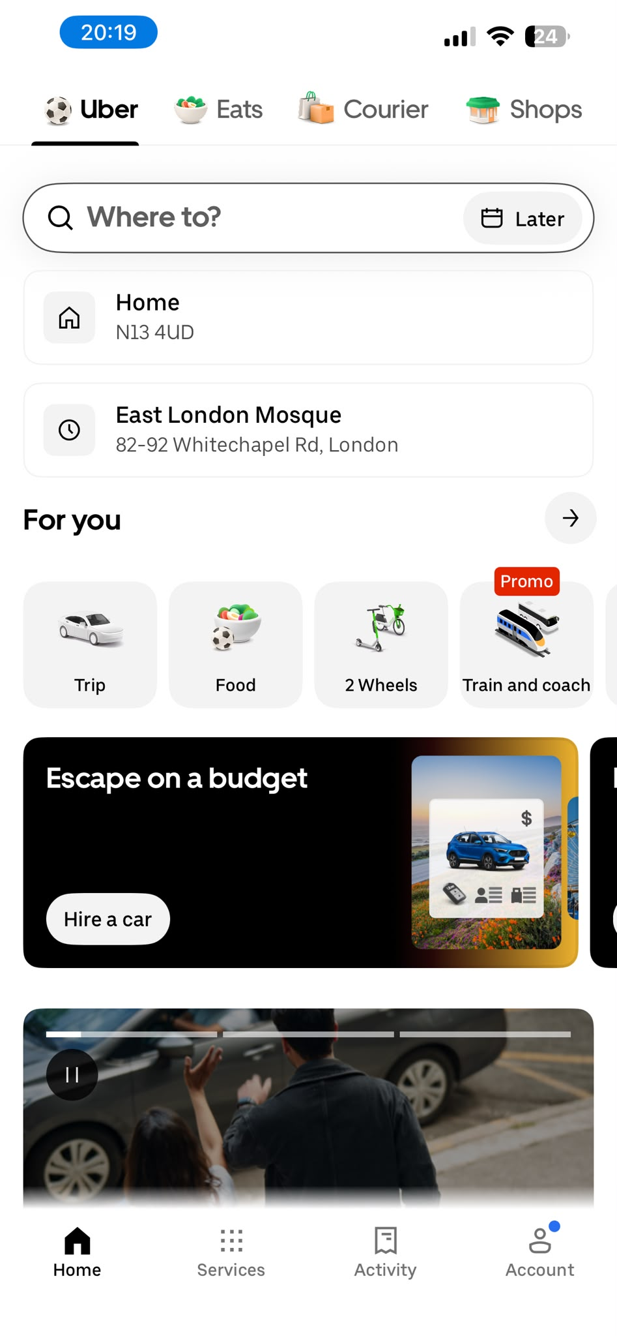
I use the ride sharing app Uber to travel from one place to another. It is very reliable, especially in emergencies. I feel confident using it to book ride.

Screenshot/Photo 6
Microsoft Word
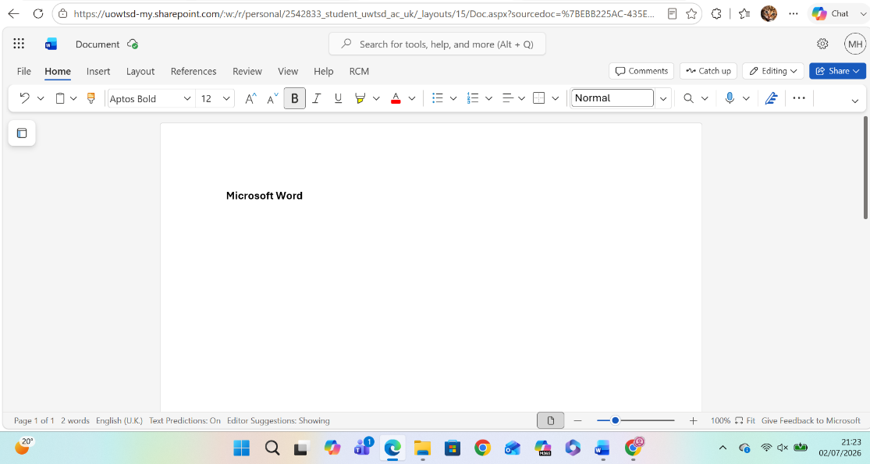
I use Microsoft Word to write my assignments and class notes. I feel confident to use it to type and edit documents.

My Short Reflection
I use digital tool everyday for my work, study and personal life. I often use outlook, UWTSD HUB, WhatsApp, YouTube, Microsoft Word, Uber app. I feel confident using these apps for communication and learning purpose. I want to improve my skills using library and finding better academic resources that will help me in future assignments. I also want to improve my typing skills it will help me save time when I do my assignments. I hope this module will help me become more confident with digital tools. Digital skills are important for me because they help me with my studies now.

Submission Checklist
Before you submit, please check:
​​​ ☒ I added 4–6 screenshots
☒ I wrote short sentences for each screenshot
☒ I wrote my short reflection
☒ My work is my own
☒ My file opens correctly
​​☒ My file opens correctly

