MODULE CODE: BMSW4002
EFFECTIVE TEAM WORKING & COMMUNICATION

Name: Ana Maria Dragnea
Student number: 1921781
Module title: EFFECTIVE TEAM WORKING & COMMUNICATION
Assignment Title: EFFECTIVE TEAM WORKING & COMMUNICATION
Module Lecturer name: Saqib Shamim

Table of Content
1.0 Introduction 3
2.0 Models of communication 3
2.1 Shannon and Weaver 3
2.2 Schramm 4
2.3 Berlo 6
3.0 Communication Skills and methods of Communication 7
3.1 Verbal 7
3.2 Non-verbal 7
3.2 Listening 8
4.0 Conclusion 9
Reference List 11
Appendices 12

1.0 Introduction
Communication is a complex and layered way of transferring vital information from the sender to the receiver. According to Andersion, communication encompasses the interaction of thoughts, information and opinions through the mediums of writings and signs. The path of human evolution has given human beings various opportunities to communicate. Yet communication is still counted as an essential skill which requires practical knowledge and understanding of various factors which are illustrated through various theories and models of communication. The integrity of modern communication mediums is imbued in both social and professional contexts. In management and operational cultures, communication is the essential lifeline and the inability to communicate shows threats to the integrity and functionality of the organization as a whole. This assessment in the form of a report will analyses these factors and will give detailed estimates on how to mitigate communication issues. The resort will take examples of various case studies and also subjective experiences to construct its line of suggestions and analysis of the problems.

2.0 Models of communication

2.1 Shannon and Weaver
The communication model of “Shannon and Weaver” was published in 1948 when the communication industry was still in its infancy. This model is an essential tool to identify the source of possible communication errors in any given context. It breaks down the whole communication process in factors and actors, a choice which has been borrowed or carried forward by other researchers as well. This model consists of seven different factors like “sender”, “encoder”, “noise”, “decoder”, “receiver” and “feedback” (Mehrabian, 2007). The model is applicable in the context of human to human communication as well through various communication mediums as well. The case study of Maria and Pedro can be explained more fluently with this model. The inability of Pedro to distinguish the word “Kitchen” from “Chicken” can be attributed to poor networking problems in their telephonic conversations. The definition of noise for Shannon and Weaver is varied and can be defined by the circumstances rather than the individuals themselves (Ferrer-Cancho, 2018). The similarity between encoder point and the decoder point determines the quality of the communication.
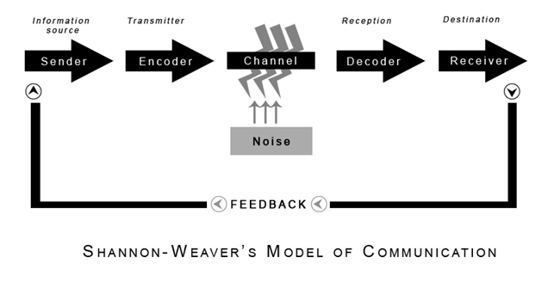
Figure 1: Shannon and Weaver model of communication
(Source: https://www.communicationtheory.org/wp-content/uploads/2011/06/shannon_weaver_model.jpg)
The understanding of this model allows participants to foresee any possible predicaments in communication and work on them. For instance. Pedro, after this incident, might ask Maria to repeat the phrase or the word multiple times if Pedro suspects that some form of miscommunication is happening between them. The simplicity and transparency of this model have garnered it the designation of "the mother of all communication models" (Mehrabian, 2007). The model has its implications and linkings with social science, as Shannon and Weaver had not provided any definitive definition of noise. Intangible assets like inner thoughts, assumptions or hearing problems might create internal noise which also can distort communication.

2.2 Schramm
The "Osgood-Schramm model" is another approach of comprehending a communication from a functional ground. In spirit, this model builds upon the foundation laid by "Shannon and Weaver". Both these models allow for the consideration of sender, receiver and encoders and decoder, but the model acknowledges that communication in its technicality is a two-way street. The need for both encoding and decoding from both sides of the communicators are thus an integral part for a successful and errorless communication path. Schramm's suggestions highlight the limitations of the "Shannon and Weaver" model, and it allows for a more coherent and strategic approach towards communication as a process. Unlike the "Shannon and Weaver" model for Schramm, there are four primary components for a successful massage delivery (Macnamara, 2017). The sender, the message, the receiver and the semantic barriers. These barriers account for the internal noises suggested by “Shannon and Weaver”. The experiences, education, background and cultural significance are all part of this defined barrier.
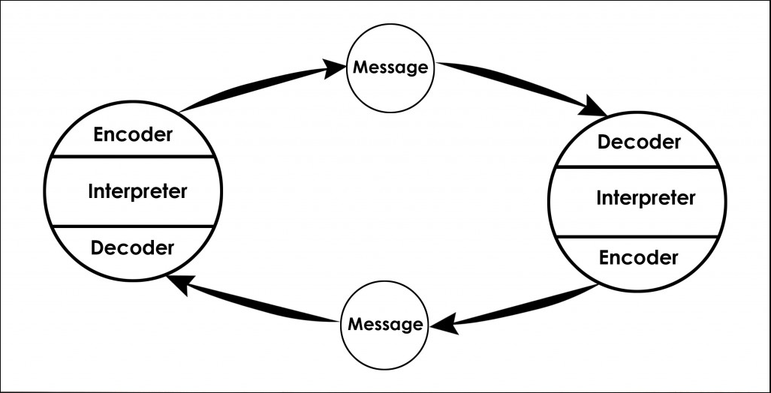
figure 2: Osgood- Schramm Model of Communication
(Source: https://www.communicationtheory.org/wp-content/uploads/2010/01/Osgood-Schramm-model-of-communication1-1024x522.jpg)
The in-class task relating to the English professor might be linked here for better understanding of these principles. The lack of social interactions between the Wales English professor and the villagers can be identified by education alone. The phraseological choices and diction used by the professor created a communication barrier between him and the villagers. The inability of the villagers to understand complex jargons like “edifice” and “conflagration” and the professor's choice to use them creates this communicational blind spot (Macnamara, 2017). As per the Osgood-Schramm model, the sender and the receiver must interpret and decode the message in a similar framework which will eradicate any and all possibility of a communication error. Thus the communication needs to follow a predefined pattern and use preset ques.

2.3 Berlo
Berlo's model, often referred to as the SMCR model, was first proposed in the 1960s. This model also utilizes the same elements set by other models and critical thinkers, but it spins the idea of communication to its basic rules. For Berlo, the communication in its sampling stage is a one-way street, and the flow of the communication allows for the feedback to generate and continue this line in loops (Stead, 1972). However, Berlo’s model emphasized more on the importance of channels and their ability to make or break the message and communication. The model also accounts for some of the criteria of sender and receiver classes and layers of interpretation from both ends in the form of communication skills, knowledge, social dynamics, and their attitudes (Macnamara, 2017). The inability of a sender to properly communicate is not the fault of the communication channel or the medium but from the sender's end. These parameters of communication must be the same across the board and the reflective part of their innate ability to communicate. (Cherry, 2020)
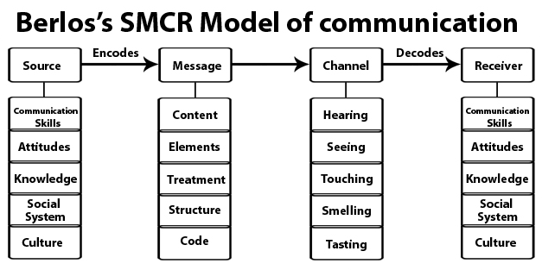
Figure 3: Basic SMCR Model by Berol
(Source: https://www.communicationtheory.org/wp-content/uploads/2010/01/berlos-smcr-model-of-communication-picture.jpg)
In the context of the case studies, it was seen that Pedro's inability to separate the context of Maria's message was his own fault as there are various words in the English lexicon which sound similar but means very different things. Similarly, the professor was also in a different social stature than the common villagers who made his message faulty and not the communication channels. The arguments and observations of Berlo stand true (Jenkinson, 2013).

3.0 Communication Skills and methods of Communication

3.1 Verbal
Verbal communication is the most common form of communication which is experienced by all irrespective of national and social parameters. Mehrabian (2007) had argued that verbal communication accounts for only 7% of whole human interaction in an average communication session. The models discussed before are part of this communication process, and it is most prevalent in telephonic conversations. The uses of verbal language are prevalent in any organizational and administrative setting where the importance of the message is far more than the individuals in charge of communicating it. The use of embellishment and formal writing and speaking approach is an extended part of it. The case of Maria and Pedro is part of this form of communication. Individuals working in various professional working situations are likely to face this predicament of not knowing the importance and emphasis of the message communicated as it is not possible to communicate gestures or non-verbal cues in any other way (Macnamara, 2017).
The need for this form of communication is only limited to telephonic conversions, formal letters and reports where the information is more clean-cut and information by design. The importance of this type of communication is very high as it allows organizations to have lower rates of errors. The case of Maria and Pedro showcases that only the verbal form of communication is prone to various errors as the human mind fills up communication gaps with its own interpretations. The possibility of having an accent or any form of speech deficiency also heightens the chance of miscommunication as 38% of the conversation depends upon it as well. The importance of mastering communicative superiority in verbal mediums is often considered a great skill and this skill has been mastered by great orators in history (Kulkarni and Kulkarni, 2017).

3.2 Non-verbal
As per Mehrabian (2007), the rest 55% of the conversation dynamics among individuals depend upon non-verbal mediums. This includes gesture, the tonality of voice, grooming, accent, expressiveness, eye movement and changes in skin pigments like blushing. These forms of communication are interpersonal, and it depends on our social dynamics. The difference between the various social classes can also be attributed to this form of communication. Gestures of body language speak volumes about the technicality of the tone and the intentions of the message and the senders. In any organizational context, the need for a strong gravitas and personal presence is crucial for attaining a successful and influential professional stace (Kulkarni and Kulkarni, 2017). The organizational leaders and administrative departments depend upon their personas to make statements which define their character and abilities. Human evolution dictates that sometimes where words fail the gesture conveys the rest. My professional context dictates me to be upright, considerate and hardworking. Some of these traits I can illustrate with my dedication and efforts, but for the rest, I am to showcase these non-verbal gestures.
Smaller gestures like nodding can have multiple implications (Taherdoost, 2018). Nodding can have positive or negative meaning attached to it and its interpreted as per the intent of the sender more than the interpreter. The initiatives taken by various individuals in the form of personality development and grooming in some ways refers to these non-verbal components and their inclusion in the professional domain. In the case study context of Maria and Pedro, these non-verbal factors were wholly missing as the conversation was a telephonic one. Had the conversation been interpersonal, this form of communicational error could have been avoided. (Skillsyouneed, 2020)

3.2 Listening
If the communication models are to be taken as active components in any conversational context, then the function of listener or receiver is equally important. Thus an individual must also learn the ability to transform himself or herself from the position of a listener to an active listener. I have also struggled in the past to maintain a proper way of communication more objectively, which lack connection and empathy (Kulkarni and Kulkarni, 2017). The following tools in this matter have various applications in the transformational process towards active and empathic listening-
S.O.L.E.R- The SOLER model of listening is an effective tool for individuals who want to increase their listening and engagement skills even further.
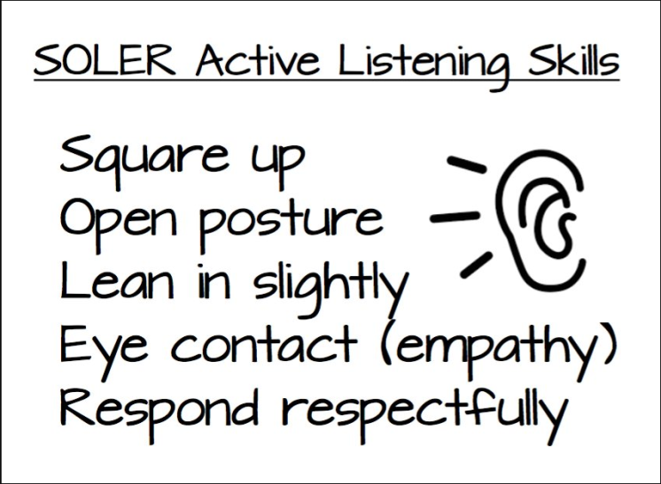
Figure 4: SOLER model
(Source: https://pbs.twimg.com/media/Dr14EpTVAAAqc4n.jpg)
The acronym lists some of the most basic elements of active listening. The professional space where I work much of the communication is conducted over the phone, and thus I hardly get any opportunity to take part in active listening (Taherdoost, 2018).
Proxemics- This concept allows us to make optional use of the available space in our environment. The space of the communication or the conversion is always appreciated if the nature of the message is more intricate and important (Ferrer-Cancho, 2018). While outdoor locations give a conversion candidness and informality, it is not appropriate for private or personal conversations. (The Balance Careers, 2020)
K.E.Y.S- It is a tried and tested way of judging personal awareness for in communication one is to determine one's own strength and capabilities before engaging with the next person. I always judge the communication dynamics before making any statement on my own in my professional space (Ferrer-Cancho, 2018).

4.0 Conclusion
The report concludes with the fact that communication as a part of human interactions, existence and survival has garnered less exposure. The models and theories discussed here illustrate how these models of communications describe and enumerate the whole process. They also define the roles and dynamics of the various components functioning in synchronization to transfer information from one end to the next. Modern times demand individuals to be equally fast-paced and informative. The prowess of communication skill is thus an essential one which justifies this need. The implications of verbal and non-verbal skills also have immense importance in organizational and formal interactions. It proves to be a tool which makes the whole endeavor worthwhile. The contributions of researchers and authors like "Shannon and Weaver", "Schramm" and "Berol" is epoch-making. Without these perspectives, this whole topic would have lost relevance in contemporary society. The report concludes with the realization that true communication can bridge differences across the globe.

Reference List
Books
Macnamara, J., 2017. Evaluating public communication: Exploring new models, standards, and best practice. Routledge.
Mehrabian, A., 2007. Nonverbal Communication. New Brunswick, NJ: Aldine Transaction.

Journals
Ferrer-Cancho, R., 2018. Optimisation models of natural communication. Journal of Quantitative Linguistics, 25(3), pp.207-237. Available at <https://arxiv.org/ftp/arxiv/papers/1412/1412.2486.pdf> [Accessed 21 July 2020]
Kulkarni, S. and Kulkarni, S., 2017. Communication models in the internet of things: a survey. International Journal of Science Technology & Engineering, 3, p.3. Available at <https://d1wqtxts1xzle7.cloudfront.net/55646674/IJSTEV3I11049.pdf> [Accessed 21 July 2020]
Stead, B., 1972. BERLO'S COMMUNICATION PROCESS MODEL AS APPLIED TO THE BEHAVIORAL THEORIES OF MASLOW, HERZBERG, AND McGregor. Academy of Management Journal, 15(3), pp.389-394. DOI: 10.2307/254868
Taherdoost, H., 2018. A review of technology acceptance and adoption models and theories. Procedia manufacturing, 22, pp.960-967. DOI: 10.1016/j.promfg.2018.03.137

Websites
Cherry, K., 2020. What Are The 9 Types Of Nonverbal Communication You Might Be Missing?. [online] Verywell Mind. Available at: <https://www.verywellmind.com/types-of-nonverbal-communication-2795397> [Accessed 21 August 2020].
Skillsyouneed, 2020. Barriers To Effective Communication | Skillsyouneed. [online] Skillsyouneed.com. Available at: <https://www.skillsyouneed.com/ips/barriers-communication.html> [Accessed 21 July 2020].
The Balance Careers, 2020. These Are The Communication Skills Employers Look For In Employees. [online] The Balance Careers. Available at: <https://www.thebalancecareers.com/communication-skills-list-2063779> [Accessed 21 July 2020].

Youtube
Jenkinson, P., 2013. Communication Models: Basic SMCR Model. [video] Available at: <https://www.youtube.com/watch?v=yUGW2d6nXe0&feature=youtu.be> [Accessed 21 July 2020].

Appendices
Appendix 1: A case study of Maria and Pedro
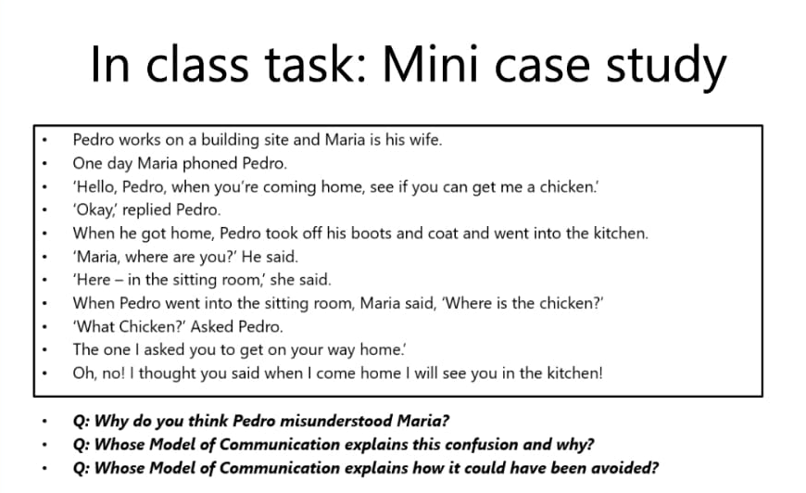

Appendix 2: English Professor case study


