Electrical Engineering
Assignment
HND Electrical & Electronic Engineering Course
UWTSD
By Krzysztof Matela
Student ID: 1804424

- Abstract
- Introduction
  - Impedance and reactance
Figure 1. Voltage across capacitor against frequency in RC circuit
Figure 2. Voltage across inductor against frequency in RL circuit
Figure 3. Voltage across inductor and capacitor in series in RLC circuit
  - Power factor
  - Complex numbers
Figure 4. Complex numbers on a vector graph
Figure 5. Impedance triangle
Figure 6. Power triangle
  - Formulas
- Task 1
  - Circuit diagram
  - Current
Figure 4. Circuit current plot against frequency
  - Component voltage drop
Figure 5. Component voltage drop against frequency
  - Active, reactive and apparent power
Figure 6. Active, reactive and apparent power against frequency
  - Power factor
Figure 7. Power factor against frequency
  - Figure 8. What happens at resonance?
- Task 2
  - 25Hz before resonance
Figure 9. VLC to VR phasor diagram
  - At resonance
Figure 10. VLC to VR phasor diagram
  - 25Hz after resonance
Figure 11. VLC to VR phasor diagram
  - Summary
- Task 3
  - Voltage source with impedance
  - Figure 12. Maximum power transfer
- Conclusion
- References

- Abstract
This paper contains investigation of complications of having a reactive circuit on power consumption. Starts from clearing basic terminology such as reactance and impedance, as properties of linear devices. Next sections display the concept of complex numbers and their usefulness in theory of an AC circuit.
Next sections involve exemplar application of theory by performing an analysis on a parallel RLC circuit with the values for it coming from my student number. The analysis included current and voltage drops across components; and power factor against frequency. Each graph was done in frequency domain on a logarithmic scale. Additionally, 3 phasor diagrams will show the angle of voltage to current in that circuit.
Last task will show the required impedance to achieve maximum power transfer for a described inductive power source and its visualization behind a 3D graph.
- Introduction
  - Impedance and reactance
Capacitors and inductors are known as linear devices which means that this device has the ability to output a signal proportional to that of an input waveform. The output often has a change in amplitude and phase but never the frequency [1].

A typical resistor, has the property called resistivity and it generally defines that the voltages and currents are always in phase however, the linear devices have similar property called reactance and it behaves like a frequency depended resistance. The combination of both resistivity and reactance is called impedance [1].

The capacitors on their own have the ability to store a charge within internal electric field and it does it by applying positive voltage to one side which cannot go through because of an isolation. The positive voltage building up on one conductive plate will result in negative charge building up on opposite plate [2]. The charging property of a capacitor in purely capacitive circuit with an AC power source circuit results in current leading the voltage by 90° [3].
The linear property is best visualized using frequency domain graph which shows voltage drop in a circuit:
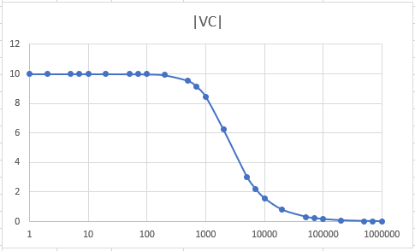
Figure 1. Voltage across capacitor against frequency in RC circuit
This graph shows that the voltage across capacitor decreases as the frequency rises and maintain linear attenuation for a range of about 1kHz to about 10kHz

The principle of operation for an inductor is very similar to a capacitor but opposite. In capacitors, the rate of voltage change is proportional to the current through it and, for inductors, the rate of current change is proportional to the voltage across it. So, applying voltage to an inductor will cause a current to rise, unlike in capacitors where applying current will cause voltage to rise [4].

Using same form of frequency analysis for a RL circuit a following graph was produced: 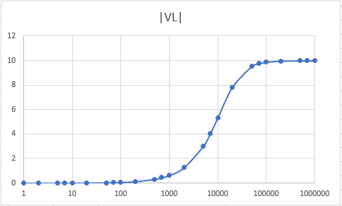
Figure 2. Voltage across inductor against frequency in RL circuit
This graph shows how the voltage across inductor rises up with the frequency applied.

The inductive and capacitive properties together produce in RLC circuit produce: 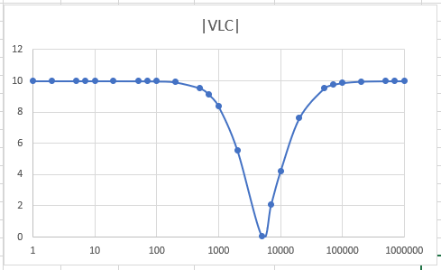
Figure 3. Voltage across LC network in series against frequency in RLC circuit
This graph shows how the two slopes meet creating a slope for bandwidth of frequencies.
  - Power Factor
The power factor is important in industrial sectors where inductive loads are common and heavy. The electrical distribution companies actually bill industrial users with the poor power factor as it costs them in heating resistance of transformers generators and wirings [5].
The power delivered to the circuit is generally defined by a product of voltage and current but for reactive circuits V and I is not proportional and are generally defined as complex RMS amplitudes (see 2.4. Formulas) [5].

  - Complex numbers
The complex numbers are made out of two parts, the real part and imaginary. The imaginary number contains algebraic component $\sqrt{-1}$ which can’t exactly be solved and it is denoted in engineering as $"j"$. The individual parts of a complex number can be used as a vector points to plot them on a graph: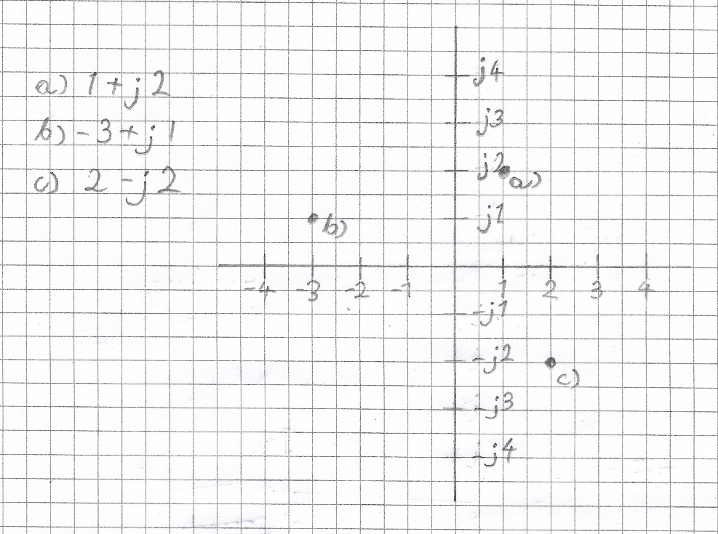
Figure 4. Complex numbers on a vector graph
This figure shows an example of how complex numbers can visualized on graph.
In the theory of an AC circuit, the total impedance takes form of a complex number where resistance is real and reactance is imaginary and this gives an ability to take into account phase of a signals in theory using θ:
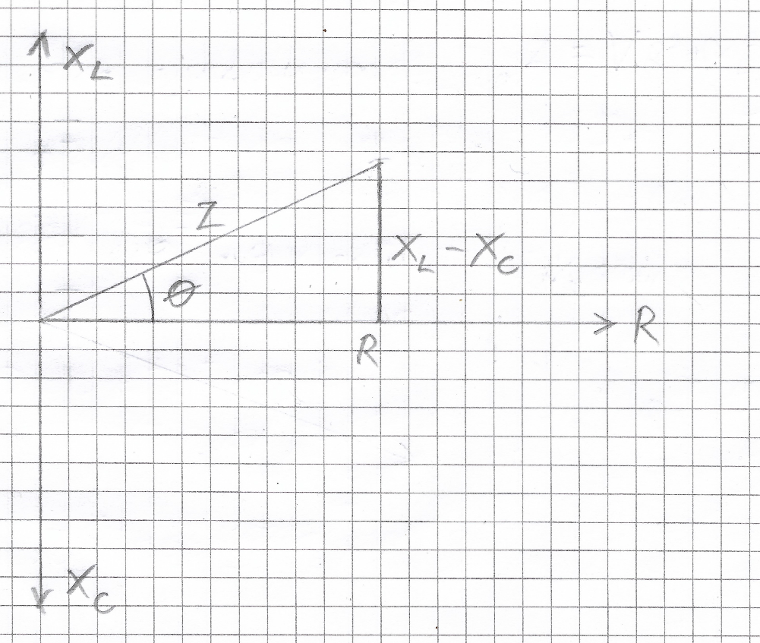
Figure 5. Total impedance triangle
Figure 5 shows how a combined reactance and resistance form a triangle and therefore a complex number can be a subject to a number of trigonometric functions such as Pythagoras theorem $c=\sqrt{a^{2}+b^{2}}$.
The similar operations relate to the power consumption by a circuit where the imaginary number is the amount of power used up by reactive components and real part is the actual power delivered to the circuit.
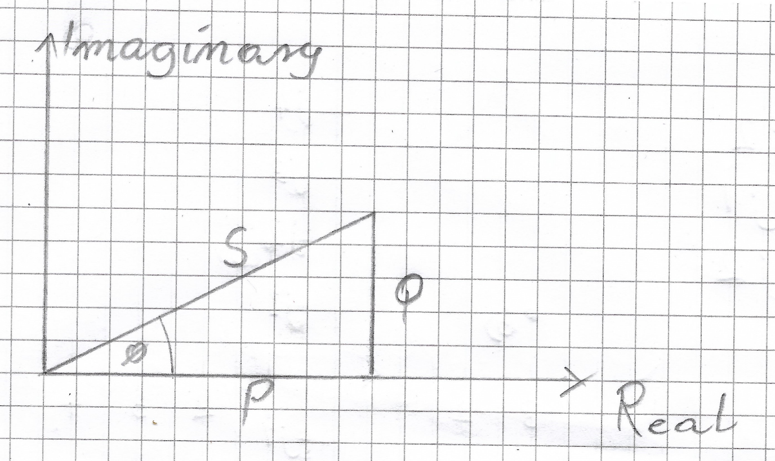
Figure 6. Power triangle
Figure 6 shows the power triangle where P is the Real power, S is the apparent power, and Q is the reactive power.
  - Formulas
The next tasks will require formulas:
The Ohms’ Law
$$I=\frac{V}{R}=\frac{V}{Z}$$
V - Voltage
I - Current
R - Resistance
Z - Total impedance

Angular Frequency (omega)
$$ω=2πf$$
f – Frequency
π - PI
Inductive Reactance
$$X_{L}=jωL$$
Capacitive Reactance
$$X_{C}=-\frac{1}{jωC}$$
Total Reactance for in series LC
$$X_{T}=X_{L}-X_{C}$$
Total Reactance for parallel LC circuit
$$X_{T}=\frac{X_{L}X_{C}}{X_{L}+X_{C}}$$
Total Impedance
$$Z=R+jX_{T} \left|Z\right|=\sqrt{R^{2}+{X_{T}}^{2}}$$
Phase Angle
$$φ=\tan^{-1}{\frac{X_{T}}{R}}$$
Power with proportional voltage to current
$$P=VI$$
Power with phase component
$$P=Re\left(VI^{*}\right)=Re\left(V^{*}I\right)$$
I* & V*- complex conjugate
Resonant frequency
$$f_{res}=\frac{1}{2π\sqrt{LC}}$$
Real power
$$P={|I|}^{2}R$$
Reactive power
$$Q={|I|}^{2}X$$
Apparent power
$$S=P+jQ$$
Power factor
$$pf=\cos{φ}$$
ϕ – Phi

- Task 1
  - Circuit diagram
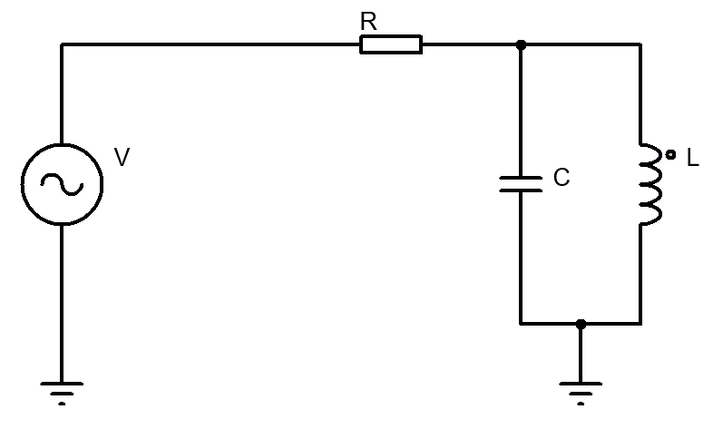
Component Values:
R - 44Ω
L - 180mH
C - 24μF
  - Current against frequency graph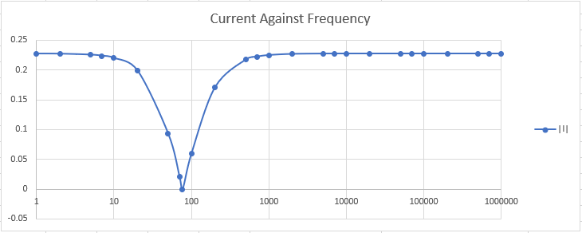
Figure 4. Circuit current drop against frequency
This frequency domain graph was made using ohms law for current $\left|I\right|=\frac{V}{Z}$ and it shows gradual decrease of current as the frequency approach resonance and then gradual increase of current as the frequency leaves resonance.
  - Component voltage drop 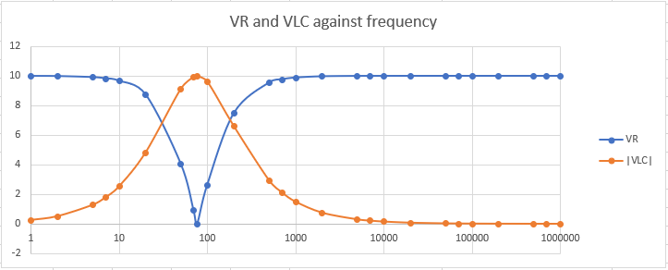
Figure 5. Circuit component voltage drop against frequency
Using ohms law $V_{R}=\left|I\right|R$ and $\left|V_{LC}\right|=IX_{LC}$ produced a graph that shows a clear colleration between voltage drop at resistor and voltage spike at reactive components when at the resonant frequency.
  - Active, reactive and apparent power 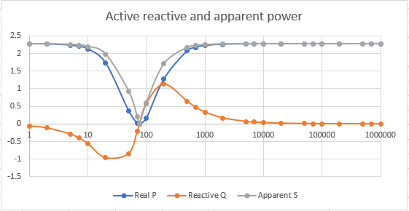
Figure 6. Active, reactive and apparent power against frequency
Using formulas $P={|I|}^{2}R$, $I={|I|}^{2}X$, and $|S|=\sqrt{P^{2}+jQ^{2}}$ produced a graph which firstly, the reactive power took a sinusoidal shape, which for a brief moment, passes through apparent power slope. Secondly, the shapes of apparent power and reactive power are shaped exactly as $V_{R}$and $\left|V_{LC}\right|$ in Figure 5, suggesting corelation between resonant frequency and power consumption.
  - Power factor 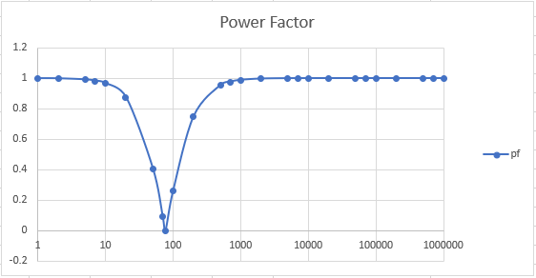
Figure 7. Power Factor against frequency
Using formula $pf=\cos{φ}$ made a graph which again shows an exact same shape of $V_{R}$ in Figure 5. apparent power in Figure 6. along with $\left|I\right|$ in Figure 4. while each time vector is matching at frequency.
  - What happens at the resonance?
Reactive power in Figure 6. shows how the reactance goes from being purely capacitive to being purely inductive. The resonance must be a result of combined reactance of inductor and capacitor which as described in section 2.1, both have opposite results to the phase of voltage to current which then impacts the power consumption.
- Task 2
Task 2 is to produce three phasor diagrams to visualize what happens:
  - 25Hz before resonance 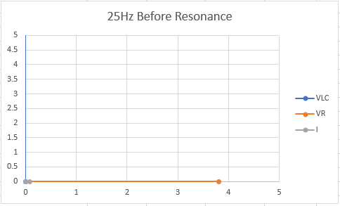
Figure 8. VLC to VR phasor diagram

  - At resonance
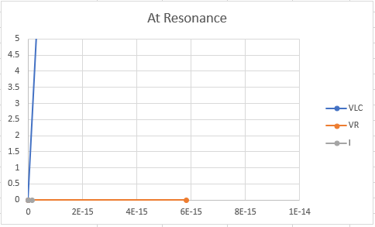
Figure 9. VLC to VR phasor diagram
  - 25Hz after resonance
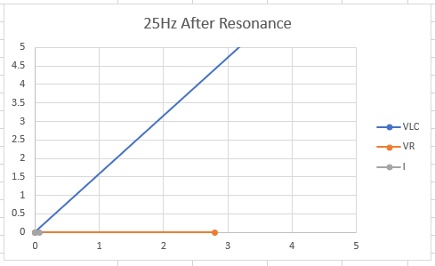
Figure 10. VLC to VR phasor diagram
  - Summary
Figures 9-11. Show hows the phase difference between voltages at resistor and LC network. At first, the voltages are 90° apart then move to 45° 25Hz after resonance.
- Task 3
For a voltage source with 5Ω resistance and 150μH inductance the maximum power transfer is calculated by equalizing source and load impedances. Using formula for $P=R\left[\left|I^{2}\right|Z_{load}\right]$ and $X_{src}=2πL$ the following graph was produced.
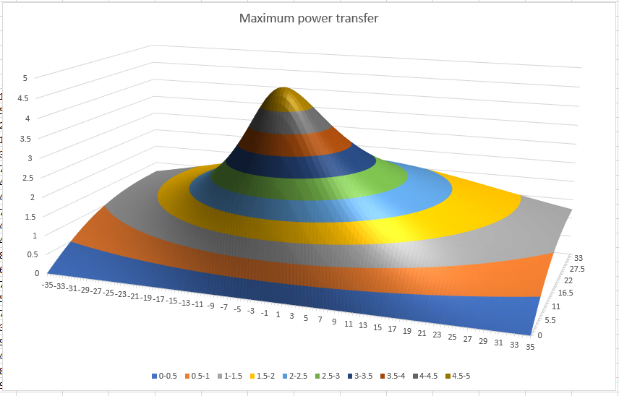
Figure 12. Maximum power transfer
This graph differs from others by having both reactive and real elements to it. The maximum power transfer occurs at the peak of the shape at around 16.5Ω and -3 inductance.
- Conclusion
The linear properties of capacitors and inductors appear to have both applications and implications. The application is that an RLC circuit can be used to filter out frequencies and therefore can be used for things such as noise filter. The problem is in large inductive loads, the resonance causes by having certain loads with poor power factor cause a lot of power consumption.
Application of complex numbers in AC theory gives an ability to estimate the results of various frequencies on the load. Interesting are the shapes in Figures 5-7, which have identical components for voltage drop across $V_{R}$ and power factor showing how at resonance, the impedance, being a product of resistance and reactance, is at its maximum. This causes complications for power because of ${P=I}^{2}R$.
Lastly the 3D graph shows how the source impedance can affect the power consumption.
In future it would be best to investigate further the magnetism in devices such transformers and inductors.
- References
[1] P. Horowitz, W. H. (2015). ”The Art of Electronics”, Third Edition. Cambridge University Press. Chapter 1.7 Impedance and reactance. Page 40
[2] P. Horowitz, W. H. (2015). ”The Art of Electronics”, Third Edition. Cambridge University Press. Chapter 1.4.1 Capacitors. Page 18
[3] P. Horowitz, W. H. (2015). ”The Art of Electronics”, Third Edition. Cambridge University Press. Chapter 1.7.1 Frequency analysis of reactive circuits. Page 41
[4] P. Horowitz, W. H. (2015). ”The Art of Electronics”, Third Edition. Cambridge University Press. Chapter 1.7.2 Reactance of inductors. Page 44
[5] P. Horowitz, W. H. (2015). ”The Art of Electronics”, Third Edition. Cambridge University Press. Chapter 1.7.6 Power in reactive circuits. Page 47

