Curtis Stephens
1903184 UWTSD
ACCB4012 - Assignment

Introduction
In this assignment, I have been asked to create a database system for a small bookstore based in Swansea. The database system will keep track of books that are part of their stock, customer details, staff details, as well as in-store and delivery orders. It will also keep details of suppliers of the books.

User requirements
The client has stated that the system must be capable of doing the following:
- Keeping track of which books are in stock in the store, by giving each book a unique ID number and by using the ISBN number of the book.
- Keeping details of customers using their unique customer ID numbers, to be able to find which customers are purchasing which books, and to see a customer purchase history.
- Keeping contact details of staff as well as giving them a unique staff ID, to be able to contact them if required, and see which sales they have completed.
- Having supplier details on the system and having the ability to find out which books are from which suppliers. Contact details may also be stored for suppliers of rare and coveted books, such as first editions.
- When inputting book details, there should be an option to mark rare/coveted copies of books as people like to collect these.
- The system should be menu driven, using a switchboard as the main screen to be able to navigate, as well as exit the system.
- Having a table to show mail orders, using the customer ID, Book ID as well as an Order ID.
- Having a table to show instore order purchases, using staff ID numbers so it can be seen which staff make which sales.
- Queries and reports – For this, I will be creating queries and reports to show rare books that are in the system, filtering by the book ID number, the name of the book and the rare copy field only.

Form Designs

Customer Data Input
For this form, I will be using a 5-digit customer ID number, which will be manually entered, and not an auto-number. This is because customers may require different numbers depending on criteria such as status, for example more frequent customers may be given a different number to less-frequent customers to make searching easier.
The customer details used are basic details which ‘make sense’ to keep, such as their name, address for mail orders, email address and date of birth to tailor to their needs more.
Below is a screenshot of the form I am using for customer data entry.
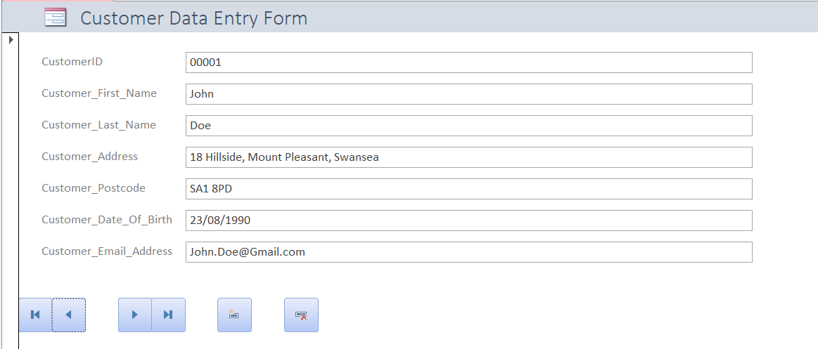
Most of the forms that I have created follow the same template, with the ability to jump to the first and last stored records, as well as the next and previous records. There is also the ability to add new records and delete records if they are not needed.

Book Data Input
For this table, each book has a unique ten digit ID number, as there are expected to be a lot of books on the system, and therefore they are to have the largest ID number.
On this form, there are fields for the book ID number, the title, author, ISBN number, publisher, as well as the year that the book was published.
There is also a yes/no field which declares whether a book is a rare or coveted copy (Such as a first edition) or not, which therefore makes it easier to find out if a rare copy is in stock, should a customer request it.
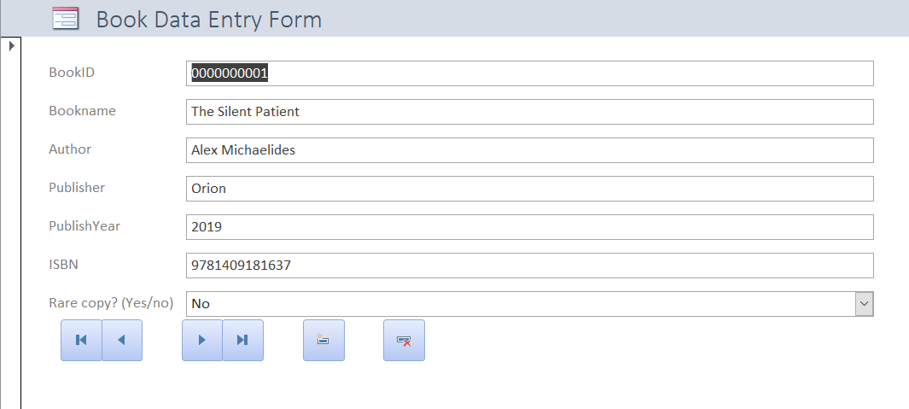

Instore Sales Form
This form is to be used to enter sales that occur instore. These sales can be connected to a staff number, and the sales will appear on the staff form (Which I will be writing about later). Sales can also be connected to a customer so the staff can go back on a customer’s purchase history if they are required to for some reason.
I added a field for the name of the book into this as it makes it easier than using the book ID number to work out which book has been sold to which customer.
However, the name of the book does need to be manually entered, but it makes it easier than having to go back to the book table and find the book if a customer wants to know their historic purchases.
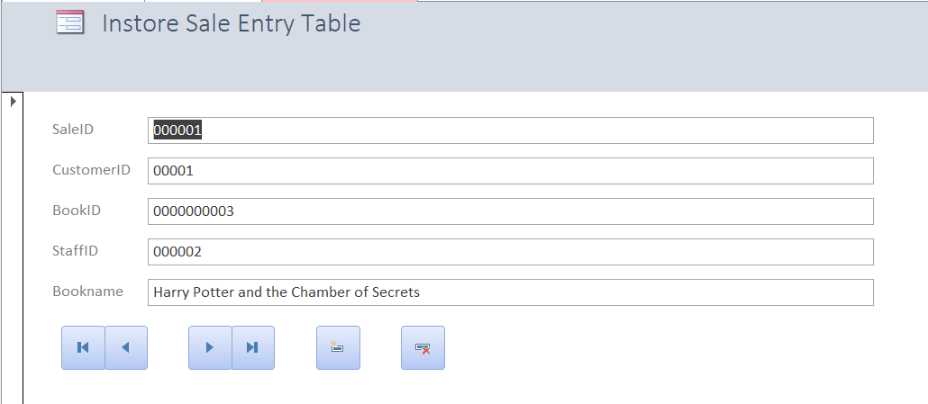

Mail Order Form
This form does not include the staff details; however it does include order, customer and the book ID. The book name is put into the table manually, along with the customer name, address and contact details.
Each mail order has a unique eight digit ID number which can be used by the customer to ask for details on their order, however I have only created the system for one book per order at the moment.
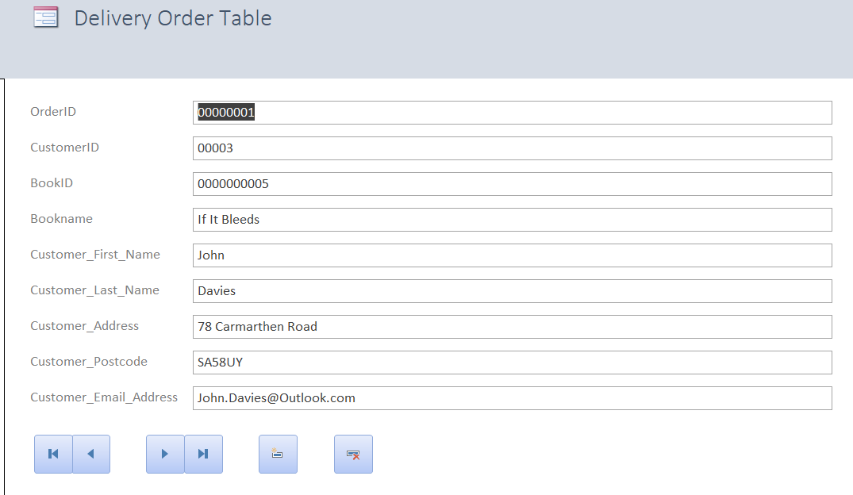

Staff Form
The staff form features the instore sales table at the bottom, so staff can see how many sales they have made in total, and what books they have sold.
This form also gives the ability to add contact information for the staff, so they can be contacted in the event that there are extra shifts, or if there is anything that management need to contact them about. The address could also be used for orders if required.
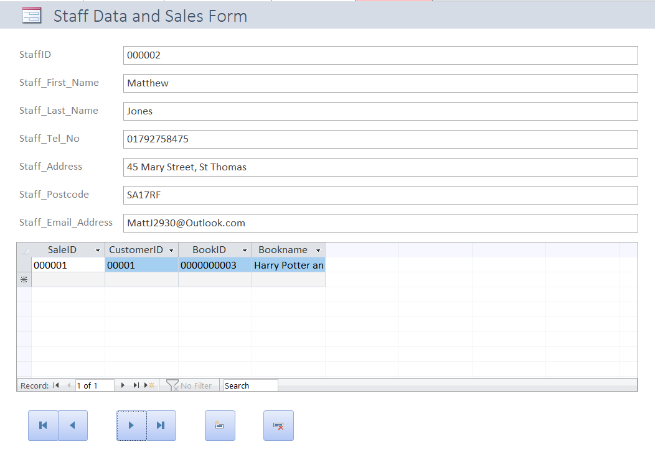

Supplier Form
Finally, I created a supplier form on the database. This allows suppliers of regular as well as rare books to be traced and contacted, in the event that the store needs to order books either for a particular customer, or just needs to reorder more books in general. It features the telephone and email address of the supplier so orders can be made through these methods, as well as the address of the supplier in case the store needs to send anything back, for example faulty or damaged books.
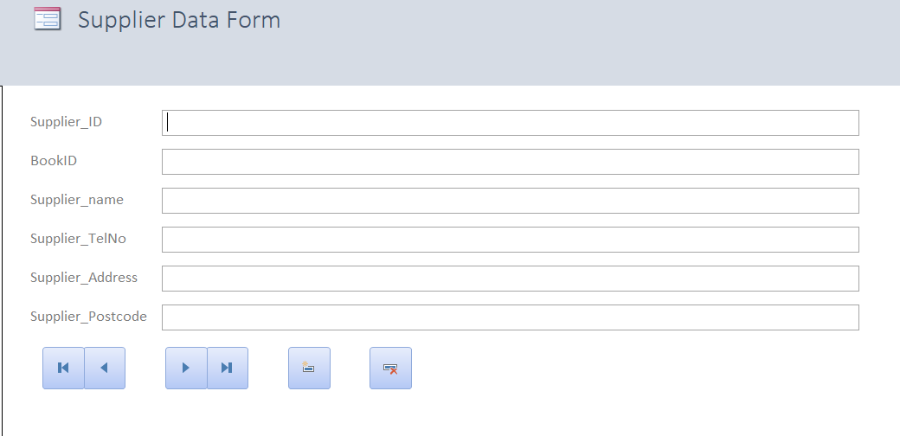

Switchboard
I have used a switchboard in this database as it makes it easier to open forms in order to add and find data. The switchboard also allows the user to close the database.
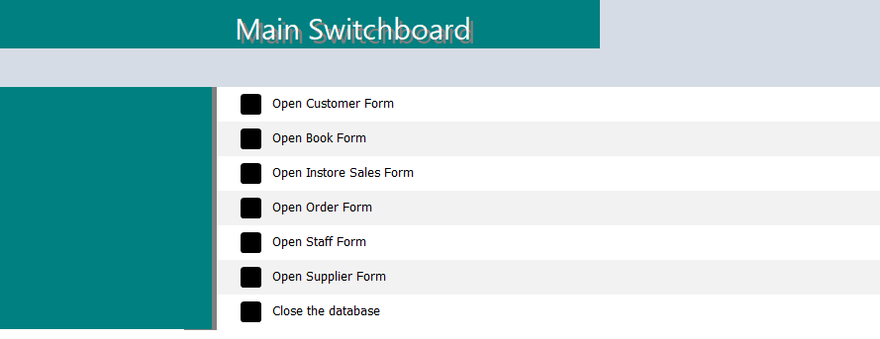

Use of SQL
I used SQL in order to create the tables for the database. As well as creating the fields, I used it to define which fields were primary and foreign key fields.
Below is the SQL code I used to create each table.

Book Table
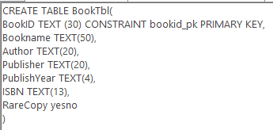

Customer Table
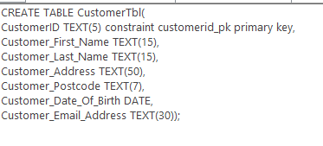

Staff Table
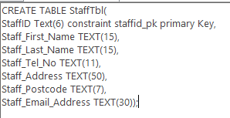

Instore Sales Table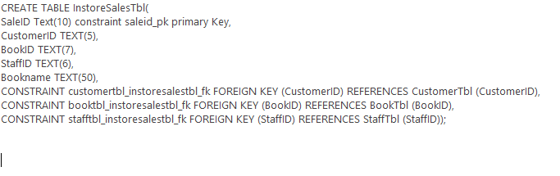

Supplier Table
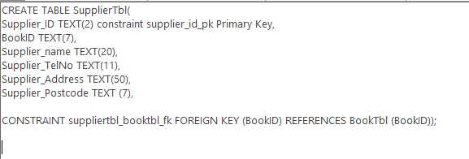

Order Table
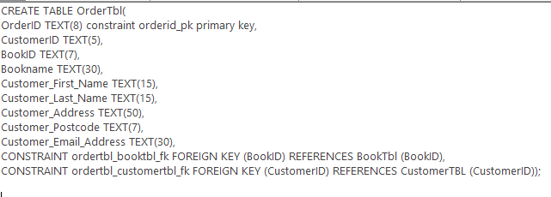

Evaluation
Overall, I feel that I have created a basic but functional database which could be used in a book store (Or can be adapted to work in a store of any type) for basic functions such as stock searching and control, keeping track of orders, keeping track of suppliers, as well as staff and customers.
I feel that there are of course some things that I could have done better if my ability allowed me to, such as autofilling forms based on data from other forms (E.g. autofilling customer address when a customer ID is typed into a form).
There is an issue with the switchboard upon opening the database where it does not open, but if it is opened from the sidebar it works correctly. If I had more time, as well as a better ability, I would fix that so the switchboard opens up with the database.
I feel that the forms I created are fit for purpose and simplistic enough, and work for their intended purpose. I would add more options to the firms in the future though, such as the ability to print records and save records to the computer.
I would also add more options on the forms. For example, on the book form, I could have added options for genre, and on the staff table I could have added ranks. I would have also created more reports and queries which would have been useful to the shop staff.

Appendix

Testing
Test No | What is being tested? | Purpose | Data | Expected | Actual | Comment
1 | BookFrm BookID Input Mask | To ensure the mask works properly | 0000000000 | Input should be accepted as it is numeric | Input accepted
2 | BookFrm BookID Input Mask | To ensure the mask works properly | Text | Input should not be allowed as it is text | No input allowed
3 | BookFrm  Year input mask | To ensure the mask works properly | 0000 | Input should be accepted as it is numeric | Input accepted
4 | BookFrm  Year input mask | To ensure the mask works properly | Text | Input should not be allowed as it is text | No input allowed
5 | BookFrm  ISBN input mask | To ensure the mask works properly | 0000000000000 | Input should be accepted as it is numeric | Input accepted
6 | BookFrm  ISBN input mask | To ensure the mask works properly | Text | Input should not be allowed as it is text | No input allowed
7 | BookFrm  Rare yes/no | To ensure the yes/no field works correctly | Yes | Input should be accepted as it is yes or no | Input accepted
8 | BookFrm  Rare yes/no | To ensure the yes/no field works correctly | No | Input should be accepted as it is yes or no | Input accepted
9 | BookFrm Rare yes/no | To ensure the yes/no field works correctly | Other | Input should not be allowed as it is not yes or no | Not accepted
10 | BookFrm  Last record button | To ensure the button works correctly | Click | Form should go to the last record | Button does as it should
11 | BookFrm  First record button | To ensure the button works correctly | Click | Form should go to the first record | Button does as it should
12 | BookFrm  Previous record button | To ensure the button works correctly | Click | Form should go to the previous record | Button does as it should
13 | BookFrm  Next record button | To ensure the button works correctly | Click | Form should go to the next record | Button does as it should
14 | BookFrm New record button | To ensure the button works correctly | Click | New record should be created | Button does as it should
15 | BookFrm Delete record button | TO ensure the button works correctly | Click | Confirmation, then deletion of the record | Button does as it should
16 | CustomerFrm CustomerID input mask | TO ensure the input mask works correctly | 00000 | Input is accepted | Input mask works correctly
17 | CustomerFrm CustomerID input mask | To ensure the input mask works correctly | Text | No input allowed | Input mask works correctly
18 | CustomerFrm Postcode field length | To ensure that the field only accepts 8 characters | Maximum amount of characters | Field only accepts 8 characters | Field accepts maximum of 8 characters
19 | CustomerFrm Date of Birth | To ensure the field only accepts date | 23/08/1990 | Input accepted | Field accepts date format
20 | CustomerFrm Date of Birth | To ensure the field only accepts date | Text | Error should appear before submitting form | Error appears and form cannot be submitted
21 | CustomerFrm  first record button | To ensure the button works correctly | Click | Form should go to the first record | Button does as it should
22 | CustomerFrm  last record button | To ensure the button works correctly | Click | Form should go to the last record | Button does as it should
23 | CustomerFrm  next record button | To ensure the button works correctly | Click | Form should go to the next record | Button does as it should
24 | CustomerFrm  Previous record button | To ensure the button works correctly | Click | Form should go to the previous record | Button does as it should
25 | CustomerFrm  Add record button | To ensure the button works correctly | Click | Form should add a record | Button does as it should
26 | CustomerFrm  Delete record button | To ensure the button works correctly | Click | Form should delete the record after confirmation | Button does as it should
27 | InstoreSalesFrm SaleID input mask | To ensure the input mask works correctly | 000000 | Input should be accepted | Input mask works correctly
28 | InstoreSalesFrm  SaleID input mask | To ensure the input mask works correctly | Text | Input should not be accepted | Input mask works correctly
29 | InstoreSalesFrm  CustomerID input mask | To ensure the input mask works correctly | 00000 | Input should be accepted | Input mask works correctly
30 | InstoreSalesFrm  CustomerID input mask | To ensure the input mask works correctly | Text | Input should not be accepted | Input mask works correctly
31 | InstoreSalesFrm  BookID input mask | To ensure the input mask works correctly | 0000000000 | Input should be accepted | Input mask works correctly
32 | InstoreSalesFrm  BookID input mask | To ensure the input mask works correctly | Text | Input should not be accepted | Input mask works correctly
33 | InstoreSalesFrm  StaffID input mask | To ensure the input mask works correctly | 000000 | Input should be accepted | Input mask works correctly
34 | InstoreSalesFrm  StaffID input mask | To ensure the input mask works correctly | Text | Input should not be accepted | Input mask works correctly
35 | InstoreSalesFrm first record button | To ensure the button works correctly | Click | Form should go to the first record | Button does as it should
36 | InstoreSalesFrm last record button | To ensure the button works correctly | Click | Form should go to the last record | Button does as it should
37 | InstoreSalesFrm next Record button | To ensure the button works correctly | Click | Form should go to the next record | Button does as it should
38 | InstoreSalesFrm previousrecord button | To ensure the button works correctly | Click | Form should go to the previous record | Button does as it should
39 | InstoreSalesFrm delete record button | To ensure the button works correctly | Click | Record should be deleted after confirmation | Button does as it should
40 | InstoreSalesFrm add record button | To ensure the button works correctly | Click | New record should be added | Button does as it should
41 | OrderFrm  OrderID input mask | To ensure the input mask works correctly | 00000000 | Input should be accepted | Input mask works correctly
42 | OrderFrm  OrderID input mask | To ensure the input mask works correctly | Text | Input should not be accepted | Input mask works correctly
43 | OrderFrm  CustomerID input mask | To ensure the input mask works correctly | 00000 | Input should be accepted | Input mask works correctly
44 | OrderFrm  CustomerID input mask | To ensure the input mask works correctly | Text | Input should not be accepted | Input mask works correctly
45 | OrderFrm  BookID input mask | To ensure the input mask works correctly | 0000000000 | Input should be accepted | Input mask works correctly
46 | OrderFrm  BookID input mask | To ensure the input mask works correctly | Text | Input should not be accepted | Input mask works correctly
48 | OrderFrm postcode field length | To ensure the button works correctly | Maximum of 7 characters | Input should be accepted up to seven characters | Input mask works correctly
49 | OrderFrm first record button | To ensure the button works correctly | Click | Form should go to the first record | Button does as it should
50 | OrderFrm Last record button | To ensure the button works correctly | Click | Form should go to the last record | Button does as it should
51 | OrderFrm next record button | To ensure the button works correctly | Click | Form should go to the next record | Button does as it should
52 | OrderFrm previous record button | To ensure the button works correctly | Click | Form should go to the previous record | Button does as it should
53 | OrderFrm add record button | To ensure the button works correctly | Click | Record should be added | Button does as it should
54 | OrderFrm delete record button | To ensure the button works correctly | Click | Record should be deleted after confirmation | Button does as it should
55 | StaffFrm StaffID input mask | To ensure the input mask works correctly | 000000 | Input should be accepted | Input was accepted
56 | StaffFrm StaffID input mask | To ensure the input mask works correctly | Text | Input should not be accepted | Input was not accepted
57 | StaffFrm postcode field length | To ensure the field only allows seven characters | Maximum of seven characters | Maximum of seven characters should be accepted | Up to seven characters were accepted
58 | StaffFrm first record button | To ensure the button works correctly | Click | Form should go to the first record | Button does as it should
59 | StaffFrm last record button | To ensure the button works correctly | Click | Form should go to the last record | Button does as it should
60 | StaffFrm next record button | To ensure the button works correctly | Click | Form should go to the next record | Button does as it should
61 | StaffFrm previous record button | To ensure the button works correctly | Click | Form should go to the previous record | Button does as it should
62 | StaffFrm add record button | To ensure the button works correctly | Click | Record should be added | Button does as it should
63 | StaffFrm delete record button | To ensure the button works correctly | Click | Record should be deleted | Button does as it should
64 | SupplierFrm SupplierID input mask | To ensure the input mask works correctly | 00 | Input should be accepted | Input mask works correctly
65 | SupplierFrm SupplierID input mask | To ensure the input mask works correctly | Text | Input should not be allowed | Input mask works correctly
66 | SupplierFrm first record button | To ensure the button works correctly | Click | Form should go to the first record | Button does as it should
67 | SupplierFrm last record button | To ensure the button works correctly | Click | Form should go to the last record | Button does as it should
68 | SupplierFrm next record button | To ensure the button works correctly | Click | Form should go to the next record | Button does as it should
69 | SupplierFrm previous record button | To ensure the button works correctly | Click | Form should go to the previous record | Button does as it should
70 | SupplierFrm add record button | To ensure the button works correctly | Click | Form should add a record | Button does as it should
71 | SupplierFrm delete record button | To ensure the button works correctly | Click | Form should delete the record after confirmation | Button does as it should
72 | SupplierFrm Postcode field length | To ensure the field length is set correctly | Maximum of seven characters input | Input should be accepted up to seven characters | Input was accepted

