Data Handling and Business Intelligence (M5X00842)
Assignment 1- Journal Review
Big Data Journal Discussion
How Companies Say They’re Using Big Data
By Randy Bean
“However, big data isn’t just being used for cost-cutting. The survey strongly indicates that firms are also undertaking “offensive” efforts that are explicitly intended to change how they do business. After the initial “quick wins” are wrung from cost-reductions, executives are turning their attention to new ways to innovate using data.
In spite of the investment enthusiasm, and ambition to leverage the power of data to transform the enterprise, results vary in terms of success.”
Key Words: BIG, DATA, OFFENSIVE, INNOVATE, TRANSFORM.

As seen above, the issue discussed in the article is Big Data. Randy Bean gives a brief overview of his thoughts and research regarding the talking points of Big Data. “Randy Bean is CEO/Founder of NewVantage Partners, and contributor to Forbes, MIT Sloan Review, Harvard Business Review, and The Wall Street Journal.” This information shows me that Bean has a keen interest in the development of Big Data, whilst also being concerned with how it can help his own business. Big Data is described as “the process of collecting and analysing large data sets from traditional and digital sources to identify trends and patterns that can be used in decision-making.” Big Data is becoming increasingly important with the development of the modern world, especially for large companies who need to keep on top of a large amount of data in order to make their business thrive.
Within the article, Bean is clearly attempting to evaluate the usefulness of Big Data, he goes on to express other uses of the method that may be less conventional and describes it as ‘offensive’ by businesses. Bean also includes figures to back up his research later in the article. From reading the article entirely, it appears that Bean may be slightly bias. This is because he seems to already have made an opinion pre-conducting his research, which means the data has been collected with him already having a positive opinion on the benefits it brings. This is apparent in the article as it does not really express any counter points that may counteract the benefits of Big Data.
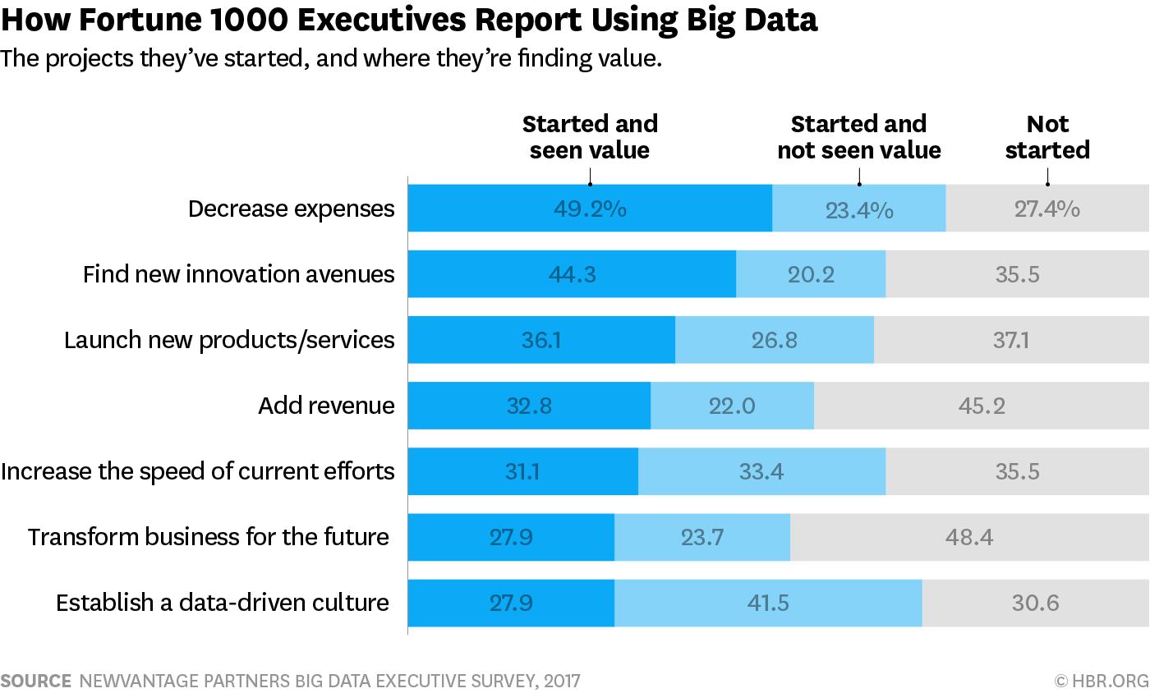
The table shows the benefits of using Big Data for things such as decrease in Expenses.
Although the journal could definitely come across as a biased point of view, Randy Bean has provided detailed and well researched points to show the benefits of Big Data and so means it is a reliable source of information to use. From reading the journal, it is clear that there are many positive implications of implementing the methods according to Bean. The data is well presented, showing facts that such as that of all businesses that were questioned on the methods, 49.2% had started and seen a decrease in expenses. 44.3% had also become more innovative. 32.8% also saw an increase in revenue which is a key factor for any business that wants to be successful. Finally, 27.9% feel it has transformed their business for the future.
To conclude, Randy Bean makes some credible well researched points that fit in to a thesis that Big Data is important for many businesses going forward. “as big data continues to change how businesses operate and compete. Companies that fail to adapt do so at their own competitive and market risk.” Although Bean is clearly slightly bias in his support of Big Data, he backs up his opinions with researched information that does seem to give both sides to an extent. I believe that this journal and the information it provides could be of use to a company that is considering adopting these methods. It clearly lays out the benefits and potential costs of implementing it allowing companies to assess the position they are in and whether it would benefit their profitability and business as a whole.
Big Data and Machine Learning Won’t Save Us from Another Financial Crisis
By Stephen Blyth
“Ten years on from the financial crisis, stock markets are regularly reaching new highs and volatility levels new lows. The financial industry has enthusiastically and profitably embraced big data and computational algorithms, emboldened by the many triumphs of machine learning. However, it is imperative we question the confidence placed in the new generation of quantitative models, innovations which could, as William Dudley warned, “lead to excess and put the [financial] system at risk.””
Key Words: EMBRACED, INNOVATIONS, FINANCIAL, RISK.
The second article that I have chosen, gives a stark contrast to the first by Randy Bean. The journal looks more towards the negative side effects that could come about from changing so drastically to a more modern approach. Stephen Blyth is also a well-established figure, Professor of the Practice of Statistics at Harvard University. He was previously President and CEO of the Harvard Management Company. Blyth chooses to look more towards the financial sector and how it can be affected by these modern methods. As shown in the extract, Blyth bases his research on the negative effects and how it could potentially lead to another financial crisis, perhaps similar to the one in 2008. From reading the article, it makes the previous one written by Bean seem far less bias in comparison. It is very clear from start to finish that Blyth is opposed to such a drastic switch in methods. Blyth insinuates this by stating the ‘correlations’ between what has happened in previous financial crisis’ and what is currently happening. Although Blyth does touch upon the increasing computer power we possess in the modern world and the benefits this brings, he counter-acts these short points by stating “as our algorithms become more complex, as with deep learning, it is becoming more difficult to identify gaps in logic that may be embedded within algorithms, or to comprehend when models might badly fail.” This is just one example of the theme of the article, it shows very clear bias that Blyth is against Big Data methods, this is because even after acknowledging the benefits he goes on to counter act the points. Blyth also provides minimal statistical data to back up his opinions which shows that the article was done based more on an opinion and a theory. Blyth consistently questions the ‘confidence’ placed on Big Data and Machine Learning with minimal facts on why it is a problem
To conclude, I believe that although Stephen Blyth makes good points on Big Data and the potential drawbacks, he does not back these up in a way that proves him right, with a lack of statistics and figures. In that sense, the article could be improved on to resemble that of Randy Bean’s that was packed with statistics and facts.

REFERENCES
- Available from: https://hbr.org/2017/04/how-companies-say-theyre-using-big-data?autocomplete=true (Accessed on 24th April 2019).
- “Randy Bean is CEO/Founder of NewVantage Partners, and contributor to Forbes, MIT Sloan Review, Harvard Business Review, and The Wall Street Journal.” Available from: https://www.linkedin.com/in/randybeannvp (Accessed on 24th April 2019).
- “the process of collecting and analysing large data sets from traditional and digital sources to identify trends and patterns that can be used in decision-making.” Available from: https://www.tutor2u.net/business/reference/big-data-explained (Accessed on 24th April 2019).
- The table shows the benefits of using Big Data for things such as decrease in Expenses. Access table from: https://hbr.org/2017/04/how-companies-say-theyre-using-big-data?autocomplete=true (Accessed on 25th April 2019).
- “as big data continues to change how businesses operate and compete. Companies that fail to adapt do so at their own competitive and market risk.” Available from: https://hbr.org/2017/04/how-companies-say-theyre-using-big-data?autocomplete=true (Accessed on 25th April 2019).
- “Ten years on from the financial crisis, stock markets are regularly reaching new highs and volatility levels new lows. The financial industry has enthusiastically and profitably embraced big data and computational algorithms, emboldened by the many triumphs of machine learning. However, it is imperative we question the confidence placed in the new generation of quantitative models, innovations which could, as William Dudley warned, “lead to excess and put the [financial] system at risk.”” Available from: https://hbr.org/2018/09/big-data-and-machine-learning-wont-save-us-from-another-financial-crisis (Accessed on 25th April 2019).
- Professor of the Practice of Statistics at Harvard University. He was previously President and CEO of the Harvard Management Company. Available from: https://hbr.org/2018/09/big-data-and-machine-learning-wont-save-us-from-another-financial-crisis (Accessed on 25th April 2019)
- “as our algorithms become more complex, as with deep learning, it is becoming more difficult to identify gaps in logic that may be embedded within algorithms, or to comprehend when models might badly fail.” Available from: https://hbr.org/2018/09/big-data-and-machine-learning-wont-save-us-from-another-financial-crisis(Accessed on 25th April 2019).

Available from: https://hbr.org/2017/04/how-companies-say-theyre-using-big-data?autocomplete=true (Accessed on 24th April 2019).
“Randy Bean is CEO/Founder of NewVantage Partners, and contributor to Forbes, MIT Sloan Review, Harvard Business Review, and The Wall Street Journal.” Available from: https://www.linkedin.com/in/randybeannvp (Accessed on 24th April 2019).
“the process of collecting and analysing large data sets from traditional and digital sources to identify trends and patterns that can be used in decision-making.” Available from: https://www.tutor2u.net/business/reference/big-data-explained (Accessed on 24th April 2019).
The table shows the benefits of using Big Data for things such as decrease in Expenses. Access table from: https://hbr.org/2017/04/how-companies-say-theyre-using-big-data?autocomplete=true (Accessed on 25th April 2019).
“as big data continues to change how businesses operate and compete. Companies that fail to adapt do so at their own competitive and market risk.” Available from: https://hbr.org/2017/04/how-companies-say-theyre-using-big-data?autocomplete=true (Accessed on 25th April 2019).
“Ten years on from the financial crisis, stock markets are regularly reaching new highs and volatility levels new lows. The financial industry has enthusiastically and profitably embraced big data and computational algorithms, emboldened by the many triumphs of machine learning. However, it is imperative we question the confidence placed in the new generation of quantitative models, innovations which could, as William Dudley warned, “lead to excess and put the [financial] system at risk.”” Available from: https://hbr.org/2018/09/big-data-and-machine-learning-wont-save-us-from-another-financial-crisis (Accessed on 25th April 2019).
Professor of the Practice of Statistics at Harvard University. He was previously President and CEO of the Harvard Management Company. Available from: https://hbr.org/2018/09/big-data-and-machine-learning-wont-save-us-from-another-financial-crisis (Accessed on 25th April 2019)
“as our algorithms become more complex, as with deep learning, it is becoming more difficult to identify gaps in logic that may be embedded within algorithms, or to comprehend when models might badly fail.” Available from: https://hbr.org/2018/09/big-data-and-machine-learning-wont-save-us-from-another-financial-crisis(Accessed on 25th April 2019)

