Student number: 1810349

Simulink simulation of increasing additive white gaussian noise on different methods of digital signals processing

By Joseph McNicholas
Contents
Introduction 3
Background Information 3
Digital Signals Processing 3
Amplitude-shift keying 3
Phase-shift keying 4
Quadrature phase-shift keying 4
Quadrature amplitude modulation 5
Simulation Models 5
Amplititude-shift keying (ASK) 5
Phase-shift keying (PSK) 9
Quadrature phase-shift keying (QPSK) 10
Quadrature amplitude modulation (QAM) 10
Results 10
ASK 10
PSK 11
QPSK 12
QAM 13
Discussion 14
Conclusion 14
Appendices 14
References 16

Introduction
The purpose of this lab report is to compare the performance of amplitude shift keying (ASK), phase shift keying (PSK), Quadrature phase shift keying (QPSK) and Quadrature amplitude modulation (QAM) with the addition of white gaussian noise (AWGN) within MATLAB. Each of these techniques is a form of signal modulation and this experiment will determine which of the methods performs best when put under increasing amounts of AWGN. The bit error rate (BER) will be calculated by comparing the demodulated data created by the channel with the source data given off by the Bernoulli random number generator. This will then be compared against the signal to noise ratio of each channel to create reportable results.

Background Information

Digital Signals Processing
Digital signals processing (DSP) is the alteration of an existing digital signal into an analogue form which can be used in another device. For example, a piece of music recorded and digitised to be played through a speaker system. Mosey states that DSP allows you to replace analogue parts of a signal’s processor such as amplifiers, and that the waveform to be processed goes through the following process “filtered, sampled, converted to digital representation and input to the signal processor” [1]. Ikimi lists four key components that DSP must have, “computing engine, data memory, programme memory and input and output” [2]. The computing engine controls the processing and computing of the maths analysis of the signal, data memory holding the required data until required by the computing engine for manipulation, the programme memory containing the commands for the computing engine and dictating the tasks and functions of the DSP and the input and output parts for the unprocessed and processed data to enter and exit the unit [2]. Orfanidis provides a diagram visualising the basic concept of how a digital signals processor works: Figure 1.
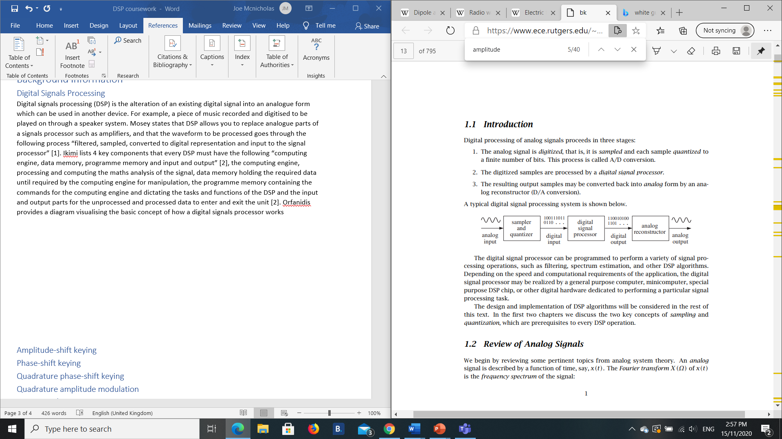

Figure 1 - Typical digital signals processing system [3]
Orfanidis also gives three stages to Digital processing of analogue signals. These are:
- The analogue signal is first digitised, as seen in Figure 1, it is sampled and quantised into bits. This is also known as A/D conversion
- These newly digitised samples are processed by the DSP
- The signal is then reconstructed into analogue form by the analogue reconstructor (A/D conversion) [3].

Amplitude-shift keying
Amplitude-shift keying is a form of digital modulation, being a “carrier signal that varies in accordance with the message signal” [4]. ASK is a digital signal which shows a change in the amplitude of the carrier wave while phase and frequency are kept constant. This change is demonstrated digitally between two discrete values, 1 and 0. When the digital bit is 0, the carrier wave is not transmitted, when the data bit is 1 then the carrier wave can be transmitted. In Figure 2 digital bits (i) are seen influencing the carrier wave (ii) to produce the ASK modulated wave (iii) [5].
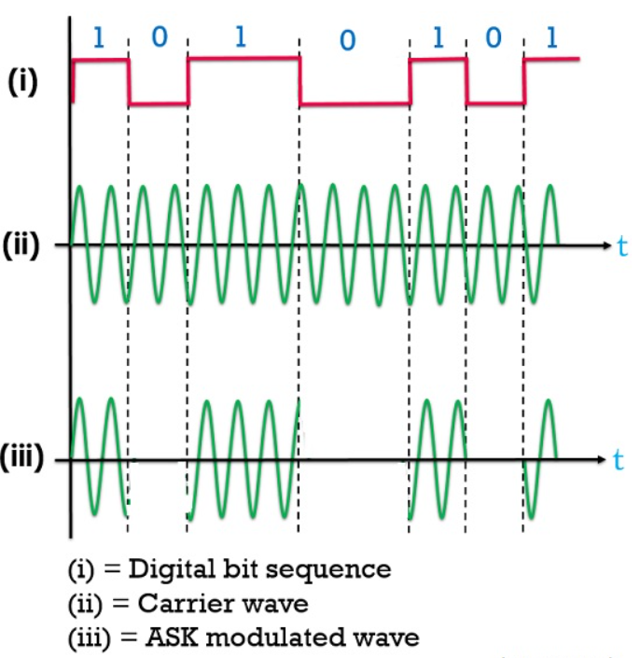
Figure 2 - Waveforms of amplitude phase keying (ASK) [5]

Phase-shift keying
PSK or Phase shift-keying is another form of digital modulation which utilises changing phases rather than amplitude. Penttinen states “Another way to modulate digital data onto an analogue carrier is to apply data-dependant phase shifts to the carrier signal” [6]. We can see in Figure 3 that the phase changes from 0 to 180 degrees depending on the digital data being transmitted. [7].
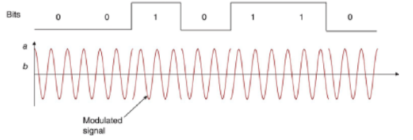

Figure 3 - BPSK Modulated signal [7].

Quadrature phase-shift keying
Quadrature phase-shift keying (QPSK) is another form of modulation which unlike ASK and PSK can display two bits per symbol, instead of a 1 or a 0, it can display 00, 01, 10 and 11 as seen in Figure 5. In ASK there are only two amplitude options 1 and 0. In QPSK there are four and these are determined by phase [8]. In a phase there is 360 degrees of phase, meaning the phase can be split into 4 phase states spaced at 90 degrees apart (Figure 5). Frenzel states “The modulator produces two sine carriers 90 degrees apart. The binary data modulates each phase, producing four unique sine signals shifted by 45 degrees from one another” [9].

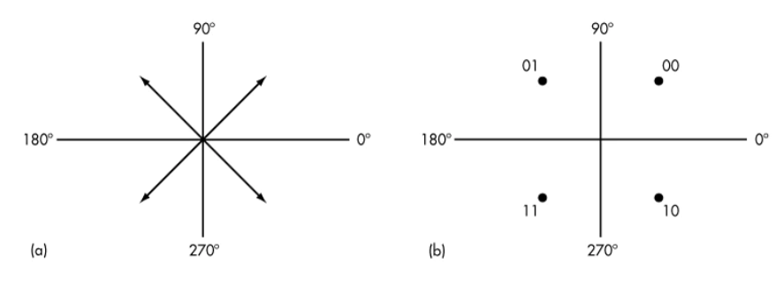

Figure 4 - (a) phasor diagram, (b) constellation diagram. Showing QPSK Modulation

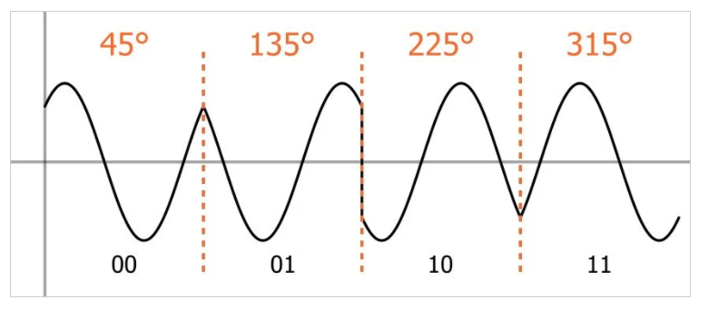

Figure 5 - QPSK modulation showing phase differentiation

Quadrature amplitude modulation
Quadrature amplitude modulation (QAM) is described by Alencar as “a versatile scheme that uses sine and cosine orthogonality properties to allow the transmission of two different signals in the same carrier, using a common bandwidth” [10]. QAM is a signal whereby two carrier signals are shifted in phase by 90 degrees (sine and cosine) and then modulated and combined, one signal being referred to as the in phase signal, the other being referred to as the Q signal. This new modulated signal incorporates phase and amplitude variations [11]. QAM serves to increase the channel bandwidth by using two input signals and can transmit two different message signals in the same channel [12].

Simulation Models

Amplititude-shift keying (ASK)
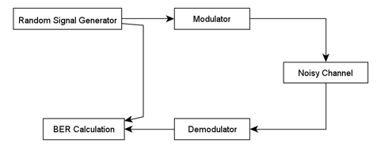
A generic diagram of how each DSP system will work can be seen in Figure 6. However the components that make up each of these systems may differ. These components can be found in the annex. ASK will be explained in detail in this section, the following sections for different systems will show the different components and settings for the other systems.
Figure 6 - Generic DSP diagram

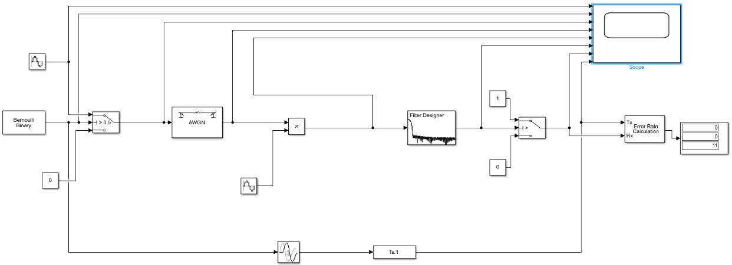

Figure 7 - ASK simulation on Matlab
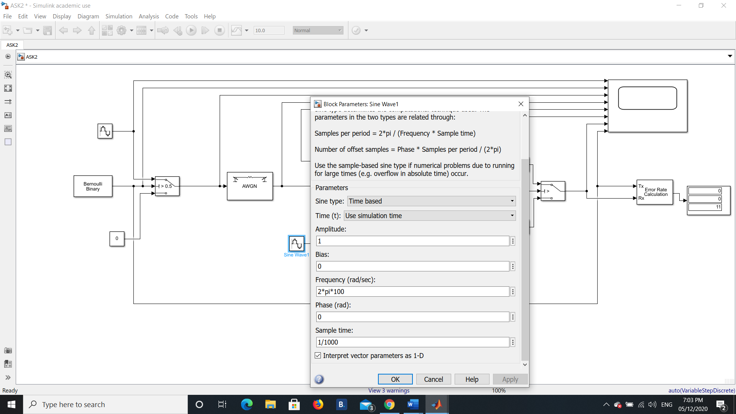
Figure 7 shows amplitude shift keying, the sine wave generators are created with the settings in Figure 8. It should be noted that a signal delay was created to compare transmitter data with receiver data, this is due to the transmitter data being slightly delayed by the filter.

Figure 8 - Sine Wave settings
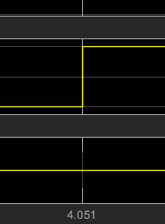
The upper yellow line in Figure 10 shows how the signal is delayed by the filter. As the simulation lasts 10 seconds, meaning the change in data should be on the second. Here we see a delay of 0.051 seconds, this will be the delay that is inputted into the transport delay seen in Figure 9.
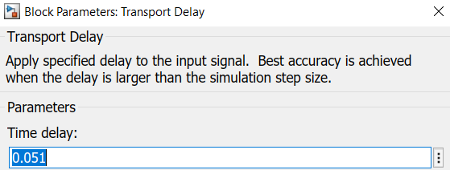

Figure 9 - Transport delay time delay input

Figure 10 - Scope readings showing delay of filtered signal

The filter in Figure 11 blocks out signals that are not of interest and focuses on the correct signals to complete the experiment. For this filter a low pass configuration has been chosen as the signal being looked at will start at zero and then continue to grow. The F pass and F stop have been set up in such a way to lower the order to 102, which means there will be 102 samples delay between the input and output of the filter. As a whole the cycle from 0 to 1 and back again will take two seconds, our frequency is 0.5hz, so a value of greater than 0.5 can be selected for the F pass category.
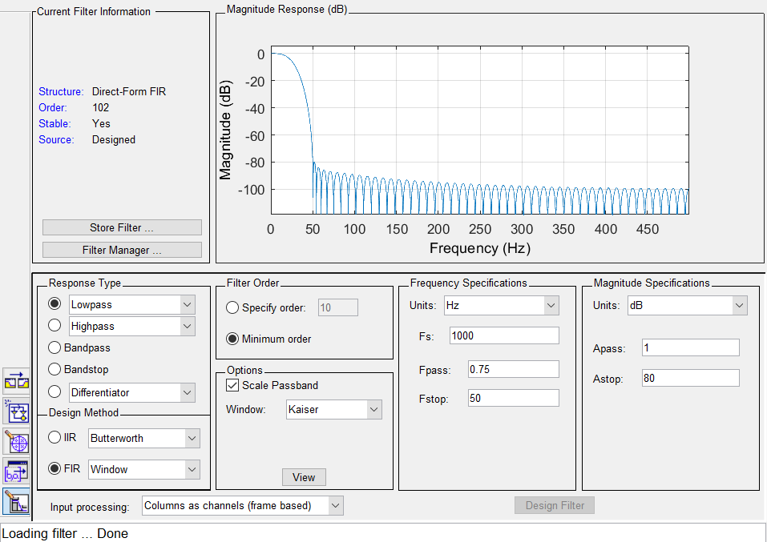

Figure 11 – Filter design for demodulating component of ASK modem.
Once the ASK modem has been built, then the simulations commenced. This was done by changing the signal to noise ratio in the AWGN box seen in Figure 12. The higher the number input into this box the more signal will come through. Conversely the lower the number the more noise was be added to the signal.
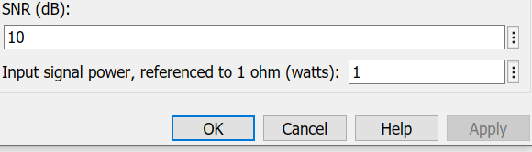
Figure 12 - Signal to noise ratio
As a new binary sequence is generated each time, the author will run a simulation five times at each SNR value and take the average bit error rate (BER) of those five to plot against the corresponding SNR. As a control the simulation is run without the AWGN box to give a clean signal with zero chance of noise.

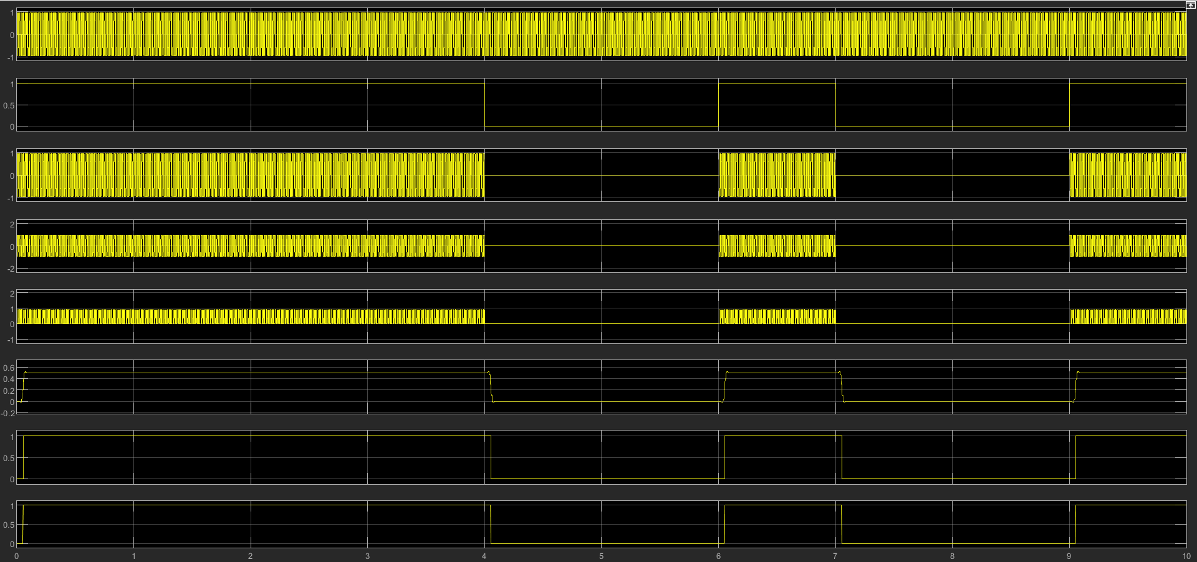
Figure 13 - Scope showing different signal readings taken at different parts of the modem
Waveforms numbered top to bottom | Waveform description
1 | Carrier wave
2 | Binary signal from Bernoulli generator
3 | Modulated Signal
4 | Modulated signal with AWGN
5 | Pre filtered signal
6 | Filtered signal
7 | Received data
8 | Transmitted data

Table 1 - Table explaining the signals shown in Figure 13
According to Table 1 any errors should be seen in row seven of Figure 13, as this image was taken from an ASK simulation with no AWGN, there are no errors showing here.
The author will use the same SNR values for each simulation to show where the signal begins to be clouded by noise more comparatively between systems.

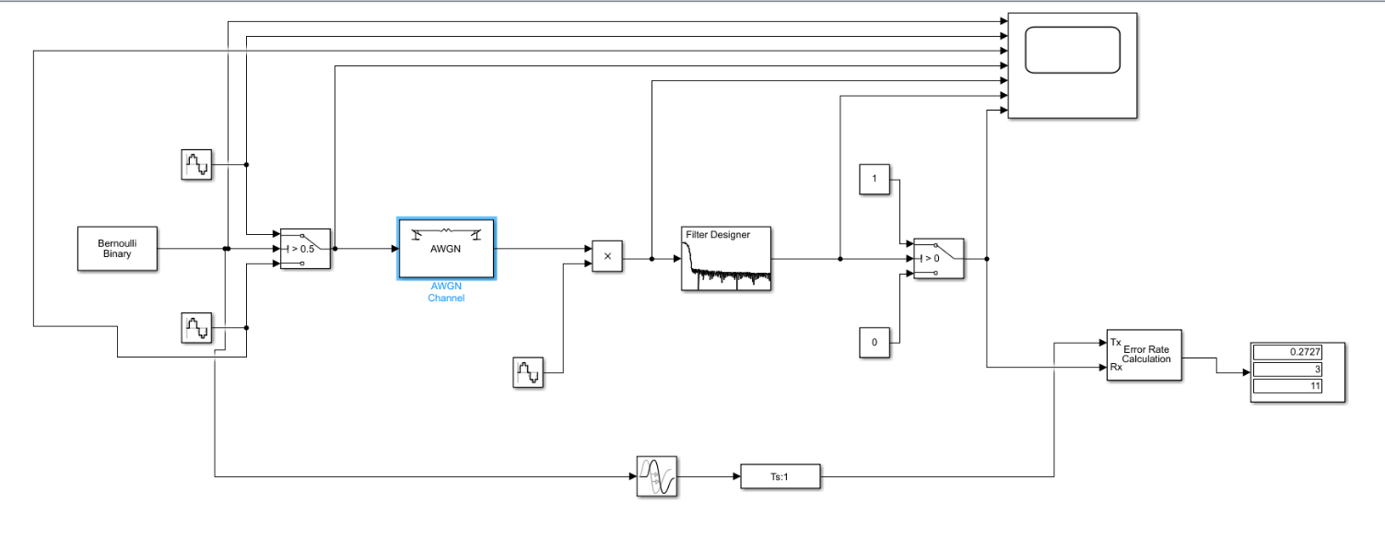
Phase-shift keying (PSK)
Figure 14 - PSK simulation on Matlab
Figure 14 shows a simulation in Matlab of a phase shift key modem. The author will briefly discuss the differences between the two systems.
The first difference is the value of the phase section within the sine wave circled in Figure 14. It has been set to pi, as seen in Figure 15.
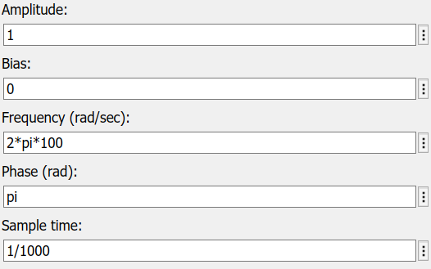
Figure 15 - Sine wave configuration settings
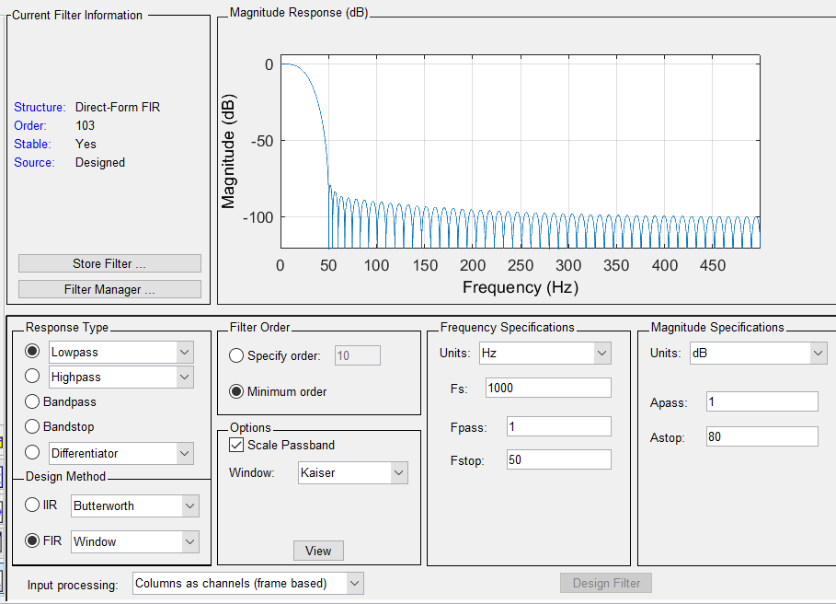
The other difference is the filter settings seen in Figure 16. The order is different due to the Frequency specifications in the circled area.

Figure 16 - Filter design settings for PSK

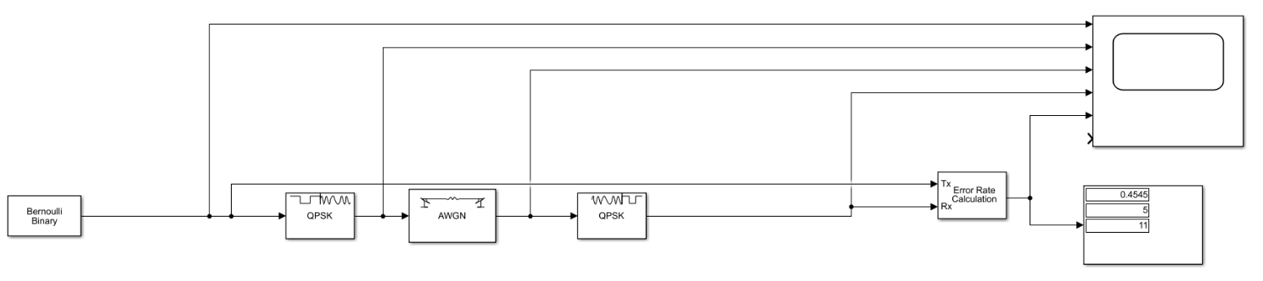
Quadrature phase-shift keying (QPSK)
Figure 17 - QPSK simulation on MATLAB
Due to unfamiliarity with the MATLAB component system, the author has elected to use QPSK modulator and demodulator baseband boxes to fulfil the simulation requirement for QPSK.

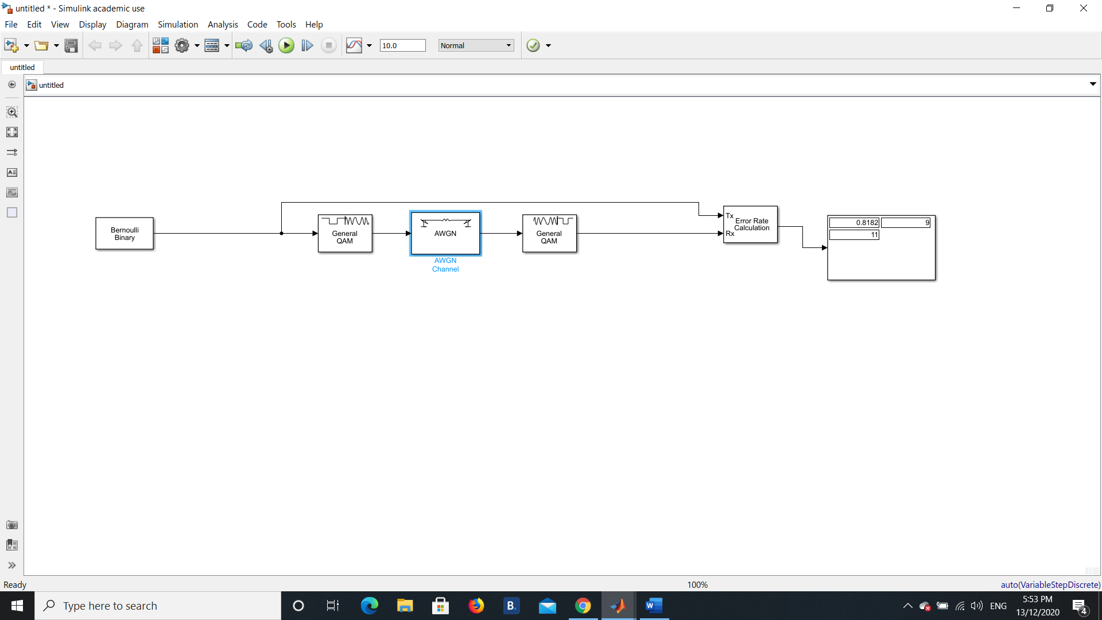
Quadrature amplitude modulation (QAM)
Figure 18 - QAM simulation on MATLAB
Again, due to unfamiliarity with the MATLAB component system, the author has elected to use pre-made QAM modulator and demodulator components.

Results

ASK
SNR | BER (Average of 5)
N/A - Control | (0 + 0+ 0 + 0+ 0) / 5 = 0
0 | (0 + 0.09091 + 0 + 0.09091+ 0) / 5 = 0.036364
-1 | (0 + 0.09091 + 0 + 0 + 0) / 5 = 0.018182
-2 | (0.09091 + 0.09091 + 0 + 0.09091 + 0.09091) / 5 = 0.072728
-3 | (0.2727 + 0.2727 + 0.1818 + 0.2727 + 0.09091) / 5 = 0.218162
-4 | (0.09091 + 0.1818 + 0.2727 + 0.1818 + 0.2727) / 5 = 0.199982
-5 | (0.09091 + 0.2727 + 0.2727 + 0.1818 + 0.1818) / 5 = 0.199982
-6 | (0.1818 + 0.2727 + 0.1818 + 0.1818 + 0.09091) / 5 = 0.181802
-7 | (0.1818 + 0.09091 + 0.1818 + 0.09091 + 0.09091) / 5 = 0.127266
-8 | (0.1818 + 0.1818 + 0.2727 + 0.2727 + 0) / 5 = 0.1818
-9 | (0.1818 + 0.09091 + 0.2727 + 0.1818 + 0.4545) / 5 = 0.236342
-10 | (0.4545 + 0.1818 + 0.1818 + 0.1818 + 0.3636) / 5 = 0.2727
-15 | (0.09091 + 0.1818 + 0.2727 + 0.2727 + 0.2727) / 5 = 0.218162
-20 | (0.6364 + 0.1818 + 0.1818 + 0.6364 + 0.3636) / 5 = 0.4
-25 | (0.6364 + 0.2727 + 0.4545 + 0.4545 + 0.3636) /5 = 0.43634
-30 | (0.4545 + 0.4545 + 0.2727 + 0.4545 + 0.5455) / 5 = 0.43634
-50 | (0.6364 + 0.4545 + 0.5455 + 0.8182 + 0.4545) / 5 = 0.58182
Table 2 - Table showing signal to noise ratio versus bit error rate for ASK

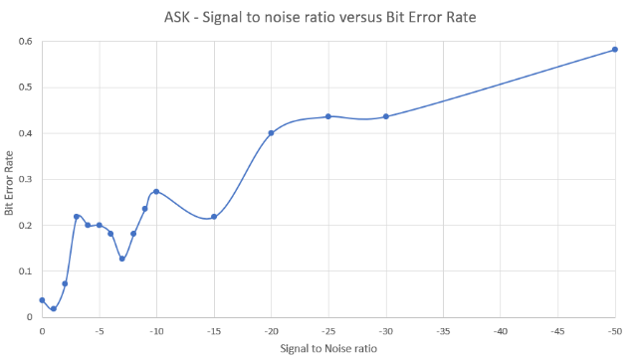
Graph 1 - Signal to noise ratio versus Bit Error Rate for ASK
As seen Table 2 and Graph 1 bit error rate increases as signal to noise ratio is decreased (more noise in system). There are some inconsistencies in this curve, but as the sequence is random each time, this may lead to a recorded error rate that is lower.

PSK
SNR | BER (Average of 5)
N/A - Control | (0 + 0 + 0 + 0 + 0) /5 = 0
0 | (0 + 0 + 0 + 0 + 0) /5 = 0
-1 | (0 + 0 + 0 + 0 + 0) /5 = 0
-2 | (0 + 0 + 0 + 0 + 0) /5 = 0
-3 | (0 + 0 + 0 + 0 + 0) /5 = 0
-4 | (0 + 0 + 0 + 0 + 0) /5 = 0
-5 | (0 + 0 + 0 + 0 + 0) /5 = 0
-6 | (0.09091 + 0 + 0 + 0.09091 + 0) / 5 = 0.036364
-7 | (0 + 0.09091 + 0.09091 + 0.09091 + 0) /5 = 0.054546
-8 | (0.09091 + 0 + 0.09091 + 0.09091 + 0) /5 = 0.054546
-9 | (0.09091 + 0.2727 + 0.09091 + 0.09091 + 0.1818) / 5 = 0.145446
-10 | (0.1818 + 0.1818 + 0.1818 + 0.2727 + 0.2727) / 5 = 0.21816
-15 | (0.2727 + 0.3636 + 0.1818 + 0.3636 + 0.4545) / 5 = 0.32724
-20 | (0.3636 + 0.3636 + 0.09091 + 0.4545 + 0.2727) /5 = 0.309062
-25 | (0.4545 + 0.2727 + 0.3636 + 0.4545 + 0.4545) / 5 = 0.39996
-30 | (0.5455 + 0.4545 + 0.3636 + 0.6364 + 0.3636) / 5 = 0.47272
-50 | (0.5455 + 0.2727 + 0.5455 + 0.4545 + 0.3636) / 5 = 0.43636
Table 3 - Table showing signal to noise ratio versus bit error rate for PSK

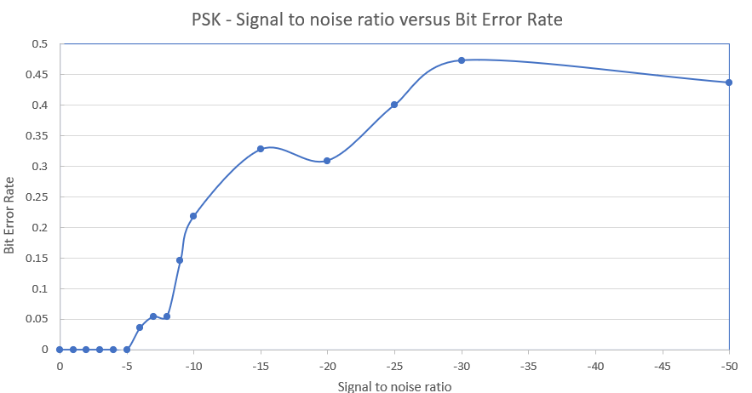
Graph 2 - Signal to noise ratio versus Bit Error Rate for PSK
Graph 2 and Table 3 show that it isn’t until the SNR reaches negative six that errors begin to creep into the system. Again, this appears to be subject to the random nature of the signals given out by the Bernoulli generator. The increase is BER also seems to be steeper from negative five to negative fifteen SNR.

QPSK
SNR | BER (Average of 5)
N/A - Control | (0 + 0 + 0 + 0 + 0) / 5 = 0
0 | (0.09091 + 0.1818 + 0.09091 + 0.2727 + 0.1818) / 5 = 0.163624
-1 | (0.1818 + 0.09091 + 0 + 0.1818 + 0.1818) / 5 = 0.127262
-2 | (0.2727 + 0.1818 + 0 + 0.2727 + 0.09091 / 5 = 0.163622
-3 | (0.09091 + 0.09091 + 0.1818 + 0.3636 + 0.1818) / 5 = 0.181804
-4 | (0.09091 + 0.2727 + 0.09091 + 0.2727 + 0.1818) / 5 = 0.181804
-5 | (0.4545 + 0.3636 + 0.1818 + 0.3636 + 0.3636) / 5 = 0.34542
-6 | (0.4545 + 0.3636 + 0.4545 + 0.2727 + 0.3636) / 5 = 0.38178
-7 | (0.4545 + 0.5455 + 0.3636 + 0.4545 + 0.5455) / 5 = 0.47272
-8 | (0.5455 + 0.5455 + 0.5455 + 0.5455 + 0.4545) / 5 = 0.5273
-9 | (0.6364 + 0.6364 + 0.6364 + 0.6364 + 0.6364) / 5 = 0.6364
-10 | (0.4545 + 0.4545 + 0.4545 + 0.5455 + 0.4545) / 5 = 0.4727
-15 | (0.6364 + 06364 + 0.5455 + 0.7273 + 0.7273) / 5 = 0.65458
-20 | (0.7273 + 0.7273 + 0.5455 + 0.4545 + 0.4545) /5 = 0.58182
Table 4 - Table showing signal to noise ratio versus bit error rate for QPSK

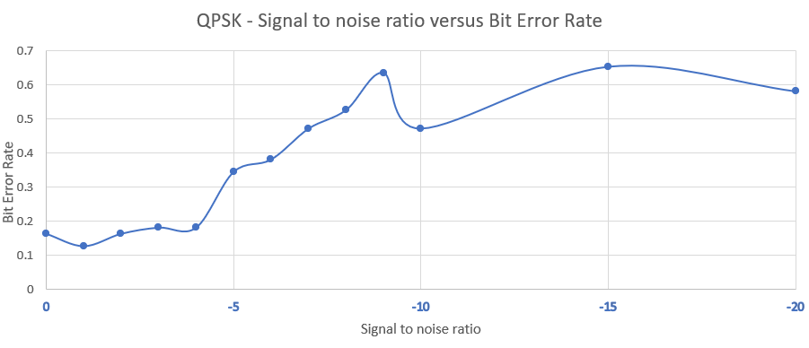
Graph 3 - Signal to noise ratio versus Bit Error Rate for QPSK
As can be seen in Table 4 and Graph 3 in comparison to PSK and ASK the BER is much greater at lower SNR. Breaking the 50% error rate at an SNR of negative eight. The SNR was not raised any further as the BER was greater than 50%.

QAM
SNR | BER (Average of 5)
N/A - Control | (0 + 0 + 0 + 0 + 0) / 5 = 0
0 | (0.3636 + 0.3636 + 0.3636 + 0.3636 + 0.3636) / 5 = 0.3636
-1 | (0.4545 + 0.4545 + 0.4545 + 0.3636 + 0.4545) / 5 = 0.43632
-2 | (0.4545 + 0.4545 + 0.4545 + 0.6364 + 0.6364) / 5 = 0.52726
-3 | (0.7273 + 0.8182 + 0.6364 + 0.6364 + 0.5455) / 5 = 0.67276
-4 | (0.6364 + 0.7273 + 0.7273 + 0.6364 + 0.6364) / 5 = 0.67276
-5 | (0.7273 + 0.7273 + 0.6364 + 0.6364 + 0.6364) / 5 = 0.67276
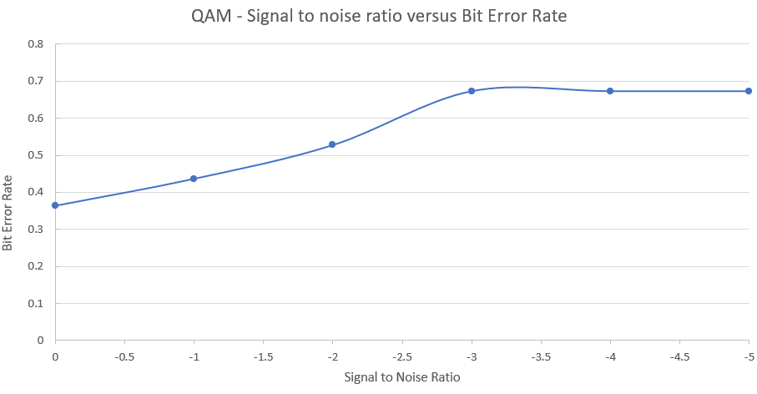
Table 5 - Table showing signal to noise ratio versus bit error rate for QAM
Graph 4 - Signal to noise ratio versus Bit Error Rate for QAM

As seen in Graph 4 and Table 5, only a minor increase in the SNR causes an increase in Bit error rate. Logging a 36% error rate at a zero SNR. An increase of SNR to negative two causes the error rate to increase above 50%. This is the least robust system when additive white gaussian noise is added.

Discussion
ASK and PSK were far more robust when AWGN was added than QPSK and QAM. PSK in particular did not react to additional noise until SNR reached -6, although after this BER rose sharply before beginning a steadier incline at -10 SNR. ASK proved to be the next most effective system at resisting the effects of noise, although the ASK system began displaying BER as soon as SNR was at zero gradually raised it took until -50 SNR for it to breach the 50% BER ceiling. QPSK begun with a 16% BER at 0 SNR before breaching 50% BER ceiling at -8 SNR, reaching this level much quicker than ASK or PSK. ASK breached the 50% BER ceiling at -50 SNR and PSK did not breach at all throughout the experiment. QAM was by far the worst affected by AWGN, starting at 36% BER for 0 SNR and breaching the 50% BER ceiling at only -2 SNR. These results are reflected in a similar study by Sadeque who noted that in Simulink BPSK outperformed QPSK and QAM [13]. It should be noted that the author selected pre made and configured modulation and demodulation components for building the QPSK and QAM circuits and that had the same method of construction been applied to PSK and ASK simulations the results may have turned out differently.

Conclusion
In conclusion as a means of transferring data in a Simulink setting, PSK appears to be the system of choice, followed by ASK, QPSK and QAM. However, author unfamiliarity with the workings of MATLAB and Simulink may have led to a defective experiment in that different components could have been used to build the QPSK and QAM circuits and have led to different results.

Appendices
Annex A: Component parts to simulated DSP systems.
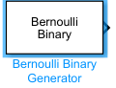
Bernoulli Binary Generator. Used to generate random sequences of binary code. The “Random signal generator”. Used in ASK, PSK, QPSK and QAM simulations

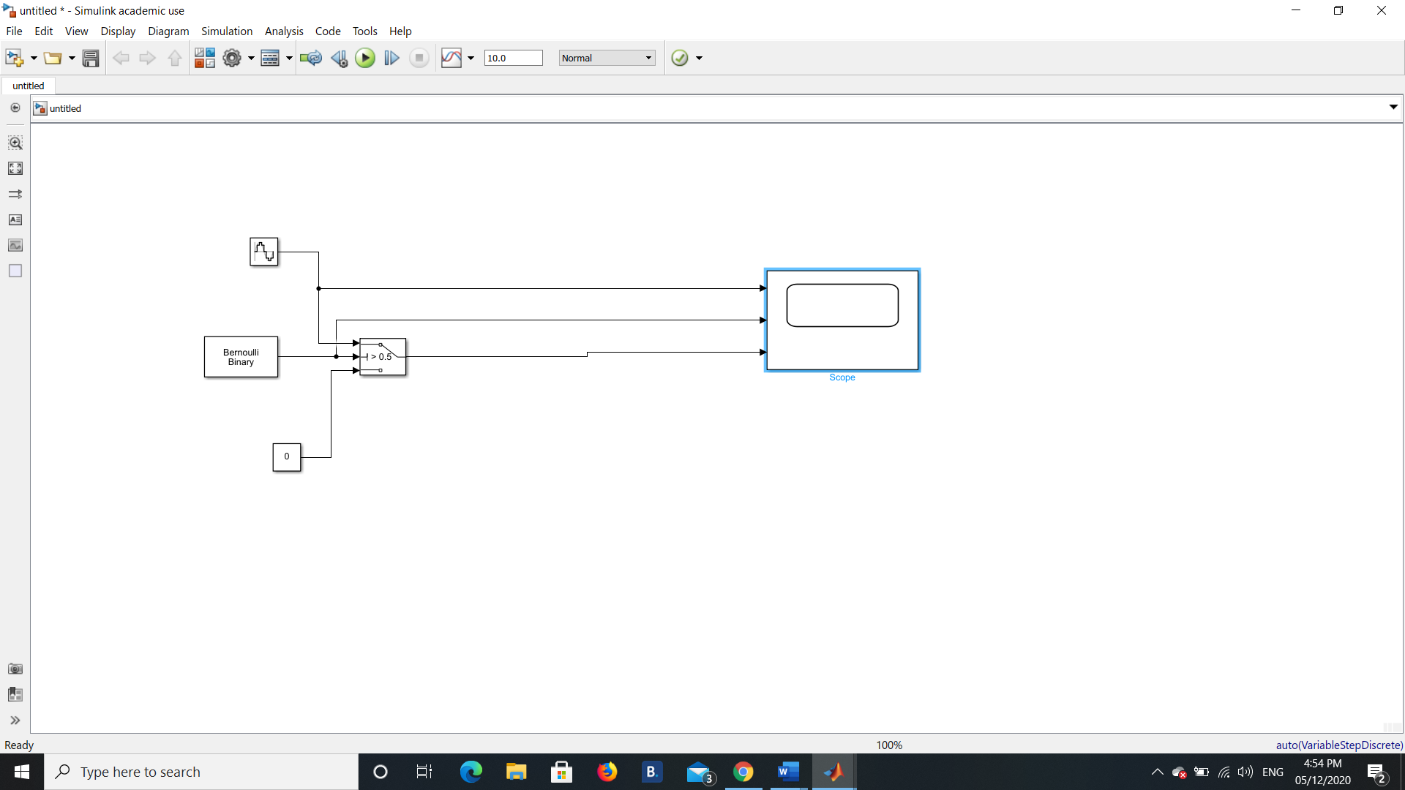
Modulator in ASK and PSK system. Consists of sine wave generator (carrier wave), switch set to allow zero through 50% of the time. A constant set to zero.

Additive white gaussian noise generator. This generates the signal noise and is constantly changed to add noise to each DSP system. Used in ASK, PSK, QPSK, QAM.
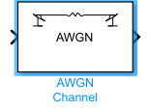

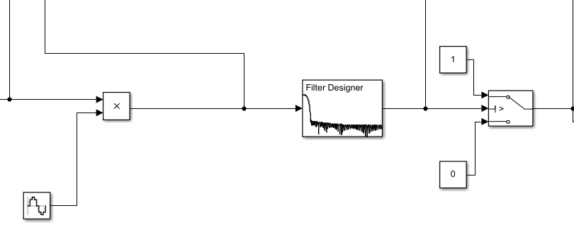

Demodulator for ASK and PSK DSP system. Consists of sine wave generator, a product to multiply sine wave generator and signal moving through AGWN generator. A filter designer component. A Switch with 1 and 0 constant inputs into them.
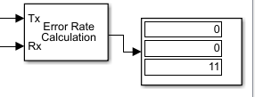

Error rate calculator with delayed carrier signal moving into the transmit input and the delayed carrier wave going into the receive input. The readout shows from top to bottom: Bit Error rate, number of errors detected, number of symbols compared.

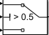
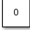
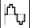
Switch
Contstant
Sine Wave Generator

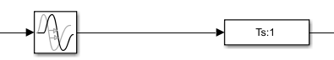
Signal delay. Containing transport delay and signal specification blocks

References

[1] | S. Mosey, "Signals and Sequences," University of Wales Trinity St David, Swansea, 2020.
[2] | E. Ikimi, "The Fundamentals of Digital SIgnal Processing," Electronics Point, March 2020. [Online]. Available: https://www.electronicspoint.com/research/fundamentals-of-digital-signal-processing/#:~:text=The%20Fundamentals%20of%20Digital%20Signal%20Processing%201%20Key,carry%20out%20efficient%20signal%20modulation.%20More%20items...%20. [Accessed 15 November 2020].
[3] | S. J. Orfandis, "Sampling and Reconstruction," in Introduction to Signal Processing, Pearson Education Inc, 2010, p. 1.
[4] | WatElectronics.com, "What is modulation? Different types of modulation techniques," WatElectronics.com, 30 July 2019. [Online]. Available: https://www.watelectronics.com/types-of-modulation-techniques-with-applications/. [Accessed 15 November 2020].
[5] | Electronics Coach, "Amplitude Shift Keying - ASK," 2020. [Online]. Available: https://electronicscoach.com/amplitude-shift-keying.html. [Accessed 15 November 2020].
[6] | J. T. J. Penttinen, "Phase Shift Keying (PSK)," in The Telecommunications Handbook: Engineering Guidelines for fixed, Mobile and Satellite systems, Chichester, John WIley & Sons, 2015, p. 266.
[7] | R. Esmailzadeh, "Phase Shift Keying," in Broadband Telecommunications Technologies and Management, Wiley, 2016, pp. 162-163.
[8] | R. Keim, "Understanding Quadrature Phase Skift Keying (QPSK)," All About Circuits, 17 August 2016. [Online]. Available: https://www.allaboutcircuits.com/technical-articles/quadrature-phase-shift-keying-qpsk-modulation/. [Accessed 28 November 2020].
[9] | L. Frenzel, "Understanding Modern Digital Modulation Techniques," Electronic Design, 23 January 2012. [Online]. Available: https://www.electronicdesign.com/technologies/communications/article/21798737/understanding-modern-digital-modulation-techniques. [Accessed 23 November 2020].
[10] | M. S. d. Alencar, "Quadrature Amplitude Modulation," in Modulation Theory, Gistrup, River Publishers, 2018, p. 121.
[11] | electronicsnotes, "What is QAM: quadrature amplitude modulation," Radio-electronics.com, [Online]. Available: https://www.electronics-notes.com/articles/radio/modulation/quadrature-amplitude-modulation-what-is-qam-basics.php. [Accessed 29 November 2020].
[12] | Elprocus, "Quadrature Amplitude Modulation : Working Principle and Its Applications," [Online]. Available: https://www.elprocus.com/quadrature-amplitude-modulation/. [Accessed 29 November 2020].
[13] | G. Sadeque, "Bit Error Rate (BER) Comparison of AWGN Channels for Different Type's Digital Modulation Using MATLAB Simulink," American Scientific Research Journal for Engineering, Technology and Sciences (ASRJETS), vol. 13, no. 1, pp. 61-71, 2015.

