Student ID: | Student Name: William (Kai) Thompson
Working Title: The ripple effect of decarbonisation within the Marine Contracting Industry

- Academic Focus and Research Rationale

This dissertation proposes to examine the strategies deployed by incumbent firms within the marine contracting industry seeking to decarbonise their value chain.

The primary research question is: "What are the perceived changes in the marine contracting business environment related to decarbonization, and what strategies are being employed by incumbent firms to achieve effective decarbonization within the marine contracting industry?"

The aims and objectives of the research are as follows:

- To develop and deepen sector-specific understanding of decarbonization strategies utilized by incumbent firms in the marine contracting industry.
- To identify the perceived success factors of effective decarbonization strategies within the industry.
- To assess the risks and opportunities associated with energy transition and decarbonization in the marine contracting industry.
- To derive strategic insights from the study that could benefit the industry in terms of decarbonization efforts and sustainability practices.
- These aims and objectives will guide the research process and contribute to filling the existing research gap in understanding decarbonization strategies within the marine contracting industry.

The research will focus on examining the strategies employed by incumbent firms in the Marine Contracting Industry (MCI) to decarbonise their value chain. The context of the study includes the voluntary alignment or exceeding of Paris Agreement targets by organizations within the MCI, motivated by stakeholder and socio-economic forces. The boundaries of the study will encompass understanding the methods, capabilities, business models, continuity risks, and overall strategies that enable the realisation of decarbonization ambitions within the pledged timeframes. Ethical considerations will include obtaining informed consent from participants, ensuring confidentiality, and adhering to competition law compliance, specifically IMCA’s competition law policy.

The topic choice is justified based on the existing research gap in understanding the specific circumstances and embedded concepts surrounding decarbonization strategies in the marine contracting industry. The MCI is a niche and under-researched industry segment within the broader area of sustainability. Existing literature often infers or postulates information about the MCI from better-researched areas such as the energy sector or maritime industries. By focusing on the MCI, this research aims to contribute to academia by expanding the understanding of decarbonisation strategies and their implementation within this niche area of the industry. What is more, the MCI will become a significant actor within the future energy mix.

The research will be informed by various concepts and theories related to sustainability transition studies, stakeholder theory, energy transition, and business models. These frameworks will provide a foundation for analysing and interpreting the data collected. Additionally, concepts such as decarbonisation, value chain, and sustainability performance will be defined and applied within the research.

- Research Paradigm and Method

Given the omission of reliable secondary data sources, the proposed methodology will also be exploratory. Exploratory research methods will be instrumental in synthesising the nebulous challenges surrounding the decarbonisation of value chains that are otherwise not understood or researched for this niche segment—in particular, identification of the implied uncertainties, risks and opportunities presumed to be a component of Research Questions. Exploratory methodologies will complement the research questions by delving into new concepts and perspectives from industry actors- enriching the understanding of the research problem, improving the accuracy of results by identifying biases or data limitations and guiding future research areas (George, 2023)

To answer the Research Questions, a triangulation research method has been proposed to increase the credibility and validity of the research findings. This approach shall gather primary and secondary data from multiple sources whilst comparing and contrasting results to ascertain a more comprehensive understanding of the research topic.

The research methods chosen to gather data for this study are semi-structured interviews, content analysis of non-financial reports, and a literature review.

Advantages and Disadvantages of the Chosen Research Methods:

Semi-structured interviews:

Advantages:
- Allows for in-depth exploration and understanding of participants' perspectives and experiences.
- Provides rich, qualitative data that captures the nuances and complexities of decarbonisation strategies (Kvale, 1996).

Disadvantages:
- Time-consuming process, requiring scheduling and conducting interviews.
- Findings may be influenced by interviewer bias or participant self-presentation (George, 2023).

Content analysis of non-financial reports:

Advantages:
- Enables analysis of tangible decarbonisation efforts and strategies documented by incumbent firms (Lou, 2019)..
- Provides insights into industry-wide trends and patterns (Lou, 2019).
- Convention content analysis considered flexible, complimenting exploratory research designs (Elo & Kyngäs, 2008).

Disadvantages:
- Limited to the information disclosed in reports, which may not accurately represent true decarbonisation status given the presence of corporate self-interest (Cohen, 2022).

Literature review:

Advantages:
- Helps establish a theoretical framework and context for the study (Hart, 1998).
- Provides a broad overview of existing knowledge and identifies research gaps (Snyder, 2019).

Disadvantages:
- Relies on the quality and relevance of existing literature.
- May not capture the most recent developments or specific nuances of the marine contracting industry.

There are some methodological limitations associated with the aforementioned research design;

- Sample Size: The study may have a limited sample size due to resource constraints, potentially impacting the generalizability and representativeness of the findings.

- Researcher Bias: Given the Primary Researcher works within the researched industry preconceptions and subjectivity may influence the interpretation and analysis of the data, potentially introducing bias into the findings.

- Data Availability: The availability and quality of non-financial reports may vary across incumbent firms, potentially limiting the scope and depth of the content analysis.

- Time Constraints: Conducting interviews, analysing data, and reviewing literature within a limited timeframe may restrict the depth of analysis and exploration of the research topic.

- Data Collection and Analysis

A key challenge of this study was to ensure that qualitative data collected via the outlined research methods are representative of the Marine Contracting Industry. This is deemed essential given the research aim to 'deepen sector-specific understanding of utilised decarbonisation strategies' and 'perceived success factors' for the marine contracting industry. The respondent population for semi-structured interviews and content analysis consists of individuals and organisations working in global or international marine contracting firms. In filtering to 'Global Contractors' and 'International Contractors' within the IMCA membership, the 'leading' organisations within the industry. The sample organisations chosen are industry leaders, reflecting current market trends, the competitive landscape, and the latest consumer insights. These organisations also address the most critical concerns of stakeholders by adapting and shaping stringent standards. As industry forerunners, they influence the direction and terms of engagement for their peers in the MCI.

The study shall also utilise purposive sampling for semi-structured interviews, as per Table 1.

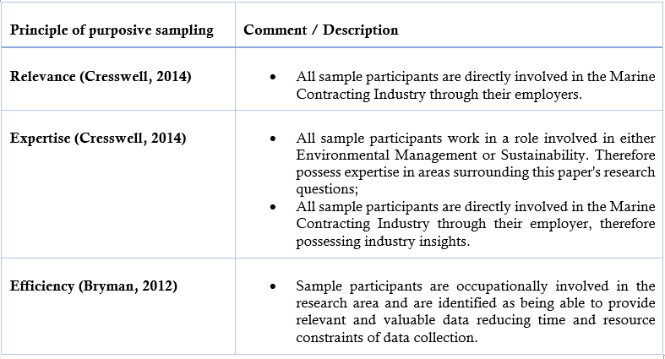
Table 1: Purpose Sample Principle (Cresswell, 2014) (Bryman, 2012)

The data collected through semi-structured interviews will be transcribed and analysed using a conventional content analysis approach. The interviews will be coded for themes and patterns to reveal key insights and trends. Content analysis of non-financial reports will involve systematic coding and categorisation of relevant information related to decarbonisation strategies. The literature review will involve synthesising and analysing existing scholarly works to identify gaps and common themes. ATLAS.ti shall be used within this Research Design for data coding, transcription, and analysis. Specifically, ATLAS.ti Software package will be used to assign codes to collected data and then query the data. The software will create 'code co-occurrence' and 'code-document' tables for relevant sections.

The research may face limitations in terms of reliability due to subjective interpretation of qualitative data and potential biases in coding and analysis. Validity may be limited by the small sample size of interviews and the potential for self-reporting biases. Content analysis and literature review may also have inherent limitations in terms of generalisability.

However, efforts will be made to mitigate these limitations through transparent research practices, triangulation methods, and acknowledgment of potential biases in data interpretation (Noble & Heale, 2019) (Naeem, 2019).

- Resource and Time Management

There are limited human and financial resources required to complete the aforementioned research proposal.

Human Resources:
- Researcher: There will be one primary researcher involved in the study who will be responsible for conducting interviews, data analysis, and dissertation writing.

- Participants: Individuals will be recruited for semi-structured interviews, representing a purposive data sample across global and international IMCA organisations.

- Research Supervisor: Ad-hoc meetings with the research supervisor will ensure guidance, feedback, and support throughout the research process. This is anticipated to be limited given the availability of online resources and researchers prior experience.

Data Collection:
- Semi-Structured Interviews: Access to appropriate interviewees, scheduling, and conducting interviews with the participants. Semi-structured interviews will be performed online using Microsoft Teams application.
- Annual Reports: Obtaining the annual reports from nine organizations, which may involve communication and collaboration with relevant personnel.
- Literature Review: Access to online scholarship.

Data Analysis:

- As previously specified, Atlas.ti shall be utilised. Researcher will use a student subscription, costing 16.28 AUD per month. It is anticipated that this will be required for four months, once primary data sources are available.

Research Facilities:

- Computing Resources: It is not anticipated that specialised computing or research facilities will be required. Availability of a laptop and standard Window Applications is required for data analysis, online semi-structured interviews, and dissertation writing.

Timeline

Please see Appendix A.

References
Bryman, A., 2012. Social research methods. 4 ed. s.l.:Oxford University Press.
Cohen, S., 2022. Greenwashing Decarbonisation. [Online]
Available at: https://news.climate.columbia.edu/2022/05/16/greenwashing-decarbonization/
[Accessed 4 Febuary 2023].
Cresswell, J. W., 2014. Research design: qualitative, quantitative, and mixed methods approaches.. s.l.:Sage.
Elo, S. & Kyngäs, H., 2008. The qualitative content analysis process. Journal of advanced nursing, 1(62), pp. 107-115.
George, T., 2023. Exploratory Research | Definition, Guide, & Examples. [Online]
Available at: https://www.scribbr.com/methodology/exploratory-research/#:~:text=Exploratory%20research%20is%20a%20methodology,can%20be%20quantitative%20as%20well.
George, T., 2023. Semi-Structured Interview | Definition, Guide & Examples. [Online]
Available at: https://www.scribbr.com/methodology/semi-structured-interview/
Hart, C., 1998. Doing a literature review: Releasing the social science research imagination.. s.l.:Sage Publications.
Kvale, S., 1996. InterViews: An introduction to qualitative research interviewing. s.l.:Sage Publishing.
Lou, A., 2019. Content Analysis | Guide, Methods & Examples. [Online]
Available at: https://www.scribbr.com/methodology/content-analysis/
[Accessed 11 Feburary 2023].
Naeem, S., 2019. Data Triangulation in Qualitative Research. [Online]
Available at: http://researcharticles.com/index.php/data-triangulation-in-qualitative-research/
[Accessed 6 Febuary 2023].
Noble, H. & Heale, R., 2019. Triangulation in research, with examples. Evidence Based Nursing, 22(3), pp. 67-68.
Snyder, H., 2019. Literature review as a research methodology: An overview and guidelines. Journal of Business Research, Volume 104, pp. 333-339.

Appendix A: Dissertation Gantt Chart

