
Why organisational change requires careful implimentation
Deep dive into changes in IVS

April 26, 2026
UNIVERSITY OF WALES TRINITY SAINT DAVID

Executive Summary
Organisational change refers to significant changes in how work is done within a workplace, ranging from new structures and technologies to alterations in the company’s strategy and/or culture. With changes within an organisation, there are structures that can assist management during the planning and implementation stages, focusing especially on supporting and preparing their employees throughout the transition. There are often key drivers that cause organisations to make these changes, with these often being external forces such as technological innovation, shifts in markets and regulations, and internal forces such as new leadership or strategies within the company, lack of performance, growth stages, and employee needs.
Within the category of change there are really two different types which can be considered such as, Large scale change and small scale changes, with the large one often being referred to as transformational, in which a company can experience massive sweeping changes with a key example of this being Netflix changing from a DVD mail based system to a streaming system, as well as small scale changes, often referred as incremental, in which the change can be more of an tactical/incremental process, this being the change referred to within this report.
This report evaluates the implementation of a new clocking-in system, SAGE HR, within a well-established organisation, IVS, as well as defining the concepts within the category of change, summarising the driving forces and types of change, comparing many different models of change, and evaluating the employee motivation/support and the success/failure of the implementation.
The analysis of the report applies key changes in management theories, including Lewin’s Force field analysis as-well as his Three step Model (Unfreeze-Change-Refreeze), Herzberg’s Two factor Theory, Kotter’s eight-step model & ADKAR’s model, since many issues with the systems implementation stemmed from failing to adhere to these exact theories listed throughout the report, since these theories are widely used to guide various changes within an organisation. While the findings within the report suggest that the organisation achieved the technical implementation, it failed to effectively consider/manage the employee resistance due to a breakdown in communication, minimal training, and a lack of engagement during and after implementation.
Recommendations are provided at the latter end of the report to provide improvements that could be made during the implementation of any future changes within the organisation, emphasising employee involvement during the process, applying more of a phased implementation, and providing the employees with continuous support during the process.

Table of Contents
Executive Summary 2
Table of Figures 3
1.Introduction 4
2.Main Findings 5
2.1. Evaluation of the change within management. 5
2.2. Force field analysis 6
2.3. Application of Lewin’s Three-Step Model 7
2.3.1 Unfreeze 7
2.3.2 Change 7
2.3.3 Refreeze 8
2.4. Critical Comparison of Change Models (Lewin vs Kotter vs ADKAR) 8
2.5 Employee Motivation and Support 9
2.6. Evaluation of Success/Failure 10
2.7 Recommendations 11
3. Conclusion 12
Bibliography 13

Table of Figures
Figure 1: Force Field Analysis of Sage HR Implementation 5
Figure 2 - Herzberg’s Two-Factor Theory 8

1.Introduction
IVS (Industrial Valve Services) is a valve technician-based company based in Pembroke-dock, Swansea, and recently in Southampton, which specializes in maintenance, repair, and testing of various valves, ranging from control valves, pilot-operated relief valves to PSVs (pressure safety valves) or PRVs (pressure relief valves). Across the years, IVS has gone through many changes, ranging from changes with management to clock-in systems & new software, replacing its manual clocking-in system with a new digital platform (SAGE HR) to track employee hours and to manage payroll more efficiently. The main driving force for this change was due to the major changes in management, as well as the fact that IVS went public with backing from Amcomri Group plc, enforcing new rules with the need for more efficient timekeeping and integration with HR systems. However, with new changes come issues, including many senior and long-term serving employees expressing resistance to these changes, due to differences in expectations employees have over their managerial/employer counterparts, which creates a lot of tension in the workplace.
They found the new systems unfamiliar and were more comfortable with the old systems in place, with many also expressing that they don’t have the required digital literacy skills to use the required app, meaning the company had to train and purchase company devices so that they could implement these systems fully.
The reason why organisational change is required within IVS is that it is an essential tool used for a company to stay competitive within its operational efficiency (Mullins & Rees., 2023) (Burnes, Managing change, 2017). However, having poorly managed change can make this implementation much harder, with resistance and reduced morale, possibly leading to implementation failure (Kotter, 1995).
This report examines how the SAGE HR Implementation was managed within the company, evaluating its effectiveness, applying various theories of change, such as Lewin’s Force Field analysis, to identify the driving and restraining factors within the changes made, to evaluate the process of its implementation, and to provide recommendations for future implementations.

2.Main Findings

2.1. Evaluation of the change within management.
The implementation of the new system, SAGE HR, was a completely top-down idea, with minimal employee involvement. With simply one meeting prior to its implementation, followed by a very basic training session, mainly consisting of just installing the app on the devices & providing logins to the system, the meeting lasted 10 minutes with the employees, being told to figure it out. According to Kotter (Appelbaum, Habashy, Malo, & Shafiq, 2012) (Kotter, 1995), achieving effective change requires creating urgency within the company, enabling participation, and building coalitions, which were largely absent when it came to the implementation within IVS.
The lack of input from the employees, regarding the implementation, contributed to significantly more employee resistance. (Mullins & Rees., 2023) (Oreg, Personality, context, and resistance to organizational change, 2006) argue that when applying change within the workplace, employee involvement is a critical component for it to succeed, due to reducing the uncertainty and improving the commitment employees have towards the change. In the case of IVS, the employees, in this case, the older workers, felt massively excluded, which led to resistance and disengagement (Oreg, Vakola, & Armenakis, Change Recipients’ Reactions to Organizational Change, 2011). This led to key workers within the company sadly departing, stating that the company didn’t require the change and that it wasn’t worth spending their remaining years relearning new systems when they could just retire.
With the implementation of these new systems, one of the key contributors to the Pushback by the older employees was due to the Training and provision being inadequate for the speed at which it was implemented, requiring employees to go home and by the morning completely understand the new system and all of its kinks, without any training at all. The only meeting that we had on the app was just the downloading of the application on either company devices or personal ones, which many employees weren’t happy with due to failing to accommodate different learning needs, particularly for employees with lower digital literacy (Davis, 1989), as well as the possible invasion of privacy, led by downloading on personal devices. Research by Burnes (Burnes, Managing change, 2017)and Venkatesh et al. (Venkatesh, Morris, Davis, & Davis, 2003) mentions that continuous learning and perceived ease of use are essential requirements when implementing technological change.
Additionally, IVS failed to implement a phased transition of the new changes, which Hayes (Hayes, 2025) suggests that a more gradual approach to implementing change reduces the possible disruption and allows for feedback on where it can improve, further allowing the older lot to get comfortable with the change more gradually. The instant switch to the new systems introduced major stresses on not just employees but also payroll staff which resulted in errors on Payday, which further disoriented the employees to the new changes, highlighting that issues like this never happened during the old system, reinforcing the findings of Bordia on the uncertainty within the company during major organisational change (Bordia, Hobman, Jones, Gallois, & Callan, 2004).
In total, the process of implementation was completely ineffective, as while the system was implemented within the company, the acceptance of the employees was very low, eventually leading to returning to the old system of time clocking, with everyone returning to a paper based system in which we log all of our work done during the day, showing job numbers and date, in which we return to the office at end of day. The only thing that stuck with the implementation was the payroll system and holiday booking, since the cost of implementation was too great for the employer to go back on, with them spending great sums of money training the payroll staff before implementation, demonstrating a failure in managing the human aspects of change (Todnem, 2005).

2.2. Force field analysis
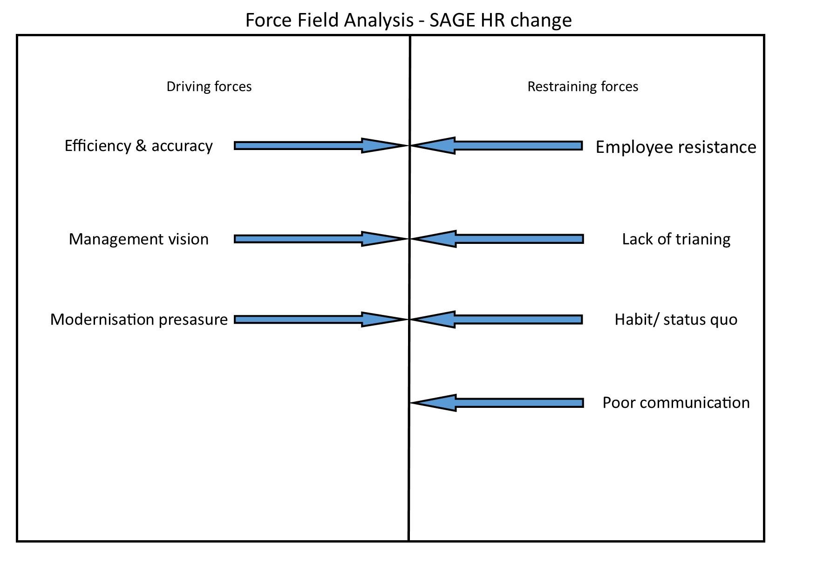
Figure 1: Force Field Analysis of Sage HR Implementation
Figure 1 above shows the balance between the restraining forces and the driving forces that affect the implementation of the new SAGE HR system. This diagram highlights the type of restraining forces that were seen during the implementation of a new system, such as employee resistance, lack of training, Habit/status quo & poor communication, which outweighed the driving forces of efficiency & accuracy, management vision & modernisation pressure, which contributed to the limited adoption of the new system. Lewin’s Force Field Analysis is used to provide a framework for understanding the dynamics of change (Lewin, 1951) (Burnes & Bargal, Kurt Lewin: 70 Years on, 2017).

Driving Forces
• Desire for increased efficiency and accuracy (Kotter, 1995)
• Management’s strategic vision for digital transformation (Beer & Nohria, 2000)
• External pressures to modernise HR systems (Pettigrew, 2012)

Restraining Forces
• Employee resistance and fear of technology (Oreg, Personality, context, and resistance to organizational change, 2006)
• Lack of training and digital skills (Venkatesh, Morris, Davis, & Davis, 2003)
• Strong attachment to existing routines (Weick & Quinn, 1999)
• Poor communication and lack of trust (Bordia, Hobman, Jones, Gallois, & Callan, 2004)

According to Burnes (Burnes, Managing change, 2017), achieving successful change requires strengthening the driving forces within the new system, while also reducing the restraining forces, ensuring an easy adoption of new systems. In the case of the adoption within IVS, this structure was not followed, in which the restraining forces were not addressed adequately, leading to a failure in adoption. This then shows that even with the best adoption of a new system, failing to minimise the restraining forces will lead to a failure in adoption to some level (Swanson & Creed, 2014).

2.3. Application of Lewin’s Three-Step Model

2.3.1 Unfreeze
Due to the Company IVS having failed to correctly prepare its employees for a new change within the workplace, the implementation of the new systems was not accepted by the employees. (Lewin, 1951) emphasises that it is important to initially break down the existing mindsets for old systems before implementing a new change, as doing so will allow the employees to more happily adopt the new systems more freely. Improving the communication, employee involvement, & more training prior to the adoption of the system would’ve reduced the resistance experienced (Hussain, et al., 2018)

2.3.2 Change
During the phase of transitioning from one system to another, there were no support mechanisms in place to assist with the change, which Hayes (Hayes, 2025) then highlights the importance of these systems of continuous feedback and engagement between the employer and employees during its implementation. Improving adoption through introducing ideas such as mentoring, tailored training & pilot testing prior to its complete adoption (Appelbaum, Habashy, Malo, & Shafiq, 2012).

2.3.3 Refreeze
Due to the new systems not being fully embedded into the company before passing out to the employees there was very limited reinforcement to these new behaviours from the new systems in place, & according to Mullins (Mullins & Rees., 2023), having these reinforcement mechanisms in place such as policy integration and recognition are essential to sustain change, which also aligns with Cummings, Bridgeman and Browns theory of the importance of stabilising the change within the company prior to full implementation (Cummings, Bridgman, & Brown, 2016).

2.4. Critical Comparison of Change Models (Lewin vs Kotter vs ADKAR)
A critical comparison of these change models within companies provides a clearer picture of the effectiveness they may have over different approaches, such as Lewin’s Three-Step model, which is widely used for its simplicity and foundational contribution to change management (Burnes & Bargal, Kurt Lewin: 70 Years on, 2017). Lewin’s offers a clear structure, such as (unfreeze-Chance-Refreeze), which makes it much more useful in understanding the planned change within the company. It is argued, however, that it is overly simplistic and linear, and doesn’t reflect the reality of the complexity within a modern organisation, where change is often a continuous process rather than in stages (Cummings, Bridgman, & Brown, 2016).
In comparison, Kotter’s eight-step Model provides a more detailed and practically realistic framework for implementation (Appelbaum, Habashy, Malo, & Shafiq, 2012) (Kotter, 1995), which emphasises that good leadership, vision, and communication are required in order to successfully implement change in the workplace, which was sorely lacking in the case of the implementation of the SAGE HR system. Kotter’s Model is great for highlighting the importance of creating urgency within the company and creating a guiding coalition towards the change. Kotter’s model, however, has also been criticised for being greatly time-consuming and too top-down heavy, which may be detrimental to a fast-changing environment (Appelbaum, Habashy, Malo, & Shafiq, 2012).
The last model for change is the ADKAR model, which stands for The (Awareness, Desire, Knowledge, Ability, Reinforcement) focuses more heavily on the Individual levels of change within the workplace (Hiatt, 2006), whereas unlike Lewin's and Kotter, ADKAR Addresses the employees experiences rather than the employers, making this model much more acceptable in cases where there may be heavy resistance. Such as in the case of The SAGE HR in IVS, this model may have made the implementation much more successful by looking clearly at its framework and applying its principles, looking at the failures made with its awareness being the poor communication, the knowledge which would be the training provided, and the ability with the lack of support provided after its implementation. However, ADKAR from an organisational perspective is much less focused on the strategy of the organisation and the leadership than Kotter’s model.
In conclusion, Lewin’s model is great for conceptual understanding of change within the organisation, Kotter’s model is an effective tool for a more structured change within the organisation, and lastly, ADKAR provides a Strong insight into the employee’s individual behaviours when change is implemented. Therefore, to provide the organisation with the best and most effective ability to apply change, a combined approach would be the most suitable, such as for the example of the SAGE HR within IVS, Lewin’s could’ve provided the overall structure to follow, Kotter could’ve provided a guide of its implementation, with ADKAR ensuring that the employees engagement and adoption of the new systems go as smoothly as possible. This approach reflects the contemporary idea that no single model is better than the other in guiding/managing organisational change (Al-Haddad & Kotnour, 2015).

2.5 Employee Motivation and Support
When making organisational change, it is important to consider the Motivation as well as support for your employees, which is why considering the Herzberg’s Two-Factor Theory (Motivation-Hygiene Theory) throughout the process is an important consideration, as this theory states that to have a highly motivated and productive workforce, companies must satisfy both hygiene needs and motivator needs to keep your workforce happy (Herzberg, 1968). This theory states that job satisfaction and dissatisfaction are driven by two independent sets of factors, including hygiene factors, which are used to prevent dissatisfaction, as well as motivators to create satisfaction, which can be further explained in Figure 2. Key takeaways for management when implementing the theory would be firstly focusing on the hygiene factors within the organisation, ensuring to minimise any dissatisfaction within before trying to increase the motivation within the organisation, as an employee can be motivated in their job while still being dissatisfied, such as with a poor salary.

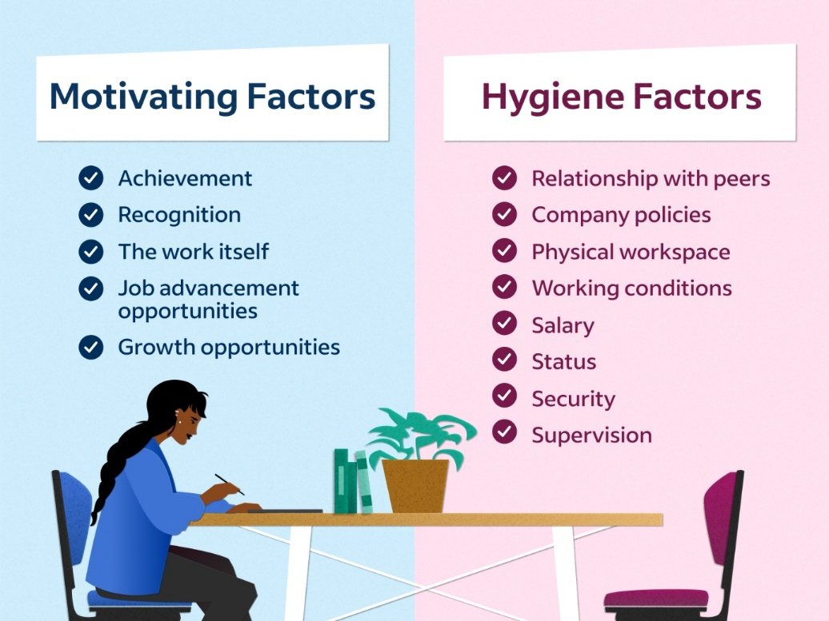
Figure 2 - Herzberg’s Two-Factor Theory
This was clearly apparent, during the implementation of the new SAGE HR system since they failed to consider both the hygiene and motivating factors of the employees, expecting the change to satisfy the workforces needs without any consideration of current working conditions, which is shown by the workforces attitude after its implementation, showing clear discontent and many choosing to retire/leave the company after its implementation, showing clear dissatisfaction with current conditions, due to hygiene and motivational factors not being examined within the company over the many years. (Taylor & Armstrong, 2026) and Deci and Ryan (Deci & Ryan, 2000) also suggest that having intrinsic motivation is a key part of retaining employee engagement during the changes in the organisation.
Furthermore, Vroom’s Expectancy Theory states that employees must believe that they can successfully perform the new tasks set for them (Steele, 1964), further clarifying why the implementation of SAGE HR within IVS failed, as many of the senior employees lacked the digital literacy skills required to be successful. This, coupled with the fact that there was inadequate training, further reduced the employees' confidence in the new system, lowering the workforce's motivation, leading to a complete breakdown of this new system (Wanberg & Banas, 2000).

2.6. Evaluation of Success/Failure
The implementation of the SAGE HR system within IVS could possibly be considered a small success, with many of the systems still in use by management to provide payslips and to apply for annual leave. However, with one of the key components being the clock-in system, the change process failed to achieve any kind of employee acceptance. This would align with Kotter’s (Kotter, 1995) argument that neglecting the human element is a common mistake and cause of failure in organisational change, with the key components of failures including;
• Poor communication
• Lack of employee involvement
• Inadequate training
• Absence of phased implementation
The findings within the implementation of the system in IVS are also consistent with research done on employee cynicism and resistance to organisational change by Stanley (Stanley, Meyer, & Topolnytsky, 2005),

2.7 Recommendations
Considering the failure of the SAGE HR implementation, here are some recommendations for the next time IVS may implement changes in the future;
- Improve Communication during the transition process and adopt two-way communication channels, including feedback sessions and workshops (Mullins & Rees., 2023) (Bordia, Hobman, Jones, Gallois, & Callan, 2004).
- Increase Employee Involvement by engaging with the employees early through pilot groups and perform consultations, ensuring to consider the thoughts of employees (Kotter., 2012) (Appelbaum, Habashy, Malo, & Shafiq, 2012) (Armenakis & Harris, 2009).
- Provide Continuous Training and offer tailored and ongoing training programmes for all employees within the organisation (Burnes, Managing change, 2017); (Venkatesh, Morris, Davis, & Davis, 2003).
- Implement Phased Rollout rather than straight adoption introducing the systems gradually to allow for adaptation issues (Hayes, 2025) (Appelbaum, Habashy, Malo, & Shafiq, 2012).
- Strengthen Motivation and use recognition and development opportunities to enhance engagement of everyone within the organisation (Herzberg, 1968) (Deci & Ryan, 2000).

3. Conclusion
In conclusion, the example of IVS’s SAGE HR implementation highlights the importance of managing both the technical and human aspects of change. In this case, while the system was implemented within IVS, it failed to fully cultivate, due to failing many of the theories discussed, with all employees returning to a paper-based logging system. Applying these various established theories demonstrates that training, employee involvement, and communication are essential for a successful change within an organisation (Burnes, Managing change, 2017) (Kotter, 1995).
Applying Lewin’s Force Field Analysis showed that the restraining forces present within, such as fear of using new technology, lack of digital literacy, and attachment to old systems, were not at all addressed, which ultimately led to the intended driving forces of modernisation and increased efficiency being completely outweighed. Similarly, the failure to correctly execute the three-stage model by Lewin meant that the employees were not at all supported during any process of the implementation, which resulted in the change failing to embed within the organisational process.
Furthermore, the insights into the motivational theories, Herzberg’s two-factor theory, and Vroom’s expectancy Theory, further reinforce that employee confidence, satisfaction, and perceived ability are essential components when adopting successful change. The neglect of these factors within IVS leads to disengagement of the system and, in some cases, workforce attrition.
Overall, this demonstrates that to achieve any type of successful change within a company, you require a well-structured, human-centred approach, with future changes prioritising clear communication, continuous training, employee involvement, and a much more phased-out approach to its introduction. By doing so, organisations can achieve a more sustainable and effective approach to change.

Bibliography
Al-Haddad, S., & Kotnour, T. (2015). Integrating the organizational change literature: a model for successful change. pp.234-262.
Appelbaum, S. H., Habashy, S., Malo, J.-L., & Shafiq, H. (2012). Back to the future: revisiting Kotter's 1996 change model. p.764-782.
Armenakis, A. A., & Harris, S. G. (2009). Reflections: our Journey in Organizational Change Research and Practice. pp.127-142.
Beer, M., & Nohria, N. (2000). Cracking the code of change. pp.133.
Bordia, P., Hobman, E., Jones, E., Gallois, C., & Callan, V. J. (2004). Uncertainty during Organizational Change: Types, Consequences, and Management Strategies. pp.507-532.
Burnes, B. (2017). Managing change. Pearson.
Burnes, B., & Bargal, D. (2017). Kurt Lewin: 70 Years on. Kurt Lewin: 70 Years on, pp. 91–100.
Capatina, A., Bleoju, G., Matos, F., & Vairinhos, V. (2017). Leveraging intellectual capital through Lewin's Force Field Analysis: The case of software development companies. pp.125-133.
Cummings, S., Bridgman, T., & Brown, K. G. (2016). Unfreezing change as three steps: Rethinking Kurt Lewin’s legacy for change management. pp.33-60.
Cummings, T. G., & Worley, C. G. (n.d.). Organization Development & Change. CENGAGE learning.
Davis, F. D. (1989). Perceived Usefulness, Perceived Ease of Use, and User Acceptance of Information Technology. pp.319-340.
Deci, E. L., & Ryan, R. M. (2000). The "What" and "Why" of Goal Pursuits: Human Needs and the Self-Determination of Behavior. pp.227-268.
Ertmer, P. A., & Ottenbreit-Leftwich, A. T. (2010). Teacher Technology Change: How Knowledge, Confidence, Beliefs, and Culture Intersect. pp.255-284.
Hayes, J. (2025). The theory and practice of change management. Bloomsbury Academic.
Herzberg, F. (1968). One more time: how do you motivate employees? not by improving work conditions, raising salaries, or shuffling tasks. pp.53-62.
Hiatt, J. M. (2006). ADKAR: A model for change.
Hussain, S. T., Lei, S., Akram, T., Haider, M. J., Hussain, S. H., & Ali, M. (2018). Kurt Lewin's change model: A critical review of the role of leadership and employee involvement in organizational change. pp.123-127.
Kotter, J. P. (1995). Leading change: Why transformation efforts fail. pp.59-67.
Kotter., J. P. (2012). Leading change. Harvard Buisness Review Press.
Lewin, K. (1951). Field theory in social science. Harper.
Mullins, L. J., & Rees., G. (2023). Management and organisational behaviour. pearson education.
Oreg, S. (2006). Personality, context, and resistance to organizational change. pp.73-101.
Oreg, S., Vakola, M., & Armenakis, A. (2011). Change Recipients’ Reactions to Organizational Change. pp.461-524.
Pettigrew, A. M. (2012). Context and Action in the Transformation of the Firm: A Reprise. pp.1304-1328.
Stanley, D. J., Meyer, J. P., & Topolnytsky, L. (2005). Employee Cynicism and Resistance to Organizational Change. pp.429-459.
Steele, F. I. (1964). Work and Motivation by Victor H. Vroom. pp.106.
Swanson, D. J., & Creed, A. S. (2014). Sharpening the Focus of Force Field Analysis. p.28-47.
Taylor, S., & Armstrong, M. (2026). rmstrong's handbook of human resource management practice : a guide to the theory and practice of people management. Kogan Page.
Todnem, R. (2005). Organisational change management: A critical review. pp.369-380.
Venkatesh, V., Morris, M. G., Davis, G. B., & Davis, F. D. (2003). User Acceptance of Information Technology: Toward a Unified View. pp.425-478.
Wanberg, C. R., & Banas, J. T. (2000). Predictors and Outcomes of Openness to Changes in a Reorganizing Workplace. pp.132-142.
Weick, K. E., & Quinn, R. E. (1999). ORGANIZATIONAL CHANGE AND DEVELOPMENT. pp.361-386.

