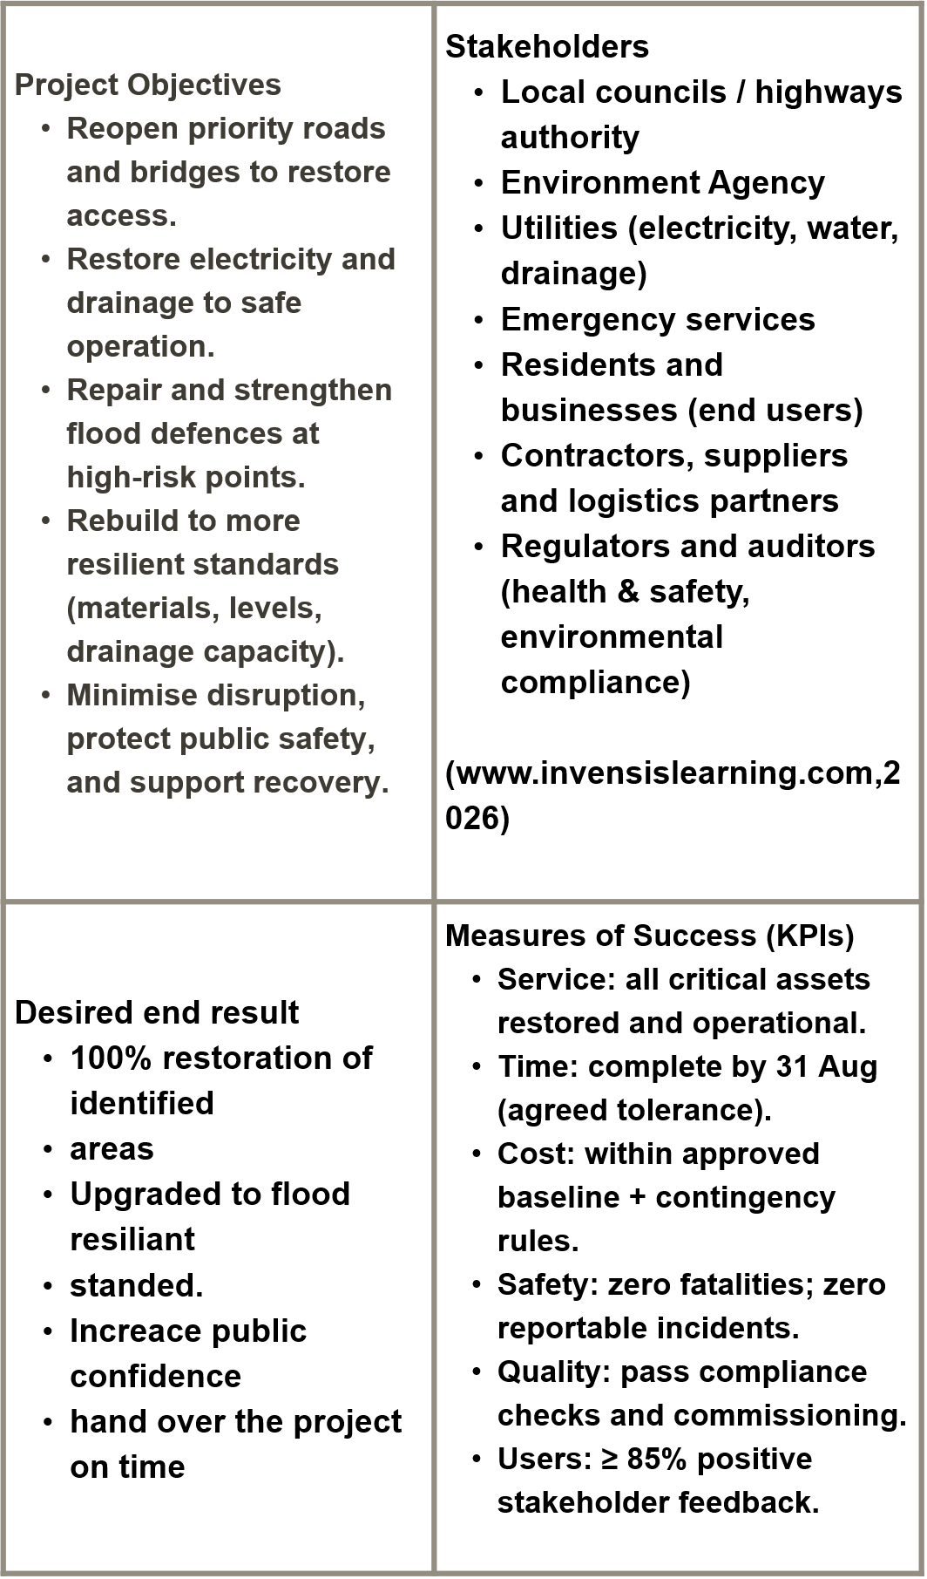
CONCLUSION:
Reconstructing flood-damaged infrastructure is essential for restoring
services and protecting communities. This project combines recovery with
improved flood resilience. Our goal is to help the West Midlands
community to prepare for future extreme weather events
Reference
Worcester, Shrewsbury, and Kidderminster flooding maps in history -
Search accessed (28/01/26)
West Midlands (region) - Wikipedia (25/01/26)
Envirohttps://www.invensislearning.com/blog/who-are-projectstakeholders/
nment(Accessed 11/02/2026)
Agency (2023). Flood Risk Management Plans.
https://leandatapoint.com/resources/quad-chart {Accessed
11/02/2026]
https://www.gov.uk/government/publications/floodproof-an-actionplan-
to-build-resilience/floodready-an-action-plan-to-build-theresilience-
of-people-and-properties [ Accessed 11/02/26)
https://www.gov.uk/government/publications/national-assessment-offlood-
and-coastal-erosion-risk-in-england-2024 {accessed 12/02/2026}
This Photo by africalive,net (accessed 25/01/26)
Daniel J. Dunmire; Rebuilding Infrastructure Through Better Decisions.
Materials Performance 1 April 2011; 50 (4): 10.
https://doi.org/10.5006/MP2011_50_4-10
(bing.com,2025)
West Midlands (region) -
Wikipedia(25/01/26)
(afrialive.net, n.d)
QUAD CHART
Resources and Budget (Summary)
Labour: civils team, utilities crew, traffic management.
Plant: excavators, pumps, generators, temporary works.
Materials: asphalt, concrete, culverts, barrier components.
Funding: local authority + recovery funding streams (TBC).
Cost baseline: £__________ (confirmed post-survey).
Key Risks and Mitigations
Risk Mitigation
Further heavy rain delays works Allow float; temporary protections; standby crews/plant
Supply delays / price volatility Early orders; framework suppliers; defined alternatives
Safety incidents (traffic + live services) CDM compliance; traffic management; permits-to-work
Scope creep Baseline scope; change control; governance approvals
Environmental non compliance Permits; monitoring; environmental management plan

Name: Nilmini Jayasinghe Karunagoda Appuhamilage
Module Code: LCLM5003
Module: Project Management
Assignment title: A project Portfolio
Student Number: 2415983

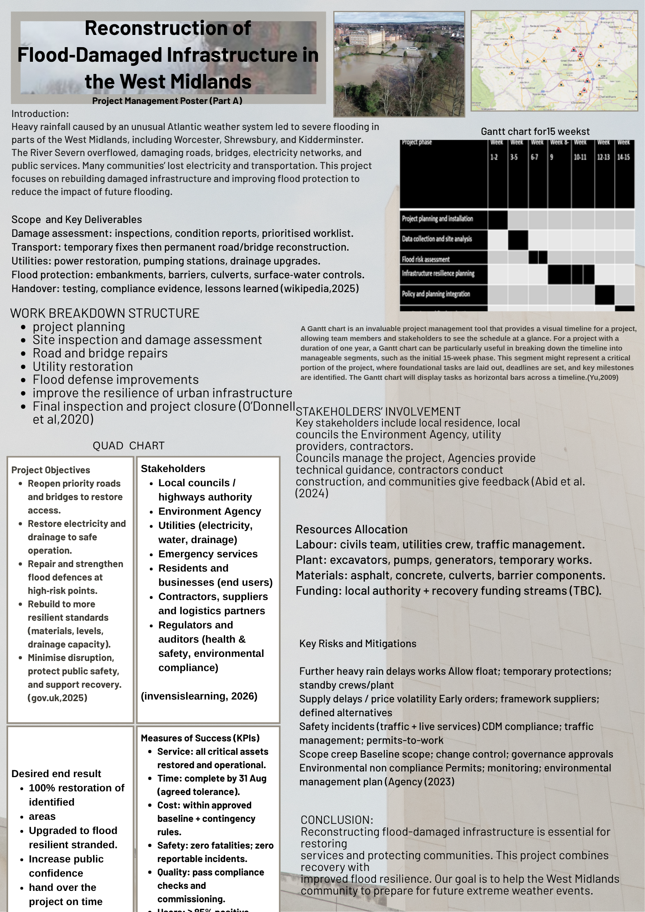
References– Part A
Worcester, Shrewsbury, and Kidderminster flooding maps in history ( accessed on 28/01/26)
Yu, W.W. (2009) Design and implementation of gantt chart control. ProQuest Dissertations & Theses.
Abid, S.K. et al. (2024) “Community-based flood mitigation in Malaysia: Enhancing public participation and policy effectiveness for sustainable resilience,” Journal of global health, 14. Available at: https://doi.org/10.7189/jogh.14.04290.
O’Donnell, E. et al. (2020) “The blue-green path to urban flood resilience,” Blue-green systems, 2(1), pp. 28–45. Available at: https://doi.org/10.2166/bgs.2019.199.
Rezvani, S.M.H.S., Silva, M.J.F. and de Almeida, N.M. (2024) “Urban Resilience Index for Critical Infrastructure: A Scenario-Based Approach to Disaster Risk Reduction in Road Networks,” Sustainability, 16(10), p. 4143. Available at: https://doi.org/10.3390/su16104143.
West Midlands (region) - Wikipedia ( Accessed on 25/01/26)
Envirohttps://www.invensislearning.com/blog/who-are-projectstakeholders/nment (Accessed 11/02/2026)
Agency (2023). Flood Risk Management Plans.
https://leandatapoint.com/resources/quad-chart {Accessed
11/02/2026]
https://www.gov.uk/government/publications/floodproof-an-actionplan-to-build-resilience/floodready-an-action-plan-to-build-theresilience-of-people-and-properties [ Accessed 11/02/26)
https://www.gov.uk/government/publications/national-assessment-offlood-and-coastal-erosion-risk-in-england-2024 {accessed 12/02/2026}
This Photo by africalive,net (accessed 25/01/26)
Daniel J. Dunmire; Rebuilding Infrastructure Through Better Decisions.
Materials Performance 1 April 2011; 50 (4): 10.
https://doi.org/10.5006/MP2011_50_4-10(bing.com,2025)

Section B - Insights Gained from Tutor and Peer Feedback
1, Description
For the assessment component of my Project Management module, I was tasked with creating and presenting a poster on a selected topic. My project focused on rebuilding infrastructure damaged by flooding in areas of the West Midlands. During the poster session, each student presented their work to classmates and the lecturer, followed by feedback and discussion.
2, Feeling
Before presenting, I felt nervous because speaking in front of a group is challenging for me. However, I managed to stay calm and clearly explain the key aspects of my project. After presenting, I received constructive feedback from both my peers and the lecturer. One important suggestion was to include a Gantt chart to better illustrate the project timeline. I implemented this improvement, which made my poster more structured and easier to understand.
3. Evaluation
Overall, the experience was positive because it helped me improve my presentation skills and receive constructive feedback. Reflective learning models suggest that individuals learn from experience through reflection and improvement (Borton, 1970).
This activity allowed me to present my work, reflect on feedback, and improve my poster by adding a Gantt chart. Designing the poster without a template was challenging but also rewarding. I needed to organise around 500 words of content including images, tables, and charts. I also ensured that the font size was readable from one meter away.
In addition, I selected a light brown colour theme to make the poster visually appealing. Fortunately, I did not receive negative feedback about the design. However, the moment when my lecturer stopped me highlighted the need to be more attentive during discussions.
4. Analysis
This experience helped me understand the importance of feedback in academic learning. Reflection encourages students to evaluate their experiences and improve their future performance (Bolton, 2014). Feedback from peers and lecturers can help identify strengths and areas for improvement.
From a project management perspective, adding a Gantt chart demonstrated effective planning practices. A Gantt chart is widely used to show project timelines and task relationships. Including this tool improved the clarity and professionalism of my poster.

Conclusion:
In conclusion, this activity helped me build confidence in presenting and reinforced the value of constructive feedback. It also showed that independent work can be successful when carefully planned and executed. Most importantly, I learned the significance of communication and active listening in collaborative environments.

Action plan:
For future development, I plan to practice speaking in front of groups to further improve my confidence and presentation skills. I will also ensure that I remain attentive during discussions and respect others’ opportunities to contribute. Furthermore, I will consistently utilise project management tools (including Gantt charts) to improve the organisation and transparency of my work. I will proactively seek and implement feedback to advance both my academic and professional development.

Reference List- part B
Borton, T. (1970) Reach, Touch and Teach: Student Concerns and Process Education. (“(PDF) Reach touch and teach - Academia.edu”) New York: McGraw-Hill.
Bolton, G. (2014) Reflective Practice: Writing and Professional Development. 4th ed. Los Angeles: Sage.
Williams, K., Woolliams, M. and Spiro, J. (2012) Reflective Writing. Available at: LS006—Guide-to-Reflective-Writing.pdf (Accessed: 21 February 2026).

Part-3

Project Plan
Contents list
- Introduction ………………………………………………….5
- Project description ………………………………………….6
- Scope ………………………………………………………...7
- Work breakdown structure …………………………………8
- Quad Chart ………………………………………………….10
- Gantt Chart ………………………………………………….11
- Stakeholders' involvement…………………………………12
- Allocation of resources……………………………………..13
- Risk Analysis ………………………………………………..13
- Conclusion …………………………………………………..16
- References …………………………………………………..17

West Midlands Flood Recovery and Resilience Project Plan
1, Introduction:
Mamatlepa et al. (2024) defines project management as the practice of employing systems, methods, and personnel to finish a project successfully within set timeframes, budgets, and quality requirements. It involves coordinating resources and activities to achieve project objectives. Ng and Ho (2019) define project management as a structured process using suitable tools and techniques to achieve specific objectives. Successful project management delivers projects on time, within budget, and meets quality and stakeholder requirements. This project management plan focuses on the development of infrastructure in the West Midlands.

May 2025 Flooding Event
1. 1 Executive Summary
In July 2025, severe floods hit Worcester, Shrewsbury, and Kidderminster in the West Midlands, damaging homes, businesses, infrastructure, and essential services. Thousands of residents were displaced. Transport systems were disrupted. Economic activities in the region were severely impacted.
This document presents a comprehensive Project Management Plan (PMP) for the West Midlands Flood Recovery and Resilience. The programme aims to restore essential infrastructure, support affected communities, and implement long-term flood resilience measures. Cziesielski, et al. (2024) explain that the plan outlines project objectives, scope, governance structure, stakeholder engagement strategies, risk management procedures, communication frameworks, and monitoring mechanisms.
The project will adopt established project management methodologies aligned with PRINCE2 principles. It ensures structured governance, accountability, and efficient resource utilisation. Key stakeholders include local authorities, the Environment Agency, emergency services, infrastructure providers, community organisation, and residents. (prince,2026)

The programme is expected to be delivered over 36 months, with phased implementation including emergency response recovery, infrastructure restoration, and long-term flood mitigation projects. Success will be measured through timely restoration of services, effective stakeholder collaboration, improved flood protection infrastructure, and increased community resilience.

1.2 Project Background
The west Midlands region is vulnerable to flooding due to its river systems. Including River Seven and River Teme. In July 2025, an unprecedented weather pattern produced continuous heavy rainfall across the UK. River levels rose rapidly, overwhelming existing flood defenses and draining systems. Worcester, Shrewsbury, and Kidderminster were most affected by flooding. Inundated floodwater residential areas, businesses, and transport networks. Critical infrastructure such as roads, bridges, utilities, and communication systems significantly damaged. Over 8000 homes flooded. Hospitals, schools, and public facilities were damaged. Major roads and public facilities were heavily effected and they are temporarily closed. Estimated economic losses exceeded £1.5 billion. While emergency services responded immediately, there is a need for a coordinated structured programme repair and implement long term resilience.

2.Project Scope
Mitropoulos and Sanchez (2016) define project scope as the explicit delineation of all tasks necessary for the successful completion of a project. It encompasses the project's objectives, deliverables, activities, limitations, and requirements. For effective scope management, projects are commonly segmented into work packagessmaller, manageable units of work allocated to specific teams or subcontractors.
The scope of this project focuses on improving flood resilience and supporting sustainable infrastructure development in the West Midlands. The project aims to assess flood risks and implement strategies that reduce vulnerability. Furthermore, project aims to improve the resilience of urban infrastructure. Key activities include the analysis of environmental and spatial factors such as land use, slope, morphology, and hydrological conditions to better understand flood exposure in the region. (Rehman et al. Derenskaya (2018) explains that projects operate within three primary constraints (scope, time, and cost) which together form the Project Management Triangle. Thus, a successful and efficient project consistently follows a clearly defined scope.

The project will involve evaluating existing planning frameworks and infrastructure systems to identify weaknesses that contribute to flood risk, particularly in areas where residential developments are located within flood-prone zones. Based on these findings, the project will propose improvements such as upgrading drainage systems, widening river channels, reopening tributaries, and implementing green infrastructure solutions. (Hughes, Resor, and Newberry, (2023)
In addition, the project will promote water-sensitive urban planning approaches and encourage coordination between basin-scale flood management strategies and statutory land-use planning policies. The overall objective is to enhance long-term flood resilience, support sustainable urban development, and ensure that future infrastructure planning in the West Midlands reduces exposure to flooding while improving community safety.

3. Project Breakdown Structure (WBS)
According to Cerezo-Narváez et al. (2020) a Work Breakdown Structure (WBS) is needed to organize and manage a project effectively by breaking the overall project into smaller, manageable tasks and work packages arranged in a hierarchical structure. With this approach, project managers and teams can plan, delegate tasks, and track progress more efficiently. A thorough Work Breakdown Structure (WBS) clarifies every project activity, helping the team meet objectives, finish on schedule, stay within budget, and deliver the desired quality.

Project breakdown structure for West Midlands Reconstruction:
Project planning and initiation | Data collection and site surveys | Food risk assessment | Infrastructure and resilience planning | Policy and planning integration | Implementation strategy | Project monitoring and evaluation
Define project objectives and scope | Field observations and site surveys | Identify flood-prone areas | Channal widening and river improvement planning | Review of existing planning regulation | Develop food resilience strategy | Monitor project progress
Identify stakeholders | Conduct stakeholders’ interviews | Analyze runoff patterns and tributaries | Reopening enclosed tributaries | Align basin-scale strategies with zoning pans | Prepare infrastructure design recommendations | Evaluate effectiveness of resilience measures
Develop project management plan | Collect spatial and environmental data. | Evaluate exiting infrastructure and drainage systems | Installation of derbies traps and improved bridge | Recommend improvements to planning enforcement | Establish monitoring and early warning systems | Draft the final report along with recommendations, referencing Anggraini et al. (2021).
Allocate resources and budget | Analise slope, morphology, land use, and hydrological data | Assess residential development in flood zones | Development and green infrastructure solutions
Fang et al. (2010)

5. Quad chart:
Aidan Meegan (2020) explains that QUAD charts are a concise tool used to summarise and evaluate important technical aspects of a project. They allow complex information (such as simulation results, key variables, and performance measurements) to be presented in a clear and structured format. For example, in the evaluation of shaped charges, QUAD charts help project members quickly observe the effects of different variables and assess technical performance. By presenting complex technical data in a simple and accessible way, QUAD charts support efficient communication, informed decision-making, and effective assessment within project teams.
Project Objectives  The overall goal of the programme is to restore affected communities while reducing the likelihood and impact of future flooding.  Strategic Objectives  - Restore essential public infrastructure within 12 months.  - Provide housing support and recovery assistance to affected residents.  - Rebuild damaged infrastructure using resilient design principles.  - Improve regional flood defenses and drainage systems.  - Strengthen community preparedness and early-warning systems. | Stakeholders  - Government Bodies  Local councils and national agencies responsible for funding, regulation, and strategic oversight.  - Environment Agency  Responsible for flood defense planning and environmental protection.  - Emergency Services  Police, fire, and medical teams responsible for disaster response coordination.  - Infrastructure Providers  Utilities, transport authorities, and telecommunications providers responsible for restoring essential services.  - Local Communities (Rakes, et al. 2023)  Residents and businesses directly affected by the flooding.  Non-Governmental Organisation  Charities and community organisation providing humanitarian support.
Desired Outcomes  - Restoration of essential public infrastructure so communities can function normally again.  - Affected residents receive housing support and recovery assistance.  - Damaged infrastructure is rebuilt using resilient and flood-resistant design.  - Improved regional flood defenses and drainage systems to reduce future flood risks.  - Communities are better prepared through effective early-warning systems and awareness. | Success Measures  - Essential public infrastructure restored within 12 months.  - Housing and recovery support successfully provided to affected residents.  - Infrastructure rebuilt according to resilient design standards.  - Flood defenses and drainage systems are upgraded and fully operational.  - Early-warning systems implemented and community preparedness improved.  (current, 2021)

6.Gantt chart
Pankaja (2025) describes a Gantt chart as a straightforward visual for project management, outlining tasks, timelines, durations, and dependencies to simplify planning and progress sharing.
Project phase | Week 1-2 | Week 3-5 | Week 6-7 |  | Week 8-9 | Week 10-11 |  | Week 12-13 | Week 14-15
Project planning and installation
Data collection and site analysis
Flood risk assessment
Infrastructure resilience planning
Policy and planning integration
monitoring and final evaluation
(Gantt chart for main project phrase. Timeline is 15 weeks)
Legend:
█ = active project work during that period

Main Phases Explained
- Project Planning and Initiation – Define scope, objectives, stakeholders, and resources.
- Data Collection and Site Analysis – Field observations, interviews, and spatial analysis.
- Flood Risk Assessment – Identify flood-prone areas and infrastructure weaknesses.
- Infrastructure and Resilience Planning – Develop channel improvements, green infrastructure, and drainage strategies.
- Policy and Planning Integration – Align basin strategies with zoning and planning regulations.

- Stakeholders’ involment:
According to Alnhari ed, al stakeholder engagement is essential for project success. It means identifying stakeholders early, understanding their needs and influence, and maintaining clear communication throughout the project. This helps manage expectations, avoid misunderstandings, and reduce the risk of delays or project failure.
Stakeholder engagement is essential for project success, as highlighted by Alnhari, because it involves identifying stakeholders early, understanding their needs and influence, and maintaining clear communication throughout the project lifecycle. This approach helps manage expectations, prevent misunderstandings, and reduce the risk of delays or failure. In this project, key stakeholders include local councils, the Environment Agency, emergency services, infrastructure providers, community representatives, and the project sponsor, DEFRA. Their involvement supports informed decision-making, enhances transparency, and encourages effective collaboration. Engagement will be achieved through public consultations, community workshops, stakeholder meetings, and regular progress updates, allowing stakeholders to provide feedback and contribute their expertise.
According to Radovanovic (2024), stakeholder mapping in project management involves identifying and analysing those who can influence or are affected by a project. This process helps managers prioritise stakeholder engagement, allocate resources effectively, and engage the right people at key stages for better outcomes. Power-interest analysis refines this approach: stakeholders with high power but low interest (e.g., the Environment Agency, infrastructure providers) should be kept satisfied; those with high power and high interest (e.g., DEFRA, local councils, project sponsors) require close management; low power/low interest groups (e.g., the wider public) need minimal monitoring; and those with low power but high interest (e.g., community representatives, emergency services) should be kept informed.

8. Allocation of resources
Allocating resources in a project involves assigning the appropriate people, equipment, materials, budget, and time to different tasks so the project can be completed efficiently and meet its objectives within the planned scope and budget. In the Flood Resilient Infrastructure Project in the West Midlands, this process begins with identifying the resources required for the project. These resources can be grouped into several categories. Human resources include professionals such as engineers, urban planners, surveyors, environmental specialists, GIS analysts, project managers, and field workers who contribute their expertise to different project activities. Material resources involve construction materials like concrete, pipes, and debris traps, as well as surveying tools, monitoring equipment, and computer systems used for data analysis. Financial resources refer to the allocated budget needed for fieldwork, infrastructure improvements, green infrastructure development, and community engagement programmes. Time is also a key resource, requiring clear scheduling and sufficient duration for each project task. Finally, technology resources include tools such as GIS software, hydrological modelling systems, data collection devices, and early warning systems, which support planning, monitoring, and decision-making throughout the flood resilience project.

9.Risk analysis:
Risk analysis in project management helps identify, assess, and control potential problems that could impact the project. It allows teams to address issues early before they become serious, improving decision-making and increasing the chances of successfully achieving project goals. (Gudmestad, ed al. 2014)
Risk analysis identifies potential events that could affect the project’s success and develop strategies to mitigate them. For this project, risks are categorized into environmental, technical, financial, regulatory, and stakeholder risks.

 | Risk | Likelihood | Impact | Mitigation
Environment Risks  Cziesielski, et al. (2024) | Heavy rainfall or unexpected flooding during construction | Medium | High | Schedule work outside peak rainy season, implement temporary flood barriers, monitor weather forecasts
 | Soil erosion and slope instability in narrow valleys | Medium | Medium | Conduct detailed site surveys, install temporary retention systems, use erosion control measures
 | Failure of drainage or river infrastructure design | Low | High | Conduct hydraulic modeling, peer review designs, phased construction testing
Technical Risks (Tubaldi, et al. (2022) | Ineffective debris traps or tributary reopening  Limited capability under climate change | Medium  high | Medium  High | Regular maintenance, field inspections, contingency repair plans  Integrate climate projections into design standards. Use scenario-based modelling approaches regular update risk assessment and guidelines.
 | Budget overrun due to unforeseen construction cost (Vannucci et al (2021) | Medium | High | Contingency budget (10-15), regular cost monitoring, supplier nagotiatios
Financial risk | Delayed increasing project expenses | Medium | Medium | Allow schedule contingency and focus resources on critical tasks to reduce the risk of financial dealys
 | Weak enforcement of planning regulations | High | High | Engage local authorities earlier integrate statutory policies into project plan, provide compliance reports
Regiutery and planning risk (Muritala, 2025) | Conflicts between basin-scale strategies and zoning laws | Medium | Medium | Regular maintenance, field inspections, contingency repair plans
 | Low community awareness about flood risks | High | Medium | Conduct awareness campaigns, workshops, distribute educational materials
Stakeholdes’ and community risk | Opposition to relocation or infrastructure changes | Medium | High | Engage stakeholders in planning, incorporate

1.6. Risk Monitoring and Review
Risk monitoring and review are essential parts of the Flood Resilient Infrastructure Development Project. They ensure that potential risks are recognised, evaluated, and managed throughout the project’s duration. A risk register is kept recording the likelihood, impact, and mitigation status of each risk. The project team will carry out regular reviews (at least once a week) to identify new risks, check how effective current mitigation measures are, and update strategies as needed. Ongoing monitoring also enables a prompt response to environmental changes, technical challenges, or stakeholder concerns, helping keep the project on track, within budget, and focused on resilience goals. Weekly risk reviews support maintaining a risk register that tracks probability, impact, and mitigation status, and guide mitigation strategies according to project progress and environmental conditions.
Key risks involve environmental hazards, technical failures, budget overruns, weak enforcement, and stakeholder resistance. Effective risk mitigation will rely on planning, monitoring, stakeholder engagement, and adaptive management. (Hammond, et al. 2018)

10. Conclusion:
This project management plan has outlined a structured and integrated approach to the recovery and long-term flood resilience of infrastructure in the West Midlands. By applying recognised project management principles, including clear scope definition, work breakdown structures, scheduling through a Gantt chart, and comprehensive risk analysis, the plan demonstrates how complex post-disaster recovery programmes can be effectively managed. The project emphasises stakeholder engagement, efficient resource allocation, and proactive risk mitigation to ensure timely delivery and cost control. Overall, the proposed framework supports not only the restoration of essential services but also the development of resilient infrastructure capable of withstanding future flood events, contributing to sustainable regional development and community safety.

Reference list- part C
Mamatlepa, M.C. and Mazenda, A. (2024) “Building project management tools and techniques capacity to drive Information and Communications Technology projects in the Department of Social Development, South Africa,” Information development [Preprint]. Available at: https://doi.org/10.1177/02666669241264740.

1. Ng, J.J. and Ho, J. (2019) “The 80/20 Principle Thinking as a Tool for Project Management,” IEEE engineering management review, 47(4), pp. 18–20. Available at: https://doi.org/10.1109/EMR.2019.2950294.
2.hhtp://www.prince2.com/
Bektaş, Y. and Demirezen, Z. (2025) “Spatial Planning and Flood Resilience: Lessons From the 2021 Bozkurt Flood, Türkiye,” The journal of comparative Asian development, 21(1), pp. 1–36. Available at: https://doi.org/10.4018/JCAD.388553.
Mitropoulos, P., and Sanchez, R. (2016) “Criteria and considerations for project work structuring,” Proceedings of the Institution of Civil Engineers. (“Criteria and considerations for project work structuring”) (“Criteria and considerations for project work structuring”) Management, procurement, and law, 169(3), pp. 124–130. Available at: https://doi.org/10.1680/jmapl.15.00020.
Cerezo-Narváez, A. et al. (2020) “Integration of Cost and Work Breakdown Structures in the Management of Construction Projects,” Applied sciences, 10(4), p. 1386. Available at: https://doi.org/10.3390/app10041386.
Anggraini, A. and Latief, Y. (2021) “Development of work breakdown structure standard for safety planning on stadium construction work based on risk,” Journal of physics. (“Development of Work Breakdown Structure for Stadium Work as Project ...”) Conference series, 1858(1), p. 12073. Available at: https://doi.org/10.1088/1742-6596/1858/1/012073.
Meegan, A. (2020) Stockpile Assessment (Quad Chart). United States.
PANKAJA PRADEEP KUMAR (2005) “Effective use of gantt chart for managing large scale projects,” Cost engineering (Morgantown, W. Va.), 47(7), pp. 14–21.
Alnhari, A.A. and Qureshi, R. (2024) “Unified External Stakeholder Engagement and Requirements Strategy,” arXiv.org [Preprint]. Available at: https://doi.org/10.48550/arxiv.2409.05019.
Gudmestad, O.T. (2014) “Influence of human and organizational factors, communication and management on risk in organizations and projects,” International journal of safety and security engineering, 4(1), pp. 54–63. Available at: https://doi.org/10.2495/SAFE-V4-N1-54-63.
Nicholas, J.M. and Steyn, H. (2012) Project Management for Engineering, Business, and Technology. 4th ed. London: Routledge. Available at: https://doi.org/10.4324/9780080967059.

Cziesielski, M. et al. (2024) Study for a methodological framework and assessment of potential financial risks associated with biodiversity loss and ecosystem degradation: final report. Luxembourg: Publications Office. Available at: https://doi.org/10.2874/646909.
Rehman, S.U. et al. (2024) “A Laboratory Study of the Role of Nature-Based Solutions in Improving Flash Flooding Resilience in Hilly Terrains,” Water (Basel), 16(1), p. 124. Available at: https://doi.org/10.3390/w16010124.
Hughes, S., Resor, C., and Newberry, H. (2023) “State policy and local resilience: evaluating state policies for flood resilience in the Great Lakes region of the United States,” Climate policy, 23(10), pp. 1302–1313. Available at: https://doi.org/10.1080/14693062.2023.2242309.
Fang Jian et al. (2010) “Application and innovation of structured project breakdown technique in large-scale complex projects: A case study on 2010 Shanghai World Expo,” in 2010 International Conference on Management Science & Engineering 17th Annual Conference Proceedings. IEEE, pp. 1626–1631. Available at: https://doi.org/10.1109/ICMSE.2010.5720000.
Tubaldi, E. et al. (2022) “Invited perspectives: Challenges and future directions in improving bridge flood resilience,” Natural hazards and earth system sciences, 22(3), pp. 795–812. Available at: https://doi.org/10.5194/nhess-22-795-2022.
Vannucci, E., Pagano, A.J. and Romagnoli, F. (2021) “Climate change management: a resilience strategy for flood risk using Blockchain tools,” Decisions in economics and finance, 44(1), pp. 177–190. Available at: https://doi.org/10.1007/s10203-020-00315-6.
MURITALA, T.A. (2025) “ASSESSING THE SOCIO-ECONOMIC AND ENVIRONMENTAL IMPACTS OF URBAN FLOODING IN RAPIDLY DEVELOPING CITIES: PATHWAYS TO SUSTAINABLE RISK MANAGEMENT AND CLIMATE-RESILIENT URBAN PLANNING,” International Studies Journal, 9(7), pp. 246–256. Available at: https://doi.org/10.64633/wissj.v9i7.19.
Hammond, M. et al. (2018) “A new flood risk assessment framework for evaluating the effectiveness of policies to improve urban flood resilience,” Urban water journal, 15(5), pp. 427–436. Available at: https://doi.org/10.1080/1573062X.2018.1508598.
Current practice in flood risk management in the European Union: September 2021 (2021). Luxembourg: Publications Office.
Rakes, K. et al. (2023) Planning Climate Action in Cities and Regions: Towards Carbon Neutral and Resilient Territories in the face of Climate Change, Inter-American Development Bank eBooks. Available at: https://doi.org/10.18235/0005141.
Radovanovic, N. (2024) Identification of the smart specialisation priority domains of Tunisia. Luxembourg: Publications Office of the European Union. Available at: https://doi.org/10.2760/818423.
Derenskaya, Y. (2018) “PROJECT SCOPE MANAGEMENT PROCESS,” Baltic Journal of Economic Studies, 4(1), pp. 118–125. Available at: https://doi.org/10.30525/2256-0742/2018-4-1-118-125.

