

Task 1 – Reading Task
Upload your photo of your A3 in-class notes here:
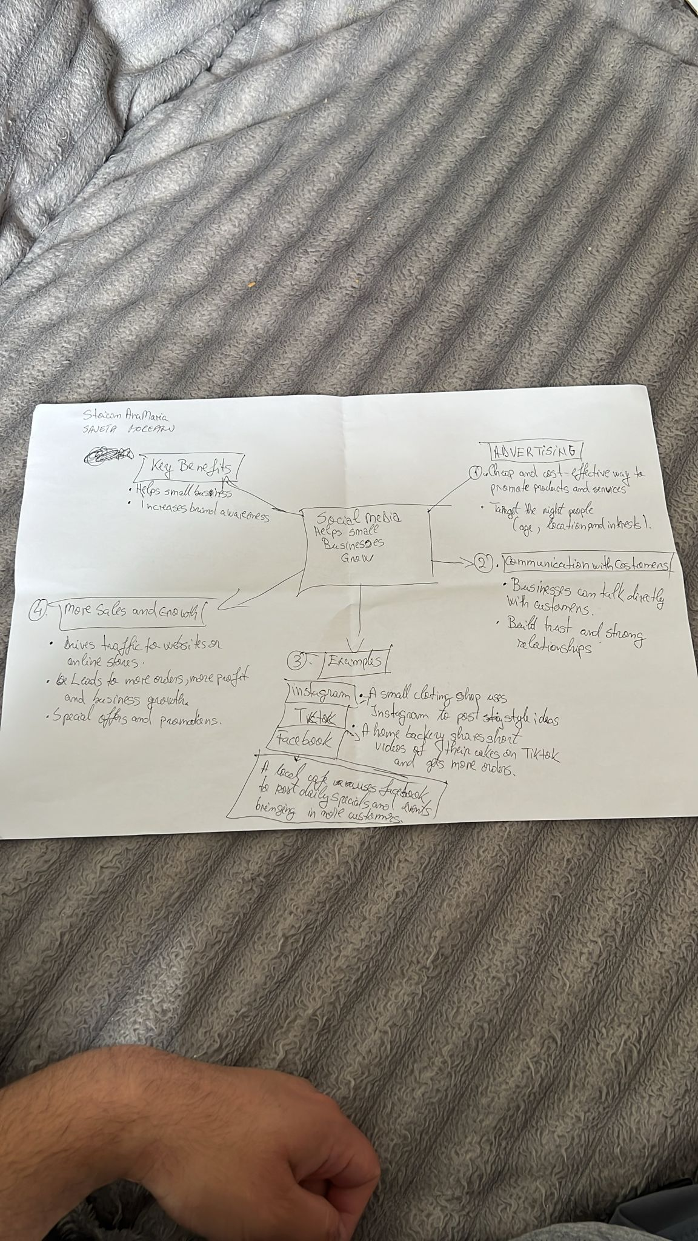

1. Answer these questions using the sentence starters below
a. What is the main idea of the text?
The main idea is that social media like Instagram, Facebook, TikTok etc. helps small businesses grow by promoting products, communicating with customers, and increasing sales.
b. What are two key points?
One key point is that social media is a cheap and cost-effective way for businesses to advertise their products and services to the right target audience.
Another key point is that social media allows businesses to communicate directly with customers, helping them to build trust and strong relationships.
c. What part of the text did you find most important? Why?
The most important part of the text is the section about increasing sales and business growth because it shows the ways in which social media can attract more customers, increase orders, and help businesses make more profit.
d. Was anything unclear or difficult to understand?
I was not sure about how businesses decide which social media platform is best for advertising their products.
e. How did your group help you understand the text better?
My group helped me by discussing the different benefits of social media and sharing examples of how small businesses use platforms such as Instagram, TikTok, and Facebook.
3. One sentence reflection
Question: What did you find challenging about this task?
The hardest part was identifying the most important information and summarising it into a clear mind map.

