

Programme: Master of Business Administration
Module Name: Marketing Management
Module Code: LCMB7024

Lecturer’s Name: Dr Laila Maazouz (London)

Student Name: Md Alamin
Student ID: 2434280

Word Count: 2605

Table of Contents
Element 1: STDP Analysis for Helio (Tesla) 3
Introduction Concept 3
Segmentation 4
Targeting 4
Differentiation 5
Positioning 6
Future risks and opportunities 7
Element 2: Marketing Mix (4Ps) for Helio Core 8
Product 8
Price 9
Place 10
Promotion 11
Measurement, timeline and critical risks 12
Element 3: Element 3: Marketing Strategy Pitch for Helio 13
Element 4: Reflection 14
References 18

Element 1: STDP Analysis for Helio (Tesla)

Introduction Concept
Tesla is a world leader in EVs and battery technology (Ozsevim, 2025); Helio is a new sub-brand that will take Tesla's energy business into a separate, consumer-facing category with high-end solar-powered home batteries and integrated home energy systems. Helio Core: An open, modular, scaled home battery with a target market in households with rooftop solar and in retrofit markets and EV-owner markets to maximise smart load-shifting and vehicle-to-home (V2H) compatibility and resiliency (Figgener et al., 2022).
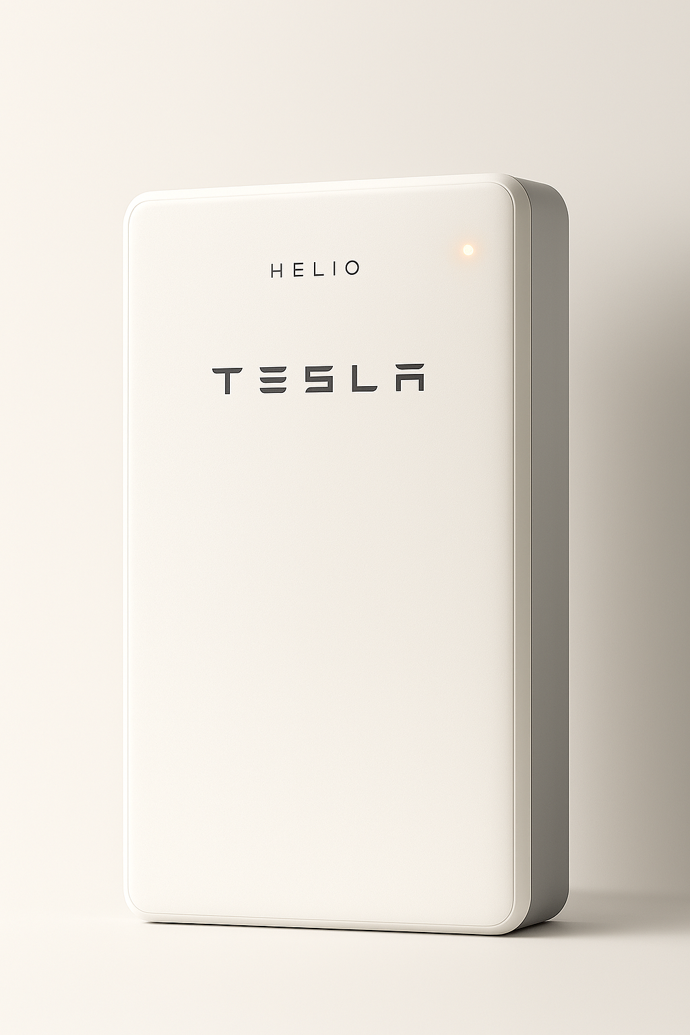
Figure 01: Product Demo (Source: Self-made)
The idea is to capitalise on Tesla battery R&D and energy software by building distance between automotive brand connection and individual consumer anticipations of home safety, service and energy knowledge. The demand for these addresses is driven by increased residential storage (with a high CAGR) and the consumer's need for energy independence and resilience.

Segmentation
Here are the potential market segmentations for the new products. The segmentation for the target market is broken down into four types:
Demographic: The core segment is the middle-to-high income homeowners who have more than 80k in income, and the secondary segment is the wealthy early adopters. The households are divided into permanent dwellers (single-family homes, townhouses) and renters, with the latter having low priority. Ownership status and disposable income are some of the major factors that determine the purchasing decision since the battery is an investment that is capital-intensive (TechSci, 2018).
Geographic: Targets areas where the rate of solar penetration is high and where electricity rates are high, like in Australia, Germany, California, and some parts of Europe and the US, with high tariffs and incentives (Factmr.com, 2025). Faster adoption is experienced in these regions and better returns on investment (ROI) on storage systems.
Psychographic: Targets have adopters that are driven by their interests in sustainability, resilience, and technology. These people place importance on carbon cutting, use of backup power in case of power outages and use of smart-home technology.
Behavioural: Targets solar owners/buyers intending to make retrofits, and price-sensitive buyers who require financing/leasing. The likelihood of purchasing is determined by the current ownership of solar or EV and the financing habits.

Targeting
Primary target:
Owner, solar-powered, EV-owning families in high-tariff and high-incentive areas - suburban owners aged 30-60, have higher income, appreciate sustainability and resiliency.
Rationale: Solar and EV offer the most value, and these customers already have an environment of appreciating smart energy equipment.
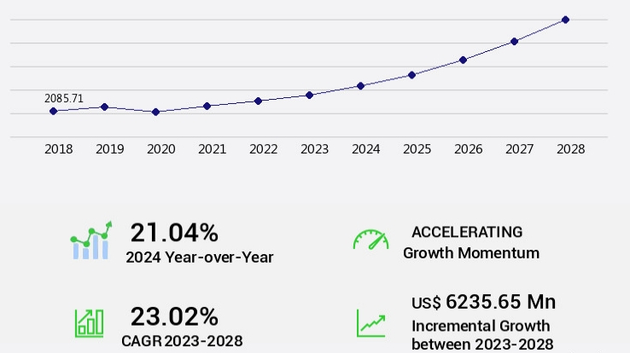
Figure 02: Residential Battery Energy Storage System Market Size (Source: Technavio, 2024)
Evidence: The market continues to expand, and the global market for residential battery energy storage systems is projected to reach USD 12.8 billion by 2027 (Technavio, 2024). This evidence supports that the new product has a significant potential to meet the customer needs.
Secondary targets:
- Affluent homeowners without solar but planning retrofits.
- Small businesses in similar geographies seeking resilience.
Since the perceptions of the Tesla brand may divide the consumer interest (Gao, 2023). The distinct identity of the brand in the case of Helio will enable targeted advertising to minimise collateral brand risk and highlight home-specific service and safety guarantees. The interest in the Tesla battery market has varied in recent times (Doedee, 2022); the adoption rate can be enhanced through this Helio adoption.

Differentiation
In several ways, Helio differentiate its core value from its competitors:
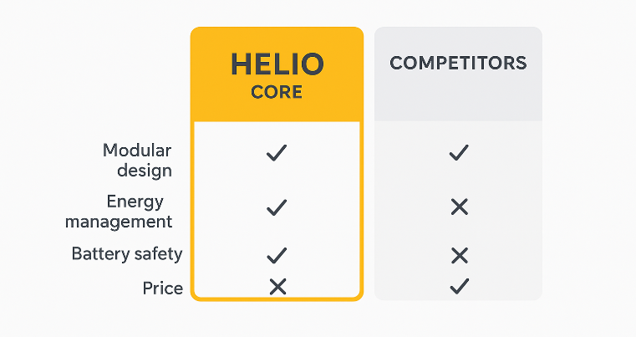
Figure 03: Helio’s core differentiation from its competitors (Source: Self-made)
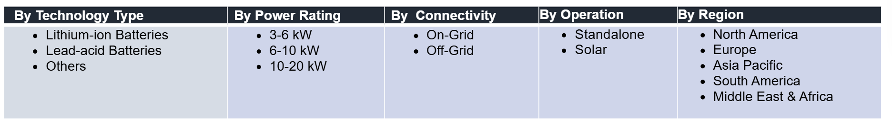
Figure 04: Key marketing trends based on various criteria (Figure: (TechSci, 2018)
Technology and integration: Helio Core will be differentiated by modular, scalable kWh building blocks, high-cycle-life cells, built-in V2H/V2G enablement, and high-quality energy management software, making the best use of self-consumption and EV charging schedules (Comello et al., 2019).
Service and safety positioning: Home-battery post-recall sensitivity implies that Helio will focus on independent third-party safety certification, open-source cell sourcing, and a special Helio Service network. The issue of service and safety is of high importance due to the recent recalls in the industry (Durmuş Senyapar, 2024).
Ecosystem and financing: Locating Helio as a more energy-oriented sub-brand will minimise brand-spill risk and make Helio a reputable, committed home energy provider.
Brand architecture: Placing Helio as an energy-focused sub-brand reduces brand-spill risk and positions Helio as a trusted, dedicated home energy specialist will appeal to households who feel not motivated about automotive associations.

Positioning
Positioning statement for the new product development and marketing will be:
‘Helio Core is the service-focused, high-quality, intelligent choice to satisfy the needs of the homeowner who desires reliable, safe and intelligent home energy independence, connecting your home and EV and reducing bills, maximising resilience and simplifying energy management with guaranteed safety.
Support pillars: The support pillars of positioning include Modular high-efficiency battery technology, certified safety standards and recall-free procedures, integrated saving and resilience software, customised financing and installer network. These will appeal directly to the buyer's core consideration, like cost, safety, complexity and trust (Tsirpopoulos et al., 2017).

Future risks and opportunities
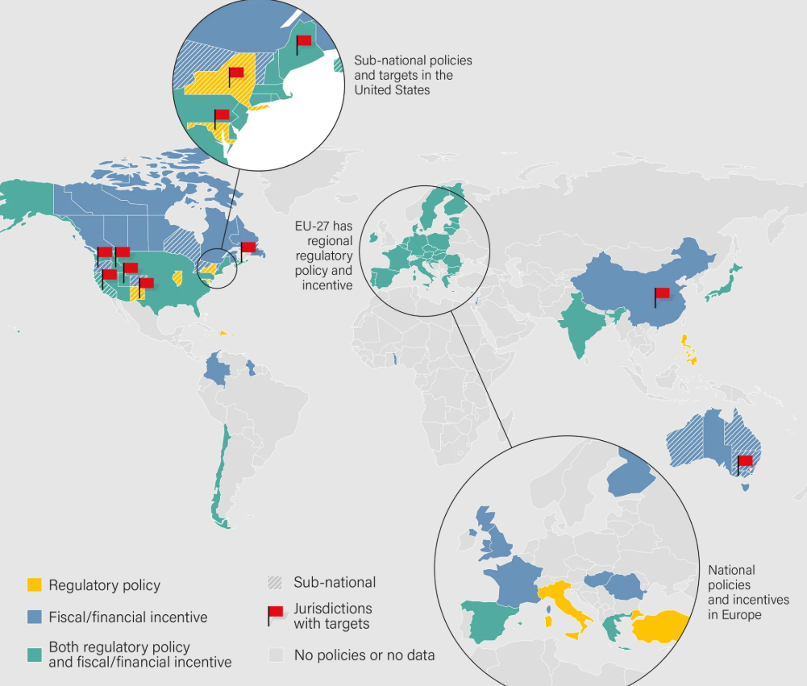
Figure 05: Future Expansion Opportunities (Source: Self-made)
Opportunities: The new product has very good potential, as strong market development, policy incentives and consumer demand for resiliency are a good launching opportunity for Helio (Nohekhan and Barzegar 2024). It can expand all over the world after launching successfully in the domestic marketplace. It is important to find the global marketplace where Tesla can get policy support and other necessary incentives.
Risks: There are certain risks, too, for the adoption of new products. Automobile scandals, supply chain cell limitations, and safety accidents can induce brand spillovers, which can slow adoption (Scott, 2025). For minimising or eliminating the potential risk, it will be controlled through separate branding, open safety procedures, and fragmented suppliers. The competitive environment consists of proven home-battery competitors and effective product pricing (Schauf et al., 2023), and Helio will combine better software and service, and financing to maintain premium pricing.

Element 2: Marketing Mix (4Ps) for Helio Core
The following is a critical, strategy-oriented 4Ps of Tesla Helio Core, a premium, solar-paired home battery sub-brand, on how each component contributes to supporting the brand objectives of Helio.

Product
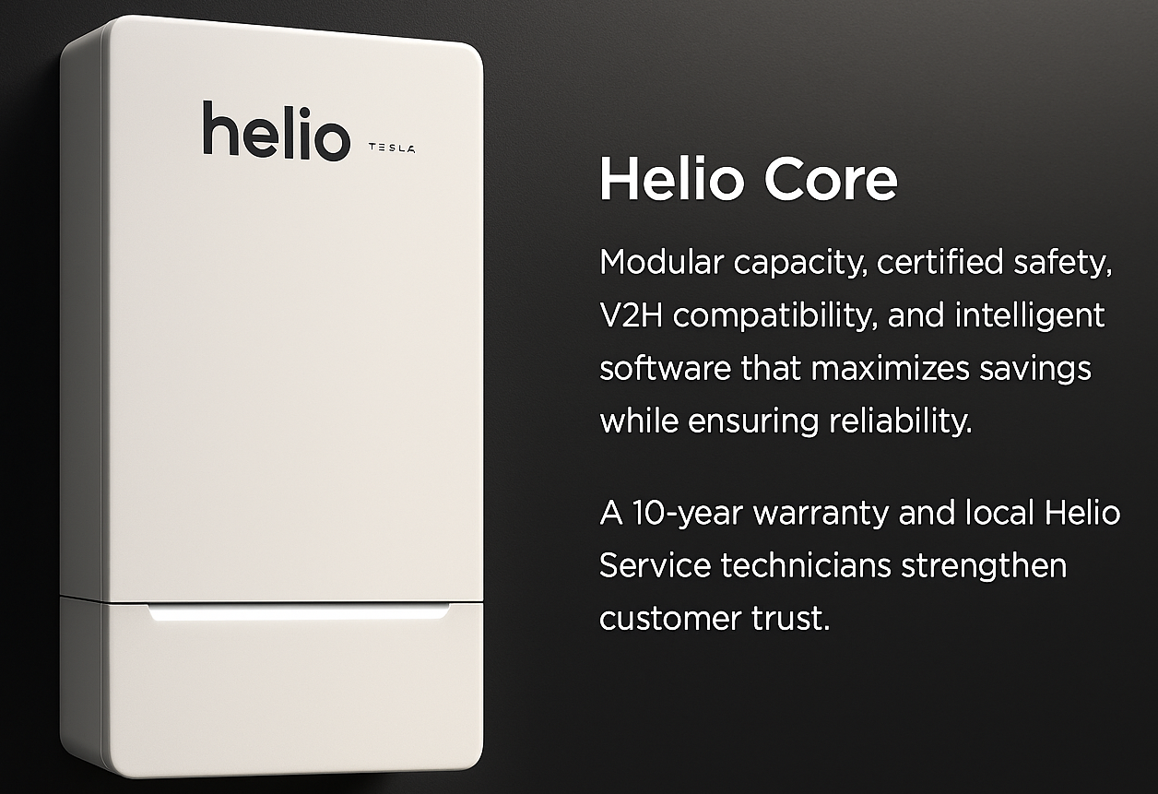
Figure 06: Core product functionality (Source: Self-made)
Helio Core is a 6 kWh (scalable in 6 kWh increments), round-trip, 97% efficiency, bidirectional-charging (V2H/V2G-capable) wall-or-floor-mounted lithium-ion home battery with a range of initial usable capacity of 6-14 kWh per module, self-consumption, peak-shaving, and EV charging schedule optimising energy-management software. Such hardware characteristics as fire-hardened enclosure design, redundant thermal control, and built-in safety monitoring with remote diagnostics are provided. The product will be shipped with a 10-year warranty of performance and optional extended service plans.
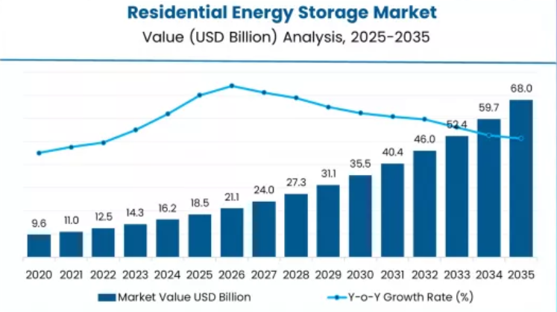
Figure 07: Residential Energy Storage Market (Source: Factmr.com, 2025)
Rationale: Residential storage is a fast-growing market as it is predicted to grow from USD 2.69 billion in 2024 to USD 4.56 billion by 2030 at a CAGR of 9.3% during the forecast period (MarketsandMarkets, 2024). Thus, the buyer will demand more than just storage capacity; it has to be safe, serviced, with software, funded and integrated with other ecosystems (Jorges, 2023). Helio will be credible, using Tesla-derived cell technology and software, and the independent brand identity can allow Helio to focus on home energy safety and local service.
Products Risks and Mitigations: Safety claims are vulnerable currently, especially after the recent safety incidents in the industry (such as a high-profile Tesla Powerwall recall) (Kolodny, 2025); Helio will ensure to have third-party certifications (like UL9540A, IEC, CE), transparent test data and a clear repair procedure to establish trust.

Price
Price will be high but value-based. The price of Helio will be higher than its competitors in the commodity market but lower than an unlabeled ultra-luxury layer, which will entail excellent software, safety guarantees, and additional services (Ngoy et al., 2025). Example structure:
Upfront purchase: base module price 6 kWh module (target mid-/per kWh comparable with premium market participants). Tesla Powerwall prices are used as a market anchor; customers are used to paying around USD several thousand per unit installed in case of about 1314 kWh (Lane, 2024). Helio will focus on a close price installed rate but will provide financing and subscription offset solutions.
Financing or lease: It will provide 0% or low-interest finance within a 5-10-year period through partner banks, and operating-lease options to customers who would prefer opex.
Subscription (SaaS): This will also provide an optional monthly charge to get high-quality energy-management functionality (advanced analytics, aggregated grid support participation, and priority service).
Performance guarantee & buyback: It will offer an optional guaranteed payback program (kWh guarantee or revenue share) to minimise the purchase risk.
Incentives and regional tariffs have a significant influence on payback (Majeed et al., 2022). The financial model of Helio will be regionally optimised with payback displayed to sales teams and sales customers.

Place
Omnichannel distribution will be applied through direct online sales (configurator and site survey), a national network of verified local installers and collaboration with solar integrators, EV dealers, and utilities. Key channels:
Certified installer network: They will be crucial since installers offer trust, allowance and physical installation (Tsirpopoulos et al., 2017). Helio will hire qualified installers, provide training, offer co-branding and offer priority dispatching.
Utility/aggregator partnerships: It will sell aggregated capacity to grid services and demand-response initiatives to generate more revenue streams amongst customers. V2H/V2G interoperability provides utility business cases within some jurisdictions. Standards and pilots (Comello et al., 2019).
Geographic rollout: The product will open new markets (like California, Australia, Germany and strong EU markets) where solar adoption, tariffs and incentives favour optimum ROI; scale as local supply and service footprint is increased.
Critical logistics considerations: Premium positioning can be ensured by technician training and quick replacement logistics of the product, because slow service destroys trust easily (Mishra, 2020). Helio ought to invest at an early stage in regional service hubs and real-time remote diagnostics.

Promotion
Core message pillars: Security, Stability, Economy and Simplicity. Safety issues will be mentioned in the promotional strategy since recent incidents in the industry.
Messaging differentiators: Service-first home energy (Helio technicians, local response, 10-year warranty), and integrate your EV (V2H) as a distinctive convenience narrative.
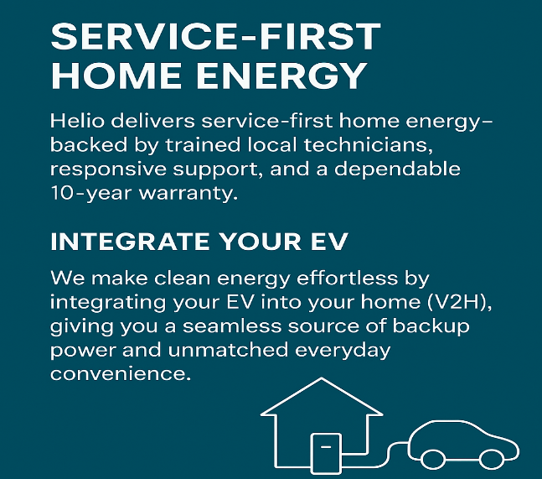
Figure 08: Key Messaging for new product marketing (Source: Self-made)
Tactics:
Targeted digital campaigns: Digital campaigns will focus on homeowners who investigate solar/EV; refer to ROI calculators and local payback estimates.
Installer co-marketing: This will also collaborate with solar companies, EV dealers, have demo homes and local demo vans to demonstrate the use of the systems.
Pilot & proof programs: Also, the new brand will collaborate with municipalities, identified utilities and demonstration neighbourhoods to develop case studies and references.
Promotion KPIs: The promotional KPI will be measured by a 70% lead conversion rate, a 30% cost per installed system, a lower average time-to-install, NPS after installation, and service response time than competitors.

Measurement, timeline and critical risks
KPIs: The KPI of these strategies will be measured by units installed per quarter, average ticket size, quote to install, churn on subscription services, warranty claim rate, NPS and time to replace faulty modules.
Initial 18-month timeline: Year 1 (18 months) plan and Pilot two markets (Q1-Q2), installer network and service hubs (Q3-Q4), and national rollouts in priority markets in Year 2.
Therefore, Tesla can implement the plan according to the given method and timeline. Since the product is new, there may be some potential risks like supply chain limitations, safety measures and regulatory concerns. For these, Tesla will collaborate with quality suppliers and perform various tests before providing its products to customers, as well as provide after-sales support to the customers for any safety issues. Altogether, this product will help the customers to meet their needs, and its distinctive feature will differentiate it from other similar products of competitors.

Element 3: Element 3: Marketing Strategy Pitch for Helio
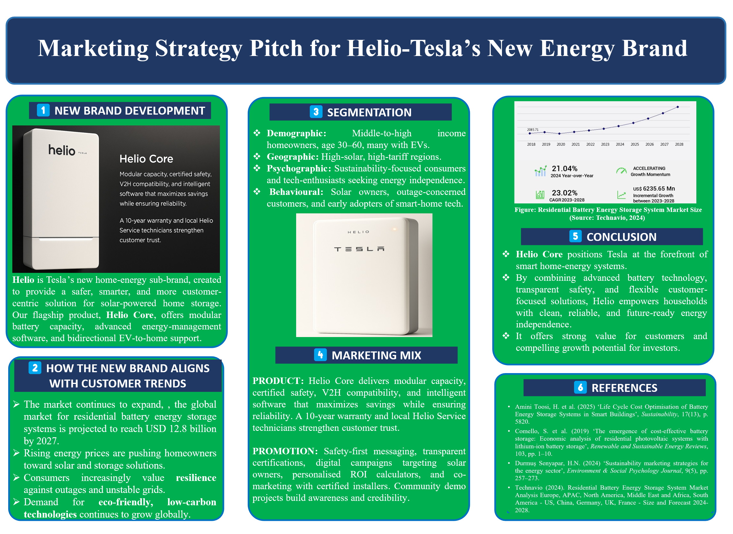
Overview of the New Brand
Helio, the new home-energy sub-brand by Tesla that will transform the way people store and use solar energy at home. Helio Core is a modular and intelligent battery system will connect with electric vehicles through bidirectional EV-to-home support.
Market Expectations
Helio was developed based on customer trends. The market continues to expand, and the global market for residential battery energy storage systems is projected to reach USD 12.8 billion by 2027 (Technavio, 2024). There is a growing demand in the world towards environmentally friendly, low-carbon technologies and the adoption of smart homes.
Segmentations
Our demographic is middle-to-high income homeowners aged between 30 and 60, with most of them already the owners of EVs. Our target markets will be high-solar, high-tariff areas, where tech-oriented ones are going to find smarter energy options.
Marketing Mix
Marketwise, Helio Core will be unique due to its product superiority in terms of modular capacity, certified safety, smart software and ten-year warranty. We will create safety-first messages, online promotional campaigns, and community demo projects through promotion to create trust and awareness.
Overall, Tesla is at the leading position of smart home-energy systems by Helio, putting households in the position of reliable and future-proof energy autonomy, ready to create a powerful value to the customers.

Element 4: Reflection

Reflecting on Developing the New Brand Concept and Marketing Strategy
Reflection is helpful for an individual (Heleta, 2025), particularly for me, for evaluating past performances, as I was involved in developing a sub-brand of Tesla and its new product. Here is the reflection using the Gibbs Reflection model, which involves six stages:
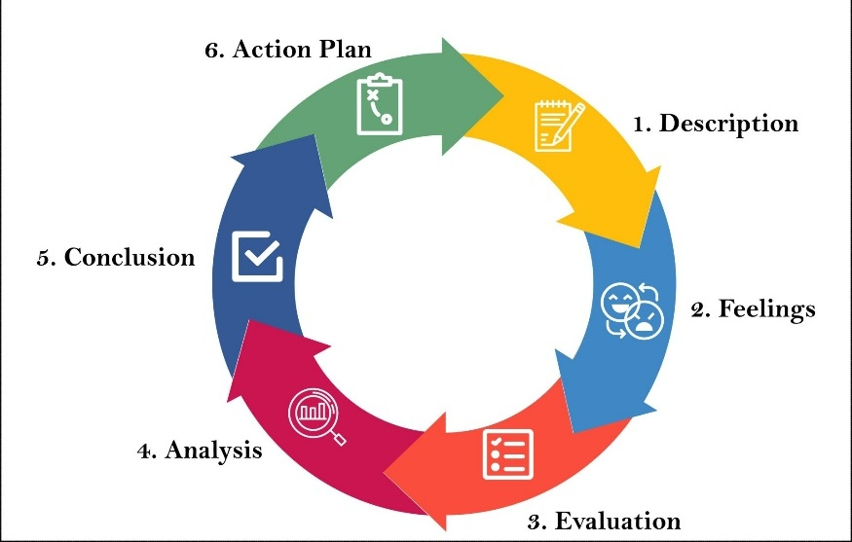
Figure 09: Gibbs Refective model(McLeod, 2025)
- Description: I worked on this specific project to create a sub-brand of Tesla and its new product. First of all, I was overwhelmed with the task as I have never been involved in brand development. The possibilities of products to be considered were numerous, and I needed to weigh them in relation to the latest market tendencies and the capabilities of Tesla to make them possible. I was also required to determine the needs of the customer; this was in terms of the durability of the product, consumption of low power, and little effect on the environment. I also chose the right marketing avenues, pricing policies, and strategic points to make the products reachable to the clients (Heleta, 2025).
- Feelings: Initially, I was doubtful and nervous about my inexperience with this sphere. Nevertheless, I became confident as I went through the process. I understood that with the implementation of market research, I would be able to design a viable approach that would be aligned with the values of Tesla. This increased belief in my capability of developing and delivering a brand idea was very satisfying, and I were starting to enjoy the challenge.
- Evaluation: The project has helped me greatly in strategic thinking and marketing. I put emphasis on product specifications that not only met the needs of the customers, but also those that were in tandem with the market trend. The marketing plan that I formulated made me understand more the aspects of pricing, distribution and communication. It was also an insightful experience making the preparation of the pitch, as it enhanced my skills in summarising complex strategies to formulate clear and convincing messages. Nevertheless, I understood that I could have done more work on competitor benchmarking and gathering consumer feedback to prove my assumptions (Abubakar, Ruslan, and Surani, 2024).
- Analysis: One of the key lessons learned through this experience is that a balance between features of the product and emotion should be made during product marketing. It was essential to pay attention to such product benefits as energy efficiency and sustainability, yet I had to make sure that the message would be emotional and appeal to the target audience. The pitch preparation allowed me to realise that, though customers are sensitive to technical information, they must be able to relate to a good story. I also got to know that emotional appeal should be supported with factual evidence to be effective (McMillan and Weyers, 2018).
- Conclusion: The project was a great learning experience that has given me the intricacies of brand development, strategic marketing, and pitching. This is because I have gained a sense of the importance of integrated market research and competitor intelligence, as well as consumer feedback. I have also been able to understand how to explain complicated concepts and get others to agree with me. This has enhanced my communication skills and my strategic skills.
- Action Plan: The action plan will enable me to improve my skills of creating successful products and marketing plans and refine my communication and pitching skills in future projects.
Moving forward, I plan to further develop my skills by:
Action | Objective | Deadline | Measurement
Benchmark competitors regularly | Validate product assumptions | Ongoing | Comparative analysis reports
Gather consumer feedback more actively. | Ensure product aligns with customer needs | Pre-launch | Consumer survey and feedback analysis
Practice pitch delivery | Improve verbal presentation and confidence | Ongoing | Pitch practice sessions and peer feedback
Expand market research | Understand consumer behaviour and trends more deeply | Ongoing | Updated market research reports

This action plan will help me to achieve deeper knowledge of the process so that I can apply that knowledge in my future professional life.

References
Abubakar, H., Ruslan, M. and Suriani, S. (2024) 'The role of competitor analysis, market orientation, and service quality in working capital management and operational leverage as links to financial stability of manufacturing companies listed on the IDX: A Qualitative Approach,' ATESTASI Jurnal Ilmiah Akuntansi, 7(1), pp. 459–495. https://doi.org/10.57178/atestasi.v7i1.807.
Comello, S. et al. (2019) ‘The emergence of cost-effective battery storage: Economic analysis of residential photovoltaic systems with lithium-ion battery storage’, Renewable and Sustainable Energy Reviews, 103, pp. 1–10.
Durmuş Senyapar, H.N. (2024) ‘Sustainability marketing strategies for the energy sector’, Environment & Social Psychology Journal, 9(5), pp. 257–273.
Factmr.com. (2025). Residential Energy Storage Market | Global Market Analysis Report - 2035. [online] Available at: https://www.factmr.com/report/residential-energy-storage-market? [Accessed 8 Dec. 2025].
Figgener, J., Hecht, C., Haberschusz, D., Bors, J., Spreuer, K.G., Kairies, K.-P., Stenzel, P., & Sauer, D.U. (2022) ‘The development of battery storage systems in Germany: A market review (status 2023)’, arXiv preprint.
Gao, Y. (2023) ‘A Study of Tesla’s International Marketing Strategy Based on the STEPPS Model’, Business, Economics and Management Research, vol. 23.
Heleta, S. (2025) 'Higher education in conflict settings: realities, challenges and possibilities of international solidarity and support,' Globalisation Societies and Education, pp. 1–10. https://doi.org/10.1080/14767724.2025.2499602.
Jorges, E.E.M. (2023) ‘Economic analysis of lithium-ion battery recycling for residential energy storage’, AIMS Energy, 11(4), pp. 813–830.
Kolodny, L. (2025) Tesla recalls 10,500 Powerwall 2 battery systems due to overheating, fire risk. https://www.cnbc.com/2025/11/13/tesla-recall-powerwall-2-overheating-fire-battery.html.
Lane, C. (2024). The Actual Cost of a Tesla Powerwall: Is it Worth it? (2025 Data). https://www.solarreviews.com/blog/is-the-tesla-powerwall-the-best-solar-battery-available (Accessed: November 25, 2025).
McLeod, S. (2025). Gibbs Reflective Cycle. [online] Simply Psychology. Available at: https://www.simplypsychology.org/gibbs-reflective-cycle.html [Accessed 8 Dec. 2025].
McMillan, K. and Weyers, J. (2018). How to Improve Your Critical Thinking & Reflective Skills. Pearson Higher Ed.
Mishra, N. (2020). Marketing management. SBPD Publishing House.
Ngoy, K.R. et al. (2025) ‘Lithium-ion batteries and the future of sustainable energy: A review of recent advances and applications’, Renewable and Sustainable Energy Reviews, in press.
Nohekhan, M. & Barzegar, M.M. (2024) ‘Impact of Green Marketing Strategy on Brand Awareness’, arXiv preprint.
Ozsevim, I. (2025) &apos; Tesla’s EV battery production and global gigafactory network | Article | Automotive Manufacturing Solutions,&apos; Automotive Manufacturing Solutions, 7 July. https://www.automotivemanufacturingsolutions.com/electrification/electric-dreams-teslas-gigafactory-network-and-ev-battery-production-blueprint/545858.
Schauf, M., Themessl, M., Wörner, A. & Reichelstein, S. (2023) ‘System price dynamics for battery storage: Why consumer prices lag behind pack cost declines’, Energy Policy, 183, p. 11364.
Senyapar, H.N. (2024) Sustainable Marketing in the Energy Sector: Strategies for Renewable Brand Growth, 1st edn.
Technavio (2024) Residential Battery Energy Storage System Market Analysis - US, China, Germany, UK, France - Size and forecast 2024-2028 | TechNavio, Technavio, https://www.technavio.com/
Technavio (2024) Residential Battery Energy Storage System Market Analysis - US, China, Germany, UK, France - Size and forecast 2024-2028 | TechNavio, Technavio, https://www.technavio.com/
TechSci (2018). Residential Energy Storage Market By Size, Growth, Trends and Forecast 2028 | TechSci Research. [online] Techsciresearch.com. Available at: https://www.techsciresearch.com/report/residential-energy-storage-market/20111.html? [Accessed 8 Dec. 2025].
Thornhill-Miller, B. et al. (2023) 'Creativity, Critical Thinking, Communication, and Collaboration: Assessment, Certification, and Promotion of 21st Century Skills for the Future of Work and Education,' Journal of Intelligence, 11(3), p. 54. https://doi.org/10.3390/jintelligence11030054.
Tsirpopoulos, I. & co-authors (2017) ‘Li-ion batteries for mobility and stationary storage applications’, Joint Research Centre Report, European Commission.

