Date:19/12/2025
Module Name: Introduction to Web and Database Concepts
Code: ACCA4023

Assignment title: HTML & CSS Web Development

Student Name: Syeda Sumaya Begum
Student ID:2436007
Group :2

Contents
1. Introduction 3
2. Requirements 3
3. Implementation 4
4. Evaluation 11
4.1 Usability, Accessibility, And Search Engine Optimisation 11
4.2 Evaluation of The Northbridge Digital Studio Website 11
4.3 Comparison Of Two Live Websites 12
7. References 13

1. Introduction
This report explains the design, implementation, and evaluation of the Northbridge Digital Studio website, a hand-coded multi-page site created for a small local digital agency. The site demonstrates how semantic HTML, responsive CSS, and light JavaScript can deliver an accessible brochure-style presence that is easy for non-technical clients to navigate and understand [1]. The report sets out the requirements that shaped the build, explains key implementation choices, and evaluates the finished site in relation to usability, accessibility, and search engine optimisation SEO, drawing on recognised standards and recent guidance [1] [2] [3].
Small organisations rely on clear web presences to communicate services, build credibility, and collect enquiries [4]. Northbridge Digital Studio is positioned as a small agency that designs accessible, content-focused sites for such organisations, so the implemented site uses five core pages, including home, about, services, gallery, and contact, with a consistent header, footer, and navigation pattern. Figure 1 and Figure 2 show the home page layout, which introduces the value proposition and summarises service updates and contact information. The following sections provide a structured account of requirements, implementation, and evaluation that link web standards and good practice to the specific design decisions taken for this website [4] [5].

2. Requirements
The core technical requirement was to design and hand-code a responsive website with at least five related pages that can run by opening index.html on a desktop computer [1]. This ruled out visual design tools that generate proprietary project files and instead required standard HTML, CSS, and JavaScript with relative paths so that the project can be compressed and moved easily between machines [1]. Northbridge Digital Studio is positioned as a service provider for local organisations that need maintainable websites, so the brief emphasised clarity and ease of maintenance rather than advanced interaction or heavy back-end logic [4].
Content requirements focused on explaining what the studio offers, how projects are delivered, and how potential clients can make contact in language that is direct and free of unnecessary jargon [4]. The five pages had to introduce the value proposition, describe values and project stages, outline core service packages, showcase example layouts, and provide a structured contact route, so the home, about, services, gallery, and contact pages were planned as a connected set, as shown in Figures 1 to 6 [3] [5] [6]. Each page, therefore, needed concise headings, paragraphs that are easy to scan, and calls to action that guide visitors towards service information or an enquiry, with content written for organisations with limited technical knowledge [4].
Non-functional requirements combined usability, accessibility, performance, and search visibility [1]. Usability expectations drew on the ISO 9241 11 definition of effectiveness, efficiency, and satisfaction in context, so the site needed clear navigation, consistent layouts, readable text, and an uncomplicated enquiry flow [1] [2] [5]. Accessibility expectations followed WCAG version 2.1 and its four principles of perceivable, operable, understandable, and robust content, which led to requirements for text alternatives, keyboard access, sufficient colour contrast, clear labels, and predictable navigation [3] [7] [8]. SEO expectations were based on descriptive titles, accurate meta descriptions, meaningful headings, descriptive link text, and simple URL structures that match guidance for small business sites [9] [10]. Performance requirements called for short load times and a responsive layout using flexible grids, fluid images, and media queries so that one code base adapts across devices without heavy frameworks [11] [12].

3. Implementation
The Northbridge Digital Studio site is delivered as five HTML documents that share one header, footer, and stylesheet, which keeps presentation consistent and reduces maintenance effort across the codebase [1]. Each page uses the HTML5 doctype, declares English as the language, sets UTF-8 character encoding, and includes a responsive viewport meta tag, which follows current guidance for accessible and device-independent markup [1]. Document titles use the pattern "Page name | Northbridge Digital Studio", and each page provides a concise meta description, which reflects advice that titles and summaries should describe page purpose clearly for both users and search engines [9] [10]. A keyboard focusable skip link appears at the top of the body so visitors using keyboards or assistive technologies can move straight to the main content, which meets expectations for bypassing repeated navigation blocks under WCAG [1]. The header groups the studio name, strapline, and global navigation list, and applies a current page state both visually and programmatically, which improves orientation and reduces the risk of users losing track of location on the site [1].
The home page opens with a hero section where a clear heading, introduction and two primary buttons lead visitors to explore services or request a quote, reflecting evidence that explicit calls to action improve task completion [5] [14]. An illustration reinforces the digital studio focus and, together with card sections for the latest updates and a brief summary, helps visitors grasp what the service offers, who it serves and next steps after a brief scan. Visual design is managed through a single CSS file while Flexbox, CSS Grid and media queries control layout so colour, typography and structure remain consistent and free of horizontal scrolling [11] [12]. The About page reuses this system and outlines purpose, values and project stages as a journey, which supports trust building by clarifying process and outcomes before enquiry [4] [6].
The Services page explains that projects begin with content and hierarchy planning before layout and navigation are fixed, then groups discovery, design, build, testing, and basic SEO setup into three card-based packages so scope and value are transparent with cognitive effort reduced. The Gallery page presents work examples inside figure elements with descriptive captions so visitors who cannot perceive images still receive meaningful explanations, while a responsive grid keeps images clear without horizontal scrolling, which aligns with accessibility and responsive image expectations. The Contact page combines a labelled form, helper text, a consent checkbox and a side panel listing contact details and opening hours so visitors can choose contact options with confidence in the studio’s legitimacy [4] [9]. A JavaScript file adds progressive enhancement by providing a mobile navigation toggle and clieclient-sideidation with a status region, which keeps navigation robust and form interaction understandable while supporting timely feedback.
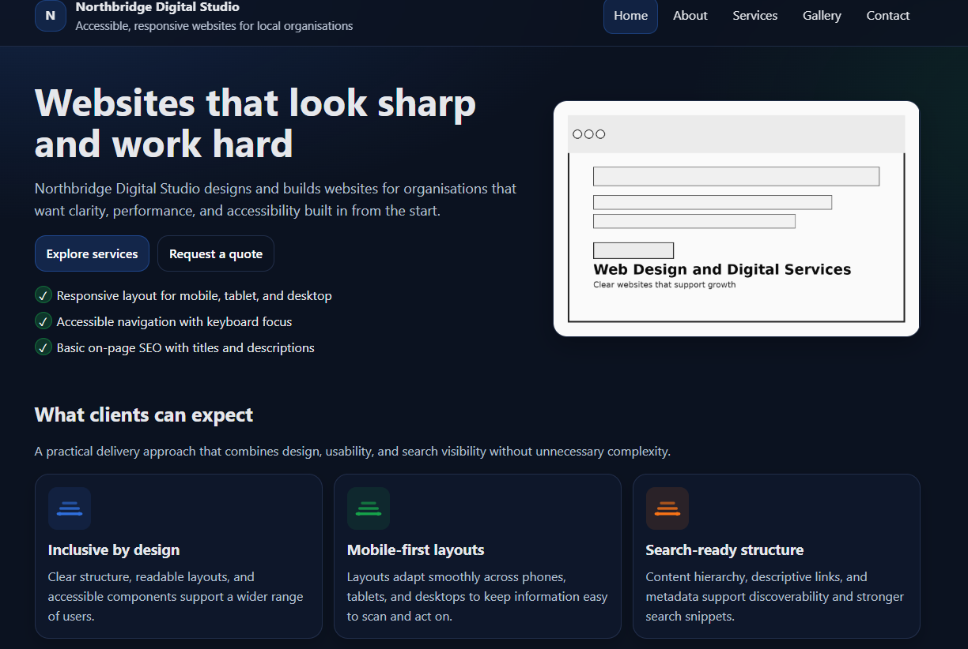
Figure: 1 - Website front page (Part 1)
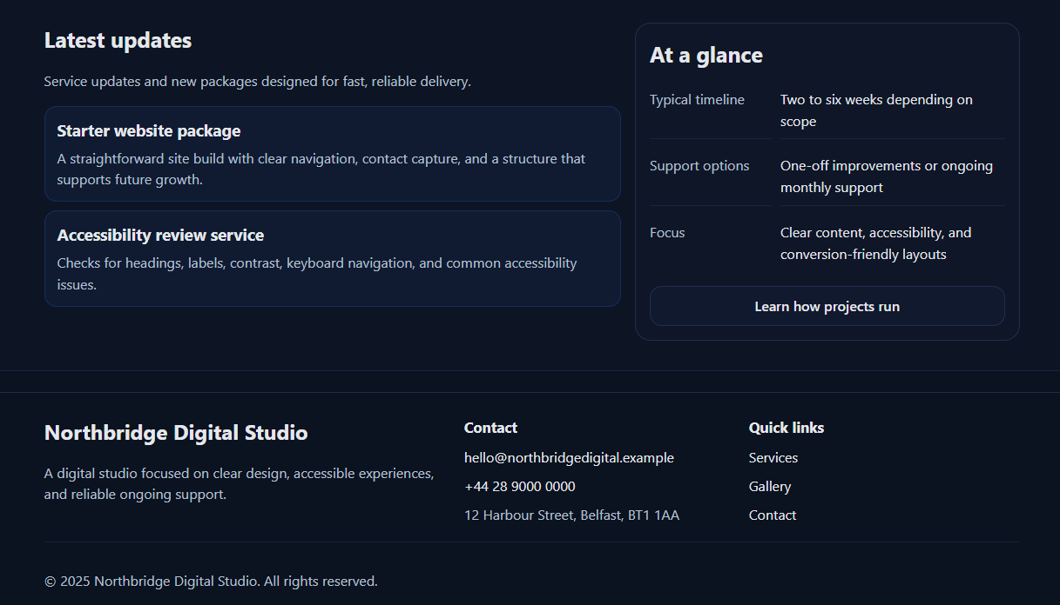
Figure: 2 - Website front page (Part 2)
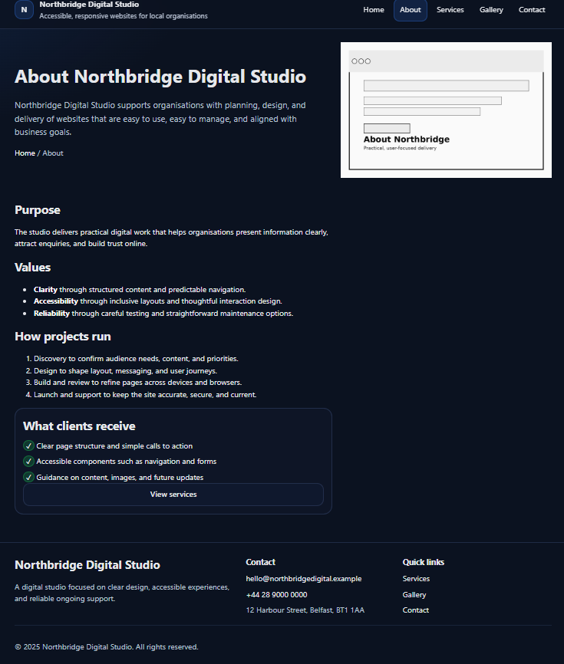
Figure: 3 - About page
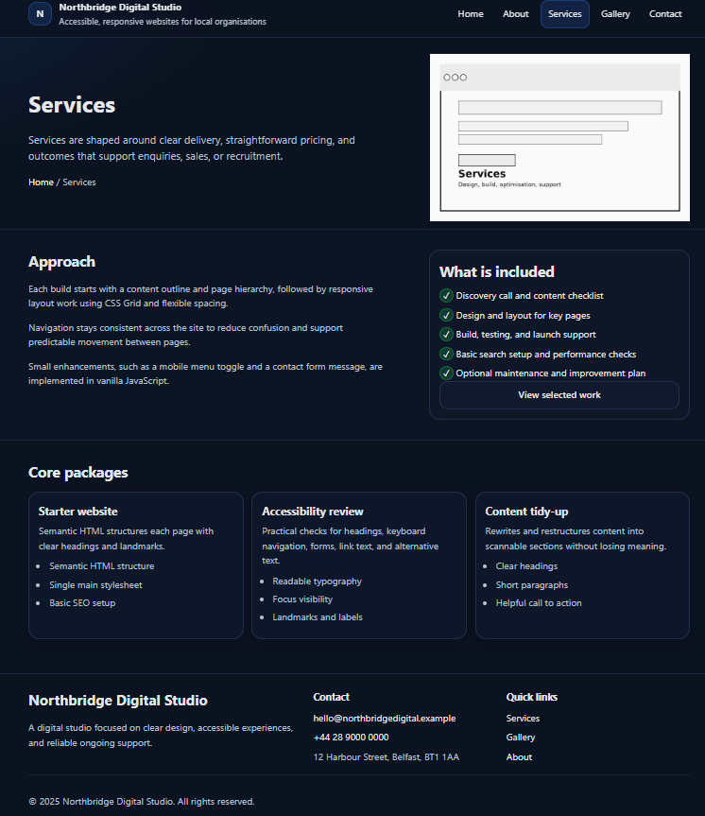
Figure: 4 - Service page
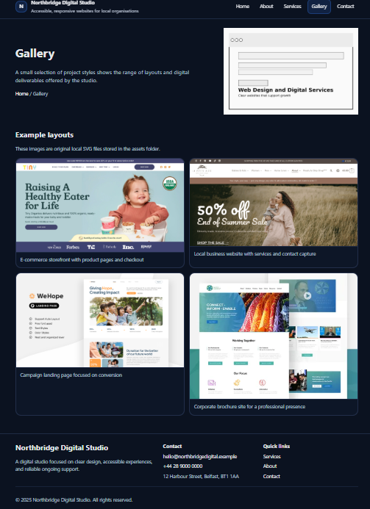
Figure: 5 - Gallery page
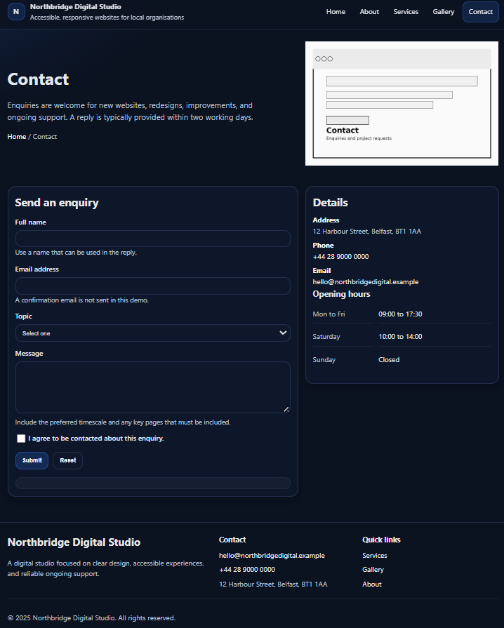
Figure: 6 - Contact page

4. Evaluation

4.1 Usability, Accessibility, And Search Engine Optimisation
ISO 9241-11 defines usability through effectiveness, efficiency, and satisfaction within a specified context of use, which means evaluation must be tied to real users doing real tasks on real devices [1]. This framing prevents weak claims because a site can appear smooth in a demo yet fail when users attempt core tasks under time pressure or poor connectivity. Recent ISO work on usability reporting requires clear descriptions of context, user groups, tasks, and measures so that results are interpretable and comparable across studies [2]. This emphasis improves rigour because it forces evaluators to state what “success” means, how it is measured, and why it matters for the target audience. Modern web usability summaries consistently link perceived usability to navigation clarity, content clarity, accessibility of key features, and speed, which are practical levers for a small service site [5] [14] [15].
WCAG 2.1 remains the core accessibility reference and adds success criteria beyond WCAG 2.0 to better support cognitive, motor, auditory, and visual needs, including mobile use [3] [7]. WCAG guidance is organised around four principles and requires meeting testable criteria that cover text alternatives, keyboard access, contrast, error identification, and consistent navigation [4] [8]. This structure is valuable because it converts accessibility into specific checks that can be verified and documented rather than treated as a vague design preference. Industry guidance also recommends combining automated checks with manual inspection and user testing because automated tools cannot fully reflect assistive technology behaviour or task-level barriers [13]. For SEO, the Google SEO Starter Guide prioritises descriptive titles, useful meta descriptions, logically nested headings, descriptive links, and mobile-friendly layouts to support crawling and understanding [9]. Independent guidance for 2023 and 2024 adds that internal linking, schema markup, and high-quality content are vital, especially for smaller sites competing in local markets [10] [11] [12].

4.2 Evaluation of The Northbridge Digital Studio Website
The Northbridge website shows strong usability through clear entry points and short, predictable task flows that match the scale of a small studio site [5] [15]. The home page headline and short supporting paragraph state what the agency does in plain language, so first-time visitors need little time to understand the offer [5] [15]. Primary buttons such as “Explore services” and “Request a quote” present immediate next steps and reduce the chance that visitors hesitate or wander without direction [5] [15]. Sections such as “What clients can expect” and “Core packages” reuse a simple card layout so users see the same pattern repeated and can scan details quickly with less effort [5] [15]. Navigation depth remains low, and labels are direct, which supports findings that flat structures and focused content help users complete tasks more smoothly on smaller service sites [6]. Planned usability testing using ISO 9241-11 could confirm these impressions by measuring completion rates, time on task, and reported satisfaction for core tasks such as sending a quote request or comparing packages [1] [2].
Accessibility measures on the Northbridge site reduce barriers for visitors who rely on keyboards or assistive technologies by providing a clear structure and predictable navigation [3] [4]. Semantic landmarks using header, nav, main and footer, together with a focusable skip link, visible focus outlines and keyboard operable menus, support efficient movement across pages and stable orientation [3] [4]. Clear form labelling, helper text and a consent checkbox make the contact form easier to complete, while contrast-checked colour choices, readable typography, automated tools such as WAVE and manual keyboard-only and screen reader testing give a clearer view of accessibility over time.

4.3 Comparison Of Two Live Websites
Comparison with two established UK websites, one a national news portal and one a large online retailer, shows how increasing content volume changes demands on structure and navigation [5]. The news portal presents dense screens filled with headlines, live updates, and media, so clear headings and internal links become crucial wayfinding anchors for readers moving through fast-changing stories [5]. The retailer supports a very large product catalogue through deep category hierarchies, strong site search, and layered filters so users can narrow down long lists of items, which follows familiar e-commerce design patterns [5] [14]. Both large sites must balance usability with commercial pressures and the need to expose many pieces of content, so some screens appear visually busy even when the underlying structure is logical [5] [14]. Studies on small business and service websites suggest that clear navigation labels and simple hierarchies strongly influence visitor satisfaction and intention to return [6] [15]. Northbridge matches this evidence by keeping pages short, flattening the structure, and making the path from initial visit to enquiry very direct [6] [15].
Accessibility at this larger scale is harder to maintain because many templates, interactive components, and external scripts must all satisfy WCAG consistently across thousands of pages [7] [13]. Industry reports repeatedly identify issues such as absent alternative text, low contrast, and controls that fail under keyboard use, which often appear when components are reused widely without a full accessibility review [7] [13]. Northbridge gains an advantage by working with a small set of templates and limited scripting so teams can apply automated checks and manual testing in a more focused way and keep conformance stable as content grows [4] [8] [13]. The two large sites demonstrate strong search visibility through descriptive titles, dense internal linking, structured data, and frequent content updates that support ongoing SEO performance [9] [10]. Northbridge adopts appropriate on-page SEO patterns through descriptive titles, concise meta descriptions, and meaningful internal links that connect home, services, gallery, and contact content in a coherent way [9] [10]. Further refinements, such as adding structured data for local business details and expanding case studies, would deepen local search visibility while keeping the navigation simple enough for a small service website [10] [12].

7. References
[1] International Organization for Standardization, ISO 9241-11:2018 Ergonomics of human-system interaction Part 11 Usability Definitions and concepts, Geneva, Switzerland, 2018.
[2] N. Bevan, “New ISO standards for usability, usability reports and usability measures,” in Human-Computer Interaction Theory, Design, Development and Practice, M. Kurosu, Ed., Cham, Switzerland, Springer, 2016.
[3] World Wide Web Consortium, Web Content Accessibility Guidelines (WCAG) 2.1, W3C Recommendation, 2018.
[4] W3C Web Accessibility Initiative, “WCAG 2 Overview,” World Wide Web Consortium, 2025.
[5] Interaction Design Foundation, “What are the Web Content Accessibility Guidelines (WCAG),” Interaction Design Foundation, 2016.
[6] Google Search Central, Search Engine Optimization (SEO) Starter Guide, Google LLC, 2022.
[7] B. Dean, “Google SEO 2023 Complete SEO beginner’s guide,” Backlinko, 2023.
[8] E. Marcotte, Responsive Web Design, 2nd ed., A Book Apart, New York, NY, 2014.
[9] S. Dhopte and S. Sharma, “Responsive Web Design Present and Future,” 2018.
[10] Baymard Institute, “Website Usability Best Practices backed by research,” Baymard Institute, 2024.
[11] Recite Me, “Website usability testing A comprehensive guide,” Recite Me, 2025.
[12] ADA Global, “Why is usability important for your business website,” ADA Global, 2024.
[13] J. L. Fisher, J. Bentley, R. Turner and A. Craig, “A usability instrument for evaluating websites navigation elements,” in OZCHI 2004 Supporting Community Interaction Possibilities and Challenges Proceedings of the Australian Computer Human Interaction Conference, Wollongong, Australia, 2004.
[14] WebAIM, “WAVE Web Accessibility Evaluation Tool,” WebAIM, Utah State University, 2024.
[15] Level Access, “WCAG 2.1 Understanding the success criteria,” Level Access, 2025.

