BMIH5003 Hotel Handbook for Intercultural competence

Romeo Popescu
1922487

Executive summary
Cultural awareness is helpful to perform diverse activities. Proper understanding makes sure intercultural competence. Hospitality sector requires proper identification of the culture to serve customer from all over the world. Seeking guest preferences and delivery activities through gaining proper knowledge about customers and culture can help to maintain all the areas in the appropriate directions.

Table of Contents
Introduction 1
Hotel Location Country A: Dubai 1
Guests cultural background Country B: Romania 2
Country analysis 3
Hotel handbook 4
Conclusion 4
References 5

Introduction
Cultural awareness has large impact on the hospitality industry (Testa, 2009). International hotel management requires proper evaluation of the culture and implement them to maintain adequate decision-making process. Undertaking cultural consideration are helpful to increase the guest service experience. Hofstede’s cultural dimension mainly evaluates a country’s culture following six dimensions. This report will focus on the application of the Hofstede model on cultural differences of hotel location country and guests’ country. Country analyses are also done in this report evaluating hotel handbook to give do’s and don’t list.

Hotel Location Country A: Dubai
Selected hotel country is Dubai which is famous for tourists’ interaction activities. Tourists from different counties mainly stays in the hotel to exchange views and other activities that are helpful to enhance proper views.
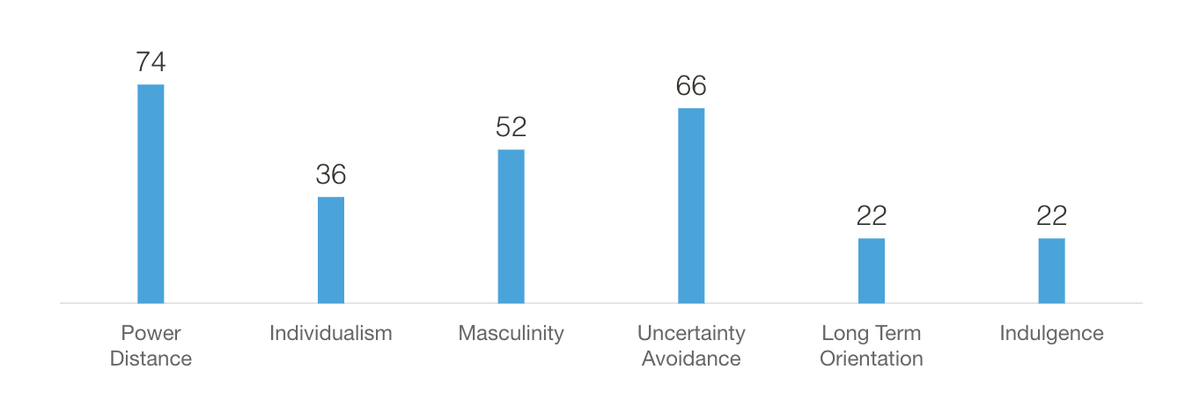
Figure: Dubai cultural dimension (Source: Hofstede, 2009)
Power distance: All individuals in Dubai are not equal that express the attitude of the culture towards these inequalities (Baum et al., 2007). Power distance is also considered as the less powerful members of institutions and organisation with the country that accept the power unequally. Power index of Dubai scored 74 which means hierarchical order has place without further justification.
Individualism: This is the degree of interdependence among a societies member where Dubai scored 36 that considered as a collectivistic society. A close long-term commitment of the group members, extended family or other relationships are related to the loyalty.
Masculinity: High masculine means a country is driven by competition, achievement and success that defined by the winner and other value system. Low score of feminine on the dimension means dominating values in society that impact on quality of life. Dubai scored 52 which means there is avenger on this dimension.
Uncertainty avoidance: Dealing with the uncertainty with the future are never unknown and diverse activities are maintained to control the future. Dubai scored 66 on this dimension that makes high preferences for avoiding uncertainty.
Long term orientation: Maintaining links with the own past at the time of dealing challenges of the present and future are the long-term orientation. Dubai scored 22 on this dimension which is lower on the dimension.
Indulgence: This challenges the confronts of humanity in the degree to the extent of controlling desire and impulses (Ogbonna and Harris, 2002). Indulgence impact on the weak control and strong controlling is called as the restraint. Dubai scored 22 on this dimension in contrast to indulgent societies to put much emphasis on leisure time and control the desires.

Guests cultural background Country B: Romania
Power distance: Romania scored 90 in the power distance that means the country follows hierarchical order to maintain daily activities putting further justification (Hofstede, 2009). Hierarchy reflects inherent, inequalities, centralisation, and other activities of Romania.
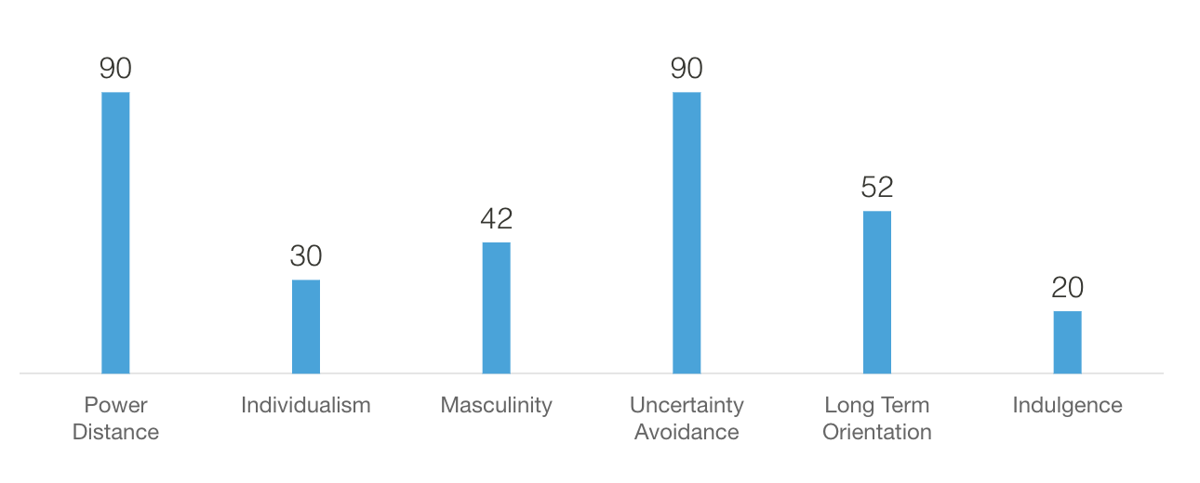
Figure: Romania cultural dimension (Source: Hofstede, 2009)
Individualism: With the score of 30, Romania is considered as the collectivistic country. With a close long-term commitment to the group member, family, extended family or extended relationships, Romania fosters stronger relationship.
Masculinity: Romania scored 42 on the masculinity dimension what considered as feminine society. They mainly focus working in order to live where managers strive for consensus, equality, solidarity and quality in their working lives.
Uncertainty avoidance: With the score of 90, Romania has high preferences for avoiding uncertainty. Evaluating different factors of the uncertainty mainly impacts on the rigid codes and behaviour. Innovation process in the uncertainty mainly impacts on the rules evaluation practices.
Long term orientation: Romania maintains diverse links with the past activities and dealing with the challenges of the present and future that scores 52 on this dimension (Testa, 2007). Engagement with the different past activities and goals evaluation practices allows to prepare for the future.
Indulgence: Poor controlling of desires and impulses makes Romanian culture restraint with the score of 20 (Roper et al., 2022). In contrast to indulgent, restraint activities of Romania create less emphasis on the leisure time and controlling of the gratification of their desires.

Country analysis
Comparison analysis: Dubai scored less in power distance compared to Romania which makes impact on the hierarchal activities in the hospitality sector (Soares et al., 2007). For instance, maintaining different activities compared to Romania as per hierarchy are less differences in the Dubai. Average availability of the masculinity and femininity in Dubai allows to work in the right direction in the hospitality sector. However, Romania scored high in the uncertainty avoidance that allows to maintain different activities in the adequate manner.
Critical analysis: Dubai has better flexibility compared to Romania that allows to perform different activities and working preferences in the hospitality (Manrai and Manrai, 2011). Employees of Dubai hotel can provide diverse facilities and accommodation facilities to the customers of Romania.

Hotel handbook
Differences | Country A: Dubai | Country B: Romania
Flexibility | High flexibility in the hospitality areas. | Less flexibility due to high power barriers.
Culture | Lack of cultural differences or barriers impact on the flexibility areas. | Complicated cultural practices.
Service process | Constant improvement and controlling activities. | Less emphasis on the controlling.
Management | Collaboration with the management makes successful implications. | Constant collaboration on the hospitality.

Conclusion
Hospitality services requires proper evaluation of the culture that allows to maintain different services in the right direction. Adequate management activities and cultural significance criteria are helpful to maintain complicated tasks without barriers. For instance, constant improvement and controlling areas encourages understanding of the cultural behaviours and delivering the appropriate services to the guests.

References
Baum, T., Dutton, E., Karimi, S., Kokkranikal, J., Devine, F. and Hearns, N., 2007. Cultural diversity in hospitality work. Cross cultural management: an international journal.
Hofstede, G., 2009. Geert Hofstede cultural dimensions.
Manrai, L.A. and Manrai, A., 2011. Hofstede’s cultural dimensions and tourist behaviors: A review and conceptual framework. Journal of Economics, Finance & Administrative Science, 16(31), p.23.
Ogbonna, E. and Harris, L.C., 2002. Managing organisational culture: Insights from the hospitality industry. Human Resource Management Journal, 12(1), pp.33-53.
Roper, A., Brookes, M. and Hampton, A., 2022. The multi-cultural management of international hotel groups. International Journal of Hospitality Management, 16(2), pp.147-159.
Soares, A.M., Farhangmehr, M. and Shoham, A., 2007. Hofstede's dimensions of culture in international marketing studies. Journal of business research, 60(3), pp.277-284.
Testa, M.R., 2007. A deeper look at national culture and leadership in the hospitality industry. International Journal of Hospitality Management, 26(2), pp.468-484.
Testa, M.R., 2009. National culture, leadership and citizenship: Implications for cross-cultural management. International Journal of Hospitality Management, 28(1), pp.78-85.

