

LEVEL 7 ASSESSMENT SPECIFICATION
Student name: | Salomiben Rasikbhai khristi | Student ID number: | 2433236
Programme: | MSc Public Health and Social Care in Practice
Module: | Health Care System, Organisation and Leadership
Module code: | LCHS7002 | Contribution to Overall Module Assessment (%): | 100%
Lecturer: | Shepherd Ziko | Internal Verifier: | Dr Hamdi Hussain
Assignment Title: | Case Study Analysis  Report:  Comparative report on  COVID19 leadership  responses | Word count (or equivalent): | 5000 words (+/-  10%)
Submission  deadline: | 16th December 2025  14:00 (2PM) | Return date of  provisional marks & written feedback: | 27th January 2026

TITLE:
HEALTH SYSTEM COMPARISONS DURING COVID-19 PANDEMIC

Table of Contents
1. Introduction 5
1.1 Overview of the report 5
1.2 Discuss about main aspects discussed in the comparative health of the three countries to compare their systems approaches to the COVID-19 pandemic with an inference to centralised and decentralised approaches 5
1.3 Outline the concepts of centralisation and decentralisation and importance of leadership approaches 6
2. Critical Analysis of each countries Centralised/decentralised approaches to the pandemic 6
2.1 Outline the systems approach for the healthcare system during COVID-19 6
2.2 Three countries' decisions and approaches based on centralised and decentralised state 8
2.3 Critically discuss advantages and disadvantages of the systems approaches used by three countries 9
2.3.1 Outline centralised and/or decentralised approaches taken by each country 12
2.3.2 Approaches yielded positive health outcomes 13
2.4 Did you also explain the challenges that resulted from these approaches? 14
2.5 Demonstrate a critical engagement with wider literature to support of key points 15
3. Critical Analysis of the Leadership Styles taken in each Country 15
3.1 Leadership styles covered in this course to compare the approaches of the three mentioned leaders as they tackled the pandemic 15
3.1.1 Leadership theories and styles in Spain 16
3.1.2 Leadership theories and styles in South Korea 18
3.1.3 Leadership theories and style in Canada 19
3.2 Critically discuss the advantages and disadvantages of the leadership styles taken by each country 21
3.3 Demonstrate an engagement with wider sources of literature 22
4. Conclusion 23
References 24

Table of Figure
Figure 1: Excess Morality attributable to COVID-19 in Spain 5
Figure 2: Age distribution of pregnant women at childbirth in Spain during 2020–2022 7
Figure 3: Prevalence by symptom cluster at 1 and 3 months 7
Figure 4: Impact of COVID-19 on sustainable development goals in South Korea 8
Figure 5: Compassion between centralised and decentralised approach 9
Figure 6: Ratio public health expenditure from Government of Spain, Ministry of Health Own elaboration 11
Figure 7: The number of COVID-19 cases in PWHS from 2020 to 2021 in Canada 13
Figure 8: Leadership and Governance experiences during COVID-19 pandemic 16
Figure 9: Leadership style during crisis in Spain 17
Figure 10: The framework of crisis leadership during pandemic in South Korea 19
Figure 11: Leader character dimensions and associated character elements outlined by Canadian Government 21
Figure 12: The transformational leadership Model 22

1. Introduction

1.1 Overview of the report
This report presents the major features of the comparative system approaches on the COVID-19 pandemic based on centralised and decentralised response models in Spain, South Korea and Canada. It considers how the governance structures, how they coordinated and how they made their decisions influenced the effectiveness of each of these countries in dealing with the crisis.

1.2 Discuss about main aspects discussed in the comparative health of the three countries to compare their systems approaches to the COVID-19 pandemic with an inference to centralised and decentralised approaches
The discussion provides the primary features of the comparative health responses in Spain, South Korea, and Canada to COVID-19. It puts emphasis on variations in preparedness, testing capacity, governing structures, and coordination between the public-health activities (Fonsen et al., 2025). The comparison particularly points out how the approach of each country, more centralised (Spain), highly coordinated yet decentralised (South Korea) and or provincially decentralised system (Canada), worked to determine the response speed and effectiveness to the pandemic (Glenn et al., 2021). The comparison of these models is also emphasised in the analysis to learn about the impact of governance, decision-making freedom, and communication on the results, and to provide information about the reasons why particular systems coped with the crisis more successfully than others.
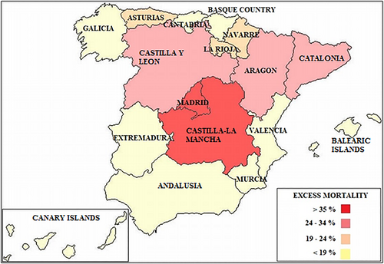
Figure 1: Excess Morality attributable to COVID-19 in Spain
(Source: Erkoreka and Hernando‐Pérez, 2022)
This map of Spain displays the regional excess mortality in the course of the study. The excess mortality was greatest in Madrid and Castilla-La Mancha, being above 35%. Between 2434% was registered in Castilla y Leon, Catalonia, Aragon, and La Rioja. There were moderate values of 19-24% in regions like Valencia, Murcia, Basque Country, and Navarre, and lowest excess mortality rates in regions such as Andalusia, Extremadura, Asturias, Galcia and the Canary Islands (Erkoreka and Hernando‐Pérez, 2022). There were intermediate rates of 19-24% in the regions of Valencia, Murcia, Basque Country and Navarre, as well as the lowest rates of excess mortality in the regions of Andalusia, Extremadura, Asturias, Galcia and the Canary.

1.3 Outline the concepts of centralisation and decentralisation and importance of leadership approaches
Analysis provides the meaning of centralisation and decentralisation, elaborating on the distribution or concentration of authority on different levels of government. It also explains why leadership strategies are relevant, and proper coordination, decision-making, and constant communication play a crucial role in successful countries in dealing with a pandemic (Rossi and Sørensen, 2022).

2. Critical Analysis of each countries Centralised/decentralised approaches to the pandemic

2.1 Outline the systems approach for the healthcare system during COVID-19
The healthcare system's approach to the COVID-19 crisis was well defined through the analysis of the interactions of various components, such as governance, workforce, infrastructure, data systems, and public-health coordination, that were influenced to affect the national responses. A systems approach perceives healthcare as an integral system rather than separate components, in which decisions made in one sector have a trickle effect on the entire system (Morgan, 2022). In the midst of the pandemic, this view was key in unravelling the way hospitals, laboratories, supply chains and government agencies had to work as one and not as isolated states.
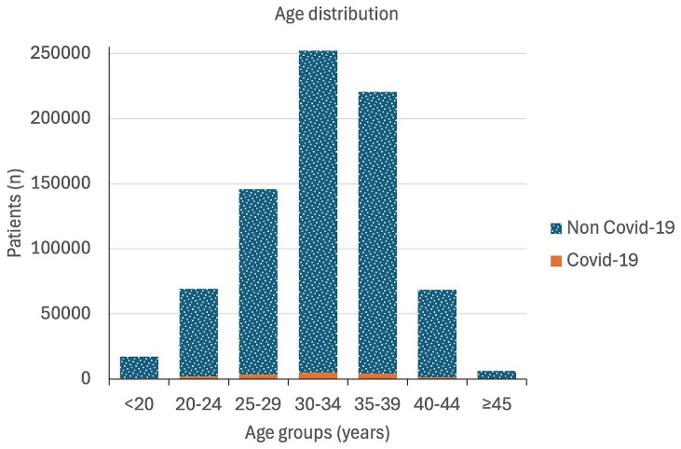
Figure 2: Age distribution of pregnant women at childbirth in Spain during 2020–2022
(Source: Álvarez-del Río et al., 2025)
The figure represents the distribution of the age of COVID-19 and non-COVID-19 patients. The age group of most patients ranges between 25 and 39, with most being 30-34 and 35-39. The number of COVID-19 cases is negligible compared to non-COVID-19 cases with respect to all age groups (Álvarez-del Río et al., 2025). The number of patients younger (under 20) and older (over 45) is very low, pointing to the fact that there are usually younger patients overall.
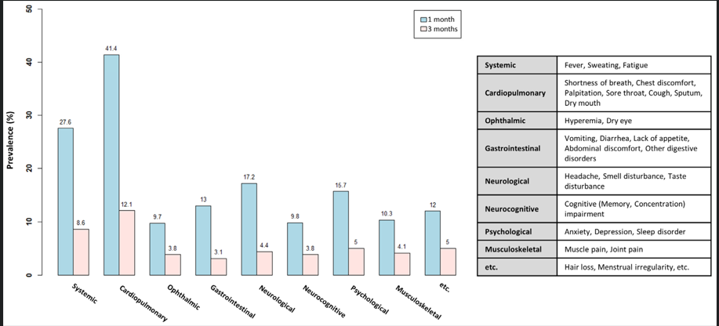
Figure 3: Prevalence by symptom cluster at 1 and 3 months
(Source: Son et al., 2024)
The graph compares the prevalence of various post-COVID symptoms at one month and three months. In all of the categories, such as systemic, cardiopulmonary, ophthalmic, gastrointestinal, neurological, neurocognitive, psychological and musculoskeletal, the symptoms are more frequent in the first month, and decrease 3 months later (Son et al., 2024). There are higher rates of cardiopulmonary and systemic symptoms as compared to those of ophthalmic and gastrointestinal ones. The table attached to it contains examples of the symptoms that belong to each of those categories, including fatigue, headache, shortness of breath, and anxiety, with a heavy impact on post-COVID conditions being very broad.

2.2 Three countries' decisions and approaches based on centralised and decentralised state
The overview discusses that the countries that had well-developed surveillance systems, functional data systems, and fast decision-making systems, like South Korea, could spot the cases at the initial stage, isolate the clusters, and allocate resources. Their decentralised but very coordinated nature enabled the swift response of local authorities with the national controls (Biela et al., 2024). In contrast, the centralised system in Spain had bottlenecks, especially in resource allocation and relaying information, which weakened the responsiveness during the first wave. The decentralised system of governance used in Canada presented strengths and challenges, as the provincial governments were able to formulate policies to fit the needs of the local populations, but data systems were not integrated, and coordination was a problem (Cornito, 2021).
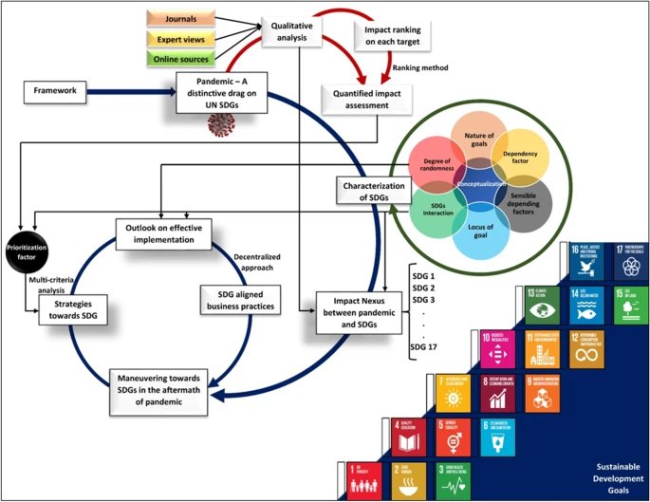
Figure 4: Impact of COVID-19 on sustainable development goals in South Korea
(Source: Elavarasan et al., 2022)
The conceptual representation explains the effects of the COVID-19 pandemic in all 17 UN Sustainable Development Goals (SDGs) using qualitative and quantitative evaluation tools. It presents interactions depending on such aspects as dependency and randomness, on the characteristics of goals (Elavarasan et al., 2022). The framework links pandemic-based disruptions with SDG implementation practices, multi-criteria analysis and decentralised business operation. Though the figure does not show any numerical values, it shows the interactive nature of the pathways with which SDG is driving growth both during the pandemic and beyond it.
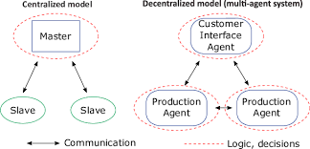
Figure 5: Compassion between centralised and decentralised approach
(Source: Egger et al., 2020)
The diagram is a comparison of a centralised model and a multi-agent system that is decentralised. A top-down structure is used in the centralised model, where there is one Master node that decides and gives directives to Slave units. Contrary to this, the decentralised model spreads the decision-making between several agents, such as the Customer Interface Agent and related Production Agents (Egger et al., 2020). A centralised approach to communication does not provide them with the flexibility, reactiveness, and resilience of the system as they make independent decisions.

2.3 Critically discuss advantages and disadvantages of the systems approaches used by three countries
The centralised and decentralised mechanisms used in each country were spelt out
Spain
The health system of Spain has long been consistent with a decentralised structure, with delivery of healthcare services, manpower, and regional public-health activities being handled by the 17 autonomous communities of the country. Nevertheless, in the initial stage of COVID-19, there were tremendous increases in cases, which exposed profound fragmentation in data reporting and preparedness, and resource allocation (Navarro and Velasco, 2022). Consequently, Spain has temporarily switched to a centralised system of emergency governance, where national leadership of the Ministry of Health became exercisable.
The efforts did not stop Spain, which continued to use decentralised implementation. Regions provided the implementation of restrictions, operating hospitals, testing of organisms and local outbreak management. This created a conflict situation where local governments wanted to restore some autonomy, and it was in the later waves that some governments were willing to take harder or less rigid actions depending on the local epidemiology (Anderson, 2021).
South Korea
South Korea showed one of the most effective demonstrations of the response to the pandemic in the world, which was constructed on the basis of centralised coordination and decentralised execution of the public-health procedures. The Korea Disease Control and Prevention Agency (KDCA) was a powerful agency to provide central leadership, through which the organisation issued nationwide instructions on activities in terms of testing, tracing, quarantine, and communication (Shin and Kim, 2023). Decision-making regarding border control, epidemiological surveillance, digital contact tracing, and emergency laws was immediately centralised by the government. This centralisation facilitated the quick mobilisation of resources as well as uniform messaging in the country.
Meanwhile, South Korea strengthened the position of local public-health centres, urban governments, and the regional organisations in making situational decisions. Local organisations carried out vigorous contact tracing, managed community testing facilities, issued quarantine directives, and put cluster-control measures into place within their purview (Lee and Suh, 2021). The other de facto roles in contributing to the mass diagnostic capacity were played by the hospitals and health care laboratories in a decentralised manner.
Canada
Canada is one of the most decentralised healthcare systems in the world. The local government of provinces and territories is in charge of health services, public health, management of hospitals, and emergency responses (Smith et al., 2023). This decentralisation brought about vast differences in policies around the pandemic, including masking policies, school reopening policies, opening businesses, and the pace of vaccine rollout. Decisions varied in each province based on their level of infection and available healthcare capacity, and worked out in certain instances to its advantage, e.g. initial actions in British Columbia, but failed miserably in others due to incoherent actions among the populace (Scarffe et al., 2022).
Nonetheless, in spite of this decentralisation, some centralised measures were applied in Canada, with particular reference to national acquisition and data organisation. The federal government got vaccines and PPE, and financial support programs like CERB. It also capped national borders, quarantine needs for travellers and guidelines issued by the Public Health Agency of Canada (Sundquist et al., 2021).
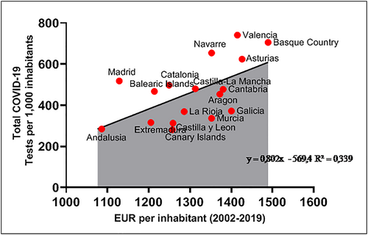
Figure 6: Ratio public health expenditure from Government of Spain, Ministry of Health Own elaboration
(Source: Erkoreka and Hernando‐Pérez, 2022)
The scatter plot demonstrates the correlation between the EUR per inhabitant (20022019) and the total of the COVID-19 tests per 1,000 inhabitants per region in Spain. Areas that spent more in the long term on the public tended to do more testing. Indicatively, the region of the Basque Country, Valencia, and Navarre reported more than 600 tests per 1000 people, which translated to a EUR of over 1400 (Erkoreka and Hernando‐Pérez, 2022). Conversely, other regions such as Andalusia, Extremadura, as well as the Canary Islands, performed less than 300 tests, with EUR values of around 1,100 candidates -1,200. The positive relationship between investment and testing capacity shows a moderate correlation with a trend line that is expressed as y = 0.802x 569.4, R 2 = 0.339.

2.3.1 Outline centralised and/or decentralised approaches taken by each country
Spain is predominantly a decentralised health system where health services are under the care of autonomous communities. Nevertheless, at the beginning of the COVID-19 waves, Spain bypassed a centralised governance, allowing the Ministry of Health to control national lockdown, procurement of supplies and a set of rules (Martínez-Cantó and Fernandes, 2025). Regions were still accountable for operational implementation, which led to a hybrid model.
South Korea was shown to have a coordinated, decentralised approach aided by good central leadership. About the national strategy, the KDCA implemented it, and the local public health centres executed testing, tracing and control in the regions (Park and Fowler, 2021). This system was national oversight mixed with decentralised decision-making, which could easily be contained without locking down the whole country.
As one of the most decentralised systems in the world, Canada depended on autonomy at the provincial level as the main factor. Restrictions, hospital planning and sequencing of vaccination were determined at the provincial level (Mazzocca et al., 2025). The federal government centralised border control, centralised procurement and financial assistance, but it could do very little to implement uniform health measures. Canada thus presented more of a decentralised system of selective central coordination.
Spain: The Problems of Decentralisation or Centralisation
The decentralised health system in Spain dealt with the lack of coherent data reporting, indifferent regional surveillance, and uneven ability to do testing. As the pandemic grew at breakneck speed, the central government's intervention led to an immediate, abrupt change towards centralisation, and caused tensions between the central and regional governments (Erkoreka and Hernando‐Pérez, 2023). Regions complained that the central control stunted their response to local needs, and the central government had difficulties in coordinating the buying and hospital resources of 17 independent communities.
South Korea: Problems of a Coordinated Decentralised Model
Despite the good results in South Korea, there were problems associated with its extremely centralised system involving surveillance and digital tracing. Mobile tracking, credit-card histories, and CCTV were widely used, which has put privacy into the limelight, and raised a question for society on what the government should not be able to do (Kim et al., 2022). Also, sometimes a decentralised local health centre faced the full force of the process of contact tracing and the enforcement of quarantine due to the intensive load. There were also challenges in resource distribution among regions, with the local governments not able to sustain staffing and testing facilities in the case of a cluster outbreak (Kim et al., 2022). Nevertheless, South Korea succeeded in ensuring coherence of the whole system.
Canada: Problems of a Heavily Decentralised System.
The provincial autonomy of Canada led to unequal reactions to the pandemic in all provinces. Different provinces used various timelines of restrictions, testing and reopening, which confused residents and made inter-provincial travel complicated (Shahzad and Fareed, 2023). In other provinces, there were acute shortages of staffing in long-term-care positions, intensive care unit capacity, and protective gear since the structures of resources were highly decentralised and therefore hard to share. The decentralised vaccine delivery was also uneven and generated disparities in the timely access to vaccinations.

2.3.2 Approaches yielded positive health outcomes
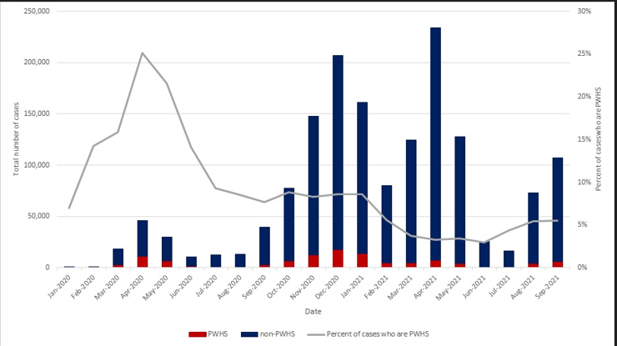
Figure 7: The number of COVID-19 cases in PWHS from 2020 to 2021 in Canada

(Source: Canada, 2021)
The graph indicates the monthly COVID-19 cases between January 2020 and September 2021, including cases of PWHS and non-PWHS cases. The non-PWHS cases are highest in May 2021 at approximately 240,000, whereas PWHS cases are much lower at approximately 2,000 and 12,000. Initially, PWHS reported the highest number of cases in April 2020 (up to 27% ) but gradually dropped to 46% in 2021 (Canada, 2021). Generally, there are both considerable increases and falls in total cases; the peaks were in December 2020, January 2021, and May 2021.
Critically comment on the merits and demerits of the systems approaches applied
This is critically analysed to discuss the strengths of each country's approach to the system during COVID-19. The decentralised system in Spain permitted the regional governments to customise decisions based on local epidemiology, which had the advantage of creating data fragmentation, a lack of coordination, and national response delays (Cadaval-Sampedro et al., 2025). During the first wave, centring control increased homogeneity, reduced regional adaptability, and caused stress and a slow rate of change.
The hybrid system in which South Korea was a country of central leadership and decentralised local implementation was quite effective. These benefits were high-speed testing, coordinated digital tracing, and effectiveness in communication.
The decentralised mechanism in Canada allowed the provinces to develop situation-specific policies, but there was an absence of homogeneity along the borders, which undermined national unity (Al Jasem et al., 2025). The key damage that was gained was province-level autonomy and innovation, whereas the drawbacks entailed uneven responses, disjointed health data and inconsistent vaccine allocation plans.

2.4 Did you also explain the challenges that resulted from these approaches?
The initial periods of Spain were hard due to decentralised systems, which did not integrate data and the lack of coordination, which led to high rates of mortality and congested hospitals (Bonal et al., 2023). Despite contributions to consistency and centralisation of control, there were mixed results in the long term due to delays in decision-making and regional differences.
The hybrid system in South Korea has resulted in some of the most favourable health outcomes in the world. Infection and mortality rates were low due to early testing and effective tracing, as well as effective communication. Its experience goes to show that decentralisation with high leadership through coordination produces solid results.
Canada has had moderate results, worse than most European countries but better than South Korea. Provinces like British Columbia and the Atlantic provinces dealt with cases well through early decentralised efforts, whereas other provinces dealt with the cases with a drastic outbreak, allowing for the variability in decentralised performance (Zhou et al., 2023).

2.5 Demonstrate a critical engagement with wider literature to support of key points
Critical analysis of broader literature reveals that the structure of the health system is a major influence on how a pandemic is dealt with. The challenges are supported by multiple studies by Greer et al. (2020), who highlight that the Canadian system is frequently linked with fragmented information, disjointed actions on a regional scale, and so on. According to a study under the OECD (2025), effective central coordination of testing, tracing, and communication, which has been witnessed in South Korea, is beneficial. On the other hand, Spanish researchers like PÉREZ-GARCÍA et al. (2020) believe that the Spanish ad hoc centralisation revealed the lack of coordination between autonomous regions.

3. Critical Analysis of the Leadership Styles taken in each Country

3.1 Leadership styles covered in this course to compare the approaches of the three mentioned leaders as they tackled the pandemic
The COVID-19 pandemic also demonstrated how greatly leadership is important in managing the crisis. In Spain, the style of leadership portrayed by Prime Minister Pedro Sánchez was a transformational and participative leadership style. Transformational leaders encouraged group effort, and Sanches tried to stimulate citizens by using national demands to solidarity and civic duty (HIGGINS et al., 2024). Yet the political system in Spain was decentralised and therefore difficult to enforce, leading to unequal regional application and dialogue in decision-making that crippled the effectiveness of his participative strategy in general.
By comparison, South Korea, with President Moon Jae-in in office, exhibited a transactional and adaptive leadership approach, which was influenced by the experience related to past epidemic outbreaks, namely MERS. Transactional leadership focuses more on specific guidelines, organised reactions and responsibility. The government of Moon performed speedy testing, constructive contact tracing and technological surveillance, and guaranteed transparent and coherent communication. Evidence-based and proactive measures by the administration enabled people to trust and cooperate without the deployment of hard lockdowns over the entire nation (Santiago-Capella, 2024). The experimental strategy of South Korea shows how timely, efficient, and measurable outcomes can be achieved in a health crisis in the case of adaptive and rule-oriented leadership.
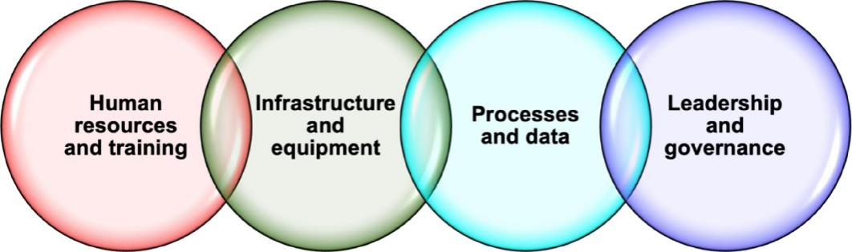
Figure 8: Leadership and Governance experiences during COVID-19 pandemic
(Source: Phillips et al., 2022)
The picture proposes four pillars related to each other and therefore necessary to enhance systems and guarantee successful performance. The training and human resources have shared the focus on the importance of highly skilled human resources and constant capacity building. The need to have reliable facilities, tools, and technology is brought out in infrastructure and equipment. Processes and data are centred on the efficient working processes, information gathering, and data-driven decision-making (Phillips et al., 2022). Accountability, policy and leadership: are strategic direction, accountability and policy oversight. Collectively, these factors form a comprehensive system in which one component supports the others, making sure that there is resilience, quality delivery of services and improved organisation in the long term.

3.1.1 Leadership theories and styles in Spain
During the COVID-19 pandemic, the Prime Minister of Spain Pedro Sanchez used the transformational as well as participative style of leadership. He focused on national unity urging its citizens to become united by making calls to solidarity and responsibility (Moreno-Domínguez et al., 2024). Nonetheless, the high level of decentralization in the system of governance in Spain proved to be problematic, with various parts executing actions in a disordered fashion. Even though the transformational approach of Sánchez enhanced collaboration and involvement of the populace, the lack of the negative effect of early decision-making and coordination challenges restrained the efficacy of the Spanish reaction.
Compared to South Korea and Canada
President Moon Jae-in chose a more transactional and adjustive leadership style of South Korea. Its key centralized governance allowed making testing fast, contact tracing strict, and technology-based monitoring leading to effective containment. In comparison, Canada under the leadership of Justin Trudeau reflected the transformational and inclusive style, which also includes empathy, open and direct communication, transparency, and cooperation with provincial governments (Shoemaker, 2022). In comparison to Spain, the structured, proactive action in South Korea created speedy and definite action of higher coordination, whereas the inclusive approach to action generated high levels of trust among the people in Canada and delayed the decision-making process.
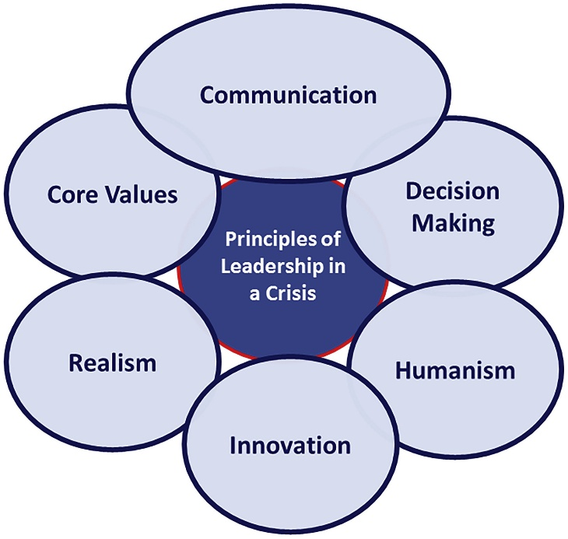
Figure 9: Leadership style during crisis in Spain
(Source: Kaul et al., 2020)
The main rules of effective leadership in a crisis. The main concept is in the centre: Principles of Leadership in a Crisis. It is surrounded by six things that leaders have to be guided by, namely Communication to guide people, Decision Making to take action in time, Humanism to put others in their positions, Innovation to identify new solutions, Realism to evaluate a situation the right way, and lastly Core Values to remain put (Kaul et al., 2020). All these combined contribute to the ability of the leaders to respond to a stressful situation in a responsible and wise way.

3.1.2 Leadership theories and styles in South Korea
The COVID-19 case illustrated that South Korea displayed a transactional and adaptive style of leadership by its leaders, who were led by President Moon Jae-in. The decision-making in transactional leadership is structured, with clear rules and accountability, and adaptive leadership is flexible and responsive to emerging situations. South Korea had previous experience with the MERS outbreak in 2015, and this experience informed its preparation in dealing with the crisis, so that the process was quick and effective (Jang, and Jeong, 2022).
Maintaining transparency and timely communication was among the priorities of President Moon, and he gave frequent briefings to help people be informed. The trust of the population was ensured with clear guidelines, information-based updates, and public responsibility for policy-making decisions. South Korea was able to control outbreaks by segregating them through interventions, the incorporation of technology and adherence, as opposed to using the nationwide lockdowns as employed in the other countries (Shin et al., 2023).
Real-time adaptive strategies enabled South Korea to change policies during an outbreak, e.g. strengthening measures when cases of infection increased and weakening them when the number of cases decreased. The transactional rigour and the adaptive flexibility, combined with the transparent communication, proved to be efficient in terms of enhancing cooperation between the citizens, registering tangible results in terms of pandemic control (Choi, 2021).
Canada/Spaniards Comparison
The leadership of South Korea regarding transactional and adaptive leadership is in contrast to that in Spain and Canada. The leadership style employed by Spain under Pedro Sánchez was transformational and participative, whereby they turned to solidarity as a source of appeal, yet experienced difficulties because of the decentralisation of regions and unequal implementation (Shin et al., 2023). Canada had applied a transformational and inclusive leadership of Empathy, federal coordination, and clear communication to strike a balance between health and economic balance under Justin Trudeau. Comparatively, Spain had issues with the coordination aspect, Canada succeeded in getting people to trust and obey government policies because of inclusivity, whereas South Korea had a structured and adaptive model, so it could easily and effectively handle crises with a minimal level of disturbance.
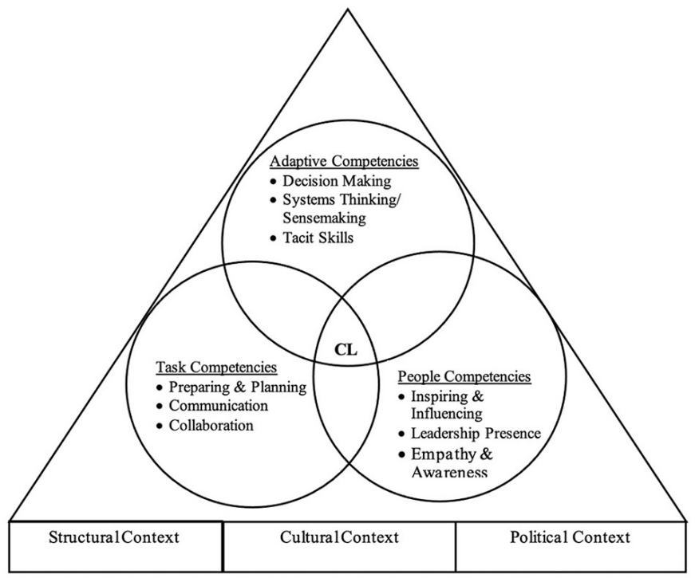
Figure 10: The framework of crisis leadership during pandemic in South Korea
(Source: Sriharan et al., 2021)
Three critical areas of competencies that create effective crisis leadership. Adaptive competencies include decisions, system thinking, and the use of practical judgment. Task competencies revolve around planning, communication and teamwork. Such people's competencies as inspiring others, having great leadership presence, and empathetic qualities will be presented. These three domains intersect in the centre, which consists of core crisis leadership (CL) (Sriharan et al., 2021). The competencies all act under the larger structural, cultural, and political context, which determines the reaction of leaders and their ability to lead others through a crisis.

3.1.3 Leadership theories and style in Canada
A transformational and inclusive leadership style was observed in Canada, which was led by Prime Minister Justin Trudeau during the COVID-19 pandemic. Transformational leaders are inspirational and encouraging to citizens to be united in their actions, whereas inclusive leaders focus on collaborating, empathy and participative decisions (Ertem, 2021).
Trudeau stated kindness, recognising the suffering people and companies experience, but also took the supporting steps to reduce the impact of the crisis, which included providing economic relief packages, wage support, and aid to the citizens who are vulnerable. The federal government collaborated with provinces, giving them the freedom to act according to the requirements of the region, but providing them with a unified direction on the situation concerning public health (Müller et al., 2021).
The Canadian leadership struck a balance between the social welfare, economic status and level of public health. Lockdowns and travelling were synchronised, as well as vaccination efforts and health awareness. The main feature in this case is that Trudeau used a clear and touching communication strategy that made people feel unified as a nation, and everyone had a part to play. Incorporating the aspects of participative, transformational, and servant leadership, Canada could attain a quite high level of public confidence, high compliance with health measures, and positive crisis control despite such challenges as the logistics of vaccination implementation and a surge of cases in certain regions (Bentein et al., 2022).
Comparison to South Korea and Spain
The leadership of Canada is transformational and inclusive, unlike in South Korea and Spain. South Korea under Moon Jae-in practised both transactional and adaptive leadership that focused on fast testing, contact tracing and monitoring with the aid of technology, and this made South Korea contain the virus effectively. Spain, under the management of Pedro Sanchez, was based on the transformational and participative leadership approach that appeals to solidarity, yet struggled because of the regional decentralisation and delays in the early response (Hertelendy et al., 2021). The strategy of Canada was based on the principles of empathy, federal management, and open communication, and the country managed to balance both the health and economic interests of the population.
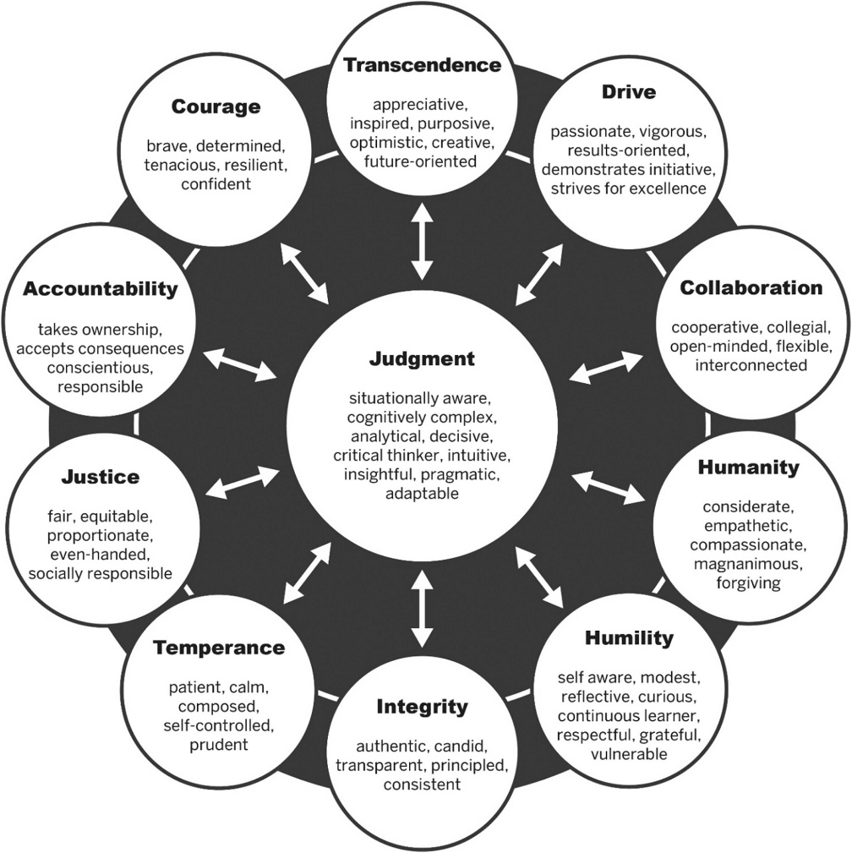
Figure 11: Leader character dimensions and associated character elements outlined by Canadian Government
(Source: Seijts et al., 2022)
emphasises the fact that Judgment is the heart of good leadership and gives it nine key virtues. They are Courage, Accountability, Justice, Temperance, Integrity, Humility, Humanity, Collaboration, Drive and Transcendence. All the virtues define such traits as confidence, responsibility, fair, patient, honest, empathetic, teamwork, ambition, and positive vision (Seijts et al., 2022). Their combination makes them a leader who is conscious-minded, critical, confident, flexible and able to make sound decisions in complicated scenarios.

3.2 Critically discuss the advantages and disadvantages of the leadership styles taken by each country
The leadership styles embraced by Spain, South Korea, and Canada in the COVID-19 pandemic have been discussed critically with reference made to their strengths and weaknesses in reference to their government frameworks.
Prime Minister Pedro Sanchez used a transformational and participative leadership style, which felt solidarity and consulted regional authorities, in Spain. The benefit of this strategy was that it promoted citizen involvement and civic responsibility. This also shows that participative leadership can be weak in fragmented political situations; quick action should be taken in unison (Gil-Espinosa et al., 2024).
The transactional and adaptive leadership style with a centralised system of governance was adopted by South Korea under the leadership of President Moon Jae-in. This allowed quick decision-making, protocol compliance and effective application of technology in testing and tracking. The drawback was that more of a top-down method gets them less close to the people, and they are also greatly dependent on the current institutional capability and citizen obedience.
Canada, under the government of Justin Trudeau, used transformational and inclusive leadership in the federal system. Its advantages were in empathy, strong communication, and cooperation with provincialities and led to popular trust. Its shortcoming was the slow decision-making process at some points since the negotiations between federal and provincial governments might postpone execution.

3.3 Demonstrate an engagement with wider sources of literature
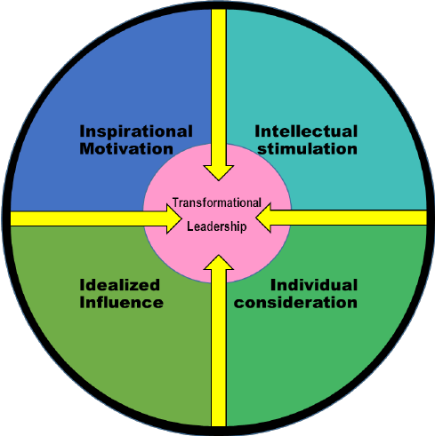
Figure 12: The transformational leadership Model
(Source: Deng et al., 2023)
The use of wider literature concerning leadership would offer a useful explanation of the impacts of the leadership styles of leaders on the outcomes of the crisis. According to Burns (1978) and Bass (1990), transformational leadership focuses on the motivation of the followers, instilling commitment, and encouraging action on the part of the followers. The Prime Minister of Spain, Pedro Sanchez, displayed some aspects of this approach in the COVID-19 pandemic, which asked people to be responsible and unite as a country. Structured decision making, accountability and quick adjustments in policies are factors that have been linked to transactional and adaptive leadership, as was the case in South Korea under the leadership of Moon Jae-in (Heifetz and Linsky, 2002). The experience of South Korea in holding COVID-19 helped to understand the efficiency of such methods, together with the integration of technologies and the active preparations at the crisis level. South Korea was able to implement testing and contact tracing effectively, relying on the lessons of the MERS outbreak (Kim et al., 2020).
The stylexamines the impact of centralisation and decentralisation of governance on the actions taken in response to the pandemic in Spain, South Korea, and Canada, as well as the influence of leadership styles ts of the leadership approach.

4. Conclusion
The report considers the effects that centralisation and decentralisation of governance had on the actions taken in response to the pandemic in Spain, South Korea, and Canada, and the effects leadership styles had on these responses. With a decentralised political system, Spain had a decentralised political system where Prime Minister Pedro Sánchez used a transformational and participative leadership style, which encourages solidarity and consultation with the regional authorities. Regional autonomy, however, created inconsistencies in implementation and delays, and restricts effectiveness. The centralised system in South Korea allowed President Moon Jae-in to adopt a transactional and adaptable leadership style, which involved fast testing, contact tracing, and technology-driven monitoring. The situation was easy to contain due to the rapid and coordinated reactions and the centralisation process of decisions.

References
Al Jasem, M.S., De Clark, T. and Shrestha, A.K. (2025). Toward decentralized intelligence: a systematic literature review of blockchain-enabled AI systems. Information, 16(9), p.765. https://www.mdpi.com/2078-2489/16/9/765
Álvarez-del Río, B., Sánchez-de Prada, L., Arroyo-Hernantes, I., Álvarez, F.J., Tamayo, E. and Gutiérrez-Abejón, E. (2025). Nationwide analysis of COVID-19 complications, outcomes, and costs of childbirth in Spain. Frontiers in Medicine, 12. doi:https://doi.org/10.3389/fmed.2025.1548245.
Anderson, P. (2021). Decentralisation at a crossroads: Spain, Catalonia and the territorial crisis. In Federalism as a Tool of Conflict Resolution (pp. 14-27). Routledge. https://www.taylorfrancis.com/chapters/edit/10.4324/9781003141303-2/decentralisation-crossroads-spain-catalonia-territorial-crisis-paul-anderson
Bass, B.M. (1990). From Transactional to Transformational leadership: Learning to Share the Vision. Organizational Dynamics, [online] 18(3), pp.19–31. doi:https://doi.org/10.1016/0090-2616(90)90061-S.
Bentein, K., Lapalme, M.È., Guerrero, S., Parent‐Rocheleau, X. and Simard, G. (2022). How can servant leaders foster public employees’ service‐oriented behaviors? A multilevel multisource study in Canadian libraries. Public Administration Review, 82(2), pp.269-279. https://onlinelibrary.wiley.com/doi/abs/10.1111/puar.13416
Biela, J., Hennl, A. and Kaiser, A. (2024). Policy making in multilevel systems: Federalism, decentralisation, and performance in the OECD countries. ECPR Press. https://books.google.co.in/books?hl=en&lr=&id=FNInEQAAQBAJ&oi=fnd&pg=PT6&dq=decisions+and+approaches+based+on+centralised+and+decentralised+state&ots=nXeH7iND_t&sig=Z3i50KAW0lgtkgPNbY4suSHhG-4&redir_esc=y#v=onepage&q=decisions%20and%20approaches%20based%20on%20centralised%20and%20decentralised%20state&f=false
Bonal, X., Verger, A. and Zancajo, A. (2023). Regional Policy Trajectories in the Spanish Education System: Different Uses of Relative Autonomy. Education Policy Analysis Archives, 31(68). https://eric.ed.gov/?id=EJ1394033
Cadaval-Sampedro, M., Herrero-Alcalde, A., Lago-Peñas, S. and Martinez-Vazquez, J. (2025). Extreme events and the resilience of decentralised governance. Regional Studies, 59(1), p.2255627. https://www.tandfonline.com/doi/abs/10.1080/00343404.2023.2255627
Canada (2021). COVID-19 infections among healthcare workers and other people working in healthcare settings. Canada. [online] 3 Mar. Available at: https://www.canada.ca/en/public-health/services/diseases/coronavirus-disease-covid-19/epidemiological-economic-research-data/infections-healthcare-workers-other-people-working-healthcare-settings.html.
Choi, H.J. (2021). Effect of chief executive officer’s sustainable leadership styles on organization members’ psychological well-being and organizational citizenship behavior. Sustainability, 13(24), p.13676. https://www.mdpi.com/2071-1050/13/24/13676
Cornito, C.M. (2021). Striking a Balance between Centralized and Decentralized Decision Making: A School-Based Management Practice for Optimum Performance. International Journal on Social and Education Sciences, 3(4), pp.656-669. https://eric.ed.gov/?id=EJ1318785
Egger, G., Chaltsev, D., Giusti, A. and Matt, D.T. (2020). A deployment-friendly decentralized scheduling approach for cooperative multi-agent systems in production systems. Procedia Manufacturing, 52, pp.127–132. doi:https://doi.org/10.1016/j.promfg.2020.11.023.
Elavarasan, R.M., Pugazhendhi, R., Shafiullah, G.M., Kumar, N.M., Arif, M.T., Jamal, T., Chopra, S.S. and Dyduch, J. (2022). Impacts of COVID-19 on Sustainable Development Goals and effective approaches to maneuver them in the post-pandemic environment. Environmental Science and Pollution Research, 29. doi:https://doi.org/10.1007/s11356-021-17793-9.
Erkoreka, M. and Hernando‐Pérez, J. (2022). Decentralization: A handicap in fighting the COVID‐19 pandemic? The response of the regional governments in Spain. Public Administration and Development, 43(2). doi:https://doi.org/10.1002/pad.1988.
Erkoreka, M. and Hernando‐Pérez, J. (2023). Decentralization: A handicap in fighting the COVID‐19 pandemic? The response of the regional governments in Spain. Public Administration and Development, 43(2), pp.129-140. https://onlinelibrary.wiley.com/doi/full/10.1002/pad.1988
Ertem, H.Y. (2021). Relationship of School Leadership with School Outcomes: A Meta-Analysis Study. International Education Studies, 14(5), pp.31-41. https://eric.ed.gov/?id=EJ1297653
Fonsen, E., Marchant, S. and Ruohola, V. (2025). Leadership in early childhood education: Cross-cultural case studies before and during the COVID-19 pandemic. Educational Management Administration & Leadership, 53(4), pp.850-869. https://journals.sagepub.com/doi/full/10.1177/17411432231194849
Gil-Espinosa, F.J., López-Fernández, I., Jiménez-García, J.D. and Cadenas-Sanchez, C. (2024). Gender differences in school leadership: Collaborative and task-oriented styles of principals in Andalusia, Spain. Educational Management Administration & Leadership, p.17411432241267873. https://journals.sagepub.com/doi/abs/10.1177/17411432241267873
Glenn, J., Chaumont, C. and Villalobos Dintrans, P. (2021). Public health leadership in the times of COVID-19: a comparative case study of three countries. International Journal of Public Leadership, 17(1), pp.81-94. https://www.emerald.com/ijpl/article-abstract/17/1/81/164815/Public-health-leadership-in-the-times-of-COVID-19?redirectedFrom=fulltext
Greer, S.L., King, E., Massard da Fonseca, E. and Peralta-Santos, A. (2021). Coronavirus politics: The comparative politics and policy of COVID-19 (p. 663). University of Michigan Press. https://library.oapen.org/handle/20.500.12657/48284
Heifetz and Linsky (2002). Leadership on the Line: Staying Alive through the Dangers of Change. [online] www.hks.harvard.edu. Available at: https://www.hks.harvard.edu/publications/leadership-line-staying-alive-through-dangers-change.
Hertelendy, A.J., Tochkin, J., Richmond, J. and Ciottone, G.R. (2021). Preparing for the next COVID-19 wave in Canada: managing the crisis facing emergency management leaders in healthcare organisations. BMJ leader. https://eprints.whiterose.ac.uk/id/eprint/175492/1/Hertelendy%20et%20al%2C%202021.%20Preparing%20for%20the%20next%20COVID-19%20wave%20in%20Canada.%20BMJ%20Leader.pdf
HIGGINS, C., DOGAN, A. and SCHROEVERS, S. (2024). Global Leadership Literacy: Empirical analyses of cross-cultural leadership styles and practices. CCBS Press. https://books.google.co.in/books?hl=en&lr=&id=Td02EQAAQBAJ&oi=fnd&pg=PA6&dq=Critical+Analysis+of+the+Leadership+Styles+taken+in+spain,+south+korea+and+caanda&ots=YhrnsKJvNL&sig=Nqr9nWfCPFcEwkQFsgnXlwUwJho&redir_esc=y#v=onepage&q&f=false
Jang, J. and Jeong, J. (2022). A meta-analysis of police leadership and organizational effectiveness: focusing on the South Korean police. Policing: An International Journal, 45(2), pp.315-333. https://www.emerald.com/pijpsm/article-abstract/45/2/315/318891/A-meta-analysis-of-police-leadership-and?redirectedFrom=fulltext
Kaul, V., Shah, V.H. and El-Serag, H. (2020). Leadership during Crisis: Lessons and Applications from the COVID-19 Pandemic. Gastroenterology, 159(3), pp.809–812. doi:https://doi.org/10.1053/j.gastro.2020.04.076.
Kim, S., Lee, Y. and Kim, T. (2022). The relationship between fiscal decentralization and trust in government: evidence from the South Korean case. International Review of Administrative Sciences, 88(2), pp.373-389. https://journals.sagepub.com/doi/abs/10.1177/0020852320933325
Lee, J.H. and Suh, J. (2021). Decentralisation and government trust in South Korea: Distinguishing local government trust from national government trust. Asia & the Pacific Policy Studies, 8(1), pp.68-93. https://onlinelibrary.wiley.com/doi/full/10.1002/app5.317
Martínez-Cantó, J. and Fernandes, J.M. (2025). The implementation of decentralisation reforms in multi-level systems. Journal of European Public Policy, pp.1-29. https://www.tandfonline.com/doi/abs/10.1080/13501763.2024.2448513
Mazzocca, C., Acar, A., Uluagac, S., Montanari, R., Bellavista, P. and Conti, M. (2025). A survey on decentralized identifiers and verifiable credentials. IEEE Communications Surveys & Tutorials. https://ieeexplore.ieee.org/abstract/document/10891701
Moreno-Domínguez, M.J., Escobar-Rodríguez, T., Pelayo-Díaz, Y.M. and Tovar-García, I. (2024). Organizational culture and leadership style in Spanish Hospitals: Effects on knowledge management and efficiency. Heliyon, 10(20). https://www.cell.com/heliyon/fulltext/S2405-8440(24)15247-4
Morgan, M.J. (2022). COVID‐19: A systems perspective on opportunities for better health outcomes. Geographical Research, 60(4), pp.637-650. https://onlinelibrary.wiley.com/doi/full/10.1111/1745-5871.12561
Müller, R., Drouin, N. and Sankaran, S. (2021). Balanced leadership: Making the best use of personal and team leadership in projects. Oxford University Press. https://books.google.co.in/books?hl=en&lr=&id=3RpREAAAQBAJ&oi=fnd&pg=PP1&dq=Leadership+theories+and+styles+in+canada&ots=rB9EfFPaCE&sig=M2AcoAz0tUPik4qxEhNRoMXwIHE&redir_esc=y#v=onepage&q=Leadership%20theories%20and%20styles%20in%20canada&f=false
Navarro, C. and Velasco, F. (2022). From centralisation to new ways of multi-level coordination: Spain’s intergovernmental response to the COVID-19 pandemic. Local Government Studies, 48(2), pp.191-210. https://www.tandfonline.com/doi/full/10.1080/03003930.2022.2042683
OECD. (2025). Strengthening governance, investment, and skills for digital government: Digital Government Review of Korea. [online] Available at: https://www.oecd.org/en/publications/digital-government-review-of-korea_9defc197-en/full-report/strengthening-governance-investment-and-skills-for-digital-government_a4dabc49.html.
Park, S. and Fowler, L. (2021). Political and administrative decentralization and responses to COVID-19: comparison of the United States and South Korea. International Journal of Organization Theory & Behavior, 24(4), pp.289-299. https://www.emerald.com/ijotb/article-abstract/24/4/289/145102/Political-and-administrative-decentralization-and?redirectedFrom=fulltext
PÉREZ-GARCÍA, J.A., RUIZ-ABIERNO, A. and ARMENTEROS, M. (2020). A checklist of aquatic nematodes from Cuban Archipelago. Zootaxa, 4731(3). doi:https://doi.org/10.11646/zootaxa.4731.3.1.
Phillips, G., Kendino, M., Brolan, C.E., Mitchell, R., Herron, L.-M., Kὃrver, S., Sharma, D., O’Reilly, G., Poloniati, P., Kafoa, B. and Cox, M. (2022). Lessons from the frontline: Leadership and governance experiences in the COVID-19 pandemic response across the Pacific region. The Lancet Regional Health - Western Pacific, 25, p.100518. doi:https://doi.org/10.1016/j.lanwpc.2022.100518.
Rossi, E. and Sørensen, C. (2022). The meaning of de/centralization: a theoretical review, towards a conceptual framing. Centralization: A Theoretical Review, Towards a Conceptual Framing (May 14, 2022). https://papers.ssrn.com/sol3/papers.cfm?abstract_id=4233664
Santiago-Capella, E.F. (2024). Cultural Influences on the Self-Perception of the Big Five Leadership Personality Traits on Immigrant Latino College Students in Management Positions: Increasing Latino Representation in Management Ranks (Doctoral dissertation, Keiser University). https://www.proquest.com/openview/b5b88936649014ef1672b312aef7e5ef/1?pq-origsite=gscholar&cbl=18750&diss=y
Scarffe, A.D., Coates, A., Evans, J.M. and Grudniewicz, A. (2022). Centralization and innovation: Competing priorities for health systems?. The International journal of health planning and management, 37(5), pp.2534-2541. https://onlinelibrary.wiley.com/doi/full/10.1002/hpm.3531
Seijts, G., de Clercy, C. and Miller, R. (2022). Character and Trust in Crisis Leadership: Probing the Relationships Among Character, Identification-Based Trust, and Perceptions of Effectiveness in Political Leadership During the COVID-19 Pandemic. The Journal of Applied Behavioral Science, 59(1), p.002188632211106. doi:https://doi.org/10.1177/00218863221110627.
Shahzad, F. and Fareed, Z. (2023). Examining the relationship between fiscal decentralization, renewable energy intensity, and carbon footprints in Canada by using the newly constructed bootstrap Fourier Granger causality test in quantile. Environmental Science and Pollution Research, 30(2), pp.4617-4626. https://link.springer.com/article/10.1007/s11356-022-22513-y
Shin, H. and Kim, W. (2023). Comparison of the centralized and decentralized environmentally constrained economic dispatch methods of coal-fired generators: A case study for South Korea. Energy, 275, p.127364. https://www.sciencedirect.com/science/article/abs/pii/S0360544223007582
Shin, J., Mollah, M.A. and Choi, J. (2023). Sustainability and organizational performance in South Korea: The effect of digital leadership on digital culture and employees’ digital capabilities. Sustainability, 15(3), p.2027. https://www.mdpi.com/2071-1050/15/3/2027
Shoemaker, A. (2022). Leadership theories, styles, and approaches. Standardization–Journal of Research and Innovation, 1(4), pp.1-4. https://watermark02.silverchair.com/i2831-7920-1-4-i.pdf?token=AQECAHi208BE49Ooan9kkhW_Ercy7Dm3ZL_9Cf3qfKAc485ysgAAA2kwggNlBgkqhkiG9w0BBwagggNWMIIDUgIBADCCA0sGCSqGSIb3DQEHATAeBglghkgBZQMEAS4wEQQMRU1sRl88h4LBU4aBAgEQgIIDHMDSC-Ecq4aO4rzEnV3bU4iXnVFgqbKHABIagqf_76q5u1XaGjaUsKBY7RtslOC-8iFj-0G0WhKLo7u3OFk1_-pJ0F0Zwo56AsEbs-l6fZqjrux-415wDrKoHWA5ZHkxEiXkstJ5qDZQjl3_G7zwQmKt99Cpd8E4v-fD2kew-5dtre5CfWv5rHtahb9HvSRSAglSwl6lVXyxlzlTi1PvPqHWxPtmduUaWaKNKzV_StSExYKF2WBoPCyHd1VVaOypxJ5XtIXCgaw_YFEm5d3FsEWitYxj1Zr0F7QS6V_tlcCWbJt8HDep4h_tn97M0z5W8qRnsaULc64lpx14mQUMCwTIyv8ELWClDbveFKQMMi2rOeyTW2za6UjPUZEsMfHUv5ERdUrqHRCH7OBe2kNH_IP0rAD1a-neSuYpHl5AYtIW1_4X2e7LjoP25eV_fvj5ryT-jadoxHMTV9JlQB1ysjdp_7S1zKxlOTLejzsMjOflsWRZFdC7LPDti1PAqwEFgDMmvjNpq416eMu36bWLksDhbpobgIXS0SZIQZsr1SbTt8jfad2h441aCYGjJUDHZaHJPr3ZGVhJHMStCivEso2RXbKFQ_quEQ4mp7ysddazEeGFlCfS31td9GvDlKC5jaxAc1ngIXbJrxWK9HgOXcbuR3XLWv0C9lrCYYrgW8e7aLz7X9XZOzxbjI3YqrDBf1d-Njx-NMEW___bzFzcGoHQMECuMWpjcd0zQ65nUQMfhZ-Vda8hxpwOkCmJFd44hTbG4jDvUvbi7MyezexzcIwJtmAXUEW4gE0NmJdtsKdCn1AfFfwrhi8qDazq8z5p-3NYztfxw2GJAzWu4Uf1L4qQl0G9Gn1sZebe40RqZs2Q13ikp37MvjhIuwF-BedT5__IJB2lJB0IrmLPHHBuAGDi-lV5x_ths1uNVJ8YCfApo_tIKEgTDKY0fxPt5AJhFPSS0yTpTzFbeh3_MLmwYIMVLs-GJy-528d0JZSAxcqbF7c2fdG-Jn03t2vtVwTFiNaUUmHS2vTFkzBq8l0JTY27ElUOaPDhP3M8VRg
Smith, R.W., Jarvis, T., Sandhu, H.S., Pinto, A.D., O'Neill, M., Di Ruggiero, E., Pawa, J., Rosella, L. and Allin, S. (2023). Centralization and integration of public health systems: Perspectives of public health leaders on factors facilitating and impeding COVID-19 responses in three Canadian provinces. Health Policy, 127, pp.19-28. https://www.sciencedirect.com/science/article/pii/S0168851022003050
Son, H.-E., Hong, Y.-S., Lee, S. and Son, H. (2024). Prevalence, Risk Factors, and Impact of Long COVID Among Adults in South Korea. Healthcare (Basel, Switzerland), [online] 12(20), p.2062. doi:https://doi.org/10.3390/healthcare12202062.
Sriharan, A., Hertelendy, A.J., Banaszak-Holl, J., Fleig-Palmer, M.M., Mitchell, C., Nigam, A., Gutberg, J., Rapp, D.J. and Singer, S.J. (2021). Public health and health sector crisis leadership during pandemics: A review of the medical and business literature. Medical Care Research and Review, [online] 79(4), p.107755872110392. Available at: https://doi.org/10.1177%2F10775587211039201.
Deng, C., Gulseren, D., Isola, C., Grocutt, K. and Turner, N. (2023). Transformational leadership effectiveness: an evidence-based primer. Human Resource Development International, 26(5), pp.627-641. https://www.tandfonline.com/doi/full/10.1080/13678868.2022.2135938
Sundquist, S., Batist, G., Brodeur-Robb, K., Dyck, K., Eigl, B.J., Lee, D.K., Limoges, J., Longstaff, H., Pankovich, J., Sadura, A. and Sullivan, P. (2021). CRAFT—A proposed framework for decentralized clinical trials participation in Canada. Current Oncology, 28(5), pp.3857-3865. https://www.mdpi.com/1718-7729/28/5/329
Zhou, X., Liang, W., Kevin, I., Wang, K., Yan, Z., Yang, L.T., Wei, W., Ma, J. and Jin, Q. (2023). Decentralized P2P federated learning for privacy-preserving and resilient mobile robotic systems. IEEE Wireless Communications, 30(2), pp.82-89. https://ieeexplore.ieee.org/abstract/document/10105168

