

Does arming United Kingdom response officers with firearms increase safety: Focusing on Public perception, with links to serving Police Officer’s perceptions.

Tyler Daniels
2016515
BSC Professional Police Practice

Acknowledgements
I would like to thank my supervisor, Sergeant Gareth Davies and the rest of my team for supporting me whilst I undertook this project, assisting in answering the survey questions and in understanding the level of commitment needed to complete such a project.
Lastly, I would like to give sincere thanks to my fiancé and my mother for their support and kindness throughout. Their patience and understanding have motivated me throughout the completion of my degree and without such it would have been a difficult process. I feel privileged to have such a strong support system from my family and work colleagues alike.

Declaration

This work has not previously been accepted in substance for any degree and is not being concurrently submitted in candidature for any degree.
Signed:
Date: 21st April 2023
STATEMENT 1
This dissertation is being submitted in partial fulfilment of the requirements for the degree of BA.
Signed:
Date: 21st April 2023
STATEMENT 2
This dissertation is the result of my own independent work/investigation, except where otherwise stated.
Other sources are acknowledged in the Reference Section.
Signed:
Date: 21st April 2023
STATEMENT 3
I hereby give consent for my dissertation, if accepted, to be available for photocopying and for interlibrary loan, and for the title and summary to be made available to outside organisations.
Signed:
Date: 21st April 2023
STATEMENT 4
I hereby give consent for my dissertation, if accepted, to be available on the university’s IT system to those who have consent to use the system.
Signed:
Date: 21st April 2023

Table of Contents

Chapter 1: Introduction 7
1.1 Introduction 7
1.2 Aim and objectives 8
1.2.1 Aim 8
1.2.2 Objectives 8
1.3 Structure 9
Chapter 2: Literature review 10
2.1 Introduction 10
2.2 Public opinion 11
2.3 Police opinion 12
2.4 Emerging issues 14
2.5 Conclusion 16
Chapter 3: Research method 17
3.1 Introduction 17
3.2 Research Strategy 18
3.3 Data Collection 19
3.4 Limitations and Potential Problems 20
3.5 Summary 20
Chapter 4: Data Analysis 21
4.1 Introduction 21
4.2 Data analysis 22
4.3 Survey findings 23
4.3.1 Theme one – Uncertainty 23
4.3.2 Theme two – For armed 25
4.3.3 Theme three - Against armed 26
4.4 Conclusion 28
Chapter 5: Conclusions and Recommendations 29
5.1 Introduction 29
5.2 Summary of primary findings 29
5.3 Recommendations 30
5.4 Limitations 31
5.5 Further research 31
5.6 Achievement of the objectives 31
5.7 Self reflection 32
Reference list 33
Appendix 1 – Research Proposal 38
Appendix 2 – Ethical Proposal 46
Appendix 3 – Online Questionnaire 62
Appendix 4 – Online questionnaire results 68

Chapter 1: Introduction

1.1 Introduction

This chapter aims to provide a background into the subject matter, rationale for the study and outline the aim and objectives of the research.

The information this dissertation aims to collect is the opinion of the public and Police officers on whether arming UK Police Forces would make them feel safer. The term arming in this dissertation refers to the police officers being in possession of a firearm to conduct duties. There will be mention of the firearms policies adopted by other countries to compare perception of safety and how such policies affect this.

Over recent years, the United Kingdom has witnessed a rise in the use of illegal firearms. According to a report from The Office for National Statistics (2019) ‘there were 9,787 offences in which firearms were involved; this is a 4% increase compared with the previous year.’ With crimes involving the use of firearms making up around 0.4 per cent of all recorded offences in England and Wales and having doubled since the mid to late-1990s (Povey and Kaiza, 2006: 81), this topic is evidently relevant to the society in which we face today. Following catastrophic major incidents such as The London Bombings and the death of Nicola Hughes and Fiona Bone killed in the line of duty in Manchester in 2013, the question as to whether the Police in the United Kingdom should be armed, to protect the public they serve and themselves whilst on duty is often raised. As can be seen from an article by Kelly (2012) which mentions the death of the two unarmed Police officers above, ‘But despite the loss of two of his officers, Greater Manchester Chief Constable Sir Peter Fahy was quick to speak in support of the status quo - "We are passionate that the British style of policing is routinely unarmed policing.’ However, Tony Rayner, the former chairman of Essex Police Federation, has called for officers to be routinely armed, due to such major incidents.

Worldwide only eighteen countries/territories do not arm they police officers, with the United Kingdom being one (Statista, 2020) this showing these countries are within the minority worldwide. With the fundamental principle in UK policing being ‘policing by consent’ (Home Office, 2012), this meaning that for policing to be effective, there must be public support for a police service's actions, the public’s opinion on such matters is essential. A survey of 1,000 people by the Scottish Police Authority suggested 53% were supportive of arming UK police officers (BBC, 2015). Not only is the opinion of the Public important but also the opinion of the serving police officers. A survey conducted by police union PolFed (2017) showed that 42.5 per cent was for firearms to not be issued routinely to all officers, but for more to receive training and be issued with firearms as and when needed. With uncertainty from rising levels of illegal firearms use and the hostile situations currently seen worldwide, this topic is one that should be further discussed to ensure the highest level of safety can be obtained for the public by those who serve them.

1.2 Aim and objectives

1.2.1 Aim

The aim of this dissertation is to investigate whether serving police officers and the public they serve would feel safer if all UK Police officers were armed whilst conducting their duties.

1.2.2 Objectives

In order to satisfy the aim, the following objectives need to be accomplished which will provide the view of the current opinion from serving Police officers and the public.

- Objective 1: To explore the opinion of police officers regarding perception of safety if they were to carry a firearm as part of daily duty.

- Objective 2: To explore the opinion of members of the public regarding perception of safety if UK Police officers carried firearms whilst conducting their duties.

- Objective 3: To critically analyse the results, use such results to establish whether arming UK Police officers would increase the safety of officers and public.

- Objective 4: To provide a final conclusion on findings, if necessary, recommendations, limitations and self- reflection.

1.3 Structure

This dissertation will be structured with five main sections, each titled and included in the table of contents.

Chapter one thus far has provided an introduction into the dissertation topic, highlighting why such research is relevant and the reasoning for it being conducted. This chapter has also identified the main aim and the objectives necessary to achieve that aim.

Chapter two shows the literature review based on the subject topic, this section will assist the reader to understand current issues that cause the discussion of arming UK Police, other studies that have investigated the relationship between Police and members of public whereby firearms are routinely used or have been used in a critical situation and highlight the current government policies.

Chapter three will explain the research methodology, identifying the means in which data will be collected to complete the objectives and how such will be analysed.

Chapter four will analyse the data collected from the research survey as discussed in chapter three, this data will be used to understand the officer’s and public’s opinion on arming Police and the impact on safety.

Chapter five will summarise the findings of the dissertation and review the aim and objectives set out to be achieved. Any recommendations and limitations to the research will also be discussed, as well as self-reflection on the researcher.

Chapter 2: Literature review

2.1 Introduction

This literature review will look thematically at research conducted by others and identify the opinions and results concluded. The aim of this literature review is to bring forth a clear understanding of research conducted prior and identify any gaps in the research. In doing so the following objectives shall be completed.

- Objective 1: To explore the opinion of police officers regarding perception of safety if they were to carry a firearm as part of daily duty.

- Objective 2: To explore the opinion of members of the public regarding perception of safety if UK Police officers carried firearms whilst conducting their duties.

The prior studies and articles used focus on the opinion of police officers being routinely armed as part of daily duties. The studies look at opinions from members of public and serving police officers, in the UK and countries where firearms policies within their police service differs. By looking at both the public opinion and Police opinion in different countries, the factors such as cultural, geographical, and differing Policing policies can be compared. In order to structure this literature review the conceptual framework model has been used (Hassan, 2022).

The Metropolitan Police was established in 1829, the main aim in creating a reformed Police Service was to disassociate from the way the army had policed the population in the past. The officers were issued with dark navy uniforms compared to the bright red uniforms of the army. The new officers were given truncheons as a means of self-defence as appose to firearms (Smith, n.d.). The aim of this reform was to 'Police by consent' and to provide the public with an approachable Police force who were essentially Citizens in uniform (Home office, 2012).

The matter of arming Police Constables on the streets has been questioned for decades as well as today, usually on the death or serious injury of victims by armed criminals as can be seen from a BBC (2010) article that brought up the discussion. Derrick Bird in 2010 used a firearm and killed twelve people at random, it was said by DCC Stuart Hyde ‘unarmed officers tried to pursue Bird but could do nothing to stop the killings’. This incident has raised questions as to whether officers should be routinely armed on patrol.

In recent years the level of violent crimes needing an armed response has increased as can be seen from the following statistics. There were 20,186 police firearms operations in the year ending March 2019, a 7% increase in the latest year and continuing the increase since the year ending March 2016 (Home Office, 2020). The rise in crimes involving knives can also be seen in hospitals. In the five years to March 2017, the number of admissions for stab wounds increased by 13% in England and 17% in London, 39 children and teenagers were killed by knives in the UK and more than half of those were in the capital (Kommenda, Barr and Voce, 2018). These statistics show the importance of having the availability of armed response vehicles and brings the discussion of whether regularly unarmed officers need the protection of a firearm to ensure their safety and from this the safety of the public they serve.

Whilst conducting the research for this dissertation a severe incident occurred in Nottingham, in which three persons were killed after a man armed with a knife stabbed them to death and then used a stolen van in an attempt to injure further persons (King, 2023). This incident shows that the subject of arming UK Police Officers is a topic that is relevant in today’s society and the use of firearms could have an impact on stopping the abilities of armed criminals.

2.2 Public opinion

The policing style used for generations within the United Kingdom is that of 'Policing by Consent' first constructed by Robert Peel's Policing principles, which is commonly defined as, policing through co-operation rather than fear and therefore maintain approval, respect and affection (Home Office, 2012).

Yesberg, Bradford and Dawson (2021) conducted an experiment looking at how the presence of a firearm changed the way people reacted to the Police. They did this by showing three groups of public images. The first group were shown images of non-armed Police officers, the second group shown images of armed Police officers and the third group were a selection from the two previous groups, these were prompted to think about terrorism prior to being shown images of the officers. The results of this study show the participants had more negative responses to police when armed. The major contributing factor being the idea of 'Group Membership' whereby persons feel connected to other persons through similarities of values and behaviour and therefore are more trusting of the others. This above study and others alike have shown that public support for police depends, to a significant degree, upon the extent to which the police act as 'prototypical representatives' of the group (Yesberg, Bradford and Dawson, 2020). Given this information and looking at the history of Great Britain and British Policing, firearms have not been widespread and deemed as 'the norm' unlike other countries such as the USA, which is shown by the Firearms Act 1968 which places restrictions on firearm possession and use in the UK (UK Government, 2011). Therefore, seeing Police officers being militarised and carrying powerful firearms would create distance between the public and the police, thus meaning the public would not feel the previously mentioned 'Group membership'. With that in mind, the public feeling disassociated with the police due to the possible present of firearms means they are more likely to view them negatively, less trustworthy and feel their legitimacy is questionable. When the public have cohesion in their social environment and a sense of belonging, they are more likely to cooperate and comply with the rules that the Police uphold. This can be seen from a report by The National Policing Improvement agency (2010), ‘This makes people feel better about their circumstances, increases their positive feelings towards each other and the statutory services which serve them.’ However, the latter means the public would be less likely to obey the law and grant police legitimacy. Results from this study show the majority of the public reacted negatively to armed officers, meaning they would be less trusting and cautious of police intervention. The police service relies on the public to cooperate in order to access information and intelligence and to ensure they comply with minimal risk. These results on firearms being widely used by the British police shows from the public perspective, the safety of the public would not be improved by the presence of firearms as the public would be untrusting and disassociated with police, leading to lower crime reporting and less accessibility to vital information.

A study conducted by Hendy (2014) looked at the use of firearms in European countries whereby there are many different policies controlling the use of firearms whilst on duty. Both police officers and the public views were considered in this research study. When focussing on the public view, the results from this are similar to those concluded in Yesberg, Bradford and Dawson’s (2021) research. Arguments are made that arming Police officers ‘will result in Police officers becoming more aggressive when interacting with the public and that it will increase the risk of injury to the public and Police’ (Buttle, 2010). Not only this, but by providing the officers with firearms it means they feel almost unstoppable, having an ‘illusion of safety’ and are therefore more likely to engage in increasingly dangerous situations, resulting in further risk, providing a decrease in the safety of the public and Police officers involved (Roberts, 2010).

The main contributing factor towards the negativity of arming police officers in Hendy's (2014) study looks more at the demeanour and behavioural changes the officers could experience when being given a lethal weapon to conduct their duties with, rather than the possession of a firearm itself. The public in this sense are worried the possession of a firearm would alter the style of policing and give the police a disillusioned version of their abilities, causing more dangerous situations and taking more risks.

2.3 Police opinion

When considering the safety implications of arming police officers who are not regularly armed, it is important to understand the opinions of serving officers and the impacts on their safety also.

There is a long-standing argument in the British Police Force as to whether police officers should be armed, being one of the countries in the minority whereby officers are not regularly armed. Long (2016) an ex-serving Metropolitan Firearms officer put the following statement forward, 'Your job is to protect the public. How can you do that if you cannot first protect yourself?' which can be seen as a valid point in terms of if the officer is unable to go forward to minimize the risk presented then essentially, they are ill-equipped to provide their basic duty of protecting the public (Farmer and Evans, 2019).

An article from The Guardian put forward plans to have more firearms officers on visible foot patrol within areas whereby there is high levels of violent and serious crimes. Commander Kyle Gordan stated,

If they leave the vehicle to do a patrol their weapons would be accessible and visible, what we are asking is can we use all the assets [of the Met], including armed officers, to enhance confidence and deter activity (Dodd, 2018).

This idea has been met with positive views, the public in these areas deserve a higher level of security however, it has been noted by ex-commander Victor Olsa these further patrols are likely to take place in areas with higher ethnic minority populations and therefore the police should be careful to not misinterpret this (Dodd, 2018).
A study conducted by Hendy (2014) looked at Police officers in Norway and Denmark where their firearms rules differ from each other and in the UK. The study looked at the risk-management and officer behaviour linked with carrying a firearm on duty and used this to determine whether the safety for all involved was affected. The Norwegian Police force are not routinely armed, the firearms are in the trunk of the police vehicle, and in order to use the weapons they must seek higher authorisation (Albert, 2022). In contrast the Police in Denmark carry their firearm on their person and therefore have immediate access, with no further authority needed to use the weapon. One Norwegian Officer (Interviewee six) who was interviewed for the study stated, ‘That time delay to seek the authorisation and issue of firearms gave other officers vital time to mentally prepare for the incident, it enhanced time to plan the tactical approach and allowed for additional units to arrive’ (Hendy, 2014). From this it can be understood the Norwegian officer sees the time delay in seeking authorisation to access the firearm as an advantage, providing further time to risk assess, take action appropriately and therefore manage the situation safer, thus increasing the safety for both officers and the public involved.

The Danish officers always carry a firearm on their person whilst on duty and are allowed to deliver warning shots as an offensive tactic, however the research showed that many officers take long term sick leave after delivering these warning shots, or they struggle with their mental health after doing so and therefore the unit’s operational capability is compromised (Hendy, 2014). This in turn could have a detrimental effect on their safety perception and the actions they take. Due to this the Danish Police force have adopted the ‘Stop and think’ model, whereby the officers take time before considering their firearms as a solution, the aim of this is to reduce warning shots therefore reducing officer sickness, suffering and reduce any lethal shots taken. It was noted by interviewee six that ‘Stop and think’ – ‘That’s what we have been doing in Norway since, well before I started in the force almost 25 years ago’. This shows the Danish Police authority implementing a plan which is arguably a safety plan in an attempt to improve the safety of officers and public as they have identified faults in their current policies. As previously mentioned, the presence of a firearm can alter the officer’s perception of danger and therefore they are likely to get involved in more dangerous situations. This is evident in the comments made by a Danish Police officer in Hendy’s (2014) research, ‘I am feeling a little bit safer when I put my gun on because there are more situations I can handle’. This is first-hand information from a serving officer that states it is his gun that makes him feel safer and more capable of doing his job. Another concern identified in this study was regarding safety when the officers discharge their weapons when the action was not planned or processed. For example, ‘Over half shots fired (56%) were before the officer was mentally prepared to shoot’ (Hendy, 2014). This links with the ‘Stop and Think’ process being adopted by the Danish Police to ensure any use of firearms has first been risk assessed and the necessity for its use is present, a policy which the Norwegian Police automatically adopt through their authorisation to access the firearms process.

The Police Federation for England and Wales ran a survey in 2017 to seek the opinion from Police officers on whether all officers should be armed, the results showed that in 2006 23% were in favour of routinely arming, with the majority stating firearms should not be routinely issued but the training given to all should they be needed in a situation that required firearms (PolFed, 2018). As can be seen the biggest support was for firearms not to be issued to all serving officers, however this is not officers refusing to carry firearms, they would be compliant with the capability of carrying and using firearms if they were given the correct training, support, and the necessity for them to use the firearms was there.

Overall, the Police opinion on being armed varies between the locations in which the idea is proposed, the personal experiences and the perceived support they would face from their force in times of lethal force being used.

2.4 Emerging issues

With such a controversial topic many issues can be identified from routinely arming officers, which will be discussed below.

On Tuesday 27th June 2023 a 17-year-old male was fatally shot by French Police officers after failing to comply with a traffic stop, ‘They asked the driver to turn off the ignition, but the car moved forward, one of the officers fired, fatally wounding the young man in the chest’ (BBC, 2023b). This has caused riots within the city of Paris, leading to hundreds of arrests and damaged property, the tensions between the public and the government continues to grow with the public questioning the necessity for firearms during routine traffic stops. This example shows the risks involved with regularly using firearms and the negative implications that can come as a result of taking a life which is deemed unnecessary by the public.

An article by Dodd (2018) points out the implications on firearms officers when they have taken the lethal shot and executed their duty to protect themselves and the public. The article looks at how when a lethal shot is taken, rightfully the matter is investigated however, this can take years in some cases, and it leaves the officer feeling in the wrong and under additional stress. Due to this it has been seen in some cases that the firearms officers’ team up and 'Hold the public at ransom' stating if their colleague is not treated fairly and supported during the investigation process then they shall all refuse to carry arms, therefore jeopardising the safety of the public. From this research it can be see that the officers who undertake the intense training to have the right to carry firearms whilst serving feel heavily scrutinised and feel as though they cannot do right. When they take the lethal shot, which at the time they feel is necessary to do so, to save further lives and is essentially what they are employed to do, they feel let down by the system and are criminalised. Therefore, it can be argued that an officer with a firearm is going to make little effect on public safety and that of their colleagues if they feel overly cautious when conducting their duty.
The Danish officers always carry a firearm on their person whilst on duty and are allowed to deliver warning shots as an offensive tactic, however the research showed that many officers take long term sick leave after delivering these warning shots, or they struggle with their mental health after doing so (Hendy, 2014). A study looking at the mental health impacts of officers after shooting their firearm conducted by Stratton, Parker and Snibbe (1984) showed that 30% of the respondents felt that the shooting incident affected them greatly or a lot, about 33% only moderately and 35% not at all. They stated it affected them by causing time distortion, sleep difficulties, fear of legal consequences, and emotional reactions, such as anger, elation, or crying. The mental health of police officers who are unarmed being affected by the stressful situations they face in their day-to-day duties shows concerning figures, with half of officers employed in the UK taking sickness leave for mental health-related illnesses in the last 5 years (Edwards, Kotera, 2020). The implications of provided such officers with firearms and the additional stress of being in possession of a lethal weapon could increase the mental health illnesses for officers.
The idea of increased armed patrols in areas with higher serious crime rates has been met with positive views, as the public in these areas deserve a higher level of security however, it has been noted by ex-commander Victor Olsa these further patrols are likely to take place in areas with higher ethnic minority populations and therefore the police should be careful to not misinterpret this (Dodd, 2018). An article by Nagesh (2023) stated ‘Black people were seven times more likely to die than white people after being restrained by police’, raising concerns of deep-rooted racism within the Police. The death of Chris Kaba who was killed by a single shot to the head fired by a Metropolitan firearms officer, was being followed by police as they believed his vehicle was involved in a previous firearms incident (BBC, 2023a). Incidents such as this provoke the discussion of racial profiling within the Police, often leading to community tension and mistrust. However, reports state that it is not through racism that these incidents occur but due to the demographic in these areas. In 2019, 15% of the Met’s police officers were from Asian, black, mixed and other non-white backgrounds, this compares to 40% of London’s population who come from these backgrounds (Haves, 2020). This report attempts to explain that with higher levels of ethnic minorities, there will more likely be a higher level of persons involved in crime from those backgrounds.

With normalising the use of Firearms within the UK there is the risk of desensitisation, with the public becoming used to the police carrying firearms it could increase their desire to carry such or after some time have no impact on how serious they see the possession of a firearm. ‘In other words, the more this happens, the more we expect it to happen, and the less surprised we are when it does’ (Morgan, 2018) and ‘these tragedies amongst the headlines no longer stand’ (Theriault, 2018). At current, response officers calling for firearm units to assist with an incident steps up the level of protection and seriousness and often has a noticeable affect on how the public perceive the threat faced.

There is also the issue of the possession of a firearm will cause the officer to feel unstoppable and possibly overstep their authority. An article by Obordo (2017) looked at the potential impacts of arming all police officers, ‘arming all officers would change the power dynamic between the police and the public’ which is something that the British police praise themselves on, the relationship built from generations from policing by consent. Another article by Barton (2020) stated, ‘I can’t imagine police acting the way they do without a firearm’ this referred to the police brutality seen in the United States of America, causing the idea that it is the presence of a firearm that makes the officers act in a more violent and aggressive manner as they feel they can due to their firearm. This article also stated that members of the public witnessing police brutality are less likely to intervene to assist the victim as they fear being shot themselves, ‘bystanders were desperately attempting to intervene but were hesitant to get physical as a fear of being shot themselves’, this is in response to the killing of George Floyd in the United States. This shows that the presence of a firearms can alter the power dynamic of the Police and result in how the public interact with officers.

2.5 Conclusion

In conclusion, there is a clear apprehension from both the public and Police officers when considering arming officers who are not routinely armed. The public perception focuses more on how the demeanour of the officer would change if they had a firearm in their possession, meaning they could be more inclined to involve themselves in more dangerous situations and taking further risks. The possible change in behaviour could also lead to separation between police and public, therefore hindering the critical trust and cooperation links. This in turn would affect the reporting levels from the public and intelligence provided from them, meaning the safety level would be decreased. Essentially the public does not fully object to police officers being armed, however they need reassurance that such would not result in a lack of group membership with the Police, and they would remain Citizens in uniform.

The police opinion tends to depend on the history of the force in which they serve, as can be seen from the European study, if the officers have always been exposed to carrying a firearm, then they become reliant on such and cannot see how other forces can expect their officers to conduct their duties without a weapon. However, in contrast, officers who have never been in possession of a firearm on duty find it a concern to use a firearm when dealing with incidents and believe it could create more dangerous situations and increased risk levels and scrutiny to themselves.

Overall, the discussion about routinely arming officers is complex, it needs to consider human rights, legislation, and the acceptance of public and officers in order to operate effectively.

Chapter 3: Research method

3.1 Introduction

This chapter provides an outline of the research methodology used to answer the research questions – Research strategy, data collection, data analysis, limitations and potential problems.

This research will look at the opinion of the public and police officers on whether the use and accessibility to firearms within the police forces makes them feel more protected and therefore safer.

3.2 Research Strategy

To conduct this research the chosen method will be through questionnaires, these will be sent out via internet accessible links to the sample audience.
The reasons why this method of research has been selected are as follows:
- Faster – The time span needed to complete surveys online is on average two-thirds shorter than that of traditional research methods (SmartSurvey, n.d.). The information is automatically accessible once the participant has completed the questionnaire and therefore the researcher does not have to physically make time to collect the information, meaning the analysis process is then quicker too.
- Adaptable – Having the ability to alter the questionnaire when deemed necessary by the researcher, means that whilst in the planning process the creator can change certain elements if they feel it necessary, unlike paper copies where once printed it would mean a new set of questionnaires being altered and printed, causing the process to be longer and more expensive.
- Increased accuracy – Giving the participant the option to complete the questionnaire when they feel in the best position to do so and the option to return to the questionnaire to complete it when they are available, means the quality of the data is not reliant on their attentiveness and concentration (Howard, 2019).

The sample audience will be members of the public, of no particular age, sex or employment and police officers who are currently or have worked as response officers. The method in which these online questionnaires will be distributed varies between the sample audience groups. The aim is to provide twenty questionnaires to members of the public and twenty questionnaires to police officers, this is in order to understand whether the presence of firearms within the police force changes safety perception for those serving and those who the police are serving.
The questionnaires will be distributed to the members of the public via social media, this method will mean it can reach more participants due to the high level of population using social media with 53 million active social media users in the UK, which is 77.9% of the UK population (Zivkovic, 2021) and the ability for those who have completed it to share it with their friends online too. For the serving police officers, the questionnaire link will be shared upon the South Wales Police’s intranet page that police officers’ access daily this will mean over 3,000 police officers will see this link, meaning the likely hood of achieving the sample target of twenty participants will most likely be met.

The sampling methods create an easily accessible way for the participants to complete the questionnaire and placing the links on platforms in which have high traffic levels means the data necessary to complete this research will be achieved in an easy to complete, easy to analyse means.

3.3 Data Collection

Given the research method of a questionnaire, the results will provide qualitative data. Qualitative data is defined as the collection of non-numerical data such as words, images, and sounds. The focus is on exploring subjective experiences, opinions, and attitudes (McLeod, 2023). In order to analyse this information a thematic analysis approach will be taken. Thematic analysis is a method for systematically identifying, organising, and offering insight into, patterns of meaning (themes) across a dataset. Through focusing on meaning across a dataset, TA allows the researcher to see and make sense of collective or shared meanings and experiences (Braun and Clarke, 2006). Unlike quantitative data where programmes can be run to create statistics in relation to the data collected, this research will be more about the concept and theories that are identified, looking more at the participant’s feelings and opinions on the subject matter.
The data will be collected then examined, the answers will be sorted into themes, for example participants who feel safer with the presence of firearms, those who are unsure and those who do not agree. This will provide the overall opinion on the participants involved, from this the answers relating to how and why they feel such way can be used to try and understand the reasoning behind their decision and used to compare with findings in the literature review. This method will enable the direct communication from the participants to be evaluated and can produce a further understanding of their thought process.
The data will be collected via Smart Survey online platform, this enables a time efficient method for creating the survey and distributing it via a weblink automatically created by the platform. The participant will be presented with an information page before conducting the questionnaire, this will provide them with the reason for the data collection and inform them of the mention of firearms throughout. The participants will also be informed that the data will be anonymously collected and allow them at this point to close down the link and not complete the questionnaire, or if they choose to continue their consent will be given to use the data provided, therefore taking into consideration the ethical element of the research.
.

3.4 Limitations and Potential Problems

There are several potential limitations and problems that could occur when conducting this research, the first being the possible sensitive nature of the topic. There could be participants who have been victim or may have witnessed situations whereby a firearm has been present and had a negative impact on them. This could be a person who has previously served with the armed forces or a person who has been involved/has connections to a person effected by a major incident. The research could therefore cause them discomfort and due to this they could refuse to take part, or the answers provided could be affected. To tackle this a user warning will be displayed at the beginning of the questionnaire to inform them of the topic and ultimately give them the opportunity to then stop participating.
Although there are many benefits from conducting the research through an online questionnaire, it could also cause some issues. The participants could be unfamiliar with online questionnaires if this is something they have never been involved in before. There could be difficulties with their internet connection and therefore the possibility the platform will not perform correctly on their device, or the data could be lost. An example of this would be when the NHS lost over 3,000 sensitive patient documents, showing issues with the internet and data systems can affect large organisations (BBC, 2013).
In particular with the police officer elements of the research, due to the dynamic role it could mean a high percentage of police officers will not have the time necessary to complete the questionnaire, or they could be halfway through and have an emergency call of which they need to attend immediately. In order to combat this, before starting the questionnaire there will be information regarding how long approximately it takes to complete and to ensure a safe quiet space is available to complete.
The data collected could be affected by the participants cultural and social differences, those involved could have lived in a different country whereby their police forces regularly carry firearms and therefore are used to this, or they could have experienced police brutality or believe that there is police corruption when it comes to dealing with different cultural and religious beliefs and therefore they could automatically think arming police officers would lead to further incidents.
There are limitations for timing available to the researcher, there needs to be strong time management skills in place in order to construct, dispense and analyse the data to a high standard that can be easily understood.

3.5 Summary

To summarise, this research will be conducted in a concise and clear manner using an online questionnaire, enabling easy access and a timely completion. Providing data which is readily available to analyse and used to answer the dissertation topic of whether arming UK Police increase safety, for the officers and the public. Each limitation has been considered and where applicable preventative measures will be put in place, to eliminate or lessen the effects of such.

Chapter 4: Data Analysis

4.1 Introduction

The previous chapter identified the methodology, the research and discussed why such methods were used. This chapter aims to achieve the third objective:

- Objective 3: To critically analyse the results, use such results to establish whether arming UK Police officers would increase the safety of officers and public.

4.2 Data analysis

This chapter will present and analyse the data that was sourced by the primary research undertaken. An online survey was constructed whereby 35 participants in total (police and public) started the survey with 4 partially completing and 31 provided full results, thus enabling the perception of whether arming Police Officers in the United Kingdom increases safety to be collected. The survey was predominantly completed by members of the public compared to serving police officers, this possibly allowed for less bias results, as those currently serving as police officers could have faced extremely dangerous situations whereby the presence of a firearm could possibly have saved a life and therefore.

The figures are as follows;

(SmartSurvey, 2023)

The data collected was not separated into members of the public or police officers as the researcher wanted honest answers for the questions without the thought of being judged upon for their profession, there was the concerns that if the participants were asked to state if they were Police officers at the beginning of the questionnaire that the answers could be affected as they felt professional and diplomatic answers should be provided.

4.3 Survey findings

As previously mentioned, the method used for analysing the qualitative data collected from the online survey is through thematic analysis, the following themes were identified.

- Uncertainty
- Those in favour of firearms
- Those in disapproval of firearms

4.3.1 Theme one – Uncertainty

The term uncertainty was used to define those results that did not provide a definite answer, whereby the participants have clicked the ‘Prefer not to say’ option to answer the question or have left a comment showing that they are debating their answer. The official definition of uncertainty is ‘a situation in which something is not known, or something that is not known or certain’ (Cambridge Dictionary, n.d.).

Question one and two asked if the participants had ever witnessed Police officers carrying firearms and where, the aim of this question was to see how many participants experienced Police in possession of firearms, so that the researcher could understand if the participants were familiar with the idea. Question one showed all but one participants had witnessed Police with firearms, with the majority being in the UK, United states of America and Europe.

Question three of the online survey asked participants ‘How would it affect your perception of safety if all UK Police carried Firearms? ’With the answer options being:

- Would make me feel safer.
- Would make me feel uneasy and scared.
- Would not have an effect.

There was also a requirement to provide a comment to further explain the response given. For this question 16.67%, 5 of the participants answered, ‘Would not have an effect’. This being such a controversial and complex topic the number of participants providing an uncertain answer for this was surprising, having expected the responses to be at a higher uncertainty level. The findings from the literature review showed the public being ultimately uncertain overall to the idea of arming UK police. They did not oppose the idea, however, were unsure due to the implications of their behaviour and trust as can be seen from a study conducted by Buttle (2010), 'will result in police officers becoming more aggressive when interacting with the public and that it will increase the risk of injury to the public’. However, given the fact that the UK public do not usually see their officers carrying firearms due to the current regulations within UK Police forces, their uncertainty could be due to being unfamiliar. This can be seen from one comment left by a participant,

‘This is only due to firearms not being carried in UK and is something I’m not used to’.

The following question asked, ‘Do you believe there is a need for UK Police to carry firearms?’ this question required a yes, no, or unsure answer to be selected. For this 19.35%, 6 participants answered unsure. The results for this question were similar to the previous question where less participants than anticipated answered unsure. This again can be linked to the fact it is a matter of which UK members of public are not used to due to the strict gun laws enforced within the UK. Again, within the comments left by participants there was clear hesitance as to their opinion on the matter, with one participant stating,

‘Not all police should have them when out doing their jobs, but they should be available if needed’.

This comment is a prime example of the uncertainty, when breaking down the comment it says in essence, police should not be armed routinely, but they should have access and the ability to use a firearm should it be necessary to do so. Comparing this to points highlighted in the literature review, it clearly shows it is not just a case of the UK considering whether their Police should carry firearms, but they are thinking in depth about the psychological impacts the weapon would have on the officers and how that would impact the demographic currently associated with public and police. This can be seen from the research conducted by Hendy (2014) which focussed ‘more at the demeanour and behavioural changes the officers could experience when being given a lethal weapon to conduct their duties’.

Question nine in particular looked at the cause for concern of officer behaviour changing with the presence of a firearm as this was identified as the main issue relating to study subjects being unsure as to whether firearms given to police officers increases safety. Question nine asked ‘If UK Police carried firearms do you think this would change their behaviour?’, this was aimed to give the participants the opportunity to indicate if this was the reason, they were unsure. Comparing the results of this from the information gathered in the literature review the results showed only 9.68%, 3 participants clicked the unsure selection with 45.16%, 14 participants selecting yes. In contrast with the previous responses discussed surrounding uncertainty this showed that almost half believe that the presence of a firearms would affect the officer’s behaviour. Although this shows a certain answer, it reflects the uncertainty that the participants have when visualising their current non-armed police force carrying weapons. This reflects the fear identified in Hendy’s (2014) study that the police officer’s behaviour and perception of safety would be altered, and as the officer is in control of the firearm their behaviour and decision making is what decides to use the weapon or not, ‘The stimuli for the officer’s reaction and possible resort to firearms depends on the officer’s assessment of the incident’ (Burrows, 2007).

4.3.2 Theme two – For armed

This theme identified those participants who from the results they provided were in favour of UK Police being routinely armed as a means of increasing safety.

When looking at the data provided from a question asking whether UK police being armed would make the participants feel safer, 50.00%, 15 of the participants stated it would make them feel safer. Similarly, the following question asked whether the participants believed there was a necessity for UK police to carry firearms with 54.84%, 17 participants answering yes. This data contrasts the previous theory that there is apprehension around arming routinely unarmed officers, this could be due to personal experiences whereby these participants have in some way been victim of a serious crime and therefore want more rigorous methods of threat elimination. They could have lived in an area previously where gun laws are more lenient, or they could have served in the armed forces so are used to firearms being used in combat scenarios, this can be seen by one comment left by a participant,

‘This would not affect me personally as I have been used to officers carrying firearms while living in and visiting Northern Ireland’.

This could also be due to a desensitisation of guns being used, due to social media, the movie industry and worldwide headlines that expose people to shooting incidents daily, this can be seen from the following statement ‘these tragedies amongst the headlines no longer stand out and hit the exposed nerves of our nation as they used to’ (Theriault, 2018).

Question six provided the participants the opportunity to state whether recent major incidents and terror attacks had impacted their opinion on arming all UK police officers. This data showed that 83.87%, 26 of the participants stated that due to recent major incidents and terror attacks the matter of arming officer should be considered. This response coincides with the opinion from senior members of the Metropolitan Police stated in the literature review who, due to the demographic they police often incur more major incidents than other police forces in general, a comment from an article states 'If they leave the vehicle to do a patrol their weapons would be accessible and visible, what we are asking is can we use all the assets, including armed officers, to enhance confidence and deter activity.' (Dodd, 2018). This data shows that when considering the terror threat of the UK currently which stands at ‘The threat to the UK (England, Wales, Scotland and Northern Ireland) from terrorism is SUBSTANTIAL’ (MI5, 2022), the participants feel it would improve safety if all officers were routinely armed. With participants leaving comments such as,

‘Knowing all police can protect public to highest level would make me feel safer’.
‘Given the incidents I have seen on the news recently, I believe the officers would be more equipped to protect the public’.
‘I’d feel safer knowing police can use lethal force should they need to protect us or themselves’.

Conflicting the data that showed a high level of the participants who were in favour of firearms are the results from question eight, which stated ‘Would you feel more comfortable approaching a police officer with or without a firearm?’. Most participants selected they would feel more comfortable approaching an officer without a firearm, 46.67%, 14 participants. This data reflects the apprehension surrounding officers carrying firearms within the UK and does not tie in with the high percentage of participants confirming they feel the need for firearms within the UK Police forces.

4.3.3 Theme three - Against armed

This section looks at those participants who indicated they would not agree with UK police being armed with firearms, through their answers and comments reasons for such can be identified.

When looking at the key question from the survey which asks about the impact firearms would have on safety, 33.33%, 10 participants stated that UK police being armed on regular duty would make them feel uneasy and scared and therefore not increase their perception of safety. When looking at the comments stated by the participants a further level of understanding arises. Two participants expressed concerns relating to potential for issues as seen in the United States of America, they stated,

‘Apprehensive about this due to gun violence problems in America’

‘I would be concerned that more criminals would carry more guns and then we become a country like the States where gun violence is more rife.’

This is an issue which is frequently discussed amongst the news, in 2022 the most killings by US Police officers occurred ‘the most people killed by police in the United States at 1,237 people’ (Statista, 2022). Seeing such headlines of police brutality and fatal shootings by officers in the USA, has for this participant affected their opinion about arming UK Police negatively. Other comments stated,

‘Would not like to see this as it may encourage other people to think that it’s ok to carry a firearm even if they think that it is for their own protection, the less people carrying the better.’
‘Would encourage criminals to also arm themselves.’

These comments show that the participants believe that if UK Police were to routinely carry firearms, then the criminals in which they aim to apprehend would also feel it necessary to arm themselves to be of equal power and have a better chance at committing their intended offences without being reprimanded. Therefore, not complying with the ethos of British policing which portrays that ‘The power of the police coming from the common consent of the public’ and ‘To prevent crime and disorder, as an alternative to their repression by military force’ (Home Office, 2012). If both the UK police and the criminals were armed the result would become violent, as stated ‘their contacts with each other very frequently take the form of shooting matches, each side believing that, because the other side is armed, firing is necessary, in self-defence (Reith 1952, p. 107).

This question also highlighted the trust element of Police conducting their duties effectively, with comments made such as,

‘Too many police already have an exaggerated sense of authority and I fear arming them further would add to the draconian attitude they exude’.

‘Police have lost my trust so would feel uneasy knowing they are armed’.

‘Though I understand the need for firearms officers, I do not believe it necessary for every officer to carry a firearm as there are non-lethal alternatives at their disposal. If all officers carried firearms, I think there would be mistrust and fear.’

This can be linked to findings in the literature review which indicated that Police should represent the public that they serve. As seen in the following report quote, ‘Research has shown that public support for police depends, to a significant degree, upon the extent to which the police act as 'prototypical representatives' of the group’ (Yesberg, Bradford and Dawson, 2020). Taking this into consideration if the Police differentiate themselves from the public by following different rules, carrying a firearm, it could cause the sense of group membership they have with the public to be altered therefore having a negative impact on the trust levels.

Leading on from the trust element, question seven directly asked the participants if the presence of a firearm would affect their levels of trust, 29.03%, 9 participants stated it would negatively impact their trust, with the comment stating,

‘Accidents can happen’.

This has been evidenced by the recent death of ‘Daunte Wright, 20, who was shot after the officer meant to use a Taser, but mistakenly drew her gun instead’ (BBC News, 2021). Incidents such as this identify the impacts of human error, this leading to irreversible grief for the family and severe implications for the officer involved.

There is also concern that due to the psychological effects of carrying a firearm capable of ending a person’s life it would affect the officer’s sense of boundaries and compliance. In the data from a question asking whether the participants think a firearm would affect the officer’s behaviour, participants stated,

‘I think like any profession, there is always the potential for certain people to abuse their power and the police are no exception to this’.

‘It would make them feel safer, crime would be reduced due to increased risk of being shot to criminals, however, the power may make some police officers overstep their authority’.

Again, this looks at the level of trust the participants would have if all UK Police were armed and how some are worried it could cause officers to feel further empowered and misuse their power.

4.4 Conclusion

This chapter has achieved the objective of:

- Objective 3: To critically analyse the results, use such results to establish whether arming UK Police officers would increase the safety of officers and public.

To conclude the analysis of this data has shown the subject of routinely arming UK Police is a controversial and complex matter with more than just personal opinion being considered. The data has provided answers which are varied and explain the concerns the participants have around the idea of arming UK Police, however, has established that they do feel it a subject that should be discussed, and that the UK public should be involved in the decision.

Amongst the data the need for reassurance, the correct policies, and procedures to be in place for the most effective and safest way of arming the UK Police to increase safety should be adopted was identified. With participants mentioning high levels of monitoring from supervisors, a focus on recruiting the correct people and installing higher standards for those who serve. However, if such factors were taken into account there could be an alikeness to the military which is something that would not be favoured by the public as it is important to maintain the group membership of police and public. With that taken into account the data has provided an insight into the opinions of the participants and allowed the researcher to better understand what would be needed to increase safety by arming UK Police in line with the public and serving police officers queries and concerns.

Chapter 5: Conclusions and Recommendations

5.1 Introduction

The previous chapter analysed data collected from the study, it outlined main findings and opinions and attempted to divulge why these might have been through previous data collections.

This chapter will achieve the final objective set out:

- Objective 4: To provide a final conclusion on findings, if necessary, recommendations limitations and self-reflection.

This chapter will provide a conclusion to the dissertation, highlight any recommendations, discuss limitations, look at self-reflection on the researcher and finally revisit the objectives set out in the proposal of this dissertation. The reason for this being, to ascertain if the objectives were met and to compare the findings with those identified in the literature review.

5.2 Summary of primary findings

The aim of this dissertation is to investigate whether serving police officers and the public they serve would feel safer if all UK Police officers were armed whilst conducting their duties.

The information collected by the online questionnaire, although complex and not resulting in a definite answer, appears to support the theory proposed by Hendy (2014) whereby there are significant concerns regarding the behavioural changes in officers if carrying firearms, and that the necessity for trust is crucial for cooperation, which aligns with the theory by Yesberg, Bradford and Dawson (2021), looking at group membership and affiliation between police and public.

5.3 Recommendations

During this study, a selection of recommendations could be made as this topic affects every member of the public, and therefore their opinion as well as the opinion of serving police officers should be highly researched and considered prior to any policy changes.

The first recommendation that can be made is the consideration for the public to be able to voice their opinions on the matter in a way that is easily accessible and more frequent than currently. Research on the topic is usually conducted after a major incident, a select group of both police and public are asked their opinion for the purposes of an article or a report. However, with the increase of more violent crimes, the opinion of arming UK Police to increase safety should be more frequently gathered, possibly annually, similarly to an electoral poll, with this more up to date opinions can be gathered and used to structure discussions of UK Policing policies to best suit the nation’s needs.

A second recommendation would be to further support specialist trained firearms officers who take a lethal shot, as from Dodd (2018) we can see that officers face high scrutiny and lengthy investigations which in turn has an impact on their effectiveness to complete their dedicated role, therefore undermining the point of having officers capable of using firearms at all. Ensuring this support was available would mean more confidence in executing their duty, meaning more operational effectiveness and a lesser stigma attached to the role.

Lastly it can be recommended that the communication between the police and the public, in terms of their recruitment, the policies they follow and in line with data protection the happenings of major incidents, the process and reasoning for why such decisions are made could be more transparent. This in theory would provide the public with a better understanding of the inner workings of the Police and appreciate why certain actions are taken, thus increasing trust and confidence in Police ability. An example of this would be the recent death of two young males in Cardiff, CCTV footage from a nearby house shown a police van driving behind the e-bike that the males crashed which resulted in their death. This caused riots in the local community as the police were blamed as they were seen to be ‘chasing’ the males. However, each police vehicle is fitted with a tracking device linked to each police officer’s driver key, if this information was released to the public sooner it would have shown the police vehicle deemed as being responsible was in fact over one mile away at the time of the accident, being transparent with the public in this instance could have prevented the high levels of community tension. Relating this to the use of firearms, if all relevant and non-sensitive information surrounding any shooting from armed officers was explained to the public, they could have a better understanding and therefore be less defensive.

5.4 Limitations

The first limitation of this study is the sensitivity of the topic matter, having to discuss this topic can often be difficult for participants, thinking about the lethal force of weapons and considering major incidents which participants could have been affected by, therefore leaving some participants no longer wanting to partake in the study.

The second limitation is ultimately there is no comparison, as the United Kingdom’s gun laws are extremely strict this topic is something that many residents are unfamiliar with. This could result in biased opinion on the matter as many of the participants have never experienced firearms being used at all. The comparisons available are from other countries of which often have a bad reputation when it comes to Police behaviour, therefore this adds to the lack of fair comparison available.

5.5 Further research

As the data collected from the online questionnaire was based on only a proportion of persons available at the time, a large amount of data was not collected, mainly due to the time scale. This study used participants who were available at the time, however the information possibly received from a wider variety of participants would be interesting. In relation to this the researcher realised that attempting to get serving Police officers to carry out the online survey was difficult due to their long shifts and little free time available to complete such.

Further research could investigate into different generations, who have experienced their representative Police force prior to the Police and Criminal Evidence act 1984 (Home Office, 2013) which regulates Police powers and protects public rights. This could have provided opinions from those who have experienced the Police without such high levels of restrictions. Also looking at separating the research into those who have had experience of firearms either from living in an area where police regularly carry firearms or have previous military experience. This way the data received could be analysed to ascertain whether previous experience would alter their opinion possibly due to being desensitised to the idea.

5.6 Achievement of the objectives

This dissertation has completed the set-out objectives:

- Objective 1: To explore the opinion of police officers regarding perception of safety if they were to carry a firearm as part of daily duty.

- Objective 2: To explore the opinion of members of the public regarding perception of safety if UK Police officers carried firearms whilst conducting their duties.

These objectives were achieved using the online questionnaire which was completed by both members of the public and serving police officers. The questionnaire asked questions that caused the participants to think about their existing perception of safety and then consider the difference if firearms were involved. These objectives were also completed during the literature review, whereby pre-existing studies on the topic were identified in order to ascertain opinions from police and public in order to compare with the researcher’s primary data.

- Objective 3: To critically analyse the results, use such results to establish whether arming UK Police officers would increase the safety of officers and public.

This objective was achieved by systematically collecting the data via the online questionnaire, these results were then analysed and used to interpret how the participants felt in regard to their perceived level of safety.

- Objective 4: To provide a final conclusion on findings, if necessary, recommendations, limitations and self-reflection.

This was completed by summarising the findings of the dissertation, identifying limitations the dissertation faced and providing recommendations focussing on how to broaden the data received and gather further understanding of perceived safety of firearms being used by the UK Police forces.

5.7 Self reflection

The researcher of this study wanted to further their understanding of this topic in order to provide an educated opinion themselves. It was also the researcher’s goal to gather the opinions of members of the public and serving police officers. This is due to the researcher’s personal role as a serving Police officer, one who is looking for a career within the Joint Firearms unit and has prior military experience. The researcher can now use the results moving forward in their career, for example the public’s concerns about behavioural changes when a Police officer is in possession of a firearm, with this understanding the researcher can ensure their code of ethics and professional behaviour is maintained to ensure the public’s trust and cooperation.

This dissertation has uncovered difficulties, it has taught the researcher the importance of time management and how to work more independently. The researcher has developed new skills through undertaking data analysis and developed their academic writing skills. The researcher has enjoyed conducting this dissertation as the topic was one the researcher is interested in and has had prior experience in from military service.

Reference list

- Albert, D. (2022). Police in Norway: The Norwegian Policing System Explained. [online]. Available at: https://www.lifeinnorway.net/police-in-norway/ [Accessed 20 Jul. 2023].

- Barton, C. (2020). Police, Power, and the Specter of Guns. [online] Available at: https://www.thetrace.org/2020/06/police-power-guns-george-floyd/ [Accessed 20 Jul. 2023].

- BBC (2010). Q&A: Armed police in the UK. [online] Available at: https://www.bbc.co.uk/news/10260298 [Accessed 10 Jun. 2023].

- BBC (2013). NHS Surrey fined £200,000 after losing patients’ records. [online] Available at: https://www.bbc.co.uk/news/technology-23286231 [Accessed 20 Jul. 2023].

- BBC (2015). Survey suggests backing for routinely armed police. [online] Available at: https://www.bbc.co.uk/news/uk-scotland-scotland-politics-31024883 [Accessed 14 Nov. 2022].

- BBC (2023a). Chris Kaba: Met Police shooting case referred to CPS. [online] Available at: https://www.bbc.co.uk/news/uk-england-london-65123767 [Accessed 20 Jul. 2023].

- BBC (2023b). French teen shooting: Piecing together what happened. [online] Available at: https://www.bbc.co.uk/news/world-europe-66075798 [Accessed 2 Jul. 2023].

- BBC (2023c). Nottingham: Three killed, three injured in city centre attacks. [online] Available at: https://www.bbc.co.uk/news/uk-england-nottinghamshire-65887752 [Accessed 17 Jun. 2023].
- BBC News (2021). Daunte Wright shooting: Officer ‘mistook gun for Taser’. [online] Available at: https://www.bbc.co.uk/news/world-us-canada-56724798 [Accessed 20 May 2023].

- Braun, V. and Clarke, V. (2006). Using thematic analysis in psychology. [online] Available at: https://www.researchgate.net/publication/235356393_Using_thematic_analysis_in_psychology [Accessed 25 Apr. 2023].

- Burrows, C. (2007). Critical Decision Making by Police Firearms Officers: A Review of Officer Perception, Response, and Reaction. [online] 1(3), pp.273–283. Available at: https://doi.org/10.1093/police/pam046 [Accessed 20 May 2023].

- Buttle, J. (2010). The Case Against Arming The New Zealand Police. [online] Available at: https://www.academia.edu/395156/The_Case_Against_Arming_The_New_Zealand_Police [Accessed 11 Jan. 2023].

- Cambridge Dictionary (n.d.). UNCERTAINTY | meaning in the Cambridge English Dictionary. [online] Available at: https://dictionary.cambridge.org/dictionary/english/uncertainty [Accessed 10 May 2023].

- Nowell, L. S., Norris, J. M., White, D. E., & Moules, N. J. (2017). Thematic Analysis: Striving to Meet the Trustworthiness Criteria. [online] 16(1). Available at: https://doi.org/10.1177/1609406917733847

- Dodd, V. (2018). Met police push ahead with armed patrols despite backlash. [online) Available at: https://www.theguardian.com/uk-news/2018/dec/O1/met-police-push ahead-with-armed-patrols-despite-backlash [Accessed 20 May. 2023].

- Edwards, AM., Kotera, Y.(2021). Mental Health in the UK Police Force: a Qualitative Investigation into the Stigma with Mental Illness. [online] 19, 1116–1134. Available at: https://doi.org/10.1007/s11469-019-00214-x [Accessed 20 Jul. 2023].
- Fanning, E. (2019). Formatting a Paper-based Survey Questionnaire: Best Practices. Practical Assessment, Research, and Evaluation. [online] 10(1). Available at: https://doi.org/10.7275/s84t-8a63 [Accessed 8 Jan. 2023].

- Farmer, C. and Evans, R. (2019). Primed and Ready: Does Arming Police Increase Safety? Preliminary Findings. Violence and Gender. [online] 7(2). Available at: https://doi.org/10.1089/vio.2019.0020 [Accessed 17 Apr. 2023].

- Hassan, M. (2022). Conceptual Framework - Types, Examples, Tips. [online] Available at: https://researchmethod.net/conceptual-framework/ [Accessed 9 Jan. 2023].

- Haves, E. (2020). Accusations of racism in the Metropolitan Police Service. [online] Available at: https://lordslibrary.parliament.uk/accusations-of-racism-in-the-metropolitan-police-service/ [Accessed 20 Jul. 2023].

- Hendy, R. (2014). Routinely Armed and Unarmed Police: What can the Scandinavian Experience Teach us? Policing, [online] 8(2), pp.183–192. Available at: https://doi.org/10.1093/police/pau012. [Accessed 8 Jun. 2023].

- Home Office (2012). Definition of Policing by Consent. [online] Available at: https://www.gov.uk/government/publications/policing-by-consent/definition-of-policing-by-consent [Accessed 9 Jan. 2023].

- Home Office (2013). Police and Criminal Evidence Act 1984 (PACE) Codes of Practice. [online] Available at: https://www.gov.uk/guidance/police-and-criminal-evidence-act-1984-pace-codes-of-practice [Accessed 20 Jun. 2023].

- Home Office (2020). Police use of firearms statistics, England and Wales: April 2020 to March 2021 second edition. [online] Available at: https://www.gov.uk/government/statistics/police-use-of-firearms-statistics-england-and-wales-april-2020-to-march-2021/police-use-of-firearms-statistics-england-and-wales-april-2020-to-march-2021 [Accessed 12 Jan. 2023].
- Howard, C. (2019). Advantages and Disadvantages of Online Surveys [online] Available at: https://www.cvent.com/en/blog/events/advantages-disadvantages-online-surveys [Accessed 20 Jul. 2023].

- Kelly, J. (2012). Why British police don’t have guns. [online] Available at: https://www.bbc.co.uk/news/magazine-19641398 [Accessed 20 Jul. 2023].

- King, J. (2023). Everything we know so far after 3 killed in van rampage. 13 Jun. Available at: https://www.express.co.uk/news/uk/1780244/what-we-know-about-nottingham-attacks [Accessed 20 Jul. 2023].

- McLeod, S. (2023). What’s the Difference between Qualitative and Quantitative research? [online]. Available at: https://www.simplypsychology.org/qualitative-quantitative.html [Accessed 20 Jul. 2023].

- MI5 (2022). Threat Levels | MI5 - The Security Service. [online] Available at: https://www.mi5.gov.uk/threat-levels [Accessed 20 May 2023].

- Morgan, K. (2018). The Psychological Explanation for Why We Become Desensitized to Mass Shootings. [online] Available at: https://www.thecut.com/2018/02/stoneman-shooting-why-we-become-desensitized-to-mass-shootings.html [Accessed 20 Jul. 2023].

- Nagesh, A. (2023). Racism in police killings not being properly examined [online]. Available at: https://www.bbc.co.uk/news/uk-64703648 [Accessed 20 Jul. 2023].

- Niko Kommenda, Caelainn Barr and Voce, A. (2018). Why is violent crime on the rise – and who is most at risk? 27 Apr. [online]. Available at: https://www.theguardian.com/uk-news/2018/apr/27/why-are-knife-and-gun-offences-on-the-rise-and-who-is-most-at-risk [Accessed 18 Jan. 2023].

- Obordo, R. and Guardian readers (2017). ‘It would change the power dynamic’: police officers on carrying guns. [online] Available at: https://www.theguardian.com/uk-news/2017/jul/28/it-would-change-the-power-dynamic-police-officers-on-carrying-guns [Accessed 20 Jul. 2023].

- Panlogic (n.d.). Illegal firearms. [online] Available at: https://nationalcrimeagency.gov.uk/what-we-do/crime-threats/firearms [Accessed 26 Oct. 2022].

- Perera, A. (2021). What is the Hawthorne Effect? [online]. Available at: https://www.simplypsychology.org/hawthorne-effect.html [Accessed 17 Nov. 2022].

- PolFed (2017). Two thirds of officers don’t want routine arming. [online] Available at: https://www.polfed.org/Leics/news/2017/two-thirds-of-officers-dont-want-routine-arming/#:~:text=Two%20thirds%20of%20officers%20don%27t%20want%20to%20be [Accessed 14 Nov. 2022].

- PolFed (2018). Firearms. [online] Available at: https://www.polfed.org/our-work/operational-policing/firearms/ [Accessed 21 Jan. 2023].

- Povey, D. and Kaiza, P. (2006) ‘Recorded crimes involving firearms’. [online] Available at: http://firearmsuk.org/wp-content/uploads/2013/03/a-guide-to-and-review-of-home-office-gun-crime-statistics.pdf [Accessed 20 May. 2023].

- Reith C. (1952). The Blind Eye of History: A Study of the Origins of the Present Police Era. (Faber & Faber, London, England) p. 107 [Accessed 20 May. 2023].

- Roberts, C. (2010). Shooting to Kill? Policing Firearms and Armed Response. [online] 51(1), pp.222–224. Available at: https://doi.org/10.1093/bjc/azq068. [Accessed 15 Feb. 2023].

- SmartSurvey (n.d.). 10 Advantages of Online Surveys. [online] Available at: https://www.smartsurvey.co.uk/articles/10-advantages-of-online-surveys#:~:text=10%20Advantages%20of%20Online%20Surveys%201%201.%20Faster [Accessed 20 Jul. 2023].
- SmartSurvey (2023). [online] Available at: https://app.smartsurvey.co.uk/c/surveys/results/1292702 [Accessed 22 May 2023].

- Smith, D. (n.d.). The History of Firearms in the British Police. [online] Available at: https://www.historic-uk.com/HistoryUK/HistoryofBritain/Firearms-in-the-British-Police-Force/ [Accessed 18 Jan. 2023].

- Statista (2020). Where are the World’s unarmed Police Officers? [Online] Available at: https://www.statista.com/chart/10601/where-are-the-worlds-unarmed-police-officers/ [Accessed 14 Nov. 2022].

- Statista (2022). U.S. people killed by police 2022. [online] Available at: https://www.statista.com/statistics/1362796/number-people-killed-police-us/ [Accessed 20 May 2023].

- Stratton, J. G., Parker, D. A., & Snibbe, J. R. (1984). Post-Traumatic Stress: Study of Police Officers Involved in Shootings. [online] 55(1), 127–131. Available at: https://doi.org/10.2466/pr0.1984.55.1.127 [Accessed 20 Jul. 2023].

- TemplateLab (2015). 30 Free Likert Scale Templates & Examples [online] Available at: https://templatelab.com/likert-scale/ [Accessed 17 Nov. 2022].

- The National Policing Improvement Agency (2010). Cohesion Guide Contents. [online] Available at: https://library.college.police.uk/docs/npia/CohesionGuide.pdf [Accessed 20 Jul. 2023].

- Theriault, L. (2018). Desensitization to tragedy. [online] Available at: https://digitalcommons.library.umaine.edu/social_justice/211/ [Accessed 15 May 2023].

- UK Government (2011). Firearms Act 1968. [online] Available at: https://www.legislation.gov.uk/ukpga/1968/27/contents [Accessed 20 Jul. 2023].

- Vartanian, T.P. (2011). Secondary data analysis. Oxford : Oxford University Press.
- Waldren, M. (2007). The Arming of Police Officers. [online] 1(3), pp.255–264. Available at: https://doi.org/10.1093/police/pam043. [Accessed 15 Jul. 2023].

- Yesberg, J.A. and Bradford, B. (2022). Predictors of Public Reactions to Armed Police: Findings from the UK. Policing & Firearms. [online] pp.317–336. Available at: https://doi.org/10.1007/978-3-031-13013-7_14. [Accessed 20 May. 2023].

- Yesberg, J.A., Bradford, B. and Dawson, P. (2020). An experimental study of responses to armed police in Great Britain. [online] Available at: https://doi.org/10.1007/s11292-019-09408-8. [Accessed 20 May. 2023].

- Zivkovic, J. (2021). UK Social Media Statistics and facts . [online] Available at: https://cybercrew.uk/blog/social-media-statistics-uk/ [Accessed 20 Jul. 2023].

Appendix 1 – Research Proposal Form



UNDERGRADUATE DISSERTATION
RESEARCH PROPOSAL FORM

Please complete the following research proposal and submit it to Turnitin.

Which project option are you taking?

8,000 word project

NAME:  TYLER DANIELS | STUDENT ID No.:  2016515
DRAFT RESEARCH TITLE QUESTION:

Does arming UK Police increase safety, for the officers and the public?

INTRODUCTION:

Over recent years, the United Kingdom has witnessed a rise in the use of illegal firearms. According to a report from The Office for National Statistics (2019) ‘there were 9,787 offences in which firearms were involved; this is a 4% increase compared with the previous year.’ With crimes involving the use of firearms making up around 0.4 per cent of all recorded offences in England and Wales and having doubled since the mid to late-1990s (Povey and Kaiza, 2006), this topic evidently relevant to the society in which we face today.

Following catastrophic major incidents such as The London Bombings and the devasting death of Nicola Hughes and Fiona Bone killed in the line of duty in Manchester in 2013, the question as to whether the Police in the United Kingdom should be armed, to protect the public they serve and themselves whilst on duty is often raised.
Worldwide only eighteen countries/territories do not arm they police officers, with the United Kingdom being one (Statista, 2020) this showing these countries are within the minority worldwide.

With the fundamental principle in UK policing being ‘policing by consent’ (Home Office, 2012), this meaning that for policing to be effective, there must be public support for a police service's actions, the public’s opinion on such matters is essential. A survey of 1,000 people by the Scottish Police Authority suggested 53% were supportive of arming UK police officers (BBC, 2015).

Not only should is the opinion of the Public important but the also the opinion of the serving police officers. A survey conducted by police union ‘PolFed’ showed that 42.5 per cent was for firearms to not be issued routinely to all officers, but for more to receive training and be issued with firearms as and when needed. (PolFed, 2017).
With uncertainty from rising levels of illegal firearms usage and the hostile situations currently seen worldwide this topic is one that should be further discussed to ensure the highest level of safety can be obtained for the public by those who’s duty it is to serve the public.

SUMMARY OF RESEARCH OBJECTIVES:

The information on which this dissertation aims to collect is the opinion of the public and Police officers on whether arming UK Police Forces would make them feel safer. This information will then be compared to those from countries whereby the Police Officers are armed as part of normal duty, to see whether the public/police in these areas feel safer.
In order to satisfy the aim for which this research is being undertaken, following objectives need to be accomplished which will provide us the clear view of the current opinion form officers and the public.
- Objective 1: To explore the opinion of police officers regarding perception of safety if they were to carry a firearm as part of daily duty.

- Objective 2: To explore the opinion of members of the public regarding perception of safety if UK Police officers carried firearms whilst conducting their duties.

- Objective 3: To critically analyse the results, use such results to establish whether arming UK Police officers would increase the safety of officers and public.

- Objective 4: To provide a final conclusion on findings, if necessary, recommendations, limitations and self- reflection.

LITERATURE REVIEW:

Due to the regular news coverage on the topic and the long-standing debates within legislation and Police Services about response Officers being armed as part of regular duty, it means the subject is relevant and a considerable amount of research has already been conducted.

Although there is a sufficient amount of research on the topic, the research primarily focuses on the legislation of the Police being armed as a response to major incidents, or to uphold the necessary deterrence levels to coincide with the threat level. This can be seen from the below, taken from an article looking at arming Police Officers.

‘The idea of having armed officers patrolling for public reassurance purposes was introduced most notably after the 7/7 attacks on the transport system in London in 2005 but it has not always been because of concerns over terrorism.’ (Waldren, 2007)

The current research seems to focus on the opinions from the persons in leadership and political roles, rather than the Police officers who are directly affected by their decisions and the members of public who are served by said Police Officers.

With that in mind there is a gap within the current research in terms of getting the public’s feelings and opinions across, granted some articles touch on this there is scope for further research to be conducted in this field.

One article in particular has focussed on the public’s perception of their Police forces being armed, making suggestions such as support for the routine arming of police varied significantly across different sociodemographic, psychological, and attitudinal characteristics (Yesberg, Bradford and Dawson, 2020). This opens up the potential research as to why certain members of the public feel a particular way compared to others. The issue of social background and ethnicity affecting the repose to arming police was researched again;

‘We find that trust, political orientation and ethnicity were the strongest predictors of reactions to armed police: those who trust the police and have authoritarian or right-wing political orientations respond more positively to armed police, whereas those from Black and Mixed ethnic groups respond less positively’ (Yesberg and Bradford, 2022).

This highlighting the research necessity into what makes the public opinion of arming the police differ between areas, social beliefs and self-expressed ethnicity.
The use of government statics from surveys will be used as a means of readily available secondary data that can be used to compare research findings and identify certain patterns among the research that can then be investigated further.

Overall, the majority of the literature being used shall be formed of articles and government reports of the similar nature, this information will assist in the analysation of the research collected during this study. The literature outcomes can be compared to the research results from this study and then used to understand certain similarities and trends that present themselves. The government reports which include statistics from previous years can also be used to see if the change in time has affected the results.

SUMMARY OF RESEARCH –SURVEY METHOD:

In order to accomplish the objectives of this dissertation, the main research will be from primary data collection using a questionnaire completed by members of the public and serving Police Officers, this will provide qualitative data. The results of such will then be analysed and used to divulge the overall opinion of those undertaking the survey.
Secondary data collection will also be conducted from Government publications, articles and legislation, this will then be used as a comparison to the findings from the primary data collection.

Data Collection – Questionnaire stage.

In order for a questionnaire to gather the necessary information, it has to have a clear set of goals. In this instant the point of the questionnaire is to gather the thoughts, feelings and opinions about UK Police forces being armed from members of the public and secondly on serving Police Officers.

Questions relating to the selected topic will be put to then in the form of a written set of questions, with a scale system provided for their answers. The format of the questionnaire will be closely looked at, as this can alter the person’s responses.

‘Your first question set should be general but pertain to the purpose of the Questionnaire– as it is stated on the cover. If not, you risk losing your respondents’ trust and focus (Fanning, 2019).

The most appropriate scale is that of the ‘Likert scale’ which is a type on an ordinal scale, it is an attitude measurement technique most widely used which allows respondents to rate how strongly they agree or disagree with the proposed questions. An example is shown below:
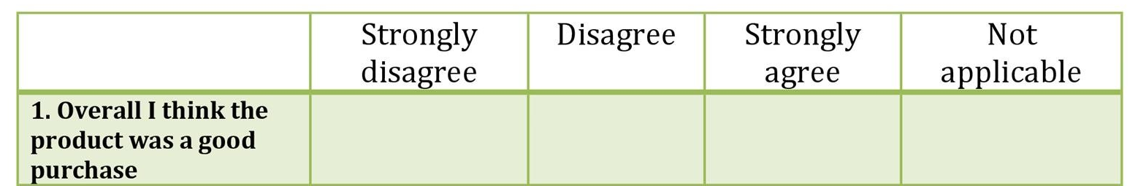

(TemplateLab, 2015)

The questionnaire will provide the thoughts and opinions of those undertaking it, which in turn gives up to date readily available data which can be compared to similar research which has been conducted in countries whereby their Police Officers are already armed in order to evaluate the level of security and perception of safety perceived by the public and serving Officers.

The number of members of the public to complete the questionnaire is 20 and the number of serving Police Officers is 20, there 40 sets of completed questionnaires in total.

Secondary Data:
Secondary data is that which already exists at the time of research. Therefore, the information is readily available so that the researcher does not have to generate it themselves, it can be used by them as a comparison to their own collected primary data.
‘Using Secondary data sets provides an alternative to the collection of primary data, often giving the researcher access to more information than would be available in primary data sets.’ (Vartanian, 2011)
Sources whereby secondary data can be gathered from include but are not limited to;
- Libraries (Textbooks, Journals)
- National statistics sites via the internet.
- Articles and studies alike which provide similar information which can be used for analysing primary data.
These types of research methods have been selected due to the ability to gather more personal evidence form the findings. Although the questionnaire will have pre-set answers in which the participants will response, this provides a more detailed response than a yes/no option. The scale for the responses can be easily analysed and provides broader scope for the participant to answer.
The written questionnaire means the participant will not feel pressured into answering as they believe they should or providing the answer they believe the research wants to hear. More commonly known as ‘The Hawthorne Effect’ which is described as the increase in performance of individuals who are noticed, watched, and paid attention to by researchers or supervisors (Perera, 2021). Therefore, using a written questionnaire participants complete without observation will mean the results should be a truer reflection on their options and feelings.
As previously discussed, serving Police Officers will be asked to complete the questionnaire, knowing they work shifts and often having very little spare time, the questionnaire will be an easily available research method which can be sent out on a large scale via a weblink and can be held until they have time to complete.
The use of the secondary data allows the researcher to compare the primary data they have collected with research conducted globally to understand on a broad scope the overall opinion on arming Police Officers and using this come to the conclusion as to whether the public and police officers feel arming Police Officers makes their community safer.

SUMMARY OF SAMPLING FRAMEWORK:

The target sample for this research will be a mixture of personnel in order to gain the information necessary to answer the dissertation title.

There will be a questionnaire which can be answered using Likert Scale, this questionnaire will be send to twenty members of the public, via paper issue or web link if they preferred. The questionnaire will also then be sent to twenty serving Police Officers in the same manner.

The title of this dissertation looks at the opinions of perceived safety arming the UK Police would instil on both members of the public and how it would make those serving as Police Officers feel. Therefore, this sample group would provide the best information to analyse and complete a report on.

ETHICAL ISSUES:

Prior to any continuation of the dissertation research the related ethics form will need to be overseen by superiors and the research authorised.

The participants will need to be informed as to why the research is being undertaker and how their answers will be used, therefore ensuring they have provided informed consent.

In relation to the sample group there will need to be confidentially in terms of their details, as to ensure their data is protected and the research conforms with the ethical principles and regulations.

When selecting the Police Officers to undertake the questionnaire, it will be important to select Officers from a variety of experience levels, this way the opinion on newer/older Police Officers will not take precedent.

TIME SCALE:

The final dissertation is due to be submitted by the beginning of July 2023, therefore each section of the dissertation shall be split up into smaller units, which therefore makes the workload more achievable.

The Literature review chapter will be the next section of the dissertation to be completed, this will be started a week commencing the proposal being submitted.

Following this allocated submission dates allowing, each section shall be given approximately one month to complete, with any extra time being used to proof-read and planning for the next section.

REFERENCE LIST:

BBC (2015). Survey suggests backing for routinely armed police. BBC News. [online] 29 Jan. Available at: https://www.bbc.co.uk/news/uk-scotland-scotland-politics-31024883 [Accessed 14 Nov. 2022].
Fanning, E. (2019). Formatting a Paper-based Survey Questionnaire: Best Practices. Practical Assessment, Research, and Evaluation, [online] 10(1). doi:10.7275/s84t-8a63.
Home Office (2012). Definition of policing by consent. [online] Gov.UK. Available at: https://www.gov.uk/government/publications/policing-by-consent/definition-of-policing-by-consent [Accessed 14 Nov. 2022].
Panlogic (n.d.). Illegal firearms. [online] nationalcrimeagency.gov.uk. Available at: https://nationalcrimeagency.gov.uk/what-we-do/crime-threats/firearms [Accessed 26 Oct. 2022].
Perera, A. (2021). What is the Hawthorne Effect? | Simply Psychology. [online] www.simplypsychology.org. Available at: https://www.simplypsychology.org/hawthorne-effect.html [Accessed 17 Nov. 2022].
PolFed (2017). Two thirds of officers don’t want routine arming. [online] www.polfed.org. Available at: https://www.polfed.org/Leics/news/2017/two-thirds-of-officers-dont-want-routine-arming/#:~:text=Two%20thirds%20of%20officers%20don%27t%20want%20to%20be [Accessed 14 Nov. 2022].
Povey, D. and Kaiza, P. (2006) ‘Recorded crimes involving firearms’. Chapter 3 in K. Coleman, C.
Statista (2020). Where are the World’s unarmed Police Officers? [Online image] Statista. Available at: https://www.statista.com/chart/10601/where-are-the-worlds-unarmed-police-officers/ [Accessed 14 Nov. 2022].
TemplateLab (2015). 30 Free Likert Scale Templates & Examples ᐅ TemplateLab. [online] TemplateLab. Available at: https://templatelab.com/likert-scale/ [Accessed 17 Nov. 2022].
Vartanian, T.P. (2011). Secondary data analysis. Oxford: Oxford University Press.
Waldren, M. (2007). The Arming of Police Officers. Policing, 1(3), pp.255–264. doi:10.1093/police/pam043.
Yesberg, J.A. and Bradford, B. (2022). Predictors of Public Reactions to Armed Police: Findings from the UK. Policing & Firearms, pp.317–336. doi:10.1007/978-3-031-13013-7_14.
Yesberg, J.A., Bradford, B. and Dawson, P. (2020). An experimental study of responses to armed police in Great Britain. Journal of Experimental Criminology. doi:10.1007/s11292-019-09408-8.

Appendix 2 – Ethical Proposal

SECTION A: About You (Principal Researcher)
Full Name: |  | Tyler Leigh Daniels
Tick all boxes which apply: |  | Member of staff: | ☐ | Honorary research fellow: | ☐
Undergraduate Student | ☒ | Taught Postgraduate Student | ☐ | Postgraduate Research Student | ☐

Institute/Academic Discipline/Centre: | IMH
Campus: | Swansea
E-mail address: | 2016515@STUDENT.UWTSD.AC.UK
Contact Telephone Number: | N/A
For students:
Student Number: | 2016515
Programme of Study: | BSc (Hons) Professional Policing Practice
Director of Studies/Supervisor: | Jane Thomas

SECTION B: Approval for Research Activity
Has the research activity received approval in principle?  (please check the Guidance Notes as to the appropriate approval process for different levels of research by different categories of individual) |  | YES | ☒ | NO | ☐
 |  |  |  | Date
If Yes, please indicate source of approval (and date where known): Approval in principle must be obtained from the relevant source prior to seeking ethical approval | Research Degrees Committee |  | ☐
 | Institute Research Committee |  | ☐
 | Other (write in) |  | ☒ | Jane Thomas

SECTION C: Internal and External Ethical Guidance Materials
Please list the core ethical guidance documents that have been referred to during the completion of this form (including any discipline-specific codes of research ethics, and also any specific ethical guidance relating to the proposed methodology). Please tick to confirm that your research proposal adheres to these codes and guidelines.
UWTSD Research Ethics & Integrity Code of Practice | ☒
UWTSD Research Data Management Policy | ☒
 | ☐

SECTION D: External Collaborative Research Activity
Does the research activity involve collaborators outside of the University? |  | YES | ☐ | NO | ☒
If Yes, please provide the name of the external organisation and name and contact details for the main contact person and confirmation this person has consented to their personal data being shared.as part of this collaboration.
Institution
Contact person name
Contact person e-mail address

Has this individual consented to sharing their details on this form? |  | YES | ☐ | NO |  |  | ☐
Are you in receipt of a KESS scholarship? |  | YES | ☐ | NO |  |  | ☐
Is your research externally funded |  | YES | ☐ | NO |  |  | ☐
Are you specifically employed to undertake this research in either a paid or voluntary capacity? | Voluntary | YES | ☐ | NO |  | ☐
 | Employed | YES | ☐ | NO |  | ☐
Is the research being undertaken within an existing UWTSD Athrofa Professional Learning Partnership (APLP) | If YES then the permission question below does not need to be answered. | YES | ☐ | NO |  |  | ☐
Permission to undertake the research has been provided by the partner organisation | (If YES attach copy)  If NO the application cannot continue | YES | ☐ | NO |  |  | ☐

Where research activity is carried out in collaboration with an external organisation
Does this organisation have its own ethics approval system? | YES | ☐ | NO | ☐
If Yes, please attach a copy of any final approval (or interim approval) from the organisation

SECTION E: Details of Research Activity
Indicative title: | Does arming UK Police increase safety, for the officers and the public?
Proposed start date: | 28/09/2022 | Proposed end date: | 03/07/2023
Introduction to the Research (maximum 300 words)
Ensure that you write for a Non-Specialist Audience when outlining your response to the three points below:
- Purpose of Research Activity
- Proposed Research Question
- Aims of Research Activity
- Objectives of Research Activity
Demonstrate, briefly, how Existing Research has informed the proposed activity and explain
- What the research activity will add to the body of knowledge
- How it addresses an area of importance.
Purpose of Research Activity

This research addresses the case of whether arming UK Police increases safety for the public and serving Police Officers.

Research Question

MAIN QUESTION:

Does arming UK Police increase safety, for the officers and the public?

SUB-QUESTIONS/TOPIC QUESTIONS:

How does the perception of safety compare with to countries that already have armed Police?
Is there a need for arming Police officers given todays heightened risks?
What is the public’s opinion a Response Police Officers being armed?
How do Serving Police Officers in the UK feel about possibly being armed?

Aims of Research Activity

This research aims to aims to collect the opinion of the public and Police officers on whether arming UK Police Forces would make them feel safer. This information will then be compared to those from countries whereby the Police Officers are armed as part of normal duty, to see whether the public/police in these areas feel safer in comparison.
In order to satisfy the aim for which this research is being undertaken, following objectives need to be accomplished which will provide us the clear view of the current opinion form officers and the public.
- To systematically collect data from serving police officers about perception of carrying a firearm as part of daily duty.
- To systematically collect data from members of the public about perception of police officers carrying a firearm.
- To identify the current opinion from both parties.
- To critically analyse the results, comparing to opinions globally where police are armed.
Existing research and news coverage regularly brings this topic into debate, therefore making this a current, relevant and important topic to cover and research.

With this topic being a long-standing debate within legislation and Police Services worldwide it means there is extensive amounts of research which has already been conducted, this will be used to compare and contrast findings from this research to highlight similarities and areas where patterns can be found.
Objectives of Research Activity

- To conduct an extant literature review of articles documenting findings that have already been Collected.
- Understand the legislation behind the use/no use of arms by Police officers around the world and compare this to UK Police forces.
- Gain an understanding on the feelings/opinions of those who are served by the Police in UK in relation to Police Officers being armed and conduct research as to why they feel how they state.
Proposed methods (maximum 600 words)
Provide a brief summary of all the methods that may be used in the research activity, making it clear what specific techniques may be used. If methods other than those listed in this section are deemed appropriate later, additional ethical approval for those methods will be needed.
The main research will be from primary data collection using a questionnaire completed by members of the public and serving Police Officers, this will provide qualitative data. The results of such will then be analysed and used to divulge the overall opinion of those undertaking the survey.

Secondary data collection will also be conducted from Government publications, articles and legislation, this will then be used as a comparison to the findings from the primary data collection.

In order for a questionnaire to gather the necessary information, it has to have a clear set of goals. In this instant the point of the questionnaire is to gather the thoughts, feelings and opinions about UK Police forces being armed from members of the public and secondly on serving Police Officers.
Questions relating to the selected topic will be put to then in the form of a written set of questions, with a scale system provided for their answers.

The most appropriate scale is that of the ‘Likert scale’ which is a type on an ordinal scale, it is an attitude measurement technique most widely used which allows respondents to rate how strongly they agree or disagree with the proposed questions. An example is shown below:

The questionnaire will provide the thoughts and opinions of those undertaking it, which in turn gives up to date readily available data which can be compared to similar research which has been conducted in countries whereby their Police Officers are already armed in order to evaluate the level of security and perception of safety perceived by the public and serving Officers.

The number of members of the public to complete the questionnaire is 20 and the number of serving Police Officers is 20, there 40 sets of completed questionnaires in total.

Secondary data is that which already exists at the time of research. Therefore, the information is readily available so that the researcher does not have to generate it themselves, it can be used by them as a comparison to their own collected primary data.

Sources whereby secondary data can be gathered from include but are not limited to;
• Libraries (Textbooks, Journals)
• National statistics sites via the internet.
• Articles and studies alike which provide similar information which can be used for analysing primary data.

These types of research methods have been selected due to the ability to gather more personal evidence form the findings. Although the questionnaire will have pre-set answers in which the participants will response, this provides a more detailed response than a yes/no option. The scale for the responses can be easily analysed and provides broader scope for the participant to answer.

The written questionnaire means the participant will not feel pressured into answering as they believe they should or providing the answer they believe the research wants to hear.
Therefore, using a written questionnaire participants complete without observation will mean the results should be a truer reflection on their options and feelings.

As previously discussed, serving Police Officers will be asked to complete the questionnaire, knowing they work shifts and often having very little spare time, the questionnaire will be an easily available research method which can be sent out on a large scale via a weblink and can be held until they have time to complete.

Location of research activity
Identify all locations where research activity will take place.
This research will primarily take place within the sample groups place of home or work, when they are completing the questionnaire.

In terms of the research set up and analysation, this will take place at home address and with the university library/study areas.

There is no dedicated location as to where the research/questionnaire will take place, and there is no research that will be taking place outside of Wales.

Research activity outside of the UK
If research activity will take place overseas, you are responsible for ensuring that local ethical considerations are complied with and that the relevant permissions are sought. Specify any local guidelines (e.g. from local professional associations/learned societies/universities) that exist and whether these involve any ethical stipulations beyond those usual in the UK (provide details of any licenses or permissions required). Also specify whether there are any specific ethical issues raised by the local context in which the research activity is taking place, for example, particular cultural and/or legal sensitivities or vulnerabilities of participants.
NO
Use of documentation not in the public domain: Are any documents NOT publicly available? | NO | ☒
 | YES | ☐
If Yes, please provide details here of how you will gain access to specific documentation that is not in the public domain and that this is in accordance with prevailing data protection law of the country in question and England and Wales.

(this box should expand as you type)

SECTION F: Scope of Research Activity
Will the research activity include: | YES | NO
Use of a questionnaire or similar research instrument? | ☒ | ☐
Use of interviews? | ☐ | ☒
Use of diaries? | ☐ | ☒
Participant observation with their knowledge? | ☐ | ☒
Participant observation without their knowledge? | ☐ | ☒
Use of video or audio recording? | ☐ | ☒
Access to personal or confidential information without the participants’ specific consent? | ☐ | ☒
Administration of any questions, test stimuli, presentation that may be experienced as physically, mentally or emotionally harmful / offensive? | ☐ | ☒
Performance of any acts which may cause embarrassment or affect self-esteem? | ☐ | ☒
Investigation of participants involved in illegal activities? | ☐ | ☒
Use of procedures that involve deception? | ☐ | ☒
Administration of any substance, agent or placebo? | ☐ | ☒
Working with live vertebrate animals? | ☐ | ☒
Other primary data collection methods, please explain in this box  For example, ‘focus groups’. Please indicate the type of data collection method(s) in this box and tick the accompany box. | ☐ | ☒
Details of any other primary data collection method:  (this box should expand as you type) | ☐ | ☒
If NO to every question, then the research activity is (ethically) low risk and may be exempt from some of the following sections (please refer to Guidance Notes).

If YES to any question, then no research activity should be undertaken until full ethical approval has been obtained.

SECTION G: Intended Participants
Who are the intended participants: | YES | NO
Students or staff at the University? | ☐ | ☒
Adults (over the age of 18 and competent to give consent)? | ☒ | ☐
Vulnerable adults? | ☐ | ☒
Children and Young People under the age of 18? (Consent from Parent, Carer or Guardian will be required) | ☐ | ☒
Prisoners? | ☐ | ☒
Young offenders? | ☐ | ☒
Those who could be considered to have a particularly dependent relationship with the investigator or a gatekeeper? | ☐ | ☒
People engaged in illegal activities? | ☐ | ☒
Others (please identify specifically any group who may be unable to give consent) please indicate here and tick the appropriate box. | ☐ | ☒
Other – please indicate here:  (this box should expand as you type) | ☐ | ☒

Participant numbers and source
Provide an estimate of the expected number of participants. How will you identify participants and how will they be recruited?
How many participants are expected? | 40  (this box should expand as you type)
Who will the participants be? | 20 Members of the public aged 18+  20 Serving Police Officers within the UK.  (this box should expand as you type)
How will you identify the participants? | Self-administrated questionnaire survey will be conducted to collect empirical data from members of the public.  They will be identified through associates who can gather details of personnel who would be willing to participate, the web link for the questionnaire will then be sent directly to them to complete.  Serving Police officers will also be sent a web link to access the questionnaire, these Police Officers will be selected randomly to ensure a mixture of experience levels is selected.  (this box should expand as you type)

Information for participants: | YES | NO | N/A
Will you describe the main research procedures to participants in advance, so that they are informed about what to expect? | ☒ | ☐ | ☐
Will you tell participants that their participation is voluntary? | ☒ | ☐ | ☐
Will you obtain written consent for participation? | ☒ | ☐ | ☐
Will you explain to participants that refusal to participate in the research will not affect their treatment or education (if relevant)? | ☐ | ☐ | ☒
If the research is observational, will you ask participants for their consent to being observed? | ☐ | ☐ | ☒
Will you tell participants that they may withdraw from the research at any time and for any reason? | ☒ | ☐ | ☐
With questionnaires, will you give participants the option of omitting questions they do not want to answer? | ☒ | ☐ | ☐
Will you tell participants that their data will be treated with full confidentiality and that, if published, it will not be identifiable as theirs? | ☒ | ☐ | ☐
Will you debrief participants at the end of their participation, in a way appropriate to the type of research undertaken? | ☒ | ☐ | ☐
If NO to any of above questions, please give an explanation
(this box should expand as you type)

Information for participants: | YES | NO | N/A
Will participants be paid? | ☐ | ☒ | ☐
Is specialist electrical or other equipment to be used with participants? | ☐ | ☒ | ☐
Are there any financial or other interests to the investigator or University arising from this study? | ☐ | ☒ | ☐
Will the research activity involve deliberately misleading participants in any way, or the partial or full concealment of the specific study aims? | ☐ | ☒ | ☐
If YES to any question, please provide full details
(this box should expand as you type)

SECTION H: Anticipated Risks

Outline any anticipated risks that may adversely affect any of the participants, the researchers and/or the University, and the steps that will be taken to address them.

If you have completed a full risk assessment (for example as required by a laboratory, or external research collaborator) you may append that to this form.
Full risk assessment completed and appended? |  | Yes | ☐
 |  | No | ☐
Risks to participants
For example: emotional distress, financial disclosure, physical harm, transfer of personal data, sensitive organisational information
- The research: The questions being asked may cause some emotional harm, if the participants have been affected by any gun related crimes  - The participants could be concerned about their data being used inappropriately and concerned about confidentiality.  - The participants could be worried about how their answers could reflect on them as people, especially if they feel they are representing an organisation. | 1.If the participant has potential emotional challenges, they will need to be provided with support. Participants will be made aware of their right to withdraw from research or limit their participation, at any point should they feel uncomfortable. If the research affects the participant to the point whereby, they stop completing the research, a debrief should be provided whereby external counselling or psychological support would be offered.  2. Ensure the participants are briefed on the use of the data being collected and how said data will be protected. Again, allow them the opportunity to withdraw from the research should they feel it necessary.  3. Explain to the participants that the questionnaires will be anonymous and therefore the answers will not be linked to the participants in anyway.
If research activity may include sensitive, embarrassing or upsetting topics (e.g. sexual activity, drug use) or issues likely to disclose information requiring further action (e.g. criminal activity), give details of the procedures to deal with these issues, including any support/advice (e.g. helpline numbers) to be offered to participants. Note that where applicable, consent procedures should make it clear that if something potentially or actually illegal is discovered in the course of a project, it may need to be disclosed to the proper authorities
N/A

Risks to investigator
For example: personal safety, physical harm, emotional distress, risk of accusation of harm/impropriety, conflict of interest
- Emotional distress from the workload of completing the research pack and setting up the participants involvement.  - Technical issues, meaning the web link to the questionnaire potentially not sending properly or the results not being saved.  - Risk of the selected participants quit halfway through for personal issues. | - Ensuring time management so that the workload does not cause emotional stress, also seeking advice and assistance from supervisors should it be necessary.  - Researching the most reliable online questionnaire system. Ask personnel who have already completed an online questionnaire and use the internet reviews for research.  - Ensuring that the participants feel as comfortable as possible when conducting the research, in order to reduce quitting rate. However, have reserve participants to hand should more than expected quit.
University/institutional risks
For example: adverse publicity, financial loss, data protection
- A negative impact on the university.  - Responsibility in terms of data protection once the results have been shared by the researcher with the university. | - Ensure all communications and work emitted is professional to ensure the high standards of work, and University reputation is upheld.  - This will be primarily the university concerns, however the research must be transparent in stating what data is being sent to them.

Disclosure and Barring Service
If the research activity involves children or vulnerable adults, a Disclosure and Barring Service (DBS) certificate must be obtained before any contact with such participants. | YES | NO | N/A
Does your research require you to hold a current DBS Certificate? | ☐ | ☒ | ☐

SECTION I: Feedback, Consent and Confidentiality
Feedback
What de-briefing and feedback will be provided to participants, how will this be done and when?
The feedback will automatically be provided upon completion of the online research questionnaire.

(this box should expand as you type)
Informed consent
Describe the arrangements to inform potential participants, before providing consent, of what is involved in participating. Describe the arrangements for participants to provide full consent before data collection begins. If gaining consent in this way is inappropriate, explain how consent will be obtained and recorded in accordance with prevailing data protection legislation.
I will ensure that both the consent process and the consent form must be approved by the Ethic committee. The potential participants who are capable of volunteering to participate in a research study must be given sufficient information to allow them to make an informed decision about participation. I will make sure that the participant understands all the important elements of the consent form at the time the consent form is written signed, and, all during the research study. For those online questionnaires, before the questions start, potential participants will be presented (either verbally or in writing) with the same information required in a written consent document.

(this box should expand as you type)
Confidentiality / Anonymity
Set out how anonymity of participants and confidentiality will be ensured in any outputs. If anonymity is not being offered, explain why this is the case.
Confidentiality and anonymity will be guaranteed by the researcher.
I will employ a number of methods to keep my subjects' identity confidential and anonymous. Foremost, keep their records secure through the use of password protected files, encryption when sending information over the internet. Do not record information in a way that links subject responses with identifying information (usually by use of a code known only to them). And ensure removing the contributor's name as the basic step to protect a participant's identity. Besides, avoiding more pieces of information that are presented together, for example: job title, age, gender, length of service, membership of clubs, and strongly expressed opinions. I will often only report aggregate findings, not individual-level data, to the public.

(this box should expand as you type)

SECTION J: Data Protection and Storage
In completing this section refer to the University’s Research Data Management Policy and the extensive resources on the University’s Research Data Management web pages (http://uwtsd.ac.uk/library/research-data-management/).
Does the research activity involve personal data (as defined by the General Data Protection Regulation 2016 “GDPR” and the Data Protection Act 2018 “DPA”)? | YES | NO
“Personal data” means any information relating to an identified or identifiable natural person (‘data subject’). An identifiable natural person is one who can be identified, directly or indirectly, in particular by reference to an identifier such as a name, an identification number, location data, an online identifier or to one or more factors specific to the physical, physiological, genetic, mental, economic, cultural or social identity of that natural person. | ☐ | x
If YES, provide a description of the data and explain why this data needs to be collected:
(this box should expand as you type)
Does it involve special category data (as defined by the GDPR)? | YES | NO
“Special category data” means sensitive personal data consisting of information as to the data subjects’ –  (a) racial or ethnic origin,  (b) political opinions,  (c ) religious beliefs or other beliefs of a similar nature,  (d) membership of a trade union (within the meaning of the Trade Union and Labour Relations (Consolidation) Act 1992),  (e) physical or mental health or condition,  (f) sexual life,  (g) genetics,  (h) biometric data (as used for ID purposes), | ☐ | x
If YES, provide a description of the special category data and explain why this data needs to be collected:
N/A

(this box should expand as you type)
Will the research activity involve storing personal data and/or special category data on one of the following: | YES | NO
Manual files (i.e. in paper form)? | ☐ | ☒
University computers? | ☐ | ☒
Private company computers? | ☐ | ☒
Home or other personal computers? | ☒ | ☒
Laptop computers/ CDs/ Portable disk-drives/ memory sticks? | ☐ | ☒
“Cloud” storage or websites? | ☐ | ☒
Other – specify: | ☐ | ☒
For all stored data, explain the measures in place to ensure the security of the data collected, data confidentiality, including details of password protection, encryption, anonymisation and pseudonymisation:
The data will have no personal information, only the answers provided on the research questionnaires.
These will be saved on Police personal issued laptop, which is assigned to one person only.

The laptop is locked away when not in use at the police station in a secure locker.
To access any files on the laptop a passcode is needed and then a password and well as authentication through a link sent to Police issue mobile phone.

The data can not be accessed by any other person other then the researcher due to the passcode/password requirements to logon.
(this box should expand as you type)
All Data Storage
Will the research activity involve any of the following activities: | YES | NO
Electronic transfer of data in any form? | ☐ | ☒
Sharing of data with others at the University? | ☐ | ☒
Sharing of data with other organisations? | ☐ | ☒
Export of data outside the European Union or importing of data from outside the UK? | ☐ | ☒
Use of personal addresses, postcodes, faxes, emails or telephone numbers? | ☐ | ☒
Publication of data that might allow identification of individuals? | ☐ | ☒
Use of data management system? | ☐ | ☒
Data archiving? | ☐ | ☒
If YES to any question, please provide full details, explaining how this will be conducted in accordance with the GDPR and DPA (and/or any international equivalent):
N/A
(this box should expand as you type)
List all who will have access to the data generated by the research activity:
Researcher only and university when the data is analysed and submitted.

(this box should expand as you type)
List who will have control of, and act as custodian(s) for, data generated by the research activity:
Researcher only

(this box should expand as you type)
Give details of data storage arrangements, including security measures in place to protect the data, where data will be stored, how long for, and in what form. Will data be archived – if so how and if not why not.
Research data must be stored in a managed environment that protects against data loss and corruption, unauthorised access and modification, and complies with relevant legal, regulatory, contractual, and other obligations for the period that it needs to be kept.

The data from this research will be saved on a Police personal issued laptop, which is assigned to one person only, in this case the researcher.

The laptop is locked away when not in use at the police station in a secure personal locker.
To logon onto the laptop itself a passcode is needed and then a password and well as authentication through a link sent to Police issue mobile phone.
The data cannot be accessed by any other person other than the researcher due to the passcode/password requirements to logon.

The data will be transferred onto the managed secure storage environment as soon as possible. Once the data has been analysed and the results written up in the conclusive report, the data can then be deleted. Up until that point they will be saved on said secure storage system.

Please indicate if your data will be stored in the UWTSD Research Data Repository (see https://researchdata.uwtsd.ac.uk/ ). If so please explain. (Most relevant to academic staff)
N/A

Confirm that you have read the UWTSD guidance on data management (see https://www.uwtsd.ac.uk/library/research-data-management/) | YES | ☒
 | NO | ☐
Confirm that you are aware that you need to keep all data until after your research has completed or the end of your funding | YES | ☒
 | NO | ☐

SECTION K: Declaration
The information which I have provided is correct and complete to the best of my knowledge. I have attempted to identify any risks and issues related to the research activity and acknowledge my obligations and the rights of the participants.

In submitting this application I hereby confirm that I undertake to ensure that the above named research activity will meet the University’s Research Ethics and Integrity Code of Practice which is published on the website: https://www.uwtsd.ac.uk/research/research-ethics/
Signature of applicant: | T.Daniels | Date:20/11/2022

For STUDENT Submissions:
Director of Studies/Supervisor: |  | Date:
Signature: |  | Date:

For STAFF Submissions:
Academic Director/ Assistant Dean: |  | Date:
Signature: |  | Date:

Checklist: Please complete the checklist below to ensure that you have completed the form according to the guidelines and attached any required documentation:
☒ | I have read the guidance notes supplied before completing the form.
☒ | I have completed ALL RELEVANT sections of the form in full.
☒ | I confirm that the research activity has received approval in principle
☐ | I have attached a copy of final/interim approval from external organisation (where appropriate)
☐ | I have attached a full risk assessment (and have NOT completed Section H of this form) (where appropriate) ONLY TICK IF YOU HAVE ATTACHED A FULL RISK ASSESSMENT
☒ | I understand that it is my responsibility to ensure that the above named research activity will meet the University’s Research Ethics and Integrity Code of Practice.
☒ | I understand that before commencing data collection all documents aimed at respondents (including information sheets, consent forms, questionnaires, interview schedules etc.) must be confirmed by the DoS/Supervisor, module tutor or Academic Director.
☒ | I have deleted the guidance notes before submitting the PG2 for consideration

RESEARCH STUDENTS AND STAFF ONLY
All communications relating to this application during its processing must be in writing and emailed to pgresearch@uwtsd.ac.uk , with the title ‘Ethical Approval’ followed by your name.
You will be informed of the outcome of your claim by email; therefore it is important that you check your University and personal email accounts regularly.

STUDENTS ON UNDERGRADUATE OR TAUGHT MASTERS PROGRAMMES should submit this form (and receive the outcome) via systems explained to you by the supervisor/module leader.

Appendix 3 – Online Questionnaire

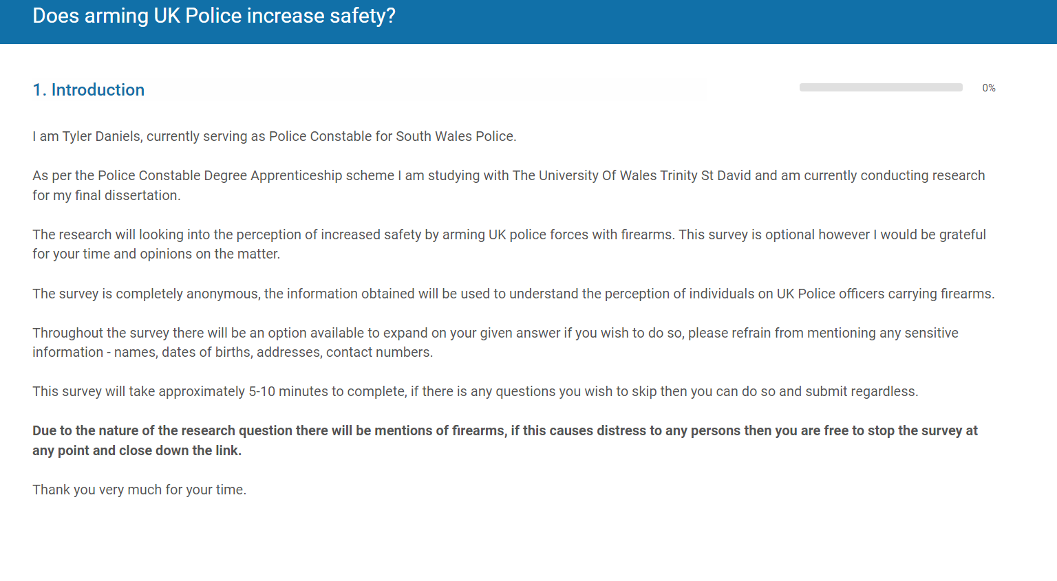
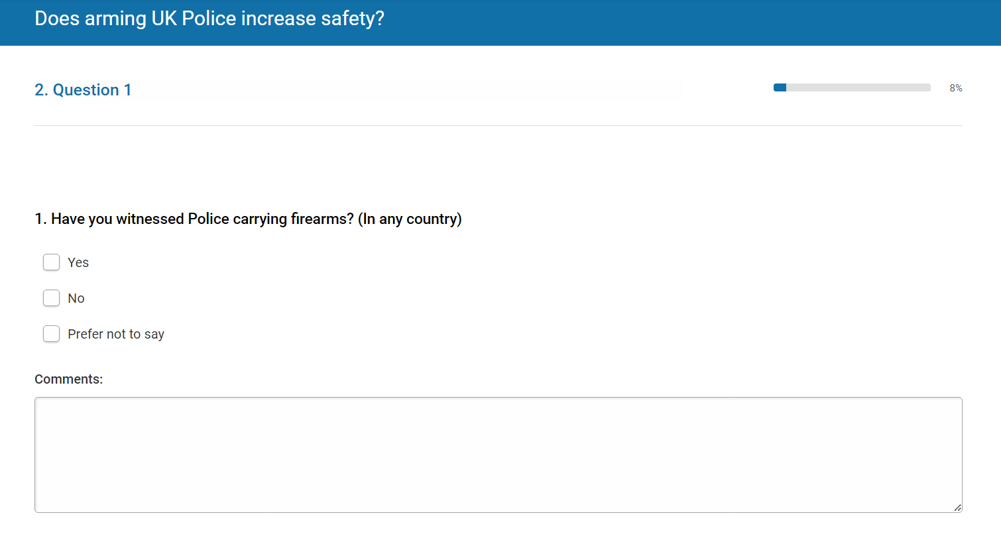

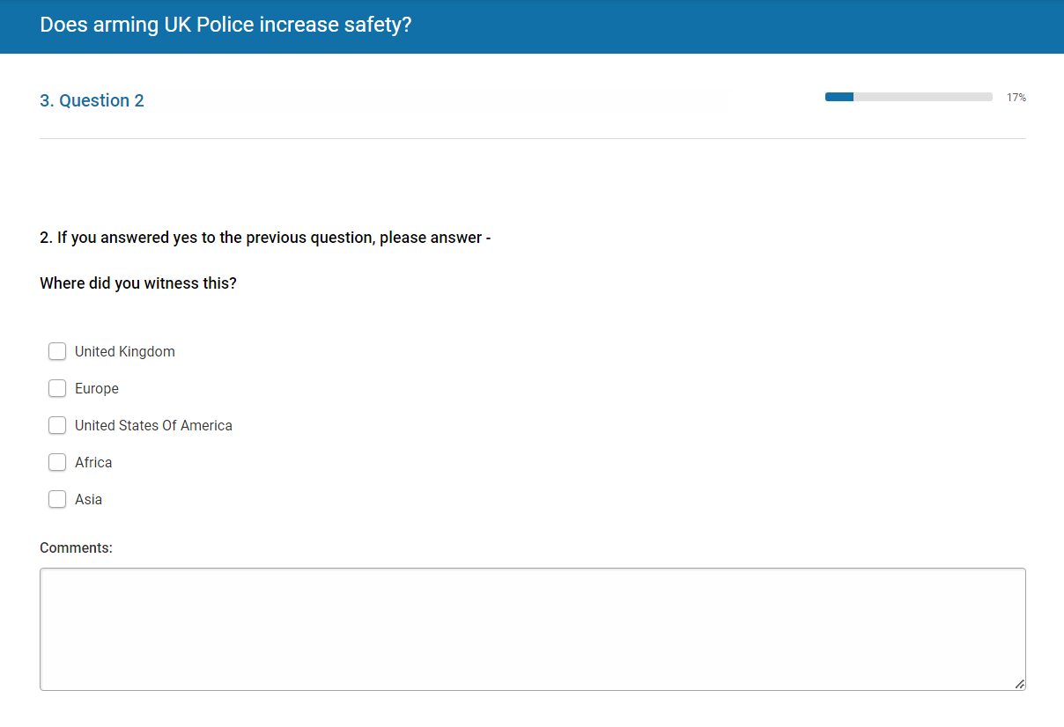
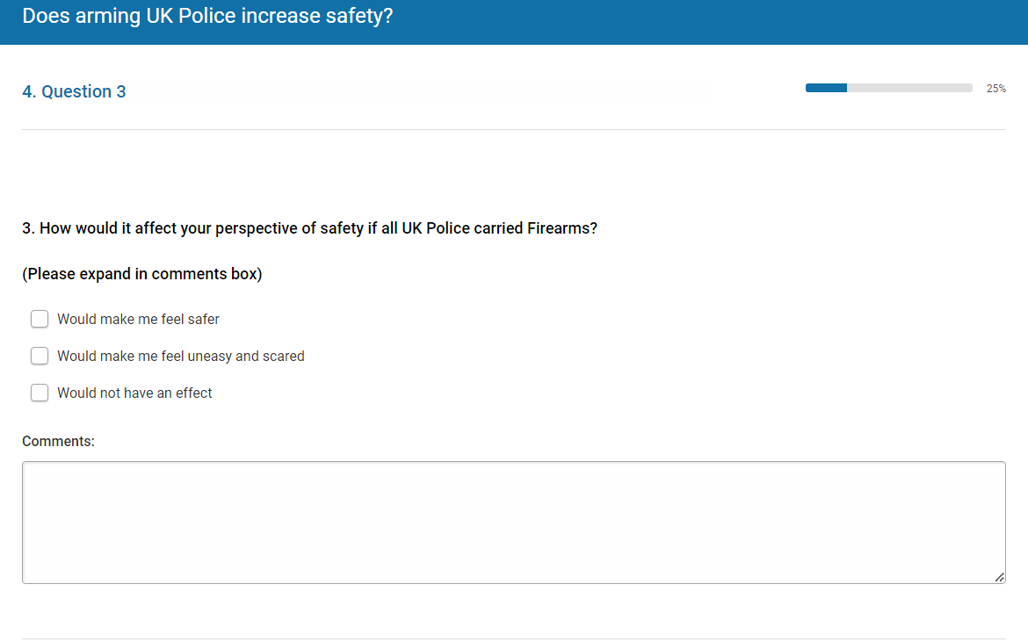
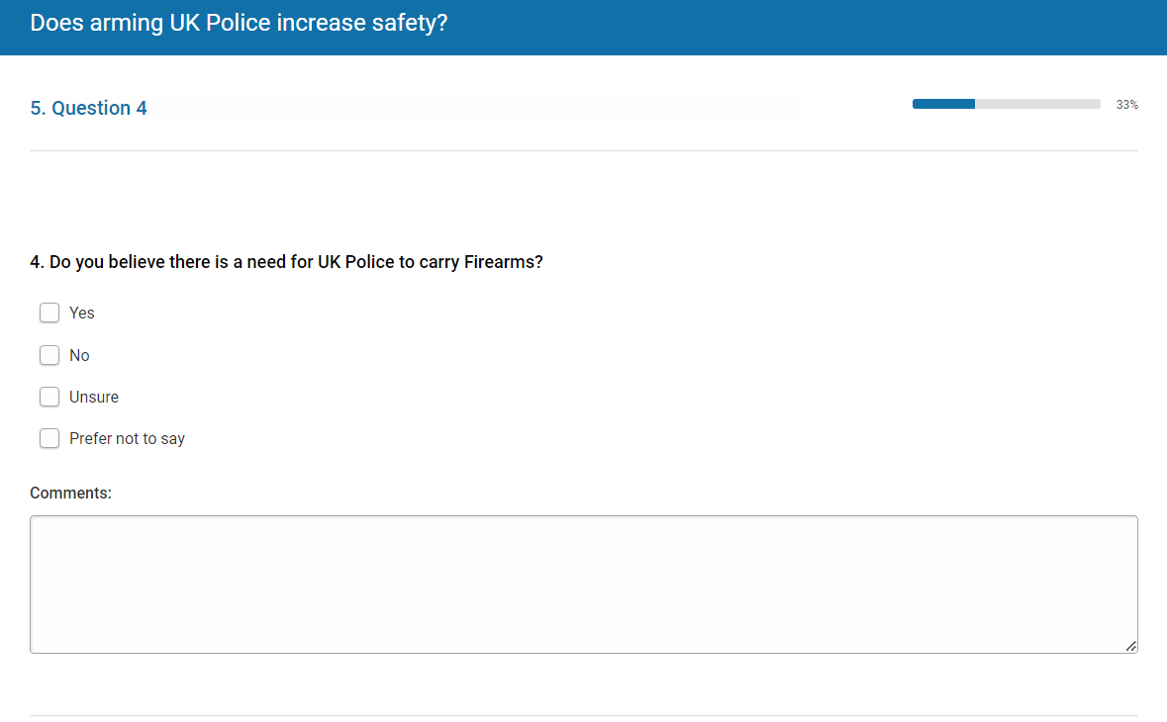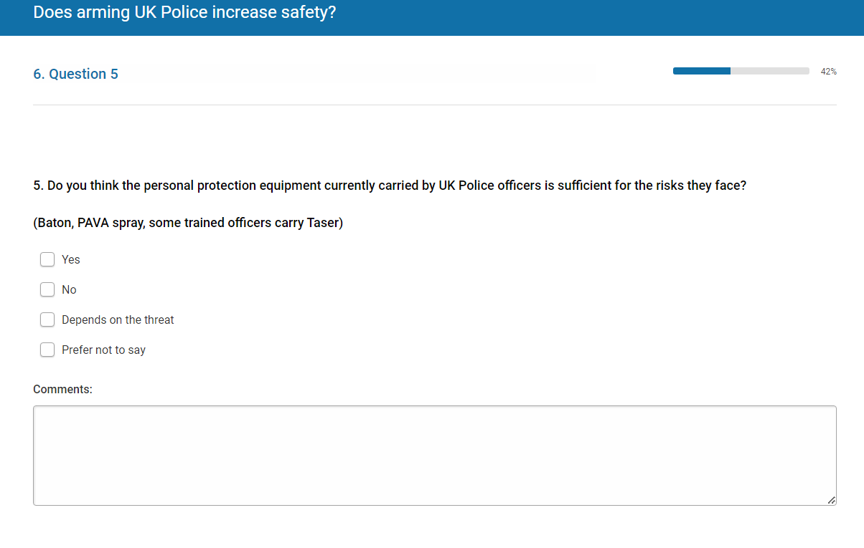
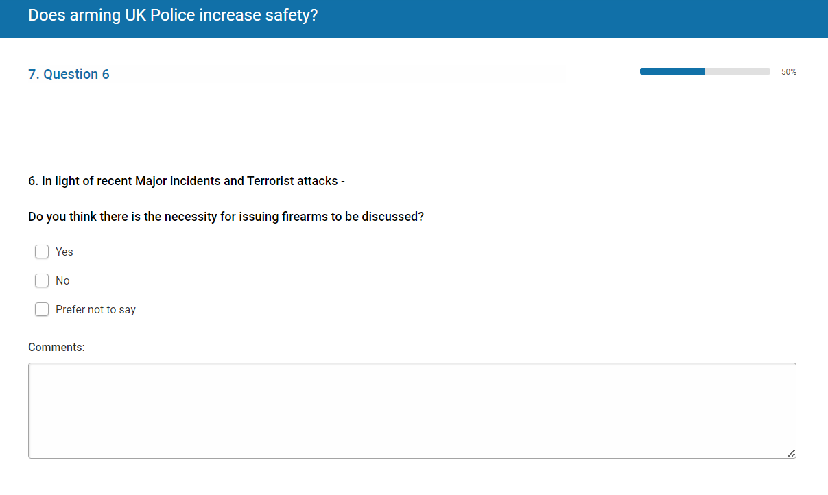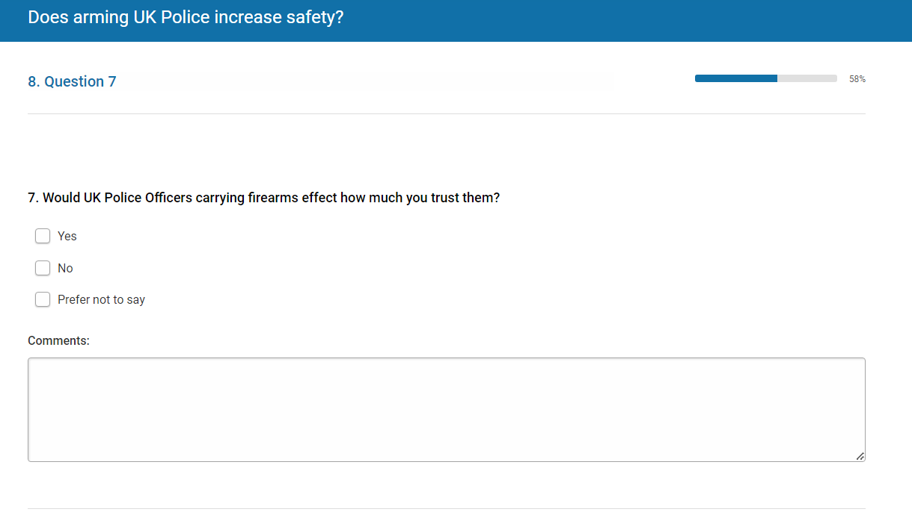
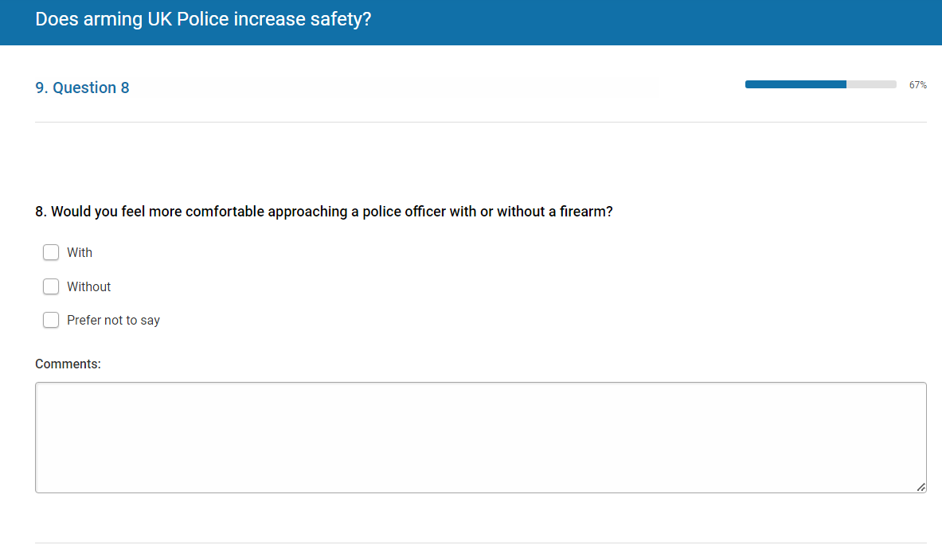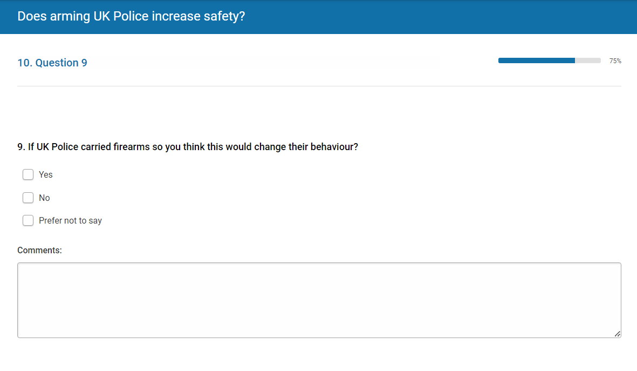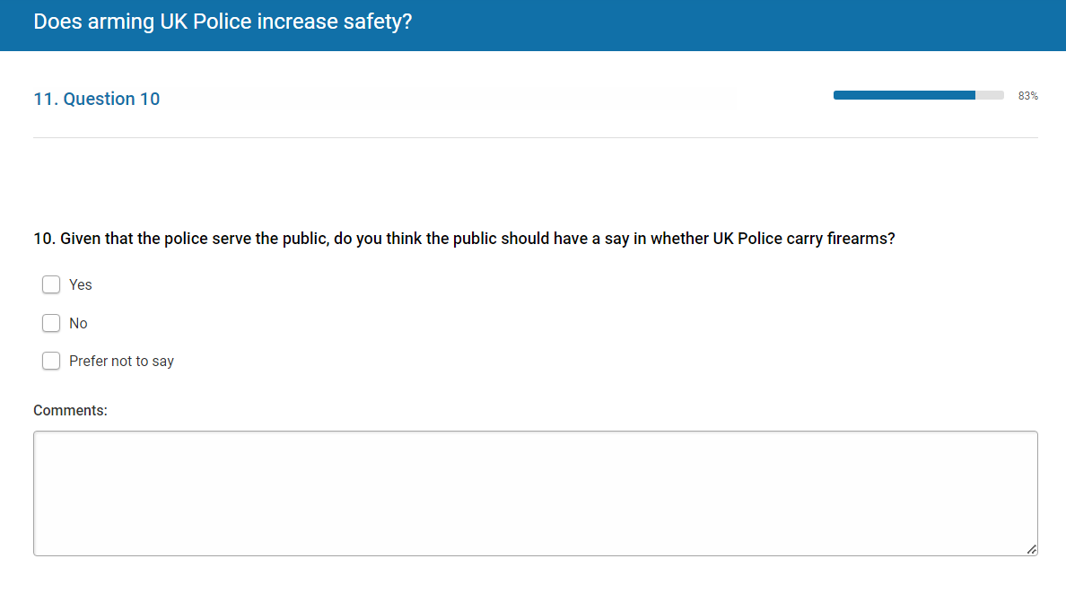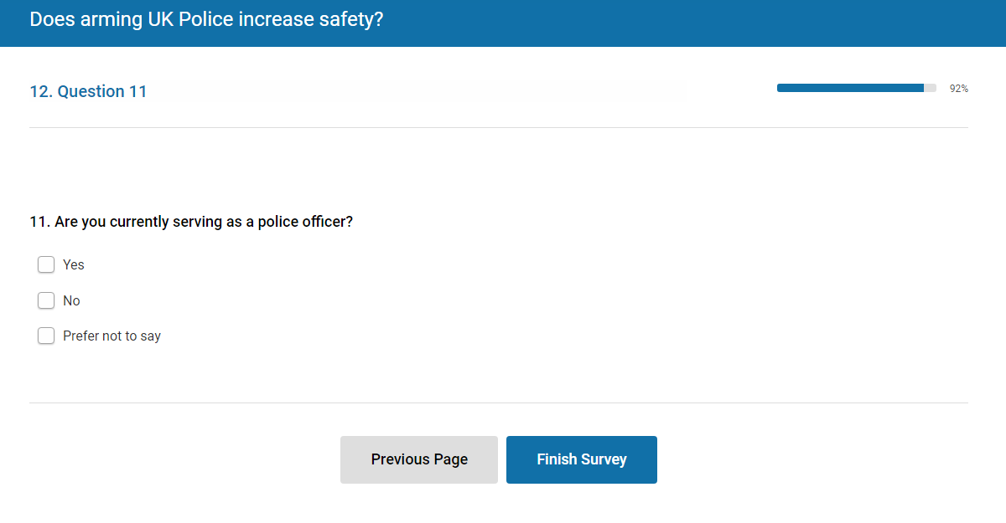

Appendix 4 – Online questionnaire results



