Table of content
- Introduction
- Picked issue
- Work life
- My experience
- Steps to problem solving and critical thinking
- PMI
- SWOT Analysis
- Proposed solution 1,2
- Conclusion-Assessment of the proposed solutions
- References

Introduction
This assignment is made with the help of a report and refers to the knowledge accumulated and also explores an issue at the workplace which is common. This problem is working under pressure. Moreover, explores a solid balance for work-life. Also we can see an examination of which are the favourable circumstances for soling the issue and critical thinking will be applied while analysing the theories, models and tools for this report. A swot analysis will be made as well and it will incorporate two proposed solutions.
Working compelled to fit an objective in a restricted time implies managing unpleasant circumstances at work environment. Working under tension requires most extreme consideration, fast response and precise direction in time and over the undertakings set for satisfaction, as Belhumeur (2018), brings up. Working under tension can antagonistically influence a few people, as it makes pressure, which causes work productivity to decrease.
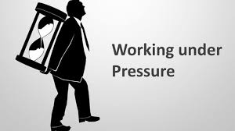
Figure. 1 Working under pressure
Working under tension can antagonistically influence a few people, as it makes pressure, which causes work productivity to decrease. The representative can commit errors, gotten fomented, stall out and, unexpectedly, the ideal opportunity for completing certain errands set as the standard and time is postponed. "Numerous individuals handle working under tension in various manners. A few people are driven by the weight and some are deadened." (Answers.com, 2020). Workplace stress is caused not just by playing out some enormous undertakings for the time being, yet additionally by different clash circumstances between colleagues, administrators and chiefs. Certain misconceptions or absence of correspondence or absorption of data uniquely in contrast to its goal at first delivered the equivalent can causepressure that will be exacerbated by absence of consideration, gradualness, botches at work or not-satisfied work. Stress influences negatively the individual conduct with those around him.
"Work-life balance is about making and keeping up strong and healthy work conditions, which will empower representatives to have balance between work and personal obligations and in this manner fortify worker dependability and productivity. Numerous examines have been directed on work-life balance… If job over-burden is incorporated, at that point near 60 percent of employees surveyed experience work-family struggle. Of all the activity factors that impact work-life strife, the measure of time spent at work is the most grounded and most consistent predictor. The more elevated levels of work-to-family struggle detailed by chiefs or professionals frequently are an element of their more drawn out work hours. Different reasons include: job security, uphold from one's director, uphold from colleagues, work demands or over-burden, work-job struggle, work-job uncertainty, work disappointment, and extensive utilization of correspondence innovation that obscures the limits between home and work’’.
My experience of working under pressure at the workplace
- The manager of our company gave us work which he thought it will be done in 30 minutes. We were a group of 6 individuals. The task that needs to be done is formed of 2 sections.
- The initial segment of the activity needed to be finished by 4 of us and the subsequent part needed to be done by the other 2 individuals. We were assigned to work in two unique work areas.
- Our group of 6 persons was composed by people from different countries. Three people are Romanian, the forth individual is Hungarian, the fifth individual is Columbian and the last individual is from Africa.
- We all were inviting to understand the task and cheerful carrying out the responsibility which the manager gave us.
- We additionally planned to do other sort of tasks together and sharing the tasks between us or sharing even the activity in the event that one of us could get more over-burden than others.
The things took another level of competition. We thought that we first need take out the numbers from the envelopes and than the other two thought to straighten them up. The Columbian co-worker was a woman who brought me three additional heaps as she felt that I have less work than the other three colleagues from their work area. I was glad for that. Before long I understand that on the other work area the individuals working for sifting through have completed all the heaps they had, yet I despite everything need to do mine two heaps and those three heaps that the woman brought. Also, there were ten minutes left until the activity needed to be finished. There were a lot of numbers. I was additionally feeling that in the event that I am completing the process of lifting through prior I will begin straightening so as to complete on schedule. Along these lines, I gave back the last heaps left aside. In the meantime I notice that the Hungarian miss and the Columbian woman are looking at something and they are very unpleased about it. I return to them and inquire to tell me whether anything is turning out badly. The Hungarian young lady is clarifying me that they have a lot of work to do and it is senseless because I return those last heaps. I am clarifying that the folks over their own work area have just completed their work and that I need to complete rapidly my ones remaining around my work area. The Hungarian young lady got furious and answered that she needn't bother with my assistance so I can leave those heaps around their work area as they will carry out the responsibility. The Columbian woman who was smoothing didn't let out the slightest peep. She simply kept her eyes on her numbers, yet got irritated on me.
Another Hungarian woman who was carrying out another responsibility at another work area saw that we are having a unpleasant conversation and asked me what is going on. I clarified her that I would prefer not to over-burden my group. I simply want to complete the task on time as we had just a few minutes left.
Right off the bat, I imagined that they have something against me because those two ladies didn’t welcome me or address me at all. Afterward, I understand that my co-workers misjudged my goal since I didn't convey appropriately what I proposed to do so as to have that activity done on schedule. I felt nonetheless, I attempted to carry on kindly with this two ladies from that point also.
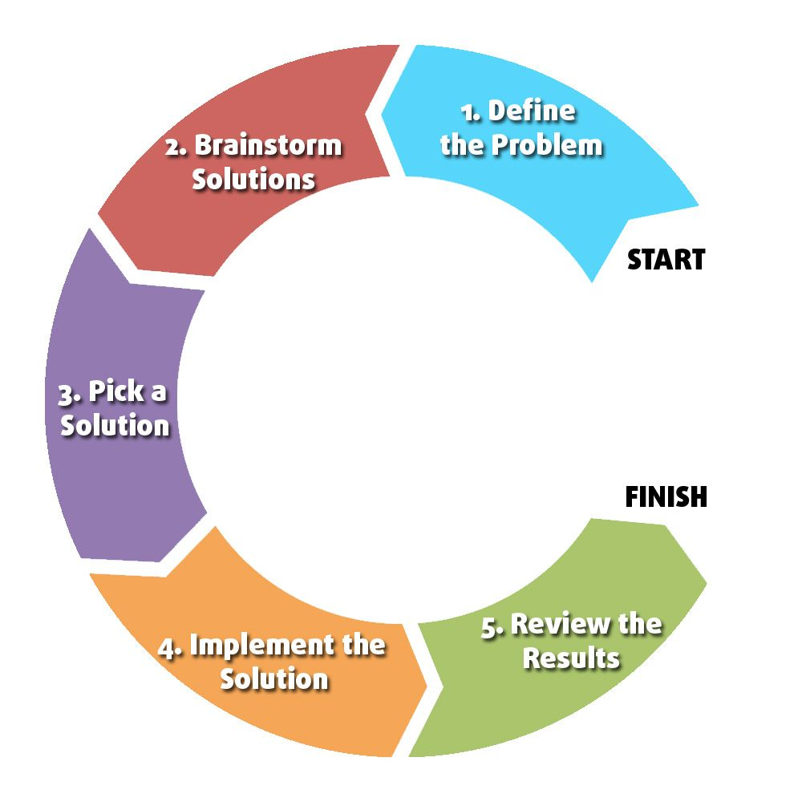
Figure 1.2. Steps for problem solving (Limbach&Waugh, 2012)
As per Figliuolo (2014), recommends 5 stages to a decent answer for the issue. The difficult should be concentrated from a few perspectives. The first significant advance is to discover the source, that caused the issue. Much the same as the malady, it is absolutely or if nothing else effectively treated if, after a few examinations, it has been conceivable to figure out which is the source that really set off the indications and the ailment itself. Once all the examinations and investigations of the issue have been uncovered and demonstrated, you have to discover an answer for each outcome (stage 3). Organize the conceivable proposed arrangements and utilize the 80/20 Pareto's strategy, (Figliuolo, 2014), brings up. The following stage is to keep breaking down the most ideal choice. Not all presumptions are fundamental, yet simply the right one that it end up being essential and right from a few perspectives. Lastly, turn the very much dissected, demonstrated and picked theory as the best arrangement, into a suggestion that can be executed.

These dynamic strategies educates to comprehend what level of choice is faced by an individual and how to adapt himself why asking himself significant questions: How? How much others might be included? Under what conditions these procedures may work best? Instinctive dynamic concentrates more on emotions and discernments while normal dynamic spotlights on realities and examination, (The Happy Manager, 2007).
PMI represent Plus Minus and Interesting and is a basic valuable device or methodology utilized for a considerable length of time expecting to gauge the advantages and disadvantages of a thought, an item, a choice, a decision and to bring or to prompt a superior end, arrangement or choice (Line, 2002). This method resembles a conceptualizing application which can be practiced by instructors among understudies in the class. It additionally can be applied by administrators when settling on choices just as in regular daily existence, (Jay Bonk and Stevenson Smith, 1998).
Identifying with my picked working environment issue – working under tension, the PMI technique shows that this sort of issue, in spite of the fact that uncover more certain segments than negatives. So we can figure out by what means our mentality needs to be in any evolving circumstance. We can learn or improve a portion of our capacities that help to performing. However, it isn't the equivalent for other colleagues. We all got dissatisfaction or disappointed.
My dynamic presently related as an end: I could carry on of my own goal by uncovering my method of dispersing undertakings, contending what are the colleagues advantage for every part independently and that everyone will have a similar errand; the speed of work will be the equivalent for each one, so we will all prevail at 12 o'clock to prepare the activity done. I could likewise include that in the event that I am quicker and finish my assignments prior I am available to support them. Subsequently, I accept that my partners would be available to my proposition and would attempt to give a valiant effort also and the cooperation would be unequivocally felt.

Fishbone analysis

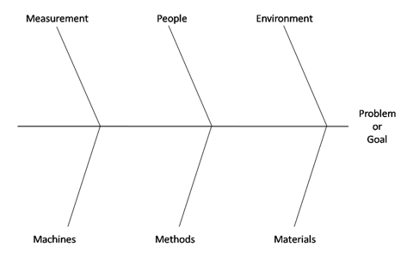
As per National Career Services test about my aptitudes and capacities my outcomes look amazing. Be that as it may, I am certain I need to work more on idealizing them. Taking everything into account I didn't utilize the delicate aptitudes at my work environment this time. I didn't set out to productively speak with my partners at work environment to confront the cut off time task and to dodge the contention. I knew about it, yet I stalled out.
Fishbone analysis can be introduced as a device, a technique, a system to determine how to get to the base of an issue, that is, the source that prompted it; to have the option to decide all the bit by bit insights concerning that causes and to have the option to examine their belongings and outcomes, (Mindtools.com, 2020).Spacey(2018), presents this graph as a more straightforward and more straightforward representation of the issues that have been produced and impacted by a scope of elements and conditions because of the absence of consideration and control because of a human blunder.
Proposed solution 1. As, this isn't the remarkable issue I could adapt to, the main arrangement I am pondering is considerably more worldwide. It depends of the whole administration arrangement of the company. Company pioneers should hold a gathering identified with the organization's administration framework at each level. To demand introductions from the assignments responsible for the administration of specific divisions in which the itemized working of the development will be introduced. Arranging yearly, quarterly, month to month and week after week standards; the quantity of staff who must satisfy these errands and how long and what number of individuals it takes to satisfy a X number of letters. The apparatus or method they have to cut envelopes, output and tally. To play out a fishbone examination of the whole working framework and to bring the important changes mulling over a solid work life balance for every representative. In the event that vital, to tweak the capacities for those with full working hours and those with low maintenance program.
Proposed solution 2. I would recommend that the administrator can ask each morning the individuals liable for the occupations to get the directions for the day's worth of effort and request the work routine for multi week, so it could be as adjusted as could be expected under the circumstance. Subsequently every representative could know precisely when to come and what time will end the work day what is the measure of letters to perform, and so forth.
Assessment of the proposed arrangements. Regardless of how great I may think of proposals and arrangements, this organization is an administration division where I am no one. Nonetheless, if it somehow managed to check the assessment of the business and could have been tuned in to probably a portion of the assessments of the government employees.
Conclusion
Regardless of how great I may think of proposals and arrangements, this organization is an administration division where I am no one. Nonetheless, if it somehow managed to check the assessment of the business and could have been tuned in to probably a portion of the assessments of the government employees, without a doubt a great deal of changes would be significantly more positive both for the development of their further business and for addressing the requirements of the staff.

Problem solving and decision making includes a lot of techniques, tools and strategies, some scientific, others tactical. Practicing and assimilating them makes the human being more human, wiser. The use of these practices at work and in everyday life contributes to the performance of personality development. and as a result the individual becomes wiser, humble enough and able to bring good suggestions and solutions where appropriate, to reconcile relationships, to create harmony, to develop, to grow.

References

Ahmed, A. (2019). How to Describe the Three Segments of a Supply Chain. [online] Bizfluent. Available at: https://bizfluent.com/how-8441767-describe-three-segments-supply-chain.html [Accessed 12 Jan. 2020].

Answers.com. (2020). How are you when you are working under pressure - Answers. [online] Available at: https://www.answers.com/Q/How_are_you_when_youre_working_under_pressure [Accessed 11 Jan. 2020].

Arrevalo, J. (2011). advantages & disadvantages of working under pressure. [online] prezi.com. Available at: https://prezi.com/dgbhfjympjav/advantages-disadvantages-of-working-under-pressure/ [Accessed 11 Jan. 2020].

Belhumeur, K. (2018). How to Work Under Pressure & Meet Deadlines. [online] Career Trend. Available at: https://careertrend.com/how-12062173-work-under-pressure-meet-deadlines.html [Accessed 11 Jan. 2020].

Businessballs.com. (2020). Pareto Principle: The 80-20 Rule - BusinessBalls.com. [online] Available at: https://www.businessballs.com/self-management/paretos-80-20-rule-theory/ [Accessed 12 Jan. 2020].

Dhas, D. (2016). [online] Research Gate. Available at: https://www.researchgate.net/publication/282685585_A_report_on_the_importance_of_work-life_balance [Accessed 11 Jan. 2020].

Figliuolo, M. (2014). 5 Steps to Solving the Problems With Your Problem Solving. [online] Inc.com. Available at: https://www.inc.com/mike-figliuolo/decision-making-process.html [Accessed 12 Jan. 2020].

Img04.en25.com. (2020). Cigna. [online] Available at: https://img04.en25.com/Web/CignaGHB/%7B3341742b-0860-4d3b-bf9c67fdeef0d24f%7D_White_Paper__Building_a_Whole_Person_Health_Approach_to_Chronic_Stress_at_Work_Final_UK.pdf?elqTrackId=aa3842c102574c3ea117d2693ac6f233

Jay Bonk, C. and Stevenson Smith, G. (1998). Alternative instructional strategies for creative and critical thinking in the accounting curriculum. Journal of Accounting Education, 16(2), pp.261-293.
Juneja, P. (2015). What is Decision Making ?. [online] Managementstudyguide.com. Available at: https://www.managementstudyguide.com/what-is-decision-making.htm [Accessed 12 Jan. 2020].

Lees, J. (2014). Under pressure: four ways to cope when things go wrong at work. [online] the Guardian. Available at: https://www.theguardian.com/careers/pressure-four-ways-cope-wrong-work-job [Accessed 12 Jan. 2020].

