FROM DESERT MYTHS TO SHEEP TALES: THE CISTERCIANS IN THE MIDDLE AGES
HPH15022
COMMENTARY THREE – ROCHE ABBEY
1902832 – DAVID LEWIS

The image is a reconstruction of Roche Abbey and gives an impression of what the abbey looked like at its height. Roche Abbey was founded in 1147 and is notable for its early Gothic architecture. (see fig 1). It was a daughter house of Newminster Abbey; grand-daughter house of Fountains Abbey; great grand-daughter house of Clairvaux. It is located in a narrow, wooded valley with rocky limestone outcrops on three sides. The siting of Cistercian abbeys had a strong connection with their surroundings. The environment being a “window on the divine.” with the taming of the environment being symbolic “of the souls return to God.” Early Cistercian legislation stated houses should be constructed in “places removed from human habitation.” To help ensure a “workshop of prayer.” Rural sites particularly associated with valleys were favoured. Access to sufficient land to be self-sufficient and water were essential elements. These elements can be seen in the siting of Roche abbey. Burton and Kerr have noted that the name of the Cistercians monasteries evoked their surroundings. This is true of Roche as its original name was Sante Maria de Rupe from the Latin rupes meaning rock, cliff.
The land for the abbey was donated by two local landowners, Richard De Bully, Lord of Tickhill and Richard son of Tigis who acted as patrons and protectors of the Abbey. The founders gifted further land in 1170’s together with gifts from other donors. This illustrates the importance of donors to the siting, development and expansion of the Cistercian order. It can be argued that the Cistercian rapid expansion and success was dependent on its ability to attract recruits and an ability to connect with donors and the spirit of the age. Bruun and Jamroziak have stated at the core of lay- monastic relationships was a reciprocity between prayers and “material support given to the monasteries.” This relationship is echoed in the image of Roche.
Roche Abbey was at its peak in the early 13 Century. In 1175 it consisted of 50 monks and 100 lay brothers and servants. The introduction and development of a lay brotherhood is an important feature of the early Cistercian Order. The lay brotherhood took vows of obedience but were responsible for managing the land, tending livestock and other industrial activities. Burton and Kerr see the lay brotherhood forming a separate community to the choir monks. This separateness can be seen in the ground plan of Cistercian monasteries as they required separate dormitories, refractories, infirmaries. This is evidenced Roche’s ground plan. This separateness also extended to the church where the lay brotherhood would have been separated from the choir monks by a screen across the church nave. The lay brotherhood’s significance changed over time and is echoed in the history of Roche. From 100 lay brothers (and servants) in 1175, 1 recorded in 1380 and none recorded at its dissolution in 1538 when the monastery had 22 monks and similar number of servants. This illustrates the Order’s adaptability and change over time
Roche is seen as an exemplar of Cistercian design and hasn’t been subject to later alterations and improvements. Cistercian abbeys had a similar layout to most other religious orders of the period. (See fig 2 and 3). What set the early Cistercian abbeys apart was a quest for simplicity which can be seen as a desire to return to simplicity and the purity of the Rule. Stalley states that it was the rebuilding of Clairvaux in 1135 from which a “distinctive approach to architecture began to emerge.” This was based on “purity of form, clarity of proportions, functional efficiency and a high standard of construction … purged of inessentials.” This was in contrast to the highly decorative and ornamental Cluniac approach. In Bernard of Clairvaux’s Apologia ad Guillelmum he wrote about “excessive heights of the oratories, their extravagant length, their inordinate width, their costly furnishings.” Bernard’s Apologia and the rebuilding of Clairvaux can be seen as being highly influential in establishing a Cistercian architectural identity. The use of green grisaille glass in the window glass as depicted in the image, replacing stained glass which would have been the norm in Cluniac monasteries can be seen as representative of ideas of simplicity. (See fig 4 and 5).
For Coomans Cistercian buildings and architecture were the synthesis of three levels; the international (Cistercian norms including aesthetics, rulings of the General Chapter); regional level (patrons, abbot and his community, mother house, regional supporting networks); and the local (builders, masons, carpenters). Cistercian architecture and practise changed over time. I believe Coomans model offers an understanding for this, as the local and regional became more important over time and demonstrates the Cistercian’s adaptability and diversity in architectural practice. This can be seen in the reconstructed image and building of Roche.

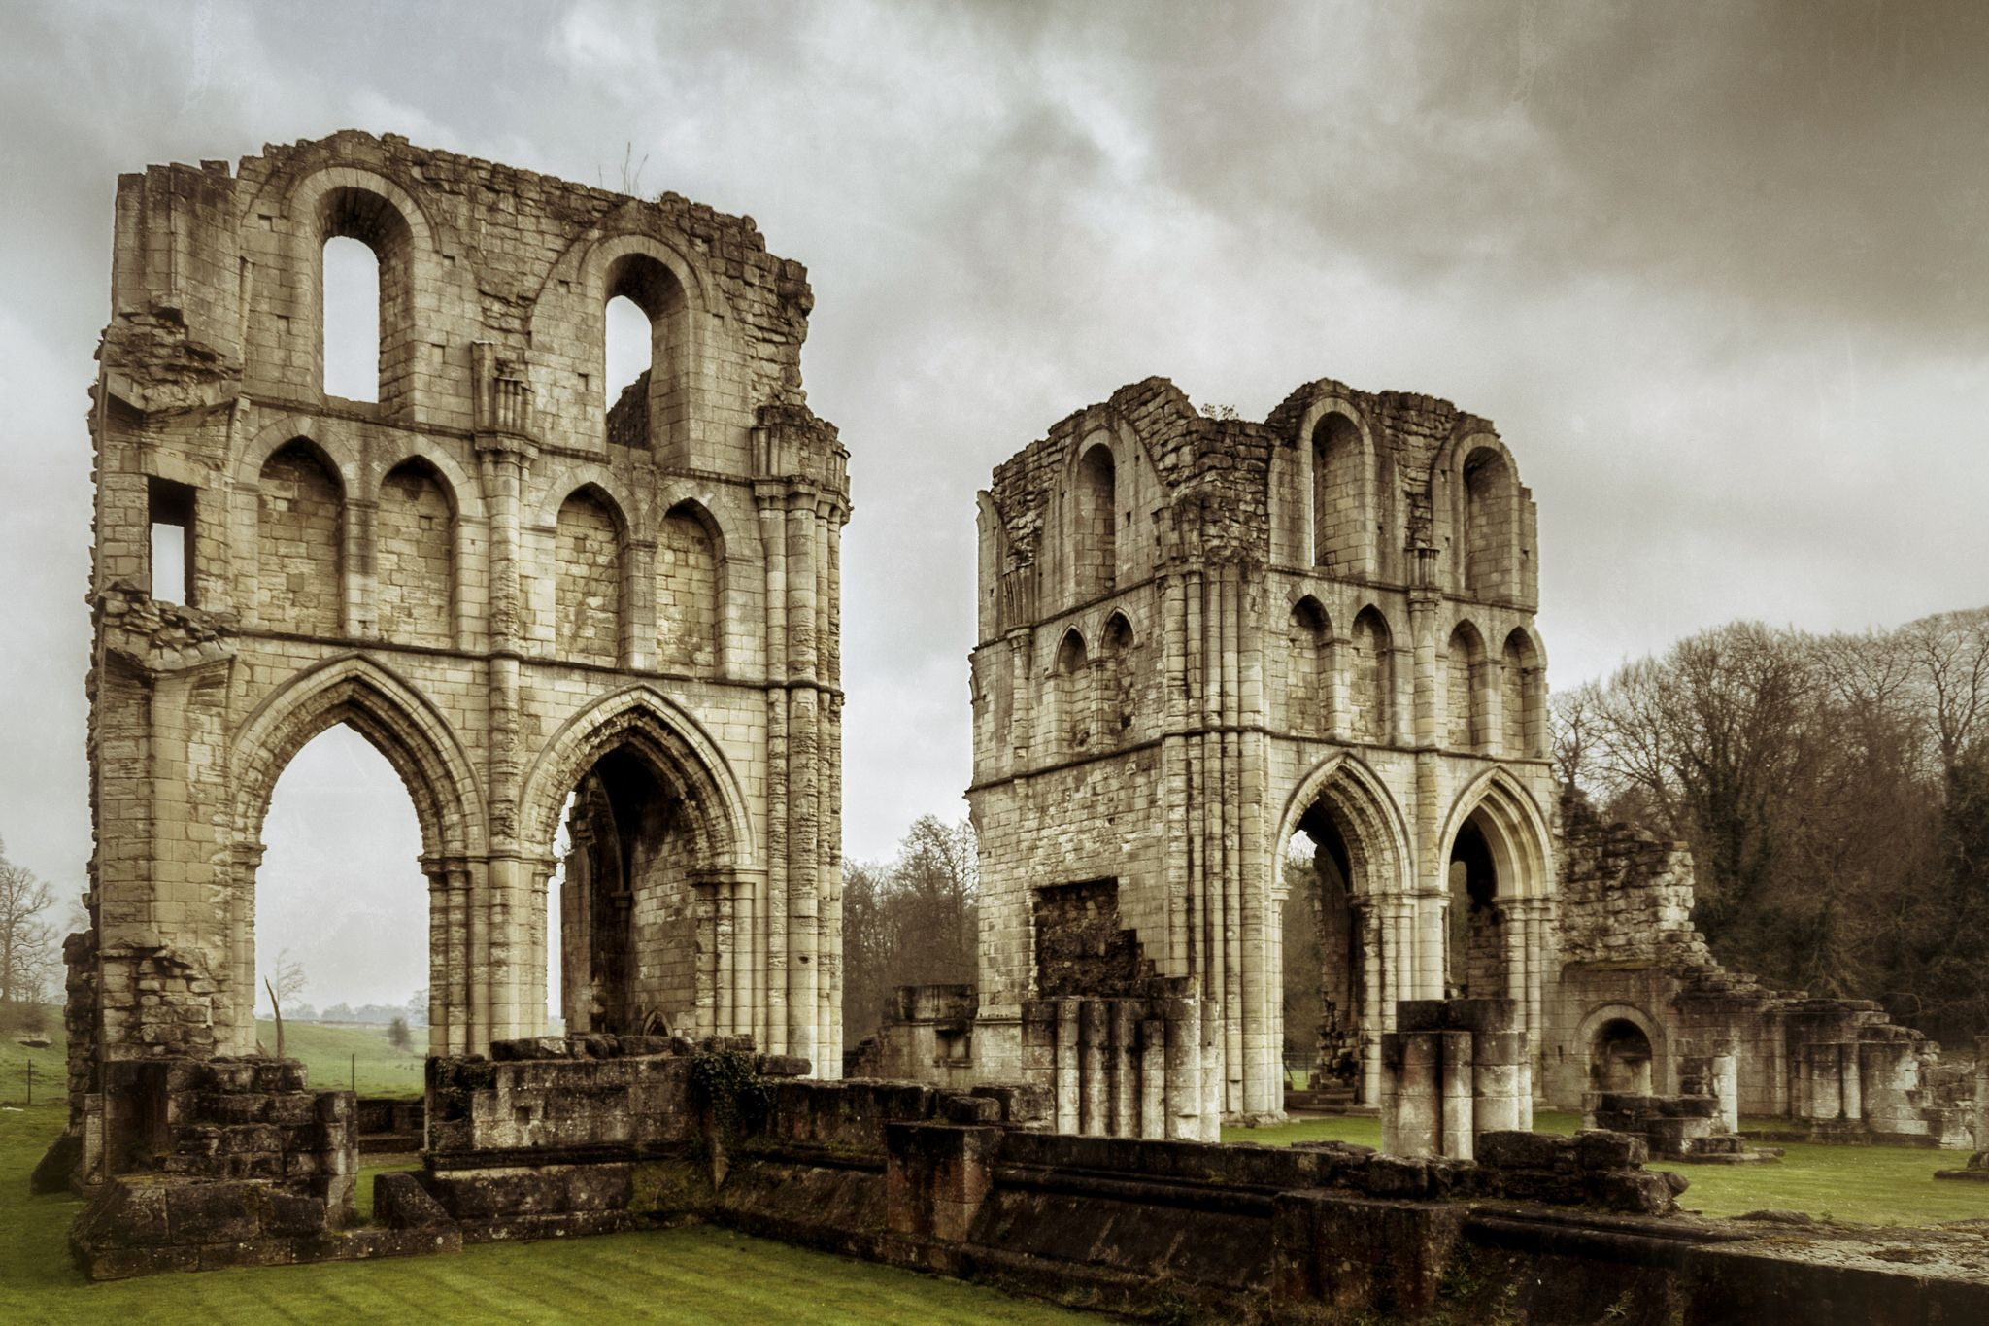
Fig 1. Remains of Eastern end of the abbey church (www.bing.com)

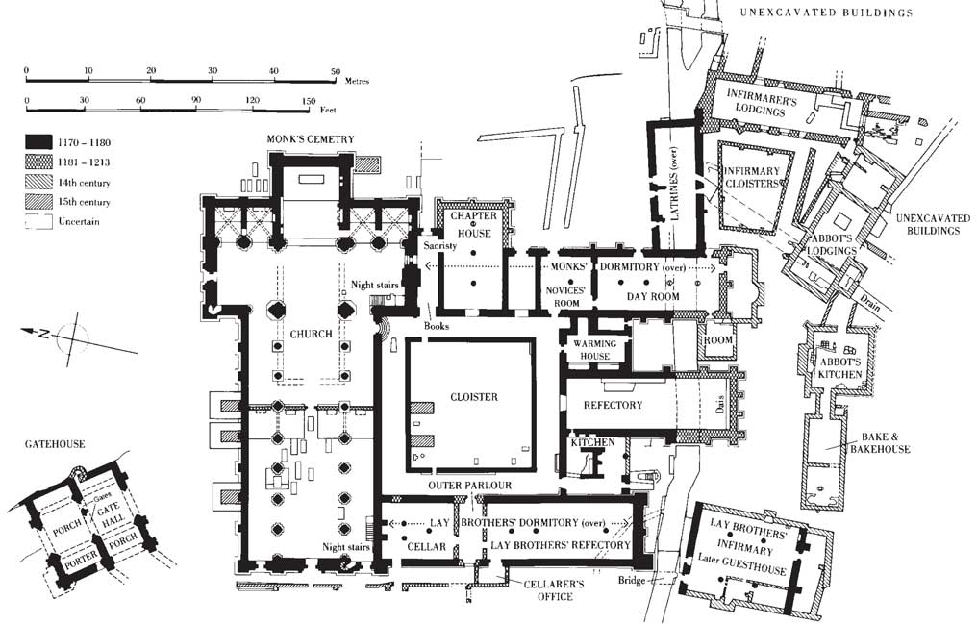

Fig 2. Ground plan of Roche Abbey (www.bing.com)

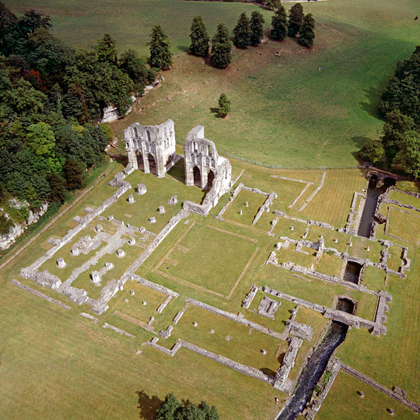
Fig 3. Aerial photograph of Roche Abbey (www.bing.com).

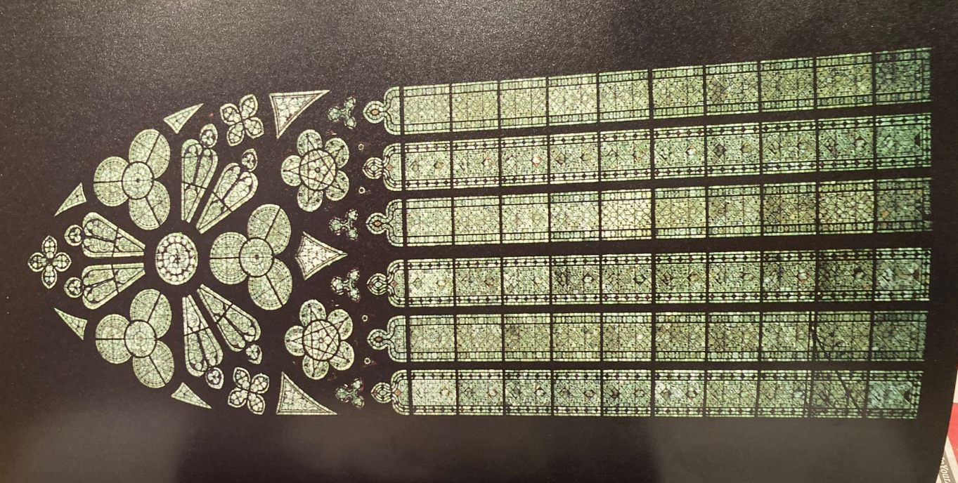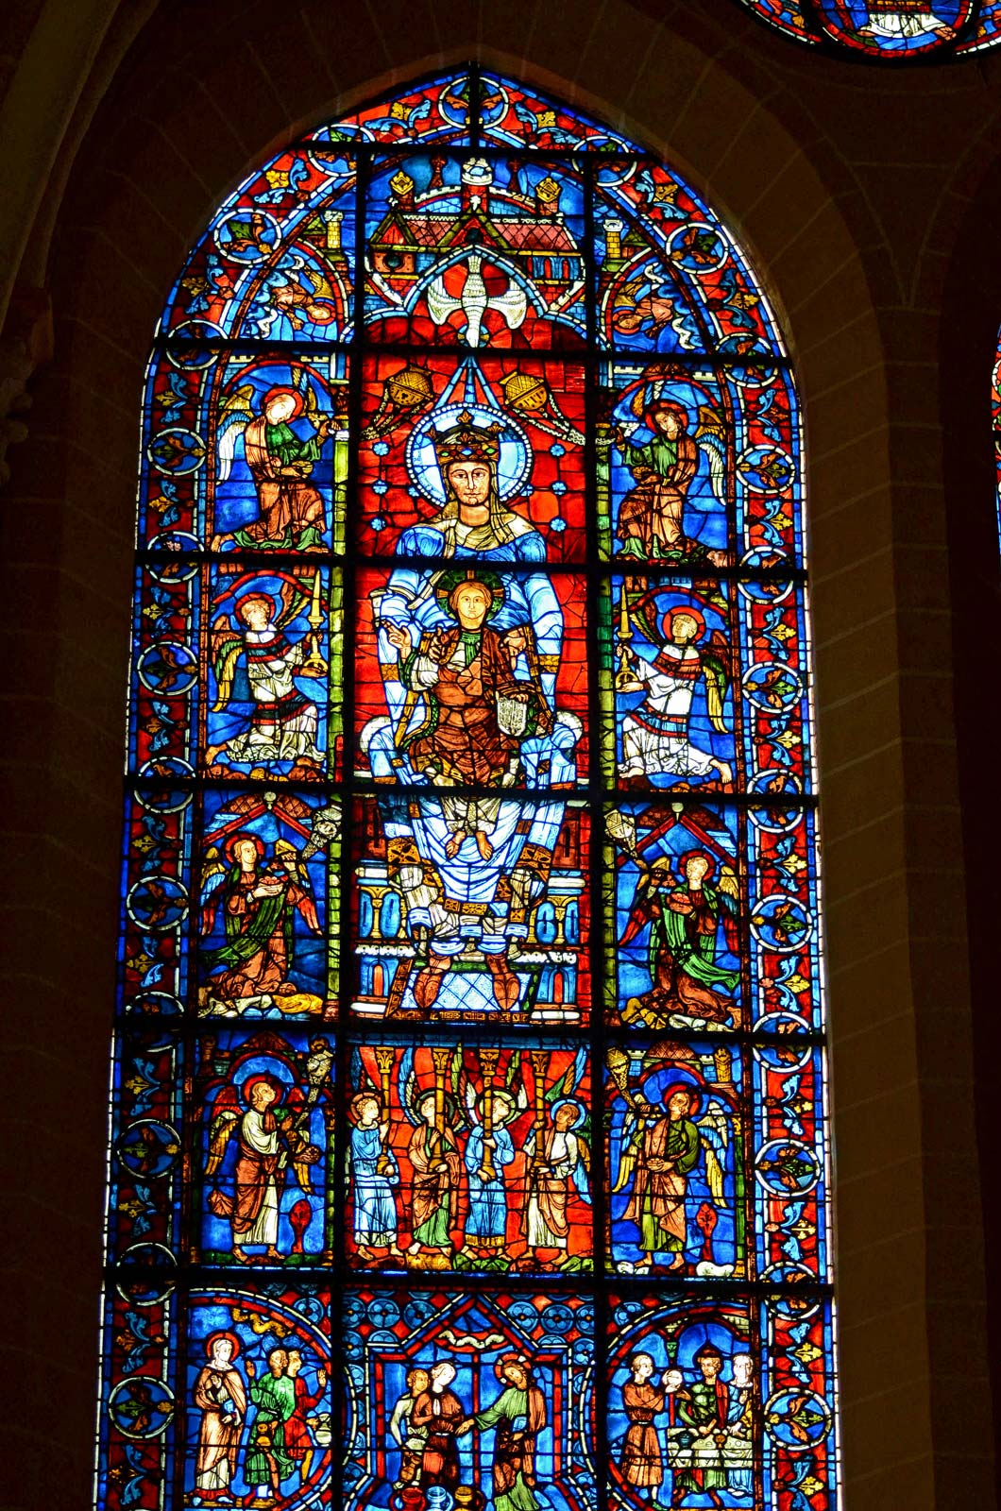
Fig 4. Grisaille glass Altenberg Abbey (Tobin) Fig 5. Stained Glass at Chartres Cathedral (www.bing.com)

Bibliography

Berman, C, H. The Cistercian Evolution. University of Pennsylvania Press. 2000
Bruun, M, B. The Cambridge Companion to the Cistercian Order. Cambridge University Press. 2013
Burton, J and Kerr, J. The Cistercians in the Middle Ages. Boydell and Brewer. 2011
Coppack, G. The White Monks. The Cistercians in Britain 1128-1540. Tempus. 2005
Dunn, M. The Emergence of Monasticism. From the Desert Fathers to the Early Middle Ages. Blackwell Publishers Limited. 2003
English Heritage. https://www.english-heritage.org.uk/visit/places/roche-abbey
(accessed 10/12/21)
Fry, T. The Rule of St. Benedict. The Liturgical Press. 1982
Jamroziak, E. The Cistercian Order in medieval Europe 1090-1500. Routledge. 2013
Lawrence, C, H. Medieval Monasticism. Longman. 2001
Leroux-Dhuys, J. Cistercian Abbeys. History and Architectural. Konemann. 1998
Tobin, S. The Cistercians. Monks and Monasteries of Europe. The Herbert Press. 1995
Stalley, R. Early medieval Architecture. Oxford University Press. 1999

English Heritage https://www.english-heritage.org.uk/visit/places/roche-abbey
ibid
Burton, J and Kerr, J. The Cistercians in the Middle Ages. The Boydell Press. 2011. p.56
Freeman, E. Narratives of a New Order: Cistercian Historical Writing in England, 1150-1220. Turnout. 2002. pp.141-2 quoted in Burton and Kerr p.56
Burton and Kerr. P.56
Bernard of Clairvaux quoted in Burton and Kerr p.56
ibid
Burton and Kerr. P.56
Tobin, S. The Cistercians. Monks and Monasteries of Europe. The Herbert Press. 1995 p.107.
Burton and Kerr. P.56
English Heritage
ibid
Bruun, M and Jamroziak, E in The Cambridge Companion to the Cistercian Order. Cambridge University Press. 2013. p.10.
Burton and Kerr p.151
Ibid. p.152
English Heritage
ibid
Tobin. P.78
Stalley, R. Early Medieval Architecture. Oxford History of Art. Oxford University Press. 1999. P.177
Ibid p.180
Bernard of Clairvaux quoted from Leroux-Dhuys. Cistercian Abbeys. History and Architecture. Konemann. 1998
Stalley.p.177
Bruun. p.160

