

University of Wales Trinity Saint David

ACCA5034

Data Security and Compliance
Research and Case Scenario in Data Security and Compliance

Student Name: | Dharar Ahmad Ahmad Morshid
Student ID: | 2411713
Programme: | Computing Portfolio
Module: | Data Security and Compliance
Lecturer: | Dr Mohamed Ben Farah
Submission Deadline: | 31st March 2026, 14:00
Word Count: | 5000 WORDS
Email: | 2411713@student.uwtsd.ac.uk

Task 1:
Abstract—
The rapid evolution of cloud computing, hybrid work environments, and advanced persistent cyber threats has rendered traditional perimeter-based security models increasingly ineffective. The Zero Trust Architecture has emerged as a modern cybersecurity framework designed to eliminate implicit trust within networks by enforcing strict identity verification and continuous access control. This paper critically analyses the principles underpinning Zero Trust Architecture, evaluates its implementation challenges, and compares its effectiveness with traditional security models. Furthermore, it explores how modern organisations can create cybersecurity environments capable of anticipating, protecting against, -detecting, and automatically responding to threats. The analysis draws upon industry frameworks such as NIST SP 800-207 and contemporary cybersecurity research to assess the practical efficacy of Zero Trust. While Zero Trust Architecture significantly enhances resilience in distributed and cloud-based environments, its success depends on strategic integration, governance alignment, automation, and organizational culture. The paper concludes that Zero Trust is not merely a technical model but a comprehensive security philosophy requiring continuous evolution.
Zero trust (ZT) is the term for an evolving set of cybersecurity paradigms that move defenses from static, network- based perimeters to focus on users, assets, and resources. A zero-trust architecture (ZTA) uses zero-trust principles to plan industrial and enterprise infrastructure and workflows. Zero trust assumes there is no implicit trust granted to assets or user accounts based solely on their physical or network location (local area networks versus the internet) or based on asset ownership (enterprise-or-personally-owned). Authentication and authorisation (both subject and device) are discrete functions performed before a session to an enterprise resource is established. Zero trust is a response to enterprise network trends that include remote users, bring your own device (BYOD), and cloud- based assets that are not located within an enterprise-owned network boundary. Zero trust focuses on protecting resources (assets, services, workflows, network accounts, etc.), not network segments, as the network location is no longer seen as the prime component to the security posture of the resource. This document contains an abstract definition of zero trust architecture (ZTA) and gives general deployment models and use cases where zero trust could improve an enterprise's overall information technology security posture.[1] [2]
Introduction
The cybersecurity landscape has transformed dramatically over the past decade. Organisations now operate within distributed environments that include cloud platforms, mobile devices, remote employees, and third-party service providers. Traditional perimeter-based security models were designed for centralised networks where internal users were considered trustworthy once authenticated. However, high-profile breaches and ransomware attacks have demonstrated that attackers often gain access through compromised credentials or insider threats, bypassing perimeter defences
The increasing sophistication of cyberattacks has exposed the weaknesses of implicit trust models. As a result, Zero Trust Architecture has gained prominence as a security paradigm that assumes no user or device should be trusted by default, regardless of network location. Instead, access decisions are continuously evaluated based on identity, context, device health, and risk posture.
This paper critically examines Zero Trust Architecture by analysing its core principles, implementation challenges, and practical effectiveness compared to traditional security frameworks. Additionally, it evaluates how Zero Trust enables organizations to anticipate, protect, detect, and automatically respond to threats in an increasingly complex threat environment.
While traditional security models assume everything in an organization’s network is trustworthy, Zero Trust security architecture authenticates every user and device before they can access resources—whether they’re located within or outside the corporate network.[3]

3. How Zero Trust architecture works.
Traditional security architecture allows users to access the entire corporate network once they’ve signed in at work. While this approach protects an organisation’s perimeter, it is tied to the physical office premises and does not support remote or hybrid work. Plus, traditional security frameworks expose businesses to risk because if someone steals a password, they can access everything.
Instead of only guarding an organisation’s perimeter, Zero Trust network architecture protects all your files, emails, and data by regularly authenticating each user and device. ZTA also helps secure remote access, personal devices, and third-party apps to provide greater flexibility, facilitate remote work, and support bring-your-own-device (BYOD) business models.
Zero Trust combines various authentication, network monitoring, encryption, and access control techniques to comprehensively strengthen your security posture. [4] [5]
- Authentication-and-authorization
All users and devices are authenticated and authorized before accessing resources. Zero Trust network access often involves multi-factor authentication and role-based access control.
Authentication:
Authentication is the process of checking who a user is.
It confirms a person’s identity before allowing them into a system.
Ex:
Entering a username and password.
Scanning fingerprint.
Using Face ID.
Entering a One-Time Code.

Authorization:
Authorization happens after authentication.
It determines what the user is allowed to do inside the system.
A student can view grades but cannot edit them
An admin can add or remove users
A guest can only read files but cannot delete them
Authentication | Authorization
Proves identity | Defines permissions
Happens first | Happens-after authentication
Uses-passwords, biometrics, OTP | Uses access rules, roles

- Network monitoring and analytics
Network traffic and user behaviors are continuously monitored to detect anomalies, suspicious activity, and potential threats.
Network monitoring:
is the process of continuously observing a computer network to ensure everything is working correctly.
Network monitoring can check:
Device status,
Network traffic,
Performance,
Security alerts,
Failures or outages.
Analytics:
Network Analytics is the process of collecting, analysing, and understanding network data to make smarter decisions.
Analytics can show,
Which applications use the most bandwidth
Unusual behaviour that might indicate a cyberattack
Long-term performance issues
User activity patterns
Predicting future network needs
- End-to-end encryption
Business data across your business is protected to ensure that even if data is intercepted, it cannot be read by unauthorized parties.
End-to-End Encryption (E2EE) is a security method where only the sender and the receiver can read the message.
How it Works
When you send a message, your device encrypts it using a secret key.
The encrypted message travels across the network as unreadable scrambled data.
Only the recipient’s device has the matching key to decrypt it.
Anyone who intercepts the message sees only gibberish.
Benefit | Meaning
Confidentiality | Only sender and receiver can read data
Security | Strong-protection-from cyberattacks
Integrity | Data cannot be modified without detection
Privacy | Companies cannot spy on users

- Access control mechanisms.
Access to resources is determined by the identity of the user and device, in addition to other contextual factors such as location and behavior.
Access control protects:
- Data
- Files
- Systems
- Networks
- Applications
4. Evolution from Traditional Security Models
Traditional cybersecurity models rely heavily on perimeter defences such as firewalls, intrusion detection systems (IDS), and virtual private networks (VPNs). These systems operate under the assumption that once a user is inside the network boundary, they can be trusted. This “castle-and-moat” model prioritizes strong external defences while providing relatively broad internal access.
However, this model presents significant vulnerabilities:
- Compromised credentials allow attackers to move laterally within networks.
- VPNs extend the network perimeter to remote devices.
- Insider threats bypass external defences.
- Cloud services reduce the relevance of a physical network boundary.
The collapse of clearly defined perimeters has fundamentally challenged the effectiveness of traditional models. As organizations adopt multi-cloud infrastructures and hybrid work environments, trust based on network location becomes increasingly obsolete.
Zero Trust Architecture emerged as a response to these limitations. Rather than defending a perimeter, Zero Trust focuses on protecting individual resources through continuous authentication and granular access control.[6]

5. Principles of Zero Trust Architecture
Zero Trust Architecture is guided by several foundational principles outlined in frameworks such as NIST SP 800-207 [7]
A. Never Trust, Always Verify
Zero Trust eliminates implicit trust. Every access request must be authenticated and authorized, regardless of whether it originates inside or outside the network. Identity verification mechanisms such as multi-factor authentication (MFA) play a central role in this process.
B. Least Privilege Access
Users and systems are granted the minimum access required to perform their tasks. This principle reduces the potential damage caused by compromised accounts and limits lateral movement within networks.
C. Micro-Segmentation
Micro-segmentation divides networks into smaller, isolated zones. Even if one segment is compromised, attackers cannot easily access other segments. This strategy significantly reduces the attack surface.
D. Continuous Monitoring and Validation
Access decisions are dynamic and context aware. Device posture, behavioural analytics, geographic location, and time of access are continuously evaluated. Risk-based authentication ensures that suspicious activities trigger additional verification.
E. Data-Centric Security
Zero Trust shifts focus from network protection to data protection. Encryption, classification, and Data Loss Prevention (DLP) mechanisms ensure sensitive information remains secure.
Together, these principles form a comprehensive framework designed to address modern cyber threats proactively rather than reactively.
6. Creating an Environment that Anticipates, Protects, Detects, and Responds
A modern cybersecurity framework must address threats across four critical dimensions: anticipation, protection, detection, and response.[8]
A. Anticipation of Threats
Zero Trust assumes breach as a fundamental premise.
By adopting this mindset, organizations proactively prepare for potential compromise scenarios. Risk assessment models, behavioural analytics, and identity governance systems help anticipate anomalous activities before significant damage occurs.
Predictive analytics and machine learning models enhance anticipation capabilities by identifying patterns associated with credential misuse or insider threats [4].
B. Protection Mechanisms
Protection in Zero Trust relies heavily on strong identity management systems. Key mechanisms include:
- Multi-factor authentication (MFA)
- Role-based access control (RBAC)
- Device compliance checks
- Encryption of data in transit and at rest
- Secure Access Service Edge (SASE) integration
These controls prevent unauthorized access and ensure that only verified users interact with sensitive systems.
C. Detection of Anomalies
Continuous monitoring is central to Zero Trust. Security Information and Event Management (SIEM) systems aggregate logs from endpoints, servers, and cloud services to detect suspicious patterns. User and Entity Behaviour Analytics (UEBA) identify deviations from normal behaviour.
Unlike traditional models, where detection often occurs after a breach, Zero Trust emphasizes real-time anomaly detection to minimize dwell time.[8]
D. Automated Response
Automation is essential for rapid incident containment. Integration with Security Orchestration, Automation, and Response (SOAR) platforms enables automated actions such as:
- Revoking compromised credentials
- Isolating infected endpoints
- Blocking suspicious IP addresses
- Enforcing step-up authentication
Automation reduces reliance on manual intervention and accelerates response times, limiting the impact of attacks.
7. Key Organisational and Technical Constraints of Zero Trust Implementation
A. Legacy Infrastructure Constraints
Many organizations rely on legacy systems that lack support for modern authentication protocols or API integrations. Retrofitting these systems into a Zero Trust framework can be technically complex and costly.
B. Financial Investment
Zero Trust requires investment in identity and access management (IAM), endpoint detection and response (EDR), cloud security tools, and monitoring platforms. Smaller organizations may struggle to allocate sufficient resources.
C. Organizational Resistance
Stricter authentication policies may be perceived as inconvenient by employees. Cultural resistance can hinder adoption, especially if usability concerns are not addressed.
D. Integration Complexity
Modern enterprises operate across hybrid environments, including on-premises infrastructure, public cloud services, and SaaS applications. Integrating these components into a cohesive Zero Trust model demands careful architectural planning.
E. Over-Reliance on Technology
Zero Trust is not a single product but a strategic framework. Organizations that implement isolated tools without aligning governance policies risk fragmented security practices.
8. Comparative Analysis: Zero Trust vs. Traditional Models
When comparing Zero Trust with traditional perimeter-based security, several distinctions emerge.
Traditional models remain useful for external perimeter defence, but they lack granular internal controls. Zero Trust enhances resilience by focusing on identity and contextual risk rather than physical boundaries.
However, Zero Trust may introduce performance overhead due to continuous verification processes. Balancing security with usability remains a critical challenge.
9.Compliance-and-Governance Implications
Zero Trust Architecture supports regulatory compliance frameworks such as GDPR, HIPAA, and ISO 27001. Its emphasis on least privilege access and data minimization aligns with data protection principles.
Furthermore, audit logging and continuous monitoring enhance transparency and accountability. Regulatory bodies increasingly recommend Zero Trust principles as part of cybersecurity resilience strategies
However, compliance does not guarantee security. Organisations must ensure that governance frameworks are integrated into Zero Trust implementation strategies rather than treated as separate initiatives.
10. Critical Evaluation
Zero Trust Architecture represents a paradigm shift in cybersecurity thinking. Its strengths include enhanced visibility, reduced attack surfaces, and improved incident response capabilities. In hybrid and cloud-based environments, it significantly outperforms traditional perimeter defenses.
Nevertheless, Zero Trust is not a universal solution. Without proper planning, phased implementation, and cultural adaptation, organizations may experience operational disruptions. Additionally, overemphasis on identity controls without robust endpoint security may leave residual vulnerabilities.
A mature Zero Trust strategy requires:
- Executive leadership support
- Continuous risk assessment
- Automation and AI integration
- Employee awareness and training
- Strong governance frameworks
Zero Trust should therefore be viewed as an evolving strategy rather than a fixed endpoint.
11. Conclusion
Zero Trust Architecture addresses the fundamental weaknesses of traditional perimeter-based security
models by eliminating implicit trust and enforcing continuous verification. In an era defined by hybrid work, cloud computing, and sophisticated cyber threats, Zero Trust provides a proactive and adaptive framework capable of anticipating, protecting against, detecting, and responding to threats.
While implementation challenges exist—including cost, integration complexity, and cultural resistance—the long-term benefits outweigh these obstacles. Zero Trust enhances organizational resilience, supports regulatory compliance, and reduces the risk of catastrophic breaches.
Ultimately, Zero Trust is not merely a technical architecture but a comprehensive security philosophy. Organizations that adopt it strategically and integrate it with governance, automation, and risk management practices will be better positioned to navigate the evolving cybersecurity landscape
REFRANCES
- Rose, S., Borchert, O., Kerman, A., Souppaya, M., & collaborators. (2025). Implementing a Zero Trust Architecture (NIST Special Publication 1800-35). National Institute of Standards and Technology.
- Kindervag, J. (2021). Build Security into Your Network’s DNA: The Zero Trust Network Architecture.
- Rahimi, N., & Jones, H. (2025). Cyber Warfare: Strategies, impacts, and future directions in the digital battlefield. Journal of Information Security, 16(2), 252–269.
- Chicovis, L. (2026) Zero Trust Architecture: What It Changes in Practice. Bix-Tech.
Available at: https://bix-tech.com/zero-trust-architecture-what-it-changes-in-practice-and-how-to-implement-it-without-the-hype/
- GGI Insights (2026) Zero Trust Security Architecture: 2026 Implementation Guide.
Available at: https://www.graygroupintl.com/blog/zero-trust-security-architecture/
- Mettu, B.P.R. (2025) Beyond the Perimeter: A Comparative Analysis of Zero Trust Framework Implementations in Hybrid Enterprise Environments. European Journal of Computer Science and Information Technology,
- Gururaj, H. L., Spoorthi, M., Ravi, V., Shreyas, J., & Roy, K. S. (2024). Securing the Future: Introduction to Zero Trust in Cybersecurity. Springer.
- Staggs, J., & Shenoi, S. (Eds.). Critical Infrastructure Protection XVI. Cham, Switzerland: Springer, 2022.
- Zero Trust Architecture: A Systematic Literature Review, M. L. Gambo and A. Almulhem, 2025
- Cybersecurity, ver. 1.1, 2018. [Online]. Available: https://nvlpubs.nist.gov/nistpubs/CSWP/NIST.CSWP.04162018.pdf
- Jason Andress and Jerry Chapman, Zero Trust Security: An Enterprise Guide. Berkeley, CA, USA: Apress, 2021.

Task 2: Zero-Trust-Aligned Security Programme for MediTrust Analytics Ltd

2.1 Introduction
MediTrust Analytics Ltd has a unique position with regards to the integration of artificial intelligence and the healthcare sector. Its clinical decision support system, hosted on the cloud, provides services to hospitals and private healthcare providers in various countries. While expanding to European countries, the company has to comply with the General Data Protection Regulation (GDPR) [5]; Digital Operational Resilience Act (DORA) [3]; and Network and Information Systems Directive 2 (NIS2) [4].

Q: Organization Structure: Design a structure that includes a Cloud Security Architect and a DevSecOps Lead role?

2.2 Organizational Structure
Considering the company is undergoing advanced AI product development pipeline, appointing a DevSecOps Lead is vital. This role will embed security concerns directly into the CI/CD processes, thereby expressing the ZTA principle of ‘never trust, always verify’ for every step of the software development lifecycle, including the safeguarding of AI training data and source code repository supply chain code. [1].

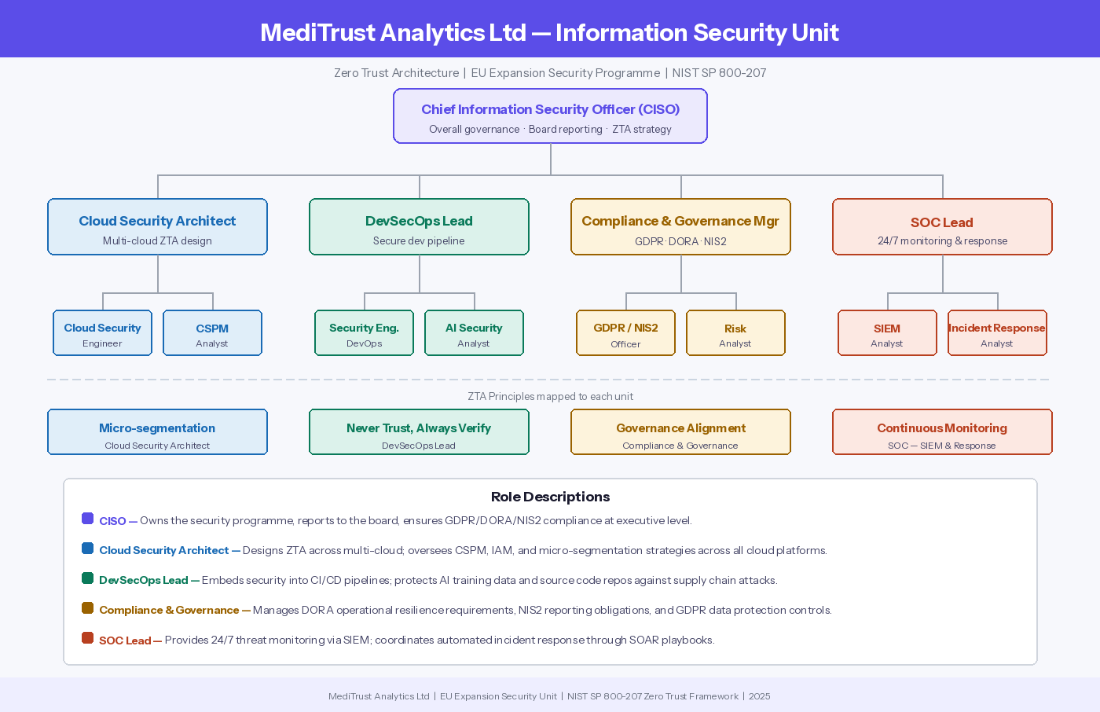
Figure 1: MediTrust Analytics Ltd Information Security Unit

Q: Policies & Procedures: Develop policies for AI Usage, Secure SaaS Configuration, and BYOD for a hybrid workforce?

2.3 Policies and Procedures
To maintain effective security governance, policies must be created that put the Zero Trust Architecture into actionable policies. The following three policies have been developed specifically for MediTrust's hybrid, cloud-native environment and based on the ZTA principles of least privilege access, continuous verification, and data-centric security outlined in Task 1. [6]

2.3.1 AI Usage Policy
Purpose: To govern the secure development, deployment, and use of artificial intelligence systems, ensuring the integrity of AI training data and ethical use of AI-generated clinical outputs.
Key Requirements:
- All AI datasets that are used for training and contain patient data must be classified, and encrypted with AES-256, and stored in isolated environments that are accessible only through access controls with no public endpoints.
- Access to AI training data must be in compliance with ZTA least privilege requirements, whereby access to datasets is governed by, and compliance confirmed via, Role-Based Access Control and phishing resistant Multi-Factor Authentication.
- Third-party AI tools are to be evaluated for supply chain risk, including assessment of model provenance and integrity of dependencies, as per NIST SP 800-207 guidelines.
- Utilization of external AI platforms for patient data is a violation of this policy; the use of any Generative AI tools requires prior approval and must be documented.
ZTA Justification: This policy incorporates ZTA’s data-centric security and least privilege strategies. Per Task 1, AI systems are considered an especially lucrative target for supply chain attacks including model poisoning [6].

2.3.2 Secure SaaS Configuration Policy
Purpose: To ensure all SaaS platforms are configured securely, minimising the risk of data exposure through misconfiguration or unauthorised access.
Key Requirements:
- All SaaS platforms must undergo a formal procurement security review assessing data residency, encryption standards, and GDPR compliance before deployment.
- Default administrative credentials must be changed immediately upon provisioning; all admin accounts require phishing-resistant MFA and privileged access management (PAM) controls.
- CSPM tooling must continuously scan all SaaS environments for misconfigurations, with critical findings remediated within 24 hours.
- SaaS platform access logs must be ingested into MediTrust's SIEM for continuous monitoring and anomaly detection.
ZTA Justification: This policy implements ZTA’s micro-segmentation and real-time monitoring principles. The traditional perimeter model considers SaaS solutions within the perimeter to be safe and secure — ZTA does not [1].

2.3.3 BYOD Policy
Purpose: To define security requirements for personal devices accessing MediTrust systems, ensuring hybrid workforce devices do not introduce unmanaged risk.
Key Requirements:
- Personal devices may only be accessed once they have been enrolled in the Mobile Device Management (MDM) system; unregistered devices are restricted by default, illustrating ZTA’s ‘never trust, always verify’ principle.
- Registered devices must have their baseline security standards updated and include full-disk encryption, an active EDR agent, and screen locking via biometrics or 6-digit PIN.
- Personal devices must connect only through Zero Trust Network Access (ZTNA) — traditional VPNs are not allowed, in line with ZTA principles in Task 1 [2].
ZTA Justification: The BYOD policy incorporates ZTA's ongoing validation and compliance verification checks for devices. As Task 1 pointed out, BYOD settings remarkably increase the attack surface outside the corporate perimeter [6].

2.4 Compliance: DORA and NIS2
DORA Compliance: Regulation DORA grants MediTrust the right to implement an enterprise-wide ICT risk management policy, and to perform ongoing and comprehensive ICT provider resilience assessments, including multi-cloud vendors. This ZTA programme meets these specific needs.
NIS2 Compliance: Under NIS2, MediTrust is recognized as critical in the field of healthcare, which also entails stringent requirements for incident reporting: an early warning must be submitted within 24 hours of a major incident, with a full report due within 72 hours [4].

Table 1: Regulatory Compliance Mapping
Table 1: DORA, NIS2, and GDPR compliance requirements mapped to ZTA controls and responsible roles
Regulation | Requirement | ZTA Control | Responsible Role | Implementation
DORA | ICT risk management framework | CSPM + SIEM continuous scanning | Cloud Security Architect | Automated cloud risk monitoring and quarterly audits
DORA | Operational resilience testing | Penetration testing + DR exercises | DevSecOps Lead | Bi-annual DR testing with documented outcomes
DORA | Third-party ICT oversight | Supply chain risk assessment + vendor ZTA access | Compliance & Governance Mgr | Vendor access via ZTNA; annual third-party reviews
DORA | Major incident reporting | Automated SIEM incident classification | SOC Lead | SOAR-generated incident logs submitted to authority
NIS2 | 24-hour early warning | Real-time SIEM alerting | SOC Lead | Automated SOC notification within 1 hour of detection
NIS2 | 72-hour full incident report | SOAR-generated evidence logs | SOC Lead + CISO | Full report with root cause analysis within 72 hours
NIS2 | Board-level accountability | CISO direct board reporting | CISO | Quarterly board security briefings
NIS2 | Supply chain security | AI model provenance + vendor controls | DevSecOps Lead | SCA scanning at every CI/CD pipeline stage
GDPR | Patient data protection | DLP + AES-256 + least privilege | Cloud Security Architect | Data classification, encryption, and access controls
GDPR | Data breach notification | Automated breach detection via SIEM | SOC Lead + Compliance Mgr | 72-hour breach notification procedure documented

Q: Governance & Strategy: Propose a governance model based on the NIST Cybersecurity Framework (CSF) 2.0, explicitly linking security strategy to business goals?

2.5 Governance and Strategy: NIST CSF 2.0
GOVERN: Newly introduced in CSF 2.0, this function establishes cybersecurity as a strategic priority. For MediTrust, this is operationalized through the CISO's direct board reporting line, quarterly policy reviews, and risk appetite documentation owned by the Compliance and Governance Manager.
IDENTIFY: The Cloud Security Architect, along with the Risk Analyst, maintains and manages the comprehensive asset inventory and regular threat assessments, respectively, of protected IP and the continuity of services at MediTrust
PROTECT: Protection mechanisms are applied throughout the identity, data, and infrastructure layers using phishing-resistant MFA, RBAC, ZTNA, DLP, and AES-256 encryption.
RESPOND: The SOC Lead utilizes SOAR for automated response actions, such as containment, credential lockouts, and endpoint disconnection. [4].
RECOVER: The Recovery role ensures that essential services are re-established quickly after disruptions. The formal Disaster Recovery plan in Section 2.7 covers disrupted services by ransomware. Recovery actions are practiced as part of regular tabletop exercises to meet the requirements of DORA’s operational resilience [3].

Table 2: NIST CSF 2.0 Governance Mapping
Table 2: NIST CSF 2.0 functions mapped to MediTrust controls, responsible roles, and business goals
CSF 2.0 Function | MediTrust Control | Responsible Role | Business Goal | Regulatory Link
GOVERN | Board CISO reporting, quarterly policy reviews, risk appetite documentation | CISO + Compliance Mgr | Regulatory trust with EU partners | GDPR, DORA, NIS2
IDENTIFY | Multi-cloud asset inventory, AI data risk assessments, IoT device cataloguing | Cloud Security Architect + Risk Analyst | Protect IP and service continuity | DORA risk management
PROTECT | Phishing-resistant MFA, RBAC, ZTNA, DLP, AES-256, DevSecOps pipeline | DevSecOps Lead + Cloud Architect | Secure clinical AI product delivery | GDPR, NIS2
DETECT | SIEM monitoring, UEBA anomaly detection, CSPM misconfiguration scanning | SOC Lead + SIEM Analyst | Early threat detection, minimal dwell time | NIS2 24-hour reporting
RESPOND | SOAR automated playbooks, NIS2 24/72-hour reporting, credential revocation | SOC Lead + CISO | Regulatory compliance and continuity | NIS2, DORA
RECOVER | Disaster Recovery plan, ransomware response, DR testing exercises | DevSecOps Lead + SOC Lead | DORA operational resilience compliance | DORA resilience testing

Q: Risk Management: Conduct a high-level risk assessment focusing on software supply chain risks (e.g., poisoned AI models, vulnerable dependencies) and cloud misconfigurations.?

2.6 Risk Management
This document outlines a high-risk assessment outline concentrating on the two domains of the greatest concerns: the risk of cloud misconfiguration and the software supply chain.
Supply Chain Risks: MediTrust's AI products rely on training datasets supplied by clinical partners and third-party research organizations. As noted in Task 1, supply chain attacks, including model poisoning, pose an advanced threat vector [6].
Cloud Misconfiguration Risks: MediTrust's multi-cloud strategy creates a significant risk for misconfigurations. A study identified the primary risk factors for breaches of healthcare data as misconfigured cloud storage and over-permissive IAM configurations [10].

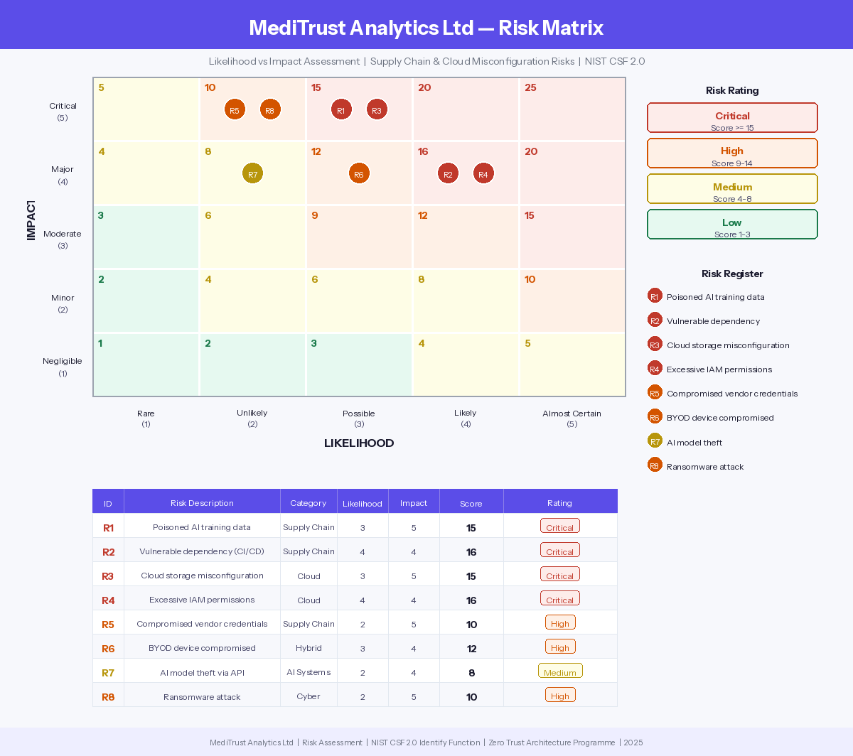
Figure 2: MediTrust Risk Matrix — Likelihood vs Impact Assessment (NIST CSF 2.0 Identify Function)

Table 3: MediTrust Risk Register — Supply chain and cloud misconfiguration risks with ZTA-aligned mitigations
ID | Risk Description | Category | Likelihood | Impact | Score | Rating | Mitigation
R1 | Poisoned AI training data | Supply Chain | 3 | 5 | 15 | Critical | AI model provenance verification; isolated training environments; third-party ZTNA only
R2 | Vulnerable dependency in CI/CD | Supply Chain | 4 | 4 | 16 | Critical | Automated SCA scanning; dependency pinning; SBOM generation
R3 | Cloud storage misconfiguration | Cloud | 3 | 5 | 15 | Critical | CSPM continuous scanning; no public endpoints; auto-remediation within 24hrs
R4 | Excessive IAM permissions | Cloud | 4 | 4 | 16 | Critical | Least privilege IAM; quarterly permission reviews; ZTA enforcement
R5 | Compromised vendor credentials | Supply Chain | 2 | 5 | 10 | High | Vendor ZTNA; PAM for admin accounts; phishing-resistant MFA
R6 | BYOD device compromised | Hybrid Workforce | 3 | 4 | 12 | High | MDM enrollment; EDR agent; ZTNA access; continuous device compliance
R7 | AI model theft via API | AI Systems | 2 | 4 | 8 | Medium | RBAC on endpoints; API rate limiting; UEBA anomaly detection
R8 | Ransomware attack | Cyber Attack | 2 | 5 | 10 | High | Immutable backups; DR plan (Section 2.7); micro-segmentation; EDR response

Contingency Planning: Outline a Disaster Recovery plan for a ransomware attack that encrypts their AI training data and source code repositories.?

2.7 Contingency Planning: Ransomware Disaster Recovery Plan
The following Disaster Recovery (DR) plan details MediTrust's organizational response, which is compliant with NIST CSF 2.0 Respond and Recover functions [1]
Phase 1 — Detection (0-1 Hour): Anomalous file encryption activity is detected by the SOC's SIEM, and UEBA alerts are generated. EDR agents cause affected endpoints to automatically initiate isolation.
Phase 2 — Containment (1-4 Hours): All privileged credentials are rotated and third-party ZTNA access is disabled. The DevSecOps Lead stops any ongoing CI/CD activities.
Phase 3 — Eradication (4-12 Hours): The attack vector is determined from forensic analysis performed by the DevSecOps Lead and the Cloud Security Architect.
Phase 4 — Recovery (12-48 Hours): AI training data is restored from immutable, air-gapped backups in a different geographic cloud region. Source code repositories are restored from signed snapshots.

Table 4: Ransomware DR Plan
Table 4: MediTrust Ransomware Disaster Recovery Plan
Phase | Timeframe | Key Actions | Responsible Role | Regulatory Link
Detection | 0-1 hour | SIEM alert triggered; EDR auto-isolates endpoints; SOAR activated; CISO notified within 30 mins | SOC Lead | NIS2 incident clock begins
Containment | 1-4 hours | Network micro-segmentation; credential rotation; ZTNA suspended; CI/CD halted; NIS2 early warning submitted | SOC Lead + DevSecOps Lead | NIS2 early warning due within 24hrs
Eradication | 4-12 hours | Forensic analysis; attack vector identified; malicious artefacts removed; environments rebuilt from clean IaC templates | DevSecOps Lead + Cloud Architect | DORA ICT incident documentation
Recovery | 12-48 hours | Restore from immutable backups; cryptographic hash verification; CSPM scan; hospital clients notified | Cloud Architect + DevSecOps Lead | DORA resilience evidence
Reporting & Review | 48-72 hours | Full NIS2 incident report submitted; root cause analysis; lessons learned; DR plan updated | CISO + All Security Leads | NIS2 full report due within 72hrs

Q: Contingency Planning: Outline a Disaster Recovery plan for a ransomware attack that encrypts their AI training data and source code repositories.

2.8 Protection Mechanisms
The first four controls are the main building blocks of the protective strategy.
Cloud Security Posture Management (CSPM): CSPM tools monitor all cloud environments to detect policy infractions and configurational changes, and track over-permissions in real-time.[3]
Security Information and Event Management (SIEM): MediTrust's SOC has a centralized SIEM platform that centralizes and correlates security logs of endpoints, cloud systems, clinical applications, and IoT patient monitoring devices. Using User and Entity Behavior Analytics (UEBA), the SIEM can recognize anomalous access patterns that indicate insider threats or compromised credentials. [4].
Endpoint Detection and Response (EDR) with Automated Response: MediTrust has deployed EDR agents on all managed devices and devices enrolled in BYOD. EDR detects in real-time any ransomware activities, lateral movements, or data access that aren’t authorised.
Phishing-Resistant Multi-Factor Authentication (MFA): Phishing and SIM-swapping are still possible with traditional MFA approaches. MediTrust utilizes phishing-resistant MFA, with aided FIDO2/WebAuthn standards and hardware security keys or device-bound passkeys. [2]

Table 5: Protection Mechanisms Summary
Table 5: Modern ZTA-aligned protection controls mapped to MediTrust applications and regulatory requirements
Control | Primary Function | ZTA Principle | MediTrust Application | Regulatory Support
CSPM | Continuous cloud configuration monitoring and auto-remediation | Micro-segmentation, Least Privilege | Scans all cloud environments; remediates R3/R4 risks within 24hrs | DORA ICT risk management
SIEM + UEBA | Real-time log aggregation and anomaly detection across all systems | Continuous Monitoring | Aggregates logs from endpoints, cloud, IoT; enables SOC triage | NIS2 24-hour reporting
EDR + SOAR | Endpoint threat detection and fully automated incident response | Automated Response, Never Trust | Auto-isolates endpoints; supports ransomware DR plan in Section 2.7 | DORA operational resilience
Phishing-Resistant MFA | FIDO2/WebAuthn cryptographic identity verification | Never Trust, Always Verify | Protects all accounts including third-party ZTNA access | GDPR access control requirements

2.9 Conclusion
This report has provided a detailed, Zero Trust aligned security program regarding MediTrust Analytics Ltd. expansion to the European Union (EU) healthcare market. Based on the key ZTA principles outlined in Task 1, such as never trust always verify, least privileged access, micro-segmentation, and continuous monitoring, the program provides the most comprehensive set of solutions for MediTrust's most prominent security issues, spanning across seven security domains: organizational, policies and procedures, compliance, governance, risk, and incident response and defense-in-depth.

References
[1] National Institute of Standards and Technology, "Cybersecurity Framework Version 2.0," NIST, Gaithersburg, MD, USA, Feb. 2024. [Online]. Available: https://doi.org/10.6028/NIST.CSWP.29
[2] Chandramouli, R., & Butcher, Z. (2023). Zero Trust Architecture Model for Access Control in Cloud-Native Applications in Multi-Location Environments (NIST Special Publication 800-207A). National Institute of Standards and Technology.
[3] European Parliament and Council of the European Union, "Regulation (EU) 2022/2554 on Digital Operational Resilience for the Financial Sector (DORA)," Official Journal of the European Union, Dec. 2022. [Online]. Available: https://eur-lex.europa.eu/legal-content/EN/TXT/?uri=CELEX:32022R2554
[4] European Parliament and Council of the European Union, "Directive (EU) 2022/2555 on Measures for a High Common Level of Cybersecurity Across the Union (NIS2)," Official Journal of the European Union, Dec. 2022. [Online]. Available: https://eur-lex.europa.eu/legal-content/EN/TXT/?uri=CELEX:32022L2555
[5] European Commission, Second Report on the Application of the General Data Protection Regulation (GDPR), 25 July 2024. [Online].
[6] B. P. R. Mettu, "Beyond the Perimeter: A Comparative Analysis of Zero Trust Framework Implementations in Hybrid Enterprise Environments," European Journal of Computer Science and Information Technology, 2025.
[7] J. Kindervag, "Build Security Into Your Network's DNA: The Zero Trust Network Architecture," Forrester Research, 2021.
[8] M. Souppaya and K. Scarfone, "Guide to Enterprise Patch Management Planning," NIST Special Publication 800-40 Rev. 4, National Institute of Standards and Technology, Apr. 2022. [Online]. Available: https://doi.org/10.6028/NIST.SP.800-40r4
[9] Brandao, P. (2025). Cybersecurity, Best Practices: A Comprehensive Guide. In Ethical and Social Impacts of ICT (LNCS 15939). Springer.
[link.springer.com]
[10] Cloud Security Alliance, "Security Guidance for Critical Areas of Focus in Cloud Computing v4.0," CSA, 2021. [Online]. Available: https://cloudsecurityalliance.org/research/guidance

