ACADEMIC AND EMPLOYABILITY SKILLS
BMSW 4001

Laura Pino 1915292

Lloyd Beharry

University of Wales Trinity Saint David

25/08/2020

TABLE OF CONTENTS

- Introduction ……………………………………………………. p. 3
- Reflective writing ……………………………………………… p. 3
2.1 Writing a Cover Letter……………………………………… p. 4
2.2 Paraphrasing………………………………………………… p. 5
2.3 Analytical and Critical Thinking……………………………. p. 6
2.4 Personal Development Plan…………………………………. p. 7
- Conclusion ……………………………………………………… p. 8
- References ……………………………………………………… p. 9
- Appendix ………………………………………………………. p. 10

- INTRODUCTION

This essay explains my personal experiences regarding the progress made during the past two academic terms; it highlights some difficulties that I have overcome as well as other obstacles that still exist.
I tried to stand back from the event and be honest and objective with the facts and it is my intention to use the model learned in the classroom, adapting it to the professional context in which I find myself operating at this moment in my life.
In this paper I will consider my own experiences, remodel them to the methods of Gibbs’ reflective cycle and contemplate this process when learning from this.
I started at the University of Trinity St. David two years after moving to London from the Italian island of Sardinia.
The idea of taking part in lessons that were taught in English and meeting new people in a similar situation both excited and frightened me at the same time.
Believing in myself has helped me stay positive when approaching the classes and lessons.
For example, when I started the first term in February, the lessons took place in the classroom and it was less challenging because eye contact made communication with the lecturers easy and we were able share our reactions through body language.
Thereafter, due to the Covid-19 global pandemic, the lessons moved online but because we had already met the teachers in person, it was relatively easy to continue following them via virtual lessons.
On the other hand, the second term started online, and I was taught by lecturers who knew nothing about me, so I had to work harder to make myself known remotely.

- REFLECTIVE WRITING

According to Cottrell (2008), the process of reflection starts from inspecting oneself and is also the ability to analyse and evaluate one’s experience and learn lessons from it. She also stresses the importance of examining the questions we ask ourselves about our experiences, so that we can understand what is significant for us and in order to use these inspected questions to deal with similar situations that could arise in the future.
Similarly, Gibbs (1988) affirms that through simple experiences one does not learn a priori, but one must follow a specific process to draw lessons from them.
For example, following one’s reflection cycle one is able to analyse their own experiences step by step and only through reflection of them, one can learn.
I structured the reflective writing following Gibbs’ thought in which he examines the experiences in six stages: description, feelings, evaluation, analysis, conclusion and action plan (University of Cumbria, 2020).
In the first phase of the description, you have to choose the experience you want to analyse and think about what happened. In the second phase we pause to think about our feelings and reactions that we experienced at that moment, subsequently, in phase three of the evaluation, we try to understand what went well and what went wrong. During the analysis we reorganise our experience by making sense of that situation, so that in the conclusion we can identify the reason for what went wrong. Finally, in the action plan we summarise what has been learned from the experience in order to apply it next time.

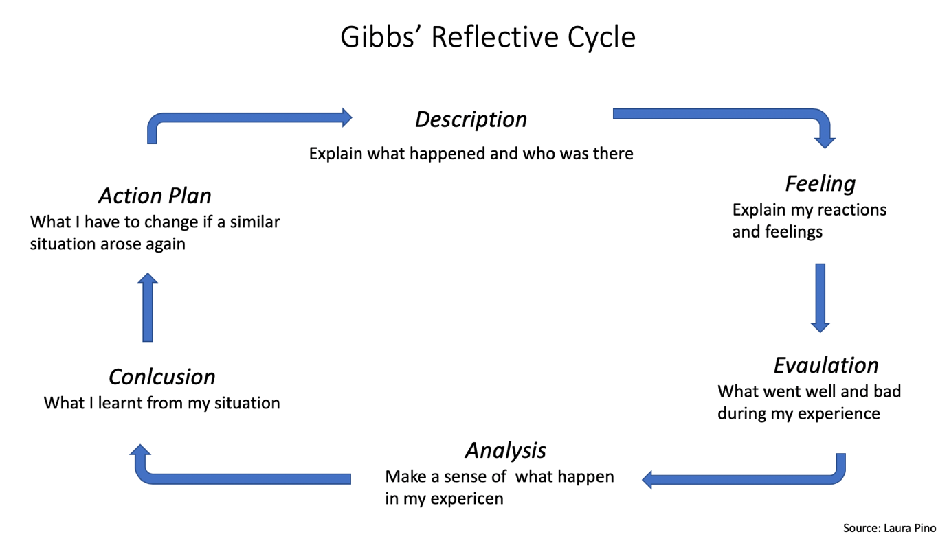

  - Writing a Cover Letter

During the third lesson of the second term, I learned how to write a cover letter. Whenever I had applied for a job position previously, I had composed and sent my curriculum vitae but the idea of a cover letter was new for me. In class we discussed this topic, the teacher then asked us to write an application for the position of an office manager for homework.
Once I had completed the task and sent to the teacher for review, he told me to remove the last phrase from my cover letter. I was asking the employer to keep me in consideration in the future, the person who recruits for an organisation doesn’t have time to reread applications, so I had to bear in mind that I was applying for the position immediately, and not in the future. For me this was an important lesson, because in doing this, I realised the significance of such a document; how having a coherent, presentable cover letter can be the difference between getting offered the job over someone else with the same qualifications and finally, I understood the importance of how I should approach it.
Consequently, I also learnt how to begin and end correspondence professionally, using the correct formulas ‘Mr/Mrs/Ms’ and ‘Sir/Madam’, with their respective and different ways of greeting: ‘Yours sincerely / Yours faithfully’.
These are ordinary notions that for many native English speakers seem basic or taken for granted, however, this was completely new information for me, and I found them interesting and useful to start and finish a cover letter or an email, for example, therefore, being aware of these notions is important for understanding how to approach them in a polite way.
Expressing oneself with a polite approach changes from culture to culture because it reflects the way of thinking and not only with the linguistic structure.
Learning is challenging and putting my knowledge into practice, as well as adapting through experience, has expanded my understanding of a new culture.
I will take this lesson onto all future exchanges in my professional life, paying attention to the form that a cover letter must have and to the polite approach that I will have to have, thus trying not to make the same mistake again.

  - Paraphrasing

In this reflective personal growth, the English language played an important role, as for me it remains a challenge and it was possible to see, for example, during the fifth week of term one when I addressed in class the topic of paraphrasing.
In order to write the final task, mastering the skill of paraphrasing is of fundamental importance because it avoids the plagiarism of the source to which it is referring. Moreover, to paraphrase you must have a good knowledge of English grammar, sentence structure and vocabulary in order to change the order of the sentence, search for synonyms and
modify the word classes like verbs into nouns, keeping the meaning unchanged.
I already knew how to paraphrase in Italian, but it was different and challenging having to do this in another language. At the beginning, it was difficult for me, however, by practising and doing exercises at home I improved my paraphrasing method and consequently I found it useful to complete my tasks.
In order to be able to evaluate the paraphrase sources, it is important to know how to select them first and understand what struck us about that particular paragraph, thus implementing a thought process.

2.3 Analytical and Critical Thinking

Cottrell (2011) defines the practise of critical thinking as not a simple and immediate process because it implies a constant cognitive activity linked to the use of the mind.
Critical thinking goes beyond memory, it shows itself in the ability to examine contents and argue them after evaluating through our own knowledge (Morgan, 2016), so I think that it must be kept in constant training, to be able to create a consequently logical argument and carefully analysed details.
I consider these affirmations important and basic to use logic and reasoning during a simple discussion between friends and in the school environment, so in my opinion, if the daily act of reflection does not take place, we can end up being superficial people.
During the sixth week in the second term, we discussed in class about analytical thinking and critical thinking. Personally, I found these topics interesting especially the analytical thinking because it was a process that I always carried out mechanically without ever thinking about. Therefore, when the lecturer asked if we knew the differences between these topics, I remember that nobody in my class expressed a thought because I think nobody recognised the difference.
I was very curious to know more about analytic thinking and it was also a discovery to put a name to that procedure. Therefore, I comprehended how the two processes were closely related to each other such as the analytical thinking can be considered as a phase preceding but also accompanying the critical one. For example, when I started this reflective writing, I first had to understand the meaning itself, then I went to reread the various topics on Moodle in order to organise, select and evaluate them, trying to start with a guideline that was drawn up with logic, finding the right order in arguing them.
This experience has taught me that every phase of our thinking, certainly, has a name that identifies it as such, and this situation will repeat again because there is always something to learn from in an experience and I am ready to welcome new notions in the future. Finally, if the information is evaluated, understood and sorted, it will be useful for formulating innovative and original solutions.

2.4 Personal Development Plan

The importance of practice in order to learn, implies the use of reflection, so one must selectively reflect on one’s own experiences and understand that they alone are not enough (Gibbs, 1988). In fact, on each experience we must ask ourselves what we could have changed or improved, so that we no longer repeat that particular error in order to learn a lesson from it. Therefore, in regard to this during the first week, of the first term, I had to analyse my situation by drawing a P.D.P. and this inevitably made me reflect on my life and work path. Initially, I was unsure and frightened, I thought I wouldn’t be able to answer my own questions because in my mind it was too specific and confusing.
For me, this process was new because I had not been thinking so deeply and in such detail about questions I had not thought of before. This practise strengthened my belief in myself and affirmed that I would find an answer for every question, indeed, I understood how to solve a specific work obstacle in concrete term, and I was able to focus on the hypothetical answers and solutions formed in my job.
It is essential to dwell and reflect on a difficulty we have experienced because if you don’t understand how to handle them in the future or where you have to change, there can be no room for improvement in the person.
In conclusion, the P.D.P. has served me to be ready to fill my working gaps and improve their performance, to then notice the benefits in the future in terms of results. Similar to Gibbs’ thinking, to learn from experiences, one has to reflect on them and if this process does not take place, the potential learn from experiences is lost.

- CONCLUSION

In conclusion, compared to the first term, I have changed the way I approach new topics and how I reflect upon.
At the beginning I was more unprepared and dubious, but as soon as I started doing the first exercise, I realised that the fear of not understanding also led me to be confused on basic arguments that I should have been clearer on from the start.
Then, I started working on homework well in advance and this helped me handle situations and especially containing stress because I felt more prepared and able to study without haste.
I hope this course trains me more to think deeply about my gaps and the work direction I want to take. It is also helping me to broaden my knowledge and I feel I have improved in analysing and focus on my unconscious questions and doubts.
Moreover, I hope the course helps me improve English in both the spoken and written language.
My final aspiration is to leave university more aware of myself and with a more enriched knowledge.
If you analyse experiences wisely, you can understand that there is always something to learn from the actions taken and from past situations.
Whenever we go back with our mind to rethink an event, we often think that we could have acted differently in that particular circumstance.
In future, we should continue to use this method of reflection as an opportunity to learn, to improve ourselves and be able to understand and admit when something is wrong.

- REFERENCES

Cottrell, S. (2011). ‘Critical Thinking Skills: Developing Effective Analysis and Argument’. 2nd edition. Basingstoke: Palgrave Macmillan.
Cottrell, S. (2008). ‘The Study Skills Handbook’. 3rd edition. Hampshire: Palgrave Macmillan.
Gibbs, G. (1988). ‘Learning by doing: A guide to Teaching and Learning Methods’. London: FEU.
Morgan, P. (2016). ‘The Business Student’s Guide to Study and Employability’. Sage Macmillan.
University of Cumbria, (2020). ‘Gibbs’ reflective cycle’. Available at: https://my.cumbria.ac.uk/media/MyCumbria/Documents/ReflectiveCycleGibbs.pdf
(Accessed: 13th August 2020).

- APPENDIX

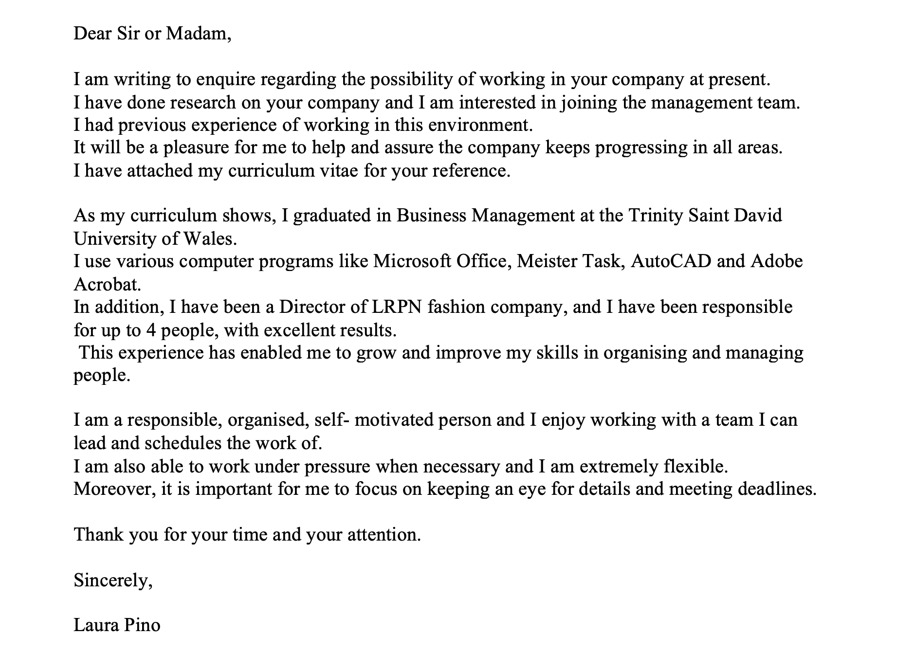
Exercise week three: Cover Letter- Task.

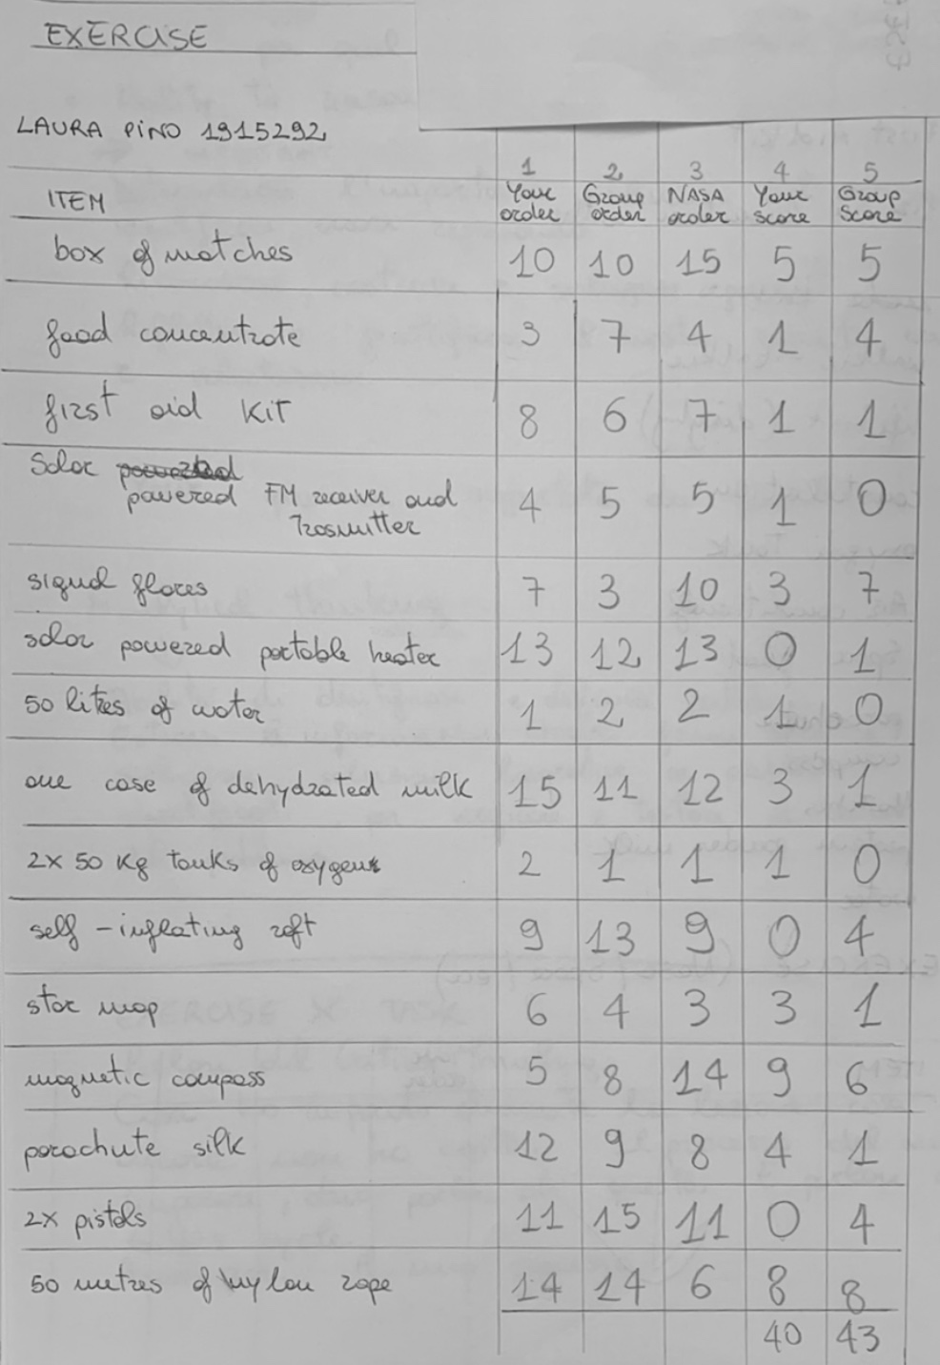
Exercise week six: Analytical and Critical Thinking- Task completed during lesson.

