Module Name: Digital Skills and Research Methods
Module code: BMSW4003_LON
Lecturer name: Asim Satti
Assignment task: 2

Student Name: Nevyana Nikolova
Student ID: 2111481

Virtual Learning Environment

Table of Contents

Ⅰ. Introduction to VLE 2
a. Synchronous learning 2
b. Asynchronous learning 2
Ⅱ. Main body 2
1. Impact of Distance Learning 2
2. Online learning platforms 3
2.1 Moodle 3
2.3 Google Classroom 3
3. Advantages of Distance learning 3
3.1 Flexibility 4
3.2 lower price 4
3.3 Commitment 4
4. Disadvantages of Distance Learning 4
4.1 Discipline problem 4
4.2 Technological barriers 5
4.3 Lack of live contact with the presenter and other participants 5
5. Challenges of Distance Learning 5
6. Future of Distance Learning 6
7. Methodology 6
7.1 Definition of Data collection 6
a. Primary data 6
b. Secondary data 6
7.2 Research 7
a. Qualitative research method 7
b. Quantitative research method 7
c. Mixed method 7
8. Questionnaire 7
8.1 VLE Survey 9
8.2 VLE CHART 10
8.3 Analysis of Questionnaire 11
Ⅲ. Conclusion 11
Ⅳ. References 12

Ⅰ. Introduction to VLE

Distance learning is any form in which the student is not physically present, conducted through online platforms, where teacher teachers or other participants participate in a video call.
Virtual Learning Environment is learning using the Internet and a desktop computer, laptop, tablet or mobile phone. Different types of formats can use in this type of training - text, video, audio, graphic images, interactive content and knowledge tests. Typically, online training falls into one of two possible categories:

a. Synchronous learning

In synchronous learning, the student and the teacher are simultaneously in the same place, similar to the face-to-face class. It has become popular because it helps minimise the challenges in online education. One example of synchronous learning is when students and instructors participate in a classroom through a web conferencing tool—creating a virtual classroom that allows students to ask questions and teachers to answer them immediately.

b. Asynchronous learning

This online training is not conducted in real-time; the teacher has often created the teaching materials (video, audio, text and tests) in advance. The participants are given access to them, and they can use them at other times. It means that participants most often decide for themselves when to study.

Ⅱ. Main body

1. Impact of Distance Learning

Digital learning has become one of the most important ways the British will teach and learn new skills in 2021. Due to the coronavirus and strict measures for social distancing, online learning has become even more popular in the UK. Secondary data collected in this report are available as statistics on www.statista.com. The study shows that, for example, the percentage of people who took an online course between 2017 and 2019 increased from 4 per cent to 17 per cent in 2020-2021. While in 2017 and 2019, the most common age group for online learning was between 16 and 24 years old, in 2020 and 2021, the age group of 25 and 34 is already of interest. In July 2021, the UK government sent over 1.35 million laptops, tablets and over 77.3 thousand wireless 4G routers to local schools and training centres to support online learning during the pandemic. Interest in various online learning applications and platforms has also increased. The Duolingo online learning application was downloaded 182,738 times in the UK in September 2021. The online classroom platform Google downloaded 248,097 in the UK in September 2021.

2. Online learning platforms

2.1 Moodle

The e-learning system based on the Moodle platform is one of the most popular e-learning platforms. This communication and information environment is a modern, effective and convenient place for training and assessment. Moodle builds various learning content, including multimedia, to make the courses easy to attend whenever and from any electronic device. The online platform can prepare exam materials, answer forums and publish all kinds of text materials.

2.3 Google Classroom

Google Classroom is similar to a virtual classroom, where teachers place the exercises on the students, assign to the students and have a particular deadline. Students can consult their notes and assignments in their spare time without getting lost in the mountains paper. The communication between teacher and student, private or public, adds comments to the exercises offered to teachers to solve publicly or privately. It allows it to organise virtual classes through Meet, Google's video chat platform, organise classwork. All content is classified, so the information is always perfectly organised at all times. Google Classroom is entirely free for all primary, secondary and education centres using Google Workspace for Education.

3. Advantages of Distance learning

3.1 Flexibility

One of the most significant benefits is the convenience and flexibility of distance learning. It can choose when and where to study and adapt the courses to the current lifestyle.
Online training only requires it to be connected to the Internet. From there, it chooses which is the most suitable place to study. It can study or write homework from the comfort of a cafe, restaurant or even a lunch break at work.

3.2 lower price

Saving money is the second significant benefit that attracts many students. Distance learning saves money from textbooks and books because all study materials are available on the online learning platform. Distance learning is also top-rated among students living abroad because it saves them travel expenses.

3.3 Commitment

It comes to interactivity, which is the incredible power of digital learning. Video tutorials, audio recordings, 3D visualisations, presentations, photos can be added to traditional textbooks. All this allows teachers to upgrade and improve the learning process and make it more attractive and exciting for students. Keeping their attention on the teaching material is usually one of the significant challenges for any teacher.

4. Disadvantages of Distance Learning

4.1 Discipline problem

The most significant disadvantage of online learning is discipline and improper time management. Students who find it difficult to focus on lessons and exercises also experience difficulties with the proper organisation of the learning process, which leads to dropping out of university.

4.2 Technological barriers

The second disadvantage is that not everyone has the necessary digital skills and can use technology. Thе study will make it difficult for students who have no experience with online learning platforms to experience difficulty, tension, and stress.

4.3 Lack of live contact with the presenter and other participants

The third disadvantage is that some online learning platforms do not direct link to the teacher. Courses are not conducted in real-time, so students often cannot immediately ask questions that interest them, hold a discussion, or ask for the Lecturer's opinion on a topic. The study is somewhat difficult for students, and the material often remains misunderstood; recorded videos can be tedious and not give students enough clarity.

5. Challenges of Distance Learning

The challenge for all teachers is to keep the students' attention, as teachers strive to use interactive video lessons and exciting discussions. However, there are professions such as hairdresser, designer or plumber who have a trumpet to be taught online. These professions need a present form in the classroom, training in the traditional way because their work requires their hands.

6. Future of Distance Learning

Online learning will allow education beyond the university walls, and many people will know. Short online courses will introduce students to complex specialities at the choice stage. Mobile solutions will make it easier for learners to get involved in the educational environment, thanks to the ability to be online in the educational process at any time. Artificial intelligence will create individual training programs at a higher level, adapting to students' abilities to achieve maximum results.

7. Methodology

7.1 Definition of Data collection

Data collection is how researchers capture the information they need to conduct research. Data collection is a critical phase before conducting a statistical survey. The data is necessary for the processing of information and its subsequent interpretation.

a. Primary data

Primary data are raw information collected from a primary source. Primary information collection is done through focus groups, surveys, and interviews. This method is much more reliable than collecting secondary data but also more expensive, and it requires more resources, time, and organisation is more complex.

b. Secondary data

Secondary data is a research method that uses pre-existing information such as research materials, reports or data from existing surveys. The costs of secondary data are significantly less than the collection of primary data, while secondary data do not require printing documents, transport costs and accommodation. Providing such data is much faster, and some of them can cost only a few hours in the library or the Internet.

7.2 Research

Research is detailed research to establish facts and new knowledge or systematic collection and analysis.

a. Qualitative research method

Qualitative is a method that describes the characteristics, attributes, properties or qualities of a phenomenon or something. The description of the data in language, not numbers, does not measure the characteristics but describes them. It deals only with observed data, such as texture, taste, smell, and beauty, but are not measured.

b. Quantitative research method
Quantitative is a method of collecting data that can be counted or quantified, and these data are useful for experiments, manipulated analysis and represented by histograms, tables, charts and graphs. It deals with height, length, volume, area, humidity or temperature.

c. Mixed method is a combination of Qualitative and Quantitative research

8. Questionnaire

1: What is your gender?

a) Male b) Female

2: What is your relationship status?
a) Married b) Single

3: What is your education?
a) College level b) Bachelor's degree c) Master's degree

4: What is your employment status?
a) Unemployed b) Student c) Self-employed d) Manager

5: Did you use Moodle/Teams for your remote learning throughout your academic studies?

a) Yes b) No

6: Is online teaching at a high level?
a) Yes, I agree b) No, I disagree

7: Do you think that online learning will completely displace university attendance?
a) Yes b) No

8: How many hours a day can you save by studying online from a daily trip?
a) 15-30 min. b) 30-40 min.

9: How much time a day do you spend in front of the computer to do
your homework?

a) 2-3 hrs b) 4-5 hrs

10: How can you rate your level of experience?

a) Very dissatisfied b) Dissatisfied c) Satisfied
d) Very satisfied

8.1 VLE Survey

Source: (Nikolova,2022)

8.2 VLE CHART

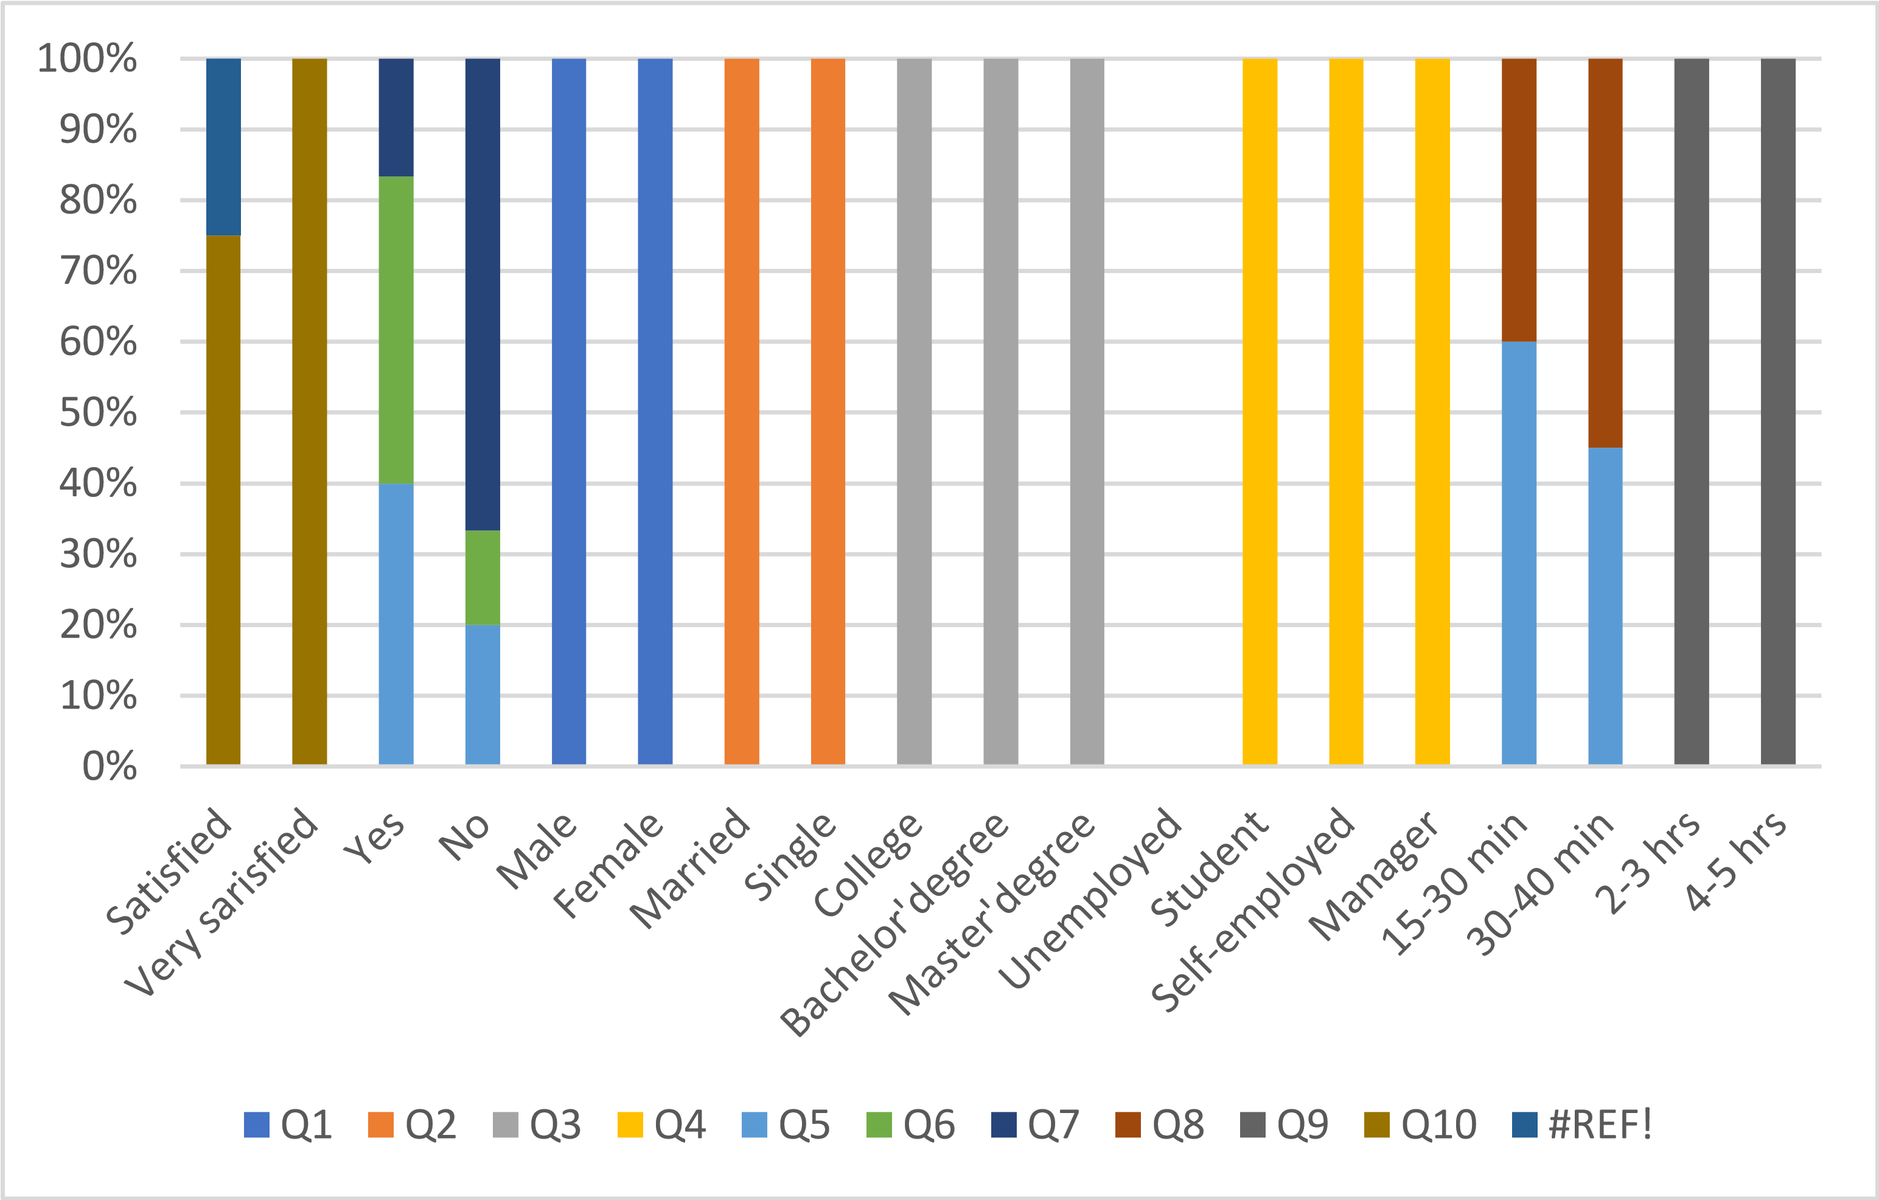
Source: (Nikolova,2022)

8.3 Analysis of Questionnaire

The study in a questionnaire collected primary data from the source: students studying at University of Wales Trinity Saint David. The method of collecting primary data in this reporter is quantitative research. Most of whom are women, self-employed students, half with a college degree and the other with a bachelor's degree. All students have experience with online learning and using the Moodle and Teams platforms. Almost one hundred per cent of the respondents think that distance learning is at a high level, and they are impressed by the excellent organisation and structure of the study material. The excellent organisation of the modules saves them time, so they do not stay too long in front of their computers. Although it saves them time and students support online learning, they do not believe that distance learning will completely replace traditional learning in the classroom.

Ⅲ. Conclusion

The primary and secondary data collected in this report summarise that students prefer online learning. Because online education is a modern form of learning available to any organisation, anyone who wants can take advantage of distance learning, such as high flexibility, low cost and increased efficiency. At the same time, online training has some disadvantages: the main ones are related to the discipline and self-organisation of the learners, the technological challenges and, sometimes, the lack of direct contact with the Lecturer.

Ⅳ. References

Bell, J., 2018. Doing your research project: a guide for first-time researchers. 7 ed. London, England; New York, New York: McGraw-Hill Education.
Benedictine University, 2021. Public Health Research Guide: Primary & Secondary Data Definitions. [Online]
Available at: https://researchguides.ben.edu/c.php?g=282050&p=4036581
[Accessed 04 01 2022].
Clark, D., 2021. Digital learning in the UK- Statistics & Facts. [Online]
Available at: https://www.statista.com/topics/8518/digital-learning-in-the-uk/#dossierKeyfigures
[Accessed 04 01 2022].
Dawson, C., 2009. Introduction to Research Method: A Practical Guide for Anyone Undertaking a Research Project. 4 ed. New York: Constable & Robinson.

