Managing Digital Strategy to Enhance Health and Care
BMDS7007
Digital Strategy Evaluation Report

Anonymous
2215316

11th May 2023

3755 words

Executive Summary
This analysis considers the first digital strategy tabled by Betsi Cadwaladr University Health Board (BCUHB), the largest health board in Wales. It appears to be more of a vision statement than a full strategy document. This essay draws out some of the details of the current technology status – identifying a vast array of operational systems (a number of which are considered legacy systems, with little active application); the extent of the infrastructure; the level of adoption of information standards; and, the local challenges of interoperable systems and data analytics.
The health board strategy has 2 clear ambitions:
- Enabled patients and carers
- Connected staff
These are underpinned by 6 ‘enablers’ – which are identified as core programmes. These programmes would be better described as quality improvement programmes.
Taking the strategy document and weighing it against the HIMMS model, as a bench marking exercise, demonstrates that BCUHB is at stage 2. The expectation of English services is that they are at stage 5. Clearly there is a gap in the maturity of these systems and strategies. Accompanying conversation, for this essay, with BCUHB medical information officers, highlights projects already in fruition that will escalate the digital competence of this organisation. The SWOT analysis has also been applied to detail a number of the internal factors that will affect, or be effected by, the digital strategy. The strategy document is not particularly explicit in this regard. There are some details which can be interpreted (complimented from discussion, as above), so there are examples of how to use the strengths to exploit the opportunities, to mitigate threats and/or address weaknesses. The final component of the strategic analysis uses the PESTLE framework to draw out the external factors impacting the proposed strategy. The document itself does not meaningfully bring these out. In conversation the overwhelming external factor identified is the political situation. Specifically the current level of oversight from Welsh Government, due to the health board being in ‘Special Measures’, limits the immediate potential for digital development and implementation of the strategy.
The (first) BCUHB digital strategy, in short, paints an aspiration and direction of travel. A number of developments are evident since its publication 2 years ago. The next digital strategy document will demonstrate how rapid the process of understanding and change has truly been.

Business drivers
Betsi Cadwaladr University Health Board is the health board serving the whole of North Wales. It is the largest health organisation in Wales – covering approximately 6,500 square kilometres and serving a population in the order of 700,000.

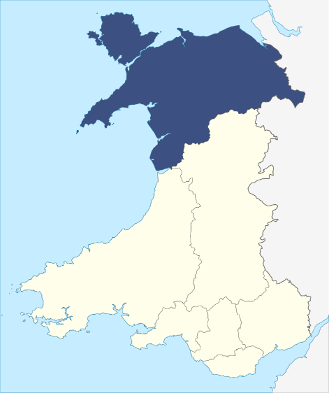
Figure 1: Betsi Cadwaladr University Health Board

It stretches across the six counties of North Wales (Anglesey, Conwy, Denbighshire, Flintshire, Gwynedd and Wrexham) as well as some parts of mid Wales, Cheshire and Shropshire. It is responsible for the operation of three district general hospitals (Ysbyty Gwynedd in Bangor, Ysbyty Glan Clwyd near Rhyl, and Wrexham Maelor Hospital) as well as 22 other acute and community hospitals, and a network of over 90 health centres, clinics, community health team bases and mental health units. It also coordinates the work of 113 GP practices and NHS services provided by North Wales’ dentists, opticians and pharmacies.
The breadth and scope of the organisation can also be appreciated when looking at the health board’s annual report (Betsi Cadwaladr University Health Board, 2022). For example, it details that BCUHB employs 19350 people and has a budget of £1.87 billion (which is a significant proportion of the £20.1 billion that the Welsh government receives from Westminster).
Acknowledging the scope and sheer scale of the organisation, there are numerous opportunities for service developments, whether consolidating services or improving efficiencies, to enhance patient experiences and outcomes. Often these service improvements will also demonstrate a cost benefit in addition to the clinical benefit. Focusing on the digital opportunities to enhance health and care, the BCUHB hierarchy have embraced a clear intent.

Our Digital Future
“Transforming the Patient experience, safety and outcomes through digital ways of working”
(Roberts, 2022)

The strategic direction for the health board is, as the vision states, to embed the experiences of patients (carers and staff) at the core of all that is done. Considering the range of national strategies, plans and programmes which need accommodating there are two of most relevance to the digital strategy:
- ‘A Healthier Wales: A Plan for Health and Social Care’ (Welsh Government, 2018); which promotes digital healthcare technology as a driver of transformational change.
- ‘Informed Digital Health - A Digital Health and Social Care Strategy for Wales’ (Welsh Government, 2015); which precipitated the formation of ‘Digital Health and Care Wales’ and is defining the national standards and services.
A number of challenges for implementing the above vision have already been identified. The scale of the health board’s geography (and the breadth of its estate), with the degree of rurality and its digital connectivity, present an array of physical challenges. Admittedly these are not exclusive to the local situation but is an exaggerated confluence of factors.
The digital literacy of the community (and workforce) is a further barrier, in response to which BCUHB have adopted a ‘Digital First - leaving no-one behind’ approach (Roberts, 2022). The level of digital exclusion in Wales has been estimated at 7% (Digital Communities Wales, 2023).
The external environment within which BCUHB has had to operate has been very complex. This is a consequence of the ‘Special Measures’ imposed by Welsh Government. Originally put in place in June 2015, they were rescinded in November 2020. Since February 2023 ‘Special Measures’ have again been put in place (BBC, 2023). The oversight from Welsh Government generates significant inertia as there is a lack of transparency as to where responsibility for senior decisions lie (even more so with elections on the horizon).
With the internal environment, as with any organisation of this size there are different teams with different demands and different levels of digital skills. The engagement is variable regarding digital projects; yet simultaneously competitive regarding the perceived benefits (or rights) in service developments.
In spite of these challenges, as this essay will continue to consider, digitalisation provides opportunities to enhance the partnership working. This is in local networks, regional engagement and indeed at a national level. Digital transformation is not seen as an easy enterprise, but the potential for changing culture and developing staff is a great opportunity. An opportunity to empower the workforce, increasing job satisfaction and staff retention, but more importantly an opportunity to improve patient care and their experiences of healthcare interactions. This is more than a soundbite. It is about taking the oft quoted mantra (and policy from the National Quality Board (2016)) – “delivering the right care, at the right time and in the right place” – and truly supporting its implementation. Digital competence is an opportunity which will enhance local services and, thereby, public confidence in a dynamic, professional and efficient service where they are required.

Technology and Digital Transformation
Current technology status
- Core operational systems
Within BCUHB, there are currently over 280 operational systems that are in use. The crystallisation of the core components will improve the seamless exchange of information and enable more coherent working. Simultaneously, it is important to acknowledge that there will be critical systems (clinical and corporate) outwith this core which will continue to require support.

One Patient Administration System across the Health Board (WPAS)
Welsh Clinical Portal (WCP)
Welsh Laboratory Information Management System (WLIMS)
Digital Health Record (DHR)
Community Information Sharing System (Currently WCCIS)
Welsh Emergency Department System (WEDS)
Welsh Radiology Information System (WRIS)
Welsh Immunisation System (WIS)
Data Warehouse and National Data Resource (NDR)
Table 1: Identified Core Systems (derived from NHS Wales, 2021)

The BCUHB strategy (BCUHB, 2021) highlighted that the core systems were not in place across the health board. The consequence being that there is an impact on the implementation of other systems and even basic functionality. At the most foundational level the Welsh Patient Administration System needs establishing across the organisation. This will then be the backbone from which other systems can operate. It will enable maximisation of the system’s capabilities thus not only saving time, effort and money but also improving patient safety, patient outcomes and healthcare experience.

- Infrastructure
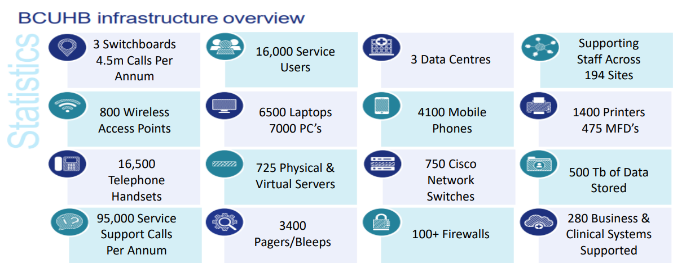
Figure 2: BCUHB infrastructure overview (Appendix 5 in Roberts, 2022)
Even appreciating that BCUHB was ranked first in Wales for their IT Infrastructure in the All Wales IT Infrastructure Review (AWIIR) 2020 (cited in Roberts, 2022; cited in NHS Wales, 2021); it remains an area of challenge. Interpreting the plan from Digital Health and Care Wales (NHS Wales, 2021), there are three principle motivators for change in this area:
- The need to replace outdated infrastructure (due to the risk of failure or being unable to have assurance regarding cyber security attacks).
- The need to mitigate identifiable risks (for example, adequate testing of ‘restore’ functionality or outdated applications and software).
- The need to embrace the use of Cloud services.

- Interoperability
In terms of definition ‘interoperability’ is “the ability of different information systems to access, exchange, integrate and cooperatively use data in a coordinated manner” (HIMMS, no date). This is distinct from ‘integration’, where different systems share data by pushing/pulling it. Commonly referred to as ‘middleware’, interoperability ‘translates’ the data between different systems so that it can be read or edited on the relevant connected devices. The distinction being that system interoperability applies to exchanges of data where ‘translation’ is not required.
Although the terms are closely related integration provides more of an immediate resolution; the caveat being that it may not be sustained and could limit the system evolution. Whereas interoperability (without the, middleware, middle link) protects the future opportunities and is more considerate of the longer perspective.
Most recently, within BCUHB, a model for an information sharing protocol has been proposed. This has had regional approval (from the Information Governance leads) and is currently with the local teams. The aspiration being that it facilitates integration of systems across the health and social care sectors.

- Information standards
There is a clear objective given the availability of the NHS Wales Data Dictionary (Digital Health and Care Wales, 2022). Regarding the current technology status in BCUHB, for this domain, it is very much a work in progress:
- the adoption of SNOMED CT (Systematized Nomenclature of Medicine - Clinical Terms) is a continuing process.
- similarly, wider adoption of the Welsh Government’s ‘Digital Service Standards for Wales’ (Centre for Digital Public Services, no date) is being driven forward by the Chief Information Officer.
- there is a focus on increasing the automation possible with clinical coding.
- incorporation of digital service standards into project and programme documentation, increasing the digital conversation and embedding system change.

- Data analytic capabilities
The digital team have put forward a business case, in BCUHB, to develop this aspect of the service. There is recognition that greater capacity and capability will provide a deeper insight at the health board level (as opposed to departmental developments) for modelling, forecasting and ultimately longer term planning. BCUHB have already begun working with ‘Lightfoot Solutions’, a statistical tool provider, considering the whole system, “to dynamically expose opportunities for sustainable change and connect services into coherent end-to-end pathways” (Lightfoot, 2023).

The BCUHB strategy
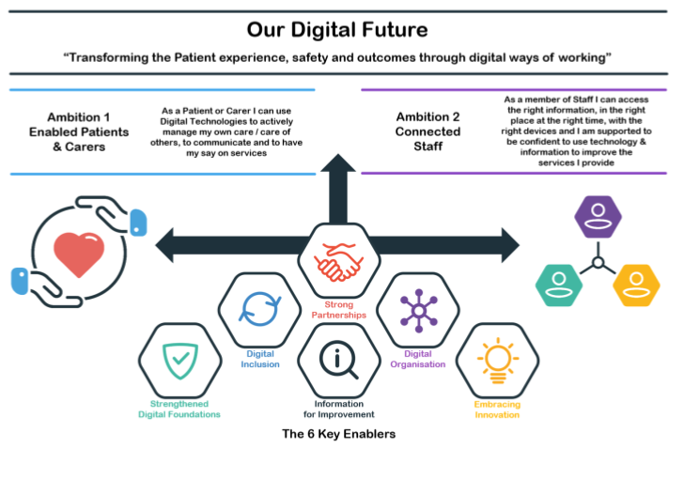
Figure 3: Overview of the Digital Roadmap for Health in North Wales
The aim of the digital transformation strategy has been explicitly laid out in the vision statement – that through digital ways of working patience experience, patient safety and patient outcome will be transformed (with the implied assumption that this is in a positive way).
As the illustration clearly demonstrates the vision statement is underpinned by two driving principles:
- To enable patients and carers. This will be through the use of digital technologies to actively participate in the management of their care, to communicate with healthcare services and to provide feedback on their experiences and outcomes.
- To empower staff. This will be by ensuring staff can access the right information, in the right place, at the right time, with an appropriate device [as an embedded approach rather than simply a response to ‘urgent and emergency care’ (NHS Wales, 2022)]. In parallel, staff will be supported in developing the necessary skills and abilities to make use of the digital technologies so that the care provided can be optimised.
The next tier highlights 6 key enablers; which are core programmes of the digital transformation strategy. These are, nominally:
- Strengthened Digital Foundations
- Information for Improvement
- Digital Organisation
- Strong Partnerships
- Digital Inclusion
- Embracing Innovation
It is important to appreciate what these headline phrases actually mean.
- “Strengthened Digital Foundations” is a programme to endeavour to ensure that the technological infrastructure, systems, devices and support are fit for purpose now and for the future. It also seeks to ensure that the information security and governance processes are strong. The final aspect is making sure that the health service maximises what suppliers provide.
- “Information for Improvement” is a programme which uses (quality) data to provide informed information (or intelligence) so better decisions can be made. This will include elements of data analysis so that demand can be predicted, and services improved or flexed, improving the overall level of service.
- “Digital Organisation” is the programme which is actively promoting the digital conversation (so called “Think Digital”), developing the digital culture and pursuing maturity. It is being embraced throughout the organisation already, with integration into business planning processes and commitment to investment.
- “Strong Partnerships” is the programme to continue to develop processes for seamlessly sharing the relevant information between the health systems, key partners, staff, suppliers and most importantly patients.
- “Digital Inclusion” is the programme which seeks to identify the impact of any new ways of working. The identified consequences of new processes for patients, carers and/or staff can be mitigated to ensure inclusion.
- “Embracing Innovation” is the programme looking forward and engaging with new ideas and novel approaches; investing in innovative research and development and adopting best practices from experience elsewhere.

Strategic Analysis
Healthcare Information and Management Systems Society
HIMSS (Healthcare Information and Management Systems Society) is an organisation that has been dedicated, over more than 60 years, to improving healthcare across all its facets through the use of information technology and management systems. (HIMSS, 2023) They provide an array of models and tools to support organisations worldwide to reimagine, and improve, healthcare through digital technology.
Even being bold enough to speculate (as an individual) with the accessible ’Digital Health Indicator Rapid Assessment’ the level of evaluation is limited. The 4 domains – Governance & Workforce, Interoperability, Predictive Analytics, Person-Enabled Health – do not provide the depth of insight for critical evaluation.
Looking more specifically: HIMSS' Electronic Medical Record Adoption Model (EMRAM) is, internationally, the most widely used assessment of digital technologies in healthcare. (Cresswell et al., 2019) The EMRAM evaluates an institution against standards related to digital imaging, interoperability and data security. The model has a series of stages to classify how well the hospital uses the available functions of the electronic medical record. The stages range from stage 0 – where there is minimal digital capability – to stage 7 – where maximised digital potential has negated pen and paper.
Given the international credibility of this model it is worth considering it lightly for the digital situation in North Wales. The word ‘lightly’ is used as there is not space to fully consider its breadth in this assignment. Furthermore, for clinicians, there is an awareness that this tool focuses on the technological aspects of the digital environment rather than the human component, or even the organisational capabilities. For North Wales the current situation would be that they are at EMRAM stage 2. There are ongoing projects which would enable rapid progression within this model, but currently the criteria for stage 3 cannot be met. The standard that an ‘electronic medication administration record application is implemented’ (HIMMS, 2018) prevents the local situation being evaluated any higher.
There is an ongoing exercise nationally, with the KLAS group, to garner perspectives and opinions on the usability of the various healthcare information systems already in place (noting that there are many instances where a system is not being used at all). The intent is to (more formally) establish the current situation against the HIMSS EMRAM standard. It is also appropriate to note the aspiration from NHS England, where HIMSS EMRAM stage 5 is considered the baseline from interpretation of the core capabilities in the government’s ‘plan for digital health and social care’ (superseding NHSX’s delivery plan for ‘The Frontline Digitisation Minimum Digital Foundations’) (Department of Health and Social Care, 2022) and ‘What Good Looks Like’ (NHS England, 2021).

Table 2: data extracted from Cohen, 2018
Looking at the American levels of digital engagement (Cohen, 2018) (achieved rather than aspirational) there is a significant opportunity for digital development. Considering the situation in North Wales, it demonstrates that quantitatively there is a need for digital development but qualitatively there is a willingness and a plan to embrace digital developments.

SWOT analysis
SWOT analysis is a simple but powerful tool for assessing an organization’s strengths, weaknesses, opportunities and threats. It has been used since the 1950s although the acronym (whether SWOT or TOWS) has been more readily recognised from the 1970s into the 1980s (Weihrich, 1982).
The enduring application of this tool over the last 60 years (Benzaghta et al., 2021) demonstrates its flexibility in strategic development in a variety of settings. As a tool the opportunity for peer review and discussion in the literature has generated multiple theses (Clardy, 2013; Gurel, 2017); and is not the focus of this essay. However, the skill of the professional using the tool may be a greater variable.
The table below identifies the strengths, weaknesses, opportunities and threats of the BCUHB digital strategy (BCUHB, 2021), and the first review of it (Roberts, 2022). There has been, largely informal, discussion with informatics team members, several health board medical information officers (given that there are roles at each of the three district general hospitals) and the chief information officer. These have provided some of the observations, and analysis, which extend beyond the written strategy.
Strengths | Weaknesses
Collaborative digital team  Flexible / Agile skilled team  Strong (rebranded) informatics brand  Leadership support: (Appointment of Chief Digital and Information officer) since the original digital strategy  National digital commitment  Growing data intelligence capability  Some robotic process automation (pharmacy)  “Excelling” in collaborative work with Small Business Research Initiative (SBRI) Centre  Establishment of business intelligence dashboards  Greater public engagement (e.g. feedback tools embedded) | Integration of, multiple, legacy systems  (with poor usability and interoperability)  Comparatively low digital department budget  Limited digital resources  Staff dissatisfaction and stress  Limited control of estate  Mixed levels of digital confidence among wider workforce  Informatics staff - staff numbers and experience  High volumes of paper based processes continue  High volumes of data held in spreadsheets continue  No quality standard or consistency for web services
Opportunities | Threats
Cloud migration; extended use  Alignment with national strategies  Funding and grant initiatives  Innovation funds  Collaboration with other trusts – including across the border to England  Video conferencing  Staff development  Improve BCU reputation/brand  Improve relationship – engage community  Better use of existing software (VPNs cited)  Workforce – becoming paperlight [WNCR]  Consolidation of aggregated data for intelligence and data driven care | Future pandemic  Poor supplier project management  Welsh Government ‘Special Measures’ for BCUHB  Corporate financial recovery  Poor supplier engagement  Government funding  Structural deficit in digital budget  Limited stakeholder capacity  Cyber attack  Legal risk – accessibility laws  Digital exclusion, given digital literacy within community  Lack of trust due to previous digital programmes  No funding for ongoing digital provision
Table 3: SWOT analysis of BCUHB digital strategy

Having detailed these differing strands, which are arguably not as discrete as this model would like (for example, cyber security is simultaneously both a weakness and a threat), there is value in developing how one strand interacts with another.
Using the strengths to exploit the opportunities:
- Enabling the skilled and Agile team to extend applications, such as video conferencing.
- Highlight the benefit and result from engagement with groups, such as the ‘Small Business Research Initiative Centre’, to further collaboration and access new funding initiatives and streams.
- Enhanced public engagement to develop the level of community engagement and health board reputation.
Using the strengths to mitigate threats and address weaknesses:
- Use ‘strength’ of established funding to facilitate digital education and confidence for staff, reducing ‘weakness’ of staff anxiety and distress; and addressing ‘threat’ of staff trust concerns.
- Empower ‘strength’ of the skilled digital team to embed tools to aid staff; reducing burden of paper based processes (‘weakness’).
- ‘Strength’ of health board, and national, engagement to embed digital change throughout the service.
- Access power and ‘strength’ of digital dashboards to focus wider strategy, demonstrating cost savings and value of prudent investment; mitigating ‘threat’ of government funding changes.
- Access new funding ‘opportunities’ to change the ‘weakness’ of the digital budget.
- Take the ‘opportunity’ of collaborative working to off-set the ‘weakness’ of limited resources.
As has begun to be detailed the power of a SWOT analysis in considering a strategy is in the causal relationships and interactions. The individual points themselves cannot be made hierarchical, nor can they prognosticate regarding the strategy. Rather the SWOT analysis can be a formative component of the process which decides how, when and where resources should be focused.

PESTLE analysis
The original PEST analysis framework dates back to the late 1960s (Aguilar, 1967). It has been used across a range of industries over the following decades to aid strategic analysis, with additional insights generated by extending to the PESTLE framework. The acronym helps analyse the events and trends across specific areas:
- Political factors
- Economic factors
- Sociocultural factors
- Technological factors
- Legal factors
- Environmental factors
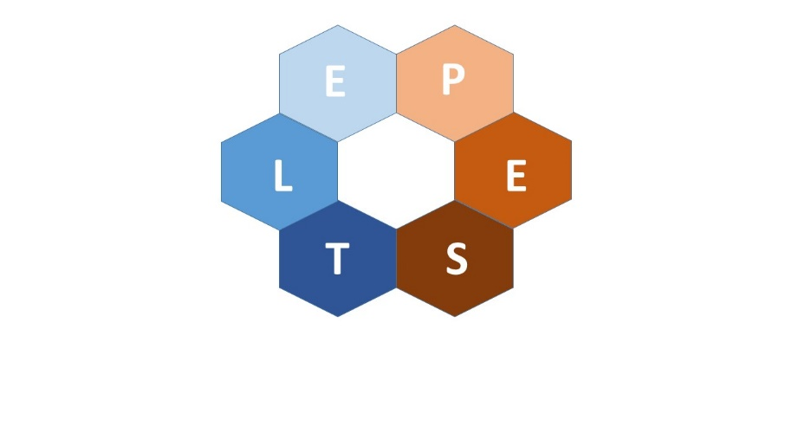
Environmental factors Political Factors
Legal Factors Economic Factors

Technological Factors Social Factors
Figure 4: The PESTLE analysis (image recreated from Marketing91)
Often represented in a tabular form, but the factors are more representative of a network given their interconnections. This reflects the reality of the real world and facilitates a greater understanding of the challenges and opportunities. A recent review, specific to the ‘health care business’ (Siddiqui, 2021), emphasizes the importance of ‘digging deep’ with this tool; as opposed to using it as a superficial checklist of factors.
Focusing purely on the BCUHB digital strategy (BCUHB, 2021), there are a number of factors which are not picked up. This limits how far the external factors can then be identified, restricting (currently) this component of the analysis. So, in brief:

Political
The 3rd appendix lists ‘National Strategies, Plans and Programmes’ but this has not been referenced anywhere in the strategy document itself. In contrast the political situation (BCUHB being under ‘special measures’ and the anticipated (?) general election) was identified as an overwhelming external influencer in conversation with all the information officers spoken with.
Economic
The strategy document touches upon the increasing costs for technology (due to the increase in demand and complexity). Although recognising this there is no consideration documented as to how this might be mitigated. Improved writing of business case proposals does not seem to appreciate the wider financial pressures or NHS financial position in a meaningful manner. Some of the subsequent ideas (Roberts, 2022) do appear to demonstrate more innovation – in, for example, accessing alternative funding streams (like the SBRI) and collaborative working.
Socio-cultural
A strong emphasis on ‘Engagement with the Public, Patients and Carers’ was made throughout the digital strategy document, and its 1st appendix. Time and space was given to the main concerns identified (‘safety of information provided’ and ‘digital exclusion’) but details, or aspirations, did not follow on within this document. In conversation the need for collaborative working was a recurring theme – for example, digital literacy should not be an exclusively healthcare objective.
Technological
In its review of the governance aspects, the digital strategy recognised a number of systems and processes needed to be reviewed and strengthened. It specifically mentioned the need for ensuring ‘the right people with the right skills’ to contribute across the organisation. However the strategy document did not expand upon this point. From conversation, all the information officers (chief and medical) have been appointed following the original document.
Legal
BCUHB in its first strategy document have not detailed this aspect, merely made passing reference within an infographic. Looking at several English trusts digital strategy documents there is significant scope to be more detailed (Izon et al., 2016, Kendall and Lovell, 2017). Given that this is an exponential area of growth, and specialism, the appointment of legal specialists seems prudent.

Environmental
There is an awareness of this aspect but little tangible substance within the strategy document. The need to engage with ‘Environmental Sustainability Strategies‘ is mentioned in passing but no more, despite the challenge of the large geographical area. Consideration of equality and diversity was not explicitly within the strategy although this was a theme that arose in discussion.

Conclusion
So to conclude this digital strategy evaluation report it is evident that the BCUHB strategy document, ‘Our Digital Future’ (BCUHB, 2021), was not as comprehensive as it might have been. Notably, there was a dearth of detail regarding external factors; although internal factors had been more deeply considered. In developing this essay it is evident (through conversations and Dylan Roberts’ review (Roberts, 2022)) that there is an evolution of personnel and process since the initial 2021 digital strategy. This essay analysis is an ongoing process and as the digital strategy itself fills out so the analysis can become more substantive. Both are works in progress.

References
Aguilar, F. (1967) Scanning the Business Environment. New York: Macmillan.
BBC (2023) ‘Betsi Cadwaladr: NHS health board back in special measures’. Available at: https://www.bbc.co.uk/news/uk-wales-politics-64788234 (Accessed: 25 April 2023)
BCUHB (2021) ‘Our Digital Future’. Available at: https://bcuhb.nhs.wales/about-us/governance-and-assurance/digital-strategy/ (Accessed: 27 April 2023)
Benzaghta, M.A., Elwalda, A., Mousa, M.M., Erkan, I. and Rahman, M. (2021) ‘SWOT analysis applications: An integrative literature review’. Journal of Global Business Insights, 6(1), pp. 55-73.
Betsi Cadwaladr University Health Board (2022) ‘Annual Report and Accounts 2021/22’. Available at: https://bcuhb.nhs.wales/about-us/governance-and-assurance/annual-report-and-accounts/annual-reports-and-accounts/bcuhb-annual-report-amp-accounts-2021-22pdf/ (Accessed: 25 April 2023)
Centre for Digital Public Services, Welsh Government (no date) ‘Digital Service Standards for Wales’. Available at: https://digitalpublicservices.gov.wales/resources/digital-service-standards/ (Accessed: 25 April 2023)
Clardy, A. (2013) ‘Strengths vs. Strong Position: Rethinking the Nature of SWOT Analysis’. Modern Management Science & Engineering, 1(1), pp. 100-122.
Cohen, J.K. (2018) ‘How many hospitals are on each stage of HIMSS Analytics' EMR adoption model?’ Available at: https://www.beckershospitalreview.com/ehrs/how-many-hospitals-are-on-each-stage-of-himss-analytics-emr-adoption-model.html (Accessed: 31 March 2023)
Coman, A. and Ronan, B. (2009) ‘Focused SWOT: diagnosing critical strengths and weaknesses’. International Journal of Production Research, 47(20), pp. 5677-5699.
Cresswell, K., Sheikh, A., Krasuska, M., Heeney, C., Franklin, B.D., Lane, W., Mozaffar, H., Mason, K., Eason, S., Hinder, S., Potts, H.W.W. and Williams, R. (2019) ‘Reconceptualising the digital maturity of health systems’. The Lancet Digital Health, 1(5), e200–e201. Available at: https://www.thelancet.com/journals/landig/article/PIIS2589-7500(19)30083-4/fulltext (Accessed: 31 March 2023)
Department of Health and Social Care (2022) ‘A plan for digital health and social care’. Available at: https://www.gov.uk/government/publications/a-plan-for-digital-health-and-social-care/a-plan-for-digital-health-and-social-care (Accessed: 17 April 2023)
Digital Communities Wales, Welsh Government (2023) ‘Digital inclusion in Wales’. Available at: htps://www.digitalcommunities.gov.wales/digital-inclusion-in-wales-2/ (Accessed: 26 April 2023)
Digital Health and Care Wales (2022) ‘NHS Wales Data Dictionary’. Available at: https://www.datadictionary.wales.nhs.uk/#!WordDocuments/geiriadurdatagigcymrunhswalesdatadictionary.htm (Accessed: 25 April 2023)
Gurel, E. (2017) ‘SWOT Analysis: a theoretical review’, Journal of International Social Research, 10(51), pp. 994-1006.
HIMMS (2018) ‘HIMMS Analytics EMRAM’. Available at: https://www.himssanalytics.org/sites/himssanalytics/files/North_America_HIMSS_Analytics_EMRAM_Criteria_2018.pdf (Accessed: 31 March 2023)
HIMSS (2023) ‘Who We Are’. Available at: https://www.himss.org (Accessed: 31 March 2023)
HIMMS (no date) ‘Interoperability in Healthcare’. Available at: https://www.himss.org/resources/interoperability-healthcare (Accessed: 24 April 2023)
Izon, A., Stafford, D., Davies, C., Robinson, C., Wilson, L. and Forster, A. (2016) ‘County Durham and Darlington NHS Foundation Trust: Health Informatics Strategy’. Available at: https://www.cddft.nhs.uk/media/649040/08.18.23%20%20final_hi_strategy_v1%202016-2020%20attachment%201.pdf (Accessed: 09 May 2023)
Kendall, D. and Lovell, M. (2017) ‘Tees, Esk and Wear Valleys NHS Foundation Trust: Digital Transformation Strategy’. Available at: https://www.whatdotheyknow.com/request/622775/response/1482933/attach/3/Digital%20Transformation%20Strategy%202017%202020.pdf?cookie_passthrough=1 (Accessed: 09 May 2023)
Lightfoot Solutions (2023) ‘Our Approach’. Available at: https://www.lightfootsolutions.com (Accessed: 25 April 2023)
National Quality Board (2016) ‘Supporting NHS providers to deliver the right staff, with the right skills, in the right place at the right time’. Available at: https://www.england.nhs.uk/wp-content/uploads/2013/04/nqb-guidance.pdf (Accessed: 26 April 2023)
NHS England (2021) ‘What Good Looks Like’. Available at: https://transform.england.nhs.uk/digitise-connect-transform/what-good-looks-like/what-good-looks-like-publication/ (Accessed: 17 April 2023)
NHS Wales. Digital Health and Care Wales (2021) ‘Digital Health and Care Wales Plan 2021-22’. Available at: https://dhcw.nhs.wales/files/key-documents/dhcw-annual-plan-21-22-nbsp-final-pdf/ (Accessed: 24 April 2023)
NHS Wales (2022) ‘Right care, right place, first time’. Available at: https://www.gov.wales/sites/default/files/publications/2022-02/six-goals-for-urgent-and-emergency-care.pdf (Accessed: 31 March 2023)
Roberts, D (2022) ‘Our Digital Future: Review’. Available at: https://bcuhb.nhs.wales/about-us/governance-and-assurance/digital-strategy/our-digital-future-review-june-2022/ (Accessed: 27 April 2023)
Siddiqui, A.A. (2021) ‘The Use of Pestel Analysis Tool of Quality Management in the Health Care Business and its Advantages’, American Journal of Biomedical Science and Research, 14(6), pp. 507-512.
Weihrich, H. (1982) ‘The TOWS matrix: a tool for situational analysis’. Long range planning, 15, pp. 54-66.
Welsh Government (2015). ‘Informed Health and Care. A Digital Health and Social Care Strategy for Wales’. Available at: https://www.gov.wales/sites/default/files/publications/2019-03/informed-health-and-care-a-digital-health-and-social-care-strategy-for-wales.pdf (Accessed: 28 April 2023)
Welsh Government (2018). ‘A Healthier Wales: A Plan for Health and Social Care’. Available at: https://www.gov.wales/sites/default/files/publications/2021-09/a-healthier-wales-our-plan-for-health-and-social-care.pdf (Accessed: 28 April 2023)

