Marks & Spencer Food – CRM Strategy Report
Prepared by: Rana Rajjoub
BMSW5007
Building a Sustainable Marketing Relationship
Student Name: Rana Rajjoub
Student Number: 2312015
Module Lead: Gwyneth Jones
University of Wales Trinity Saint David
Date of submission: 24th of November 2025
Academic Year: 2025–2026

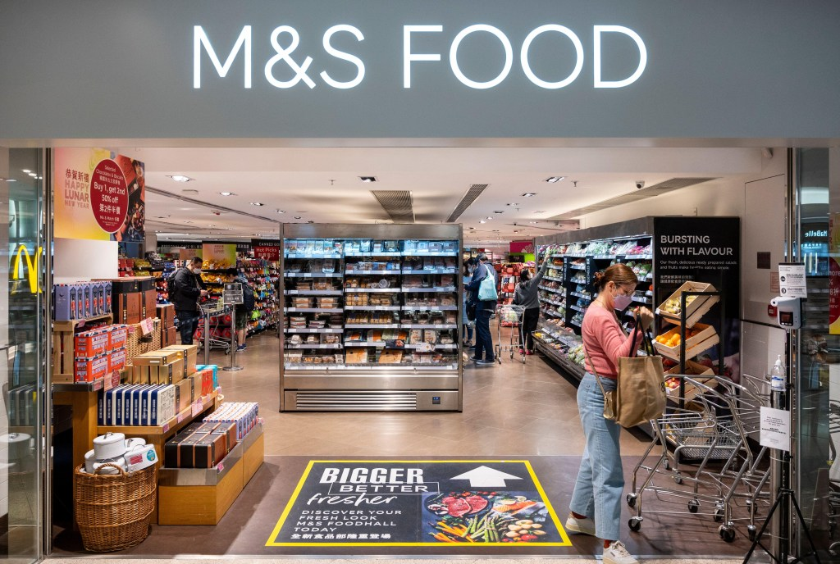

Executive Summary

This report provides a critical evaluation of the Customer Relationship Marketing (CRM) strategies implemented by Marks & Spencer Food (M&S Food) and how these practices contribute to sustainable customer relationships, retention, and loyalty. The analysis begins with an organisational overview, including the historical evolution of M&S Food, its current market position, and the alignment between its mission statement and corporate values.

The report highlights the crucial role of data collection, analysis and evaluation in developing sustainable customer relationships, supported by practical examples such as the Sparks loyalty programme and M&S’s partnerships with data-science firms.

Using key marketing theories—such as STP, the 4Ps, the 4Cs, ethical marketing, and customer centrality—the report critically examines how M&S Food differentiates itself and maintains strong customer relationships in a highly competitive grocery market.

The findings show that M&S Food leverages quality, innovation, sustainability, and data-driven insights to build long-term loyalty. The report concludes with actionable recommendations aimed at strengthening personalisation, omnichannel CRM integration, next-generation customer segmentation, and sustainability communication.

1.Organisational Overview

1.1 Historical Development and Evolution

Marks & Spencer (M&S) began as a small stall in Leeds in 1884, founded by Michael Marks before partnering with Thomas Spencer (Marks & Spencer, 2024). Although the business became widely recognised for clothing and household items, food slowly grew into a central part of its identity during the mid-20th century. M&S was one of the first UK retailers to introduce pre-packaged and ready-to-eat meals, which differentiated it from traditional grocers. This innovation set new standards in convenience and quality and helped M&S stand out in a market increasingly dominated by supermarkets.

Throughout the 1980s and 1990s, M&S Food became associated with premium quality, strict sourcing standards and reliable taste. These qualities built a loyal customer base and contributed to a strong emotional connection between the brand and consumers. Unlike many competitors that stocked numerous national brands, M&S Food focused heavily on own-brand product development, which helped maintain consistency across quality, packaging and flavour (M&S, 2023).

The official branding of “M&S Food” further established the division as a separate yet complementary identity within the larger group. Over time, the company introduced specialist ranges such as Plant Kitchen, Collection, and Eat Well, each catering to different customer needs and dietary trends. This flexibility helped M&S remain relevant within a rapidly shifting retail environment.

In the past decade, M&S Food has undergone extensive transformation as part of the company’s recovery strategy. This included major supply chain modernisation, investment in advanced logistics systems, and redesigning stores to deliver a modern retail experience (Marks & Spencer, 2024). The expansion of Simply Food convenience stores made M&S much more accessible to everyday shoppers and commuters, creating new entry points for regular shopping rather than occasional visits.
Furthermore, the retailer shifted significantly towards digital and omnichannel retailing, offering customers improved online visibility, personalised offers through Sparks, and eventually online grocery fulfilment through its partnership with Ocado (Euromonitor, 2023). These changes reflect how M&S evolved from a niche premium retailer into a more integrated and competitive grocery choice, while still maintaining its reputation for quality.
Overall, M&S Food’s evolution reflects adaptability, innovation and consistent brand identity — all of which are essential for building sustainable customer relationships grounded in trust and long-term loyalty.

1.2 Current Market Position

According to Statista (2024), M&S Food holds approximately 3.6% of the UK grocery market. Although this figure appears modest compared to major retailers such as Tesco, Asda and Aldi, the company intentionally operates in a different competitive space. Rather than competing on low prices, M&S differentiates itself through premium quality, product innovation and strong brand loyalty (Mintel, 2023).
In the broader M&S Group, the Food division has consistently performed better than the Clothing & Home division, especially during periods of financial pressure (Marks & Spencer, 2024). This stability has positioned food as a major growth engine for the company. As a result, M&S has shifted its strategic focus to expand the appeal of M&S Food beyond occasional purchases.
The goal, communicated in corporate strategy updates, is to reposition M&S Food as a credible weekly grocery destination — not just a place associated with special occasions or “treat food” (M&S, 2023). This is a significant cultural shift within the brand and has required changes to pricing architecture, value perception, range expansion and communications.
Another important element of market positioning is the joint venture with Ocado Retail, offering customers access to online grocery shopping. This partnership has helped M&S extend its reach to digital-first consumers and compete in the rapidly expanding online grocery marketplace (Euromonitor, 2023). The move is strategically important as customer behaviour increasingly shifts toward quick-delivery services, subscription-based shopping, and digital convenience.
Overall, while M&S Food’s market share is relatively small, its strong brand reputation, loyal customer base and value proposition give it a solid position within the premium segment of the UK grocery industry.

1.3 Mission Statement and Values

M&S’s mission is “to bring the magic of M&S through exceptional quality, value, service and innovation to every customer” (M&S, 2023). This mission is particularly visible in the food division, where the brand consistently highlights freshness, responsible sourcing, ethical standards and product innovation in its communications.
Sustainability is a core value for the company. M&S emphasises that products must be good for “the planet and the people who make them” (Marks & Spencer, 2024). This commitment is reflected in policies around reducing plastic packaging, sourcing sustainable palm oil, supporting fair labour practices and improving animal welfare standards. These initiatives are part of M&S’s long-standing sustainability programme known as Plan A.

From a CRM perspective, having a mission and value system that aligns with customer expectations helps build trust, emotional loyalty and brand credibility (Gummesson, 2017). Customers who view the brand as ethical and responsible are more likely to develop strong long-term relationships, especially in categories like food, where trust is essential.

2. Data and Customer Relationships

2.1 Role of Data in Sustainable Customer Relationships

Data plays a central role in modern CRM strategies because it enables companies to move from broad, one-size-fits-all marketing to tailored, relevant and personalised experiences (Buttle & Maklan, 2019). Sustainable customer relationships rely on trust, convenience, personalisation and consistent value exchange — all of which are improved through effective data use (Payne & Frow, 2017).

M&S collects data from various digital and physical sources, such as loyalty activity (Sparks), online behaviour, purchase history, in-store transactions, surveys and customer service interactions. This data gives the company insights into:
- shopping frequency and habits
- which products customers value most
- timing and patterns of purchases
- which shoppers are most profitable
- predicting which customers are at risk of leaving (Kumar & Reinartz, 2018)

Such insights allow businesses to tailor offers, adjust stock levels, create personalised communications and develop accurate customer segments. For example, high-frequency customers may receive early access to new ranges, while lower-frequency customers may be targeted with reactivation promotions.

Evaluation tools like customer lifetime value, Net Promoter Score, retention analytics and campaign measurement dashboards help M&S ensure that its CRM strategy has measurable outcomes (Peppers & Rogers, 2017). Without this analytical layer, CRM would be guesswork rather than a strategic capability.

Overall, data makes CRM more efficient, more personalised and more impactful in building long-term loyalty.

2.2 Practical Examples from M&S Food

M&S Food has made significant progress in data-driven CRM through several key initiatives.

The first major example is its partnership with Starcount, a customer insight and data analytics company. Starcount helps M&S use emotional and behavioural analytics to shape personalised Sparks offers (Starcount, 2021). Rather than sending generic discounts, the system identifies what each customer values most and tailors' offers, accordingly, increasing both engagement and satisfaction.

A second example is presented in the OSF Digital case study, which describes M&S’s transition to an integrated omnichannel loyalty system. This system connects every customer interaction — from website browsing to in-store purchases — into a single “Customer 360” view. After implementation, M&S saw a 46% loyalty penetration rate and a 13% increase in average order value among Sparks members (OSF Digital, 2022). These numbers demonstrate the power of personalisation and integrated CRM.
Data also supports broader strategic decisions. For example, M&S uses customer insight to:
- track the rising popularity of plant-based diets
- tailor ready-meal innovations
- optimise product ranges in convenience stores
- evaluate promotional performance (Accenture, 2023)

By integrating data into decision-making, M&S strengthens loyalty by offering customers products and experiences that feel relevant, personalised and convenient (Deloitte, 2024).

3. CRM Strategy Analysis

3.1 Segmentation, Targeting & Positioning (STP)

STP is a foundational marketing concept that helps companies tailor their offerings to different groups of customers.
Segmentation:
M&S Food uses demographic segmentation to target middle-to-higher income shoppers, behavioural segmentation based on shopping habits, and psychographic segmentation for lifestyle factors such as interest in sustainability or gourmet food (Mintel, 2023).
Targeting:
Although historically appealing to affluent shoppers, recent strategies indicate a shift toward broader appeal, targeting everyday grocery customers without compromising premium values (Euromonitor, 2023). This dual-target strategy requires careful positioning to avoid confusing customers.
Positioning:
M&S Food positions itself as a leader in premium quality, innovation and consistent taste (M&S, 2023). Strong branding, distinctive packaging and continuous product innovation reinforce this positioning. Effective positioning nurtures emotional loyalty, a key driver of long-term customer relationships (Peppers & Rogers, 2017).

3.2 Differentiation via the Marketing Mix

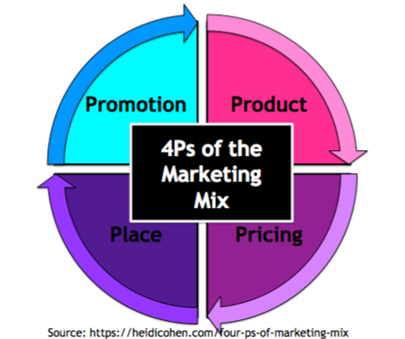

The marketing mix influences customer expectations and perceptions:
- Product: M&S Food is known for its category-leading ready meals, bakery items and seasonal products. Its investment in research and development ensures constant innovation (Mintel, 2023).
- Price: Although M&S prices are higher than mainstream competitors, the brand justifies its pricing with superior taste, consistent quality and aspirational branding (Euromonitor, 2023).

- Place: A well-balanced mix of full-line stores, Simply Food outlets and online channels provide convenience and accessibility (Marks & Spencer, 2024).
- Promotion: Sparks personalisation, social media content and in-store marketing all emphasize quality, innovation and value-added experiences (OSF Digital, 2022).
A strong and consistent marketing mix builds trust, one of the most important components of sustainable CRM (Morgan & Hunt, 1994).

3.3 The 4 Cs of Customer Needs

The 4 Cs model reframes marketing from the customer’s perspective (Kotler et al., 2022):
- Consumer Wants: M&S meets customer needs through high-quality ingredients, freshness and innovative options (M&S, 2023).
- Cost to Satisfy: Customers perceive M&S as offering value for money because of quality, even at higher prices (Mintel, 2023).
- Convenience: Simply Food formats and the Ocado partnership improve accessibility (Kantar, 2024).
- Communication: Sparks enables personalised, timely and relevant communication (Starcount, 2021).

This customer-centric approach is essential for building loyalty (Payne & Frow, 2017).

3.4 Ethical and Sustainability Practices

Ethical behaviour is increasingly influential in customer decision-making (Christopher, Payne & Ballantyne, 2013).
M&S has demonstrated leadership in sustainability through responsible sourcing, packaging reduction, food waste initiatives and long-term ethical commitments outlined in its sustainability reports (Marks & Spencer, 2024). These initiatives are particularly appealing to younger customers who value transparency and environmental responsibility (Deloitte, 2024).
Ethical alignment strengthens relational equity, meaning customers trust the brand not only for product quality but also for its values.

3.5 Customer Centrality and Long-Term Loyalty

Customer centrality requires integrating customer needs into every aspect of the business model (Kumar & Reinartz, 2018). M&S demonstrates this through:
- personalisation
- targeted product development
- omnichannel accessibility
- ethical practices
- strong value propositions
These elements collectively move customers from transactional buying to long-term loyalty, where customers advocate for the brand and maintain consistent engagement (Gummesson, 2017). But to sustain this loyalty, M&S must continuously adapt, especially as customer expectations evolve rapidly with technology and lifestyle changes (Verhoef, Kannan & Inman, 2017).

4. Conclusions and Recommendations

4.1 Conclusions
In conclusion, M&S Food demonstrates a strong and coherent foundation in Customer Relationship Marketing (CRM), supported by a clear alignment between its mission, values and strategic direction. The company effectively leverages data-driven insights, advanced segmentation and well-structured positioning to strengthen customer relationships and enhance long-term value (M&S, 2023; OSF Digital, 2022). Its ongoing commitment to sustainability and ethical sourcing further reinforces trust and relational loyalty, which are essential components of sustainable customer relationships (Deloitte, 2024).

CRM theory — including Segmentation, Targeting and Positioning (STP), the 4 Ps, the 4 Cs and relationship marketing principles — is strongly reflected in the company’s current practices (Kotler et al., 2022; Payne & Frow, 2017). These strategic capabilities position M&S Food favourably in an increasingly competitive grocery market, particularly among customers who prioritise product quality, innovation and responsible business practices. Overall, M&S Food’s CRM approach supports customer centrality, long-term loyalty and improved organisational performance.

4.2 Recommendations

1. Deepen Personalisation
M&S should use predictive analytics to personalise shopping experiences further and deliver dynamic customer journeys, improving retention and loyalty (Accenture, 2023).

2. Target Younger Segments More Effectively
Given changing food habits, M&S should focus more on digital-first consumers, plant-based eaters and younger households (Mintel, 2023).

3. Improve Omnichannel Integration
A more seamless Sparks experience across mobile, digital and in-store channels would support stronger long-term loyalty (Verhoef et al., 2017).

4. Enhance Food-Specific Sparks Rewards
Rewards such as exclusive tastings, early access to limited-edition products, and sustainability-related incentives could increase engagement (OSF Digital, 2022).

5. Strengthen Sustainability Communication
Clear, engaging storytelling around environmental impact could attract conscious consumers and deepen emotional loyalty (Deloitte, 2024).

6. Track Relationship Metrics
Monitoring retention, CLV, customer satisfaction and NPS gives a better picture of customer health than sales metrics alone (Kumar & Reinartz, 2018).

7. Maintain Agility in CRM
Given the rapidly changing retail landscape, M&S should continually test new CRM technologies, loyalty models and digital tools to stay ahead (Neslin & Shankar, 2020)

References list:

Accenture (2023) Personalisation Pulse Check: Consumer Expectations in 2023. Accenture Insights. Available at: https://www.accenture.com [Accessed: 22 November 2025].

BCG (2024) Future of Food & Grocery 2024: Consumer Behaviour Insights. Boston Consulting Group. Available at: https://www.bcg.com [Accessed: 21 November 2025].

Becky,S. (2023). Using Data to Nurture Long-Term Customer Relationships. [Online]. Actian. Last Updated: 28 november 2023. Available at: https://www.actian.com/blog/data-analytics/data-customer-experience-analytics/ [Accessed 21 November 2025].
Buttle, F. and Maklan, S. (2019) Customer Relationship Management: Concepts and Technologies. 4th edn. London: Routledge.

Christopher, M., Payne, A. and Ballantyne, D. (2013) Relationship Marketing: Creating Stakeholder Value. Oxford: Butterworth-Heinemann.

Deloitte (2024) Global Retail Trends Report 2024. Deloitte Insights. Available at: https://www2.deloitte.com [Accessed: 22 November 2025].

Euromonitor International (2023) UK Grocery Retailing Report. Euromonitor Passport Database. [Accessed: institutional access, 2025].

Financial Times (2023) ‘M&S Food performance and competitive analysis’. Available at: https://www.ft.com [Accessed: 13 November 2025].

Gummesson, E. (2017) Total Relationship Marketing. 4th edn. London: Routledge.

Kantar. (2024). Discover the 10 key trends that marketers need to know in 2026. [Online]. Kantar. Last Updated: 2024. Available at: https://www.kantar.com [Accessed 24 November 2025].
Kantar (2024) UK Grocery Market Overview 2024. Kantar Grocery IQ. Available at: https://www.kantar.com [Accessed: 23 November 2025].

Kotler, P., Keller, K.L. and Chernev, A. (2022) Marketing Management. 16th edn. Harlow: Pearson.

Kumar, V. and Reinartz, W. (2018) Customer Relationship Management: Concept, Strategy, and Tools. 4th edn. Berlin: Springer.

Kumar, V. (2020) ‘Customer Lifetime Value – Research Review’, Journal of Marketing Research, 57(6), pp. 1101–1121.

Marks & Spencer (2023) Annual Report and Financial Statements 2023. London: M&S plc. Available at: https://corporate.marksandspencer.com [Accessed: 20 November 2025].

Marks & Spencer (2024) M&S Food Strategy & Sustainability Progress Report 2024. London: M&S plc. Available at: https://corporate.marksandspencer.com [Accessed: 20 November 2025].

M&S Corporate (2024) Plan A Sustainability Strategy Overview. Available at: https://corporate.mands.com [Accessed: 20 November 2025].

McKinsey & Co. (2024) Next-Generation Grocery Personalisation Report. McKinsey Retail Practice. Available at: https://www.mckinsey.com [Accessed: 22 November 2025].

Mintel (2023) UK Food and Drink Retailing Market Report. Mintel Group Ltd. [Accessed: 12 November 2025].

Morgan, R.M. and Hunt, S. (1994) ‘The Commitment–Trust Theory of Relationship Marketing’, Journal of Marketing, 58(3), pp. 20–38.

Neslin, S. and Shankar, V. (2020) ‘Key Issues in Omnichannel Marketing: A Research Agenda’, Journal of Interactive Marketing, 51, pp. 29–41.

OSF Digital (2022) M&S Sparks Loyalty Case Study. OSF Digital. Available at: https://osf.digital [Accessed: 21 November 2025].

Payne, A. and Frow, P. (2017) Strategic Customer Management: Integrating Relationship Marketing and CRM. Cambridge: Cambridge University Press.

Peppers, D. and Rogers, M. (2017) Managing Customer Relationships: A Strategic Framework. 3rd edn. Hoboken: Wiley.

PwC (2023) UK Retail Outlook Report. Available at: https://www.pwc.co.uk [Accessed: 13 November 2025].

Starcount (2021) M&S Sparks Personalisation Insights Report. Starcount. Available at: https://www.starcount.com [Accessed: 20 November 2025].

Statista (2024) Market Share of Grocery Retailers in the United Kingdom in 2024. Statista Database. Available at: https://www.statista.com [Accessed: 12 November 2025].

Verhoef, P., Kannan, P. and Inman, J. (2017) ‘From Multi-Channel Retailing to Omni-Channel Retailing’, Journal of Retailing, 93(2), pp. 174–181.

Verhoef, P.C., Kannan, P.K. and Inman, J.J. (2017) ‘From Multi-Channel to Omni-Channel Retailing’, Journal of Retailing, 93(2), pp. 174–181.

Wirtz, J. and Lovelock, C. (2022) Services Marketing: People, Technology, Strategy. 9th edn. Singapore: World Scientific Publishing.

