Dissertation Research Proposal (M3X9083)
A Critical Evaluation of social media “INFLUENCERS” ON millennial and generation z consumer buying behaviour.

Table of contents
DISSERTATION RESEARCH PROPOSAL 2
1. TOPIC 2
2. TITLE 2
3. AIMS AND OBJECTIVES 2
4. RATIONALE 2
5. BRIEF INTRODUCTION 3
6. PARADIGM AND RESEARCH METHODOLOGY 3
6.1 Research Philosophy 5
6.2 Data collection 6
6.3 Sampling framework 6
7. RESEARCH DESIGN 6
8. RESOURCE PLANNING AND TIME MANAGEMENT 7
9. LIMITATIONS 7
10. ETHIC ISSUES AND RISKS 7
11. APPENDIX 8
12. REFERENCES 9

DISSERTATION RESEARCH PROPOSAL

TOPIC
The topic the author has chosen for this dissertation is social media and the control influencers have on consumer buying behaviour

TITLE
The title of this dissertation will be “A critical evaluation of social media ‘influencers’ on millennial and generation Z consumer buying behaviour”

AIMS AND OBJECTIVES
This dissertation aims to investigate how much control social media influencers has on its audience and the ethical implications arising from this.
1) Critically evaluate a variety of marketing literature with specific focus on ‘influencer’ marketing on millennials and generation Z.
2) Develop primary research methods to enable targeted collection of data to support the research aim.
3) Synthesise primary and secondary research materials in order to fulfil the aim of the research.
4) Draw conclusions based on the discussion and offer recommendations for future research on this theme.

RATIONALE
In today's competitive environment, marketing is critical to any organisational performance and success (Saif, 2015). Anderson (2018) stated that whilst the majority of traditional marketing techniques are in decline, others are still intact. Murthy (2018) however, argued that the use of social media has changed the way of organisational communication. Further it is discussed that there has been a shift in traditional marketing as a result of Electronic word-of-mouth (Ono et. Al, 2018). According to Neti (2011) Social media is amongst the most effective approaches to connect with prospective customers. Moreover, Neti (2011) argues that one cannot afford to not be taking part in any social media platforms as it may result in competitors gaining a competitive advantage.

Influencer marketing is considered a modern and current concept of social media marketing. Hall (2016, p.1) defined influencer marketing as “a way of providing product context and expertise through an inspirational person”.
It can therefore be suggested that this strategy is an effective approach in reaching any potential customers. The concept of influencer marketing is currently an up-rising phenomena and as a result, prior research is limited, and it will therefore be beneficial for further investigation and research. The author will investigate how influencers have an impact on consumer buying behaviour.

BRIEF INTRODUCTION
Marketing has been developing since the early twentieth century and has been broadly researched since. The concept of elasticity of demand introduced by Alfred Marshall has been used as a framework by multiple organisations and marketers as a theoretical basis of understanding marketing in general (Hermans, 2018). According to The Chartered Institute of Marketing (CIM), marketing is defined as “The management process responsible for identifying, anticipating and satisfying customer requirements profitably” (CIM, 2015:www.cim.co.uk/media/4772/7ps.pdf Last accessed 31st Oct 2018)
Furthermore, CIM (2015) argues that marketing is a key management method that is essential to the overall organisational performance and stated that every product that a customer buys, or every media message a consumer is exposed to, has been framed by the forces of marketing. Satisfying customer needs has debatably become a lot more challenging as customer demand has been seen to decline. Additionally, technological developments have had a considerable affect on communication between a company and its customers (Durmaz & Efendioglu, 2016). Banerjee (2017) claimed that in today's competitive market, most organisations use social media platforms and that it has indeed changed the way of business.
Fastenau (2018) believes that the increase of social media influencers is a trend likely to increase. It is claimed that the search of the term “influencer marketing” increased with 325% in google searchers in 2017 only. However, it has been suggested that the term “influencer” is not a new phenomenon. Further it is argued that the biggest misconception of an influencer is that it is someone with a great amount of social media followers rather than someone with the power to influence the perceptions of others (Dada, 2017).
Regardless, it could be argued that brands are intrigued by this new social media trend and understandably reaching out to social media personas. As a result, the researcher of this thesis aims to investigate to what extent influencers control their audience buying behaviour.

PARADIGM AND RESEARCH METHODOLOGY
Cameron and Price (2009, p.4) defined research as:

´any systematic attempt at collecting and interpreting data and evidence in order to inform thinking, decisions and/or actions in relation to an issue of interest to an organization and/or its stakeholder´.

Qualitative research is mainly exploratory research that includes interviews, focus groups and observations in order to gain a better understanding of the lived experience from a small homogenous group. It is used to gain an in-depth understanding of the underlying opinions of a given subject. Further it described as a method to uncover trends and thoughts (DeFranzo, 2011).
Quantitative research on the other hand, is a structured method that collects and analyse empirical data collected from a variety of sources within a larger population. It often includes the use of statistical and mathematical tools in order to analyse the results (SIS International Research, 2018). Moreover, mixed method research includes the knowledge of both qualitative and quantitative studies and it is argued to be a more beneficial approach in order to gain a greater perspective of the research as a whole (McKim, 2015).

Deductive and inductive research approaches differentiate in that whilst a deductive approach is designed at testing a theory and starting with a hypothesis or a research question, with the intent to be confirmed or disconfirmed. It is an approach that is more commonly used with quantitative research (Gabriel, 2013).

Figure 1
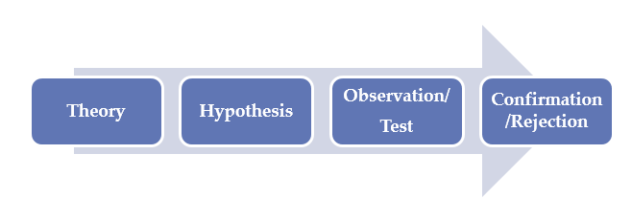
(Research Methodology, 2018)

Alternatively, the inductive approach does not include a hypothesis, but is an approach that starts with a set research aim and objective that should be achieved during the process of finding similarities and patterns within the data (Research Methodology, 2018).

Figure 2
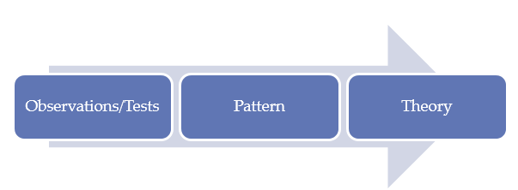
(Research Methodology, 2018)

Moreover, Saunders et al (2009) suggested that the research onion is a development where a methodology of any research can be designed. Please see attached photo of the research onion below.

Figure 3

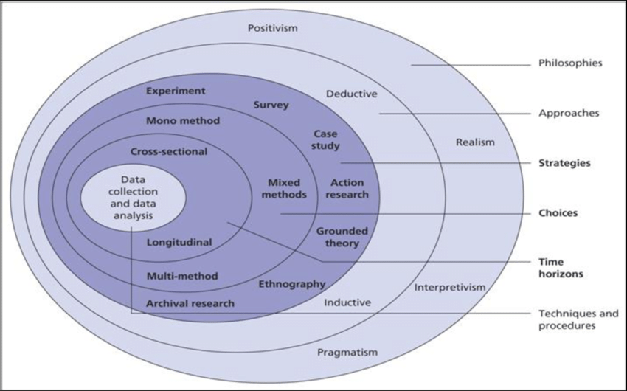

(Saunders et al, 2009)

Research Philosophy
A research philosophy is described as a belief on how information about a phenomenon should be collected, analysed and used (Dudovskiy, 2018). Creswell (2012, p.3) defined research as “a process of steps used to collect and analyse information to increase our understating of a topic of issue”.
There are two dominant research philosophies that are most commonly used as research paradigms, namely the positivist and interpretivist philosophies. Positivist paradigm can according to Levin (1988) be defined as the belief that reality is constant and relies on deductive logic. Interpretivists, on the other hand, contradict that reality can only be completely understood through individual interpretation. This approach would be used when conducting qualitative research through interviews or observation (Revise Sociology, 2015)
Ontology is another research philosophy that is concerned with the nature of reality. Ontology is associated with how the researcher identifies reality and whether social entities should be considered as objective or subjective (Dudovskiy, 2018).
Lastly, epistemology is used as a research method to describe how we know the truth of reality of something and is concerned with the nature of human knowledge (Kivunja & Kuyini, 2017)

To conduct this investigation, the researcher will apply a mixed method of primary data to gather both quantitative and qualitative data. By doing so, the researcher will gain an understanding of the participants perspectives for further investigation. It needs to be noted that using mixed methods adds value to the validity of any research. It could also be argued that using such approach would enable the researcher to gain a deeper understanding of the research topic (McKim, 2015).
The author of this thesis will therefore do both interviews and an online survey in order to analyse the data collected into graphs and tables for further investigation.

Data collection
The researcher of this dissertation will solely concentrate on primary and secondary research, whereas primary research can be defined as data that is collected by the researcher only. In contrast, secondary research is described as data that is already collected by others (Surbhi, 2016)
The researcher will undertake face to face interviews in addition to skype and telephone interviews. This is to gain an in-depth understanding of how “influencer marketing” affects its audience. Additionally, the author of this dissertation will create an online survey using Survey Monkey with a minimum of 100 participant to gather a lager sample size.

Sampling framework
By sampling it is referred to selecting a particular sample group to represent the rest of the population whereas the method is often divided into the two categories of probability and non-probability sampling (Surbhi, 2013).
Showkat & Parveen (2017) stated that in probability sampling, each sample has an equal chance of being chosen, whereas with nonprobability sampling, there is according to Devalt (2018, p.1) “no specific probability that any given person will be in the sample set”.

The researcher will use nonprobability sampling by targeting influencers, millennials and generation Z. However, as the researcher is unable to reach all influencers, it can be argued that nonprobability sampling could be useful in order to reach conclusions concerning the data set. Doing so, the researcher will be able to generalise the findings and apply them to the wider population. Furthermore, the author of this dissertation will conduct a pilot of the online survey, making sure that all questions are understood to prevent any misunderstanding.
Additionally, the author will use SPSS being a software tool in order to help analysing the data collected.

RESEARCH DESIGN
Prior to collecting data and conducting the analysis, a research design is needed to give structure to the research. The purpose of a research design is therefore to ensure that the data obtained allows the researcher to test the hypothesis and answer the initial question as clearly as possible (NYU, 2018). Furthermore, Robson & McCartan (2016, p.4) suggested that “research designs are concerned with turning the research questions into a testing project”. Kirk & Miller (1985) demonstrated the importance of data validity and suggested that if the data collected is not valid, the end result will be incorrect. As a result, the researcher of this thesis will not ask any leading questions, nor take personal thoughts or opinions into consideration.

RESOURCE PLANNING AND TIME MANAGEMENT
Due to other university commitments, it is necessary to develop a timeframe in order to carry out this research and analysis. As a result, the researcher has established a Gantt Chart to monitor progress throughout the research period. Please refer to appendix 11.1 for Gantt Chart.
Appendix 11.2 shows resources and materials needed in order to conduct this dissertation. It is likely that financial resources such as travel expenses will occur. Other expenses related to this research such as the use of Survey Monkey or international phone calls to Norway is anticipated, in addition to printing and binding final dissertation reports.

LIMITATIONS
The following limitations are anticipated and expected whilst conducting the primary research for this thesis:
- Difficulty in arranging interview with an “Influencer”
- The participates may not be truthful when taking part in survey or interviews
- The number of participants to survey may be too small

ETHIC ISSUES AND RISKS
Anaesth (2016, p.2) suggested that researchers have a responsibility to “protect the life, health, dignity, integrity, right to self-determination, privacy and confidentiality of personal information of research subjects”. Similarly, The Office of Human Research Protections provides the following framework for ethical principles associated with research:
- Respect
- Beneficence
- Justice
(The Office of Human Research Protections, 1979)

Ethical considerations will be taken under consideration at the duration of this research. Participants taking part in interviews or surveys will be informed of the research purpose in addition to possible outcomes. The participants will remain anonymous and the information and data collected will be kept confidential and secure. University guidelines and policies will be adhered to and respected whilst writhing this dissertation.

APPENDIX

Appendix 11.1 – Gantt Chart

Appendix 11.2 Possible Resources and Materials

REFERENCES
Anaesth, I. (2016). Legal and ethical issues in research. Indian Journal of anaesthesia. 60 (9), p684-688.

Anderson, J. (2018). 9 Traditional Marketing Techniques That Still Matter. Available: https://www.onlinemarketinginstitute.org/blog/2018/06/9-traditional-marketing-techniques-still-matter/. Last accessed 30th Oct 2018.

Banerjee,S.(2017). Why Social Media Marketing Is Beating Traditional Marketing. Available: https://www.rswebsols.com/tutorials/seo-tutorials/traditional-vs-social-media-marketing Last accessed 1st Nov 2018.

Cameron, S., Price, D (2009). Business Research Methods. London: Chartered Institute of Personnel and Development. p4-6.

Chartered Institute of Marketing. (2015). A brief summary of marketing and how it works. Available: https://www.cim.co.uk/media/4772/7ps.pdf. Last accessed 31st Oct 2018.

Creswell, J (2012). Educational Research. 4th ed. Nebraska: Pearson. p3-6.

Dada,G. (2017). What Is Influencer Marketing And How Can Marketers Use It Effectively?. Available: https://www.forbes.com/sites/forbescommunicationscouncil/2017/11/14/what-is-influencer-marketing-and-how-can-marketers-use-it-effectively/#50858c4923d1. Last accessed 1st Nov 2018.

DeFranzo, S. (2011). What’s the difference between qualitative and quantitative research?. Available: https://www.snapsurveys.com/blog/qualitative-vs-quantitative-research/. Last accessed 7th Nov 2018.

Devault, G. (2018). How Probability and Nonprobability Samples Differ.Available: https://www.thebalancesmb.com/how-do-probability-and-non-probability-samples-differ-2296696. Last accessed 7th Nov 2018.

Dudovskiy, J. (2018). Research Philosophy. Available: https://research-methodology.net/research-philosophy/. Last accessed 1st Nov 2018.

Durmaz,Y., Efendioglu, I. (2016). Travel from Traditional Marketing to Digital Marketing . Global Journal of Management and Business Research: E MARKETING. 16 (2), p35-40.

Fastenau,J.(2018). Under the Influence:ThePower of Social Media Influencers. Available: https://medium.com/crobox/under-the-influence-the-power-of-social-media-influencers-5192571083c3. Last accessed 1st Nov 2018.
Gabriel, D. (2013). Inductive and deductive approaches to research.Available: http://deborahgabriel.com/2013/03/17/inductive-and-deductive-approaches-to-research/. Last accessed 7th Nov 2018.
Hall, J. (2016). The Influencer Marketing Gold Rush Is Coming: Are You Prepared?. Available: https://www.forbes.com/sites/johnhall/2016/04/17/the-influencer-marketing-gold-rush-is-coming-are-you-prepared/#4d059ec234fb. Last accessed 30th Oct 2018.

Hermans, C. (2018). The History of Marketing Thought. Available: http://www.healthedpartners.org/ceu/hm/a02history_of_marketing_thought_by_bartels_hermans.pdf Last accessed 31st Oct 2018.

Kivunja, C., Kuyini, A. (2017). Understanding and Applying Research Paradigms in Educational Contexts. International Journal of Higher Education. 6 (5), p26-41.

Kirk, J., Miller, M (1985). Reliability and Validity in Qualitative Research. USA: Sage Publications.

Levin, D (1988). The opening of vision: Nihilisim and the postmodern situation. London: Routledge.
McKim, C. (2015). The Value of Mixed Methods Research: A Mixed Methods Study. Journal of Mixed Methods Research. 11 (2), p202-222.
Murthy, D. (2018). Introduction to Social Media, Activism, and Organizations. . 4 (1), p1-5.

Neti, S. (2011). SOCIAL MEDIA AND ITS ROLE IN MARKETING. International Journal of enterprise computing and business systems. 1 (2230-8849), p1-15.

NYU. (2018). WHAT IS RESEARCH DESIGN?. Available: https://www.nyu.edu/classes/bkg/methods/005847ch1.pdf. Last accessed 7th Nov 2018.

Office for Human Research Protections. (1979). The Belmont Report.Available: https://www.hhs.gov/ohrp/regulations-and-policy/belmont-report/read-the-belmont-report/index.html#xbasic. Last accessed 1st Nov 2018.

Ono, A., Kikumori, M. (2018). Consumer Adoption of PC-Based/Mobile-Based Electronic Word-of-Mouth. Available: https://www.igi-global.com/chapter/consumer-adoption-of-pc-basedmobile-based-electronic-word-of-mouth/184302. Last accessed 30th Oct 2
Research Methodology. (2018). Research Approach. Available: https://research-methodology.net/research-methodology/research-approach/. Last accessed 7th Nov 2018.
Revise Sociology. (2015). Positivism and Interpretivism in Social Research. Available: https://revisesociology.com/2015/05/18/positivism-interpretivism-sociology/. Last accessed 7th Nov
2018.

Robson, C., McCartan, K (2016). Real World Research. 4th ed. Sussex: John Wiley & Sons.

Saif, N. (2015). How does Marketing Strategy Influence Firm Performance? Implementation of Marketing Strategy for Firm Success. International Journal of Innovation and Economic Development. 1 (3), p7-15.

Saunders, M., Lewis,P., Thornhill, A (2009). Research Methods for business students. 6th ed. London: Pearson. p165-196.

Showkat, N., Parveen, H. (2017). Non-Probability and Probability Sampling. Available: https://www.researchgate.net/publication/319066480_Non-Probability_and_Probability_Sampling. Last accessed 7th Nov 2018.

SIS International Research. (2018). What is quantitative research?.Available: https://www.sisinternational.com/what-is-quantitative-research/. Last accessed 7th Nov 2018.
Surbhi, S. (2016). Difference Between Primary and Secondary Data.Available: https://keydifferences.com/difference-between-primary-and-secondary-data.html. Last accessed 7th Nov 2018.
Surbhi, S. (2016). Difference Between Probability and Non-Probability Sampling. Available: https://keydifferences.com/difference-between-probability-and-non-probability-sampling.html. Last accessed 7th Nov 2018.

