Iwan Williams (1901752)
Engineering Science II (M4X00386)
16/08/2020
Electricity and Thermodynamics coursework answers (resubmission)

Question 1
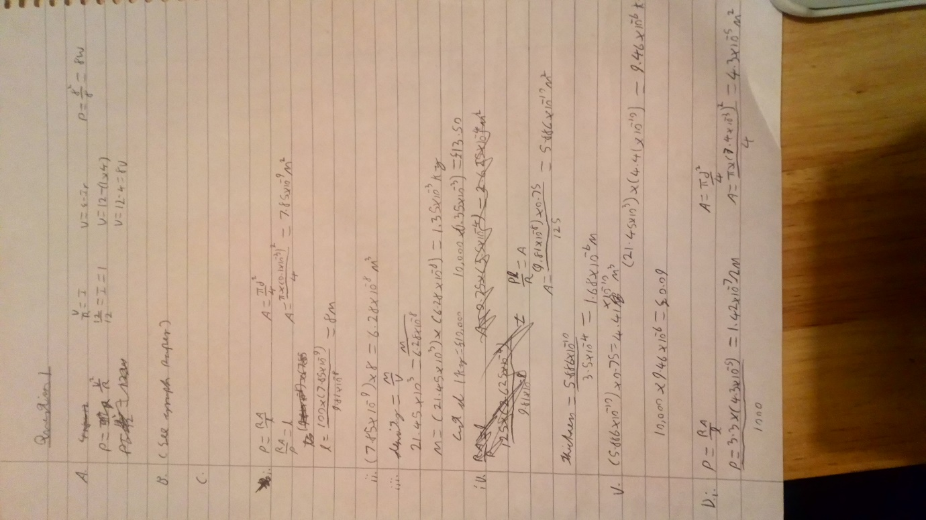

Question 2
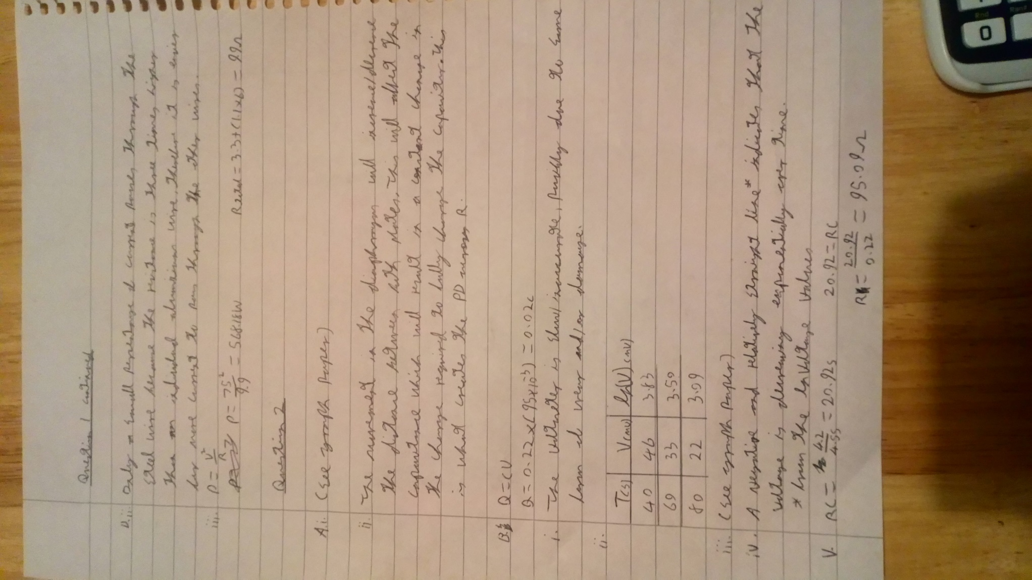
Graph Questions
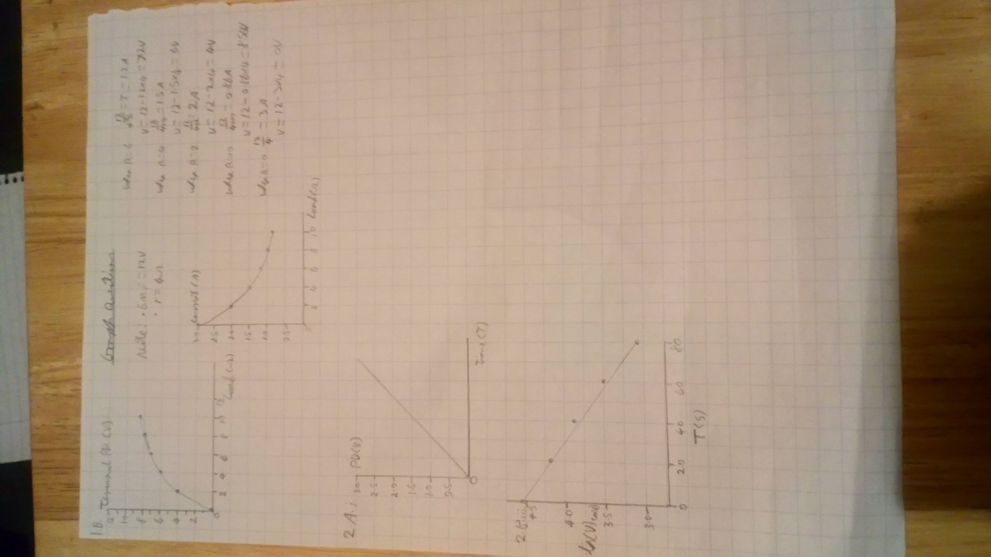
Question 3
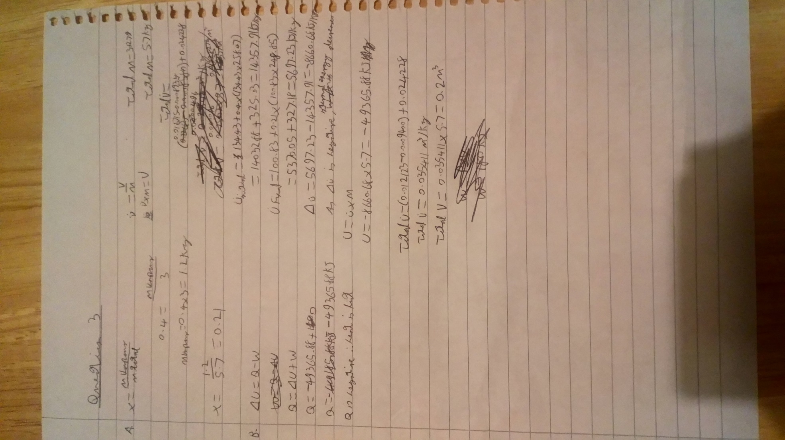

Question 4


