Module: Changemakers: Creativity and Value Creation
Module Code: BMHP5014
Assessment: Online Portfolio
Student Name: Sana Sahir
Student ID:
Lecturer: Eleni Koutsogeorgou

Table of Contents
INTRODUCTION 2
ARTEFECT 1 LEAFLET 3
ARTEFACT -2 Poster 5
CONCLUSION 6
REFRENCES 7

INTRODUCTION
Autism acceptance necessitates sensitivity and a knowledge that ASD (autism spectrum disorder) is unique to everyone. Certain methods and techniques may be effective for some people but not for others.
Awareness is the first step in understanding autism and autistic people, but it is not the end. It's important to understand the distinction between ASD (autism spectrum disorder) and ADHD (attention deficit hyperactivity disorder). Autism and ADHD (attention deficit hyperactivity disorder) are frequently misunderstood. Children with ADHD (attention deficit hyperactivity disorder) sometimes struggle with fidgeting, focusing, and keeping eye contact with others. Some autistic persons exhibit these symptoms as well. ADHD (attention deficit hyperactivity disorder) is not considered a spectrum condition, despite certain similarities. One significant distinction between the two is that persons with ADHD (attention deficit hyperactivity disorder) do not often lack socio-communicative abilities.
It is important to know that Autism is not a disease.
Being autistic does not imply that you have a disease or sickness. It indicates your brain functions differently than other people's.
It is something you are born with or develops when you are very young.
When a child is diagnosed with autism, he or she is autistic for the rest of his or her life.
Autism is not a medical illness that can be treated or "cured." However, some people require assistance with certain tasks.
Autistic persons are capable of leading complete lives.
Being autistic does not have to prevent you from living a happy life.
The United Nations-designated World Autism Awareness Day is observed on April 2 each year as part of Autism Speaks' celebration of World Autism Month. We offer opportunities to broaden awareness and acceptance of people with autism throughout the whole month of April. Everyone is invited to take part, regardless of whether they are autistic themselves or know someone who is. World autism day is one of only seven official health-specific UN days. On Autism Day organizations get to gather and research, diagnose, treatment and acceptance for those with a developmental path affected by autism.
‘’Autism Awareness Day’’ or ‘’Autism Awareness month’’ are often challenge by autism rights advocates, who claim that they feed into recognized discrimination autistic people.
Importance of public Awareness for Autism: Public awareness about autism not only help people with autism but also help families and caregivers to deal with easily. Month of April mark start of National Autism Awareness Month (NAAM). In this period companies and organizations spread awareness and promote acceptance of Autism. (Healis Autism Centre, 2022).
We are showing two artefacts in this portfolio. Leaflet and poster the objective of the leaflet and poster is to increase autism awareness for everyone. either you have a child with autism or know someone who does. Autism awareness will teach families and caregivers how to interact with autistic people.

ARTEFECT 1 LEAFLET
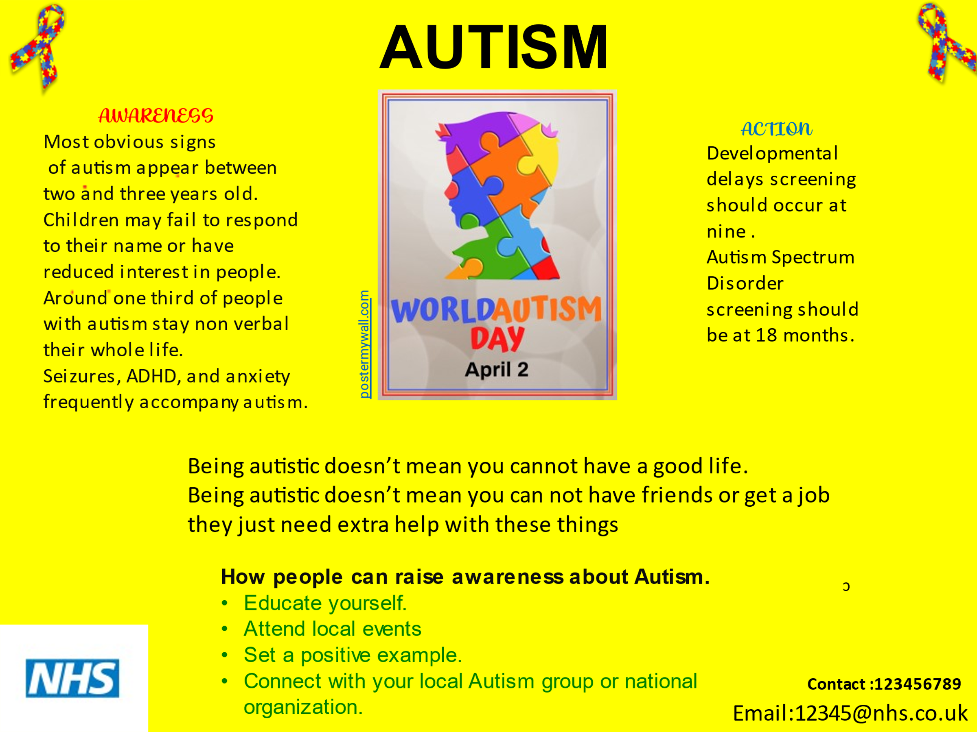
This Leaflet is all about autism Awareness. Why it’s so important people to know about Autism. Many people have cited awareness as a critical predictor of success in a variety of performance contexts. If you are aware, you will get knowledge, and if you have knowledge, you will know what you need to do and where you need to go to adjust in order to improve. It will motivate you to learn. It will provide you with knowledge for next action thinking. (Harrison, 2013)
April is Autism Awareness Month, and we want to educate individuals to think about what makes someone with Autism unique and to embrace them for the incredible minds they possess. It is not acceptable to avoid someone simply because they are different. (National Today, 2022).
Parents and caregivers who work with individuals with autism may be able to understand the significance of public awareness. Greater awareness brings about better understanding. Parents do often misunderstand from public. I recalled that a child had a sensory meltdown in public and a lady made comment such ''What an awful child''? These judgemental comment from ignorance can deeply upset individuals with autism and family members.
Together, let's recognise April as Autism Awareness Month and appreciate our diversity. It's time to find out what someone's brilliant intellect could be able to bring to the world. "Different, not less" is a phrase that everyone should understand and abide by (Grandin Temple) Since one out of every 120 children in the population is estimated to be autistic, there is a dearth of autism knowledge and understanding among parents. As a result, there was a general lack of understanding, which increased the number of autistic people. (Anwar et al, 2008).

The responsibility of a teacher to identify children with special needs as an early childhood educator, you wear several hats. From calming a grumpy youngster to resolving classroom brawls over a pencil and, of course, addressing the curriculum in the classroom. Teachers in the early year’s classroom have a clear idea of each child's personality, strengths, and shortcomings by the end of the first week of school. Teachers often notice youngsters who are detached and require more care during this critical era. Are these youngsters’ autistic? When I connect with experienced instructors, they frequently state, "I know this is a case of autism." I'm sure of it." However, it is always preferable not to leap to conclusions and instead adopt a more measured approach to resolving the issue. If you detect red flags in a youngster in your class, you should consult with an expert. (Applied Behaviour Analysis Programs Guide, 2022)

Parents Accepting Your Autistic Child It's difficult to accept that your child has autism and that your life will be very different from what you expected. Raising a special-needs child comes with its own set of challenges. However, once you've recovered from the initial shock, it's critical to enlist the assistance of your entire family, as you and your child will require every bit of assistance imaginable. (Vij, 2019a). Parents need to learn about your children needs, educate other family member, communicate with other autistic children, one day at a time, create a schedule, you are not alone taking care of yourself. (Vij, 2019a).

ARTEFACT -2 Poster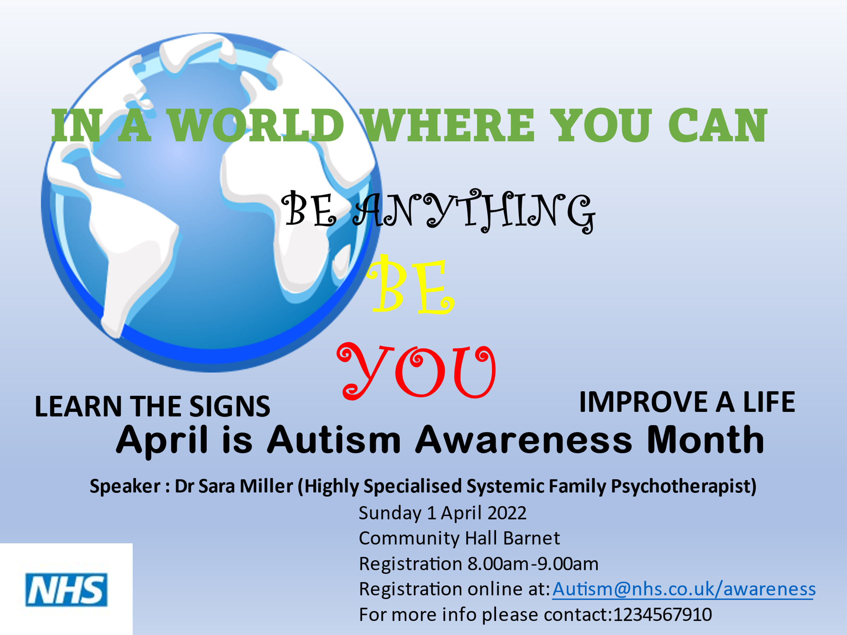
The poster is all about inviting people who wants to know or have questions about Autism. Even though World Autism Day was on April 2, the whole month of April is designated as Autism Awareness Month. Autism is not a single disease; rather, it is a collection of complex issues that affect children and their families in various ways. Autism has no known aetiology, even though its prevalence is increasing. Autism Awareness Month is important for a variety of reasons, including the reality that there is no cure for autism. The purpose of raising awareness is not to raise money to "treat" autism; rather, it is to diagnose early children and give them with the necessary resources.
Children with Autism should not be excluded from activities just because their social and intellectual abilities differ. Every school should encourage the participation of all students in the educational environment. Children in progress should be able to engage with children who have any condition or impairment, and vice versa. It is essential to make sure that measures are in place to support all children with Autism. (Kallie Haritopoulos, April11,2017).
An early and precise diagnosis has a significant impact on the child's outcomes and behaviour improvement. If there is a lack of information about the symptoms of this condition, there is a high risk of misdiagnosis or late diagnosis. When a parent's kid is accurately diagnosed, they will be able to focus on their child's improvement. An early and precise diagnosis has a significant impact on the child's outcomes and behaviour improvement. If there is a lack of information about the symptoms of this condition, there is a high risk of misdiagnosis or late diagnosis. (The Odyssey Online, 2017).

The purpose of this study was to measure the awareness of this condition among parents who did not have autistic children. It discovered a shortage of knowledge and information among the general public, especially given the country's high prevalence of autism. When a person is disabled, he or she is still a human being. Even if you don't understand them, that person with a condition has a body, a mind, hobbies, desires, and objectives. Autism is a condition that is neither good nor terrible. It just exists, and it is our responsibility to make the best of it.
We must educate our children that not everyone is like them, and that this is not a terrible thing. Instead of understanding or just being aware of autism, teach your child that he is great because of who he is, not because of his differences. Teach acceptance early and constantly. (Special Education and Inclusive Learning, 2021).

CONCLUSION
Autism is growing more prevalent over the world. Because parents are often the primary caregivers in many situations, their ability to notice and respond to signs and symptoms of autism is crucial. The goal of this study was to determine the parents' autism knowledge and awareness. A recent poll found that many parents are willing to have their children checked and treated if they are diagnosed with autism. However, only a small minority of the individuals were aware that they had autism. General practitioners must play an essential role in providing autism education to parents. Autism awareness events should be conducted to better educate parents about the illness. So, it is our job to assume that persons with autism are capable and then go about finding methods to assist them display their competence. If you're a parent, tell your child about what's going on in the family and in the world - anything intriguing that you'd tell another child. Maintain your end of the discussion even if others do not. Create teaching opportunities based on their personal interests. Give them the dignity of being accepted as average, rather than being rejected as extraordinary. Teach and read to them even if there is no requirement for a final test. Assume they are listening, appreciating, and loving us while we continue to hunt for methods for their tongues or gestures to tell us.

And then return their affection. Not for who they may have been if they didn't have autism, or for who they might be if they were "cured," but as people who need to be nothing but themselves to be loved and appreciated Because doing so allows them to enjoy a meaningful life with us without having to take an admission test. We begin to perceive persons with autism for their abilities rather than their limitations. We begin to focus less about handicap and more about humanity. Not to mention that we occasionally discover that the qualities we admire in ourselves are present because a person with autism is also present. (Autism Society., 2013).

REFRENCES
- Anon, (2022). Why is Autism Awareness Important? - Ike Foundation for Autism. [online] Available at: https://www.ikefoundationforautism.org/why-is-autism-awareness-important/ [Accessed 23 Nov. 2022].
- Healis Autism Centre. (2022). Autism Therapy | ABA-VB treatment. [online] Available at: https://www.healisautism.com/ [Accessed 23 Nov. 2022].
- The Odyssey Online. (2017). Autism Awareness and Why It Is Important. [online] Available at: https://www.theodysseyonline.com/autism-awareness-and-why-it-is-important [Accessed 23 Nov. 2022].
- www.england.nhs.uk. (2022). NHS England» Autism. [online] Available at: https://www.england.nhs.uk/learning-disabilities/about/autism/.
- Special Education and Inclusive Learning. (2021). Autism awareness. [online] Available at: https://inclusiveteach.com/2021/05/08/why-awareness-about-autism-is-important/ [Accessed 23 Nov. 2022].
- Autism Society. (2013). Autism Awareness – A Parent’s View. [online] Available at: https://www.autism-society.org/autism-awareness-a-parents-view/ [Accessed 23 Nov. 2022].

- Autism Awareness: For Teachers and Parents. [online] NutSpace. Available at: https://nutspace.in/autism-awareness-for-teachers-and-parents/ [Accessed 23 Nov. 2022].
- Autism Awareness: For Teachers and Parents. [online] NutSpace. Available at: https://nutspace.in/autism-awareness-for-teachers-and-parents/ [Accessed 23 Nov. 2022].

