

Student name: | Nazifa Sultana Ohia | Student ID number: | 2410582
Programme: | MBA
Module: | Finance for Business Managers
Module code: | BMMB7005D | Contribution to Overall Module Assessment (%): | 100%
Lecturer: | Marie Pitson | Internal Verifier: | Badir Miftah
Assignment Title: | Part 1: BAE Systems PLC ORD  Part 2: Jordons PLC | Word count (or equivalent): | 5000 words
Submission deadline: | 21th July 2025 | Return date of provisional marks & written feedback: | 14th August 2025

Contents
Part 01 3
Introduction 3
Financial Data Extraction 4
Financial Ratio Calculations 5
Limitations of the Ratio Analysis for BAE Systems PLC 17
Part 02 19
Business Report: Investment Appraisal for Jordons Plc 19
a) Investment Appraisal and Recommendation 19
Financing the Proposed Investment Programme 26
References 27
Appendix 28
Financial Statement 28
Calculation 31

Part 01

Introduction
This report provides a detailed financial analysis of BAE Systems PLC for the years 2023 and 2024, a leading defense, aerospace, and security company listed on the London Stock Exchange. Key financial ratios will be examined to assess BAE's performance. Profitability ratios such as gross profit margin, operating profit margin, and return on equity will evaluate the company's ability to generate profit. Liquidity ratios, including the current ratio and quick ratio, will assess BAE's short-term financial stability. Gearing ratios like debt-to-equity will be analysed to gauge the company’s financial leverage. Efficiency ratios, such as asset turnover, will measure how effectively BAE uses its resources. Investor ratios, including earnings per share (EPS), will help determine shareholder returns. Recommendations will be provided to improve financial management and sustainability.

Financial Data Extraction
The following data has been extracted from the Consolidated Income Statement and Consolidated Balance Sheet:
BAE Systems PLC's financial performance improved in 2024, with higher revenue, profit, total assets, and equity compared to 2023, despite an increase in liabilities from additional loans and payables.

Financial Ratio Calculations
In the following, the financial ratios are calculated for the past two years.
- Profitability Ratio: Profitability ratios are financial metrics that assess a company's ability to generate profits from its operations, assets, and equity (Vipond, 2024).
Operating Profit Margin
This ratio measures the percentage of profit a company makes from its core operations, excluding other income and expenses (Bloomenthal, 2025).
Particulars | 2024 | 2023
Operating Profit Margin= $\frac{Operating Profit before tax}{Revenue}×100$ | $\frac{2685}{26312}×100$ = 10.20% | $\frac{2573}{23078}×100$ = 11.15%

Interpretation: Operating Profit Margin decreased from 11.15% in 2023 to 10.20% in 2024, indicating a slight decline in profitability from core operations. This could be due to increased operating costs or lower revenue growth (Hayes, 2025).
Operating Profit Margin Decrease:
- Higher Operating Costs: If the company experienced an increase in operating expenses, such as labour or raw materials, this would reduce the operating profit margin (Hayes, 2025).
- Lower Revenue Growth: If revenue did not grow as expected or faced a decline, the operating profit margin would decrease, even if costs remained constant.
Net Profit Margin
It indicates the percentage of revenue that remains as profit after all expenses, including taxes and interest, are deducted (CFI, 2024).
Particulars | 2024 | 2023
Net Profit Margin= $\frac{Net Profit }{Revenue}×100$ | $\frac{2041}{26312}×100$ = 7.76% | $\frac{1940}{23078}×100$ = 8.41%

Interpretation: Net Profit Margin reduced from 8.41% to 7.76%, suggesting that while the company was profitable, it faced higher costs or taxes, impacting overall profitability.
Net Profit Margin Decrease:
- Increased Tax Expense: A higher tax burden can reduce the net profit margin, even if operating profit remains stable (Abacum, 2020).
- Higher Interest Costs: If the company’s finance costs increased (due to higher debt), it would reduce the overall net profit margin.
ROA
It shows how efficiently a company uses its assets to generate profit (Corporate Finance Institute, 2023).
Particulars | 2024 | 2023
Return on Asset (ROA)= $\frac{Operating Profit Before Tax}{Total Assets}×100$ | $\frac{2041}{38142}×100$ = 5.3+5% | $\frac{1940}{32064}×100$ = 6.05%

Interpretation: A decrease from 6.05% to 5.35% could be due to higher asset investment without proportional revenue increase, indicating less efficient use of assets.
Return on Asset (ROA) Decrease:
- Increased Asset Base: If the company invested heavily in assets (e.g., property, machinery), but those assets did not generate proportional revenue, ROA would decrease (CFI Team, 2022).
- Declining Profitability: If the company’s profitability declined or remained flat while assets increased, ROA would decrease.
ROE
This ratio measures the profitability of a company in relation to shareholders' equity (Corporate Finance Institute, 2023).
Particulars | 2024 | 2023
Return on Equity (ROE) = $\frac{Net Profit}{Total Equity}×100$ | $\frac{2041}{3519.4}×100$ =17.33% | $\frac{1940}{4111.4}×100$ = 18.09%

Interpretation: A decrease from 18.09% to 17.33% suggests that while equity shareholders still earn returns, the company’s profitability relative to equity has slightly reduced, possibly due to increased equity base or lower profits.
Return on Equity (ROE) Decrease:
- Increased Equity Base: If the company issued more shares or increased retained earnings, it would dilute the return on equity, causing the ratio to decrease (Fuhrmann, 2021).
- Lower Profitability: A decrease in net income or profit relative to shareholders’ equity would reduce ROE.
ROCE
This ratio assesses a company's ability to generate profit from its capital employed in the business (Alice Blue, 2023).
Particulars | 2024 | 2023
Return on Capital Employed (ROCE)= $\frac{Operating Profit before tax}{Total Assets-Current Liabilities}×100$ | $\frac{2685}{38142-12342}×100$ = 10.41% | $\frac{2573}{32064-12342}×100$ = 12.18%

Interpretation: The ROCE reduced from 12.18% to 10.41%, which may imply that the company’s capital is not being utilized as efficiently as before.
ROCE Decrease:
- Increased Capital Employed: If the company invested more capital without a proportional increase in operating profit, it would lead to a decrease in ROCE (Remesh, 2024).
- Declining Operating Profit: If the operating profit decreased, but capital employed remained constant or grew, ROCE would decline.
- Liquidity Ratio: A measure of a company's ability to meet short-term obligations with its liquid assets (Financial Edge, 2025).
Current Ratio
It measures the company's ability to pay its short-term liabilities with its short-term assets, with a ratio above 1 indicating more assets than liabilities (Einstein, 2025).
Particulars | 2024 | 2023
Current Ratio= $\frac{Current Assets}{Current Liabilities}$ | $\frac{11753}{12342 }$ = 0.95:1 | $\frac{11773}{10943}$ = 1.08:1
Interpretation: The Current Ratio decreased from 1.08 in 2023 to 0.95 in 2024: which shows that BAE Systems' ability to pay its short-term debts with its short-term assets has weakened (Girardin, 2023). The company now has less than one pound of assets for every pound of liabilities.
Possible reasons for change:
- Increase in current liabilities: If the company took on more short-term debt or payables, it would reduce the current ratio (Girardin, 2023).
- Decrease in current assets: A drop in cash, receivables, or inventory could lead to a lower current ratio.
Quick Ratio
A more stringent version of the current ratio, measuring the company's ability to cover its short-term liabilities using its most liquid assets excluding inventory (Corporate Finance Institute, 2023).
Particulars | 2024 | 2023
Quick Ratio= $\frac{Current Assets-Inventories}{Current Liabilities}$ | $\frac{11753-1324 }{12342 }$ = 0.85:1 | $\frac{11773-1156}{10943}$ = 0.97:1

Interpretation: The Quick Ratio also decreased from 0.97 in 2023 to 0.85 in 2024. This ratio is even lower, meaning the company has fewer liquid assets available to cover its short-term debts, excluding inventory (Team, 2015).
Possible reasons for change:
- Lower liquid assets: If cash or receivables decreased, the quick ratio would be impacted more since inventory is not considered in this ratio (Team, 2015).
- Increase in short-term liabilities: A rise in payables or other short-term obligations would affect the quick ratio more because it excludes inventory.
- Gearing Ratios: It measures the proportion of debt in a company's total capital (Kasa, 2024).
Debt to Equity Ratio
It compares the company's debt to its equity, showing financial leverage (Indeed, 2024).
Particulars | 2024 | 2023
Debt to Equity Ratio = $\frac{Total Debt}{Total Equity}$ | $\frac{7713}{11777 }$ = 0.65 | $\frac{4432}{10723}$ = 0.41

Interpretation: The increase in this ratio indicates that BAE Systems is relying more on debt financing compared to equity. A ratio of 0.65 means for every £1 of equity, the company has £0.65 in debt.
- Possible reasons for change:
- Higher debt levels: If the company took on more loans or debt in 2024, this would raise the debt-to-equity ratio (Indeed, 2024).
- Lower equity base: If BAE issued fewer new shares or reduced its retained earnings, the equity base might decrease, leading to a higher ratio.

Gearing Ratio
A higher gearing ratio suggests that the company relies more on debt for its financing (Wall Street Prep, 2024).
Particulars | 2024 | 2023
Gearing Ratio = $\frac{Total Debt}{Total Debt + Total Equity}$ | $\frac{7713}{11777+7713}$ = 0.40 | $\frac{4432}{10723+4432}$ = 0.29

Interpretation: The gearing ratio increase shows that the proportion of BAE's capital funded by debt has risen. In 2024, 40% of its capital is funded by debt, up from 29% in 2023.
Possible reasons for change:
- Increase in debt financing: A rise in borrowings or other financial liabilities would raise the gearing ratio (Bragg, 2022).
- Lower equity growth: If equity growth didn't keep up with debt increases, it would lead to a higher gearing ratio.
- Efficiency Ratio: The efficiency ratios are metrics that assess how effectively a company utilizes its resources to generate revenue (Kenton, 2024).
Inventory Turnover
It measures the average number of days it takes for a company to sell its inventory. A lower number indicates faster turnover (Corporate Finance Institute, 2023).
Particulars | 2024 | 2023
Inventory Turnover=$\frac{Cost of Goods Sold}{Inventory}$ | $\frac{26312- 2685}{ 1324}$ = 17.85 | $\frac{23078-2573}{1156}$ = 17.74

Interpretation: Increased from 17.74 days in 2023 to 17.85 days in 2024: This indicates that the company took slightly longer to sell its inventory in 2024.
- Slower sales: A slowdown in customer demand or sales could have increased the time to sell inventory (Jenkins, 2024).
- Higher inventory levels: If the company kept more stock on hand, it would take longer to sell, leading to a higher number of days.
Receivables Turnover (Days)
It indicates the average number of days it takes for a company to collect payments from its customers. A lower number is typically better (Allianz, 2025).

Particulars | 2024 | 2023
Receivables Turnover (Days) =$\frac{Trade and Other Receivables}{Revene}$*365 | $\frac{734}{ 26312}*365$ = 10.18 days | $\frac{633}{23078}$ * 365= 10.01 days

Interpretation: Increased from 10.01 days in 2023 to 10.18 days in 2024: The company took slightly longer to collect payments from its customers.
Possible reasons for change:
- Slower customer payments: Customers may have taken longer to pay, increasing the receivables days (Beaver, 2024).
- Changes in credit policies: If the company became more lenient with credit terms, it could lead to longer collection periods.
Payables Turnover (Days)
It shows the average number of days a company takes to pay its suppliers. A higher number could indicate longer payment periods (Lisa Schwarz, 2023).
Particulars | 2024 | 2023
Payables Turnover (Days) =$\frac{Trade and Other Payables}{Cost of Goods Sold}$*365 | $\frac{2685}{ 26312-2685}*365$ = 98.6 days | $\frac{2573}{23078-2573}$ * 365= 96.7 days

Interpretation: Increased from 96.76 days in 2023 to 98.61 days in 2024: The company took longer to pay its suppliers.
Possible reasons for change:
- Extended payment terms: The company might have negotiated longer payment terms with suppliers.
- Cash flow management: The company may have delayed payments to maintain liquidity, increasing payables turnover days (Tipalti, 2022).

Asset Turnover
It measures how efficiently a company uses its assets to generate revenue. A higher ratio indicates better asset utilization (BDC, 2020).
Particulars | 2024 | 2023
Asset Turnover=$\frac{Revenue}{Total Assets}$ | $\frac{26312}{38142}$= 0.69 | $\frac{23078}{32064}$ = 0.72

Interpretation: Decreased from 0.72 in 2023 to 0.69 in 2024: The company became slightly less efficient at generating revenue from its assets.
Possible reasons for change:
- Increased assets: If the company acquired more assets but did not generate enough additional revenue, the asset turnover ratio would decline.
- Decline in sales: A decrease in sales revenue could lead to a lower asset turnover, even if asset levels stayed the same (Beers, 2024).
Fixed Asset Turnover
It shows how well the company uses its fixed assets (e.g., property, equipment) to generate revenue. A higher ratio indicates better efficiency in using these long-term assets (CFI Team, 2025).
Particulars | 2024 | 2023
Fixed Asset Turnover= =$\frac{Revenue}{Total Non-current Assets}$ | $\frac{2959.9}{ 26389}$= 0.99 | $\frac{2625.2}{20291}$ = 1.14

Interpretation: Decreased from 1.14 in 2023 to 0.99 in 2024: The company became less efficient in using its fixed assets to generate revenue.

Asset Turnover and Fixed Asset Turnover Increase:
- Increased assets: If the company acquired more assets but did not generate enough additional revenue, the asset turnover ratio would decline.
- Decline in sales: A decrease in sales revenue could lead to a lower asset turnover, even if asset levels stayed the same (The Knowledge Academy, 2025).
- Solvency Ratio: Solvency Ratios are financial metrics used to evaluate a company’s ability to meet its long-term debts and financial obligations.
Interest Coverage Ratio
It measures the company's ability to pay interest on its debt from its operating profit. A higher ratio indicates that the company can easily meet its interest obligations (Maverick, 2024).
Particulars | 2024 | 2023
Interest Coverage Ratio =$\frac{EBIT}{Interest Expense}$ | $\frac{2685}{488}$= 5.50 | $\frac{2573}{419}$ = 6.14

Interpretation: Decreased from 6.14 in 2023 to 5.50 in 2024: This indicates a slight decrease in BAE Systems' ability to cover its interest payments with its operating income. Although the ratio is still above 5, a decline suggests that the company is less comfortable paying interest on its debt than in 2023.
Possible reasons for change:
- Higher interest expense: An increase in the company's debt or interest rates could have raised interest costs, lowering the interest coverage ratio.
- Lower operating income: If BAE's operating profit decreased, the ability to cover interest payments would be reduced, leading to a lower ratio (Tuovila, 2024).
Debt-to-Asset Ratio
It shows the proportion of a company’s assets that are financed through debt. A higher ratio indicates higher leverage and potential financial risk (BDC, 2024).

Particulars | 2024 | 2023
Debt-to-Asset Ratio= $\frac{Total Debt}{Total Assets}$ | $\frac{7713}{38142}$= 0.20 | $\frac{4432}{32064}$ = 0.14

Interpretation: Increased from 0.14 in 2023 to 0.20 in 2024: This shows that a higher proportion of BAE Systems’ assets are financed by debt in 2024 compared to 2023. This could indicate that the company is using more debt to finance its operations and growth.
Possible reasons for change:
- Increased borrowing: If BAE took on more debt in 2024, this would raise the debt-to-asset ratio.
- Lower asset growth: If the company’s assets grew at a slower rate than its debt, this would lead to a higher debt-to-asset ratio.
- Investor Ratio: These ratios are often used by investors to evaluate a company's profitability and potential for growth, helping them make informed investment decisions (Murtaza Quaid, 2025).
Earnings Per Share (EPS) -Basic
It is a financial metric that shows how much profit is attributable to each outstanding share of common stock (Pilot, 2025).
Particulars | 2024 | 2023
EPS- Basic = $\frac{Net Profit}{Shares Outstanding}$ | 64.9 pence | 61.3 pence
***collected from the annual report.
Interpretation: Increased from 61.3 in 2023 to 64.9 in 2024: This indicates that the company has earned more per share in 2024 compared to the previous year, suggesting better profitability.

Reasons for Increase in Earnings Per Share (EPS):
- Higher net income: The company may have earned more profits, leading to higher earnings per share (Khan et al., 2014).
- Reduction in outstanding shares: If the company repurchased shares, this would reduce the number of shares outstanding, thereby increasing EPS.
Earnings Per Share (EPS) -Diluted
Diluted EPS is the portion of a company's profit allocated to each common share by assuming all convertible securities are exercised and thus reflecting potential dilution (Sunaryo, 2025).
Particulars | 2024 | 2023
EPS-Diluted= $\frac{Net Profit}{Shares Outstanding+Dilutive Securities}$ | 64.1 pence | 60.4 pence
***Directly quoted from the annual report.
Interpretation: Increased from 60.4 in 2023 to 64.1 in 2024: Diluted EPS considers the potential dilution from stock options or convertible securities, showing a similar increase, indicating overall profitability improvement (Rahmawati and Hadian, 2022).
Price to Earnings (P/E) Ratio
The Price to Earnings (P/E) ratio measures the market price of a company’s stock relative to its earnings per share (Farah Freihat, 2019).
Particulars | 2024 | 2023
Price to Earnings (P/E) Ratio= $\frac{Market Price Per Share}{Earnings Per Share}$ | $\frac{64.1}{1148.5}$=17.92 | $\frac{60.4}{1110.5}$= 18.38

Interpretation: Decreased from 18.39 in 2023 to 17.92 in 2024: A slight decrease in the P/E ratio suggests that the market is willing to pay slightly less for each pound of earnings.
Reasons for Decrease in Price to Earnings (P/E) Ratio:
- Lower stock price: A decrease in the company's stock price, while earnings remain stable, can lower the P/E ratio (Chua et al., 2015).
- Earnings increase: If earnings grow without a proportional increase in stock price, the P/E ratio can decline.

Limitations of the Ratio Analysis for BAE Systems PLC
- Ignores External Factors: Ratios don't account for market conditions, economic changes, or competition (Faello, 2015).
- Historical Data: Ratios are based on past performance, which may not reflect future trends (Vaidya, 2024).
- Varied Accounting Methods: Different accounting practices can affect comparability.
- Not Useful for Growth Companies: Ratios may not reflect the true potential of new or rapidly changing companies (Faello, 2015).
- Lack of Context: Ratios need to be compared with industry averages or historical data to be meaningful.
- Excludes Non-financial Factors: Ratios don’t consider factors like customer satisfaction or brand value (Vaidya, 2024).
Recommendations to Improve the Financial Management of BAE Systems PLC ORD:
- Increase Profitability:
  - Optimize Costs: Reduce operating expenses and improve efficiency to boost profit margins.
  - Diversify Revenue: Explore new markets or products to increase revenue and improve profitability (Bichachi, 2025).
- Strengthen Liquidity:
  - Improve Working Capital: Manage inventory, receivables, and payables more effectively to improve current and quick ratios.
  - Build Cash Reserves: Enhance liquidity to reduce reliance on short-term borrowings (High Radius, 2024).
- Manage Debt:
  - Reduce Debt: Lower the debt-to-equity and gearing ratios by paying down high-interest debt.
  - Refinance Debt: Seek refinancing options to reduce interest costs (Mohammed, Osemeke and Ahmed, 2023).
- Enhance Asset Utilization:
  - Optimize Assets: Improve asset and fixed asset turnover by better utilizing existing resources.
  - Invest in High-Return Assets: Focus on assets that generate higher returns (Pattawe et al., 2022).
- Investor Confidence:
  - Increase EPS: Boost earnings through cost control and revenue growth.
  - Enhance Shareholder Value: Prioritize dividends and overall financial health to improve investor confidence.
- Long-Term Strategy:
  - Diversify Financing: Reduce reliance on debt by exploring equity or partnerships (Folger, 2020).
  - Sustainable Practices: Invest in innovative technologies for future growth and competitiveness.

Part 02

Business Report: Investment Appraisal for Jordons Plc

Investment Appraisal and Recommendation
The financial appeal of each investment option is assessed using the Net Present Value (NPV) method (Financial Professionals, 2025). This approach involves discounting future cash flows to their present value, allowing for a clear assessment of the value a project brings to the firm. When the NPV is positive, it suggests the project will generate returns that exceed the cost of capital, thus contributing to an increase in shareholder wealth (Mária Illés, 2025). The analysis accounts for a 25% corporate tax rate and applies capital allowances at a 20% rate on a straight-line basis. Additionally, the cost of capital is set at 6%.
NPV= $-Initial Investment+ ∑\frac{After-tax Cashflow+Tax Shield}{{(1+r)}^{t}}$
Option A: Expand Retail Outlet$​$
Jordons Plc is evaluating three different investment opportunities to grow its business. The first option involves expanding its successful retail outlet to offer a complete range of products. This expansion requires an initial investment of £600,000, and the projected cash inflows for the next four years are £200,000, £300,000, £400,000, and £500,000, respectively. Capital allowances of £120,000 per year (20% on a straight-line basis) are considered, along with a 25% corporation tax rate. The after-tax cash flows for each year are adjusted accordingly, and the present value of these cash flows is determined using a 6% discount rate.
Interpretation: The NPV for Option A (Expand Retail Outlet) is £394,632.71, indicating a profitable but relatively smaller return compared to other alternatives, suggesting limited growth potential despite being a good investment.

Option B: Develop Internet Sales
The second option involves expanding into internet sales, requiring an initial investment of £1,000,000, with projected cash flows of £400,000, £450,000, £650,000, and £980,000 over the next four years, and similar capital allowances and tax effects as Option A.
Interpretation: The NPV for Option B (Develop Internet Sales) is £748.15, showing that the project will generate a good return after covering the initial investment of £1,000,000. Compared to Option A, it offers a much higher return and greater growth potential, making it a better investment choice.
Option C: Produce Curtains and Roman Blinds
The third option involves producing curtains and Roman blinds, requiring the largest initial investment of £1,600,000. The projected cash flows for this option are £400,000, £700,000, £850,000, and £1,100,000 over four years, and the NPV is calculated after considering capital allowances and tax effects.
Interpretation: The NPV for Option C (Produce Curtains and Roman Blinds) is £616,210.01, indicating a profitable investment that will recover the initial £1,600,000 investment and generate a solid return, though less lucrative than the internet sales option.
Recommendation
Based on the NPVs, Option B (Develop Internet Sales) is the best choice as it offers the highest return, followed by Option C (Produce Curtains and Roman Blinds), while Option A (Expand Retail Outlet) provides the lowest return (Fernando, 2024).

  - Approximate IRR for Option B
The Internal Rate of Return (IRR) for Option B (Develop Internet Sales) is estimated using interpolation, with NPV calculations at 20% and 28% discount rates resulting in £ £2,50,385.80 and £ £58,683.99, respectively. By adjusting the discount rates, the IRR is determined as the rate at which the NPV approaches zero, representing the expected annual return for the project (Sun, 2022).
NPV at 20% Discount Rate for Option B:
NPV at 28% Discount Rate for Option B:
In the following, the IRR is calculated using interpolation method.
$$=20\%+ \frac{250.39}{250.39-58.68} ×(28\%-20\%)$$
$$=30.45\%$$
The approximate IRR is 30.45% for project B.

  - Interpretation of Results for Management
- Theoretical Justification for Choosing NPV:
Net Present Value (NPV) is widely regarded as the best method for investment appraisal due to its ability to measure the true value a project adds to the firm (Cavalcante and Rocha, 2018). The NPV method takes into account the time value of money, discounting future cash flows to their present value, ensuring that projects are evaluated based on their ability to generate future wealth rather than just their nominal cash inflows. A positive NPV indicates that the project will likely generate returns exceeding the cost of capital, thus enhancing shareholder value (Science Direct, 2024). Unlike other methods, NPV directly measures the net benefit to the company, aligning project evaluation with the firm's financial objectives. By focusing on the present value of expected cash flows, NPV ensures that decisions are made based on long-term profitability and sustainability.
ii. Popularity of Non-Discounting Methods:
Despite the theoretical strength of NPV, non-discounting methods such as the Payback Period and Accounting Rate of Return (ARR) remain popular due to their simplicity and ease of use. These methods do not require complex calculations, which makes them accessible to decision makers with limited financial expertise (Kagan, 2025). Non-discounting methods focus on the time it takes for an investment to repay its initial cost (Payback Period) or the ratio of average annual profits to initial investment (ARR), providing quick assessments of a project’s risk and return. While these methods may not account for the time value of money, they are useful in situations where decision makers are concerned with short-term liquidity, quick returns, or projects with high levels of uncertainty (Ravindhar Vadapalli, 2020). Their simplicity and ability to provide an immediate sense of a project’s potential are reasons for their continued use, especially in smaller firms or industries with a high degree of volatility
iii. Key Factors Before Investment Decisions:
Before making an investment decision, several other factors should be taken into consideration, in addition to NPV and other appraisal methods:
- Risk and Uncertainty: Understanding the potential risks, including market fluctuations, changes in consumer behaviour, or technological disruptions, is crucial. Sensitivity analysis or scenario planning can help assess how robust the investment is under various conditions (Meng and Ainur Kaiyrbayeva, 2024).
- Strategic Alignment: The project should align with the company’s long-term strategic goals and objectives (Gangnes, 2022). An investment that may yield positive financial returns but does not align with the firm’s core strategy could ultimately be detrimental to its overall vision.
- Market Conditions: Economic trends, regulatory changes, and industry-specific factors could affect the future cash flows and profitability of the project. For instance, changes in tax policies or tariffs could alter the financial outlook.
- Financing Considerations: The method of financing the investment (debt vs. equity) impacts the cost of capital and financial stability (CFI Team, 2025). The availability of funding and the terms of borrowing can significantly affect project outcomes.
- Environmental and Social Impact: In today’s market, environmental sustainability and social responsibility play an increasingly important role. Investments that negatively affect the environment or society may result in reputational damage and legal risks.
- Cash Flow Liquidity: Even if an investment is financially sound, firms should ensure they have sufficient liquidity to fund the project without jeopardizing their operational needs (Ayu et al., 2021).
  - Optimal Investment Under Limited Funds
Given that Jordons Plc has a capital constraint of £2,000,000 and that the projects are divisible, the Profitability Index (PI) becomes the most suitable tool for prioritizing investments. The PI allows for the ranking of projects based on their ability to generate the highest NPV per unit of capital invested (Huang et al., 2019). This method ensures that the available capital is allocated in a way that maximizes the return, making it an effective approach for determining the optimal investment strategy under budget limitations.
Particulars | Option A (Expand Retail Outlet): | Option B (Develop Internet Sales): | Option C (Produce Curtains and Roman Blinds):
PI= $\frac{NPV+Initial Investment}{Initial Investment}$ | $\frac{£994,620}{£600,000}$ =1.66 | $\frac{£1,748,151.19}{£1,000,000}$ =1.75 | $\frac{£2,216,210.01}{£1,600,000}$ =1.36

With a limited capital budget of £2,000,000 and the assumption that projects are divisible, Jordons Plc should invest in projects in descending order of their Profitability Index until the capital budget is exhausted.
- Invest in Option B:
  - Investment: £1,000,000
  - Remaining Capital:
  - £2,000,000−£1,000,000=£1,000,000
  - NPV from Option B: £747,250
- Invest in Option A:
  - Investment: £600,000
  - Remaining Capital:
  - £1,000,000−£600,000=£400,000
  - NPV from Option A: £394,620
- Invest in a fraction of Option C:
  - Remaining Capital: £400,000
  - Total Investment for Option C: £1,600,000
  - Fraction of Option C to undertake: $\frac{£400,000}{£1,600,000}$​=0.25 (or 25%)
  - NPV from 25% of Option C: 0.25×£615,870=£153,967.50
The total NPV generated from this optimal investment policy will be the sum of the NPVs from the chosen projects:
Total NPV = NPV (Option B) + NPV (Option A) + NPV (25% of Option C) Total NPV = £747,250+£394,620+£153,967.50
Total NPV = £1,295,837.50
This approach guarantees that Jordons Plc makes the most of its limited capital budget by focusing on projects that provide the greatest return for each unit of investment.

Financing the Proposed Investment Programme
To finance the proposed investment programme, Jordons Plc must carefully evaluate the available funding options, taking into consideration both internal and external sources. Given the capital constraint of £2,000,000, it is essential to ensure that the chosen financing method aligns with the company's long-term financial goals and minimizes costs (Strutner, 2023). Below are the potential sources of finance for the investment programme:
- Internal Financing (Retained Earnings): Using retained earnings is a cost-effective method for financing the investment, as it avoids interest payments and additional debt (Almanaseer, 2024). By reinvesting profits, the company can maintain control without diluting ownership. However, this option may limit the funds available for distribution as dividends, potentially causing shareholder dissatisfaction.
- Debt Financing (Bank Loans or Bonds): Borrowing through bank loans or issuing bonds can provide the necessary capital to fund the investment (Białek-Jaworska and Krawczyk, 2016). This option offers flexibility in repayment terms but comes with the downside of interest costs and increased financial risk. Also, the company must assess its debt capacity and ability to manage future repayments, ensuring that the debt-servicing costs do not exceed the projected returns from the investment.
- Equity Financing (Issuing New Shares): Raising capital through the issuance of new shares could help fund the investment while avoiding the burden of debt (Bollaert, Lopez-de-Silanes and Schwienbacher, 2021). However, this option results in the dilution of existing shareholders' control, which may not be favourable in the long term. Equity financing also involves costs associated with underwriting and regulatory compliance.
- Hybrid Financing: A combination of debt and equity financing may offer a balanced approach, allowing the company to manage its capital structure while minimizing the risk of over-leveraging (Chen, 2019). This option allows Jordons Plc to benefit from the advantages of both sources while diversifying its financial obligations.

References
Please view the attached pdf to see the references.

Appendix

Financial Statement
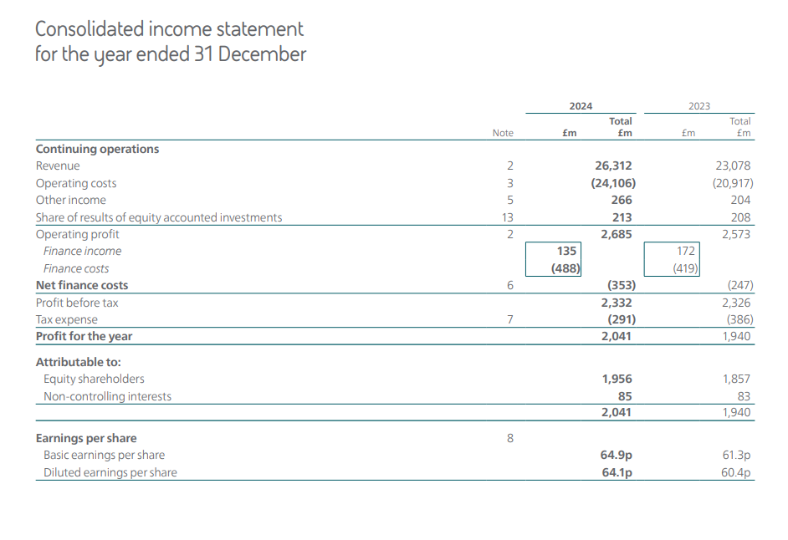
Figure 1: Consolidated Income Statement
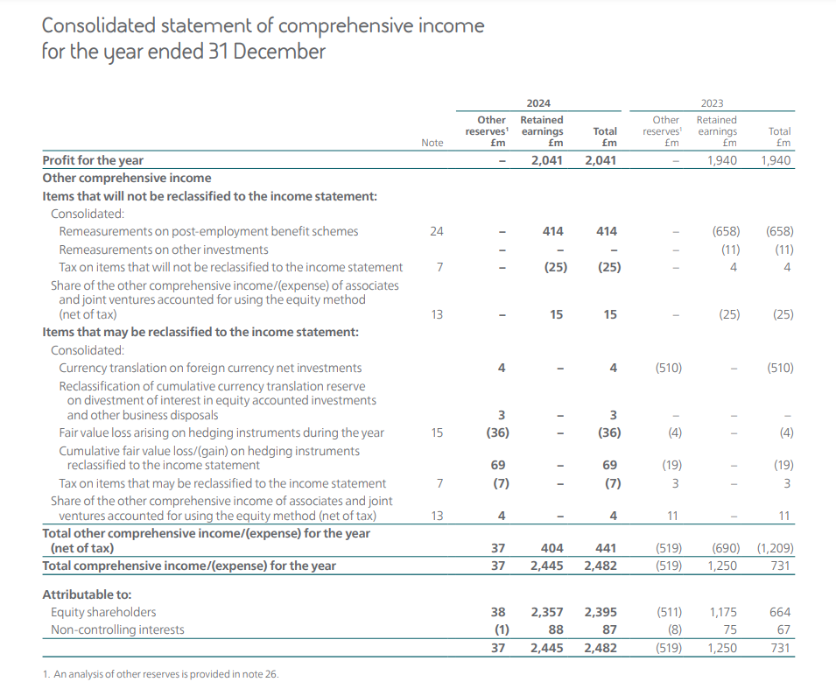
Figure 2: Consolidated Statement of Comprehensive Income
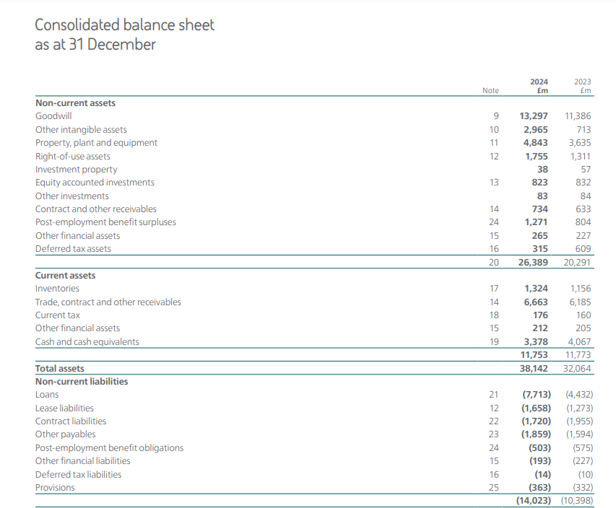
Figure 3: Consolidated Balance Sheet
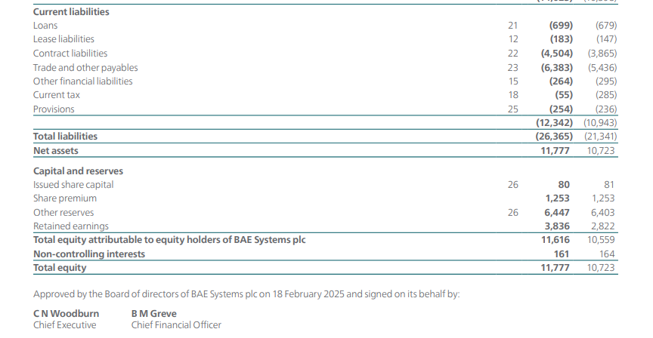
Figure 4: Consolidated Balance Sheet

Calculation
Profitability Ratios
 | 2024 | 2023
Operating Profit Margin | 10.20% | 11.15%
Net Profit Margin | 7.76% | 8.41%
Return on Asset (ROA) | 5.35% | 6.05%
Return on Equity (ROE) | 17.33% | 18.09%
Return on Capital Employed (ROCE) | 10.41% | 12.18%
Liquidity Ratios
 | 2024 | 2023
Current Ratio | 0.95 | 1.08
Quick Ratio | 0.85 | 0.97
Gearing Ratios
 | 2024 | 2023
Debt to Equity Ratio | 0.65 | 0.41
Gearing Ratio | 0.40 | 0.29
Efficiency Ratios
 | 2024 | 2023
Inventory Turnover (Days) | 17.85 | 17.74
Receivables Turnover (Days) | 10.18 | 10.01
Payables Turnover (Days) | 98.61 | 96.76
Asset Turnover | 0.69 | 0.72
Fixed Asset Turnover | 1.00 | 1.14
Solvency Ratios
 | 2024 | 2023
Interest Coverage Ratio | 5.50 | 6.14
Debt-to-asset Ratio | 0.20 | 0.14
Investment Ratios
 | 2024 | 2023
Earnings Per Share (EPS) -Basic | 64.90 | 61.30
Earnings Per Share (EPS) - Diluted | 64.10 | 60.40
Price per Earnings ratio (P/E) | 17.92 | 18.39

Option A: Expand Retail Outlet
Year | Cash Flow (£'000) | Capital Allowance (£'000) | Taxable Profit (CF - CA) (£'000) | Tax (25%) (£'000) | After-Tax Cash Flow (CF - Tax) (£'000) | Discount Factor (6%) | Present Value (£'000)
0 | -600 |  |  |  |  |  | -600
1 | 200 | 120 | 80 | 20 | 180 | 0.94 | 169.81
2 | 300 | 120 | 180 | 45 | 255 | 0.89 | 226.95
3 | 400 | 120 | 280 | 70 | 330 | 0.84 | 277.07
4 | 500 | 120 | 380 | 95 | 405 | 0.79 | 320.80
 |  |  |  |  |  | NPV | £ 394.63

Option B: Develop Internet Sales
Year | Cash Flow (£'000) | Capital Allowance (£'000) | Taxable Profit (CF - CA) (£'000) | Tax (25%) (£'000) | After-Tax Cash Flow (CF - Tax) (£'000) | Discount Factor (6%) | Present Value (£'000)
0 | -1000 |  |  |  |  |  | -1000
1 | 400 | 200 | 200 | 50 | 350 | 0.94 | 330.19
2 | 450 | 200 | 250 | 62.5 | 387.5 | 0.89 | 344.87
3 | 650 | 200 | 450 | 112.5 | 537.5 | 0.84 | 451.30
4 | 980 | 200 | 780 | 195 | 785 | 0.79 | 621.79
 |  |  |  |  |  | NPV | £ 748.15

Option C: Produce Curtains and Roman Blinds
Year | Cash Flow (£'000) | Capital Allowance (£'000) | Taxable Profit (CF - CA) (£'000) | Tax (25%) (£'000) | After-Tax Cash Flow (CF - Tax) (£'000) | Discount Factor (6%) | Present Value (£'000)
0 | -1600 |  |  |  |  |  | -1600
1 | 400 | 320 | 80 | 20 | 380 | 0.94 | 358.49
2 | 700 | 320 | 380 | 95 | 605 | 0.89 | 538.45
3 | 850 | 320 | 530 | 132.5 | 717.5 | 0.84 | 602.43
4 | 1100 | 320 | 780 | 195 | 905 | 0.79 | 716.84
 |  |  |  |  |  | NPV | £ 616.21

