THE BELFRY HOTEL & RESORT,
THE ROYAL TOWN OF SUTTON COLDFIELD

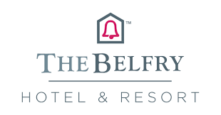

ORGANISATIONAL CONSULTANCY REPORT

Expert: Florentina Colindeata – 1706582

Representant of: P!nk Hotelier Consultancy – PHC

Specially designed to: Quin Holtzhuizen – The General Manager

Date delivery: 1st March 2023

THE EXECUTIVE SUMMARY
The P!nk Hotelier Consultancy have been contacted by the General Manager of The Belfry Hotel & Resort raising an issue that occurred within the mentioned venue.

As described by the General Manager, the stated issue is with regards to the implication of the employees towards the customer satisfaction. The motive for this was stating that the issue at stake is considerably negatively affecting the customer satisfaction, as a result of a closely observation of some reviews and feedback from the guests.

The General Manager has informed P!nk Hotelier Consultancy that the raised issue is preventing the venue, The Belfry Hotel and Resort from growing and achieving its full potential.

The General Manager also argued that her staff is not properly performing their job, issue which is directly affecting the overall performances of th business.

As a result of the mentioned and argued issue, the General Manager of The Belfry Resort and hotel as asked P!nk Hotelier Consultancy to provide with advice and guidance with the purpose of solving the issue at stake and help the towards the business growth.

After a throughout research, it was discovered that the venue at stake is a 5-star hotel with a globally recognised figure for golfing by hosting a prestigious and world-wide known golfing marathon, Ryder Cup. With its record, The Belfry Hotel and Resort was hosting Ryder Cup four times which is a record at a global scale.
Other than this, the venue is known for their facilities to host weddings and other ceremonies and party celebrations, as well as business conferences and meetings. It has a fabulous flora and fauna, which denotes a great care of the environment and its sustainability.

Numerically speaking, The Belfry is massive, with over 300 luxurious suits and other facilities to comfort the guests, such as indoor pool, tennis, a multitude of golf options for beginners and masters, SPA, gym, excellent food from numerous restaurants, and bars – the Brabazon bar which was actually a winner last year, holding the title for the best bar in West Midlands.

With all these winnings and good reputation, the General Manager presented reasons for concern regarding the customer satisfaction as a result of guests’ feedback and observation towards the employees.

The observations presented and the feedback were concerning the employee attitude towards the guests, some of which was described as being rushed.

To get to the bottom of the issue and offer the best guidance, advice, and recommendation to solve the problem, both internal and external environments should be analysed.

As a result of the analyses, it was discovered that the issue is coming from the managerial approach which may not be the suitable one. There are reasons that the employees are not happy in the workplace and in most of the cases, it comes to the improper management approach which once is changed, the employee satisfaction increased along the motivation.
Currently having authoritarian style of management, or a fusion of both authoritarian and participative – according to the Theory of X and Y, the employee does not present a good satisfaction and it is worth to try using the participative style of management as this is more permissible and reassures the employees that they are appreciated, while authoritarian type just gives directions.

Other than this, the management should focus more on boosting and improving the motivation of the employees, via motivator drivers, such as rewards, bonuses, gifts, promotions, or a good verbal feedback to ensure that their work is valued and appreciated.

There are reasons to believe that if the management style is adopted to participative and that is the managerial branch is focusing on a better working environment for employees and taking appropriate approached to improve their motivation, as presented above, the issue presented by the General Manager will no longer exist. The reason for this is that there is a sensible link between the employee satisfaction and customer satisfaction – if the employee is happy, then the likelihood of a better performance of the job considerably increases.

Table of Contents
THE INTRODUCTION 6
THE SCOPE & ANALYSIS 7
PESTLE 11
SWOT 13
DISCUSSION – THE MAIN BODY 15
THE FINDINGS & RESULTS 19
THE ACTION PLAN 20
THE RECOMMENDATIONS 22
THE CONCLUSION 23
THE REFERENCE LIST 24

THE INTRODUCTION
This particular report is being conducted with the aim and scope of demonstrating a sound knowledge of one of the key matters in the hotelier industry and business overall, the organisational consultancy, its surroundings and importance. Thus, these being said, this written piece of work will be constructed to serve as a consultancy report for the client.

An organisational consultancy report refers to a piece of work which usually is written for an audience with the lack of knowledge or for those who are not experts in the matter (Bit, 2021.) It is supposed to be clear and concise to that the reader, in this case, the client will understand the aim integrally (University of Southampton, 2023.) Expanding on the idea and for a better illustration of the purpose of the report, the client has chosen to contact a hotelier organisational consultancy provider due to the hotel’s problem.

The hotel at stake is The Belfry Hotel & Resort located in Lichfield, The Royal Town of Sutton Coldfield. The reason of the report is due to the venue’s complications which are affecting the overall functionality of the resort by representing an obstacle to its growth and success.

The issue at stake which is an obstacle for the venue stays within the lack of the afferent knowledge and approach border which does not permit the hotel to boost their customer satisfaction. Behind the presented outcome which the hotel is trying to face can be found the implication of the staff towards the guests and clients satisfaction, fact which is a great link – the employee, such as the front desk representatives of the hotel, are the face of the entire resort as these are the ones that the clients interact with upon arrival (Regan, 2023.) They give the first etiquette of the hotel and if this is not a positive one, then the client will most likely be disappointed throughout their stay within the enterprise. According to the latest statistics, a happy employee will usually be by over 30% more productive and will provide a happier environment than a less enthusiastic employee (SideMinder, 2023.)

In a such situation, the question relies over the improvement of the employees satisfaction and happiness which will have a direct and positive impact for the customer satisfaction which will eventually be improved (McAllister, 2022.)

As a result of the issue, in order to successfully provide a clear report for the purpose of improving the concerns of the client, a series of frameworks will be used, such as SWOT analysis and PESTLE analysis. Each of them has the purpose of exploring a certain matter regarding the hotel, such as SWOT closely looking at the internal environment of it by exploring its strengths, weaknesses, opportunities, and threats (Kenton, 2022.) Speaking of PESTLE analysis, it aims to explore the external factors, such as politics and technology impact for the hotel (CIPD, 2023.) It is important to keep in mind that both internal and external environment is affecting the functionality of the business and that a good handling of the relevant elements will increase the chances of a better improvement of the customer satisfaction of The Belfry Resort & Hotel (Sawyers, 2019.)

More than this, other observations, such as the work placed practices and theories, as well as approaches will be used to ensure a clear solution for the problem – customer satisfaction by the implication of the staff.

THE SCOPE & ANALYSIS
This section of the report is purposely created to observe the detailed information and relevant elements that might impact the complication of the venue. Thus, a background of The Belfry Hotel & Resort, as well as a short investigation of the surroundings, such as the nearby touristic points and other matters that may have a say in the functionality of the business will be explored. The reason of setting the scene for the report is that under this basis, a clear discussion followed by findings and an action plan can be provided. More than this, the opinion of the people via posted reviews and overall reputation that the enterprise holds will be deeply analysed. PESTLE and SWOT analysis will be thoroughly performed as these will set an insight view of the environments that the hotel currently has, making it easier to get to the bottom of the issue and advice the general manager accordingly.

The Belfry Hotel & Resort providing the public with unforgettable memories since late 1970s when it debuted. It has a great reputation for their golfing facilities thanks to the numerous golfing areas it offers. Also found under the name of Brabazon, its former president, the hotel & resort is highly associated with golf, people often referring to these as being ‘’synonyms’’. The reason for this is that it is known at a global scale due to their numerous Ryder Cup hosting four times which is more than any other venue, globally speaking (Architects, 2023.) Trying to analyse and reflect over the fact that it was the chosen venue to host the event so many times, there must be a reason behind it – as far as the people opinions goes, as well as relevant research as a result of the press reports, The Belfry Hotel & Resort was the host of some critical moments in the history of sports, especially when it comes to golf. More than this, the venue is known for their numerous programmes and courses that are aiming to teach and coach people at any level, including the beginners, up until the masters of the golf. The venue is award winning of the golf courses in the West Midlands, holding a multitude of wins for The Brabazon area, PGA National (The Belfry, 2023) and The Derby. Each of the mentioned areas are designated for a certain level of gold practitioners, starting in The Debry area and ending up in The Brabazon which is one of the most dramatic and challenging places for a golf master (Our Warwickshire 2023.) Other than this, The Belfry Hotel & Resort is known for their famous packages at a very reasonable price, each of them constructed in order to serve the needs that the client might have (The Belfry, 2023.)

As a result of this key point that defines the venue at issue for this report, The Belfry Hotel & Resort has a global name for its facilities when it comes to golf (Hall, 2022.) Hosting the most Ryder Cups and upsetting the other nations, such as USA thanks to its performance, the venue has a clearly famously established name when it comes to golf, and this is a strength of the overall business.

However, considering the background of the venue, it is important to consider other aspects that The Belfry Hotel & Resort provides, as the golfing facilities are not the only strength.

In addition to the amazing awards the hotel got thanks to the golfing experience it provides, the venue is also famous for their several places where people can celebrate an event, such as a wedding, a ceremony, a party, or any type of gathering. It provides with a very wide range of stunning suites that act as the host of the celebration – the suites are of different sizes and arrangements, as well as different locations over the Belfry’s land. The clients have a wide variety to choose from, accordingly to their preferences and tastes (Bride Book, 2022.) More than this, it offers the opportunity of customisation, such as the clients choosing their thematic, colours and other personal preferences to be added to the even – in most of the cases, the most celebration where clients use customisation is the wedding (Squaremeal, 2021.) Speaking of the weddings, Belfry might be the first choice of most of the clients, regardless the type of the event. On TripAdvisor, which is one of the most popular tourist platforms, The Belfry has over 5500 reviews, photos and comments with an overall rate of 5/5 starts (TripAdvisor, 2023.) The experience a wedding at Th Belfry provides is fabulous as they have venues to please any taste – from rustic to modern and customisation (Bhanot, 2020.) Extravagant or, in contrast, simplicity is another word to be used in this context as The Belfry is always ready to do anything to make its clients happy (Britain’s Finest, 2023.) Another benefit of Belfry is that it provides unique experiences for any type of wedding, and it actually has a great reputation of providing excellent Hindu weddings, as well as traditional one. Therefore, diversity is well implemented in Belfry’s vocabulary (Govind, 2022.)

For Belfry, the above-mentioned specifications are not all. Belfry also has a quite good reputation for the food it provides which is of a very wide range, from traditional food until grills and customisation according to the preferences of the client. Besides that, The Belfry Hotel & Resort provides the following facilities (The Belfry, 2023) –
- SPA
- Pool
- Gym
- Hot tub
- Jacuzzi
- Outdoor tennis
- Indoor pool
- Parking.

The flora and fauna The Belfry Hotel and Resort provides is unique. With over 550 of green land and lakes, the venue is benefiting from one of the most beautiful views, fact which amazes the clients into taking lots of pictures and wanting to come back in order to feel again the amazing experience. Speaking of its flora, Belfry celebrates and takes care of the nature – it has a lot of green land that is being taken care of as the venue knowns the importance of environment (The Belfry, 2023.) Something that adds a note of a special signature are the rabbits around the area. It is very common to see lots of rabbits playing around the hotel and this is something that adds a tone of unique image for the hotel – it denotes that Belfry takes care of its surroundings. Squirrels are part of the fauna of the resort as well (Foster, 2020.)

As up until this point, The Belfry has all the requirements that a client may want to see and benefit from while wanting to play golf, eat dinner, celebrate an occasion or just to relax. Speaking about the logistics, the resort is positioned close to natural fauna with lots of green land, as well as the Drayton Manor Amusement Park which is one of the most popular. Other than this, mall nearly 20 minutes away, such as Bullring Birmingham is to be found, as well as the Tamworth Castle and Cathedral (TripAdvisor, 2023.)

To better illustrate both positive and negative elements of Belfry Hotel & Resort, SWOT and PESTLE analyses will be used to outline the key points –

PESTLE analysis is used to explore the external environment elements which are known to have an either direct or indirect impact for the venue via the pillars of the world – politics, economy, society, technology, law or legal and environment (PESTLE analysis, 2023.)

ELEMENT | IMPACT AT BELFRY
POLITICS | - Politics are a matter to concern for any business as the parliament and government may at any time increase the taxation governance, as well as to increase the fees and VAT.  - Belfry being a part of the hospitality industry, it automatically implies that any change will be impacted upon the venue.  - It is critical that at all times Belfry is watching and stays focused on the news in order to adjust their policies and mode of operation accordingly to the regulations (The Belfry, 2020.)  - A matter of concern for the past 3 years has been the Coronavirus Pandemic which changes the rules in the industry as people were obligated to wear masks and keep a reasonable distance – this negatively impacted the resort as people were afraid to leave their homes. In fact, it was the government advice to not leave the house premises unless it is an emergency (O’Donnell, 2021.)
ECONOMY | - The economy had faced critical times during COVID-19 as it went down, almost causing a global crisis due to the stop movement of people and goods. Due to this, the hospitality industry was no exception, and The Belfry was impacted by this factor (The World Bank, 2022.)  - As a result, it caused in losing lots of employees and making them either redundant or following the guidance of furlough criteria.  - The profitability of the business considerably decreased (UK Parliament, 2021.)  - However, as the time passed by and the virus slowly went away, the venue started to work under the guidance and slowly grew back, after an immediate closure as a result of aggravated spread of the virus (Stewart, 2020.)
SOCIETY | - The society is one of the pillars for any business. Through the society is to understand the power of the people and the impact that it holds (Hendron, 2021.)  - Being a business to client relation, the society greatly impact it and the venue needs to take care of the needs of the society in order for the public to create a positive reputation. Nowadays, the society’s power stays within the review aspect, as well as opinions as recommendations.  - Another mentionable matter is the CSR – Corporate Social Responsibility whose essence is to self-regulate the process and transparency of the company towards the public. Being a part of this will ensure the public that the business is transparent and has only good thoughts – as proved in the above sections, The Belfry is a CSR affiliate (The Belfry, 2023.)  - As an illustration, if Belfry does not take care of the needs of the society, then the society will not appreciate the business and it will have a bad reputation, fact which is directly linked to loss of profit (Eccles, 2007.)
TECHNOLOGY | - The development of the technology enabled the hotel to benefit of so many aspects, such as a strong marketing strategy.  - Belfry uses online platforms to allow the clients to good their rooms, as well as to make any changes.  - The communication within the staff of Belfry is helped by the technology via the staff platform they use (WeBee, 2022.)
LEGAL | - Law and the regulations should be always followed in order to avoid the consequences of breaching the law, such as facing suits or fees up to unlimited amounts of money.  - Some of the regulations the Belfry must follow are the Equal Pay Act, Consumer Rights Act 2015 and the food and health safety approaches (Legislation.gov.uk., 2023.)
ENVIORNMENTAL | - In the past years, the nature had suffered a lot of changes that negatively impacted its health (Pierce, 2021.)  - All the industries must take approach in order to help it grow – being a part of CSR like Belfry does is a good start.  - Other than this, reducing the waste, the carbon footprints and recycling are great for a better impact.  - It is especially important for the hospitality industry as the natural resources are wanted by the guests (Mensah, 2019.)

SWOT analysis is used to explore the internal elements which are known to have a direct impact over the functionality of the business. It focuses on its strengths, weaknesses, opportunities, and threats. Often, the opportunities are used to transform the weaknesses in strengths and to get rid of the threats (CIPD, 2023.)

ELEMENT | IMPACT AT BELFRY
STRENGTHS | - Massive capacity – over 300 rooms  - Multitude of different suites for celebrations  - Lots of green land  - Golf rewards  - Bar excellency rewards – the Brabazon Bar, the bar of the year (Wright, 2022.)  - Accessible prices  - Excellent food  - Lots of facilities: SPA, pool, tennis, etc.  - Rich flora and fauna
WEAKNESSES | - There are some concerns raised about the implication of the staff towards the customer satisfactions as there have been some negative feedback – both on online platforms, such as on Trip Advisor where a client was complaining about the staff services.  - Other than this, there seems to be a problem with the lighting, as someone complained.  - Another feedback comment explained that the staff seemed rushed and not willing to help the guests properly (TripAdvisor, 2017.)  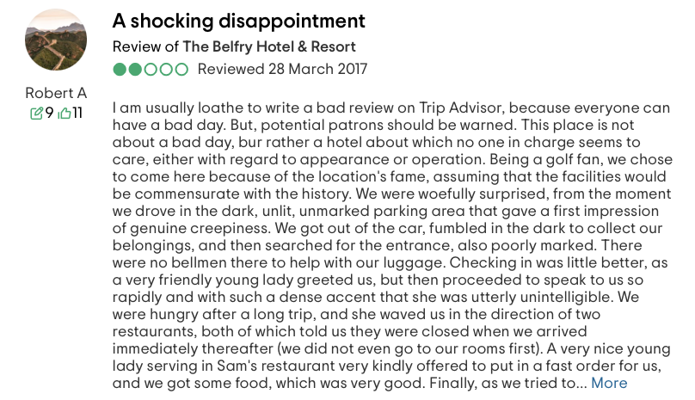  - Since then, such comments increased, fact which negatively impacts the overall functionality of it, as well as the profitability  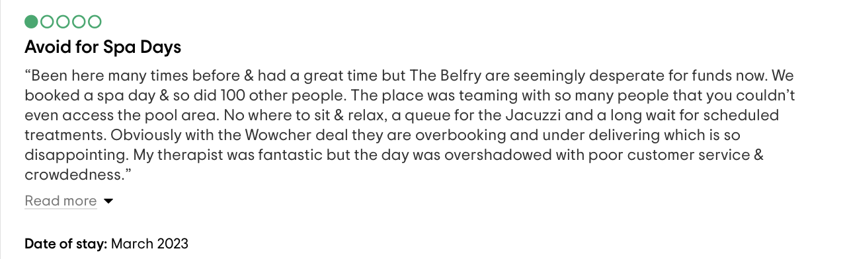
OPPORTUNITIES | - The best opportunity for Belfry in order to ensure that they do not lose all the good reputation it has tanks to their golfing facilities, as well as for their numerous venues for celebration, is to show more interest towards the motivation of employees.  - The wellbeing and happiness of the employee are a direct impact on the customer satisfaction, as the statistics shows (DeFranzo, 2023.)  - Meetings with employees, receiving & giving feedback via the 360-degree appraisal might make a great difference – it implies anonymous feedback from all staff to all staff (Appraisal 360, 2022.)  - To take a more psychological approach, sunt as understanding the McGregor X and Y theory, or Maslow’s Hierarchy of needs (MindTools, 2022.)
THREATS | - Not making the most towards the improvement of the current issue the resort is facing will result in Belfry being overstepped by the competition (Kerr, 2018.)  - Monetary losses.  - Loss of good reputation.

DISCUSSION – THE MAIN BODY
As a result of the throughout examination of Belfry Hotel & Resort via the frameworks aiming to analyse micro and macro environments both, it came to the conclusion that the issue raised by the general manager is directly proportionated with the issue that was found after the long exploration of the hotel.

The issue raised by the general manager was about the customer satisfaction, as a result of some negative comments while on the premises i.e., while the clients were staying at the hotel, as well as via some feedback posted on the social media platforms, as presented in the section above. Further than this, the issue is a little bit more complex as the customer satisfaction is reflected by the implication of the staff and how hard they work in order to ensure that the clients are benefiting from what they have been promised with – including a great customer service, positive and peaceful environment and guidance if needed.

The reviews that have been selected and also the ones that are confirming the general manager’s concern are related to the employee and their actions towards the guests. It is to be mentioned that immediate action for this matter is needed in order to avoid any possible loss in clients base, satisfactory engagement, and profits. After the examination and according to the reviews, seems that the front desk employees are the problematic department; however, the reference was made for the employees in general, thus a general approach will be recommended. There is no harm in boosting the motivation and increasing the happiness and the wellbeing of all employees – in fact, this may have an even better outcome than predicted. Discovering the department that needs the most attention, front desk, however the entire employee base will be subject to this, it leads the consultancy leaflet to the next key, such as searching the best solution for the existing issue. Knowing that the knowledge is the key to all the issues, regardless its nature, some key matters must be considered –

The employees are the first persons to interact with the clients, which means that they hold a great power towards the reputation of the business, in this case, The Belfry (Prossack, 2019.) There is a very fine and fragile link between the employee satisfaction that impacts the customer satisfaction. There is an old saying which embraces the fact that a person cannot make another person happy if they are not happy themselves (Suttie, 2021) and considering this, it is transferable and applicable here – with the exclusion of each individuals’ personal problems, an employee who is not happy with the work conditions cannot perform the job properly (Citizens Advice, 2022.)

As this clearly became a problem with regards to the management approach when it comes to the employees’ management, one main thing should be considered – the management style and its effectiveness, as well as the motivation of the employees and how to boost it, accordingly to each individual’s perspectives.

Reflecting over the management style, the theory of McGregor can be used. The Theory X and the Theory Y outlines two different management styles approaches – the authoritarian style (X) and the participative style (Y). In his book, McGregor underlines that not applying the correct and the suitable style of management for the employees will result in a poor satisfaction of them, which will eventually have negative impacts for the customer satisfaction and engagement (Morse, 2023.)

The authoritarian style (X) is the one that has the lowest rate of success, and its usage is to be found in very few enterprises. It implies a manager who is not implied in the work that has to be done, therefore s/he does not give advice and guidance, but directions. Certainly, the motivation of the employee is relevant here and if its levels are low, it is probably because the authoritarian style is erred used here (MSG, 2022.)

On a more comforting statement, the participative style (Y) is nothing alike the authoritarian style (X) and if used correctly, it may boost the employees motivation. Theory Y describes the implication of the manager and describes it as guiding and helping the workers, rather than just giving directions without any explanation (TSW Training, 2022.)

Although the style of management used at Belfry might be a combination of both, it may be beneficial to focus on one, namely the participative one so that the performance of the team can increase along the motivation. According to the presented reviews, the style used might be authoritarian as the lighting problem was reported but no manager took care of it, as well as the fact that the employees show certain signs of lack of motivation, including rushing the clients or not ensuring that their desires have been satisfied (Kurt, 2021.)

In addition to this, when the issue at stake reflects a motivation problem at the employees level, then the Hierarchy of Needs created by Maslow should be considered. The motivation of people, especially the motivation of employees, in this case, is crucially important. An unmotivated individual is less likely to perform the job at a high level, but it is known just to give the impression that the job has been done, at most. This is unacceptable for Belfry and not only, due to the fact that such high awards and reputation cannot be sustained with unmotivated staff (McLeod, 2023.)

Maslow represents the motivation by considering 5 distinctive levels, each of them having its own importance. It is notably that in order to get to the top of the pyramid, as expressed in the picture below, all of the previous stages should be fulfilled. To do this, in this case, the manager has to be aware of the level of the motivation each employee is on, in order to take the afferent approach to boost the motivation. To illustrate this, someone at the top of the pyramid achieving self-actualization has to be challenged with more difficult tasks and motivated with greater position and business recognition, as motivating them by providing with the basic needs will not work.
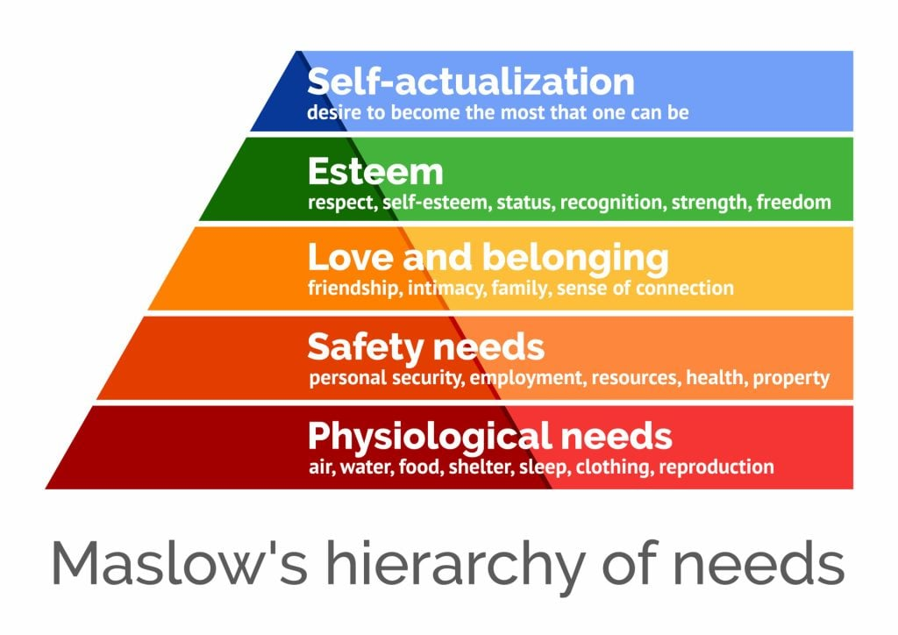

The wellbeing of the employees, their motivation and state of mind are much important for the success of the business and its operational manner. The Belfry Resort and Hotel needs to be sure of the levels of the motivation within its employee department base so that they can work their way up from there. It is important to celebrate and to promote a good environment, a good state of mind, as well as to always reassure that the employees are valued and that their work is being appreciated. An individual, an employee has to be able to develop both personally and professionally in order to properly perform the job and stay focus with a high level of motivation (CIPD, 2023.)

Even now, the hard work of the employees should be valued and appreciated as the hotel got this fantastic reputation and etiquette thanks to the hard work the employees performed over the years. This is another reason to ensure that the employees are being recognised. Here is about the improvement of their implication for a better success and a better satisfaction of the clients, which means that there are some premises to work from. The issues raised from people’s reviews are easily solved with the right approach and guidance from the above.

It can be tried either by approaching a more participative (Y theory) approach so that employees will see that they are being helped and that they are valued and appreciated. Some representative examples of it might be through (Square, 2022) –
- Motivation by money compensation.
- Motivation by awards and rewards.
- Motivation by bonuses.
- Motivation by promotion, if applicable.
- Motivation by teambuilding escapades.
- Motivation by verbal recognition, such as offering comforting words upon the performance of a task or job

Considering the pyramid of needs, a good approach of the manager will certainly have positive impacts – knowing what the employee needs will make it easier to offer it to them, thing that will show him appreciation, comfort and as a result will be more likely to improve the job performance.

THE FINDINGS & RESULTS
Although the findings and the result have been disclosed throughout the sections of the report, especially within the main body of it, very briefly for a better understanding of each issue will be presented.

This will help to avoid any confusion or misunderstanding and therefore to offer a more straightforward answer to the raised issues.

The main issue relies at the employee base, which was found that as a result of a poor motivation of the employees which gives them low motivation levels, their performance is not good enough to boost the customer satisfaction.

More than this, it was observed that the poor motivation levels of the employees are a direct result of a poor management approach, fact which should me immediately reversed with a better one, for the purpose of The Belfry Hotel and Resort improvement.

The issues at stake are mostly concerning the attitude of the employees towards the clients arriving to the destination, such as being impatient with the guests and not taking care of their needs.

THE FINDINGS | THE RESULT
Not sufficient implication of the employees towards the customer satisfaction. | It resulted in poor customer enragement and satisfaction, fact which will considerably affect the busines integrally over the time if the problem is not being taken care of.
Improper management approach – not useful methods, erred application of management theories that have no satisfactory impact. Poor knowledge of the management about the employees motivation and how to boost it. | It resulted in lack of motivation for the employees, as well as a poor performance of them which eventually have had a negative impact for the customer satisfaction, resulting in poor reviews and negative comments.

THE ACTION PLAN

THE PROBLEM | THE SOLUTION | THE DESIRED OUTCOME | THE TIME SCALE | THE COMPLETION DATE | THE PLANNED BUDGET
Improper management approach. | Proper management approach via appropriate ways, such as management X and Y theories and boosting the employee satisfaction and motivation. the solution for this issue is to undertake appropriate measures to help the employees and some ways of doing this is by working on the management approach. Very often the managers are misunderstanding their approaches and do not give it a second though, matter that is reflected towards a poor employee based with insufficient satisfaction. Another solution is represented by boosting the motivation of the employee using promotions, if applicable, bonuses, rewards, monetary compensations, and recognition, such as verbally showing appreciation to the employees job. | Desirable is to increase the motivation of the employees, as well as their satisfaction which will ultimately reflect over the issue that the general manager contacted us with – better customer satisfaction. Moreover, proper management approach will be seen, which is another desired outcome. | 5 months to educate about the topic and take appropriate steps towards successful completion. | 1st of July 2023. | Depending on the managers’ choice to use the advice and implement the recommendations, especially about the monetary rewards for the motivation of the employees, a budget of £10,000 should be secured although the usage of the entire amount is questionable.
Not sufficient employee implication towards the customer satisfaction. | The solution for this problem is to boost the employees motivation and happiness at the workplace, as described for the first issue. These are linked together and in order to solve this, the first matter has to be done. However, it is foreseen that employees being happier at the workplace by their work being valued will result in improved customer satisfaction as the staff will act accordingly and better, without rushing the clients, as seen in the reviews. | The desired outcome here is that the customer satisfaction will increase, meaning that the business will be able to grow and to be more successful. | 12 months for certain and clear results. In the first 5 months the changes towards the improvement should already be seen. | 1st of March 2024. | A monetary budged is not available for this section as it can vary from 0 to unlimited.  As far as it can be seen, a reasonable amount of money should be used here, around £5,000 which can be paid into boosting the motivation of the employees.

THE RECOMMENDATIONS
As a result of the matters explored for the benefit of The Belfry Hotel and Resort, there can be found the recommendations –
- It is recommended to take a better and more beneficial approach for the management.
- As a result, the employee satisfaction will be improved.
- For a better management approach is important to consider –
  - Theories of management, X and Y; thus, it is recommended the participative (Y) approach in order to show the employees that they are not alone and that their manager cares about them.
  - Theories of motivation and how to boost it, such as the pyramid of needs which requires the manager to consider and evaluate each employee and get to know their current level of motivation in order to boost their motivation using something that may interest them.
- Other than this, it is recommended to take care of the working environment.
- It is also recommended to ensure, at all times, the wellbeing, and the happiness of the employees in the workplace.
- After this, polls can be conducted to see the employees satisfaction, as well as to receive and consider feedback form the clients and compare with the old ones.
- Boosting the motivation and wellbeing of the employees will help improve the customer satisfaction and engagement, as presented and demonstrated throughout the entire report.
- Consider the 360 appraisal feedback for the entire employee base.
- Consider meeting with all the staff, as well as by segregations via afferent departments.
- Offer motivational rewards.

THE CONCLUSION
Thus, as it was demonstrated throughout the report, the issue as stake presented by the general manager was discovered to be linked to another issue which ultimately impacted the reported issue.

The reported issue was about the implication of the employees towards the customer satisfaction as the customers have shown some negative comments on this matter. However, as a result of the research, the issue begins from the managerial area, all the way to the customer satisfaction via improper management of the employees.

Thus, to solve the reported issue, it is first important to solve the managerial issue approach by boosting the motivation of the employees to boost their wellbeing and happiness at work to offer great services for the customers.

P!nk Hotelier Consultancy is pleased to have been chosen to prepare the organisational report for The Belfry Hotel & Resort. It is hoped that the raised issued was answered and that the solution will be accordingly. If there are any more questions, please do not hesitate to get in touch at any time.

Best wishes,
P!nk Hotelier Consultancy PHC.

THE REFERENCE LIST

Appraisal 360, (2022), ‘’What is 360-degree feedback?’’, [online] available on: https://www.appraisal360.co.uk/about/what-is-360-degree-feedback/ , last accessed on 1st of March 2023.

Architects, (2023), ‘’The Belfry (Brabazon)’’, [online] available on: https://www.top100golfcourses.com/golf-course/belfry-brabazon , last accessed on 1st of March 2023.

Bhanot, M., (2020), ‘’Small wedding package at The Belfry – the ultimate intimate ceremony to cherish forever’’, [online] available on: https://www.birminghammail.co.uk/special-features/small-wedding-package-belfry-ultimate-19059137, last accessed o 1st of March 2023.

Bit, (2021), ‘’Consultancy Report: What is it and how to create it?’’, [online] available on: https://blog.bit.ai/consulting-report/ , last accessed on 1st of March 2023.

Bride Book, (2022), ‘’The Belfry’’, [online] available on: https://bridebook.com/uk/wedding-venues/the-belfry-sutton-coldfield-warwickshire-eenXKR9r8R , last accessed on 1st of March 2023.

Britain’s Finest, (2023), ‘’The Belfry’’, [online] available on: https://www.britainsfinest.co.uk/weddingvenues/thebelfryhotel , last accessed on 1st of March 2023.

CIPD, (2023), ‘’PESTLE analysis’’, [online] available on: https://www.cipd.co.uk/knowledge/strategy/organisational-development/pestle-analysis-factsheet#gref , last accessed on 1st of March 2023.

CIPD, (2023), ‘’SWOT analysis’’, [online] available on: https://www.cipd.co.uk/knowledge/strategy/organisational-development/swot-analysis-factsheet#gref , last accessed on 1st of March 2023.

CIPD, (2023), ‘’Wellbeing at work’’, [online] available on: https://www.cipd.co.uk/knowledge/culture/well-being/factsheet#gref , last accessed on 2nd of March 2023.

Citizens Advice, (2022), ‘’Talking to your employer about a problem’’, [online] available on: https://www.citizensadvice.org.uk/work/negotiating-with-your-employer/dealing-with-a-problem-at-work/ , last accessed on 1st of March 2023.

DeFranzo, S., (2023), ‘’Satisfied employees leads to satisfied customers’’, [online] available on: https://www.snapsurveys.com/blog/satisfied-employees-leads-satisfied-customers/ , last accessed on 1st of March 2023.

Eccles, R., (2007), ‘’Reputation and Its Risks’’, [online] available on: https://hbr.org/2007/02/reputation-and-its-risks , last accessed on 1st of March 2023.

Foster, L., (2020), ‘’World wildlife day at The Belfry’’, [online] available on: https://www.thebelfry.com/news/posts/world-wildlife-day-at-the-belfry/ , last accessed on 1st of March 2023.

Govind, A., (2023), ‘’The Belfry Hotel & Resort’’, [online] available on: https://www.ankitgovind.co.uk/the-belfry-hotel-and-resort , last accessed on 1st of March 2023.

Hall, J., (2022), ‘’Ryder Cup: The Belfry eyes 2035 bid as it exits running for 2031’’, [online] available on: https://www.bunkered.co.uk/golf-news/ryder-cup-the-belfry-eyes-2035-bid-as-it-exits-running-for-2031/ , last accessed on 1st of March 2023.

Hendron, A., (2021), ‘’The importance of the hospitality industry & its four sectors’’, [online] available on: https://www.eposnow.com/uk/resources/importance-of-the-hospitality-industry/, last accessed on 1st of March 2023.

Kenton, W., (2022), ‘’SWOT analysis’’, [online] available on: https://www.investopedia.com/terms/s/swot.asp , last accessed on 1st of March 2023.

Kerr, M., (2018), ‘’7 critical risks facing the hospitality industry’’, [online] available on: https://riskandinsurance.com/7-critical-risks-facing-the-hospitality-industry/ , last accessed on 1st of March 2023.

Kurt, S., (2021), ‘’Theory X and Theory Y, Douglas McGregor’’, [online] available on: https://educationlibrary.org/theory-x-and-theory-y-douglas-mcgregor/ , last accessed on 1st of March 2023.

Legislation.gov.uk., (2023), ‘’Consumer Rights Act 2015’’, [online] available on: https://www.legislation.gov.uk/ukpga/2015/15/contents/enacted , last accessed on 1st of March 2023.

McAllister, J., (2023), ‘’Hospitality workers under increased pressure as job satisfaction dwindles’’, [online] available on: https://www.bighospitality.co.uk/Article/2022/04/04/hospitality-workers-under-increased-pressure-as-job-satisfaction-dwindles , last accessed on 1st of March 2023.

McLeod, S., (2023), ‘’Maslow’s hierarchy of needs theory’’, [online] available on: https://simplypsychology.org/maslow.html , last accessed on 1st of March 2023.

Mensah, I., (2019), ‘’Environmental Management Concepts and Practices for the Hospitality Industry’’, [online] available on: https://www.cambridgescholars.com/resources/pdfs/978-1-5275-3630-2-sample.pdf , last accessed on 1st of March 2023.

Mindtools, (2022), ‘’Theory X and theory Y’’, [online] available on: https://www.mindtools.com/adi3nc1/theory-x-and-theory-y , last accessed on 1st of March 2023.

Morse, J., (2023), ‘’Beyond Theory Y’’, [online] available on: https://hbr.org/1970/05/beyond-theory-y , last accessed on 1st of March 2023.

MSG, (2022), ‘’Theory X and theory Y’’, [online] available on: https://www.managementstudyguide.com/theory-x-y-motivation.htm , last accessed on 1st of March 2023.

O’Donnell, P., (2021), ‘’The Belfry Hotel – Preparing for a big event during Covid’’, [online] available on: https://www.hotelowner.co.uk/144984-the-belfry-hotel-preparing-for-a-big-event-during-covid/ , last accessed on 1st of March 2023.

Our Warwickshire, (2023), ‘’Golf at the Belfry: the Ryder Cup’’, [online] available on: https://www.ourwarwickshire.org.uk/content/article/golf-belfry-part-2 , last accessed on 1st of March 2023.

PESTLE analysis, (2023), ‘’What is PESTLE analysis? An important business analysis tool’’, [online] available on: https://pestleanalysis.com/what-is-pestle-analysis/ , last accessed on 1st of March 2023.

Pierce, J., (2021), ‘’Why sustainability in the hospitality industry must be our top priority’’, [online] available on: https://www.torrens.edu.au/blog/why-sustainability-in-the-hospitality-industry-must-be-our-top-priority , last accessed on 1st of March 2023.

Prossack, A., (2019), ‘’How employee satisfaction affects customer satisfaction’’, [online] available on: https://www.forbes.com/sites/ashiraprossack1/2019/05/31/employee-satisfaction-customer-satisfaction/?sh=24e2c7a05e2c , last accessed on 1st of March 2023.

Regan, (2023), ‘’10 easy tips to improve employee satisfaction in the hotel industry’’, [online] available on: https://connecteam.com/employee-satisfaction-hotel-industry/ , last accessed on 1st of March 2023.

Sawyers, S., (2019), ‘’A Hotel’s internal environment’’, [online] available on: https://www.linkedin.com/pulse/hotels-internal-environment-stephen-hotel-blog-sawyers/ , last accessed on 1st of March 2023.

SideMinder, (2023), ‘’Your guest service framework: why hotels need to focus on employee satisfaction and happiness?’’, [online] available on: https://www.siteminder.com/r/trends-advice/hotel-management/guest-service-staff-hotel-happy/ , last accessed on 1st of March 2023.

Square, (2022), ‘’10 scientifically proven ways to motivate employees’’, [online] available on: https://squareup.com/gb/en/townsquare/how-to-motivate-your-employees , last accessed on 1st of March 2023.

Squaremeal, (2021), ‘’The Belfry Hotel’’, [online] available on: https://www.squaremeal.co.uk/wedding-venues/the-belfry-hotel_1145 , last accessed on 1st of March 2023.

Stewart, J., (2020), ‘’Temporary closure – Coronavirus update’’, [online] available on: https://www.thebelfry.com/news/posts/temporary-closure/ , last accessed on 1st of March 2023.

Suttie, J., (2021), ‘’If you want to be happy, try to make someone else happy’’, [online] available on: https://greatergood.berkeley.edu/article/item/if_you_want_to_be_happy_try_to_make_someone_else_happy , last accessed on 1st of March 2023.

The Belfry, (2023), ‘’Book with confidence – best rate guaranteed’’, [online] available on: https://www.thebelfry.com/offers/ , last accessed on 1st of March 2023.

The Belfry, (2023), ‘’Corporate Social Responsibility CSR’’, [online] available on: https://www.thebelfry.com/csr/ , last accessed on 1st of March 2023.

The Belfry, (2023), ‘’Legendary Golf stay & play breaks, lessons, & more’’, [online] available on: https://www.thebelfry.com/golf/ , last accessed on 1st of March 2023.

The Belfry, (2020), ‘’Reopening Risk Assessment’’, [online] available on: https://www.thebelfry.com/media/1968/risk-assessment-positioning-statement-june-20.pdf , last accessed on 1st of March 2023.

The Belfry, (2023), ‘’Sustainability’’, [online] available on: https://www.thebelfry.com/sustainability/ , last accessed on 1st of March 2023.

The Belfry, (2023), ‘’The PGA National’’, [online] available on: https://www.thebelfry.com/golf/the-pga-national/ , last accessed on 1st of March 2023.

The World Bank, (2022), ‘’Chapter 1. The economic impacts of the Covid-19 crisis’’, [online] available on: https://www.worldbank.org/en/publication/wdr2022/brief/chapter-1-introduction-the-economic-impacts-of-the-covid-19-crisis , last accessed on 1st of March 2023.

TripAdvisor, (2023), ‘’The Belfry Hotel & Resort’’, [online] available on: https://www.tripadvisor.co.uk/ShowUserReviews-g504209-d250687-r216836156-The_Belfry_Hotel_Resort-Wishaw_Warwickshire_England.html , last accessed on 1st of March 2023.

TripAdvisor, (2023), ‘’Things to do near The Belfry hotel & resort’’, [online] available on: https://www.tripadvisor.co.uk/AttractionsNear-g504209-d250687-The_Belfry_Hotel_Resort-Wishaw_Warwickshire_England.html , last accessed on 1st of March 2023.

TSW Training, (2022), ‘’McGregor’s Theory X and Theory Y: how to increase performance in your team’’, [online] available on: https://www.tsw.co.uk/blog/leadership-and-management/mcgregors-theory-x-vs-theory-y/ , last accessed on 1st of March 2023.

UK Parliament, (2021), ‘’Coronavirus: Economic impact’’, [online] available on: https://commonslibrary.parliament.uk/research-briefings/cbp-8866/ , last accessed on 1st of March 2023.

University of Southampton, (2023), ‘’Consultancy Report’’, [online] available on: https://www.southampton.ac.uk/englishforengineers/understanding_assessed_tasks/reports/consultancy_report.page , last accessed on 1st of March 2023.

WeBee, (2022), ‘’Using technology to gain a competitive advantage in the hotel industry’’, [online] available on: https://www.getwebee.com/en/resources/latest-news-from-webee-and-hotel-industry/using-technology-to-gain-a-competitive-advantage-in-the-hotel-industry , last accessed on 1st of March 2023.

Wright, C., (2022), ‘’Brabazon bar wins hotel bar of the year’’, [online] available on: https://www.thebelfry.com/news/posts/brabazon-bar-wins-hotel-bar-of-the-year/ , last accessed on 1st of March 2023.

