
APPENDIX GA36d

LEVEL 7 ASSESSMENT SPECIFICATION

Student name: |  | Student ID number:
Programme: | MSc (Cybersecurity and Digital Forensics)
Module: | Enterprise Network Security
Module code: | ACCA7032 | Contribution to Overall Module Assessment (%): | 100%
Lecturer: | Renuga Jayakumar | Internal Verifier:
Assignment Title: | Applied Network Security: Contemporary Research, Practical Work, and Demonstrations of Principles and Practices | Word count (or equivalent): | 5000
Submission deadline: | CTF: w/c 2nd March 2026 (submission deadline : 8th March 2026)  Demonstration: 21st and 22nd April 2026 (Week 11)  Report: 20th April 2026, 14:00 (2PM) | Return date of provisional marks & written feedback: | 18th May 2026
Submission method: | All written assessments, where practical and possible, must be submitted via Turnitin unless otherwise instructed by the Lecturer. (Please DO NOT put this assessment specification into Turnitin or it will match many similarities with other students’ submissions.)  Alternative submission method (if applicable): NA  Late submission of the assessment will result in a late penalty mark:.  Work which is submitted up to 1 week late will be capped at 50% for the first attempt and will be awarded a mark of 0% for re-assessment. Late submission penalties may be lifted only if there is an approved extenuating circumstances claim.  Work submitted more than 1 week late will be considered as a non-submission and will not be marked. The work may be considered as a submission for reassessment if offered by an Examining Board or if there is an approved extenuating circumstances claim.
Academic honesty / referencing: | Academic honesty is required. In the main body of your submission you must give credit to authors on whose research and ideas your work is based. Append to your submission a reference list that indicates the books, articles, etc. that you have used, cited or quoted in order to complete this assessment.

Module Learning Outcomes
(from module syllabus)
- Demonstrate a systematic understanding of a wide range of current research and technological advances in network security underpinning the key elements of unified security management architecture in managing and monitoring network traffic;
- Apply the principles and practices of network security for mitigating the key technical security vulnerabilities that organisations face and gain insight on how security features are enabled, and policies applied.

TASK DESCRIPTION

Use of Generative AI in Assessment
(Lecturer to indicate Yes or Not against each element)

RESEARCH | For this assessment, you can use Generative AI to support you in research and data analysis. | Yes ☒  No ☐
STRUCTURE | For this assessment, you can use Generative AI to support you in structuring your submission, including creating a draft argument structure, identifying parts and headings, etc. | Yes ☒  No ☐
PROOFREADING | For this assessment, you can use Generative AI to check your own text/creation for grammatical and syntactical mistakes, including getting suggestions to rephrase your work. | Yes ☒  No ☐
WRITING | For this assessment, you can use Generative AI to create text for submission. | Yes ☐  No ☒
CREATIVE | For this assessment, you can use Generative AI to create creative materials, such as images. | Yes ☐  No ☒
PROGRAMING | For this assessment, you can use Generative AI to create and check code. | Yes ☐  No ☒
NONE | For this assessment, you are not allowed to use any type of Generative AI support. This includes research support, structure support, writing/proofreading support and creative support. | ☐

Overview

Two parts of the portfolio in this assessment. The deadline for each part is different.
- Portfolio (Part 1) Capture the Flag (20 %)
- Portfolio (Part 2): Analysis, Design, and Implementation of a Network Security Solution (80 %)

Part 1 – Capture the Flag (CTF)
Enterprise Network Deployment and Verification (20%)
Note: Submission deadline 8th March 2026 – The submission will be done on Moodle

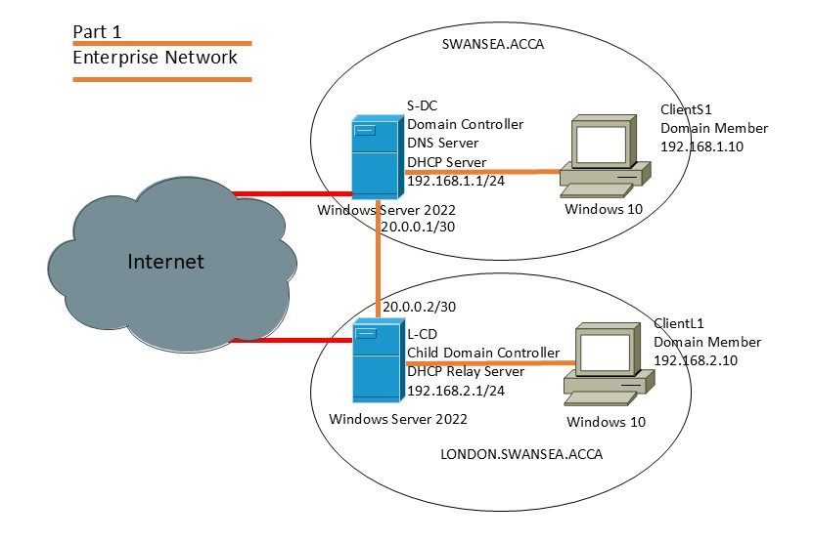
Figure 1: Enterprise Network

The Part 1 is designed to assess your practical skills in deploying and configuring essential enterprise network services using “Capture The Flag (CTF)” challenge to verify and test your understanding of this enterprise network setup.

Refer to Figure 1: The Enterprise Network consists of two sites: SWANSEA.ACCA and LONDON.SWANSEA.ACCA

Scenario:
As part of the initial practical exercises done in the class (refer Figure 1), where you will interact with virtual machines (VMs) to configure, locate misconfigurations, and capture the flags. You are expected to identify the flags (Flags are unique text strings). The Capture the Flag Task will be available on the Moodle for you to record the flags for one week (from c 2nd March 2026 to 8th March 2026 ), giving you sufficient time to engage with the network topology and submit your flags.

The topology includes the following core network services, with some pre-configured and others yet to be configured:
- DNS (Domain Name System)
- Firewalls with appropriate rule sets
- Active Directory Domain Controller (AD DC), including a child domain
- VPN (Virtual Private Network) – Site-to-Site (S2S) connection
- DHCP (Dynamic Host Configuration Protocol)
- IIS (Internet Information Services) Web Server
- User accounts added and managed within Active Directory

Evaluation Criteria:
- Successful identification and capture of all CTF flags

Part 2 - Securing the Enterprise Network
Implementation of a Network Security Solution (80%)
You will be allocated a 30-minute slot: 15 minutes for the demo and 15 minutes for questions and answers, including the submission of screenshots on Moodle.

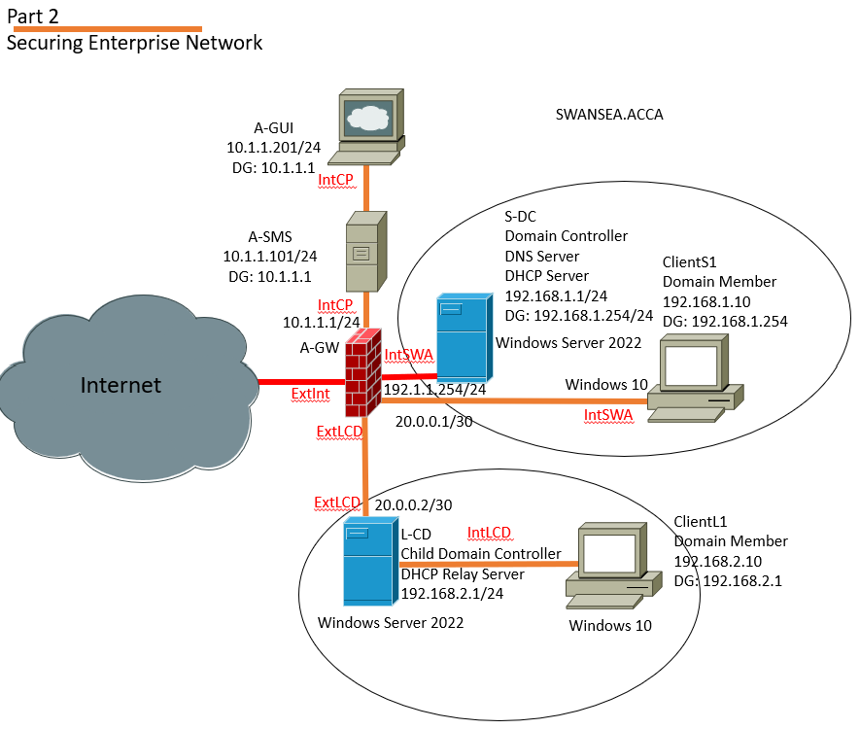
Figure 2: Securing Enterprise Network

In Part 2, you will be required to secure the Enterprise Network using GAIA appliances. After completing the security configurations, you will prepare to demonstrate your work. A submission link will be provided, where you must upload a report prior to your demo. The report should include screenshots of all completed configurations. During your assigned slot, you will give a demonstration of your work, providing detailed explanations and justifications for your configuration choices. All demonstrations will be recorded for assessment purposes.

Briefing
Building on your deployment from Part One, you will now secure the enterprise network by implementing best practices and additional security measures, including but not limited to:
- Modify the existing topology in Part One by adding a Check Point Security Management Server (SMS) with Gaia OS, which centralizes security policy management. You will need to install Smart Console on your management workstation to centrally administer the security infrastructure, connecting it to the SMS for policy management, event monitoring, and updates. You must apply the appropriate licenses on both the SMS and Check Point appliances as per the Check Point manual guidelines, verify they meet the module requirements, and document the licensing status and expiration details. (30%)
Key Aspects:
- Installation and Configuration of A-GW, A-SMS, A-GUI with appropriate IP Addresses and User Profiles.
- Licencing the Check Point Security Management Server.
- Successful connectivity between Swansea Network and A-SMS.
- Demonstrate your work

- Define and enforce firewall rules that restrict unauthorized inbound and outbound traffic, based on a real-life enterprise security policy, which you will need to justify. Implementation of additional security features—such as enabling IPS and anti-malware protections, and configuring user authentication and identity awareness to control access based on user roles and groups—will be considered an added advantage. (30%)
Key Aspects:
- (NOT LIMITED TO)
- Configuring adequate rules like Allowing/ Blocking ICMP, FTP, HTTP, Telnet, SSH Traffic etc inbound and outbound the Network.
- Demonstrate your work

- Enhance the security of your enterprise network by implementing any additional security features that align with recognized industry standards. You are encouraged to consult the official Check Point guidelines to identify and apply any advanced security functionalities that further strengthen your network infrastructure. (20%)
Key Aspects:

- (NOT LIMITED TO)
- Propose additional security features using Gaia Appliances
  - For example
    - configuring adequate rules enhancing user access controls
    - User Groups with limited access (web servers/ websites etc)

- Implement the proposed additional security features using Gaia Appliances
- Demonstrate your work

NB : As you complete each practical task, ensure you capture evidence by taking screenshots—preferably with visible timestamps. These will be compiled into a report that must be submitted after your final demonstration.

GUIDANCE FOR Students IN THE COMPLETION OF TASKS

NOTE: The guidance offered below is linked to the five generic assessment criteria overleaf.

- Engagement with Literature Skills
Your work must be informed and supported by scholarly material that is relevant to and focused on the task(s) set; you should make use of scholarly reviews and primary sources, as appropriate (for example, refereed research articles and/or original materials appropriate to the discipline). You should provide evidence that you have accessed a wide range of sources, which may be academic, governmental and industrial; these sources may include academic journal articles, textbooks, current news articles, organisational documents, and websites. You should consider the credibility of your sources; academic journals are normally highly credible sources while websites require careful consideration/selection and should be used sparingly. Any sources you use should be current and up-to-date, mostly published within the last five years or so, though seminal/important works in the field may be older. You must provide evidence of your research/own reading throughout your work, using correctly a suitable referencing system, including in-text citations in the main body of your work and a reference list at the end of your work.

Guidance specific to this assessment:

- Knowledge and Understanding Skills
At level 7, you should be able to demonstrate a systematic understanding of knowledge, and a critical awareness of current problems and/or new insights, much of which is at, or informed by, the forefront of your academic discipline, field of study or area of professional practice, with a comprehensive understanding of techniques applicable to your own research or advanced scholarship. Your work must demonstrate your growing mastery of these concepts, principles, current challenges, innovation and insights associated with the subject area. Knowledge relates to the facts, information and skills you have acquired through your learning. You demonstrate your understanding by interpreting the meaning of the facts and information (knowledge). This means that you need to select and include in your work the contemporary concepts, techniques, models, theories, etc. appropriate to the task(s) set. You should be able to explain the theories, concepts, etc. meaningfully to show your understanding. Your mark/grade will also depend upon the extent to which you demonstrate your knowledge and understanding; ideally each should be complete and detailed, with comprehensive coverage.

Guidance specific to this assessment:
- Successful identification and capture of all CTF flags

- Cognitive and Intellectual Skills
You should be able to: evaluate critically current research and advanced scholarship in the discipline; evaluate methodologies and develop critiques of them and, where appropriate, to propose new hypotheses; deal with complex issues both systematically and creatively to make sound judgements in the absence of complete data. Your work must contain evidence of logical, analytical thinking, evaluation and synthesis. For example, to examine and break information down into parts, make inferences, compile, compare and contrast information. This means not just describing what! But also justifying: Why? How? When? Who? Where? At what cost? At all times, you must provide justification for your arguments and judgements. Evidence that you have reflected upon the ideas of experts within the subject area is crucial to you providing a reasoned and informed debate within your work. Your choice of methodologies to gather data and information must be rigorously defended. Furthermore, you should provide evidence that you are able to make sound judgements and convincing arguments using data and concepts. Sound, valid, persuasive conclusions are necessary and must be derived from the content of your work. Where relevant, alternative solutions and recommendations may be proposed.

Guidance specific to this assessment:
- Propose additional security features using Gaia Appliances

- Practical Skills
At level 7, you should be able to demonstrate originality in the application of knowledge, together with a practical understanding of how established techniques of research and enquiry are used to create and interpret knowledge in the discipline. This includes acting autonomously in planning and implementing tasks at a professional or equivalent level, originality in tackling and solving problems, and decision-making in complex and unpredictable contexts or situations.

You should be able to demonstrate mastery of the leading edge subject-related concepts and ideas as they relate to real world situations and/or particular contexts. How do they work in practice? You will deploy models, methods, techniques, and/or theories, in those contexts or circumstances, to assess current situations, perhaps to formulate plans or plausible, justifiable recommendations to solve problems, or to propose new models, or to create artefacts, which may be innovative and creative, thereby demonstrating your understanding of how the boundaries of knowledge are advanced through research and/or application. This is likely to involve, for instance, the use of real world artefacts, examples and cases, the application of a model within an organisation and/or benchmarking one theory or organisation against others.

Guidance specific to this assessment:
- Installation and Configuration of A-GW, A-SMS, A-GUI with appropriate IP Addresses and User Profiles, Licencing the Check Point Security Management Server, Successful connectivity between Swansea Network and A-SMS.

- Configuring adequate rules like Allowing/ Blocking ICMP, FTP, HTTP, Telnet, SSH Traffic etc inbound and outbound the Network.
- Implement the proposed additional security features using Gaia Appliances

- Transferable Skills for Life and Professional Practice
Your work must provide evidence of the qualities and transferable skills necessary for postgraduate-level employment in circumstances requiring sound judgement, personal responsibility and initiative in complex and unpredictable professional environments. This includes demonstrating: the independent learning ability for continuing professional development to advance existing skills and acquire new competences of a professional nature that will enable you to assume significant responsibility within organisations; that you can initiate and complete tasks, projects and procedures, whether individually and/or collaboratively, to a professional level; that you can use appropriate media to effectively communicate information, arguments and analysis in a variety of forms for a variety of audiences; fluency of expression; clarity and effectiveness in presentation and organisation. Work should be coherent and well-structured in presentation and organisation.

Guidance specific to this assessment:
- Demonstrate your work on Modifying the topology to accommodate GAIA appliances, Licensing and successful connections.
- Demonstrate the implemented inbound and outbound traffic rules as outlined in Question 2
- Demonstrate your work on implemented additional security features using Gaia Appliances
- Response to questioning

Student FEEDBACK FORM

This section details the extent to which the assessment criteria are demonstrated by you, which in turn determines your mark. The marks available for each category of skill are shown. Lecturers will use the space provided to comment on the achievement of the task(s), including those areas in which you have performed well and areas that would benefit from development/improvement.

Generic Assessment Criteria | Marks available | Marks  awarded
1. Engagement with Literature Skills  . | NA
2. Knowledge and Understanding Skills  - Successful identification and capture of all CTF flags | 20
3. Cognitive and Intellectual Skills  - Propose additional security features using Gaia Appliances | 5
4. Practical Application Skills  - Installation and Configuration of A-GW, A-SMS, A-GUI with appropriate IP addresses and User Profiles, Licencing the Check Point Security Management Server, Successful connectivity between Swansea Network and A-SMS: 20  - Configuring adequate rules like Allowing/ Blocking ICMP, FTP, HTTP, Telnet, SSH Traffic etc inbound and outbound the Network: 20  - Implement the proposed additional security features using Gaia Appliances: 10 | 50
5. Transferable Skills for Life and Professional Practice  - Demonstrate your work on Modifying the topology to accommodate GAIA appliances, Licensing and successful connections.(10)  - Demonstrate the implemented inbound and outbound traffic rules as outlined in Question 2 (10)  - Demonstrate your work on implemented additional security features using Gaia Appliances(5)  NB : Marks allocated in demonstrations include response to questioning | 25

Assessment Mark (Assessment marks are subject to ratification at the Exam Board. These comments and marks are to give feedback on module work and are for guidance only until they are confirmed. ) | Late Submission Penalties (tick if appropriate) |  | %
 | Up to 1 week late (50% Max) |  | %
 | Over 1 week late (0%) |  | %

GENERIC ASSESSMENT CRITERIA

Level 7
In accordance with the Framework for Higher Education Qualifications, at the end of Level 7 students should be able to demonstrate: a systematic understanding of knowledge, and a critical awareness of current problems and/or new insights, much of which is at, or informed by, the forefront of their academic discipline or area of professional practice; a comprehensive understanding of techniques applicable to their own research or advanced scholarship; originality in the application of knowledge, together with a practical understanding of how established techniques of research and enquiry are used to create and interpret knowledge in the discipline; conceptual understanding that enables the student to evaluate critically current research and advanced scholarship in the discipline to evaluate methodologies and develop critiques of them and, where appropriate, to propose new hypotheses. They will be able to deal with complex issues both systematically and creatively, make sound judgements in the absence of complete data, and communicate their conclusions clearly to specialist and non-specialist audiences. They will demonstrate self-direction and originality in tackling and solving problems, and act autonomously in planning and implementing tasks at a professional or equivalent level to continue to advance their knowledge and understanding, and to develop new skills to a high level. They the qualities and transferable skills necessary for employment requiring the exercise of initiative and personal responsibility; decision-making in complex and unpredictable situations/professional environments; and the independent learning ability required for continuing professional development.

Level 7 | FAIL | FAIL | MARGINAL FAIL | SATISFACTORY  (Pass) | GOOD to VERY GOOD  (Merit) | EXCELLENT  (Distinction) | EXCEPTIONAL  (Distinction)
Category | 0-29% | 30-44% | 45-49% | 50-59% | 60-69% | 70-84% | 85-100%
Engagement with literature (including current research, referencing,  academic conventions and  academic honesty) | Little or no evidence of reading and/or reliance on inappropriate sources.  Views and findings mostly unsupported and non-authoritative.  Referencing conventions used incoherently or largely absent. | Poor engagement with essential reading. No evidence of wider reading. Reliance on inappropriate sources, and/or indiscriminate use of sources. Heavily reliant on information gained through class contact. Inconsistent and weak use of referencing. | Engagement with a very limited range of relevant and credible sources. Some omissions and minor errors.  Referencing conventions evident though not always applied accurately or consistently. | Engagement with an appropriate range of research-informed literature, including sources retrieved independently. Some over-reliance on texts. Referencing may show minor inaccuracies or inconsistencies. | Engagement with a wide range of research-informed literature, including sources retrieved independently.  Selection of relevant and credible sources. Very good use of referencing, with no/very few inaccuracies or inconsistencies. | Engagement with an extensive range of relevant and credible literature, informed by the latest research. Consistently accurate application of referencing. | Exceptional engagement with an extensive range of relevant and credible literature, informed by the latest research. High-level referencing skills consistently and professionally applied.
Knowledge and understanding (A systematic, conceptual understanding of knowledge, and a critical awareness of current problems and/or new insights, much of which is at, or informed by, the forefront of the discipline; a comprehensive understanding of techniques applicable to their own research) | Major gaps in knowledge and understanding of the subject matter is not systematic. Substantial inaccuracies. No awareness of current problems, insights or the latest research and/or advanced scholarship within the discipline. | Gaps in knowledge, with only superficial systematic understanding. Some significant inaccuracies and/or irrelevant material. No critical awareness of current problems, insights, or latest research within the discipline. | Limited knowledge and systematic understanding of the concepts and principles within the subject area, which to some marginal extent, is informed by current research and scholarship. Some critical awareness of current problems and/or new insights, but often under-developed. | Knowledge is accurate and reasonably detailed. A systematic understanding of the field of study informed by, to some extent, current research and scholarship, A critical awareness of current problems and/or new insights though this may be under-developed occasionally. | Knowledge has a well-defined focus, which is reasonably extensive, coherent and detailed, with a critical awareness of current problems and/or new insights. Exhibits good understanding of the breadth and depth of contemporary and established views, and the work is, at least in part, well-informed by current research and scholarship. | Excellent mastery of a complex and specialised area of knowledge. A systematic, excellent understanding of the concepts of the subject informed by current research and scholarship. Highly critical awareness of current problems and/or new insights. A critical, awareness of how the boundaries of knowledge are advanced through research. | Exceptional mastery of a complex and specialised area of knowledge. An exceptionally critical awareness of current problems and/or new insights. An outstanding understanding of the concepts of the subject, well-informed by current research and scholarship. A critical, sophisticated and nuanced awareness of how the boundaries of knowledge are advanced through research.
Cognitive and intellectual skills  (Critical evaluation of current research and methodologies and develop critiques of them and, where appropriate, to propose new hypotheses; make sound judgements in the absence of complete data.) | Wholly or almost wholly descriptive work. Little or no evaluation or critique or attempt at a systematic approach.  Failure to develop arguments, leading to illogical or invalid judgements. Unsubstantiated generalisations, made without use of credible evidence. | Largely descriptive work, with superficial use of critical evaluation of research and methodologies. Absent or weak development of hypotheses and judgements. Information accepted uncritically, uses generalised statements made with scant evidence and unsubstantiated opinions. Ideas sometimes illogical and contradictory. | Limited attempt at critical evaluation/ critique of current research and methodologies, tending towards description.  Limited attempt to propose new hypotheses. Can deal with complex issues but not systematically or creatively. Some evidence to support emerging judgements but these may be underdeveloped or with a little inconsistency / mis-interpretation.  May assert rather than argue a case. | Some critical evaluation/ critique of current research and methodologies, though slightly underdeveloped in places, Proposes adequate but limited new hypotheses, where relevant. Can deal with complex issues but not fully systematically or creatively. Ability to make judgements based on data (that may be incomplete) but with some tendency to assert/state opinion rather than argue on the basis of reason and evidence. | Sound critical evaluation/ critique of current research and methodologies, Proposes new hypotheses, where appropriate. Can deal with complex issues systematically and with some creativity. Ability to make sound judgements based on data (that may be incomplete) | Excellent critical evaluation/ critique of current research and methodologies, Proposes innovative hypotheses, where appropriate. Can synthesise complex issues systematically and creatively. Ability to investigate contradictory or incomplete information and make strong, persuasive, arguments and sophisticated judgements. | Exceptional critical evaluation/ critique of current research and methodologies, Proposes innovative hypotheses, where appropriate. Exemplary systematic and creative synthesis of complex issues.  Ability to investigate contradictory or incomplete information and make strong, persuasive, arguments and sophisticated, nuanced, judgements. Potential for journal publication or doctoral research.
Practical skills  (Originality / creativity in the application of knowledge, tools and techniques and in tackling and solving problems in complex and unpredictable professional situations; practical use of established techniques of research and enquiry to create and interpret knowledge in the discipline.) | Limited or no use of methods, materials, tools and/or techniques.  Little or no appreciation of the context of the application.  Limited understanding of the application of theory to practice or making appropriate links between the two.  Very weak problem-solving skills in complex and unpredictable contexts. | Rudimentary application of methods, materials, tools and/or techniques but without consideration and competence. Flawed appreciation of the context of the application.  Weak understanding of the application of theory to practice, with only occasional evidence of making appropriate links between the two. Weak problem-solving skills in complex and unpredictable contexts. | An awareness and mostly appropriate application of well-established methods, materials, tools and/or techniques, with occasional errors.  Basic appreciation of the context of the application. Theoretical knowledge and understanding applied in practice, but not always making logical links between the two.  Can identify problems and propose basic solutions without fully appreciating the complexity of unpredictable contexts. | An appropriate application of standard methods, materials, tools and/or techniques.  Clear appreciation of the context of the application. Mainly consistent, accurate and logical application of theory to practice, making appropriate links between the two.  Can identify problems and propose mostly appropriate solutions in complex and unpredictable contexts, with elements of originality. | A very good application of a range of methods, materials, tools and/or techniques.  Very good consideration of the context of the application, with perceptive insights. Can identify problems and propose appropriate solutions in complex and unpredictable contexts.  Evidence of originality and creativity. | An advanced application of knowledge, methods, materials, tools and/or techniques.  The context of the application is well considered, and insightful.  Can identify complex problems and propose excellent solutions. An excellent grasp of techniques applicable to own research or advanced scholarship.  Shows originality in application of knowledge and techniques, and of how established techniques of enquiry create and interpret knowledge in the discipline. | Exceptional application skills in complex, unpredictable, contexts, drawing skilfully on the latest research within the discipline. Can identify complex problems and propose sophisticated, original solutions.  An outstanding application of techniques applicable to own research or advanced scholarship.  Shows originality in application of knowledge and techniques, and of how established techniques of enquiry create and interpret knowledge in the discipline with assimilation and development of cutting edge processes and techniques.
Transferable skills for life and professional practice  (Exercise of self-direction, autonomy and personal responsibility; plan and implement tasks at a professional level; independent learning; use appropriate media to communicate effectively and professionally to a variety of audiences; fluency of expression; systematic approach; clarity and effectiveness in presentation and organisation.) | Communication medium is inappropriate or misapplied.  Work is poorly structured, disorganised and/or confusingly expressed. Very weak use of language and/or very inappropriate style. Little or no evidence of autonomy (or collaboration, where relevant) in the completion of tasks. Little or no evidence of the skills required in professional, postgraduate employment. | Communication medium is poorly designed and/or not suitable for the audience.  Work is poorly presented in a disjointed manner. It is loosely, and at times incoherently, structured, with information and ideas often poorly expressed. Weak use of language and/or inappropriate style. Weak independent initiative (or collaboration, if relevant). Limited evidence of the skills required in professional, postgraduate employment. | Can communicate in a suitable medium but with some room for improvement.  Mostly ordered presentation and structure in which relevant ideas / concepts are reasonably expressed. Work may lack coherence in places. Can work as part of a team, but with limited involvement in group activities.  Demonstrates some but not all of the basic skills required in professional, postgraduate employment, with some areas of minor weakness. | Can communicate effectively in a suitable format, but may have minor errors.  Mostly coherent, organised work, in a suitable structure and is for the most part clearly expressed. Can work effectively independently and/or as part of a team, with clear contribution to group activities.  Demonstrates the skills required in professional, postgraduate employment, with some areas of strength and some of minor weakness. | Can communicate well, confidently and consistently in a suitable format.  Work is coherent, fluent, well-structured and organised. Can work very well autonomously and/or as part of a team, with a good contribution to group activities.  Demonstrates comprehensive professional, postgraduate employment skills. | Can communicate professionally confidently and consistently in a suitable format.  Work is coherent, very fluent and is presented professionally. Can work autonomously with initiative. Where relevant can work professionally within a team, showing leadership skills as appropriate, managing conflict and meeting obligations. Demonstrates excellent professional, postgraduate employment skills and a strong appetite for further development. | Can communicate with an exceptionally high level of professionalism.  Work is remarkably coherent, very fluent and is presented professionally. Can work outstandingly well and professionally within a team, showing advanced leadership skills. Demonstrates exemplary professional, postgraduate employment skills and a strong appetite for further development.

THIS DOCUMENT IS ALSO AVAILABLE IN WELSH

