Chapter 12
The Global Cost and Availability of Capital
Learning Objectives
- Examine how a firm headquartered in a country with an illiquid and segmented capital market achieves a lower global cost and greater availability of capital
- Analyze the linkage between cost and availability of capital
- Evaluate the effect of market liquidity and segmentation on the cost of capital
- Compare the weighted average cost of capital for an MNE with its domestic counterpart
Chapter Outline
- Financial Globalization and Strategy
- Cost of Capital
- Cost of Equity
- Cost of Debt
- International Portfolio Theory and Diversification
- Portfolio Risk Reduction
- Foreign Exchange Risk
- Japanese Equity Example
- International CAPM (ICAPM)
- Sample Calculation: Trident’s Cost of Capital
- ICAPM Considerations
- Global Betas
- Equity Risk Premiums
- Equity Risk Premium History
- The Demand for Foreign Securities: The Role of International Portfolio Investors
- The Link Between Cost and Availability of Capital
- Improving Market Liquidity
- Market Segmentation
- The Effect of Market Liquidity and Segmentation
- Globalization of Securities Markets
- Corporate Governance and the Cost of Capital
- Strategic Alliances
- The Cost of Capital for MNEs Compared to Domestic Firms
- Availability of Capital
- Financial Structure, Systematic Risk, and the Cost of Capital for MNEs
- The Riddle: Is the Cost of Capital Higher for MNEs?

Questions

1. Dimensions of the Cost and Availability of Capital. Global integration has given many firms access to new and cheaper sources of funds beyond those available in their home markets. What are the dimensions of a strategy to capture this lower cost and greater availability of capital?

Gaining access to global capital markets should allow a firm to lower its cost of capital. This can be achieved by increasing the market liquidity of its shares and by escaping from segmentation of its home capital market. Exhibit 12.1 presents the dimensions of the cost and availability of capital.

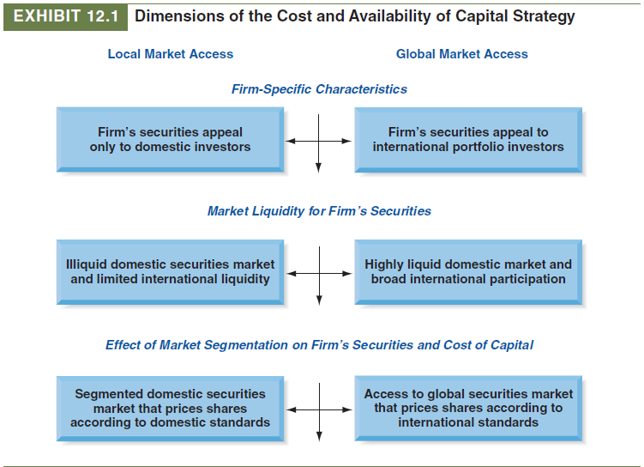

2. Benefits. What are the benefits of achieving a lower cost and greater availability of capital?

A firm can accept more long-term projects and invest more in capital improvements and expansion because of the lower hurdle rate in capital budgeting and the lower marginal cost of capital as more funds are raised.

3. Definitions. Define the following terms:

a. Systematic risk.
Systematic risk is a measure of how the firm’s returns vary with those of the market in which it trades. Systematic risk is the risk that is rewarded and cannot be avoided by diversification. Systematic risk is sometimes called market risk.

b. Beta (in the Capital Asset Pricing Model).
Beta is a measure of systematic risk. Beta is calculated as a function of the total variability of expected returns of the firm’s stock relative to the market index (k_{m}) and the degree to which the variability of expected returns of the firm is correlated to the expected returns on the market index. More formally,
where:
β_{j} (beta) = measure of systematic risk for security j
ρ (rho) = correlation between security j and the market
σ_{j} (sigma) = standard deviation of the return on security j
σ_{m} (sigma) = standard deviation of the market return
Beta will have a value of less than 1.0 if the firm’s returns are less volatile than the market, 1.0 if the same as the market, or greater than 1.0 if more volatile—or risky—than the market. CAPM analysis assumes that the required return estimated is an indication of what more is necessary to keep an investor’s capital invested in the equity considered. If the equity’s return does not reach the expected return, CAPM assumes that individual investors will liquidate their holdings.

4. Equity Risk Premiums

a. What is an equity risk premium?
The equity risk premium is the average annual return of the market expected by investors over and above riskless debt, the term (k_{m} − k_{rf}).

b. For an equity risk premium to be truly useful, what need it do?
To be useful, the equity risk premium should be forward looking and reflect what is expected to happen over the relevant future time period.

5. Portfolio Investors. Both domestic and international portfolio managers are asset allocators.

a. What is their portfolio management objective?
Their objective is to maximize a portfolio’s rate of return for a given level of risk, or to minimize risk for a given rate of return.

b. What is the main advantage that international portfolio managers have compared to portfolio managers limited to domestic-only asset allocation?
International portfolio managers can choose from a larger bundle of assets than portfolio managers limited to domestic-only asset allocations. As a result, internationally diversified portfolios often have a higher expected rate of return, and they nearly always have a lower level of portfolio risk because national securities markets are imperfectly correlated with one another.

6. Dimensions of Asset Allocation. Portfolio asset allocation can be accomplished along many dimensions depending on the investment objective of the portfolio manager. Identify the various dimensions.

Portfolios can be diversified according to the type of securities. They can be composed of stocks only or bonds only or a combination of both. They also can be diversified by industry or by size of capitalization (small-cap, mid-cap, and large-cap stock portfolios). In an international context, the most relevant dimensions are diversification by country, geographic region, stage of development, or a combination of these (global). An example of diversification by country is the Korea Fund. It was at one time the only vehicle for foreign investors to hold South Korean securities, but foreign ownership restrictions have more recently been liberalized. A typical regional diversification would be one of the many Asian funds. These performed exceptionally well until the “bubble” burst in Japan and Southeast Asia during the second half of the 1990s. Portfolios composed of emerging market securities are examples of diversification by stage of development. They are composed of securities from different countries, geographic regions, and stage of development.

7. Market Liquidity.

a. Define what is meant by the term market liquidity.
Although no consensus exists about the definition of market liquidity, we can observe market liquidity by noting the degree to which a firm can issue a new security without depressing the existing market price, as well as the degree to which a change in price of its securities elicits a substantial order flow.

b. What are the main disadvantages for a firm to be located in an illiquid market?
From a company perspective, an illiquid market is one in which it is difficult to raise new capital because there are insufficient buyers for a reasonably sized offering. A firm that must source its long-term debt and equity in a highly illiquid domestic securities market will probably have a relatively high cost of capital and will face limited availability of such capital, which in turn will lower its competitiveness both internationally and vis-à-vis foreign firms entering its home market. This category of firms includes both firms resident in emerging countries, where the capital market remains undeveloped, and firms too small to gain access to their own national securities markets. Many family-owned firms find themselves in this category because they choose not to utilize securities markets to source their long-term capital needs.

c. If a firm is limited to raising funds in its domestic capital market, what happens to its marginal cost of capital as it expands?

The marginal cost of capital increases as more funds are raised.

d. If a firm can raise funds abroad what happens to its marginal cost of capital as it expands?
The marginal cost of capital stays flat for a longer range of raising new capital, eventually rising as more funds are raised.

8. Market Segmentation.

a. Define market segmentation.
Capital market segmentation is a financial market imperfection caused mainly by government constraints, institutional practices, and investor perceptions. The imperfections may take the form of capital markets that are not fully integrated or securities with the same expected risk and return having different required returns in different markets, for example.

b. What are the seven main causes of market segmentation?
The seven main causes of market segmentation are the following:
1. Asymmetric information between domestic- and foreign-based investors
2. Lack of transparency
3. High securities transaction costs
4. Foreign exchange risks
5. Political risks
6. Corporate governance differences
7. Regulatory barriers

c. What are the main disadvantages for a firm to be located in a segmented market?
Firms located in a segmented market usually have a higher cost of capital (increasing marginal cost of capital) and less availability of capital. They can overcome these limitations by following a proactive strategy to internationalize their cost and availability of capital.

9. Market Liquidity and Segmentation Effects. What is the effect of market liquidity and segmentation on a firm’s cost of capital?

Firms located in an illiquid and segmented capital market will usually have a higher marginal cost of capital and less availability of capital.

10. Novo Industri (A). Why did Novo believe its cost of capital was too high compared to its competitors? Why did Novo’s relatively high cost of capital create a competitive disadvantage?

Novo observed that its price/earnings ratio was only 5 compared to 10 and higher for its competitors. Novo’s high cost of capital and low availability of capital in Denmark would prevent it from fully exploiting its competitive advantage in research on insulin and industrial enzymes.

11. Novo Industri (B). Novo believed that the Danish capital market was segmented from world capital markets. Explain the six characteristics of the Danish equity market that were responsible for its segmentation.

The six characteristics of the Danish equity market that were responsible for market segmentation are (1) asymmetric information base of Danish and foreign investors, (2) taxation, (3) alternative sets of feasible portfolios, (4) financial risk, (5) foreign exchange risk, and (6) political risk.

12. Novo Industri A/S.

a. What was Novo’s strategy to internationalize its cost of capital?
Novo’s strategy was to increase its level and the quality of its financial and technical disclosure in both Danish and English in order to attract foreign portfolio investors.

b. What is the evidence that Novo’s strategy succeeded?
Between 1980, when its disclosure was being maximized, and July 1981, Novo’s stock price increased from Dkr 300 per share to around Dkr 1400 per share. Its P/E ratio increased from 5 to 16, which was then in line with its international competitors.

13. Emerging Markets. It has been suggested that firms located in illiquid and segmented emerging markets could follow Novo’s proactive strategy to internationalize their own cost of capital. What are the preconditions that would be necessary to succeed in such a proactive strategy?

The Novo experience can be a model for other firms wishing to escape from segmented and illiquid home equity markets. In particular, multinational enterprises based in emerging markets often face barriers and lack of visibility similar to what Novo faced. They could benefit by following Novo’s proactive strategy employed to attract international portfolio investors. However, a word of caution is advised. Novo had an excellent operating track record and a very strong worldwide market niche in two important industry sectors, insulin and industrial enzymes. This record continues to attract investors in Denmark and abroad. Other companies would also need to have such a favorable track record to attract foreign investors.

14. Cost of Capital for MNEs Compared to Domestic Firms. Theoretically, MNEs should be in a better position than their domestic counterparts to support higher debt ratios because their cash flows are diversified internationally. However, recent empirical studies have come to the opposite conclusion. These studies also concluded that MNEs have higher betas than their domestic counterparts. According to these empirical studies

a. Why do MNEs have lower debt ratios than their domestic counterparts?
Despite the theoretical elegance of this hypothesis, empirical studies have come to the opposite conclusion. Despite the favorable effect of international diversification of cash flows, bankruptcy risk was only about the same for MNEs as for domestic firms. However, MNEs faced higher agency costs, political risk, foreign exchange risk, and asymmetric information. These have been identified as the factors leading to lower debt ratios and even a higher cost of long-term debt for MNEs. Domestic firms rely much more heavily on short and intermediate debt, which lie at the low cost end of the yield curve.

b. Why do MNEs have higher betas than their domestic counterparts?
One study found that MNEs have a higher level of systematic risk than their domestic counterparts. The same factors caused this phenomenon as caused the lower debt ratios for MNEs. The study concluded that the increased standard deviation of cash flows from internationalization more than offset the lower correlation from diversification.

15. The “Riddle.” The riddle is an attempt to explain under what conditions an MNE would have a
higher or lower debt ratio and beta than its domestic counterpart. Explain and diagram what these conditions are.

The answer to this riddle lies in the link between the cost of capital, its availability, and the opportunity set of projects. As the opportunity set of projects increases, eventually the firm needs to increase its capital budget to the point where its marginal cost of capital is increasing. The optimal capital budget would still be at the point where the rising marginal cost of capital equals the declining rate of return on the opportunity set of projects. However, this would be at a higher weighted average cost of capital than would have occurred for a lower level of the optimal capital budget.

To illustrate this linkage, Exhibit 12.6 in the chapter shows the marginal cost of capital given different optimal capital budgets. Assume that there are two different demand schedules based on the opportunity set of projects for both the MNE and domestic counterpart (DC).

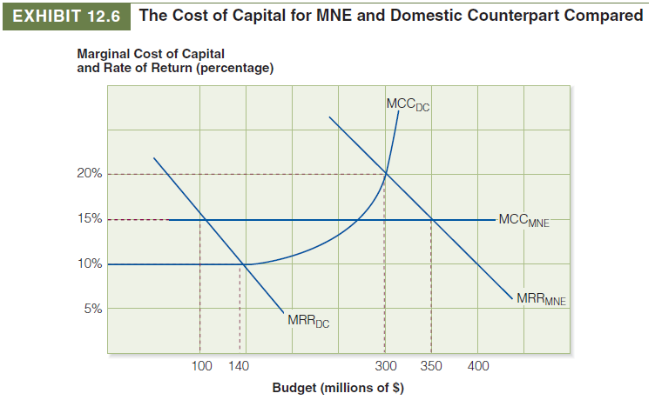

16. Emerging-Market MNEs. Apart from improving liquidity and escaping from a segmented home market, why might emerging market MNEs further lower their cost of capital by listing and selling equity abroad?

A recent study found that internationalization actually allowed emerging market MNEs to carry a higher level of debt and lowered their systematic risk. This occurred because the emerging market MNEs are investing in more stable economies abroad, a strategy that lowers their operating, financial, foreign exchange, and political risks. The reduction in risk more than offsets their increased agency costs and allows the emerging market MNEs to enjoy higher leverage and lower systematic risk than their U.S.-based MNE counterparts.

