Network Operating Systems and Services
Assignment 1
Lewis Tucker – TUC18839261

Contents
Introduction 3
Creating Virtual Machines and Establishing Connections 4
Deploying and Understanding Active Directory Services 7
Creating User Accounts Using Active Directory 9
Adjoining Domain Users and Testing Logins 12
Observations 15
Type 1 & 2 Hypervisors 15
Cloud Computing – Virtual Networks 15
DNS 16
Other Critical Network Roles 16
DHCP Server 16
Remote Desktop Services 16
Other Network Terminologies 17
Ping 17
Server Management 17
Conclusion 18

Introduction
The objective of this assignment is to demonstrate the process of creating and managing a virtual LAN server. To do this I will be creating 2 virtual servers as well as 2 clients within the network. Using Active Directory, I will also be demonstrating different techniques that are used to manage networks.

Creating Virtual Machines and Establishing Connections
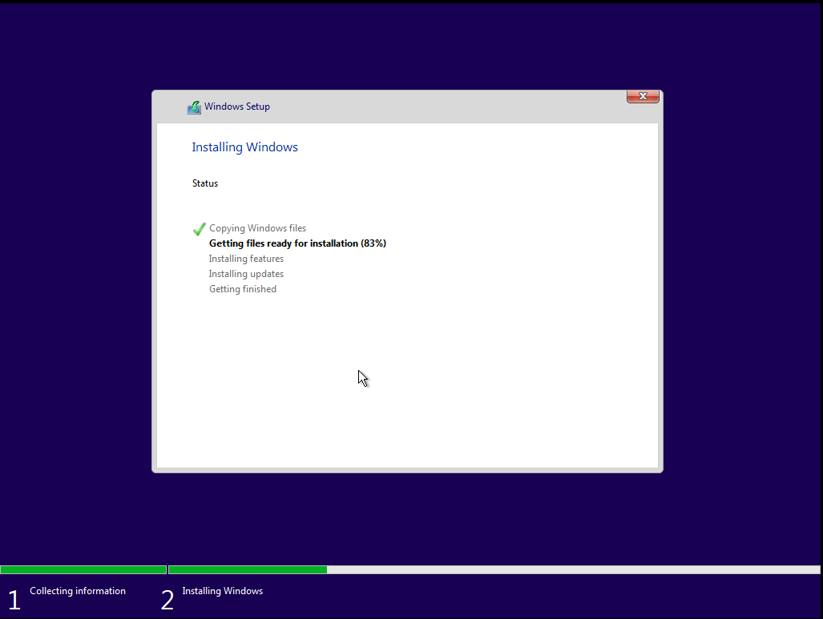
The objective of the first task is to create the different virtual machines that are required to create the virtual LAN. To do this I had to create 2 different machines with different windows ISOs, one with windows server manager installed and one regular window 10. Here are the screenshots of creating the virtual machines -

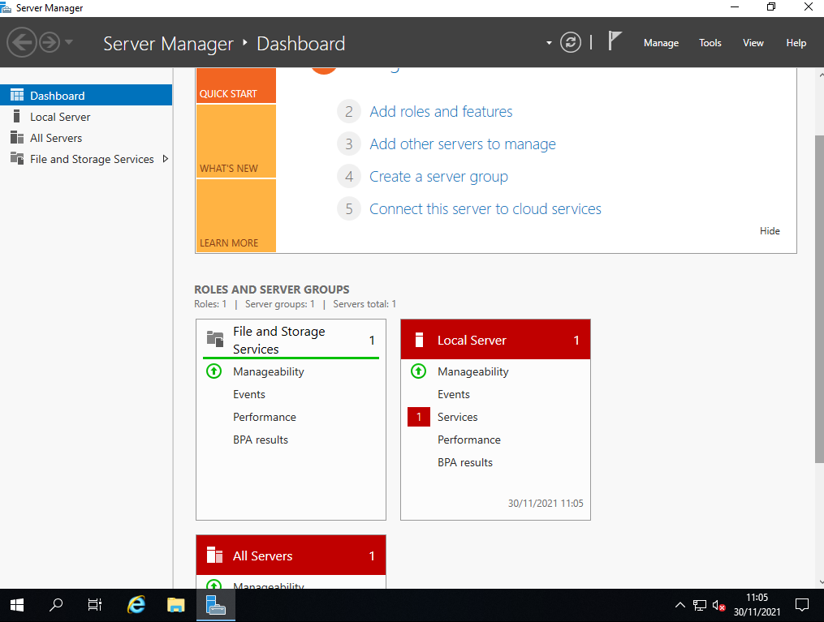
Once the windows operating systems have been successfully installed, here is the windows server manager prior to active directory being installed -

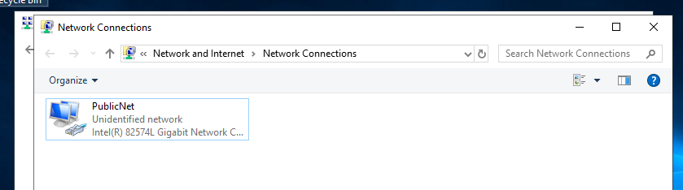
The server machine is required to have 2 different network adapter cards, one public net and one privet net. Here is the creation of the public net card on server 1.

This network card then must be assigned with an IPV4 address according to the assignment brief. Here is the card being assigned an address.
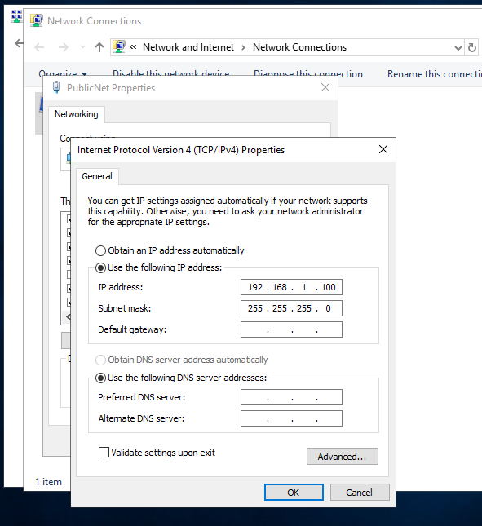

This process is then repeated for the private net card on the clients PC.
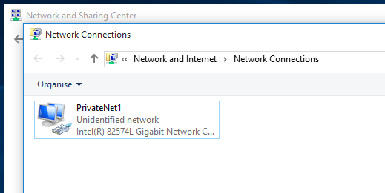

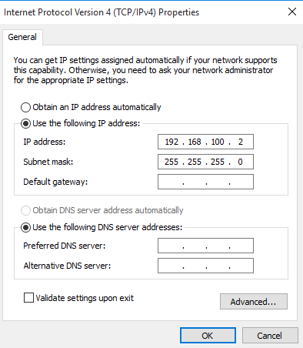

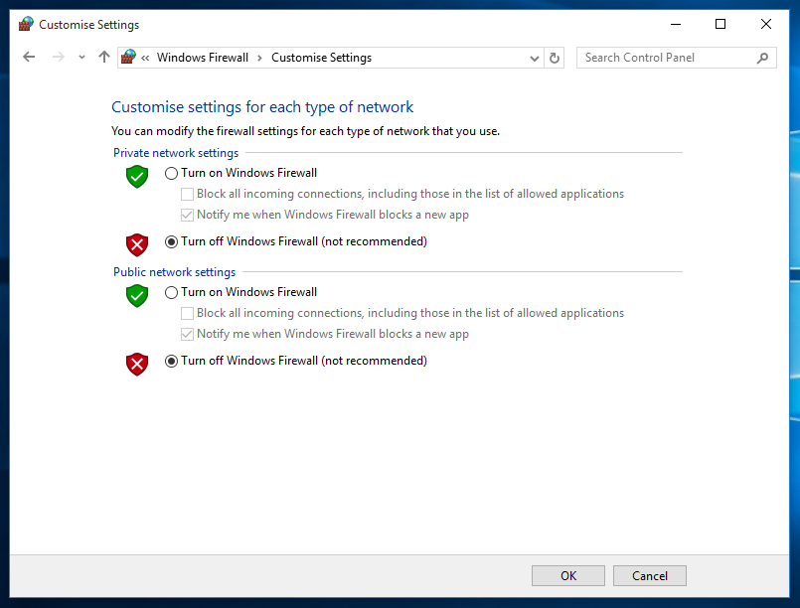
The goal of assigning the IP addresses is so that the different machines can connect to on another. The last step to ensuring they can connect is disabling the windows firewalls on both server and client machines –

Once the firewalls are disabled, in order to test if the machines can communicate with one another, they must be able to ping each other’s IP addresses. Here is evidence that the PCs can communicate with each other –
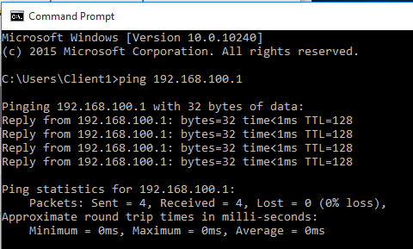
Client pinging Server PC –

Server pinging Client PC –
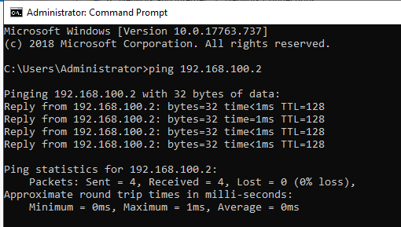

Deploying and Understanding Active Directory Services
Firstly, before installing Active Directory I must ensure that the IP address on the server machine is correctly statically defined as well as making sure that the DNS is not set up.
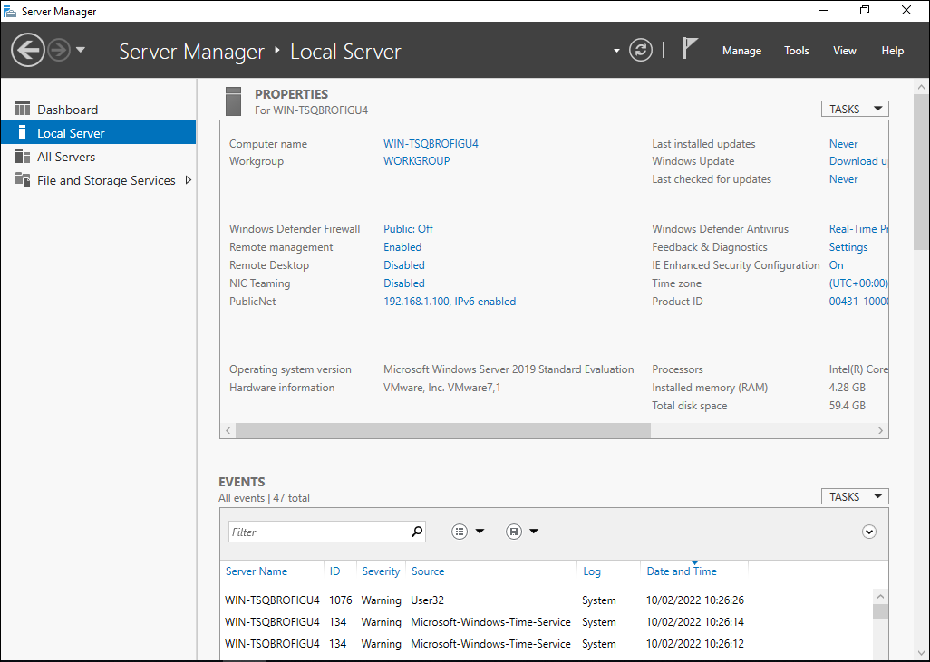

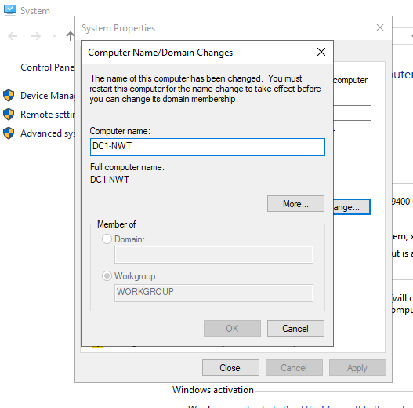
I then had to give the server PC a name. Here is the evidence of me naming the server PC “DC1-NWT” as stated on the assignment brief.

The server PC is now set up to be able to install Active Directory. Here is the install progress of Active Directory.
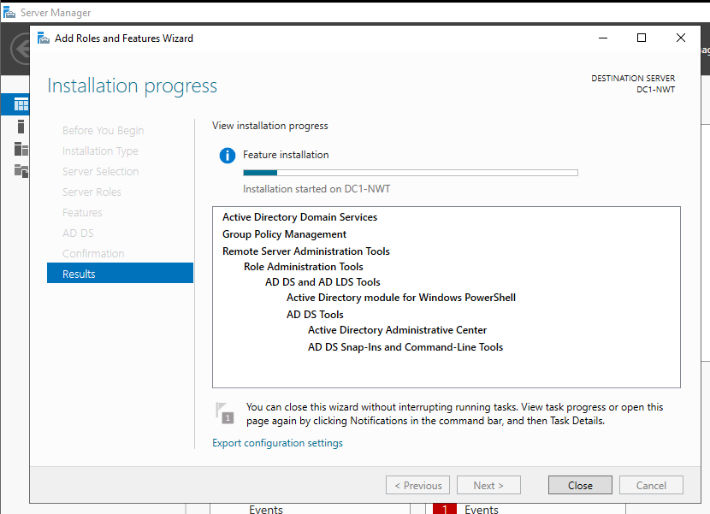

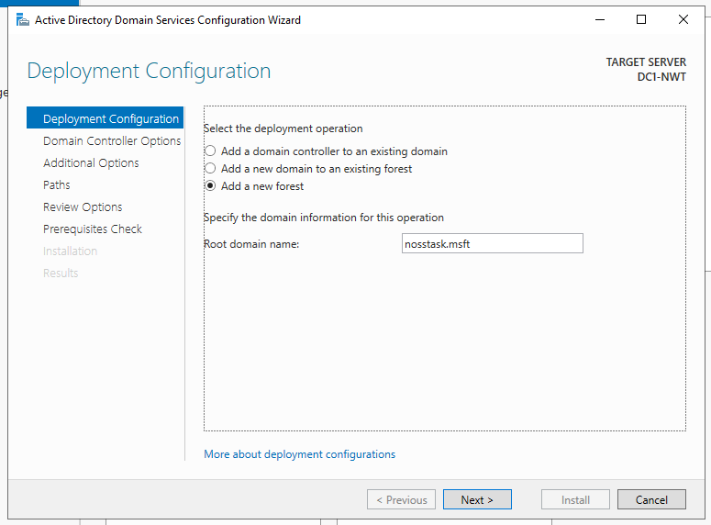
Next, I am required to create a new forest and set the domain controller options. The domain will be called “nosstask.msft”. The DSRM password is set as “P@s5w0r9”.

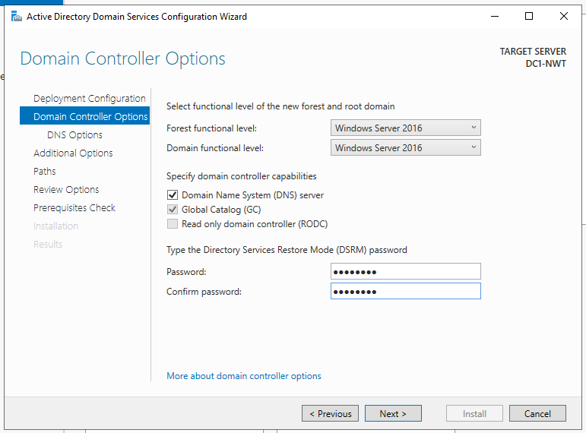

Creating User Accounts Using Active Directory
Once Active Directory has been successfully installed and set up on the server machine, I can now start using the Active Directory services to create users. Once Active Directory has been opened, here are the different domain controllers as well as the domain admins.
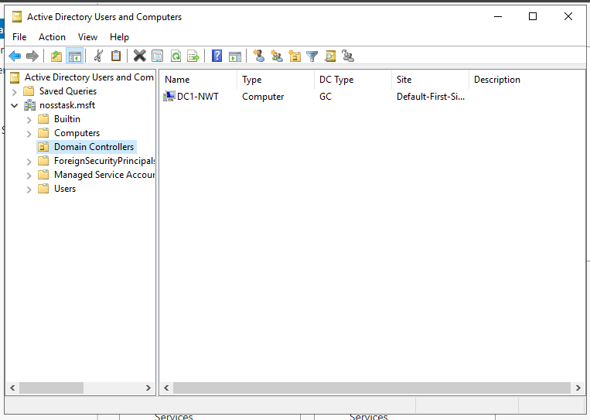

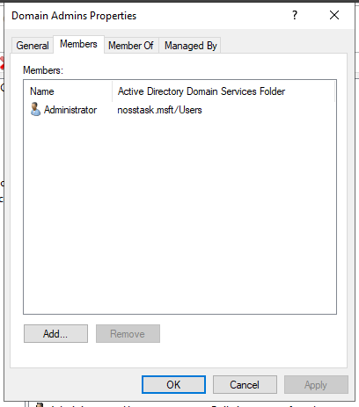

Here is evidence of the process of creating a user using Active Directory, setting passwords and adding the user to the correct domain admins group.
Creating user and setting passwords –
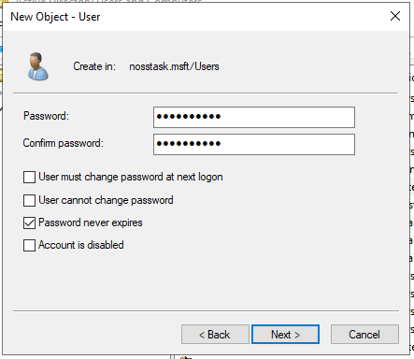
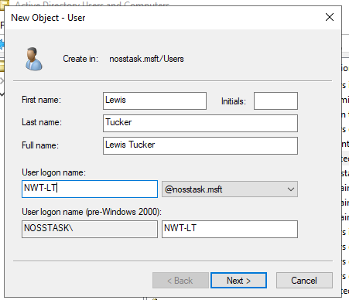

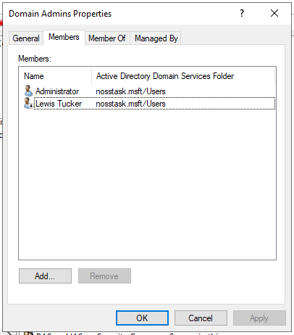
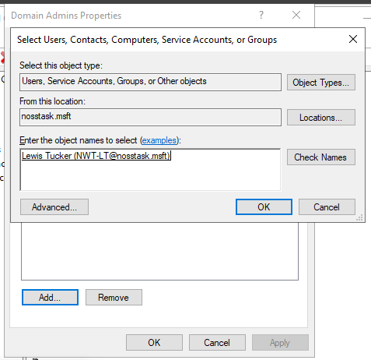
Adding user to domain admins group –

Once the first user has been added to the domain users’ group, I will now create a second called “Sam Edwards”.
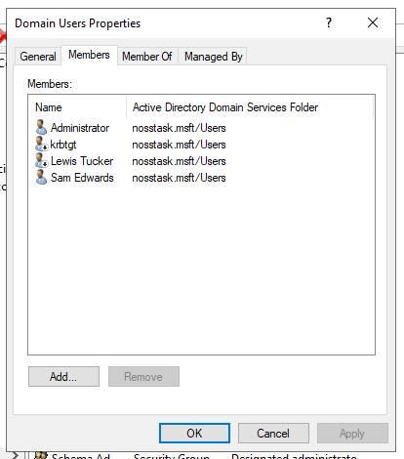

For this user, I will use some additional Active Directory features to ensure that the user can only log on between 9am Monday and 3pm Thursday as well as ensuring that the user cannot change their password.
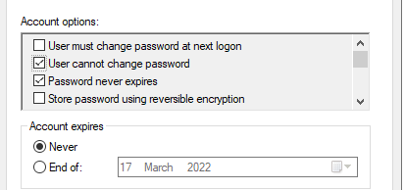
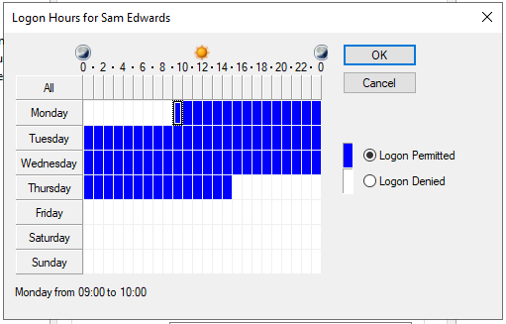

Adjoining Domain Users and Testing Logins
Finally, I had to ensure that the users could join the domain through the client PC, this will complete the set up of the virtual LAN.
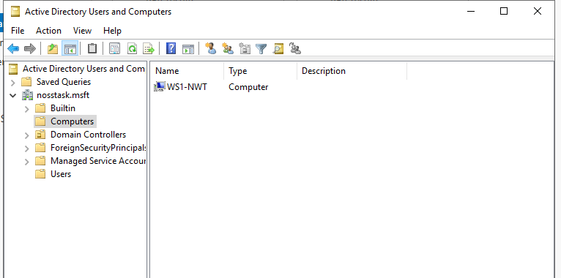
First, I must add the client PC to the domain and change the PCs name –
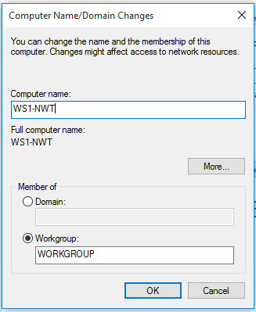

This is where the client PC must now be assigned with a DNS server address of 192.168.1.100.
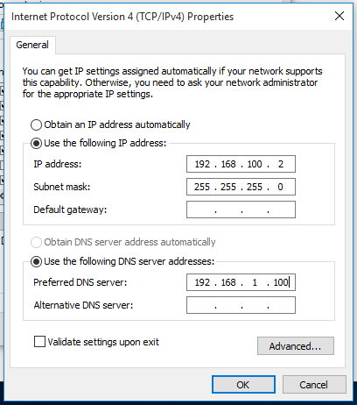

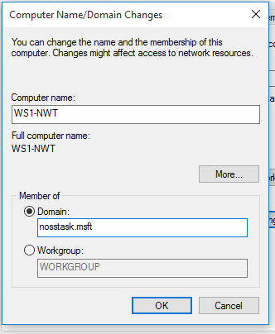
The client must now be added to the nosstask.msft domain –

Here is the client joining the domain –
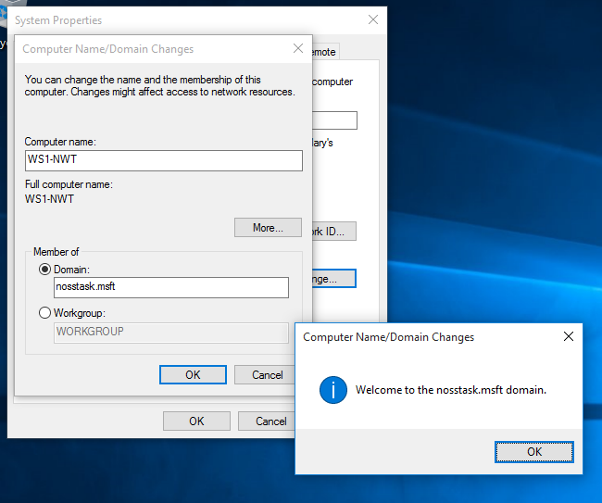

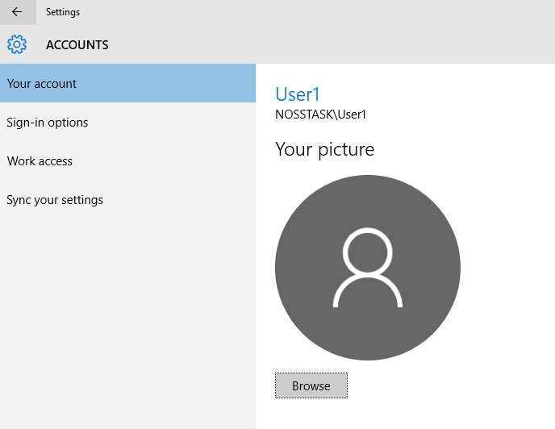
Finally, here is the evidence that the user is connected to the domain on the client PC-

Observations

Type 1 & 2 Hypervisors
A hypervisor is a virtual machine. Virtual machines are run on physical machines and mock another machine or operating system. For example, a virtual machine can be set up to create a windows server, or client depending on the ISO installed on the machine. There are two different types of hypervisors, type 1 and 2. A type 1 hypervisor is run directly through the hardware of thew physical host machine. This ensures that it doesn’t have to load any underlaying operating systems. The benefit to the type 1 hypervisors is that they are very secure as they are run from the host machine. They are typically not victim to limitations of operating systems that are installed meaning that they provide great performance and are often used in enterprise setups. A type 2 hypervisor is also known as a hosted hypervisor, as it runs off the operating system of the host machine rather than the hardware. This type of hypervisor is typically used in a smaller network environment as appose to the enterprise environment that type 1 is typically used. The advantages to a type 2 hypervisor are that it is a lot simpler to manage than a type 1 hypervisor, making it more user friendly. It is also useful for conducting testing on different software and projects.

Cloud Computing – Virtual Networks
The term cloud computing means that the user is storing their data over the internet rather than a physical hard drive. This has an impact on all types of computing including networking. Cloud networking plays a big role in how different enterprise networks operate. This allows companies to upscale and increase their business output. A virtual cloud network uses virtual machines, servers and machines just as a physical network would. The advantage to this is that a company can deploy a virtual network rather than investing in physical servers, machines and devices. The advantages to a virtual cloud network are primarily that they reduce the cost of having a network for a company. It is user friendly as well as easy to maintain. They are also reliable as the data is stored on multiple servers. It also eliminates the risk of any damage to physical equipment. On the contrary, the downside to cloud virtual networks is the security. It is a lot harder to impose physical security on a virtual network, making is more susceptible to unauthorised personnel. The downtime to these networks is also a big disadvantage as you are relying on internet access. Should the host machine lose its access to the internet, the server will not be able to operate until it re establishes an internet connection.

DNS
The term DNS stands for Doman Name Server. This is a process which turns domain names into IP addresses which a search engine uses to turn into web pages.
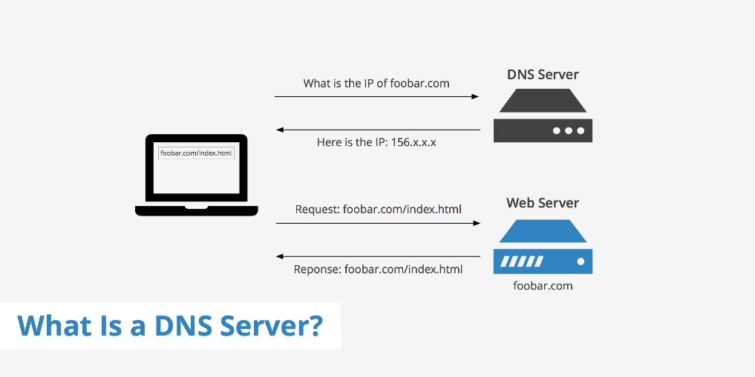

A computer will use a DNS server to search the domain name that you Are trying to search. This process is also known as DNS name resolution. This process allows the user to search for a website using text rather than entering the IP address numbers. The DNS server is like a phonebook that manages these IP addresses and converts them into what the user would search. Active Directory implements the use of a DNS server in order to ensure that the client can locate the domain controllers and ensuring that they can communicate together. Without the use of DNS, the client PC would not be able to connect to the domain.

Other Critical Network Roles

DHCP Server
A DHCP server is a protocol that assigns IP addresses with default gateways and other different network parameters. Without it, the network administrator must manually configure each client who joins the network, which can be time-consuming, particularly in big networks. Each client is normally assigned a unique dynamic IP address via DHCP servers, which changes when the client's lease for that IP address expires.

Remote Desktop Services
RDS (Remote Desktop Services) is a feature of Windows Server that allows users to interface with and access other computers remotely. The capacity to access outside desktops, session-based desktops, or data centre applications from within a corporate network as well as via the Internet is one of the virtual technology services supplied. Remote Desktop Services can be used to speed up application and desktop deployments while also allowing clients to run virtually any software or operating systems.

Other Network Terminologies

Ping
The ping command is the command that is used to ensure that two different machines can communicate with one another. If one machine can ping, and receive a reply from another machine, it demonstrates that the two machines can communicate. Here is an example –

Server Management
Microsoft Server Manager is the interface that is used on a desktop to help an administrator manage any servers within the network. It displays all the server roles as well as allowing an administrator to work on these servers remotely without physical access.

Conclusion
To conclude this report, I will reflect on the tasks completed in this report. These tasks are a demonstration as to how to set up a virtual local area network using virtual machines. This demonstrates how smaller companies can easily make use of features such as Microsoft Server Manager and Active Directory to make a small, yet functional network. It also demonstrates how to create users within a network, allow certain permissions and logon hours solely using Active Directory. Finally, it allows a small LAN to create a domain and allow the different client devices to connect to the domain.

