Design and Analysis of Electromagnetic Systems

Edward Bulpitt
UWTSD Swansea, UK
2317250@student.uwtsd.ac.uk

Abstract — This paper goes into electromagnetic wave propagation within rectangular waveguides, a half-wave dipole antenna’s behaviour and the radar-based drone detection problem. Rectangular waveguides were theoretically and via simulation studied. Findings confirm TE₁₀ as the dominant mode and demonstrates that dielectric filling decreases cutoff frequencies significantly when compared to simulated with a vacuum. A half-wave dipole was modelled on a hypothetical 1.30 GHz frequency and exhibited a resonance of about 1.90 GHz, as explained by the fringing effects. Finally, the paper discusses challenges in detecting low RCS, small, low, slow drones using radar and explores innovations like expanded frequency bands, AESA, micro-Doppler signal processing, and sensor fusion, considering their social and environmental impact.
Keywords — Rectangular waveguides; Half-Wave Dipole Antenna; low RCS;

Introduction
Electromagnetic wave radiation and propagation form the core of communication and sensing systems analysis and design. This work deals with the fundamentals through three interrelated studies. Firstly, it explores the behaviour of waves in rectangular waveguides (dimensions a=23mm, b=9mm) by comparing the performance when they are vacuum filled and when filled with a dielectric material (Teflon, εr=2.1). Theoretical calculations and simulation results for cutoff frequencies and field patterns of the first three modes (TE₁₀, TE₂₀, TE₀₁) are presented. Secondly, design, simulation, and analysis of a half-wave dipole antenna (L=115.5mm) are presented, comparing theoretical operating frequency (1.30 GHz) with simulated results (~1.90 GHz) and analysing radiation patterns. Finally, the article addresses the issue of radar systems in the detection of small Unmanned Aerial Vehicles (UAVs), explaining challenges and reviewing existing technological advancements in the direction of improving detection capabilities.

Rectangular wave guide pec walls filled with vacuum

Wave guide dimensions
For the dimensions of the rectangular waveguide, I used my student ID number: 2317250 for the cross sectional sizes. The mapping is defined as
a= first two numbers of the student ID
b= (3rd and 4th number of the student ID)/2 (rounded to the nearest integer)
a = 23 mm
b = 9 mm

Dominant Mode
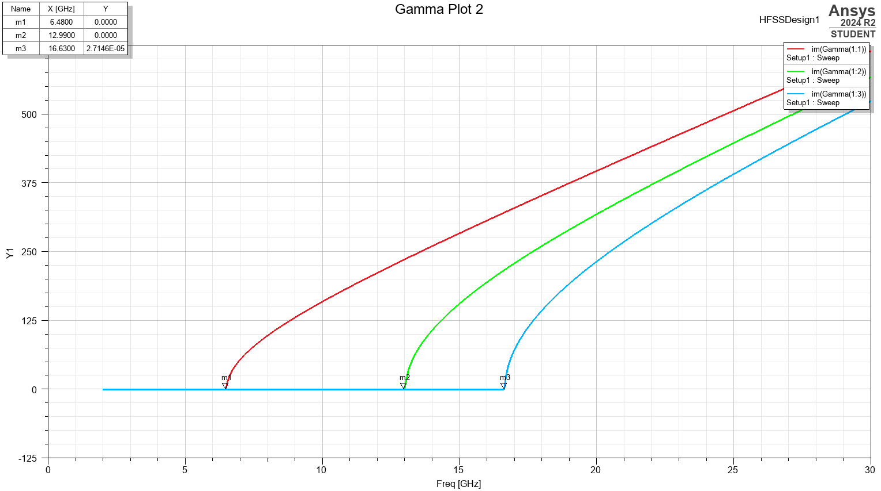
Figure 1. Frequency cut off gamma plot

The dominant mode (red curve in the gamma plot) is TE₁₀
$$-fc =\frac{c}{2a}$$
​Where c is the speed of light and a is the wide dimension of the wave guide
It has the lowest cutoff frequency of 6.48 GHz

Port field display for port 1 and 2
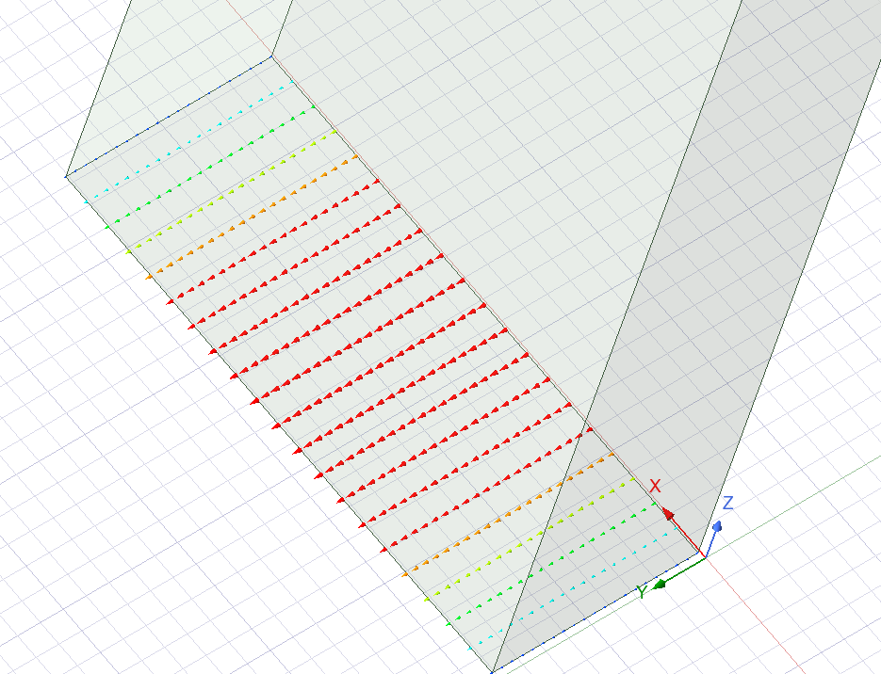  Figure 2. Port 1 Field Display | 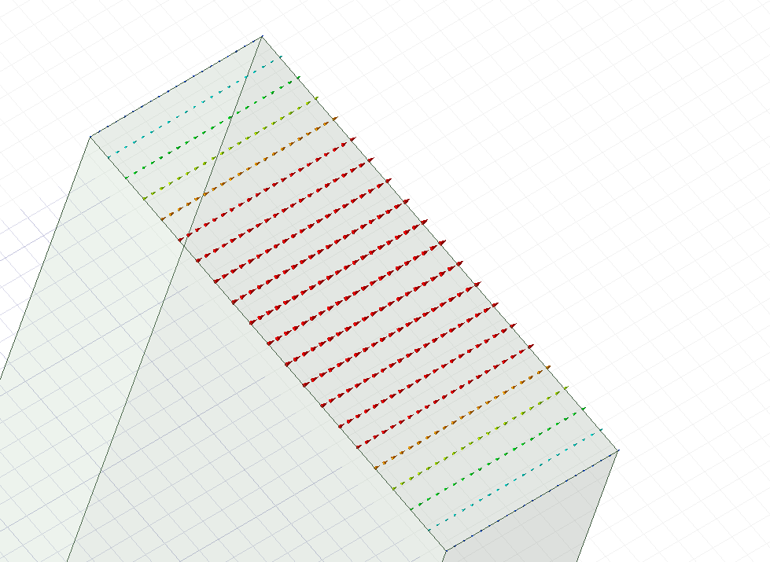  Figure 3. Port 2 Field Display

The colour map (red - high, green - medium, blue - low) confirms the maximum field at the centre of the waveguide and near null at the walls
This pattern verifies correct excitation of TE₁₀.

Magnitude and vectors of Electric and magnetic fields for the modes 1,2 & 3

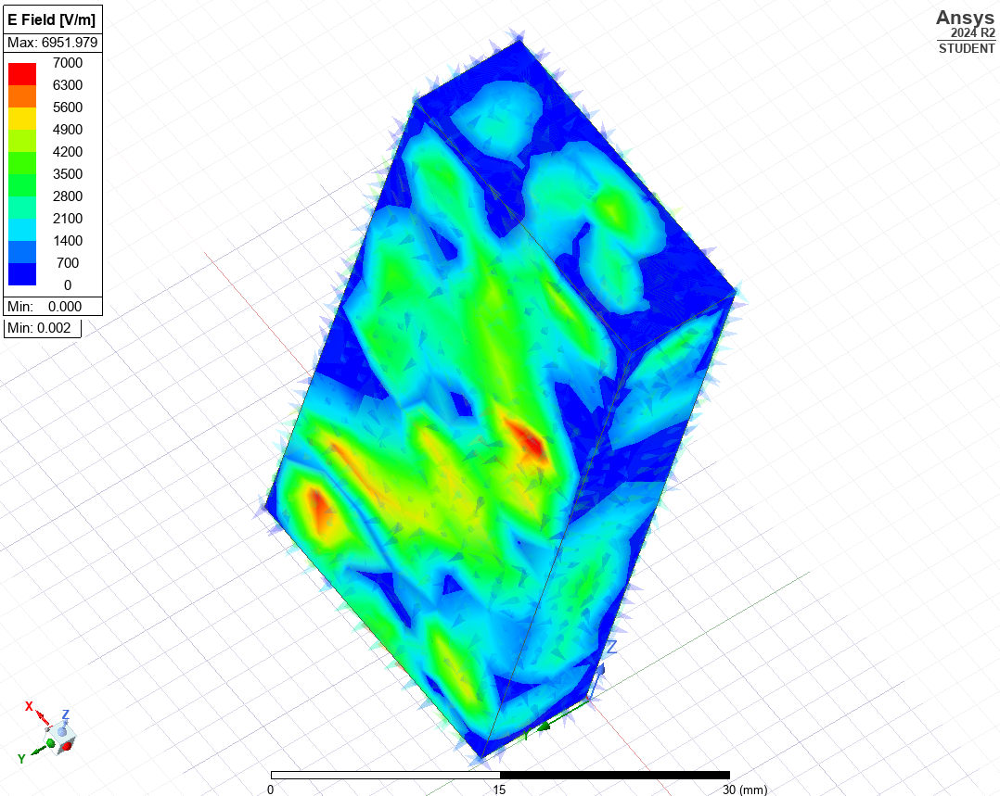  Figure 4. Mag E of Mode 1 | 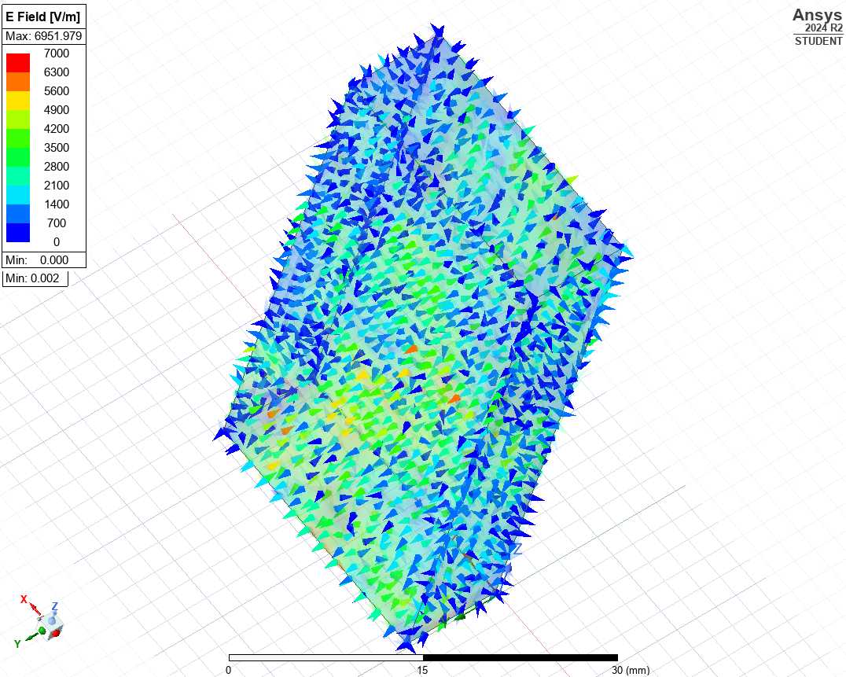  Figure 5.Vector E of Mode 1
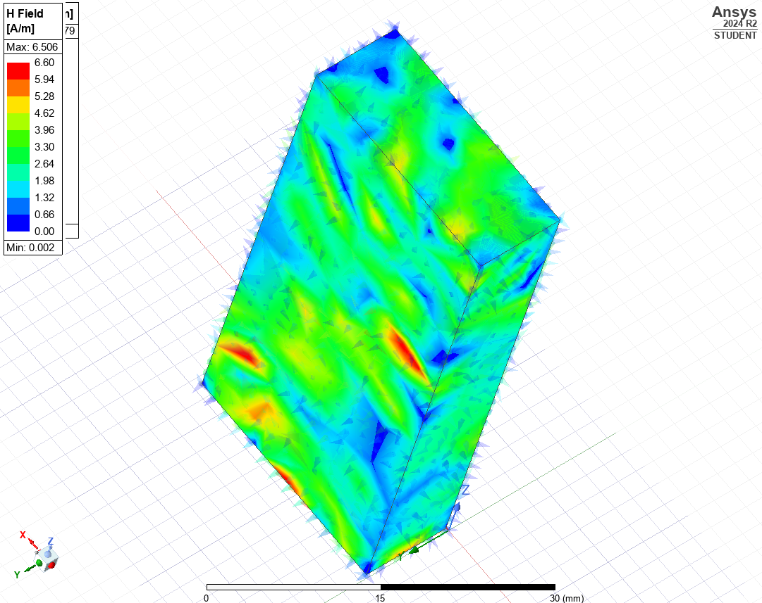  Figure 6. Mag H of Mode 1 | 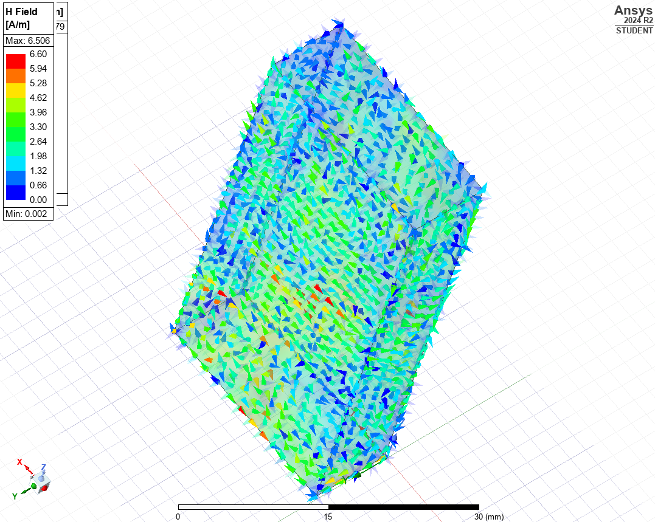  Figure 7.Vector H of Mode 1

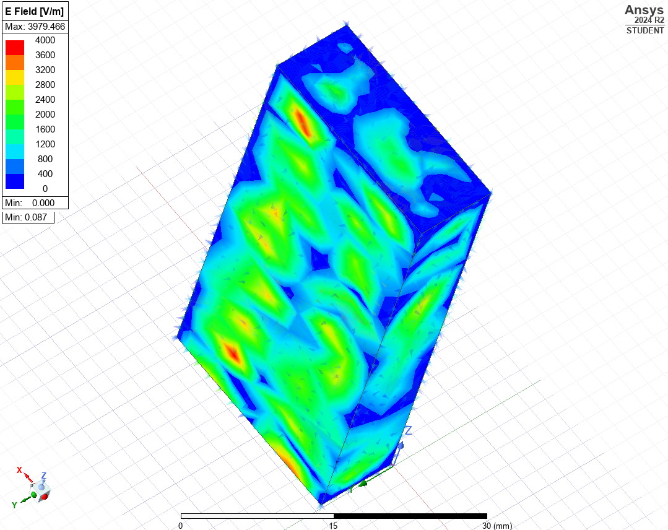  Figure 8. Mag E of Mode 2 | 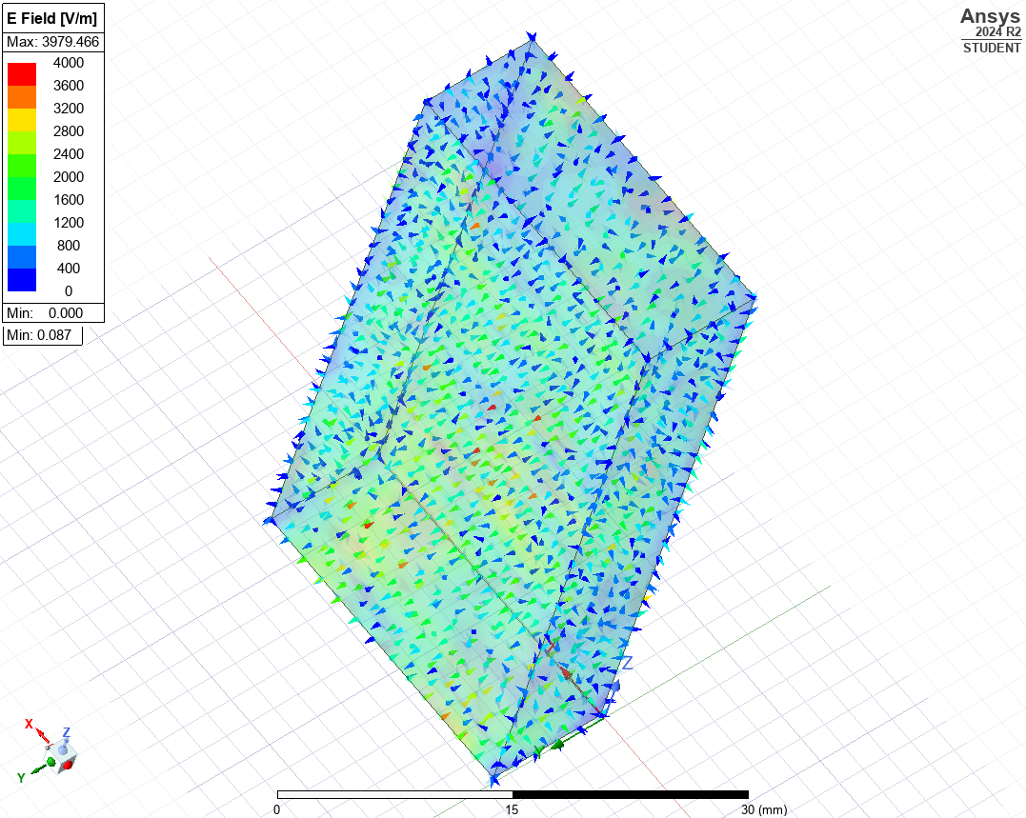  Figure 9.Vector E of Mode 2
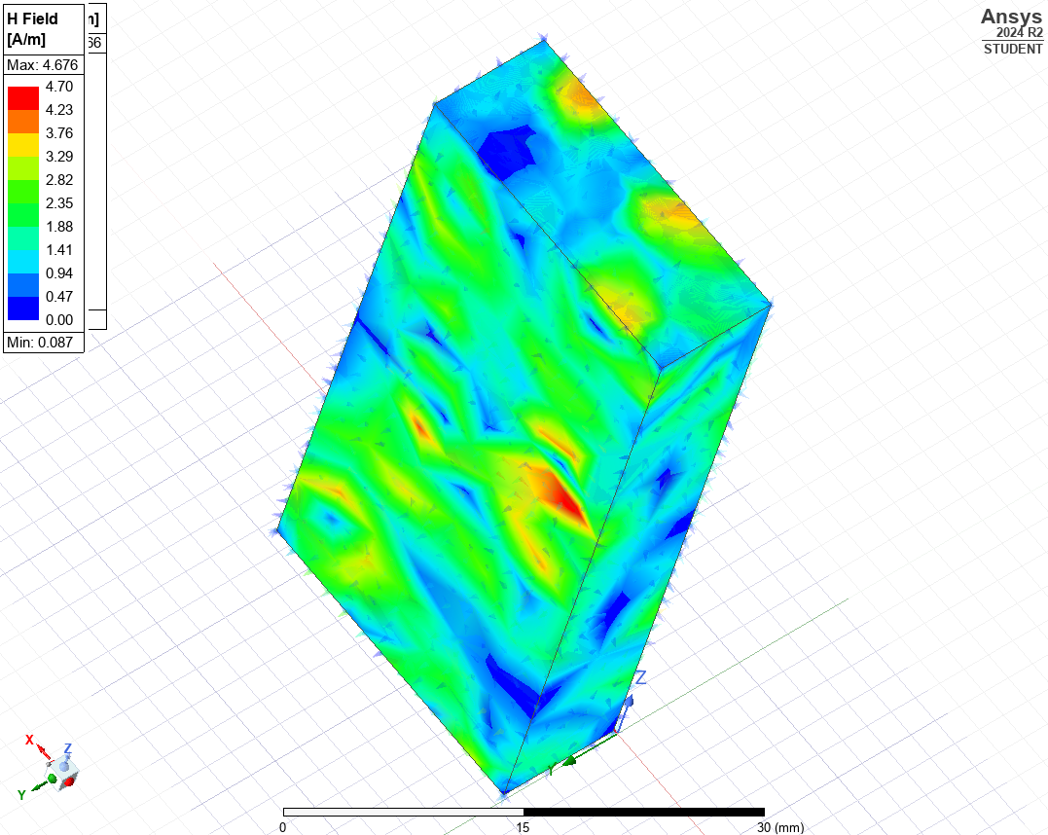  Figure 10. Mag H of Mode 2 | 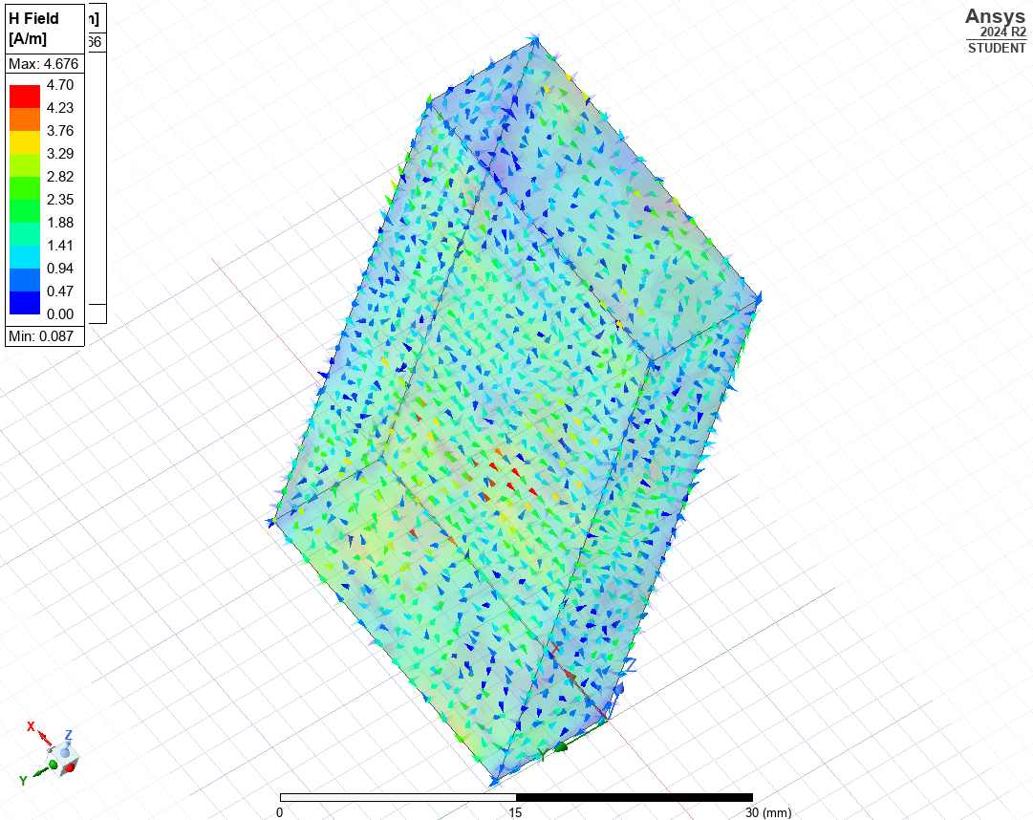  Figure 11.Vector H of Mode 2

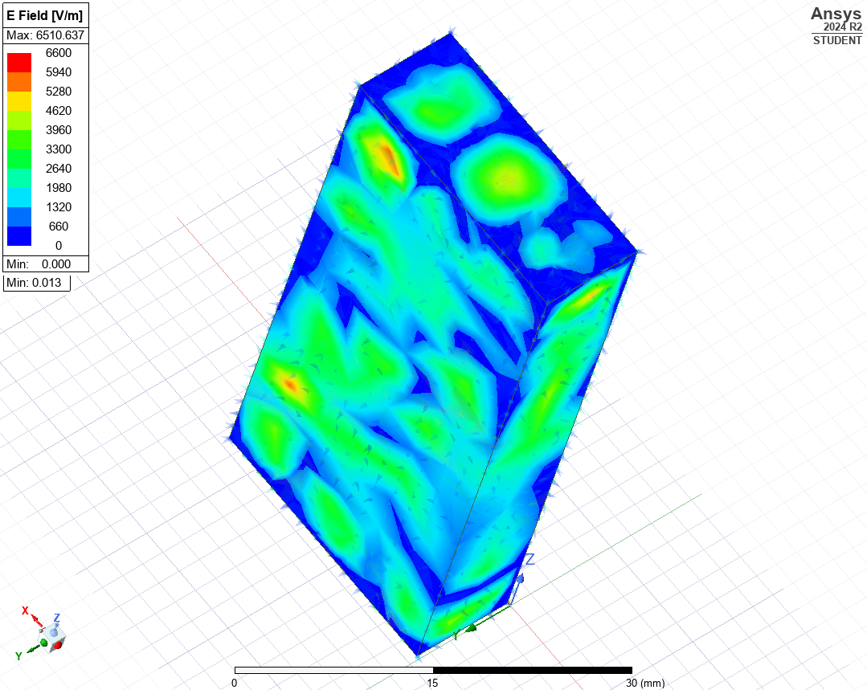  Figure 12. Mag E of Mode 3 | 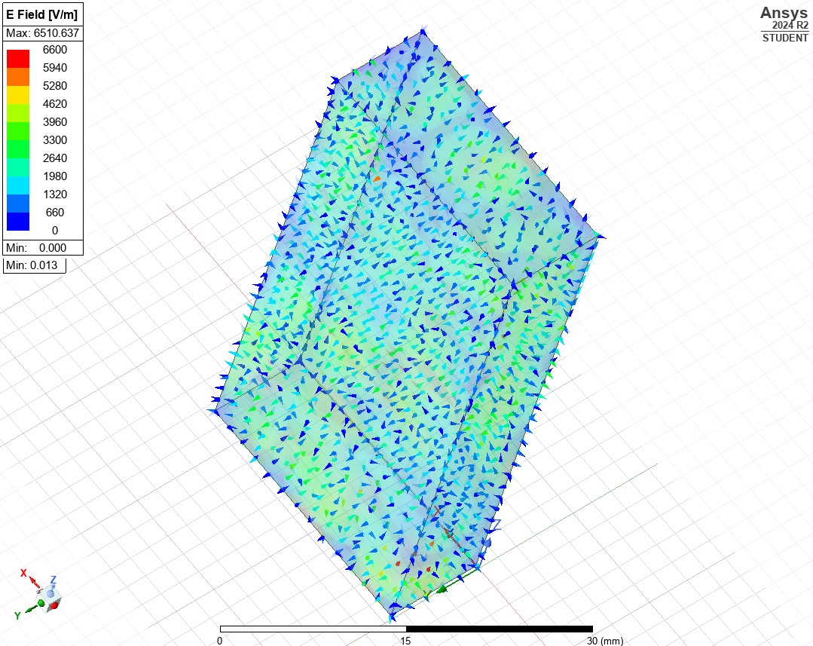  Figure 13.Vector E of Mode 3
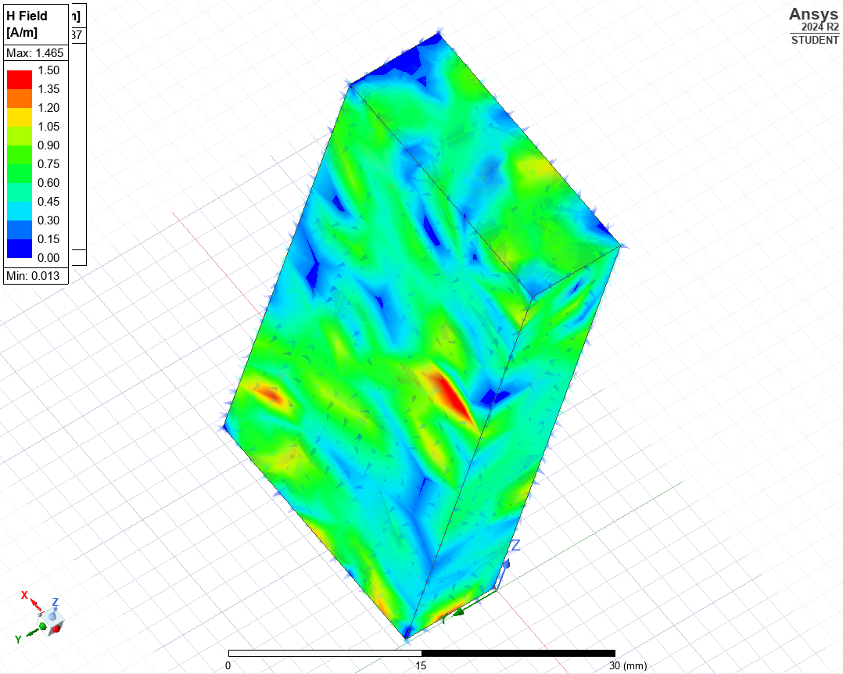  Figure 14. Mag H of Mode 3 | 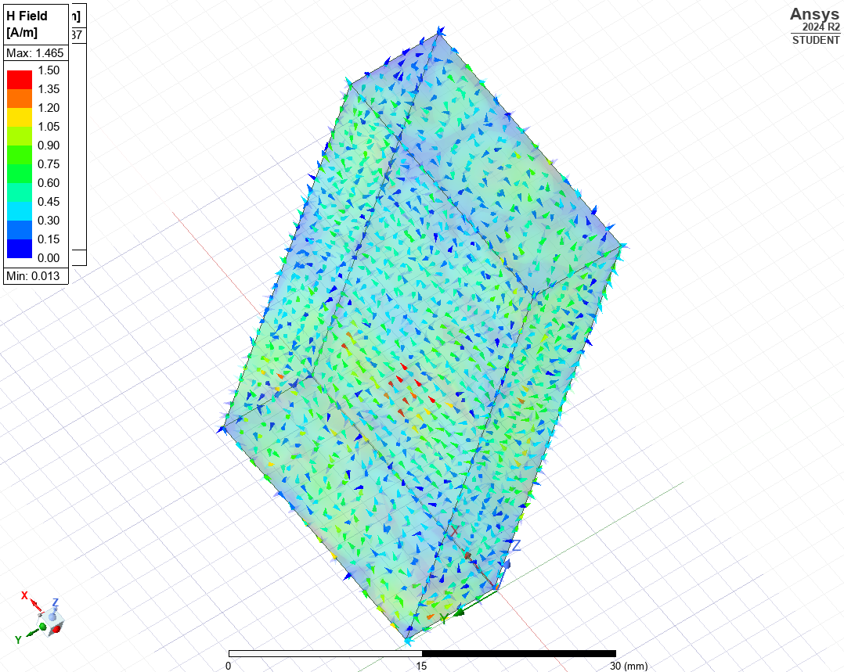  Figure 15.Vector H of Mode 3

Simulated Cut Off Frequencies
Figure 16. Rectangular Cut off frequency Plot

Mode 1:  6.480 GHz | Mode 2:  12.990 GHz | Mode 3:  16.630 GHz
Table 1. Cut Off Frequencies

Theoretical Cut Off Frequencies
To calculate the cutoff frequencies for the individual modes, we must use the general cutoff frequency formula for a rectangular waveguide:

$$f_{c(mn)}=\frac{c}{2}\sqrt{{\left(\frac{m}{a}\right)}^{2}+{\left(\frac{n}{b}\right)}^{2}}$$
where:
$$f_{c(mn)}is the cutoff frequency for the(m,n)mode,$$
$$c is the speed of light 3×{10}^{8} m/s),$$
$$a is the width of the waveguide (23 mm),$$
$$b is the height of the waveguide (9 mm),$$
$m$ and $n$ are the mode indices.

For the first three modes (TE₁₀, TE₂₀, and TE₀₁), the theoretical cutoff frequencies are calculated as follows:

TE₁₀ Mode:
$$f_{c(10)}=6.52 \text{GHz}$$

TE₂₀ Mode:
$$f_{c(20)}=13.04 \text{GHz}$$

TE₀₁ Mode:
$$f_{c(01)}=16.67 \text{GHz}$$

These results align closely with the simulated cutoff frequencies obtained from Figure 16. Rectangular Cut off frequency Plot

Rectangular waveguide pec wall filled with Teflon
The following shows the same rectangular waveguide but instead Teflon filled.

Dominant Mode
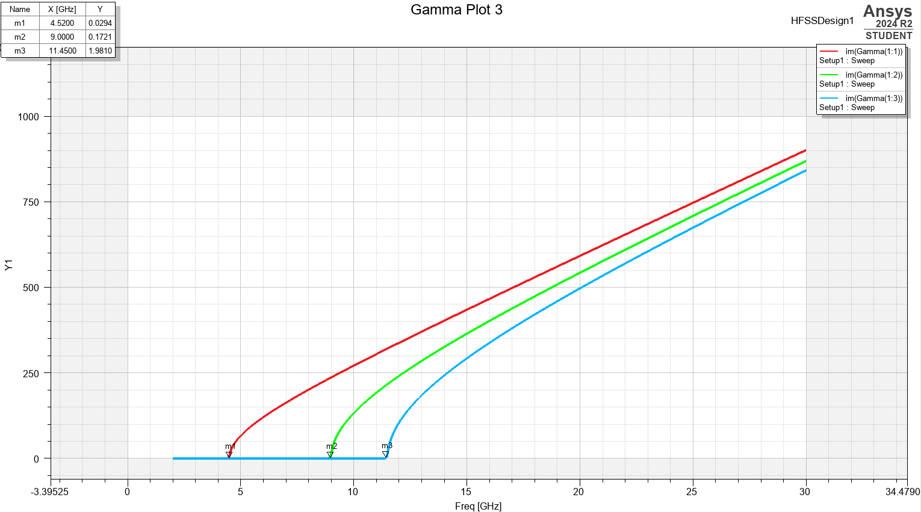
Figure 17. Cut off frequency gamma plot of Teflon filled waveguide
The dominant mode in this wave guide (red curve)
TE₁₀ has the lowest cutoff frequency of 4.52GHz meaning it is the dominant mode

PORT FIELD DISPLAY FOR PORT 1 AND PORT 2
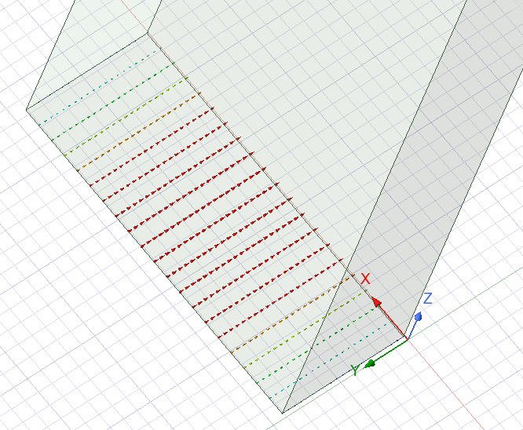  Figure 18. Port 1 Field Display | 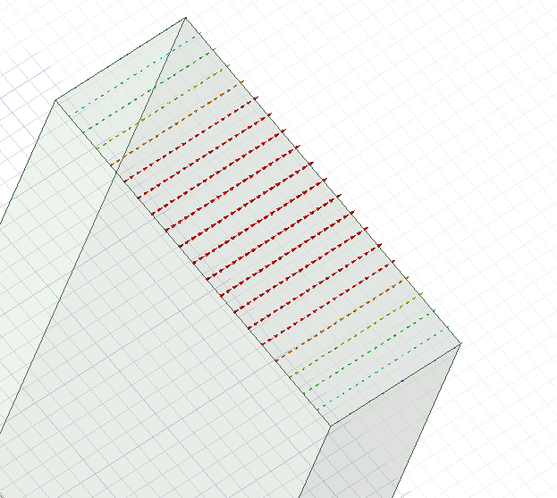  Figure 19. Port 2 Field Display

The colour on this waveguide also confirms the maximum field is at the centre of the waveguide and near null at the walls

Magnitude and vectors of Electric and magnetic fields for the modes 1,2 & 3

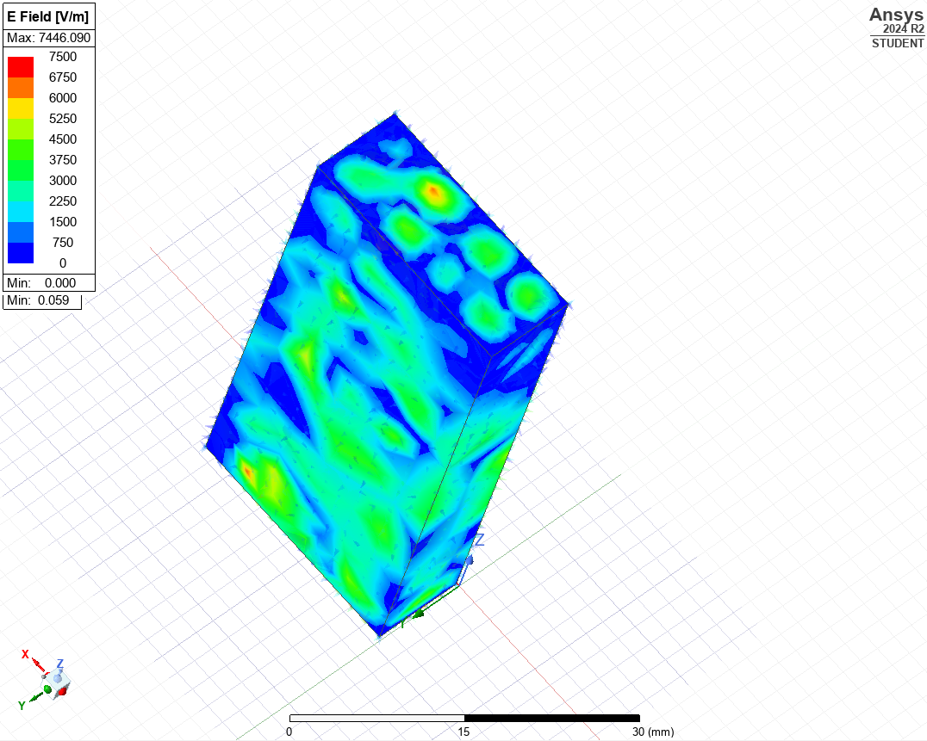  Figure 20. Mag E of Mode 1 | 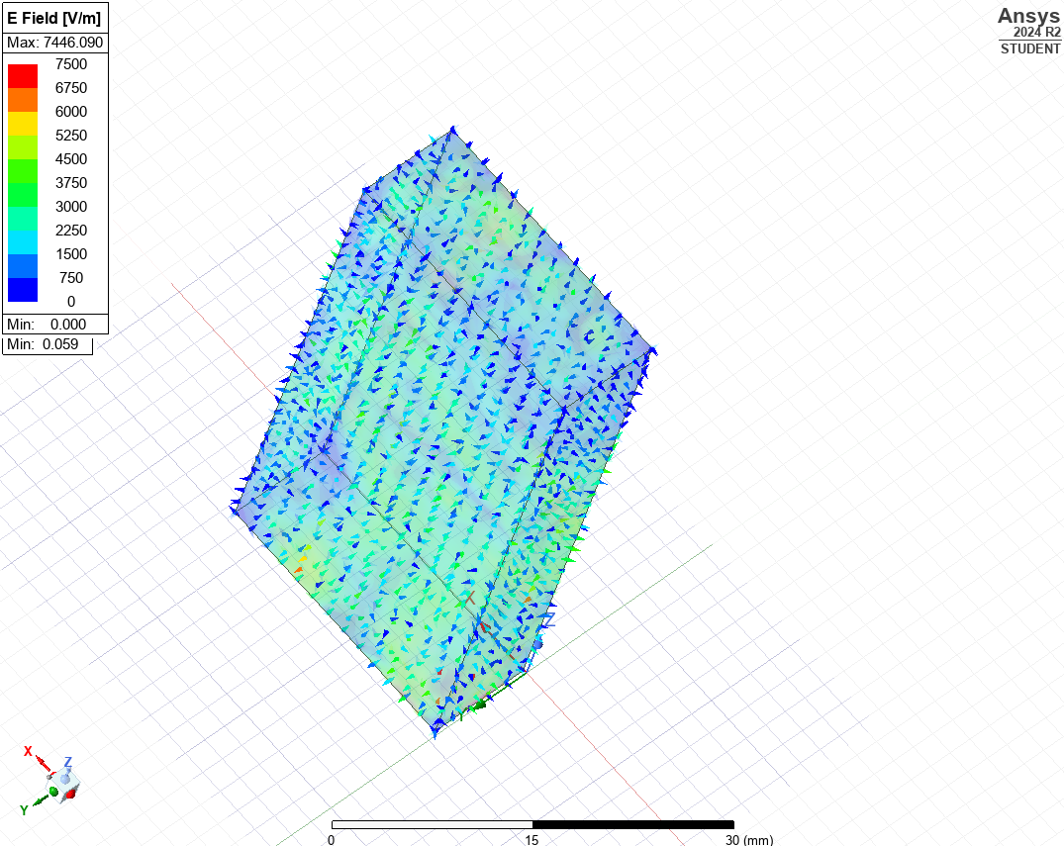  Figure 21.Vector E of Mode 1
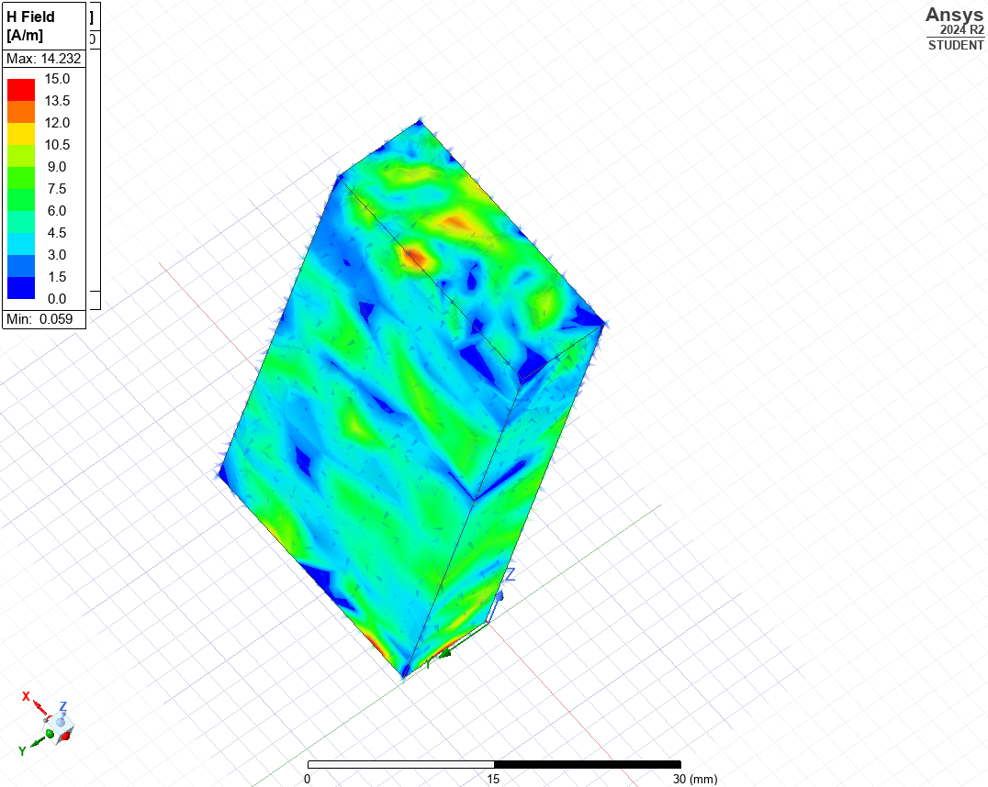  Figure 22. Mag H of Mode 1 | 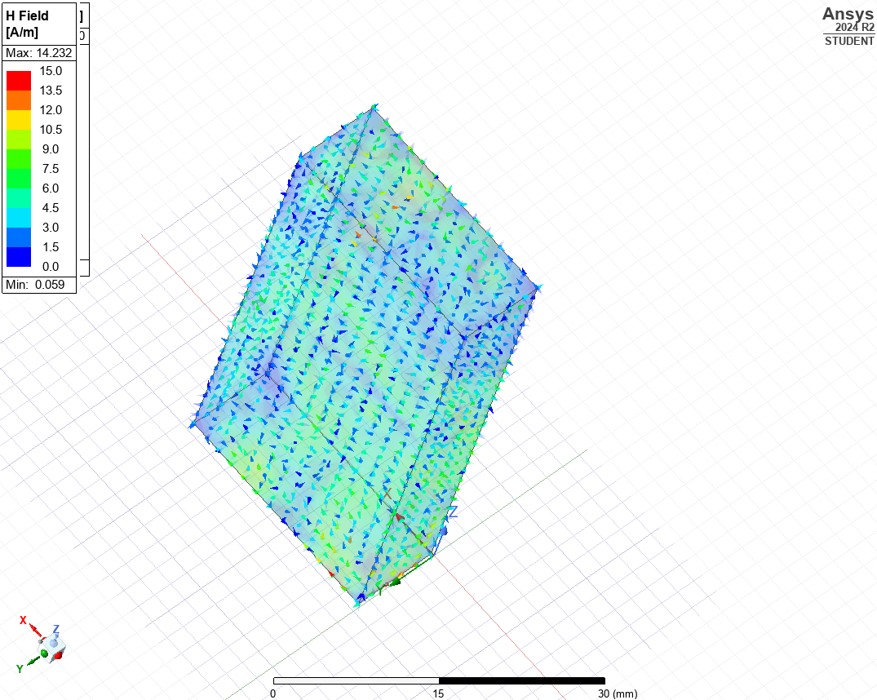  Figure 23.Vector H of Mode 1

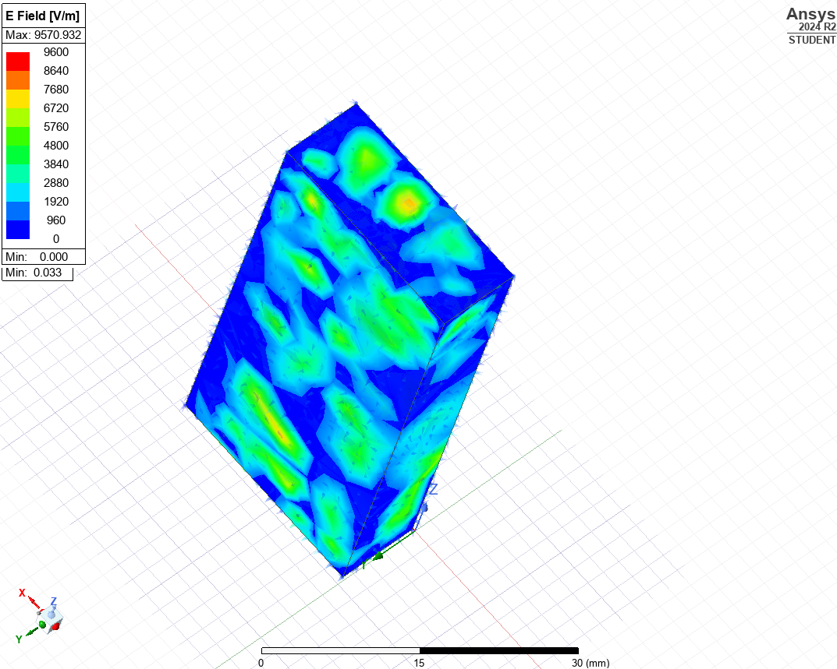  Figure 24. Mag E of Mode 2 | 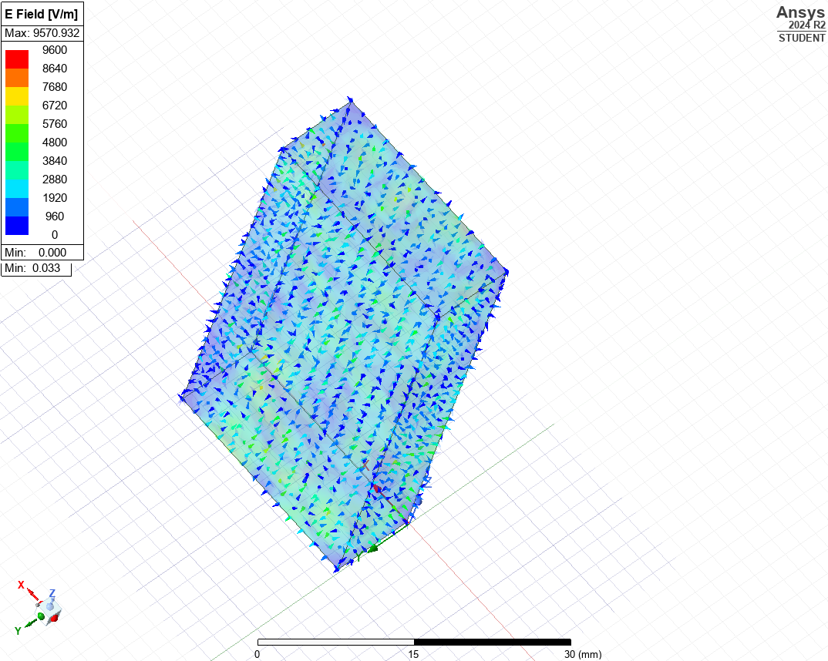  Figure 25.Vector E of Mode 2
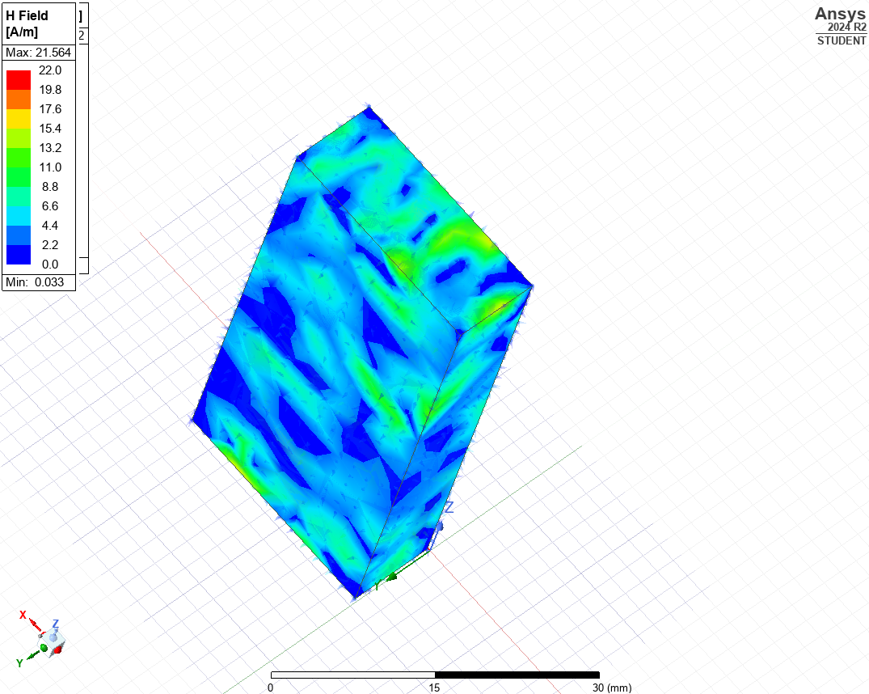  Figure 26. Mag H of Mode 2 | 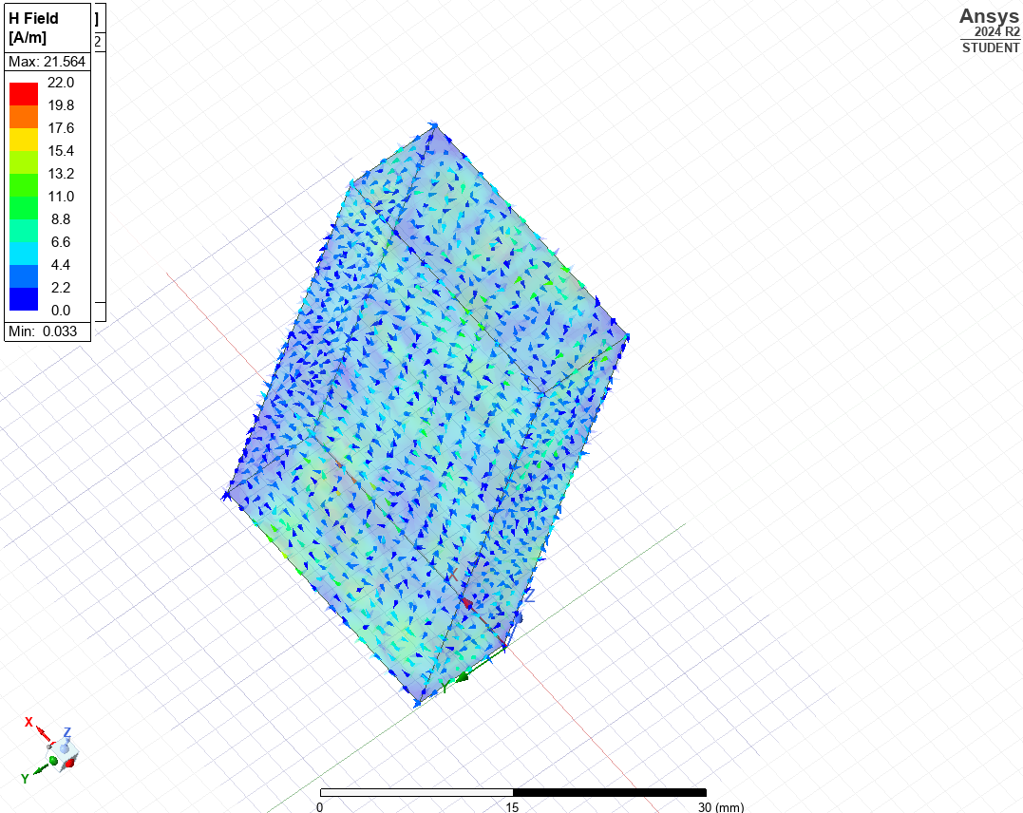  Figure 27.Vector H of Mode 2

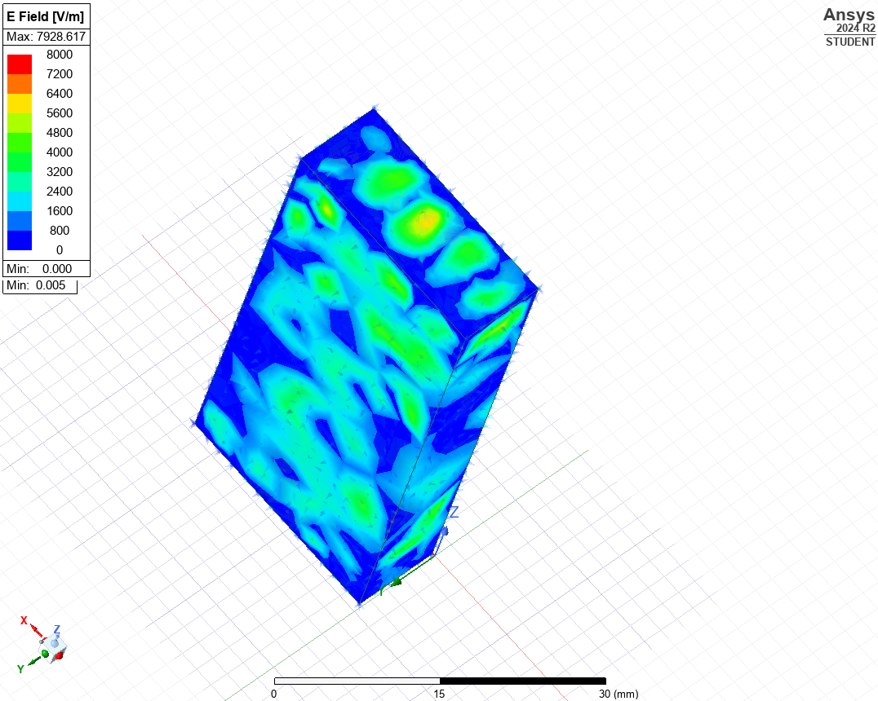  Figure 28. Mag E of Mode 3 | 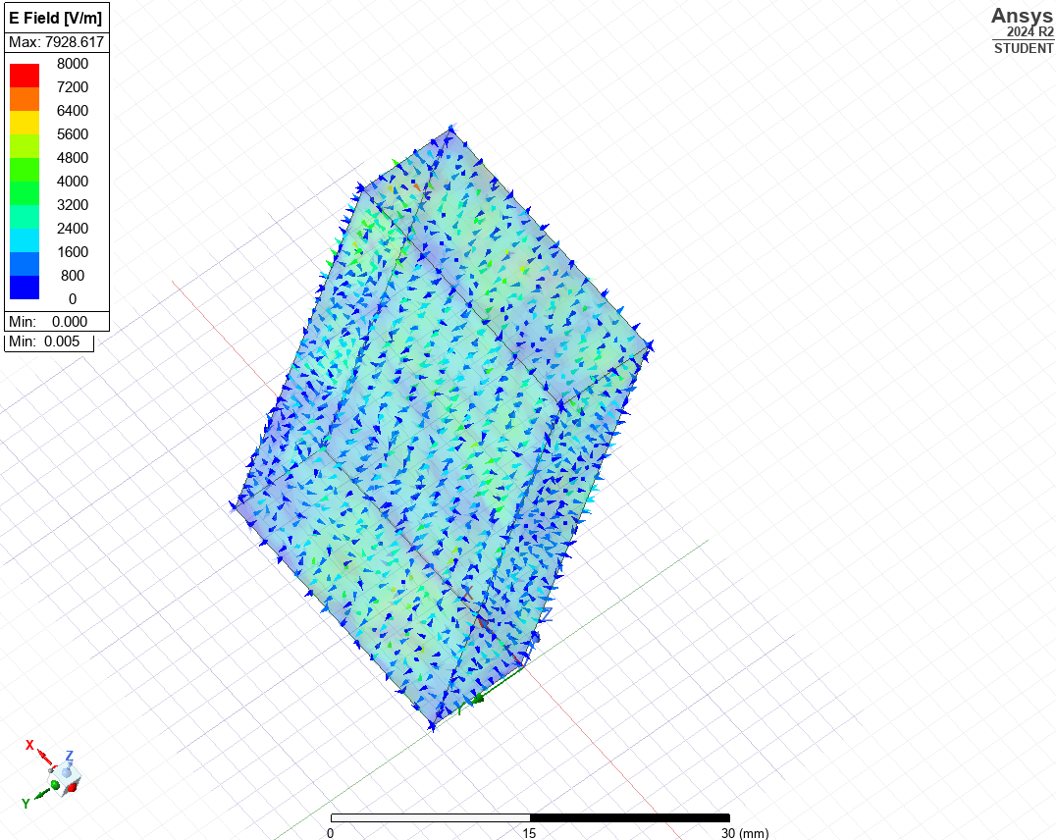  Figure 29.Vector E of Mode 3
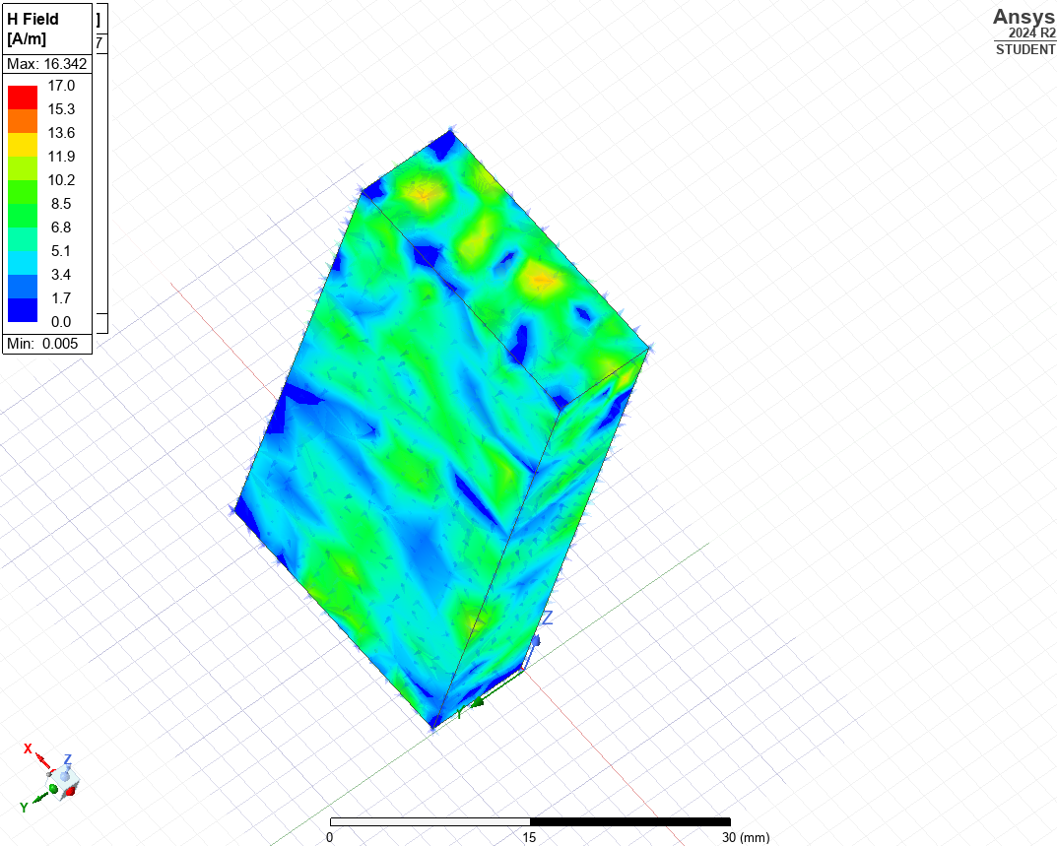  Figure 30. Mag H of Mode 3 | 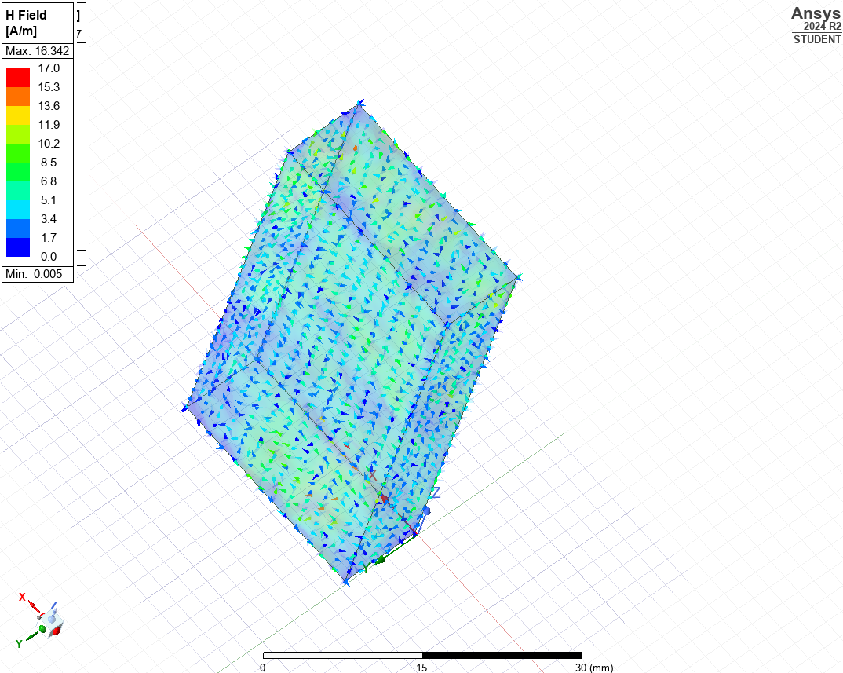  Figure 31.Vector H of Mode 3

Simulated Cut Off Frequencies with teflon
Figure 32. Rectangular Cut off frequency Plot with Teflon

Mode 1:  4.52 GHz | Mode 2:  8.00 GHz | Mode 3:  11.45 GHz
Table 2. Cut Off Frequencies with Teflon

Theoretical Cut Off Frequencies with Teflon

In Rectangular wave guide pec walls filled with teflon the cutoff frequency depends on dimensions $a$ $b$ and the speed of light in vacuum $c=3×{10}^{8} \text{m/s}$

In this waveguide (Teflon-filled) the material inside the waveguide has a different permittivity
Relative permittivity of Teflon, $ε_{r}=2.1$
The important difference being that the speed of light changes in this medium

$$v=\frac{c}{\sqrt{ε_{r}μ_{r}}}$$

And since the Relative permeability ( $μ_{r}=1)$
We can simplify to:
$$v=\frac{c}{\sqrt{2.1}}$$

Instead of using $c$ in this cutoff formula we instead use $v$

$$f_{c}=\frac{v}{2}\sqrt{{\left(\frac{m}{a}\right)}^{2}+{\left(\frac{n}{b}\right)}^{2}}$$

Where:
$$v=\frac{3×{10}^{8}}{\sqrt{2.1}}≈2.072×{10}^{8} \text{m/s}$$

Teflon-filled Waveguide Calculation:
$$a=23 \text{mm}=0.023 \text{m}$$
$$b=9 \text{mm}=0.009 \text{m}$$
$$ε_{r}=2.1$$
$$μ_{r}=1$$

Effective wave speed:
$$v=\frac{c}{\sqrt{ε_{r}}}=\frac{3×{10}^{8}}{\sqrt{2.1}}≈2.072×{10}^{8} \text{m/s}$$

For modes (TE₁₀, TE₂₀, and TE₀₁), the theoretical cutoff frequencies are calculated as follows:

TE₁₀ Mode:
$$f_{c(10)}=4.51 GHz$$

TE₂₀ Mode:
$$f_{c(20)}=9.01 GHz$$

TE₀₁ Mode:
$$f_{c(01)}=11.51 GHz$$

Comparison of Vacuum and teflon filled Rectangular waveguide

Mode | Cutoff Frequency (Vacuum) | Cutoff Frequency (Teflon)
TE₁₀ | 6.48 GHz (simulated) / 6.52 GHz (theoretical) | 4.52 GHz (simulated) / 4.51 GHz (theoretical)
TE₂₀ | 12.99 GHz (simulated) / 13.04 GHz (theoretical) | 8.00 GHz (simulated) / 9.01 GHz (theoretical)
TE₀₁ | 16.63 GHz (simulated) / 16.67 GHz (theoretical) | 11.45 GHz (simulated) / 11.51 GHz (theoretical)
Table 3. cutoff frequencies comparison with Teflon and vacuum
Filling the waveguide with Teflon (εr = 2.1) consistently reduces the cutoff frequencies for all modes compared to the vacuum-filled waveguide.

A Teflon-filled waveguide allows lower frequency signals to propagate than the same waveguide filled with a vacuum.

This expands the operational bandwidth at lower frequencies but can change the design considerations for applications requiring specific filtering.

Material filling the waveguide has a predictable effect on cutoff frequency.

Higher permittivity = slower wave speed = lower cutoff frequency.

This needs to be considered carefully when designing waveguides for specific frequency bands.

Halfwave PEC Dipole Antenna

Theoretical Length of Half-Wave Dipole Antenna
For this half wave dipole antenna, I will be using my Student ID number again to specify the dimensions.
The formula for the physical length $L$ of a half-wave dipole is:

$$L=\frac{λ}{2}$$
Thus:
$$L=\frac{231}{2}=115.5 \text{mm}$$
Dipole Length = 115.5 mm

Theoretical Operating Frequency
Operating frequency $f$ is calculated from:
$$f=\frac{c}{λ}$$

Where:
$c=3×{10}^{8} \text{m/s}$
$$λ=231 \text{mm}=0.231 \text{m}$$
Then:
$$f=\frac{3×{10}^{8}}{0.231}≈1.2987×{10}^{9} \text{Hz}=1.30 \text{GHz}$$
Resulting in an operating frequency of 1.30 GHz

Simulated operating frequency
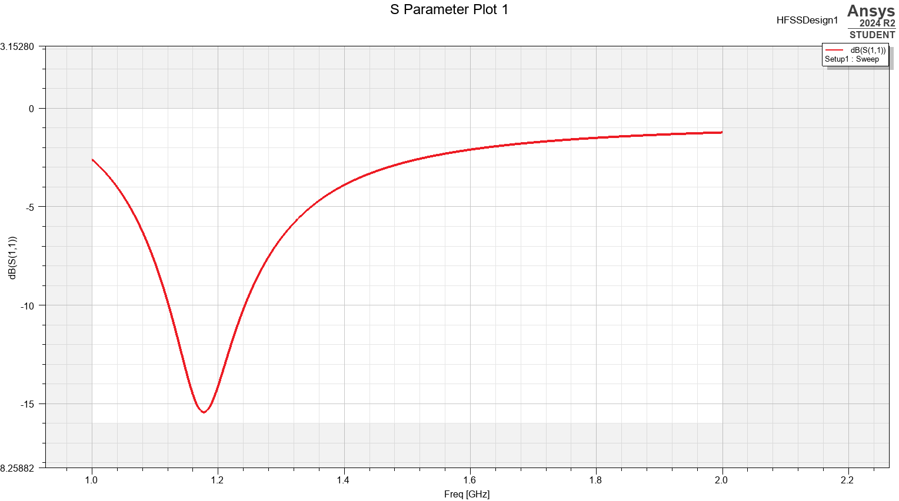
Figure 33. S parameter plot showing simulated operating frequency
The simulated operating frequency aligns somewhat close to the theoretical operating frequency of 1.3GHz however it seems to be more aligned to 1.9GHz

Design and Simulation of Half-Wave Dipole Antenna

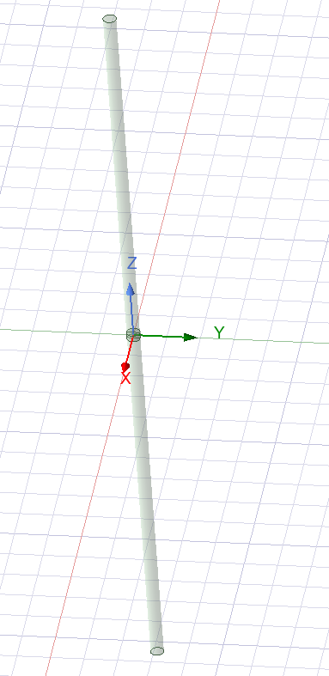
Figure 34. 3D dipole antenna design in Ansys

The dipole antenna comprises a 115.5 mm long PEC (Perfect Electric Conductor) cylinder, with a 1 mm vacuum gap at its centre. This configuration corresponds to a half-wavelength dipole designed to operate at a theoretical frequency of approximately 1.30 GHz, based on a free-space wavelength (λ) of 231 mm. This design is designed with the standard dipole antenna principles, where the total length is approximately half the wavelength of the target frequency.

Radiation pattern of the antenna
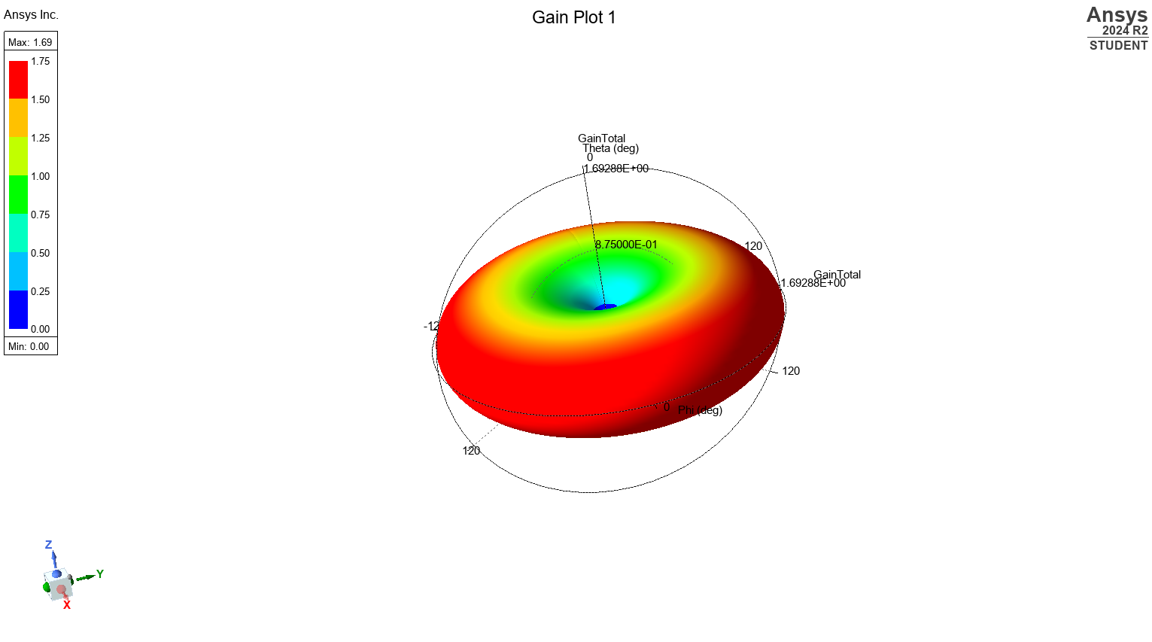
Figure 35. Ansys 3D polar plot

The radiation pattern of the half-wave dipole antenna shown in Figure 34. Ansys 3D polar plot. It exhibits the doughnut shaped pattern expected for a classical dipole, where the maximum radiation occurs perpendicular to the antenna axis and minimal radiation is seen along the y axis.

Simulation & Theory
Theory shows:
$f_{th}=c/λ=3×{10}^{8}/0.231≈1.30$GHz
Simulation shows:
Peak dip near ~1.9 GHz

Some underlying Causes:
The simple $L≈λ/2$ ignores the additional electrical length added by currents fringing fields off each tip. This fringing is caused by higher charge concentrations due to the abrupt stop and dipole width. This causes the dipole to act slightly longer than it is.

In practice, a physical dipole must be slightly longer than $λ/2$ to resonate at the same frequency.

Main findings

Main results show that even though the calculated theoretical half-wave dipole length of 115.5 mm is meant to produce a resonance of about 1.30 GHz, ANSYS simulation presents its minimum at approximately 1.90 GHz. This positive shift takes caused by the end effect and fringing at the ends of the conductors, where abrupt terminations and wire radius add effective electrical length and cause a fixed length dipole to resonate higher than the free space calculation. The 1 mm vacuum gap choice also further distort local reactance and capacitance, leading to further detuning. the simulated radiation pattern retains the classic doughnut pattern with maximum broadside gain and nulls along the dipole axis, meaning ideal expected behaviour. To attain exact theory to practice synchronization, physical dipole designs must incorporate end corrections or iterate in design through length corrections to counteract these level shifts.

Radar Systems for Drone Detection

introduction

The increasing development of Unmanned Aerial Vehicles (UAVs), or as they are commonly known, drones, presents fresh challenges to the management of airspace safety and security. Conventional radar systems, which are quite effective at detecting large, high-speed aircraft, perform poorly when faced with the slow, low-altitude, small size of most drones. Such a drawback undermines critical infrastructure, public events, and no-fly zones. This part of the paper discusses the specific difficulties in detecting drones using radar, presents recent advancements aimed at overcoming these challenges, considers the corresponding societal and ecological impacts, and proposes potential improvements toward better drone detection.

The Challenge of Detecting Small Drones

It is hard to detect drones using radar due to several reasons. First, drones have a very low Radar Cross Section (RCS), which is normally the same as that of birds, and thus they are difficult to distinguish from background clutter [1] Traditional radar systems, set up for detecting bigger targets such as planes, may filter out these small returns as noise or biological clutter (birds). Moreover, the drone normally operates at a low altitude where its signature gets masked by radar signals reflecting off the terrain, buildings, and vegetation within the ground clutter region [2]. Third, the slow speed of most drones makes them hard to detect using standard Moving Target Indication (MTI) techniques based on Doppler shift because their speed will either be less than the minimum detectable speed or be obscured by slow moving ground clutter or weather. increased use of plastic and other materials in the construction of drones renders them less reflective to radar waves compared to the usual metallic airframes of manned aircraft. All these together call for a need of special radar technologies and advanced signal processing techniques for the effective detection and tracking of drones.

Advancements, Impacts, and Improvements
Technological progress in radar gives good solutions to the problem of drone detection.

Higher Frequency Bands (Ku, Ka, W): These higher frequencies give greater resolution and are sensitive to smaller objects. The small sizes of antennas they work with are convenient for portable or deployable units. However, these tend to offer reduced range and are more susceptible to loss for example from rain or snow.
Phased Array and AESA Radars: Active Electronically Scanned Array (AESA) radars offer a big advantage with quick electronic beam steering. This allows several targets to be simultaneously tracked and can be potentially used for optimization of drone detection.

UAS(unmanned air systems) exhibit typical micro Doppler signatures due to the rotating propellers. Advanced signal processing software can pick up distinct fine frequency variations and interpret them, allowing radar systems to distinguish between UAS and birds or other clutter even when the drone body itself produces minimal Doppler shift. [3]

Networked and Sensor Fusion Systems:
Fusing radar data with data from other sensors like electro-optical/infrared (EO/IR) cameras, acoustic sensors, and radio frequency (RF) detectors creates a more robust detection system. Data fusion algorithms can be used to combine the strengths of each sensor type to improve overall probability of detection and reduce false alarms [4]

Societal and Environmental Impacts
The application of advanced drone detection radar has broader consequences. Societally, it gives protection to critical infrastructure like airports, prisons, and power stations, and aids in public safety by monitoring unauthorised drone use. It is possible there can be abuse of counter-drone technology too. For example, false positives on intent with consumer filming equipment could lead hurting an industry. Environmentally, increased application of radar technology contributes to overall radio frequency footprint, although individual counter-drone radars are usually weaker than larger air surveillance systems. Installation needs to be carefully handled to minimize any possible interference with other devices. particularly to ensure that systems designed to differentiate between drones and birds are effective in a way that does not unnecessarily disrupt birdlife. Energy consumption and mass production of persistent surveillance systems is also an environmental factor.

Proposed Improvements and Solutions
Further refinements can optimize the performance of radar against drones. The development of adaptive radar waveforms with the possibility of being dynamically optimized based on the targets characteristics and environmental factors can improve the detection of some kinds of drones. Machine learning could also be essential to detection however comes with a lot of and unseen issues due to the new technology.

The integration of radar with non-RF sensors within small, deployable units, potentially using low-cost radar modules, can provide scalable solutions to a lot of known security scenarios.

Standardization of communication protocols and data formats among different sensor systems could also help in larger security networks.

Conclusion
Detection of low, small, and slow drones continues to be problematic for conventional radar systems. Despite this, better methods such as higher frequency operation, AESA technology, micro-Doppler analysis, sensor fusion, and integration with AI/ML are making strides in capability. These capabilities provide means to counter security threats resulting from drones and other UASs but their deployment must consider societal factors as well as environmental factors,

Future developments should be focused on the adaptive methods, ML, multi-sensor fusion, and potentially new radar architectures to provide strong, resilient, and scalable drone detection systems for staying on top of the evolving character of threats.

References

[1]Charvat, G. L. “Small and Short-Range Radar Systems - Gregory L. Charvat - Google Books”.

[2] Griffiths, H., & Baker, C. “An Introduction to Passive Radar, Second Edition | Artech eBooks | IEEE Xplore”

[3] Folker Hoffmann, Matthew Ritchie, Francesco Fioranelli, Alexander Charlish, Hugh Griffiths “View article / Micro-Doppler based detection and tracking of UAVs with multistatic radar | IEEE Conference Publication | IEEE Xplore”

[4] Homeland Security, Science and Technology Directorate Counter Unmanned Aircraft Systems (C-UAS) Tech Guide

