Module Title: Hotel Placement Research Project

BA International Hotel Management

Module code: BMIH6008

Topic: Sustainable Housekeeping Practices and Their Impact on Operational Costs: A Case Study of Novotel London Wembley

Student name: Ioana Dobre
Student ID: 224087
Word Count: 7500

Declaration
I declare that the study is the result of my own research endeavours and was conducted under the mentorship of professors. All sources used in the research are highly credible and authentic. I have strictly avoided the use of AI to maintain the academic integrity and credibility of the study. Furthermore, the work is original and has not been presented to any other institutions.

Acknowledgement
I would like to thank all of my peers and teachers for helping me in completing the project on “Sustainable Housekeeping Practices and Their Impact on Operational Costs: A Case Study of Novotel London Wembley”. Both qualitative and quantitative strategies are incorporated in this research project, for which I have received enough cooperation and support from my seniors as well as from my teachers. I would also like to thank my family members and friends for helping for their time and efforts to finish the research work.
Abstract
The sustainable housekeeping practices in the hotel include significant energy and water conservation. The purpose of the study is to evaluate the sustainable housekeeping practices in Novotel Wembley. Apart from this, the evaluation of the operational cost of the hotel related to such eco-friendly practices needs to be elaborated. The key purpose is also associated with the analysis of biodegradable material use in the housekeeping department of Novotel Wembley. The aim of the research is to evaluate the adoption of Novotel Webley to sustainable housekeeping practices. Determining the operational efficiencies and cost effectiveness is the major aim of the topic. Apart from this, the objective of the study is to identify the sustainable housekeeping practices relating to the operational efficiency in Novotel Wembley.
The study has mainly shed light on the installation of water-efficient fixtures and encouraged the use of linen. It has been noted from the study that this hotel uses comprehensive composting and recycling strategies to maintain the cleaning process. They provide staff training and create awareness among customers to increase the use of sustainable housekeeping supplies. Resource conservation is a major part of such practices, which encourage guests to use reusable linens to reduce laundry costs. The smart thermostat in the hotel has been used to make energy-efficient laundry systems. Recycling, composting and sustainable procurements are the major features of the eco-friendly housekeeping practices in the hotel. Depending on the analysis, it has been recognised that a majority of the employees agreed that the hotel uses sustainable housekeeping. Management of the hotel has also provided the staff training to increase their efficiency in the use of eco-friendly housekeeping utilities. Cost reduction is the major factor that further increased the operational smoothness. Single-use plastics and reusable bottles are properly used in the hotel. In addition to this, it can be said that cleaning products used by the management are biodegradable and non-toxic. Depending on the mixed method analysis, it has been identified that harmful emissions are reduced by the company. They source products ethically and also depend on the green supply chain to maintain the overall sustainability. Moreover, the survey analysis has indicated that the use of a waste management programme is highly impactful for waste disposal and removal. However, some contrasting opinions are noted related to the use of a microfiber cloth for managing operational costs. The interview analysis has highlighted the perspective of finance and operations managers relating to the effective use of sustainable practices. Moreover, a thematic analysis has been conducted to support the Utilisation of the eco-friendly products and lower the waste generation.
Energy and water conservation needs to be done for the betterment of sustainability practices in the organisation. Apart from this, the recycling and waste removal strategies are also going to be effective for the effective use of sustainable housekeeping materials. Employee and guest engagement for managing the sustainability practices in the housekeeping department needs to be increased accordingly. Moreover, transforming the nature of activities and products can be helpful in this context.

Table of Contents
Chapter 1: Introduction 8
Research Background 8
Research Aim 8
Research Objectives 9
Research Questions 9
Problem Statement 9
Rationale 9
Chapter 2: Literature Review 11
Analysis of sustainable housekeeping practices 11
Assessment of the impact of sustainability practices on the operational costs 11
Assessment of the financial benefits of implementation 12
Evaluation of the added value for staff, guests, and the brand 13
Theoretical Underpinning 13
Literature gap 14
Conceptual Framework 15
Chapter 3: Methods 16
Research philosophy 16
Research Approach 16
Research Design 16
Research strategy 16
Data collection method 17
Population and sample 17
Data analysis 17
Ethical Considerations 17
Timeline 18
Chapter 4: Findings and Discussion 19
Findings 19
Discussion 29
Chapter 5: Conclusion 33
Conclusion 33
Linking with objectives 33
Limitations 35
Future Scope 35
Recommendations 36
Appendices 50
Appendix 1 50
Appendix 2 51

List of Figures
Figure 1: Conceptual Framework 15
Figure 2: Research Timeline 18
Figure 3: Sustainable housekeeping practices in Novotel Wembley 19
Figure 4: Efficiency improvement through sustainable practices 20
Figure 5: Effects of recycling and waste management programme 21
Figure 6: Linen reuse programme impacting laundry cost 22
Figure 7: Utilisation of durable equipment and microfibre cloth affects operational cost 23
Figure 8: Concerns over the environmental impact of tourism among adults in the United Kingdom 27

Chapter 1: Introduction

Research Background
The research provides a concise and clear overview of the sustainable housekeeping practices and their impact on the operational costs of a hospitality organisation, by assessing the case study of Novotel London Wembley. The overview of the case study highlights the strong presence of the hotel in London, as it is situated next to Wembley Park Underground station - 10 KM from Heathrow airport and contains bars along with restaurant options (Travel Weekly, 2025). The famous hotel offers superior amenities in its rooms, including air conditioning, ironing facilities, minibars, voicemail, cable/satellite television, non-smoking rooms, telephones, and a free wireless internet connection (Travel Weekly, 2025).
The hotel offers a diversified range of guest services such as crib/rollaway bed, laundry/dry cleaning service, room service, wheelchair access to common and public areas, wireless internet access in common places, electronic key/lock, smoke alarms in rooms, sprinkler in rooms, along with pet services (Travel Weekly, 2025). Hence, the services and facilities of this hotel are quite interesting and extensive, which can attract guests easily. This research project outlines the aim and objectives of the study, while also critically assessing the research objectives through an extensive literature review. The methodology highlights the type of data collection and method that are used for this project, along with the philosophy, approach and design. Both qualitative and quantitative strategies are used to analyse the findings of this project, along with a summary of the research and some effective recommendations to support the placement hotel in developing its performance.

Research Aim
To evaluate how the adoption of sustainable housekeeping practices influences operational efficiency, reduces costs, and contributes to environmental responsibility in the hospitality and facilities management sectors.

Research Objectives
- Identify sustainable housekeeping practices.
- Examine their impact on operational costs.
- Assess financial benefits of implementation.
- Highlight added value for staff, guests, and brand.
- Recommend cost-efficient sustainable strategies.

Research Questions
- What are some of the sustainable housekeeping practices?
- What are the impacts of the sustainable housekeeping practices on operational costs?
- What are the financial benefits of implementing the practices?
- What is the value added for staff, guests and brand?
- What are some recommended cost-efficient sustainable strategies?

Problem Statement
The primary challenge of implementing sustainable housekeeping practices in an organisation is the high operational and maintenance costs associated with incorporating these practices. This is the reason many hotels try to avoid implementing these initiatives due to high maintenance costs.

Rationale
The research project assesses how these practices can generate high value and benefits for the hospitality organisations in the UK by analysing the case study of Novotel, Wembley, London. Therefore, the advantages of using these approaches within the operations of a business can be understood, which include environmental protection, cost optimisation, waste elimination, along enhancing the brand’s reputation and customer satisfaction (Sukmawan and Zulganef, 2023). This is the reason this topic is so relevant nowadays to promote sustainability within the hospitality industry.

Chapter 2: Literature Review

Analysis of sustainable housekeeping practices
According to the opinion of Brychko et al. (2023), sustainable housekeeping practices in the UK hospitality industry include waste reduction, water and energy conservation, and eco-friendly cleaning practices, which are healthier and safer for guests compared to traditional housekeeping activities. This fact is entirely true because these practices are responsible for protecting natural resources and taking better care of guests by promoting the use of eco-friendly materials. Moreover, the application of recycling and reusing approaches within the business operations of the UK hotels and restaurants can significantly reduce the amount of wastage, which is extremely beneficial for them (Giousmpasoglou, 2024). However, the brands need to maintain a strong financial presence in the market to bear the expenses of these practices.
There is no doubt in the fact that the application of these sustainability initiatives can enhance the image of a brand by acquiring the trust and faith of customers, along with assuring their safety and security, but these systems are highly expensive to maintain. As per the critical view of Ally et al. (2024), the sustainable housekeeping activities reduce operational costs and improve operational efficiency, along with waste elimination and creating a very minimal impact on the environment, but these approaches cannot be applied widely due to their high maintenance costs. Most of the hotels in the UK cannot afford all of these facilities to maintain the standard of the hotel. Therefore, it can be quite challenging for brands to apply these practices and retain them for a long time without a strong economic background.

Assessment of the impact of sustainability practices on the operational costs
According to the analytical perspective of Veal, (2006), due to the implementation of sustainable practices, hospitality brands can decrease their operational costs by generating lower utility bills, lower waste disposal costs, along with reducing supply costs. These practices enhance the revenue and brand image of the companies by attracting more guests, boosting the reputation of the brand, and enhancing the loyalty of the brand, along with gaining a competitive advantage in the competitive market. The hospitality sector of the UK includes 35,000 small bed and breakfast guesthouses. It contributes 15% of the UK's greenhouse gas emissions, so following green housekeeping practices can help in reducing the annual energy cost of this sector, as it contributes 1.3 billion GBP with carbon emissions of over 8 million tons every year (British Business Bank, 2025). According to a recent survey, 74% of global travellers wanted to travel more sustainably in the upcoming 12 months, so using proper sustainable measures within the business operations and the housekeeping services of the industry can bring more consistency in their business operations by optimising business costs in the future (British Business Bank, 2025).

Assessment of the financial benefits of implementation
Ijatuyi et al. (2025) claims that the sustainability activities in housekeeping within the hospitality firms of the UK ensure incentives and long-term profitability, which is necessary in this highly competitive business landscape. The government offers several incentive programmes for implementing green practices by the brands. The analytical findings of Deng and Zhou (2022), besides the initiatives taken by the government, the approaches applied by an organisation can highly impact the financial outcomes of their businesses. Using energy-efficient LED lights, light sensors and key cards can save up to 30%/50% of the lighting costs of the companies and reducing the temperature of different areas of a hotel can reduce the heating costs by 20% (British Business Bank, 2025). Besides these practices, hotels can use eco-friendly guest room products, such as eco-friendly toiletries, organic soaps and shampoos, reusable bottles, mugs, glasses, and cutlery. Stocking biodegradable coffee pods and tea bags is also necessary. Additionally, reviewing the cooking process to reduce food waste is crucial (British Business Bank, 2025). Most importantly, reducing the number of washes, along with installing low-flow technology for showers and taps, is necessary by conducting daily checking of the bathrooms to review any kind of leakage, for preventing water wastage, can save up to 750 litres of water per day by optimising costs (British Business Bank, 2025).

Evaluation of the added value for staff, guests, and the brand
As per the analytical philosophy of Kholijah (2024), the staffs, guests and a brand are interrelated to each other by influencing the functions of the brand along with its decision-making process. Staff and guests are both of the most important stakeholders of a business, because the performance of staff and the purchase behaviour of guests influence the sales rate of a hospitality brand. The organisations have to ensure that the guests and employees are always satisfied with their services and facilities offered, so the business can grow gradually (Ayi, 2023). For example, if the staff of the hotels and restaurants are performing better, the brands can achieve a higher reputation and appreciation from their guests and the positive feedback of the customers can motivate employees to perform better, which ultimately improves the performance of an organisation. Hence, all the factors are interconnected and are generating value for the business, which is necessary for a venture to survive within the highly competitive market. Considering this fact, Cottrell (2014) states that consistency of performance of the employees is mandatory to retain the leading position of a hotel, which is not possible without the positive remarks and reviews of customers. On account of that, it depends on the service standards and the offered facilities of an organisation that how guests are going to react after receiving their services. Positive customer experience can generate high value for a brand, which can motivate the staff to increase engagement in their activities, eventually generating high value for the particular hospitality organisation.

Theoretical Underpinning
Resource-based view (RBV)
RBV is an efficient theory suggesting a hotel’s unique resources and capabilities, along with its commitment to sustainability, which is a source of competitive advantage (Kero and Bogale, 2023). The incorporation of sustainable practices like energy efficiency, waste reduction and eco-friendly design of hotels can make the hotels different from their competitors. For example, the application of eco-friendly materials for cleaning rooms, cutlery and kitchen, along with using organic toiletries are highly efficient resource that differentiates the hotels from their rivals and can provide the scope to grow gradually.
Theory of Planned Behaviour (TPB)
This particular theory helps to examine the sustainability practices of a hotel by influencing the intentions and attitudes of guests and employees to analyse their behaviour (Rozenkowska, 2023). The incorporation of this theory is highly beneficial for an organisation to explain why travellers may select a ‘green hotel’ over a traditional hotel, to motivate staff to participate in recycling programmes. Hence, the analysis of guest psychology can assist in improving the housekeeping as well as other practices and services of the hotels to provide a highly enriched customer experience to satisfy them.

Literature gap
Based on the overall analysis conducted above, it is clear that the approaches used in the business operations of the hospitality enterprises and their efficiencies can add more value to this particular sector. However, the role of changing customer purchasing intentions, along with the constantly fluctuating marketing trends, in influencing the sustainability housekeeping practices of the hotels is not discussed in depth. The demand of customers and their psychology in selecting hotels based on the changing marketing trends is not evaluated critically by generating a gap in this project.

Conceptual Framework
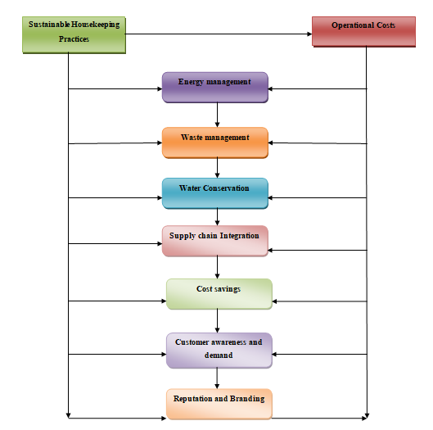

Figure 1: Conceptual Framework
(Source: Self-Developed)

Chapter 3: Methods

Research philosophy
The research philosophy refers to the beliefs, assumptions and values regarding the ontology, axiology and epistemology (Park et al. 2020). Among three different philosophies, like positivism, realism and interpretivism, the positivism methodology has been selected. Relationships between the variables and findings of a border population have been selected with positivism philosophical approaches (Maretha, 2023). However, the accurate and reliable results about the sustainable housekeeping practices cannot be generated with realism and interpretivism philosophy.

Research Approach
A research approach is recognised as a broader assumption for guiding the methods for further data collection (Thierry, 2023). Two different types of research approaches are present, such as inductive and deductive. In this context, a deductive approach has been used to explain the relationships between variables and concepts (Vears and Gillam, 2022). In contrast to this, rigid and biased data gathering failed to explain the sustainable housekeeping practices of a hotel and their implications for operational costs.

Research Design
Outlining the framework for measuring, accumulating and analysing the data to answer the research questions accurately (Anderson and Lightfoot, 2022). The study has highlighted the necessity of both exploratory and explanatory research design applicability (Groer et al. 2025). The exploratory research design has been effective in elaborating the complex issues of sustainable housekeeping practices, while the explanatory design has evaluated the operational cost phenomenon (Fishman et al. 2021).

Research strategy
Research strategy is reviewed as a systematic plan that has been effective in gathering and elucidating related data to answer research questions (Lavarda and Bellucci, 2022). The quantitative strategy mainly helps in the delivery of data-driven and statistically consistent data, while the qualitative strategy has been effective in the delivery of flexibility and exploring complex issues for sustainable housekeeping.

Data collection method
Data collection processes are the specific strategies that have been helpful in measuring and gathering necessary information for the research (Taherdoost, 2022). In this context, primary and secondary data collection methods have been used for accumulating information on the uses of eco-friendly and biodegradable products.

Population and sample
Sampling is a statistical process for gathering necessary data from a larger population. . The probability selective sampling has been used for selecting interview participants as it helps in lowering the biases and formulating generalisability (Iliyasu and Etikan, 2021). Moreover, the non-probability random sampling has been used for selecting survey participant. Two managers from the finance and operational departments have been selected for an interview. Moreover, 30 employees from different sections, like finance, marketing, operations, and other sections, have also been chosen

Data analysis
Data analysis is recognised as the systematic process for inspecting, modelling and transforming the data to discover useful patterns and information to support the decision-making process. Thematic and trend analysis are two different types of data analysis strategies utilised in the research (Saunders et al. 2022). In this context, both data analysis strategies have been used to evaluate the information. Trend analysis has been effective in generating accurate results by evaluating the information statistically. Moreover, thematic data analysis has been beneficial for facilitating qualitative data by making data-driven theme interpretation.

Ethical Considerations
The collected data from participants is kept securely to maintain data privacy, adhering to the Data Privacy Act of 2018 (Gov.uk, 2018). In this context, informed consent and voluntary participation of the participants have been allowed to maintain the overall ethics. Moreover, the information collected from secondary sources is free from copyright and plagiarism issues. No data infringement has been made during the collection of secondary information.

Timeline
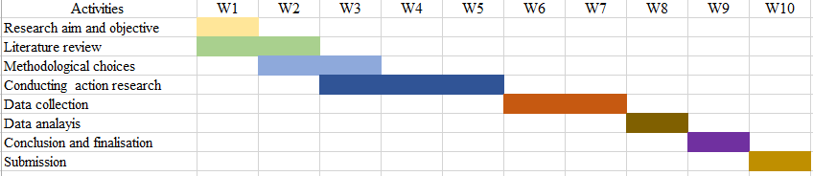

Figure 2: Research Timeline
(Source: Self-developed)

Chapter 4: Findings and Discussion

Findings
Survey analysis
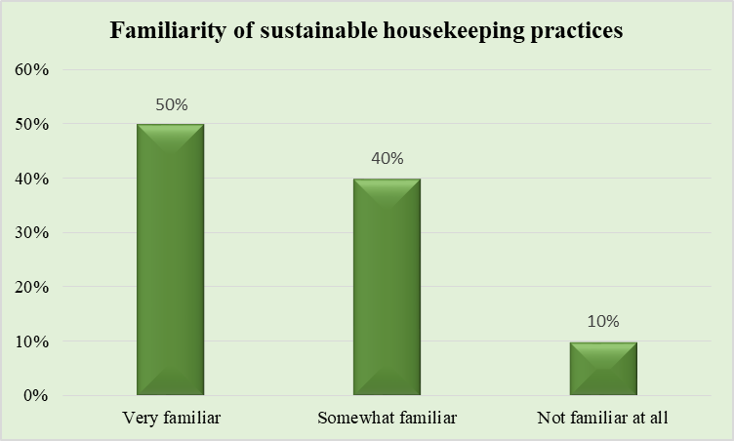

Figure 3: Sustainable housekeeping practices in Novotel Wembley
(Sources: Self-developed)
The above graph highlights that 50% of the employees in Novotel are very familiar with the sustainable housekeeping practices. Moreover, 40% of the respondents stated that they are somewhat familiar with the uses of sustainable strategies in the housekeeping practices at the Novotel Hotel. In addition to this, it can also be stated from the above chart that 10% of the employees are not familiar with the eco-friendly housekeeping practices at the hotel. Thus, the trends related to the use of biodegradable materials in the housekeeping sections of the hotel are relatively high, as the majority of the employees are very familiar with this.

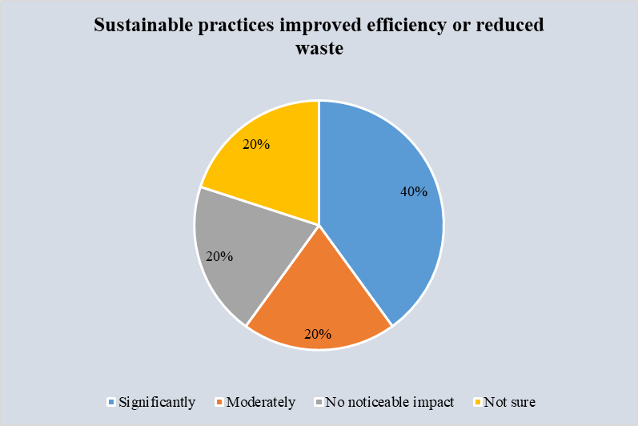

Figure 4: Efficiency improvement through sustainable practices
(Sources: Self-developed)
The above chart depicts that 40% of the employees significantly believed in the effective utilisation of sustainable practices to enhance operational efficiencies. In contrast to this, 20% of the employees agreed with the question moderately. Moreover, 20% of the employees have also indicated that they did not see any kind of noticeable impact in this process. The graph has also shed light that 20% of the employees are not sure about sustainable housekeeping procedures in this organisation. Depending on the above statement, it can be interpreted that employees showed a mixed reaction to the betterment of operational efficiency by integrating sustainable practices.

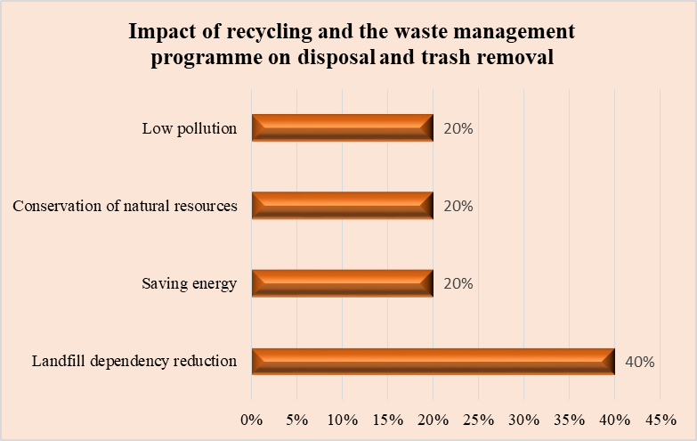

Figure 5: Effects of recycling and waste management programme
(Sources: Self-developed)
The above chart highlights that 40% of the employees agreed with the landfill dependency reduction. In this context, 20% and 20% of the employees agreed with the statement of saving energy and conservation of natural resources, respectively. Moreover, 20% of the respondents have agreed that low pollution is the major effect of waste management and recycling programmes on trash removal and disposal. Therefore, it can be interpreted from the graph that the organisation has used recycling and waste management processes for trash removal and disposal.

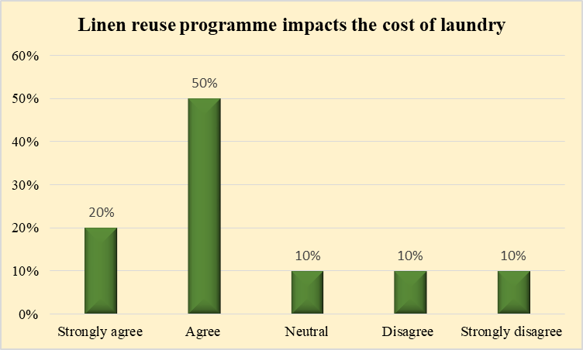

Figure 6: Linen reuse programme impacting laundry cost
(Sources: Self-developed)
This chart shows that the incorporation of linen reuse programmes impacts the cost, and 20% of the employees strongly agreed with this. Moreover, 50% of the respondents agree, and 10% of them remained neutral on this. However, 10% respondents disagreed and strongly disagreed with the statement that line reuse impacts the cost. Thus, it can be interpreted from the chart that the linen reuse programmes have highly affected the laundry cost of Novotel London.

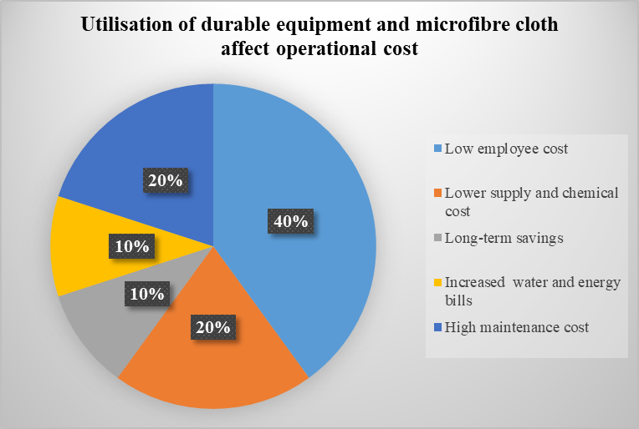

Figure 7: Utilisation of durable equipment and microfibre cloth affects operational cost
(Sources: Self-developed)
The above graph indicates that 40% and 20% of the respondents believe low employee cost and lower supply cost related to microfiber have affected the operational cost. Moreover, 10% and 10% of respondents have indicated that the long-term savings and increased water bills have affected the operational cost, respectively. However, 20% of employees also believed that high maintenance costs are associated with using microfiber and durable equipment.

Interview analysis
Question 1: How have sustainable housekeeping practices influenced operational efficiency and resource utilisation at Novotel London Wembley?
Answer
Financial Manager: The adoption of sustainable practices has led to a notable decrease in utility bills, specifically for water and energy. Moreover, better resource management has resulted in a reduction in waste disposal costs. While I have seen a positive trend in operational cost savings, some initial funding in new equipment was necessary to achieve these benefits.
Operations Manager: Sustainable practices like low-flow water fixtures and towel reuse have significantly reduced water and detergent consumption. We have also improved efficiency by focusing on waste reduction, which streamlines supply management and reduces the volume of disposables needed. Therefore, also upgrades staff productivity by concentrating on key tasks and reducing the overall inventory of cleaning supplies.
Question 2: Can you share any financial data or trends that reflect changes in operational costs since the adoption of sustainable housekeeping practices
Answer
Finance Manager: Ever since integrating sustainable practices, we have seen a steady decline in overall utility expenses, with a noticeable drop in water and energy consumption. These savings have contributed to a positive change in our operational cost trend. For example, our quarterly utility spend has decreased by around 10%.
Operations Manager: We track the reduction in waste disposal volume through specific data on cost savings is more readily available through the finance department. From an operational standpoint, we have seen reductions in consumable supply costs and greater predictability in laundry expenses due to better linen management.
Question 3: What challenges have you encountered in implementing and maintaining sustainable housekeeping practices, and how have these been addressed?
Answer
Operations Manager: A primary challenge was confirming that staff consistently followed new protocols. We addressed this through comprehensive training, clear visual aids, and a system of regular feedback. We also encountered resistance from some guests who were initially unaware or unsupportive of the changes, which we countered with guest education on the benefits of sustainability.
Finance Manager: The beginning funding in energy-efficient equipment and water-saving fixtures presented a short-term financial challenge. Thereby, this was managed by incorporating it into our capital expenditure budget and demonstrating the long-term return on investment through projected savings. Another challenge was the complexity of tracking and reporting the specific financial effect of each initiative. Our team have since implemented a more robust system for tracking these costs and savings.
Thematic Analysis
Integrating sustainable housekeeping practices for enhanced operational efficiency and cost savings
Sustainable housekeeping practices are increasingly linked to enhanced operational efficiency by embracing resource consumption for long-term cost savings. Taking advantage of conversion measures, hotels reduce usage of water, energy and chemicals (Gennitsaris et al. 2023). Hotels prioritising sustainability can achieve significant operational cost reductions. For example, low-flow fixtures and energy-efficient systems give rise to a 30% saving in operating expenses. The Novotel London Wembley employ measures similar to the Novotel London Blackfriars, which installed water flow regulators and efficient toilets, and uses biodegradable detergents (Group.accor, 2025). Energy efficiency is boosted by LED lighting and advanced HVAC systems, reducing electricity consumption. Transitioning to sustainable housekeeping suppliers, such as biodegradable cleaning agents, bulk dispensers and eco-certified materials, reduced expenses associated with waste and logistics (Lopez-Gamero et al. 2024). The ‘Zero Plastic’ initiative of Novotel London eliminates single-use plastic from guest rooms, replacing them with refillable dispensers for toiletries. Therefore, this reduces purchasing frequency, lowers waste disposal expenses and eliminates the logistical burden of restocking individual bottles.
Impact of sustainable housekeeping practices on operational costs
The transition to sustainable housekeeping affects operational expenses through both initial investment and recurring expenses (Ivanov and Webster, 2020). The beginning capital investment for new technologies like energy-efficient lighting or water-saving fixtures is substantial, but it promotes a high ROI through lower utility bills over time. Hotels' overall revenue reached around £15.1 billion, which reflects the sector’s scale and the potential for large-scale cost savings through efficiency (Tan et al. 2025). The Novitel embrace Accor Group’s purchasing power to procure sustainable products at a lower cost than smaller companies. Sustainable practice changes the nature of recurring operational expenses (Zeng et al. 2024). Non-compliances with the growing sustainability agenda are perceived as a moderate to high business risk for UK companies (Papademetriou et al. 2023). Information indicated that a failure to adopt could lead to future fines or loss of business. Therefore, Novotel reduces the costs associated with hazardous waste disposal by implementing a ‘Linen and towel reuse program’ for guests directly cuts laundry costs for water, energy, and detergent (Deloitte, 2024).
Financial benefits of implementing sustainable practices
The financial benefits of sustainable practices extend beyond general cost reduction to include enhanced brand value and competitive advantage. Sustainability is a growing consideration for UK travellers and hotels that are seen as environmentally responsible attract a larger segment of eco-conscious consumers. A growing trend with a value of 30% of British travellers choosing green hotels to reduce their environmental impact through willingness to pay a premium varies (Statista, 2025).
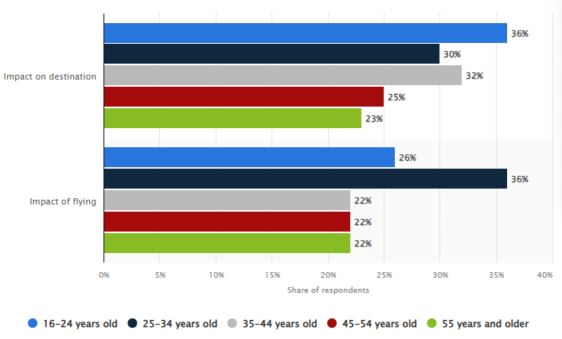

Figure 8: Concerns over the environmental impact of tourism among adults in the United Kingdom
(Source: Statista, 2025)
As part of a global brand, the Novotel embrace the PLANET21 strategy and extensive marketing to attract environmentally aware customers (Velaoras et al. 2025). This dedication upgrades brand image and positions the hotel favourably against competitors that have not invested in sustainability. Certification programmes (Green Key) and transparent reporting build brand credibility and uplifts reputation to increase customer loyalty and repeat business (Arici et al. 2023). For example, Novotel established a reputation for sustainability by reinforcing initiatives communicated to guests via in-room materials and the company website (En.ampliro, 2025).
Added value for staff, guests, and brand through sustainable practices
Sustainable practices accelerate a more positive and engaged environment for staff and guests to strengthen the brand’s image and market share (Sahin et al. 2024). Involving staff in a sustainability approach through training and engagement programs advocates morale and creates a sense of shared purpose. The staff of Novotel are trained in sustainable procedures such as proper waste segmentation, mindful energy use and new cleaning protocols. This involvement is coupled with a company culture that prioritises sustainability, which significantly increases staff pride and retention (Koytcheva et al. 2021). Guests increasingly expect hotels to operate sustainably. Therefore, Clear, authentic communication about green initiatives upgrades the guest experience and leads to higher satisfaction. For example, in-room information cards explaining the linen reuse program or the presence of recycling bins signal the hotel's dedication. The refillable toiletries improve the guest experience by offering a luxury touch while eliminating single-use plastic waste, meeting modern guest expectations (Tan, 2021).

Discussion
The sustainable housekeeping practices have mainly involved the conservation of energy and water through the recycling process. Based on the above analysis, it has been recognised that biodegradable cleaning products in the hotel help in energy and water conservation. As opined by Evryastuti et al. (2022), maximisation of natural light in the housekeeping section and utilising the high-efficiency cleaning machines has been effective in sustainable practices. The objective of recognising the sustainable housekeeping practices has been further supported by survey results that 50% of the employees agreed on sustainability approaches in the company. Implementation of a stronger recycling programme has been effective in reducing the use of plastics within the organisation (Hsieh et al. 2025). A green cleaning strategy and waste reduction process in the company has been supported by the finance and operations manager of the company. They highlighted that the use of eco-friendly strategies benefits the company in reducing utility bills and mitigating operational costs. Training for the housekeeping staff of the company has been provided to ensure consistent sustainability practices (Vavrova et al. 2024). Purchase of sustainable cleaning supplies in bulk has positively impacted the packaging process. In supporting the statement, it can be said from the survey results that 40% of the employees believed the use of sustainable practices creates operational efficiencies in the organisation by lowering costs.
Switching to non-toxic and biodegradable products has created a lot of advantages for the company to lower their operational cost and increase efficiency. Guests of the hotel have been encouraged to reuse the linens and towels to conserve water. Room insulation is maintained in this organisation very efficiently to make suitable progress to the sustainable housekeeping materials utilisation (Zu and Cong, 2022). The recycling programme for plastic, paper, glass and other metals is used in Novotel London Wembley. Nearly 70% of the employees in this company think that the incorporation of the linen reusing process lowered the laundry cost. In addition to this, it can be said that the green cleaning process streamlines operational practices by mitigating overhead costs. The reusable linen products consume less water and last longer than the traditional ones (Aagaard, 2023). Lowering the packaging cost is one of the major effects of sustainability practices in Novotel London Wembley. However, the finance and operations manager of the hotel stated that employees required adaptation to the new protocols in terms of utilising sustainable housekeeping practices. The finance manager has also faced issues in terms of conducting regular sustainability audits for recognising the improvement areas. Composting of organic and food waste has been beneficial for the management to facilitate better waste reduction throughout the operation (Koytcheva et al. 2021). Thus, the discussion clearly supports the objective of sustainable housekeeping practices in Novotel London Wembley.
Sustainable housekeeping practices can generate a huge impact on the operational costs of an organisation because these activities promote eco-friendly initiatives by making people aware of their importance in the environment (Iing et al. 2025). As per the opinion of Dimitriou (2022), by implementing sustainability approaches in housekeeping, the hospitality companies can reduce their operational costs. The reason is, these activities are known for saving energy along with conserving heat, light and water (Qi, 2024). According to the analysis of Ivanov and Webster (2020), it is clear that these functions are responsible for streamlining the operational activities of hotels, including the Novotel. Hotels like Novotel, Premier Inn, Travelodge, Marriott International and many other brands need to change their business strategies to maintain a strong presence in the competitive market. The revenue of the hotels has reached £15.1 billion, which means that this sector has high potential to grow along with improving its cost-maintaining capability (Tan et al. 2025). Hence, the organisations that belong to this sector have to try their best in terms of developing the quality of services by introducing different new sustainability initiatives to strengthen their performance in the market (Spektor et al. 2023). The critical analysis of the literature, along with the survey and the interview, shows the relevance of this objective in the business of Novotel. There is no doubt that the services of the hotel are quite premium and it is very famous for its standard customer services and quality food all over the UK, despite having high competition in the industry. In accordance with Kosasih et al. (2023), the increasing number of hotels in the hospitality industry of the UK can be a matter of concern for the Novotel because it needs to be more innovative, creative and extremely flexible to beat its customers. Otherwise, the position of the brand can be grabbed by any other hotel at any point of time.
There are multiple financial benefits of implementing these practices within an organisation, as these practices require high energy efficiency to boost the financial performance of a brand (Doborjeh et al. 2022). As per the opinion Ijatuyi et al. (2025), monitoring and tracking the operational and functional activities of a hotel is necessary to review its current position in the industry. Otherwise, the brand cannot take the required action on time to boost its economic ability over others. Using highly capable LED lights can save up to 30%-50% of energy usage of a hotel, which means the cost for lights can be reduced significantly (British Business Bank, 2025). These minor factors should be noted down by others to improve the efficiency of an organisation. 30% of British travellers have declared that they prefer to stay in green hotels, which shows the high potential of these hotels in the future (Statista, 2025). It depends on the changing customer behaviour, that how they are going to react to the services of a brand. For example, a particular service of a hotel can be liked by a customer, but the same service can be disliked by another customer (Liu-Lastres et al. 2023). This means the matter is highly contradictory in terms of improving the financial performance of a venture, as it relies on the decisions of customers. In terms of growing globally and acquiring a huge number of guests by promoting sustainability initiatives, Novotel embraces PLANET21, which is an extensive marketing strategy to attract environmentally aware customers (Velaoras et al. 2025). This strategy shows how these kinds of financial programmes can boost the credibility of an organisation in the local as well as the global market.
Based on the analytical perspective of Mitsakis et al. (2025), the role of incorporating sustainability practices in housekeeping can be understood and evaluated well, from which the significance of these practices can be assessed in terms of optimising the financial backbone of a brand. Therefore, Novotel has tried to upgrade its economic credibility by engaging customers through introducing different types of room services along with its attractive website (En.ampliro, 2025). All of these strategies are highly capable of generating positive economic growth for the organisation to secure more profit in the upcoming days, which can make the brand a popular name all over the world. This objective has been entirely aligned with the analytical literature review and the data assessment to understand the importance of financial management by using sustainable housekeeping practices.
Employees, guests and a brand are interrelated to each other in terms of generating high value to an enterprise by promoting sustainability (Dangi and Petrick, 2021). The implementation of these initiatives not only enhances the reputation of the brand but also encourages employees to perform better. Supporting this statement, Koytcheva et al. (2021), the culture of an organisation always prioritises sustainability to highlight its relevance in the contemporary business world. The expenses of implementing these services are indeed high, but the business professionals have to be extremely analytical to implement the right business strategy, so that a competitive advantage can be achieved by the companies. In accordance with Kholijah (2024), the positive reviews of customers are responsible for motivating staff and they start to perform better, which eventually upgrades the efficiency of hotel chains like Novotel. Though the application of these practices is quite a matter of risk, after implementing these activities, a company can be assured of its long-term business career along with beating its rivals (Japor, 2021).
During the time of critically analysing the significance of sustainability practices within an organisation, it has been discovered that the trend of visiting or staying in green hotels is increasing day by day, indicating the high popularity of these hotels. After Covid-19, people have become more aware of their safety and health measures, so they are willing to pay more, but are not ready to compromise with their health and safety (Colmekcioglu et al. 2022). This is the reason they prefer green hotels or eco-friendly hotels over traditional hotels. Based on the analytical philosophy of Tan (2021), the need for recycling and reusing can be understood because the refillable toiletries are now being loved by guests and the amount of waste has also been decreased, which is also a major plus point. Hence, this objective has adhered to the critical literature analysis and the secondary and primary data evaluation to find the relevance of the re-sustainability practices and value creation within this sector.

Chapter 5: Conclusion

Conclusion
The sustainable housekeeping practices at the hotel, like Novotel London in Wembley, lead to cost-saving practices of cost saving for energy and water conservation. The utilisation of eco-friendly and biodegradable products has further helped in the effective use of eco-friendly materials. Incorporation of such changes has further resulted in the reduction of utility bills in the organisation. Smart lighting and linen reusable programmes, and savings from the utility bills, have further affected the operational costs. In this context, it has been noted throughout the study that waste segregation and recycling initiatives have been further associated with the disposal fees. Long-term financial benefits have been obtained with the effective use of sustainable housekeeping practices in the company. The organisation has showcased a better commitment to sustainability practices for enriching guest satisfaction. Implementation of the mixed method data collection method has been effective in gathering a larger amount of data on the sustainable housekeeping practices of Novotel London. Employees and managers have highlighted that the effective use of sustainable practices lowers operational costs. As a result of this, it positively impacted the performance of the hotel in managing operational costs.

Linking with objectives
Objective 1
The first objective of the research has been addressed accurately during the formation of the literature review and discussion. In the literature review section, it has been recognised that the previously published article has supported the overall context. Based on the research process, some positives have been discussed related to the sustainable practices management of operational costs. The results of primary and secondary results have showcased that the housekeeping practices are extremely good in Novotel London Wembley. The effects of sustainable practices, such as the replacement of single-use items, installing smart technology, and water conservation processes, have lowered the operational cost.
Objective 2
This objective has shed light on the examination of the factors related to sustainable practices in the housekeeping department of Novotel London Wembley. The objective has been accurately met in the literature review section by critically discussing the subject. It has been noted that the sustainable practices in the housekeeping department focus on water and energy conservation. An efficient laundry and waste reduction process has also been discussed widely in the study. Lower utility and employee costs, with reference to the reduction of disposal costs, have created advantages for the management of operational costs. This objective was further met in the findings section with evidence from the survey, interview and thematic analysis.
Objective 3
In order to address the third objective, a lot of factors related to sustainable housekeeping practices have been discussed. The third objective was accurately met in the literature review section by examining the financial benefits and incorporating the resource-saving strategies. Lowering supply costs and avoiding the high utility bills are considered the major advantages for the reduction of operational costs. However, minimal drawbacks like high implementation cost and lack of skilled housekeeping employees have raised certain challenges. The objective has been accurately illustrated and supported with survey and interview findings. Moreover, secondary articles and journals have also supported the objective in the analysis section.
Objective 4
The objective focuses on the detection of sustainability strategies in the housekeeping department of Novotel London Wembley. This objective was previously addressed in the literature review section by focusing on the value-added facilities to boost employee morale and guest satisfaction. Safer working conditions and improved training have been provided to the employees in the organisation to formulate a skilled workforce. Moreover, an enhanced experience for customers has been created that significantly improves the brand image. Operational costs have been reduced with such practices, and that has added value to the overall service delivery of this organisation. The objective has been addressed in the analysis section by making a critical evaluation depending on qualitative and quantitative results.
Objective 5
In order to address the objective, different factors related to sustainable housekeeping practices have been discussed in the study. The objective was properly addressed in the literature review selection by evaluating the secondary journals, articles and research papers. Positive effects of eco-friendly housekeeping practices related to the reduction of operational costs have been accurately elaborated in this context. The objective has also been addressed in the analysis and findings section by making a critical evaluation of the employee and manager’s perception on housekeeping sustainably. Moreover, this has been properly supported with the secondary sources and numerical data.

Limitations
The research has faced certain limitations throughout the total journey of the research. The major limitations have been associated with a limited overview of secondary data and overemphasis on the primary data. Apart from this, interpreting and integrating the conflicting data has created issues for research conditions. A resource-intensive process and limited theoretical approaches have been recognised as the limitations of the research. Data integration challenges and potential bias have further created the research limitation.

Future Scope
The application of only primary analysis will help in the extension of the critical analysis of the study topic. An evaluation of the topic in an elaborative way will be possible with only numerical analysis. The applicability of only primary research is extremely essential for the future progression of the study. A systematic method regarding the inclusion of numerical processes only can be highly beneficial for future research. Facilitation of interdisciplinary collaboration and theoretical triangulation is effective in the progression of further research process.

Recommendations
Several recommendations can be provided to support the placement hotel based on the insights, findings and experiences during the placement, along with suggesting a set of well-efficient recommendations to improve its performance by optimising its operations (Levya and Parra, 2021). Some of the cost-efficient sustainable strategies in terms of implementing the practices within the hotels, especially in the Novotel, Wembley London, are analysed below:
Energy and Water Conservation
Conservation of energy and water resources is one of the most convenient and cost-effective strategies to boost the performance of hospitality enterprises (Akel and Noyan, 2024). For example, this placement hotel can encourage its guests to reuse the linens and towels by hanging them up and only washing them based on requests. The organisation can focus on installing water-saving fixtures like low-flow taps and showerheads to drastically reduce water consumption. It can switch to LED lighting technology to save energy consumption and reduce electricity usage. Most importantly, using proper cleaning equipment along with highly energy-efficient machinery can prevent the water and energy usage of the brand (Collis and Hussey, 2014). Hence, the application of these strategies can not only save the financial resources of the hotel but can also make it a highly organised and improved enterprise in the future. Utilisation of energy-efficient lights is extremely beneficial to save energy usage and companies like Novotel must utilise this approach (Dibene-Arriola et al. 2021). Another thing that the organisation needs to focus on is the continuous washing tendency of linens and towels, which need to be avoided by customers. The guests should be convinced not to wash the towels and linens repeatedly because it may require high water consumption, which should not be encouraged while implementing these sustainability initiatives within the hotel.
Waste Removal and Recycling
In order to eliminate the application of single-use plastics, Novotel can replace the plastic bottles with refillable dispensers for amenities such as, soaps and shampoos (Sihombing and Suastini, 2023). It needs to launch a comprehensive recycling program which may include clearly labelled recycling bins in guest rooms and public areas for glass, paper and plastic. These products can be recycled to be used again to reduce waste generation. Waste production is a serious problem for organisations due to it is reducing the operational efficiency of the companies is being reduced significantly (Justino et al. 2023). This is the reason it is necessary to introduce different recycling programs to eliminate waste from the hotels. The more these hotels can decrease the amount of wastage, the operational efficiency of those enterprises can increase gradually. The application of disposable cutlery is also an innovative strategy that can reduce the production of non-biodegradable waste (Nguyen-Tri and Duong, 2024). Moreover, using digital menu cards and cashless transaction methods through QR will also save the usage of paper. People can scan the available QR codes of the hotel’s restaurants and see the available items on their smartphones, through which they can order easily. Customers can opt for cashless transactions via scanning QR codes, which is quite convenient and fast mode of monetary transaction (Camilleri and Valeri, 2022).
Transforming the nature of products and activities
Switching to eco-friendly products instead of non-biodegradable items and chemicals can enhance the operational capability of the venture (Campos et al. 2022). Suppose a hotel is using non-toxic and chemical-free cleaning agents that are safer for guests, staff and the environment, then the firm can be assured of the safety of the guests because the used materials are not harmful. It should be applicable for all the hotels and restaurants worldwide, including Novotel, to take care of the safety and security of the guests, because the rooms are repeatedly used by customers, so overseeing the cleanliness along with the quality measures is mandatory for every hospitality brand to increase the customer satisfaction rate (Ntounis et al. 2022). The cleaning processes should be more streamlined to ensure proper hygiene and discipline within the hotel and for that, proper training is mandatory for the staff to make them understand how to clean intelligently while minimising the usage of resources. Most importantly, using microfiber clothes and other tools to improve the cleaning efficiency of the business is required to avoid the application of harsh chemicals (Chen et al. 2023).
Employee and Guest Engagement
Since employees and guests are both vital stakeholders of a business, an organisation has to take care of them to ensure high-quality service standards of the venture (Karatepe et al. 2022). Conducting high-quality and well-structured training programmes for the housekeeping staff is required to enrich their knowledge on cleaning and managing the services of a hospitality company (Mendes et al. 2022). The staff must know about the benefits of using proper sustainability measures to improve guest experience and for that, guests have to be informed about how they can participate in those initiatives (Moise et al. 2021). In order to achieve this aim, a clear notice should be served to the room of the guests or during the time of boarding on the welcome pack. Most significantly, leveraging technology like smart inventory management systems is required to enhance the potential of a company, along with tracking their progress (Cho and Yoo, 2021).

References
Aagaard, L.K. (2023) ‘When smart technologies enter household practices: The gendered implications of digital housekeeping’, Housing, Theory and Society, 40(1), pp. 60-77. Available at: https://www.tandfonline.com/doi/pdf/10.1080/14036096.2022.2094460
Akel, G. and Noyan, E. (2024) ‘Exploring the criteria for a green and smart hotel: insights from hotel managers' perspectives’, Journal of Hospitality and Tourism Insights, 7(5), pp. 2992-3012. Available at: https://www.researchgate.net/profile/Goekhan-Akel/publication/377410426_Exploring_the_criteria_for_a_green_and_smart_hotel_insights_from_hotel_managers%27_perspectives/links/661914c5f7d3fc28744e473d/Exploring-the-criteria-for-a-green-and-smart-hotel-insights-from-hotel-managers-perspectives.pdf
Ally, B., Abdulkadir, A., Remmen, A., Hirsbak, S., Mwevura, H., Furu, P. and Salukele, F. (2024) ‘Food waste management at selected tourist hotels in Zanzibar: Current practices and challenges in creating a circular economy in the hospitality sector’, Sustainability, 16(24), pp. 1-23. Available at: https://www.mdpi.com/2071-1050/16/24/10850
Anderson, J. and Lightfoot, A. (2022) ‘Exploratory Survey Research’, Research Methods in Language Teaching and Learning: A Practical Guide, pp. 182-199. Available at: https://www.academia.edu/download/105723092/Anderson_Lightfoot_2022_Exploratory_Survey_Research_in_Dikilitas_Reynolds_.pdf
Arici, H.E., Cakmakoglu Arıcı, N. and Altinay, L. (2023) ‘The use of big data analytics to discover customers’ perceptions of and satisfaction with green hotel service quality’, Current Issues in Tourism, 26(2), pp. 270-288. Available at: https://radar.brookes.ac.uk/radar/file/5ca08278-414e-454c-8a59-c27f2d7e252e/1/Big%20data%20analytics%20for%20green%20hotel%20service%20quality%20-%202022%20-%20Ar%C4%B1c%C4%B1%20Ar%C4%B1c%C4%B1%20Altinay.pdf
Ayi, T.D. (2023) ‘The Relationship between Reward Management Practices and Employees’ Behavior’, International Journal of Multidisciplinary Studies and Innovative Research, 11(5), pp. 1727-1739. Available at: https://www.academia.edu/download/113806263/The_Relationship_between_Reward_Management_Practices_and_Employees_1.pdf
Bardukova, L. (2023) ‘Navigating the hospitality horizon: Current trends and strategies for customer attraction and retention in the hotel industry’, Economics and computer science, 2, pp. 88-103. http://eknigibg.net/Volume9/Issue2/spisanie-br2-2023_pp.88-103.pdf
British Business Bank (2025) Becoming a sustainable hotel, B&B, or guest house. Available at: https://www.british-business-bank.co.uk/business-guidance/guidance-articles/sustainability/sustainable-accommodation-hotel [Accessed On: 11 October 2025]
Brychko, M., Bilan, Y., Lyeonov, S. and Streimikiene, D. (2023) ‘Do changes in the business environment and sustainable development really matter for enhancing enterprise development?’, Sustainable Development, 31(2), pp. 587-599. Available at: https://gs.elaba.lt/object/elaba:161048115/161048115.pdf
Camilleri, M.A. and Valeri, M. (2022) ‘Thriving family businesses in tourism and hospitality: a systematic review and a synthesis of the relevant literature’, Journal of Family Business Management, 12(3), pp. 555-576. Available at: https://papers.ssrn.com/sol3/Delivery.cfm?abstractid=3981420
Campos, F., Lima Santos, L., Gomes, C. and Cardoso, L. (2022) ‘Management accounting practices in the hospitality industry: a systematic review and critical approach’, Tourism and Hospitality, 3(1), pp. 243-264. Available at: https://www.mdpi.com/2673-5768/3/1/243.
Chen, M., Wang, X., Law, R. and Zhang, M. (2023) ‘Research on the frontier and prospect of service robots in the tourism and hospitality industry based on International Core Journals: A Review’, Behavioral Sciences, 13(7), pp. 1-21. Available at: https://www.mdpi.com/2076-328X/13/7/560/pdf
Cho, M. and Yoo, J.J.E. (2021) ‘Customer pressure and restaurant employee green creative behavior: serial mediation effects of restaurant ethical standards and employee green passion’, International Journal of Contemporary Hospitality Management, 33(12), pp. 4505-4525. Available at: https://udspace.udel.edu/bitstream/handle/19716/30905/Customer%20pressure%20and%20restaurant%20employee.pdf?sequence=1
Collis, J and Hussey, R. (2014) Business Research, A Practical Guide for Undergraduate and Post Graduate Students, Palgrave, London.
Colmekcioglu, N., Dineva, D. and Lu, X. (2022) “Building back better”: the impact of the COVID-19 pandemic on the resilience of the hospitality and tourism industries’, International Journal of Contemporary Hospitality Management, 34(11), pp. 4103-4122. Available at: https://orca.cardiff.ac.uk/id/eprint/150260/1/Colmekcigolu%2C%20Dineva%20and%20Lu%20%282022%29%20Building%20back%20better%20-%20the%20impact%20of%20the%20COVID-19%20pandemic%20on%20the%20resilience%20of%20the%20hospitality%20and%20tourism%20industries.pdf
Cottrell, S. (2014) Dissertations and project reports: a step by step guide, New York: Palgrave.
Dangi, T.B. and Petrick, J.F. (2021) ‘Augmenting the role of tourism governance in addressing destination justice, ethics, and equity for sustainable community-based tourism’, Tourism and Hospitality, 2(1), pp. 15-42. Available at: https://www.researchgate.net/profile/Samuel-Adeyinka-Ojo-2/publication/391954262_A_Scoping_Review_of_Engaging_Artificial_Intelligence_AI_in_Developing_a_Sustainable_Hospitality_and_Business_Events_Industry/links/682ea2bc8a76251f22e51734/A-Scoping-Review-of-Engaging-Artificial-Intelligence-AI-in-Developing-a-Sustainable-Hospitality-and-Business-Events-Industry.pdf
Deloitte (2024) Sustainability in the hospitality industry. Available at: https://www.deloitte.com/uk/en/Industries/consumer/sustainability-in-the-hospitality-industry.html [Accessed On: 11 October 2025]
Deng, F. and Zhou, C. (2022) ‘Sustainable development of corporate governance in the hospitality and tourism industry: the evolution and the future’, Sustainability, 14(7), pp. 1-19. Available at: https://www.mdpi.com/2071-1050/14/7/4286
Dibene-Arriola, L.M., Carrillo-González, F.M., Quijas, S. and Rodríguez-Uribe, M.C. (2021) ‘Energy efficiency indicators for hotel buildings’, Sustainability, 13(4), pp. 1-11. Available at: https://www.mdpi.com/2071-1050/13/4/1754
Doborjeh, Z., Hemmington, N., Doborjeh, M. and Kasabov, N. (2022) ‘Artificial intelligence: a systematic review of methods and applications in hospitality and tourism’, International journal of contemporary hospitality management, 34(3), pp. 1154-1176. Available at: https://pure.ulster.ac.uk/files/98492847/Zohreh_et_al_AI_in_Tourism_Main_Manuscript_accepted_version_.pdf
En.ampliro (2025) Unlocking the ROI of Sustainability Initiatives in Hospitality. Available at: https://en.ampliro.com/insights/unlocking-the-roi-of-sustainability-initiatives-in-hospitality#:~:text=Incorporating%20sustainable%20practices%20such%20as,Sustainable%20Hospitality%20Alliance%2C%202024). [Accessed On: 11 October 2025]
Evryastuti, N.K.A., Sari, I., Suarja, I.K., Suja, I.K. and Sudarmini, N.M. (2022) ‘Cleanliness, Health, Safety, and Environment Sustainability (CHSE) Implementation in Housekeeping Department’, International Journal of Travel, Hospitality and Events, 1(1), pp. 37-53. Available at: https://repository.pnb.ac.id/id/eprint/5061/1/Similarity%20Check%20-%20Cleanliness%2C%20Health%2C%20Safety%2C%20and%20Environment%20Sustainability%20%28CHSE%29%20Implementation%20in%20Housekeeping%20Department.pdf
Fishman, J., Yang, C. and Mandell, D. (2021) ‘Attitude theory and measurement in implementation science: a secondary review of empirical studies and opportunities for advancement’, Implementation Science, 16(1), pp. 87. Available at: https://link.springer.com/content/pdf/10.1186/s13012-021-01153-9.pdf
Gennitsaris, S., Oliveira, M.C., Vris, G., Bofilios, A., Ntinou, T., Frutuoso, A.R., Queiroga, C., Giannatsis, J., Sofianopoulou, S. and Dedoussis, V. (2023) ‘Energy efficiency management in small and medium-sized enterprises: current situation, case studies and best practices’, Sustainability, 15(4), pp. 3727. Available at: https://doi.org/10.3390/su15043727
Giousmpasoglou, C. (2024) ‘Working conditions in the hospitality industry: the case for a fair and decent work agenda’, Sustainability, 16(19), pp. 1-12. Available at: https://www.mdpi.com/2071-1050/16/19/8428
Gov.uk (2018) Data Protection Act 2018. Available at: https://www.legislation.gov.uk/ukpga/2018/12/contents.
Groer, R., Morrissey, P.J. and Glatte, T., 2025. Research design. In Historical Industrial Buildings and their Real Estate Utilisation: Comparison between Germany and the United Kingdom, pp. 37-42, Cham: Springer Nature. Available at: https://link.springer.com/chapter/10.1007/978-3-031-89417-6_3
Group.accor (2025) Sustainable Hospitality. Available at: https://group.accor.com/en/group/sustainable-hospitality [Accessed On: 11 October 2025]
Hsieh, Y., Hirudayaraj, M. and Hsieh, W.C. (2025) ‘Rethinking housekeeping job quality: insights from hotel housekeepers and managers’, Current Issues in Tourism, pp. 1-15. Available at: https://www.tandfonline.com/doi/abs/10.1080/13683500.2025.2456082
Ijatuyi, E.J., Yessoufou, K. and Patrick, H.O. (2025) ‘Sustainable tourism and green space: exploring how green spaces and natural attractions contribute to local tourism economies and revenue generation in Gauteng province’, Discover Sustainability, 6(1), pp. 1-17. Available at: https://link.springer.com/content/pdf/10.1007/s43621-025-00958-8.pdf
Iliyasu, R. and Etikan, I. (2021) ‘Comparison of quota sampling and stratified random sampling’, Biom. Biostat. Int. J. Rev, 10(1), pp. 24-27. Available at: https://www.academia.edu/download/85176951/BBIJ-10-00326.pdf
Ivanov, S. and Webster, C. (2020) ‘Robots in tourism: A research agenda for tourism economics’, Tourism Economics, 26(7), pp. 1065-1085. Available at: https://doi.org/10.1177/1354816619879583
Japor, J.E. (2021) ‘Organizational career growth: Literature review and future agenda’, International Journal of Business and Administrative Studies, 7(1), pp. 12-24. Available at: https://papers.ssrn.com/sol3/Delivery.cfm?abstractid=3798345
Justino, S., Calheiros, C.S., Castro, P.M. and Gonçalves, D. (2023) ‘Constructed wetlands as nature-based solutions for wastewater treatment in the hospitality industry: a review’, Hydrology, 10(7), pp. 1-16. Available at: https://www.mdpi.com/2306-5338/10/7/153
Karatepe, T., Ozturen, A., Karatepe, O.M., Uner, M.M. and Kim, T.T. (2022) ‘Management commitment to the ecological environment, green work engagement and their effects on hotel employees’ green work outcomes’, International Journal of Contemporary Hospitality Management, 34(8), pp. 3084-3112. Available at: https://www.researchgate.net/profile/M-Uner/publication/357753208
Kero, C.A. and Bogale, A.T. (2023) ‘A Systematic Review of Resource-Based View and Dynamic Capabilities of Firms and Future Research Avenues’, International Journal of Sustainable Development & Planning, 18(10), pp. 1-18. Available at: https://www.academia.edu/download/118338664/110933.pdf
Kholijah, S. (2024) ‘Analysis of economic and environmental benefits of green business practices in the hospitality and tourism sector’, Involvement International Journal of Business, 1(1), pp. 60-74. Available at: https://ejournal.agungmediapublisher.com/index.php/iijb/article/download/7/3
Kim, M.J. and Hall, C.M. (2020) ‘Can sustainable restaurant practices enhance customer loyalty? The roles of value theory and environmental concerns’, Journal of Hospitality and Tourism Management, 43, pp. 127-138. https://www.academia.edu/download/122554606/j.jhtm.2020.03.00420250428-1-47nzsy.pdf
Kosasih, W., Pujawan, I.N. and Karningsih, P.D. (2023) ‘Integrated lean-green practices and supply chain sustainability for manufacturing SMEs: a systematic literature review and research agenda’, Sustainability, 15(16), pp. 1-28. Available at: https://www.mdpi.com/2071-1050/15/16/12192
Koytcheva, M.K., Sauerwein, L.K., Webb, T.L., Baumgarn, S.A., Skeels, S.A. and Duncan, C.G. (2021) ‘A systematic review of environmental sustainability in veterinary practice’, Topics in companion animal medicine, 44, pp. 100550. Available at: https://doi.org/10.1016/j.tcam.2021.100550
Lavarda, R. and Bellucci, C.F. (2022) ‘Case study as a suitable method to research strategy as practice perspective’, The Qualitative Report, 27(2), pp. 539-555. Available at: https://www.researchgate.net/profile/Christiane-Bellucci/publication/358711195
Lester, J.N., Cho, Y. and Lochmiller, C.R. (2020) ‘Learning to do qualitative data analysis: A starting point’, Human resource development review, 19(1), pp. 94-106. https://www.researchgate.net/profile/Yonjoo-Cho/publication/339143536
Leyva, E.S. and Parra, D.P. (2021) ‘Environmental approach in the hotel industry: Riding the wave of change’, Sustainable Futures, 3, pp. 1-14. Available at: https://www.sciencedirect.com/science/article/pii/S2666188821000095
Liu-Lastres, B., Wen, H. and Huang, W.J. (2023) ‘A reflection on the Great Resignation in the hospitality and tourism industry’, International Journal of Contemporary Hospitality Management, 35(1), pp. 235-249. Available at: https://scholarworks.indianapolis.iu.edu/bitstreams/fe1c2a54-6299-43fd-be5b-6124062e809f/download
Lopez-Gamero, M.D., Molina-Azorín, J.F., Tari, J.J. and Pertusa-Ortega, E.M. (2024) ‘Interaction between sustainability practices and the mediating role of hotel performance’, Journal of Sustainable Tourism, 32(5), pp. 1027-1052. Available at: https://rua.ua.es/dspace/bitstream/10045/133744/5/Lopez-Gamero_etal_2023_JSustainTour_accepted.pdf
Maretha, C. (2023) ‘Positivism in philosophical studies’, Journal of Innovation in Teaching and Instructional Media, 3(3), pp. 124-138. Available at: https://pdfs.semanticscholar.org/9e89/639ea6052cf6fe7714717090868f0f2542c9.pdf
Mendes, T., Pereira, L., Gonçalves, R., Dias, Á. and Costa, R.L.D. (2022) ‘Sustainable practices impacting employee engagement and well-being’, Progress in Industrial Ecology, an International Journal, 15(2-4), pp. 239-267. Available at: https://www.researchgate.net/profile/Alvaro-Dias-3/publication/360907692
Mitsakis, F., Hadjisolomou, A. and Kouki, A. (2025) ‘Customer abuse and harassment in the hospitality industry: the immersion of an everyday workplace crime’, Current Issues in Tourism, 28(2), pp. 182-202. Available at: https://www.tandfonline.com/doi/pdf/10.1080/13683500.2024.2342397
Moise, M.S., Gil-Saura, I. and Ruiz Molina, M.E. (2021) ‘The importance of green practices for hotel guests: does gender matter’, Economic research-Ekonomska istraživanja, 34(1), pp. 3508-3529. Available at: https://hrcak.srce.hr/file/435162
Nguyen-Tri, N.K. and Duong, Q.N. (2024) ‘Relationship between environmental awareness and environmentally responsible behaviour in the hospitality industry: A literature review’, The VMOST Journal of Social Sciences and Humanities, 66(2), pp. 72-80. Available at: https://vmostscience.vjst.vn/index.php/vmost_jossh/article/download/359/334
Nii Laryeafio, M. and Ogbewe, O.C. (2023) ‘Ethical consideration dilemma: systematic review of ethics in qualitative data collection through interviews’, Journal of Ethics in Entrepreneurship and Technology, 3(2), pp. 94-110. https://www.emerald.com/jeet/article-pdf/3/2/94/1330691/jeet-09-2022-0014.pdf
Ntounis, N., Parker, C., Skinner, H., Steadman, C. and Warnaby, G. (2022) ‘Tourism and Hospitality industry resilience during the Covid-19 pandemic: Evidence from England’, Current Issues in Tourism, 25(1), pp. 46-59. Available at: https://www.tandfonline.com/doi/pdf/10.1080/13683500.2021.1883556
Papademetriou, C., Anastasiadou, S. and Papalexandris, S. (2023) ‘The effect of sustainable human resource management practices on customer satisfaction, service quality, and institutional performance in hotel businesses’, Sustainability, 15(10), pp. 8251. Available at: https://www.mdpi.com/2071-1050/15/10/8251
Park, Y.S., Konge, L. and Artino Jr, A.R. (2020) ‘The positivism paradigm of research’, Academic medicine, 95(5), pp. 690-694. Available at: https://journals.lww.com/academicmedicine/fulltext/2020/05000/the_positivism_paradigm_of_r%20esearch.16.aspx/%22
Qi, Y. (2024) ‘Incorporation of artificial intelligence toward carbon footprint management in hotels to create sustainable, green hotel: Mini review’, Tourism Management and Technology Economy, 7(1), pp. 51-55. Available at: http://166.62.7.99/assets/default/article/2024/03/13/article_1710316663.pdf
Rozenkowska, K. (2023) ‘Theory of planned behavior in consumer behavior research: A systematic literature review’, International Journal of Consumer Studies, 47(6), pp. 2670-2700. Available at: https://www.researchgate.net/profile/Katarzyna-Rozenkowska-2/publication/372280764_Theory_of_planned_behavior_in_consumer_behavior_research_A_systematic_literature_review/links/655fab31b86a1d521b02fa62/Theory-of-planned-behavior-in-consumer-behavior-research-A-systematic-literature-review.pdf
Şahin, E., Yiğitoğlu, V., Gök Demir, Z., Karakaya, Ç., Erendağ Sümer, F. and Güneri, B. (2024) Circular economy for sustainability: A bibliometric analysis for the tourism/hospitality field. Sustainability, 16(15), pp. 1-20. Available at: https://www.mdpi.com/2071-1050/16/15/6290
Saunders, M., Lewis, P. and Thornhill, A. (2012) Research Methods for Business Students, FT/Prentice Hall: Harlow.
Sihombing, I.H.H. and Suastini, N.M. (2023) ‘Green Jobs in The Hospitality Industry: Literature Review’, Bogor Hospitality Journal, 7(2), pp. 11-26. Available at: https://ojs.bogorhospitalityjournal.com/index.php/bhj/article/download/82/83
Spektor, F., Fox, S.E., Awumey, E., Begleiter, B., Kulkarni, C., Stringam, B., Riordan, C.A., Rho, H.J., Akridge, H. and Forlizzi, J. (2023) ‘Charting the automation of hospitality: an interdisciplinary literature review examining the evolution of frontline service work in the face of algorithmic management’, Proceedings of the ACM on Human-Computer Interaction, 7(CSCW1), pp. 1-20. Available at: https://dl.acm.org/doi/pdf/10.1145/3579466
Statista (2025) Concerns over the environmental impact of tourism among adults in the United Kingdom as of January 2025, by age. Available at: https://www.statista.com/statistics/1135573/tourism-sustainability-concerns-uk-by-age/ [Accessed On: 11 October 2025]
Stratton, S.J. (2023) ‘Population sampling: Probability and non-probability techniques’, Prehospital and Disaster Medicine, 38(2), pp. 147-148. https://www.cambridge.org/core/journals/prehospital-and-disaster-medicine/article/population-sampling-probability-and-nonprobability-techniques/1B2C94894C95BF6C7C49B62A490B4520
Sukmawan, R. and Zulganef, Z. (2023) ‘The influence of insurance service reputation, customer relationship management, and price attractiveness on insurance service customer customer experience: a literature review’, International Journal of Business, Economics, and Social Development, 4(1), pp. 32-37. Available at: https://journal.rescollacomm.com/index.php/ijbesd/article/download/366/307
Taherdoost, H. (2022) ‘What are different research approaches? Comprehensive review of qualitative, quantitative, and mixed method research, their applications, types, and limitations’, Journal of Management Science & Engineering Research, 5(1), pp. 53-63. Available at: https://hal.science/hal-03741840/document
Tan, Y., Park, S., de Medeiros, A.M.A. and Wanke, P. (2025) ‘Cost-benefit analysis in UK hotels: A hybrid SOCP-MCDM approach’, Tourism Management, 106, pp. 105034. Available at: https://doi.org/10.1016/j.tourman.2024.105034
Tan, Y.S. (2021) ‘Harvesting a new synergy: exploring ‘smart and Green’Hotels within the context of the Irish hospitality industry’. Available at: https://sword.mtu.ie/busmas/8/
Thierry, B. (2023) ‘The deductive, inductive, and comparative approaches: What drives primate studies’, Primates, 64(4), pp. 389-392. Available at: https://link.springer.com/content/pdf/10.1007/s10329-023-01073-w.pdf
Travel Weekly (2025) Novotel London Wembley. Available at: https://www.travelweekly.com/Hotels/Wembley-England/Novotel-London-Wembley-p9171345 [Accessed On: 11 October 2025]
Vavrova, J., Cervova, L., Brandova, B. and Pacheco, J. (2024) ‘Assessing sustainable practices and managerial approaches in the hotel industry: A comparative case study’, Journal of Entrepreneurship, Management and Innovation, 20(3), pp. 46-61. Available at: https://5ww.jemi.edu.pl/vol-20-issue-3-2024/assessing-sustainable-practices-and-managerial-approaches-in-the-hotel-industry-a-comparative-case-study
Veal, A J. (2006) Research Methods for Leisure and Tourism, 3rd Ed, Financial Times/ Prentice Hall.
Vears, D.F. and Gillam, L. (2022) ‘Inductive content analysis: A guide for beginning qualitative researchers’, Focus on Health Professional Education: A Multi-Professional Journal, 23(1), pp. 111-127. Available at: https://search.informit.org/doi/pdf/10.3316/informit.455663644555599
Velaoras, K., Menegaki, A.N., Polyzos, S. and Gotzamani, K. (2025) ‘The role of environmental certification in the hospitality industry: Assessing sustainability, consumer preferences, and the economic impact’, Sustainability, 17(2), pp. 650. Available at: https://www.mdpi.com/2071-1050/17/2/650
Zeng, L., Yoshida, W. and Chano, J. (2024) ‘Advancing Sustainable Hospitality Education: A Systematic Literature Review’, Higher Education Studies, 14(4), pp. 12-28. Available at: https://files.eric.ed.gov/fulltext/EJ1451862.pdf
Zu, X. and Cong, Y. (2022) ‘Green at source: an empirical examination of the effectiveness and sustainability of operational-level environmental management practices’, Total Quality Management & Business Excellence, 33(11-12), pp. 1213-1232. Available at: https://www.tandfonline.com/doi/abs/10.1080/14783363.2021.1944084

Appendices

Appendix 1
Questionnaire
Q1. How familiar are you with the sustainable housekeeping practices currently implemented at Novotel London Wembley?
Q2. In your experience, have sustainable practices improved efficiency or reduced waste in daily operations?
Q3. What is the major impact of recycling and the waste management programme on disposal and trash removal?
Q4. Do you think the implementation of the linen reuse programme impacts the cost of laundry?
Q5. How does the utilisation of durable equipment and microfibre cloth affect operational cost?

Appendix 2
Survey Transcript
Q1.
Options | Total Respondents | Responses received | Frequency (in %)
Very familiar | 30 | 15 | 50
Somewhat familiar | 30 | 12 | 40
Not familiar at all | 30 | 3 | 10
Q2.
Options | Total Respondents | Responses received | Frequency (in %)
Significantly | 30 | 12 | 40
Moderately | 30 | 6 | 20
No noticeable impact | 30 | 6 | 20
Not sure | 30 | 6 | 20

Q3.
Options | Total Respondents | Responses received | Frequency (in %)
Landfill dependency reduction | 30 | 12 | 40
Saving energy | 30 | 6 | 20
Conservation of natural resources | 30 | 6 | 20
Low pollution | 30 | 6 | 20
Q4.
Options | Total Respondents | Responses received | Frequency (in %)
Strongly agree | 30 | 6 | 20
Agree | 30 | 15 | 50
Neutral | 30 | 3 | 10
Disagree | 30 | 3 | 10
Strongly disagree | 30 | 3 | 10

Q5.
Options | Total Respondents | Responses received | Frequency (in %)
Low employee cost | 30 | 12 | 40
Lower supply and chemical cost | 30 | 6 | 20
Long-term savings | 30 | 3 | 10
Increased water and energy bills | 30 | 3 | 10
High maintenance cost | 30 | 6 | 20

