Creative Industries Process Workbook

Introduction

In this workbook, I will explore and reflect on the key aspects I’ve learned throughout my journey. This includes the development of my personal branding, navigating auditions, creating a personalised development plan, and engaging in mock auditions. Each section offers a deeper look into how these areas have shaped my growth and understanding in preparation for my career. Here’s a brief overview of the topics I will cover:

Personal Branding (A)1.

"Personal branding is the process of developing a 'mark' that is created around your career.” For me this quote perfectly gives a clear view of why personal branding is crucial for distinguishing oneself in any field, especially in creative industries like acting or performance. I’ve learned that it involves not only understanding who I am but also how to communicate that identity clearly to others. This section will reflect on the steps I’ve taken to define my personal brand, the importance of consistency in messaging, and how to utilise social media and networking to promote myself authentically.

As an actor, I’ve learned that personal branding is an essential tool for success in this industry. I initially believed that auditioning and having talent would be sufficient to get roles, but as time went on, I came to understand that my public persona is just as crucial as my acting abilities. Developing a distinctive personality that emphasises my values and identity as an actor is the goal of personal branding. In an ocean of gifted performers, it's how I set myself apart. I've discovered that having a strong personal brand helps agents, casting directors, and even fans view me as more than just an actor; it demonstrates my true self. My attitude, values, and the kinds of roles I'm most qualified for are all reflected in my brand.

I have control over my story, which is one of the main reasons personal brandings is so crucial. I have the power to influence how others perceive me, which enables me to draw in opportunities that complement my objectives and strong points. For instance, if I want to be recognised for portraying tough, dramatic roles, I may concentrate on building a brand that conveys that through interviews, social media, and even my wardrobe choices. Visibility is also another important advantage. I stand out more in the industry if I maintain consistency and authenticity in my own brand. Personal branding helps me remain visible and relevant in a crowded market, whether I'm showing my path, interacting with fans, or posting updates about my job.

In short, personal branding isn’t just a trend, it is a vital part of building a successful and sustainable career as an actor.

Auditions

Auditions are a critical part of any performance career, and I’ve learned valuable lessons on how to approach them with confidence and professionalism. In this section, I’ll discuss the techniques I’ve picked up to prepare for auditions, including how to present myself, handle nerves, and interpret roles effectively. Additionally, I’ll reflect on how auditions can be an opportunity for growth, regardless of the outcome.

Knowing who casting directors are and what they look for is one of the first steps an aspiring actor takes to navigate the profession. I discovered that choosing performers for parts in theatre, television, and film productions is the responsibility of casting directors. In addition to evaluating resumes, headshots, and audition tapes, their duties also include determining an actor's range and suitability for a certain role.

I began by looking up casting directors in the places I wish to work. To find out who casts projects in my area, I've found casting director databases and online tools like IMDbPro useful. I've been able to research their past work and preferences by looking at casting credits. I can better grasp their preferences and adjust my auditions for them thanks to this understanding. The most beneficial practical experience I can obtain is auditioning. I've learnt how to manage my anxiety, project confidence, and follow instructions on the spot by going to auditions. Regardless of whether I get the part or not, every audition helps me improve my technique and absorb constructive criticism.

My understanding of expectations has improved as a result of my research into casting directors and auditioning. I now realise that being well-prepared is crucial; I have to understand the character, be familiar with the casting director's work, and present my best self. Moreover, this quote best represents my explanation "An audition is just an opportunity to show who you are and what you can do."

Personal Development Plan (A)2.

A personal development plan (PDP) is a roadmap for self-improvement and achieving long-term goals. I’ve realised the importance of setting specific, measurable, achievable, relevant, and time-bound (SMART) goals. This section will dive into my personal development plan, breaking down the steps I’ve outlined for myself to continue advancing in my career and enhancing my skills. It will also include strategies for tracking progress and adjusting goals as necessary.

For me as an actor, making a personal development plan is crucial because it gives my development direction and structure. The path of an actor is frequently uncertain, full of ongoing obstacles and chances for development. Setting specific, quantifiable goals with the aid of a personal development plan helps me stay motivated and focused. By clearly defining my desired skill set, experience, and professional accomplishments, I can make sure that I am always improving rather than only responding to chances. Through this method, I learn to examine my strengths and faults honestly. Whether it's scene study, voice technique, physicality, or emotional range, I can identify where I need to grow. This self-awareness helps me identify what specific skills to focus on, allowing me to prioritise training and practice more effectively. It also encourages me to step out of my comfort zone and take risks in my work. I got inspiration from this quote "You have to be willing to fail to succeed. You have to work on your craft consistently and take the hits along the way."

A development plan also holds me responsible. I can modify my strategy as necessary by monitoring my development and thinking back on my successes and failures. In addition to teaching me fortitude when I fail, it gives me a sense of satisfaction when I achieve my objectives. All things considered, the process of making and adhering to a personal growth plan gives me the ability to approach my acting career with clarity and purpose, guaranteeing that I am not stagnating in one stage of my journey but rather continue to evolve as an artist. It is a tool that gives me the ability to direct the development of my own art.

Mock Auditions

Mock auditions provide a safe space for practice and feedback. In this section, I will discuss the role of mock auditions in preparing for real-life casting calls. I’ll reflect on the value of feedback, the importance of taking risks in a practice environment, and how mock auditions have helped me build confidence and refine my craft.

Having a mock audition for my assessment with my lecturer has been an essential part of my preparation process. The mock audition serves as a dress rehearsal, allowing me to perform in a setting that mimics a real audition process. This gave me a sense of what to expect and reduce any anxiety I might feel when it come to a real audition. Before our mock audition my lecture scheduled one on ones and created safe space to experiment with my performance, make adjustments, and address any concerns with both of my monologue before the assessment.

One of the most valuable aspects of the mock audition is the feedback from my lecturer. After the mock, I receive constructive criticism on areas that need improvement, such as say your name, ask whether to deliver to them or above, breath exercise to help nervous, focus and give yourself time for yourself. This feedback was crucial because, when practicing on my own, I may missed these certain nuances or errors. However, my lecturer pointed out specific adjustments, such as who my delivery was towards clarifying, which I did not consider. This kind of direct feedback helps me to pinpoint my weaknesses and improve.

Additionally, the mock audition taught me how to manage time effectively. It is important that I don’t rush through my performance or run out of time, and the mock audition helps me find the right balance, making sure I’m able to deliver my work within the allotted time frame and with the right intention.

Overall, the mock audition gives me confidence and reassurance. By practicing beforehand, I feel more prepared and less intimidated by a real audition that’s I will have to face in my career. I now know that I have refined my performance, taken feedback into account, and can confidently showcase my skills when it truly matters.

By reflecting on these areas, I aim to better understand my progress and set clear goals for future development. This workbook will serve as a guide to continue evolving in both my personal and professional life.

Arruda, W. (2007). Career Distinction: Stand Out by Building Your Brand. Wiley.

Hatcher, T. An audition is just an opportunity to show who you are and what you can do. [Quote]. Available at: https://www.brainyquote.com/quotes/teri_hatcher_467545

Caine, M. You have to be willing to fail to succeed. You have to work on your craft consistently and take the hits along the way. [Quote]. Available at: https://www.goodreads.com/quotes/687269-you-have-to-be-willing-to-fail-to-succeed-you

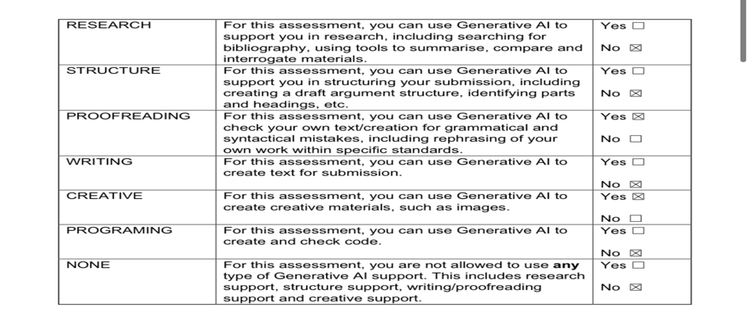

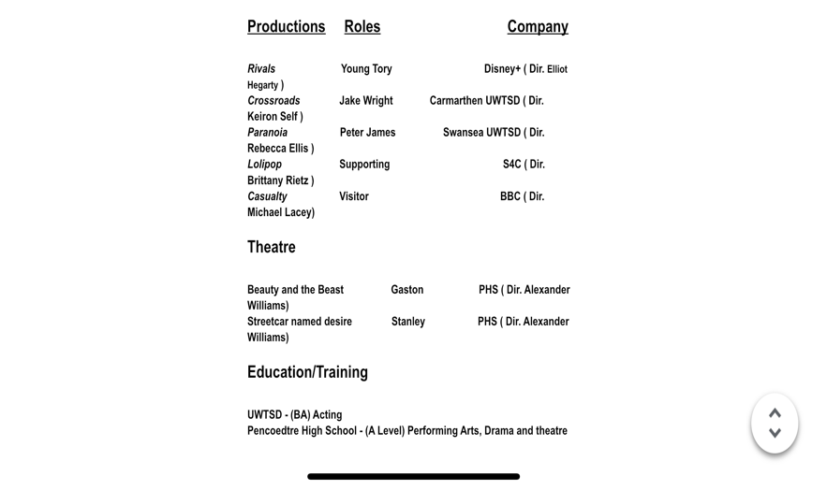
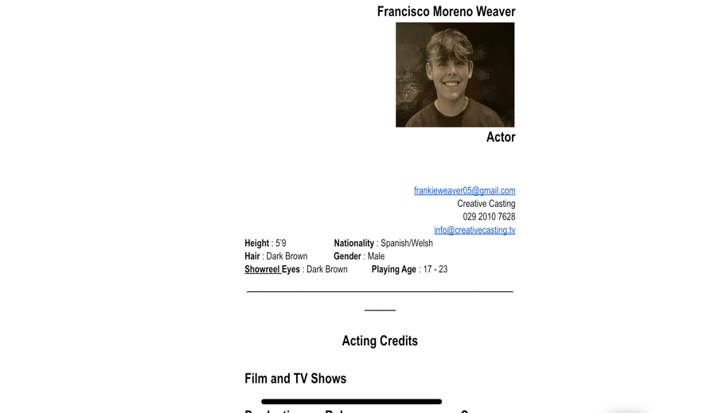
Appendix

- Acting CV

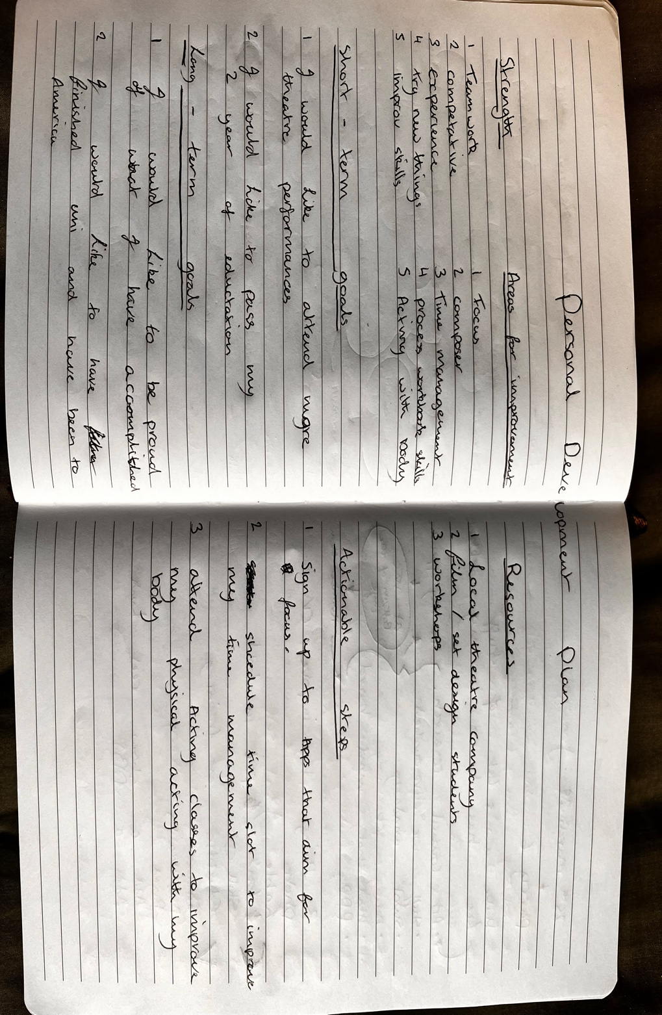

- Personal development plan

