Marketing Essentials-BMIH4005
Component A - Marketing Plan

Table of Contents
Introduction 2
Situation Analysis 2
5 C’s 2
Company: SWOT analysis (Micro analysis) 2
Strengths 2
Weaknesses 2
Threats 2
Opportunities 3
Customers: Segmentation and Targeting 3
Competitors 3
Collaborators/Partnerships 3
Climate: PESTLE (Macro analysis) 4
Objectives 4
SMART Target 4
Strategy: value proposition 4
Tactics 5
Marketing mix: 5
Product 5
Price 5
Promotion 6
Place 6
Action 6
Evaluation and Control 7
Conclusion 7
Reference list 9

Introduction

The marketing strategy of Hilton Hotels & Resorts is described in the report. One of the most advanced and prosperous companies in the world's hospitality sector is the study's topic. The hotel chain owned by Hilton Worldwide Corporation, Hilton Hotels & Resorts, offers its guests top-notch service. The paper aims to outline Hilton Hotels & Resorts' marketing strategy. The Hilton Hotels & Resorts Company's description and strategic objectives are given. A thorough scenario study is also prepared, including the industry, rivals, clientele of the business, the target market, and other crucial factors for marketing plans. The creation of the marketing mix for Hilton Hotels & Resorts is described in the program development section of the marketing strategy.

Situation Analysis

5 C’s

Company: SWOT analysis (Micro analysis)

Strengths
- Technological advancements rapidly since 2019 Epidemic (Mekhruza et al., 2022)
- A more well-known brand makes the business a top pick for customers.
- A wide-ranging presence and a strong brand portfolio
- Professional board members

Weaknesses
- A downgrading coupled with high leverage
- The company's poor financial performance (Reuters, 2021)

Threats
- The hotel sector suffered a great loss as a result of September 11. Another downturn may occur if a similar occurrence occurs (Taylor and Enz, 2002).
- Globally, the top rivals
- Legal issues

Opportunities
- Alliances and joint ventures that provide Hilton lucrative rewards with Chinese, Indian, and Japanese companies.
- Instead of using Expedia or Booking.com, opt for your personal websites.
- Guaranteeing the lowest price in order to increase its market share.

Customers: Segmentation and Targeting
Since the target clients are dispersed around the globe, Hilton Hotels & Resorts' clientele needs to be segmented based on geography. According to some factors, the Hilton Hotels & Resorts Company determines its target market from a demographic standpoint, targeting both men and women (Talbot, 2019). They could be working in a variety of professions. Nonetheless, since the company's positioning strategy focuses on the elite market targeting, people aged 35 to 60 are targeted (Yu, Kang and Kim, 2021). The requirement for significant financial resources to engage the services of a firm like Hilton is what is to blame. Geographically speaking, individuals from all over the world are targeted since they could go to the nation where the hotel or resort is located.

Competitors
There are many rivals in the hotel sector. Marriott International, Inc., which has a market value of 38 817 million USD, is the market leader. Hilton Worldwide Holdings, Inc., the parent business of Hilton Hotels & Resort Corporation, is in second position (Deng, 2022). It has a market value of USD 20,417 million. Wyndham Worldwide Corp and Hyatt Hotels Corp are other market leaders. Their market capitalization is about USD 10 billion.

Collaborators/Partnerships
Hotel chains are keener than ever to increase money from their loyalty programs. Hilton wants to do this on both extremes. In the last several months, Hilton has established loyalty alliances with companies including Lyft, Amazon, and Live Nation, which sells concert tickets, among other things.

Climate: PESTLE (Macro analysis)
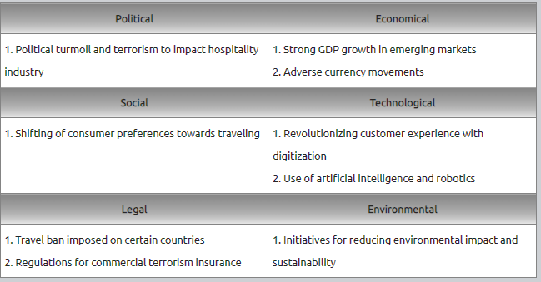

Objectives

SMART Target
- 20% decrease the energy used for direct operations
- Objective of 10% more direct reservations
- Invest more on digital marketing to attract direct traffic (e.g., Facebook, Instagram, Google, TripAdvisor, Kayak).
- Use CRM and email marketing to win over repeat customers.
- Use direct booking solutions that let you customize the booking process for higher conversion rates

Strategy: value proposition
- During the course of five years, raise brand awareness by 10%.
- Raise brand level by 5% during a five-year period.
- Throughout the course of three years, develop and provide additional services.

The profitability objectives are as follows:-
- Throughout a five-year period, increase profitability by 15%.
- Reduce spending by 5% over the course of two years.
- Raise the profits per share by 10% during a five-year period.
The company's presence in multiple marketplaces is the first point of distinction that has to be emphasized. Hilton hotels are often available practically wherever a person travels. It provides the greatest degree of confidence to the customers that they will get the best hospitality service in whichever nation they go to.

Tactics

Marketing mix:

Product
The target audience is provided with a wide variety of services by Hilton Hotels & Resorts. The primary offering of the business is a luxurious hotel or resort stay for clients. Several design types and comfort levels may be found in the rooms. Also, there are meeting rooms, casinos, SPA salons, and sports gyms for guests to use as needed while they are there (Zeng, 2021). Customers also get assistance with dishwashing and room cleaning. Extra ones such as laundry, travel guides, translators, hairdressers, massage therapists, and fitness trainers may be requested with the essential services.

Price
Hilton hotels and resorts' prices are relatively high compared to other modest rivals. It indicates that the pricing level is determined by how clients see the brand and feel about the services they get. Customers have the mindset that allows humility to pay high fees for Hilton's services because of the corporation's well-known brand name and an e of goodwill. According to the corporation, this pricing plan covers all costs while generating a profit margin. Because of this, the Hilton Hotels & Resort structure's children's camps will use the same pricing method.

Promotion
The business is heavily using several promotion marketing tool components. In order to tell the target audience about new hotels or resort openings, the firm often uses print, TV, web, and outdoor advertising (Liu et al., 2022). Using advertising, they also disseminate information about deals or planned events inside the organization. Social media has a significant role in the promotion plan. Several promotional techniques are used in conjunction with online services. The firm operates several websites with distinct goals in mind. Also, the business has official profiles on social media sites that have a high degree of popularity among clients from across the globe (Banyeva et al., 2023).

Place
The corporation has a straightforward location strategy. Given that the company's primary line of business is providing services to hotels and resorts, it has chosen a direct approach, in which its services are directly delivered to the target market. Throughout the distribution process, there are no middlemen employed. A location approach like this has the most control over the services provided. Customers, therefore, obtain such high-quality service. Nonetheless, the primary saturation of the Hilton hotels' site density is in the US.

Action
The Gantt chart for Hilton hotel marketing campaign is displayed below:
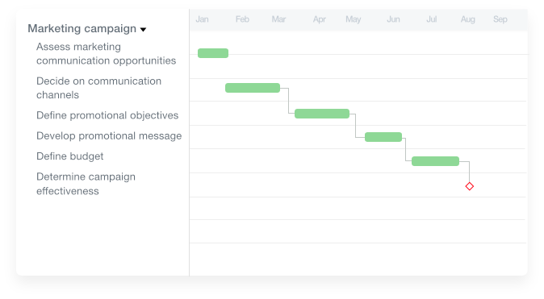

Evaluation and Control
The marketing strategy's last and most crucial step is evaluation and control. It is yet still crucial. The business should retain the marketing plan's primary course while considering the desired objectives. The marketing plan's implementation has concluded with completing the last control. The outcomes are compared to the predetermined objectives. However, the yearly control must be completed to assess the short-term objectives. The quarterly control is also one of the most significant at the same time. It should be carried out every three months. It is vital to draw inferences from the marketing plan's execution outcomes. The efficacy of the marketing strategy should also be assessed considering current external market circumstances. If necessary, the marketing strategy must be modified and put into action.

Conclusion
According to the elements listed above, the hotel industry is growing daily, and so is the level of competition. Companies employ tools to study market competitiveness. This paper also discussed Hilton's marketing approach. The business has a particular marketing target. The rising hotel industry and likely future trends of developing and promoting different digital platforms are helping to build a continuous market leadership internationally. Several factors, including customer happiness, are essential for the company to enhance business and boost profitability—strategies and a methodical approach that Hilton Hotel must consider.

Reference list
Banyeva, I., Lebedieva, N., Nehrey, M., Velychko, O., Petrova, O. and Peresichna, S. (2023). Digital Tools of Marketing Strategies in Hotel Branding. Journal of Information Technology Management, [online] 15(1), pp.62–88. doi:https://doi.org/10.22059/jitm.2023.90726.
Companies Market Cap (2022). Hilton Worldwide (HLT) - Market capitalization. [online] companiesmarketcap.com. Available at: https://companiesmarketcap.com/hilton-hotels/marketcap/.
Deng, J. (2022). Hotel Brands and the Impact of Brand Differentiation on the Success of the Global Hotel Brands. Highlights in Business, Economics and Management, 1, pp.265–276. doi:https://doi.org/10.54097/hbem.v1i.2582.
Gazzoli, G., Gon Kim, W. and Palakurthi, R. (2008). Online distribution strategies and competition: are the global hotel companies getting it right? International Journal of Contemporary Hospitality Management, 20(4), pp.375–387. doi:https://doi.org/10.1108/09596110810873499.
Liu, M.M., Zhao, X., Ye, S.J., Zhang, X. and Zhu, J. (2022). Strategies for Hotels During Crises: Covid-19. [online] www.atlantis-press.com. doi:https://doi.org/10.2991/aebmr.k.220307.242.
Maina, B.N. (2022). Marketing Mix Strategy and Business Growth In 5 Star Hotels in Nairobi City County, Kenya: A Case of Hilton Hotel. International Journal of Business Management, Entrepreneurship and Innovation, 4(3), pp.55–69. doi:https://doi.org/10.35942/jbmed.v4i3.290.
Mehta, M.P., Kumar, G. and Ramkumar, M. (2021). Customer expectations in the hotel industry during the COVID-19 pandemic: a global perspective using sentiment analysis. Tourism Recreation Research, pp.1–18. doi:https://doi.org/10.1080/02508281.2021.1894692.
Mekhruza, V., Malokhat, S., Rustam, T. and Bakhora, R. (2022). PERFORMANCE OF HILTON: HOW HILTON TACKLES THE EPIDEMIC COVID-19 DISEASE. Thematics Journal of Business Management, [online] 5(2). Available at: http://thematicsjournals.in/index.php/tjbm/article/view/1180.
Özlü, Ö. (2023). Sustainability Communication: Analysis of Sustainable Development Goals 2030 Practices of the Hotel Chains in Turkey. MANAS Sosyal Araştırmalar Dergisi, [online] 12(1), pp.364–376. doi:https://doi.org/10.33206/mjss.1154941.
Reidhead, C. (2020). Impact of Organizational Culture on Employee Satisfaction: A Case of Hilton Hotel, United Kingdom. [online] papers.ssrn.com. Available at: https://papers.ssrn.com/sol3/papers.cfm?abstract_id=3563546.
Reuters (2021). Hilton earnings disappoint as pandemic pains linger, shares fall. Reuters. [online] 5 May. Available at: https://www.reuters.com/business/hilton-posts-quarterly-loss-pandemic-hit-2021-05-05/#:~:text=On%20an%20adjusted%20basis%2C%20Hilton%20gained%202%20cents [Accessed 6 Mar. 2023].
Statista. (2022). Topic: Hotel industry in the U.S. [online] Available at: https://www.statista.com/topics/7704/hotel-industry-in-the-us/.
Talbot, P. (2019). Inside Hilton’s Marketing Strategy. Forbes. [online] 23 May. Available at: https://www.forbes.com/sites/paultalbot/2019/05/23/inside-hiltons-marketing-strategy/.
Taylor, M.S. and Enz, C.A. (2002). GMs’ Responses to the Events of September 11, 2001. Cornell Hotel and Restaurant Administration Quarterly, 43(1), pp.7–20. doi:https://doi.org/10.1177/0010880402431001.
Wang, F.X. and Anderson, C. (2023). How Firm Strategies Affect Consumer Biases in Online Reviews. Service Science. doi:https://doi.org/10.1287/serv.2023.0316.
Yu, J., Kang, B. and Kim, H.-S. (2021). A Comparative Study between Hilton Hotels in South Korea and U.S.A. through User-Generated Content Analytics. Culinary Science & Hospitality Research, [online] 27(12), pp.200–213. doi:https://doi.org/10.20878/cshr.2021.27.12.020.
Zeng, L. (2021). Analysis of Hilton Worldwide Hotel Group’s Transnational Operation Strategy. Academic Journal of Business & Management, [online] 3(11). doi:https://doi.org/10.25236/AJBM.2021.031104.

