ASSIGNMENT ONE CONFERENCE RESEARCH PAPER
Name of the student: Marius Ionut Hurmuzache
Student’s ID:2125248
Tutor name: Ernest Balutie Wavei
Module title: Contemporary Themes in the Hotel and Hospitality Sector
Module code: BMIH6001
Topic: Sustainability
Abstract
The concept of sustainability has been gaining critical importance in the contemporary business environment. The focus of the study has been on understanding how modern day hotel and hospitality companies are developing their sustainability operations to achieve consistent growth opportunities. Sustainable tourism is one of the most important and necessary techniques in the contemporary tourism market. Sustainable tourism aims towards making travelling much more eco friendly and maximizing the benefits for the locals as well as the visitors. It is a very beneficial technique for the global environmental situation and can help in minimising the negative impacts while delivery through much better alternative solutions and making travelling much more and reached and safer. The secondary data collection has been used for research purposes. The PEST framework has been used for the analysis of the impact of sustainability on hotels. The Triple Bottom Line and UN Sustainable Development Goals have been implemented for the theoretical analysis of the topic.

Contents
Introduction 4
Literature Review 4
Method 6
Theme impact analysis 7
Conclusion 10
Recommendations 11
References 12

Introduction
Sustainability in the modern world is a very important aspect of any industry whatsoever. This is due to the rising concerns about the environment around us and the ready effort that people are wanting to make to turn the situation around and be a much more responsible and global citizen. Out of all the industries tourism and hospitality is one industry which requires sustainable and healthy consumption habits the most (Streimikiene et al., 2021). This is due to the fact that this industry directly communicates and interacts with various global communities as well as different floral and fauna of various ecological and geographical diversities. Hence practicing sustainability in the industry of hospitality and tourism becomes a man date as it helps the industry to conserve various different natural resources such as energy water and minerals and the same time maximize their business in the best way possible why minimising the negative environmental impacts that it could have towards the nature, ecology and society. It is very important to address sustainability and inculcate it in the global tourism and hospitality industry as with the growing awareness people preferred to travel more responsibly which gives a rise to the demand of much more sustainable tourism practices (Ivars-Baidal et al., 2023). Furthermore, it helps in reducing waste generation and carbon footprint making the environment much more greener and helping it recover. The local economy is well supported through the practice of sustainable tourism as the main resources and services are sourced through them allowing them employment and mobility along with preserving the cultural heritage of the place and making it known to the people all around the world.

Literature Review
Energy efficient architecture
In the tourism industry buildings play a major role as a benefactor as it is the most important part for a tourist's accommodation and hospitality. This is also the part which utilises the major resources and consumes the most amount of energy from the tourism industry (Go and Kang, 2023). This makes it a mandate to address this issue and make the designs and technology involved in IT much more sustainable. One of the many ways of doing it is through building and having a very passive solar design architecture (León-Gómez et al., 2021). This helps the buildings to stay in accordance with the orientation of the sun and use the solar energy for various different electrical needs with a lot less consumption of energy and lesser amount of carbon released into the environment.
Adopting alternative energy resources
In order to do this the tourism industry leaders could adapt new solar thermal collectors as well as photovoltaic cells to convert the light into energy as well as used for domestic purposes such as heating water cooking and various other other uses (Peeters et al., 2024). Water conservation has also become a major part of today's sustainability efforts this needs to be addressed by the use of various different New year technology out in industry and adapting them with the needs of the place as well as selecting favourable conditions which are in the best way go respondent to the needs and urgencies of the nature (Irawan and Hartoyo, 2022). Through this much more non-renewable energy could be conserved as well as New year renewable energy could be created while having the least amount of impact on nature while also educating the guests and tourists visiting the property about the institution's sustainability efforts and also expecting them to encourage and participate in this (Palacios-Florencio et al., 2021). Waste management and reduction strategies are also a very important part of sustainable tourism.

Figure 1: Solar thermal
(Source: Peeters et al., 2024)
Reduce, Reuse, Recycle
The primary focus here is the Motto of reducing reusing and recycling. It urges people to reduce the use of single-use plastics, try to reuse different plastic products as well as participate promptly and learn more about waste management, waste segregation and composting. Some ways in which the hotels and participants of the tourism industry can contribute to it are in ways such as providing reusable water bottles (Font et al., 2023). The governments should also collaborate in such an initiative and install water filters across various different locations which will enable people to refill rather than wasting the plastic. Also, at various different locations businesses can offer reusable items, suggest straws and utensils made out of people rather than plastic and avoid single use packaging for various different toiletries and complimentary amenities. Sustainable tourism has also a large number of benefits for the local communities as well (Scott, 2021).
Governmental Aid
It is seen as the tourism industry of a country that the government starts investing in developing the infrastructure. This allows them to increase emploility of the people overall, promoting the economic condition of the nation to a different level. It also improves the immunities available to the local people such as building new roads, schools, hospitals and various different basic needs which may not be met but due to the heavy investment and business brought in by the tourism sector it motivates the government to invest and its infrastructure and development as well (Ngoc et al., 2021). This helps in promoting the local community and providing them with New York jobs and opportunities while at the same time preserving their culture and giving a platform to showcase itself to global audiences from across the world. One more aspect of sustainable tourism is to make sure that the local communities and the tourists mingle in a healthy way and to make sure that cultural respect and harmony is maintained. This is a very important aspect as it could lead to warring bilateral relations between Nations if cultures are not accepted open mindedly and there could be clashes among different governments leading to such situations (Sheller, 2021).
Cultural Acceptance
Respect and understanding of various different norms and societies is also a very important aspect of promoting sustainable tourism. This helps both the tourists and the locals to have much more and site full healthy and information interaction with each other where they can share and understand each other's culture and grow an appreciation for it. Overall sustainable tourism is a very important aspect of the contemporary tourism market as it helps the local communities in growing while minimising the impacts of tourism on a foreign economy and its environment (Mínguez et al., 2021). It focuses on maximizing the benefits for all the people and the stakeholders of the industry while also focusing on minimizing any kind of negative impact that could deplete the resources and result in negative impacts for the location. It also looks forward to promoting local businesses while prioritising community engagement and conservation of various different resources.

Method
Research data collection procedures
The researcher has used a secondary data collection method for the research topic. The data is collected from published resources such as industry reports, academic journals, hotel and sustainability reports and government publications. The information has also been gathered from reputable sources such as sustainable hospitality alliances and the United Nations World Tourism Organisation (UNWTO).
Analytical technique
Theoretical analysis has been implemented by the researcher to identify briefly searchability trends which have been used in the hotel sector. Different hotel sustainability strategies have been compared which have been conducted through comparative analysis. The researcher has also focused on analysing statistical data collected from reports to understand the impact of eco-friendly practices on the performance of the hotel. In addition to this, content analysis has been implemented to evaluate the sustainability initiatives and communicate between the articles and reports.
Framework
The Triple Bottom Line (TBL) framework has been used for the research purpose of analyzing the sustainability aspects and factors. The Triple Bottom Line framework mainly focuses on people, the planet and profit which provides a guide for analysing the sustainability initiatives taken into consideration by the hotel sector (Weidner et al., 2021). The efforts implemented by the hotel sector regarding sustainability have been accessed with the help of the UN Sustainable Development Goals (SDGs).

Theme impact analysis
PEST Analysis
Political factor | There are different government regulations in different countries where environmental laws are being implemented such as carbon footprint limits and waste reduction. In addition to this, Sustainability certifications are provided by the government of the countries to the hotel sector where it offers tax benefits (Rodríguez-García et al., 2023). It also offers eco-certification like Green Key and LEED.
Economic factor | Economic factors affected the sustainable initiative implemented by the hotel sector. The hotel needs to invest in energy-efficient technology (Han, 2021). On the other hand, it needs to reduce its operational costs over time. For example, Marriott implements an energy-saving initiative which helps to reduce the consumption of electricity as well as reduction in costs. As a result, the consumers who are eco-conscious can be attracted towards the hotels.
Social factor | Changing consumer preference and community engagement affects the sector and its sustainability initiatives. The travellers demand practices related to eco-tourism like waste reduction (Legrand et al., 2022). The hotels which involve the local community and staff focus on sustainability practices by monitoring the ongoing efforts.
Technological factor | The hotels in the hospitality sector need to implement green technology for water conservation and energy conservation. Therefore, it can implement such as Smart thermostats, water-saving devices and motion sensors to reduce the consumption of resources (Olya et al., 2021). Furthermore, it can also use advanced systems for tracing plastic waste and food waste. As a result, this will help to reduce the wastage conducted and implement sustainability initiatives.
Table 1: PEST Analysis
(Source: As created by the author)
From the analysis of the PEST framework, it can be stated that sustainability is essential for the long-term growth of the hospitality sector. The large hotel chain can afford investment related to eco-friendly practices as well as training their staff. The industry must balance between technology, cost and guest engagement to implement sustainability successfully.
Theories Analysis
Triple Bottom Line
The Triple Bottom Line framework evaluates the three areas in terms of sustainability. The three areas are people, planet and profit. The people choose the social impact where The hotel is seen to promote employees' well-being, fair wages and diverse policies related to it. For example, Marriott Serve 360 invests in employee training and community development which helps to support local employment and enhance the experience of the guest (Marriott, 2025). However, there are some hotels which claim ethical level practices without implementing them leading to greenwashing. The planet factor focuses on environmental impact which shows that sustainability initiatives are taken by hotels to reduce the consumption of energy and water as well as management of waste. For example, Hilton Travel aims to cut carbon emissions by 50% in the year 2030 (Hilton, 2023). It can help to reduce the operational cost of the hotel by meeting the regulatory standard related to sustainability initiatives. However, there can be some limitations such as the investment can increase for renewal energies and infrastructure related to eco-friendly practices. The economic impact can be addressed with the help of the profit factor of the framework where sustainable practices help to boost the long-term profitability of the hotel by attracting travellers who are eco-conscious (Weidner et al., 2021). Luxury hotels present themselves as green resort which helps to increase their value. As a result, it can help to increase the revenue from travellers who are sustainability conscious. However, there can be some limitations such as some consumers prefer cheap options and limited market reach.
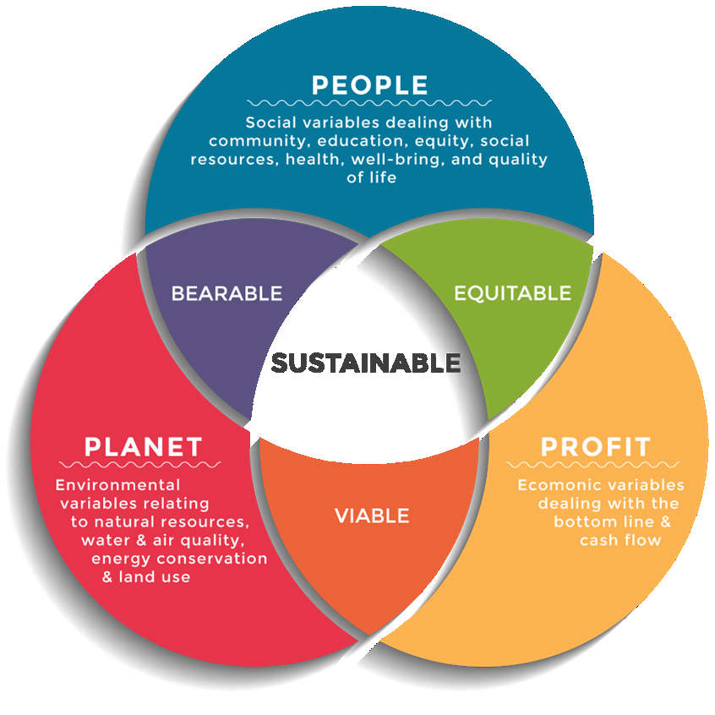
Figure 2: Triple Bottom Line
(Source: Weidner et al., 2021)
UN Sustainable Development Goals (SDGs)
The sustainability practices implemented by the hospitality sector align with several sustainable development goals of the United Nations. SDG 6 (Clean Water and Sanitation) is implemented by several hotels where it is seen that the installed water-saving system promotes towels which can be reused (United Nations, 2025). For example, IHG's Green Engage Program analyses the water being used and waste management. This helps the hotel to cut its water bills and support conservation practices. However, there are some limitations such as hotels struggle with the purification of water and its scarcity. There is another Sustainable Development Goal which aligns with sustainability practices adopted by hotels such as SDG 7 (Affordable and Clean Energy). The hotels can use solar panels and smart climate control systems to reduce the consumption of energy (United Nations, 2024). For example, Accor's Planet 21 Program focuses on building carbon-neutral systems to control energy consumption. As a result, this helps to reduce the carbon footprint in the environment and meet the regulations of the government. There are some challenges such as the investment can be costly and take years to form the infrastructure. SGD 12 (Responsible Consumption and Production) and SGD 13 (Climate Action) are also undertaken by the hotels operating in the hospitality sector to implement sustainable initiatives (United Nations, 2024). This helps to minimise waste and attract more eco-conscious consumers towards the hotels. The Corporate Social Responsibility of the hotels can be enhanced and reduce the emissions in the environment.
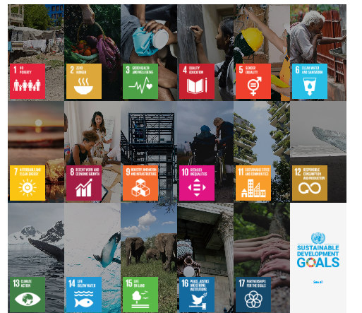
Figure 3: UN Sustainability Development Goals
(Source: United Nations, 2024)

Conclusion
This report has revealed that sustainable tourism is a very rising and useful method of working towards nature, culture and society for the betterment of it. Through this idea it is proposed that with the help of several conservative and scientific methods it is possible for companies and governments to make tourism a much more eco-friendly and sustainable business venture with the help of various different initiatives as well as the tourists themselves. It has opened the dialogue on the importance of conservation techniques and use of technology while building and architecture for tourism which helps in preserving water and our well-ventilated. These ideas paired with new technologies such as solar energy and hydro energy good help in preserving nonrenewable resources and bring renewable resources to it as an alternative which has lesser carbon release and more positive impact on nature.

Recommendations
The sustainability efforts in the industry of tourism and hospitality have increased in the past few decades by a lot. However, it is to be mentioned that there is still scope of improvement through which tourism could be made a much more sustainable business through improving various different details and norms of the industry and redefining them (Lee et al., 2021). Some of the points where the sustainability effort could be improved are conservation of natural resources and water minimising waste, spreading awareness among the tourist about various different sustainable alternatives and also engaging with different communities that are part of the local diaspora and promote their social and economic development. The industry could become more energy efficient by incorporating New year technology is an ideas such as implementing different smart grids monitors which would be keeping an eye out on the uses of energy and suggest how the consumption could be optimised as well as relay more upon energy saving appliances and technology such as solar energy which uses the renewable energy resource as the sun while saving non-renewable resources such as coal (Rinaldi et al., 2022). Water conservation could also be improved through installation of better equipment such as shower heads and low flow faucets allowing lesser waste of water. Along with that, implementing rainwater harvesting systems into the infrastructure would also save a lot of water wastage and also preserve water for future use (Grilli et al., 2021). These are some of the ways in which the governments, the companies and the businesses involved in the tourism industry could work towards making the industry much more sustainable and eco-friendlier for the world while at the same time improving the experience for the guests.

References
Font, X., Torres-Delgado, A., Crabolu, G., Palomo Martinez, J., Kantenbacher, J. and Miller, G., (2023). The impact of sustainable tourism indicators on destination competitiveness: The European Tourism Indicator System. Journal of Sustainable Tourism, 31(7), pp.1608-1630.
Go, H. and Kang, M., (2023). Metaverse tourism for sustainable tourism development: Tourism agenda 2030. Tourism Review, 78(2), pp.381-394.
Grilli, G., Tyllianakis, E., Luisetti, T., Ferrini, S. and Turner, R.K., (2021). Prospective tourist preferences for sustainable tourism development in Small Island Developing States. Tourism Management, 82, p.104178.
Han, H., (2021). Consumer behavior and environmental sustainability in tourism and hospitality: A review of theories, concepts, and latest research. Sustainable Consumer Behaviour and the Environment, pp.1-22.
Hilton, (2023). Our Progress. [online] Travel With Purpose | Hilton ESG. Available at: https://esg.hilton.com/our-progress/ [Accessed: 10 Feb. 2025].
Irawan, N.C. and Hartoyo, E., (2022, November). Environmental management and stakeholder roles in sustainable tourism development: a feasibility study. In IOP Conference Series: Earth and Environmental Science (Vol. 1108, No. 1, p. 012068). IOP Publishing.
Ivars-Baidal, J.A., Vera-Rebollo, J.F., Perles-Ribes, J., Femenia-Serra, F. and Celdrán-Bernabeu, M.A., (2023). Sustainable tourism indicators: what’s new within the smart city/destination approach?. Journal of Sustainable Tourism, 31(7), pp.1556-1582.
Lee, T.H., Jan, F.H. and Liu, J.T., (2021). Developing an indicator framework for assessing sustainable tourism: Evidence from a Taiwan ecological resort. Ecological indicators, 125, p.107596.
Legrand, W., Chen, J.S. and Laeis, G.C., (2022). Sustainability in the hospitality industry: Principles of sustainable operations. Routledge.
León-Gómez, A., Ruiz-Palomo, D., Fernández-Gámez, M.A. and García-Revilla, M.R., (2021). Sustainable tourism development and economic growth: Bibliometric review and analysis. Sustainability, 13(4), p.2270.
Marriott, (2025). Sustainable Goals | Marriott International Serve360 - csr-marriott. [online] csr-marriott. Available at: https://serve360.marriott.com/sustainable-goals/ [Accessed: 10 Feb. 2025].
Mínguez, C., Martínez-Hernández, C. and Yubero, C., (2021). Higher education and the sustainable tourism pedagogy: Are tourism students ready to lead change in the post pandemic era?. Journal of Hospitality, Leisure, Sport & Tourism Education, 29, p.100329.
Ngoc, P.B., Tien, N.H. and Trang, T.T.T., (2021). Current path to community based sustainable tourism development of Khanh Hoa Province in Vietnam. PalArch's Journal of Archaeology of Egypt/Egyptology, 18(09), pp.508-525.
Olya, H., Altinay, L., Farmaki, A., Kenebayeva, A. and Gursoy, D., (2021). Hotels' sustainability practices and guests' familiarity, attitudes and behaviours. In Sustainable Consumer Behaviour and the Environment (pp. 43-61). Routledge.
Palacios-Florencio, B., Santos-Roldán, L., Berbel-Pineda, J.M. and Castillo-Canalejo, A.M., (2021). Sustainable Tourism as a Driving force of the Tourism Industry in a Post-COVID-19 Scenario. Social indicators research, 158(3), pp.991-1011.
Peeters, P., Çakmak, E. and Guiver, J., (2024). Current issues in tourism: Mitigating climate change in sustainable tourism research. Tourism Management, 100, p.104820.
Rinaldi, C., Cavicchi, A. and Robinson, R.N., (2022). University contributions to co-creating sustainable tourism destinations. Journal of Sustainable Tourism, 30(9), pp.2144-2166.
Rodríguez-García, R., Ferrero-Ferrero, I. and Fernández-Izquierdo, M.Á., (2023). Analysis of integration of sustainability in sustainability certifications in the hotel industry. Frontiers in Sustainability, 4, p.1116359.
Scott, D., (2021). Sustainable tourism and the grand challenge of climate change. Sustainability, 13(4), p.1966.
Sheller, M., (2021). Reconstructing tourism in the Caribbean: connecting pandemic recovery, climate resilience and sustainable tourism through mobility justice. Journal of Sustainable Tourism, 29(9), pp.1436-1449.
Streimikiene, D., Svagzdiene, B., Jasinskas, E. and Simanavicius, A., (2021). Sustainable tourism development and competitiveness: The systematic literature review. Sustainable development, 29(1), pp.259-271.
United Nations, (2024). Goal 7 | Ensure access to affordable, reliable, sustainable and modern energy for all. [online] sdgs.un.org. Available at: https://sdgs.un.org/goals/goal7 [Accessed: 10 Feb. 2025].
United Nations, (2024). The 17 sustainable development goals. [online] United Nations. Available at: https://sdgs.un.org/goals [Accessed: 10 Feb. 2025].
United Nations, (2025). Goal 6: Clean water and sanitation. [online] The Global Goals. Available at: https://globalgoals.org/goals/6-clean-water-and-sanitation/ [Accessed: 10 Feb. 2025].
Weidner, K., Nakata, C. and Zhu, Z., (2021). Sustainable innovation and the triple bottom-line: a market-based capabilities and stakeholder perspective. Journal of Marketing Theory and Practice, 29(2), pp.141-161.

