What helps me learn language and mathematics? : An analysis of a child’s learning in mathematics and language with recommendations for ensuring progress.

As an educator it is crucial to understand how each individual child learns in order to be able to support and progress their learning. Therefore, the purpose this assignment is to gain an insight on how a child from Personal Teaching Experience (PTE) learns Mathematics and Language. The pupil discussed in this research is a 7-year-old girl from an average attaining year 2 class; she attended a large-scale primary school in a more deprived area of South Wales.

The methodology used to collect the information is based on the mosaic approach to learning. Proposed by Clark and Moss (2011) the approach encourages the researcher to listen to and observe the perspective of the child. With a range of data from different methods, the aim is to then construe and reflect on it in the hope of future continuity and progression. Therefore, with the information gathered it will not only allow conclusions to be made about how the individual learns but will also allow the educator to be able to suggest how the child could be progressed further. In order to reach these conclusions, the use of the ASK approach to learning will be been used to ensure an in-depth analysis and review of the child’s learning. Nottingham (2013) notes that for children to be successful learners they must be competent in their: Attitudes to learn, the skills needed to learn and knowledge of learning. Therefore, these are the aspects that will be explored while analyzing the data, using literature to expand on the points made.

In addition, with any research it Is important to ensure the exploration process is carried out ethically. For this to be the case, the research needs to be in line with the BERA and University guidelines. BERA (2018, p9) states “participants’ voluntary informed consent to be involved in a study should be obtained at the start of the study” this can be seen in Appendix 1. Furthermore, it is also important to ensure no harm is inflicted on the participant, ensuring to inform them of their right to withdraw and the ambiguity of their responses, which the researcher ensured to do before collecting any data.
Teaching language within Primary Education focuses on three key strands. Within the Foundation Phase, the oracy strand focuses on the children’s speaking and listening skills, as well as their ability to collaborate and discuss with others. The reading strand aims for children to gain a knowledge of effective reading strategies and begin to develop comprehension skills. Finally, the writing strand gives children the opportunities to develop skills needed to help their writing including purpose, features, handwriting, grammar and punctuation (Welsh Assembly Government 2015).
During time on Professional Teaching Experience (PTE) the main language topic taught was non-fiction recount writing. Although the focus was on teaching the features needed to be able to write a specific text type the need for reading and oracy skills were still vital to support the learning.

The pupil I observed had an aptitude to learning language, she was in the highest attaining group within the class and was very confident while doing her work, she enjoyed the ‘English Elephants’ aspect of the day. When I asked the child if she though learning language was important her response was very positive (appendix 2). The child was at a suitable reading level for her age and had a good knowledge of blending and segmenting words. Although, an aspect that I observed the child was clearly less confident in was ability in oracy, she was very quiet and would not like to express herself during whole class settings. This could be further seen when I asked the child ‘how do you feel when learning speaking, writing and reading?’ (appendix 3) the response of a nervous face for oracy highlights her lack of confidence in the learning. During free choice the child would often tend to want to go to the writing area or ask the teacher to do jobs to help, highlighting her maturity.

Nevertheless, when the provisions were changed in the classroom to support the writing topic, I did observe the pupil engaging happily and confidently with other pupils in the new role play area, expressing her opinions. The provision was very stimulating due to it being new and interesting. Role play provisions allow for oracy to be explored, therefore this observation suggests that she feels more confident to orally express herself and learn when in a pupil lead environment. Whitehead (1999) suggests that giving children opportunities to play and learn with groups of children begins to extend their social and oracy skills. However, from experience, some children deter away from the role play area as they find the ‘let's pretend’ aspect difficult due to lack of experiences; the child being observed had no problem with this and spoke clearly to express her ideas to her peers. This gives the idea that she is knowledgeable, just simply lacks the confidence in her speaking during whole class, teacher lead activities. Hodson (2006) proposed that for a child to feel confident, a positive classroom ethos where speaking and listening is valued is vital. Suggesting, that as an educator it is important not to impede on the development of a child’s oracy but to support and scaffold it, as it is the key foundations to learning language. Wilson (2004) suggests that a way to do this is to enrich oracy focused provisions with a facilitator, highlighting that they can encourage the children, who can then follow by example. However, regarding this learner I believe if the teacher had intervened, it could have interrupted the child and as a result stopped oracy being developed and confidence lost.

Oracy skills need to be present in a child and continue to be supported when looking at specific writing texts. Corbett and Strong’s (2011) main theory highlights the need for children to be able to talk and discuss their writing first in order to internalize skills, before they can write effectively. Therefore, if the child struggles to discuss aspects orally they may struggle when writing, in this intense the child being observed had no problem with her writing but would struggle to talk about it orally beforehand to the teacher or whole-class.

Regarding the child's attitude for writing it was very good, she took pleasure in her work to present it neatly and had a good understanding of basic punctuation and grammar (appendix 4). When I asked the child, what helped her with her writing, her response was that her sounds help her spell words. The strategy used within the school encouraged children to ‘have a go’ with their writing using their sounds to help them spell words and not rely on the teacher. Graham and Kelly (2010) favors this approach suggesting an emergent writing approach allows the child to experiment and make mistakes and allows the facilitator to monitor children's development. However, from observations I saw that this child was apprehensive to do this due to her wanting her work to be neat and correct to please the teacher. Furthermore, from appendix 5 you can see how the child sometimes becomes over reliant on the sounding out her words. This is resulting in her forgetting how to spell simple slight words and spelling them phonetically instead.

Another aspect the pupil believed help her with her nonfiction writing was going on a trip and planning, she said It helped her remember what she had to write about in her recount (appendix 6). Corbett and Strong (2011) highlight that writer need to have a good knowledge and interest in what they are writing about otherwise the writing will suffer. A suggested way of doing this is by linking the writing to a personal experience such as a trip. By doing this it allows the child to be at the center of the learning. Wilson (2004) further suggests that involving the child into decisions is key in making them active learners, however, does highlight the need for precise planning and timings to be successful. In addition, the use of writing plan to help focus the learner was discussed as helpful. Frames offer a series of prompts for the children and allow the teacher to help embed the structure for specific skills needed for the writing (Cremin 2009). Jones (2002) also suggests frames allow for informed dialogue between the facilitator and the learner to support their writing.

Finally, another form of planning of writing that the child stated helped her was doing a cold and hot task. She stated it enabled her to do something independently and use everything she had learnt to make her writing better by the end. Graham and Kelly (2010, p89) refer to the need of giving children “the ability to take control of the writing process and monitor their own work.” The assessment for learning (AFL) strategy starts with a cold write, then progresses the children by teaching the skills needed and finally ends with a redraft called a hot write. However, in order to do this effectively It requires the children to understand the meaning of it and for the teacher to scaffold the children's writing. This was done very well in PTE as the AFL approach to writing was used whole school, so children understood why they did them and how it helped them get better.

Regarding Mathematics, the main topic I taught while on PTE was from the using number skill strand of the curriculum, money (Welsh Government 2015). Cuoco, Goldenberg and Mark (1996) habits of mind research suggest for child to learn mathematics they need to be resourceful, resilient, collaborative and curious. The child in discussion was in the highest set mathematics class, working towards the skills needed for a year 2 child. Her attitude to the subject was not as prominent as language, this can be seen from the responses to question during the interview (appendix 2). She discussed how she found the subject harder and did not enjoy it so in turn lacked resilience, curiosity and resourcefulness. Cremin (2011, p15) highlights how a negative connotation with mathematics can cause “learning paralysis” which results in unengaged, unenthusiastic learners. Therefore, suggesting the importance of develop mathematics in a supportive, creative way for all learners. Nevertheless, the child did state that she enjoyed collaborating sessions with peers to problem solve and enjoyed practical lessons.

When I asked the child, what was her favorite mathematic session I taught her while on PTE, her response was the first lesson we learnt about money. Within the first session I ensured to make the learning interactive and engaging so children had the chance to explore with money prior to doing worksheets on it (appendix 7). When I asked the child why she enjoyed this session, she response stated that it was nice to do something different and because she got to work in groups to sort problems. As the emergent approach to writing was previously discussed, Whitebread (1995) supports the use of emergent mathematics suggesting children need to talk about and experiment with mathematical ideas to represent the ideas in a way that helps them. Haylock and Cockburn’s (2003) also supports this suggesting that children need to be given time to make links between four key components in mathematics: symbols, language, pictures and concrete experience, establishing their own basis for understanding. During the session all these elements were discussed, and time was given to children in each group to explore with them, a strategy that the child stated she enjoyed.

However, from classroom observations during collaboration time I would often see the child looking at other children's work when answering questions, she would also not input a great deal during group work yet stated during the interview that she enjoyed it. This suggests, that she either enjoys it due to lacking understanding and therefore it is giving her the opportunity to receive peers help, or because she has understanding but lacks confidence in her own ability so likes the clarification from peers. From appendix 8, It is clear to see that the child had some understanding of concepts being taught but also had some uncertainties, particularly the relative value of money. Hansen (2012) highlights that misconceptions are not errors; they are prior understandings that children have that they relate to new concepts. The piece of work suggests that the child understands basic number concepts, but has generalized these to the use of money, a common misconception. Lawton (2005) suggests that if a child does this, they may have a lack of experience with money and its concept in real life. If the child is lacking some understanding or has misconception it is important not to disregard or ignore the answer given, “the way a teacher responds to these indications from the child are at the heart of teaching” (Rowland, Turner, Thwaites and Huckstep 2009, p134). This advocates how misconceptions should be used as a further teaching point for pupils. If the child being discussed had been ignored by the facilitator while giving a misconception the child's cognitive-development would not have been supported and as a result may reduce her confidence, furthering a dismissive attitude of her mathematical ability. Boaler (2015) states that we should always praise mistakes and explain to the children that it helps their brains grow.

When I asked the child what she enjoyed using to help her learn mathematics, she stated that using the physical objects such as a number line, money and whiteboard help her. However, during a learning walk when I asked the child where you would go in the classroom if you needed help with mathematics her response was I am not sure, even though the class has a mathematical area with lots of physical resources to help the children if needed, including all the objects the learner had stated she used (appendix 9). This suggests that the child is reliant on the teacher to provide her with physical objects to support her learning as opposed to finding and using objects because she finds them helpful. It also suggests that the provision is not promoted enough within the classroom, during observations I would often see children using the mathematics area for coloring which is not the purpose of the corner.

Moreover, the child stated that she enjoyed using the computers to help her learn mathematics. The school always ensured to include ICT in mathematics sessions to develop digital competence as well as further the mathematical concept being taught. Williams and Easingwood (2004) support the use suggesting ICT permits the children to be exposed to more varied approach's and allows the teacher to provide a broader mathematics curriculum. However not all teachers themselves are competent in the use of ICT especially when teaching a subject like mathematics. Estyn (2018) suggest all teachers should complete an audit, so staff are presented with the skills able to develop pupils’ learning across all the curriculum. Donaldson (2015) also discusses the importance of cross curricular responsibilities for teachers in the new curriculum, with the priority not only being given to literacy and numeracy but now also digital competency.

There are many ways ICT can be used to enhance mathematical teaching, not only through individual computers/ipads but also with use of an interactive whiteboard. The child in discussion also stated that engaging introductions, with examples on the carpet help her learn mathematics. This was often done by using an interactive whiteboard (IWB). An IWB can bring lots of excitement to the classroom, as a result some children may not see it as a learning tool but instead as a form of play, therefore it is important to state the intentions to the children prior to completing activities (Williams and Easingwood 2004). Nevertheless, Hennessy (2013) states that the IWB has engaging characteristics that allow for supportive teaching with motivational learning and important dialogue about the mathematical concept. Haylock and Thangata (2007) highlight how children appreciate it when a teacher explains something clearly, developing understanding for them to make connections. Welsh Government (2013) also state the importance of the delivery of an LNF skill, stating they needs to be clear, consolidative and progressive.
Overall, after assessing the child in language on PTE, the writer believes she was attaining a high outcome 4, with several aspects of outcome 5. By the end of the foundation phase I believe that she will most definitely reach outcome 5, but there are aspects that could be implemented to ensure she is progressed further.

The main aspect the child needs to be supported with is her confidence and attitudes in oracy. Hodson (2006,p1) states “children’s speaking and listening skills are central to children’s development” suggesting, if her oracy skill progress then her overall development will improve also, as oracy feeds into all aspects of learning. Firstly, a way this could be promoted is by ensure to create a positive learning environment where participating and mistakes are valued, if children do not feel comfortable, they will not share their ideas due to shying away (Fulton 2006). Hodson furthers this idea, supporting the need for a classroom ethos where speaking and listening is celebrated and valued. This could be done by praising the pupil's speech and giving rewards for participation to show that her opinion is appreciated and valued. Skinner (1957) supports, favoring the use of positive reinforcement for repetition of desired responses.

Another way to support the child is by modeling the way you would like her to respond to aspects of classroom life, starting with small steps e.g partner/group work and progressing to whole class. Modeling is key in developing oracy skills in children, it helps engage students for an imitation of a behavior to help progress their learning (Hansen 2007). Additionally, another way to further progress the childs oracy is by ensuring to give her stimulating, opportunities to bring out natural excitement and curiosity, just like in the new role play area I observed her confidently in. The foundation phase framework (2015, pg15) highlight how children should “experience a language-rich environment that immerses them in the spoken and written word” which in turn, should allow oracy to be fostered. Examples of this include interesting hooks, change and enhancement of classroom provisions, or interesting theme/topics.

Regarding the child's writing, the child had good phonemic and phonological awareness. However, she would often come over reliant on using them, as a result her high frequency sight words would often be forgotten. To progress this child further I believe a focus on sight words would enable her writing to be improved, this could be done as a morning intervention group with other children who need the same support, sight words could be shown, said, written and repeated to practice. Which is a form of drilling. This in turn would also help the child progress in her reading, as Hayes (2016) states, sight words have a vital role is children's reading acquisition.

Finally, the child being discussed also struggled was with the ‘give things a go’ concept of writing, especially doing it first time into her book. Constructivist’s theory to spelling highlights the importance of children having the opportunity to edit and learn from their spellings, with support and credit from facilitators (Graves 1983 in Saunders 2015). By giving her a ‘have a go’ practice notebook she can attempt to sound and spell the words in draft before she puts it in her book getting clarification and correction from the teacher if needed. Both these methods should hopefully allow the child to gain more confidence in her spelling ability and improve her writing further.

After assessing the child in mathematics, I believe the child is working at outcome 5 in mathematics; however her attitude and independent skills are not as prominent as they should be and therefore actions could be put in place to help further support this child.

The child lacked positive connotations to the subject and struggled to complete work competently. She had a lack of confidence and attitude for the subject resulting in a doubt in her own ability. Therefore, as a facilitator it is important to ensure mathematical teaching is engaging and fun for the learner. From observations, the teaching in mathematics was very structured compared to other lessons. It is important to ensure mathematical sessions still have a range of interesting activities, including practice, problem solving and investigation, being careful not to fall in to a routine of a lesson structure (Adhami 2003). The Welsh Assembly Government (2015, p28) also highlight that children should “experience a mathematically-rich environment that allows them to explore and develop mathematical concepts and language”. This suggests facilitators should employ this through a range of activities and provisions. The session the writer taught that involved a carousel of interactive activities was stated as an enjoyable lesson by the child, as a educator I believe it is important to include these lessons more frequently to progress children’s learning and their attitudes towards mathematics. This could be done by incorporating stimulating ideas into a lesson such as using ICT, going outdoors, or getting the children to be ‘math detectives’ to solve a problem. The child being observed enjoyed using the computers and also working in groups to solve problems, therefore it is important to listen to the children and how they learn to keep a strong focus on this when delivery lessons.
From appendix 8, it could be seen that the child had a common misconception in money which Lawton (2005) suggests is due to lack of real-life experiences and as a result generalization. Therefore, the writer believes a way to help support this learner is to improve the provisions. By giving the children real-life experiences and allowing them to explore with it, should not only improve their interest but will also help promote their mathematical knowledge, clearing up any misconceptions the child may have. This could be done by introducing a role-play shop into the classroom or by giving the child enhanced provision tasks that link to real-life problems in money. Barnes (2011) highlights that if a mathematical experience is meaningful to a child then they are more likely to retain and apply what they have learnt.

From experience, I found that there were lots of provisions to support language but fewer to support practical use of mathematics. The mathematical provisions are often not used during or outside a mathematics session by children; a way to develop this is by not just putting physical objects to help children in mathematics but to enhance the area with a game. Sherer (2012) believes that mathematical games can provide children with opportunities to apply and develop their attitude to mathematics and apply their knowledge. By enhancing the provisions, it will also make the areas engaging and enjoyable for the child, who will want to choose to go there during free choice. However, it is important that the children understand what the provision are for and how to use them properly, otherwise the learning will not be effective.

Work count: 3608

References
Adhami, M. (2003) ‘Pedagogical Issues’ in Thompson, I. (ed.) Enhancing Primary Mathematics Teaching. England: Open University Press.
Barnes, J. (2011) Cross Curricular Learning 3-14 (2nd Ed), London: Sage.
BERA (2018) Ethical Guidelines for Educational Research, Available at:
https://www.bera.ac.uk/wp-content/uploads/2018/06/BERA-Ethical-Guidelines-for-Educational-Research_4thEdn_2018.pdf?noredirect=1 (Last Accessed 3rd of April 2019)
Boaler, J. (2015) The Elephant in the Classroom, Helping Children Learn and Love Maths, Unknown: Souvenir Press.
Clark, A. and Moss, P. (2011) Listening to Young Children: The Mosaic Approach (2nd ed.), London: National Children’s Bureau.
Corbett, P. and Strong. J. (2011) Talk for Writing Across the Curriculum. England: Open University Press.
Cremin, T. (2009) Teaching English Creatively (Primary Teaching Guides), Oxon: Routledge.
Cremin,T. (2009) Teaching English Creatively, Oxon: Routledge.
Cuoco, A. Goldenberg, P. and Mark,J. (1996) Habits of Mind: An Organizing Principle for Mathematics Curricula. 15, 375-402
Available at: https://nrich.maths.org/content/id/12640/Cuoco.HabitsOfMind.pdf (Last Accessed 3rd of April 2019)
Donaldson,G. (2015) Successful Futures, Available at:
https://gweddill.gov.wales/docs/dcells/publications/150225-successful-futures-en.pdf (Last Accessed 3rd of April 2019)
Estyn (2018) School Helps Pupils Develop Independent IT Skills, Available at: https://www.estyn.gov.wales/effective-practice/school-helps-pupils-develop-independent-it-skills (Last Accessed 3rd of April 2019)
Fulton,D. (2006) Classroom Karma, Great Britain: David Fulton Publishers.
Graham, J. and Kelly,A. (2010) Writing Under Control, Oxon: Routledge.
Hansen, A. (2012) Using Children’s Mathematical Misconceptions to Support Teaching and Learning In McAteer, M. (ed.) Improving Primary Mathematics, Teaching and Learning, England: Open University Press.
Hansen, W. (2007) Teacher Modeling as an Effective Teaching Strategy. Music Educators journal.
Hayes, C. (2016) The Effects of Sight Word Instruction on Students ' Reading Abilities. Available at: https://fisherpub.sjfc.edu/cgi/viewcontent.cgi?article=1327&context=education_ETD_masters (Last Accessed 3rd of April 2019)
Haylock, D. and Cockburn, A. (2003) Understanding Mathematics in the Lower Primary Years. 2nd edn. London: Paul Chapman Publishing.
Haylock,D. and Thangata,F (2007) Key Concepts in Teaching Primary Mathematics, Calif: Sage Publications.
Hennessy,S. (2013) Developing interactive teaching and learning using the IWB : a resource for teachers. Maidenhead, Berkshire : Open University Press.
Hodson,P. (2006) in Jones,D. and Hodgson, P (ed) Unlocking Speaking and Listening, Oxon: David Fulton Publishers.
Jones,D. (2002) in Williams,M. (ed) Unclocking Writing, A Guide for Teachers, London: David Fulton Publishers.
Lawton,F. (2005) ‘Number’ in Hanson,A. (ed.) Children’s Errors in Mathematics, understanding common misconceptions in Primacy Schools, Exeter: Learning matters.
Nottingham, J. (2013) Encouraging Learning, Oxon: Routledge.
Saunders,L (2015) Progression in Primary English, London: Sage Publications
Sherer, S. (2012) Playing with Pedagogy: The role of Games in the Teaching and Learning of Mathematics. McAteer, M. (ed.) Improving Primary Mathematics, Teaching and Learning, England: Open University Press.
Skinner, B.F (1957) Verbal Behaviour. New York: Appleton Crofts.
Welsh Assembly Government (2013b) LNF Guidance:
https://learning.gov.wales/docs/learningwales/publications/130415-lnf-guidance-en.pdf
(Last Accessed 3rd of April 2019)
Welsh Assembly Government (2013) Curriculum Planning Guidance, Available at: https://learning.gov.wales/docs/learningwales/publications/130124curriculumplanningguidanceen.pdf (Last Accessed 3rd of April 2019).
Welsh Assembly Government (2015), Foundation Phase Framework, Available at:
https://learning.gov.wales/docs/learningwales/publications/150803-fp-framework-en.pdf
(Last Accessed 3rd of April 2019)
Whitebread,D. (1995) ‘Emergent Mathematics’ in Anghileri, J. (ed.) Children’s Mathematical Thinking in the Primary Years. London: Cassell.
Whitehead,M. (1999) Supporting Language and Literacy Development in the Early Years, Buckingham: Open University Press.
Wilson, A. (2004) Supporting Speaking and Listening, Great Britain: David Fulton Publishers.

Appendix 1- Consent Form.

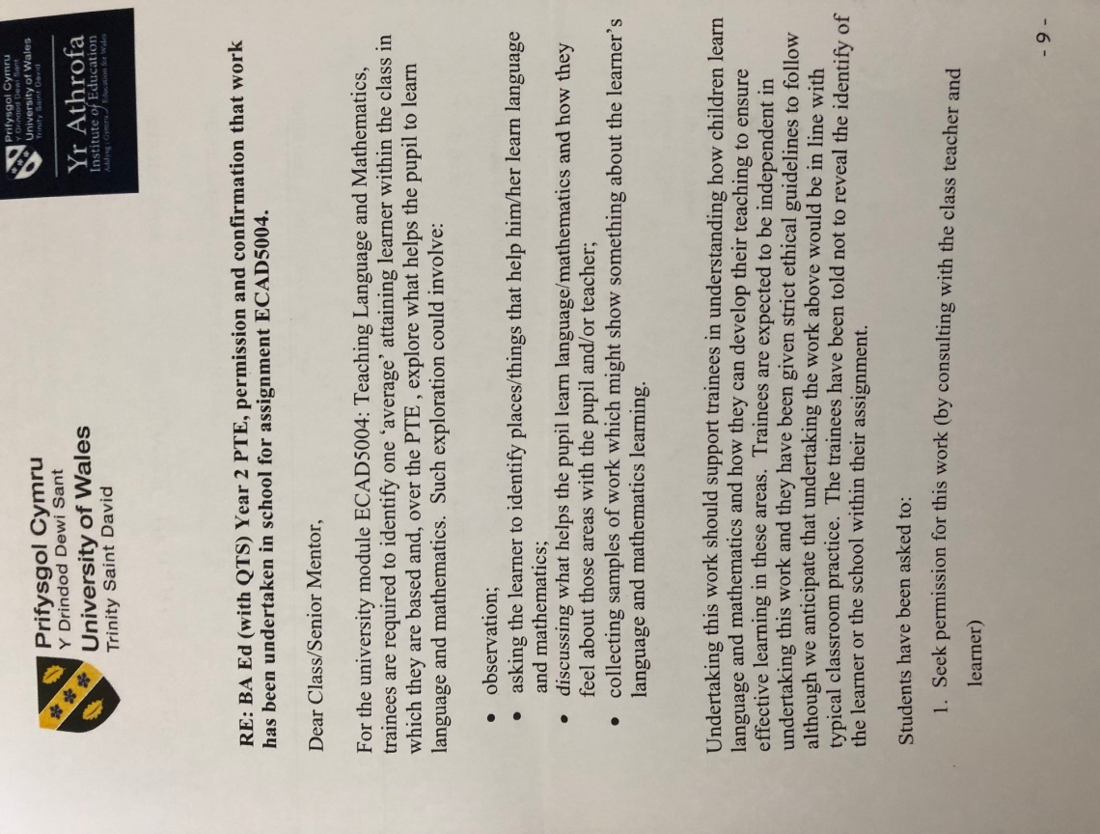

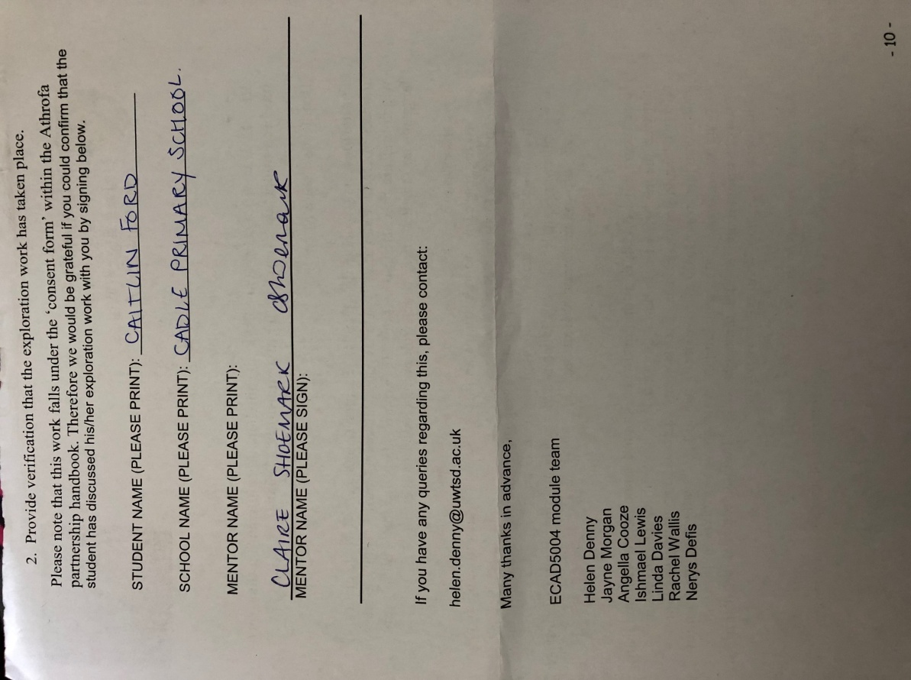

Appendix 2- Interview notes.
Interview with 7 year old child from a year 2 class.
Do you think it is important to learn language? Why?
Yes, it’s very important to learn English because everything we learn in the lessons help us learn to read, write and speak and if you cannot do any of these then you won't be able to learn. If we do not learn we cannot get a good job and if we have not got a job, we will not have any money to life a good life.

Mathematics? Why?
Yes but not as important as learning English, because we do not need Math to be able to speak and write, and we learn but we need these in English. Mathematics is harder and takes me longer to think about what I need to do to get the answer.

Which subject do you prefer English or Mathematics?
I enjoy English more than Math because I am better at it. I enjoy writing about things we have done in class. Math is harder because sometimes I forget what I have to do, and my brain needs to think a lot more.

What do you do if you need help in mathematics?
I use my brain to try and remember, if I am really stuck, I ask a teacher, or I work with my friend to get the correct answer. Sometimes I use objects that miss gives me to help me count, like a number line or whiteboard.

What do you do if you need help in language?
I try to remember all the things I have been told to use when I am writing or reading, I go to the reading area to help me learn reading and I go to the writing corner to practice my writing.

What helps you learn mathematics?
When miss gives us examples on the carpet to help teach us what we are doing in math that day, when we go on the computers, when we have fun lessons where we do not do worksheets, when I have objects to help me like money, a number line or counters, when I go on to the computers to do games to practice what I have learnt.

What helps you learn language?
Writing- My sounds help me with my writing, practicing my handwriting in the writing area, remembering my full stops and capital letters, I enjoy going on trips they help me remember what I had to write about, cold and hot tasks help me make my writing better.
Reading- Using pictures to help me, using my sounds to sound out tricky words, my sight words.
Oracy- I am not sure.

Where helps you learn mathematics?
I don’t know.

Where helps you learn language?
The colouring / writing table and the reading area.

What parts of language do you enjoy the most (e.g. reading, writing, talking)?
Writing is my favourite. The reading and talking is last because sometimes I am quiet and I don’t like to talk when miss asks questions to me.

Appendix 3-How do you feel when learning?

Oracy
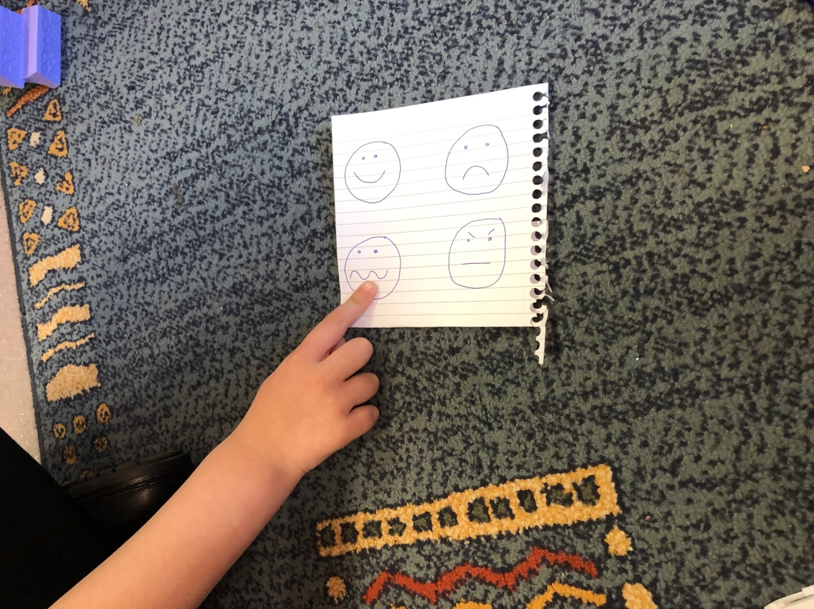

Writing and Reading
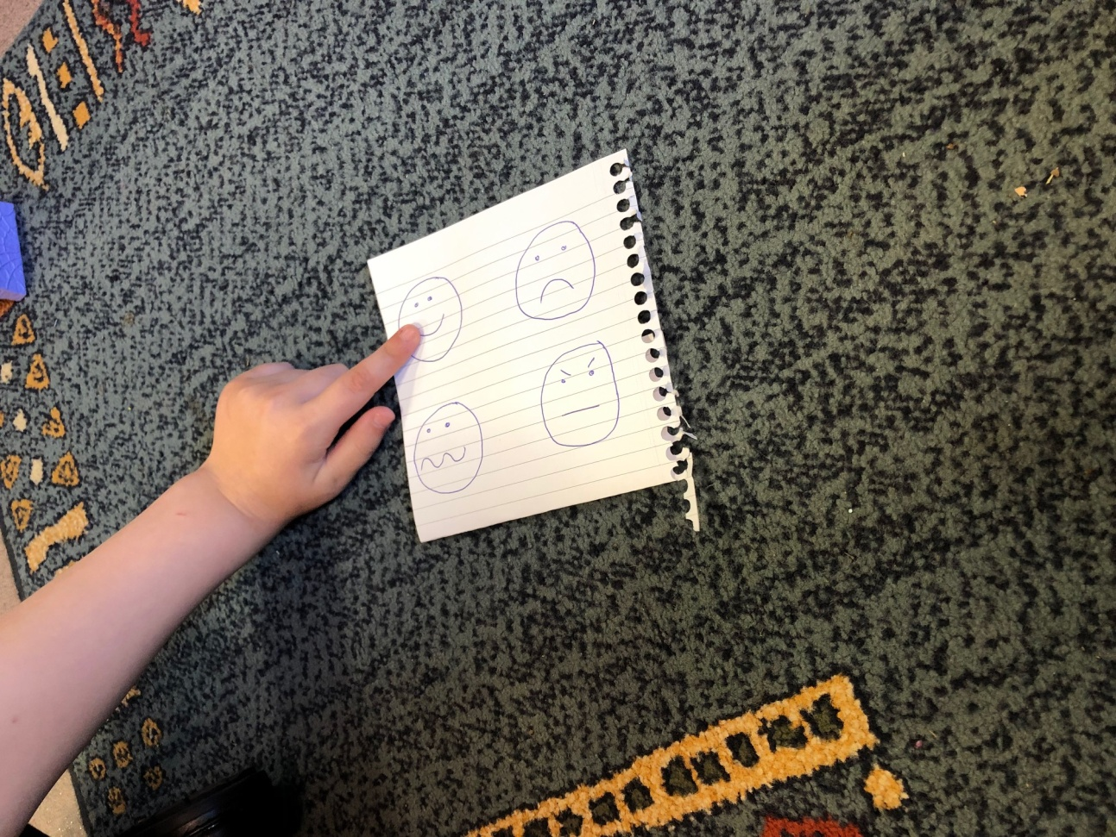

Appendix 4- piece of English work

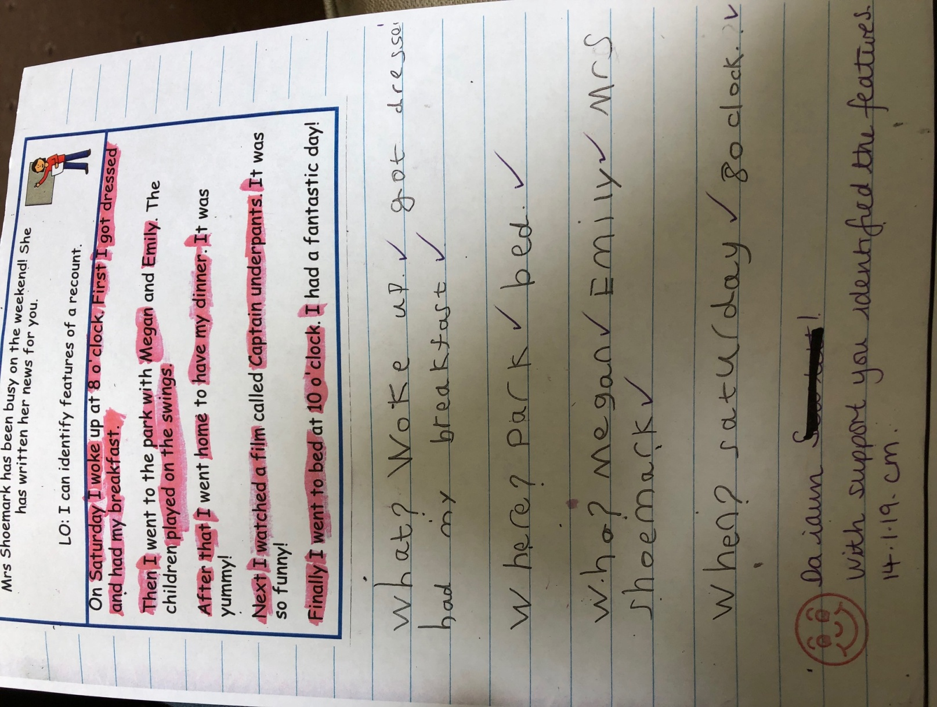

Appendix 5- incorrect spelling of slight work

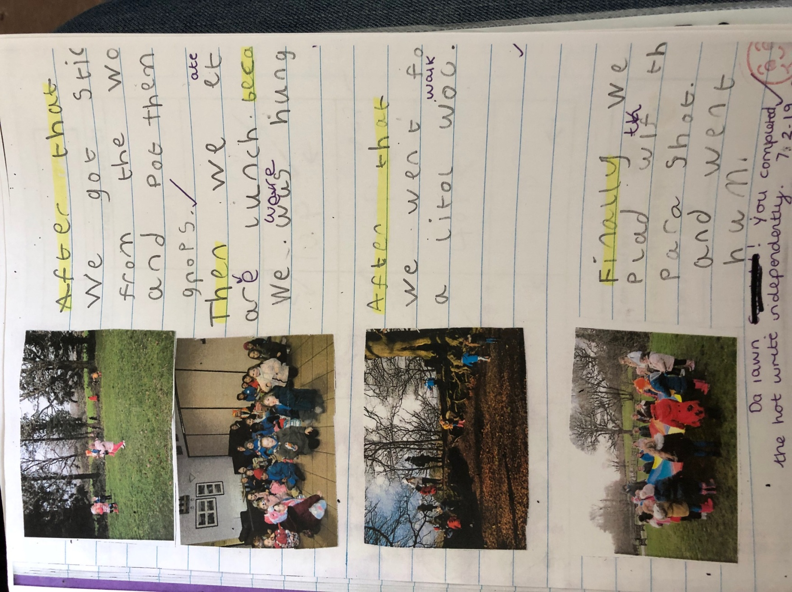

Appendix 6- Trip

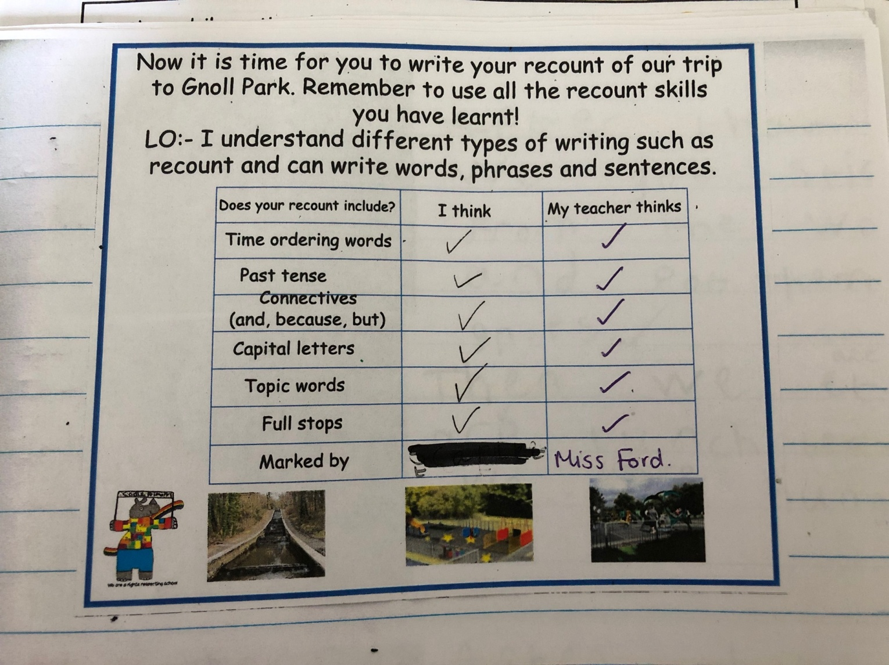

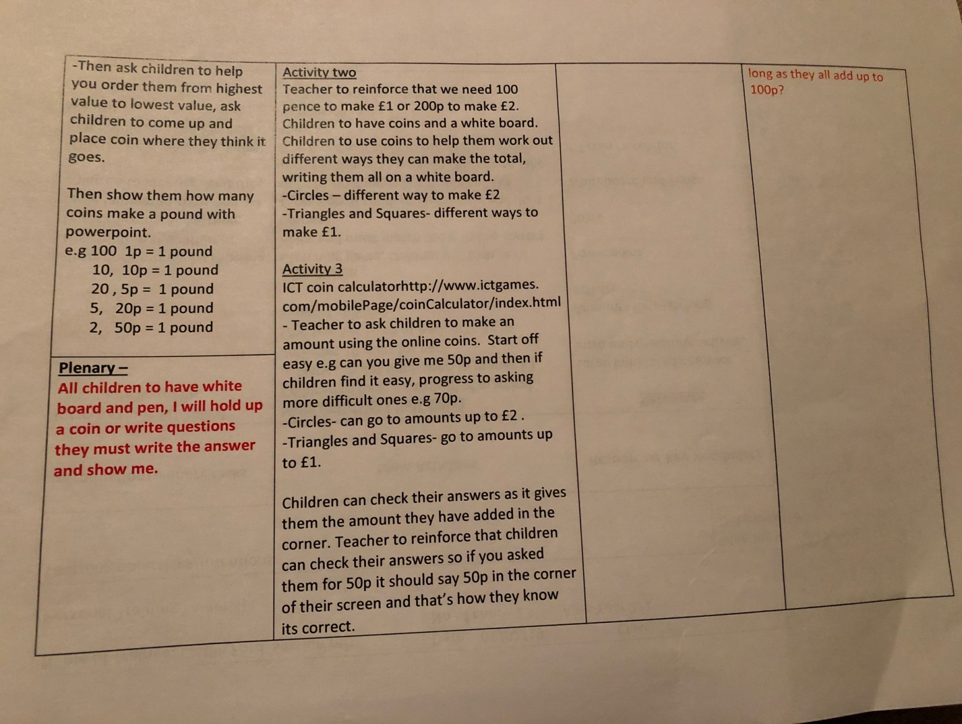
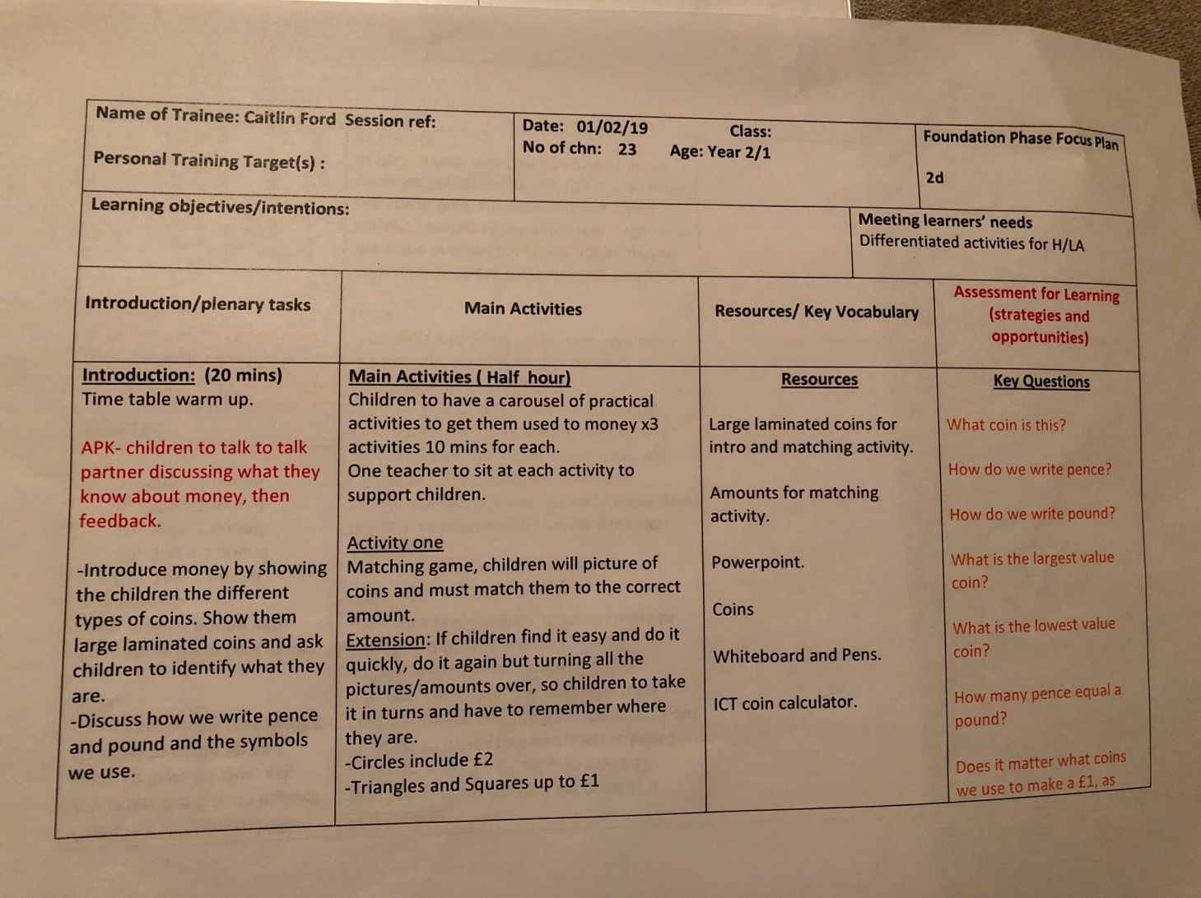
Appendix 7- Lesson Plan first session of money
-++Appendix 8- Money misconception

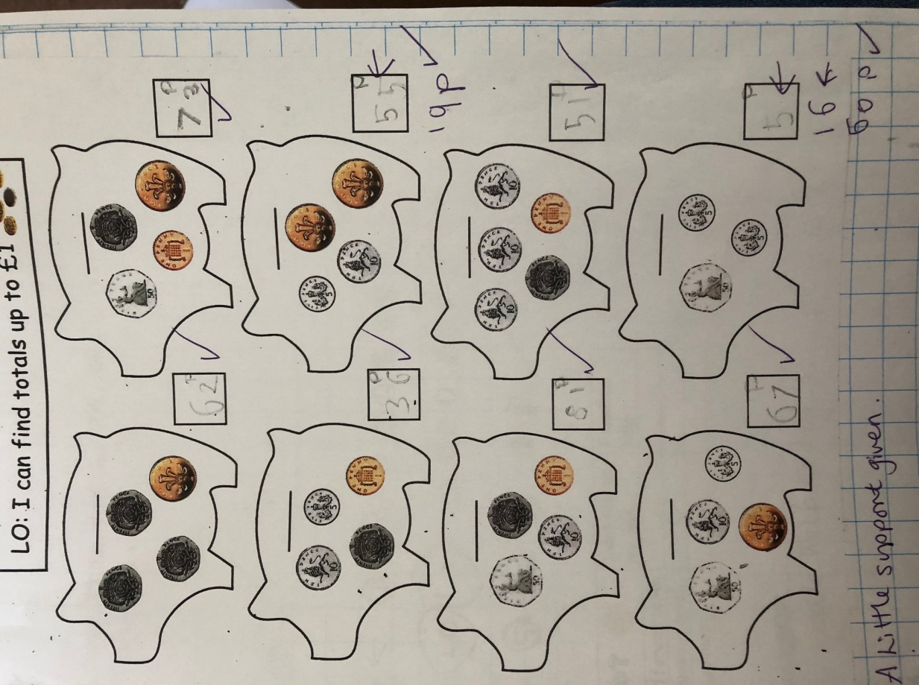

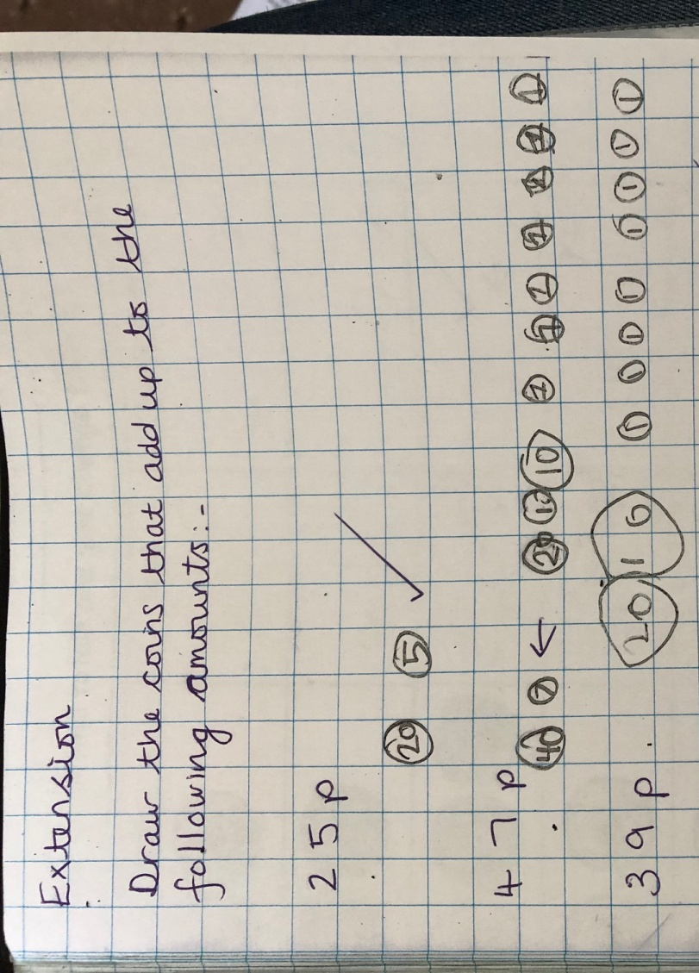

Appendix 9- Mathematics Area


